Predicting Plant Succession

David Hamoui

Department of Mathematical Sciences, New Jersey Institute of Technology

Ecology Lab with Dr. Russell and Catherine Morrison

Abstract

Plant succession is the gradual change in plant species covering a plot of land over time, and the process should be predictable. We worked on developed a model to predict plant succession and identify sources of uncertainty and noise. We began by testing the sources of two types of stochasticities in our experiment. The firs type of stochasticity came from the probabilistic characteristics of the Markov process itself. However, this only appear when modeling using plant individuals as opposed to plant proportions. The second type of stochasticity arises when combining transition matrices from separate plots into one single transition matrix known as a Markov set matrix. We also compared the variation and amount of noise that arises from the number of plots studied and the number of plant individuals in each plot. Second, we studied how the history of a certain data set affects our predictions. We checked to see how many years from the data set gave us optimal results when used in our predictions. This gave us an understanding of how homogeneity of the data affects our predictions. We show some real world data sets that illustrate the differences between homogeneity and non-homogeneity and how it affects our predictions.

Table of Contents

Introduction Page 4
The Markov Process Page 5
Estimating the Matrix Page 7
Stochasticity Page 7
Simulating Samuels’ Data Page 10
Finding Optimal Number of Individuals Page 13
Finding Optimal Number of Time Steps Page 15
Conclusion Page 19
Further Research Page 19
References Page 21

INTRODUCTION
The way an ecosystem behaves has always been an interesting topic. Different ecosystems have vastly different behavior and can evolve in a multitude of ways. In our studies, we plan to explore how ecosystems develop over time and attempt to capture that behavior in a predictable model. More specifically, we focused on plant ecosystems and attempted to model plant succession. Vegetation of a particular area evolves in a sequence of steps involving different plant species. This evolutionary process is known as plant succession.
Our hypothesis is that we can predict the outcome of plant succession with sufficient precision that we will be able to identify small interventions that will push the community towards a more desirable end state. Small interventions in this case mean little human work is required and the community needs to be somewhat self sufficient. A desirable end state is one that is attainable with minimal intervention, easily controlled, aesthetically appealing, and performs ecosystem services such as pollination (bees and birds) and aeration of the soil (earthworms).
Our model had to be mathematical in nature. There exists a vast array of processes that we could utilize, but we found it most convenient to use Markov Set Chains. A Markov chain is a process in which the present state of a system can affect future states of the system.
In a Markov chain, we have a set of states S = {s₁,s₂,s₃, … , s_{n}}. The process begins at any step and moves successively to another state. These moves are known as time steps. If the chain begins at state s_{a} and moves to state s_{b} with a probability p_{ab}. These probabilities are called transition probabilities and are only dependant on the current state of the system.
The behavior that we are trying to capture in our model is how some plant A gets replaced by another plant B in a given plot of land. To do so, we will need to know all the different probabilities of the current state in order to determine the next state of the system. The number of probabilities in the system is 2^{n}, where n is the number of species in our ecosystem. In the simplest case, we have two plant species A and B on a plot of land. Thus, there are four distinct probabilities: 1) plant A remaining A, 2) plant A being replaced by B, 3) plant B being replaced by A, and 4) plant B remaining B. The probabilities can be conveniently represented in a square matrix which is known as the transition matrix P. Below is an example of a transition matrix P and the individual probabilities.
A B
P = A 0.3 0.7
B 0.7 0.3
The entries in the first row of the matrix represent the probabilities of whether plant A will remain the same or if it will be replaced by plant B. Similarly, the second row represents the probabilities for plant B.
The Markov Process
At any given state in the system, the next state can be determined by multiplying a vector of plant proportions by the transition matrix. This is defined as the Markov Process. In general, we use plant proportions because it is more difficult to determine the exact number of different plants in a given plot of land, however the latter is still possible. The Markov process differs depending on whether the plant population is represented by proportions of plants or individuals. Creating the proportions vector can be found by estimation, however creating the transition matrix is more complicated. The figure below illustrates the Markov process where the population of plants is represented by a vector of proportions.
Figure 1 – Markov Process
A
B
C
A B C

.80 .05 .15
.05 .90 .05
.10 .20 .70

0.5
0.3
0.2

A
B
C
=
A
B
C

0.445
0.305
0.25

In this case the Markov process entails multiplying the transition matrix by the vector of proportions. This results in a new vector of proportions representing the proportion of plants in the new time step.
SECTION I
The physical part of our experiment is the actual plots of land. So given plots of land in a field, we want to be able to predict what will happen to the plants in those plots of land as time progresses. We can view the plots of land to contain proportions of plants, or they can contain individual plants. The process itself and the actual predictions will vary depending on which we chose, however the general results should be similar. Below we have a diagram representing four plots of land in a singe field. The three colors show the three different types of plants in the plots whereas the tiny boxes denote each individual plant.
Field
Individual
Plot 1
Plot 2
Plot 3
Plot 4
Figure 2- Field and Plots of Land
Estimating the Matrix
Information on the proportions of the plants in the system is needed in order to create the transition matrix. We attempt to find the matrix of transition probabilities that is most likely to have given rise to the observed sequence of proportions. We began by using the linear least squares method because of its ease to implement. The linear least squares method is simply a linear mathematical fit model which finds an approximate solution to an overdetermined system of linear equations. However, we realized that using the linear method resulted in negative probabilities which in non-sensical in our case. Therefore we used quadratic programming which is a mathematical optimization technique of several variables. What makes it more suitable in our case is that it takes constraints so we can ensure that we will not get negative results.
Stochasticity
The estimated transition matrix can be deterministic or discrete depending on the method in which the transition matrix is estimated. The deterministic model is a simplification of the behavior of the system because it does not account for any randomness in the system. In this case we have a single Markov matrix with continuous proportions of plants. The proportions of plants are treated as fractions of the plot and thus the model will always converge to a single fixed point.
The deterministic process is highly unlikely because there is always some form of noise in the ecosystem, and it is unrealistic to assume continuous plant proportions. The process is known as stochastic when it encorporates the randomness from the system. The process can differ greatly depending on the source of the randomness.
We can encorporate randomness into our model in a number of ways. Suppose we divide our plot of land into 10x10 smaller squares where each square is roughly the size of one plant. Then instead of having a vector of proportions, we have a known number of plants. Suppose that we have 30 plants of type A and 70 plants of type B. They sum up to 100 plants, one for each square in the plot. If we know the transition matrix, then we can create randomness within the system by changing the number of plants according to the probabilities. Since the top row of the matrix gives the probability of plant A remaining itself or getting replaced by plant B, we randomly pick an identity for the plant based on these probabilities. The process is done for 30 times for plant A. The same process is repeated for plant B with the lower row of the matrix. Once the process is done, we will have different amounts of plant A and plant B but they would still add up to 100. Each time the process is done from the same starting numbers, the end results will always be different because we are choosing randomly. The random factor in the process makes it stochastic and we define this as Type I stochasticity.
In a more complicated system, it is possible to collect data from numerous plots of land in close proximity to each other. Since all plots of land contain the same plant species, it is reasonable to assume that the transition matrices of each plot are similar but not identical to its neighbors. We can create a single transition matrix that captures the behavior of all plots by having each element of the matrix represent an interval of probabilities as opposed to singular probabilities. Each interval represents the highest and lowest probabilities of the plant from all four plots.
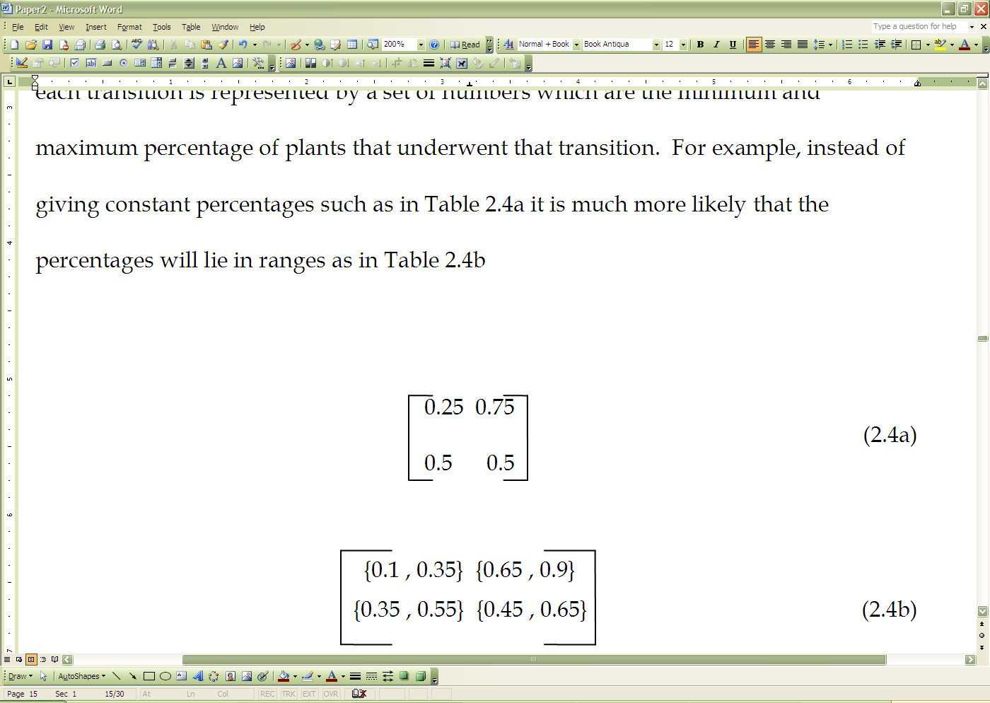

0.35 0.65

0.55 0.45

Plot 3

0.24 0.76

0.35 0.65

Plot 1

0.1 0.9

0.5 0.5

Plot 2
Figure 3 – A Markov Set Matrix
Above is a diagram illustrating how a Markov set matrix is created from three different transition probabilities.
Since multiplying a vector by a matrix of intervals is impossible, we choose a probability randomly from each interval to represent the probability for that element, and we standardize all probabilities so that they sum to 1. We call this type II stochasticity, as it introduces randomness in the probabilities as opposed to type I which introduces randomness in the proportions.
There are four different probabilities when doing Markov process as shown in the table below:
 | Continuous Proportions | Discrete Individuals
Regular Matrix | Deterministic | Type I stochastic
Intervals of probabilities | Type II stochastic | Type I and II stochastic
Table I – The Stochastic Methods
We see that it is possible to have both sources of stochasticity in our process. This is done by having a matrix consisting of the intervals of proportions and also having the plant identities being randomly chosen.
SECTION II
Simulating Samuels’ Data
Once we got an understanding of the Markov process and the stochasticities involved, we decided to test our model against real data sets to see if it was effective. We used the following data set which followed four separate plots over six years from 1994 to 1999 (Samuels). Each plot had two different plant types in them: A denotes annual plants and P denotes perennials. The table gives the proportions of plants in each plot over the six years.

Plot I Plot II Plot III Plot IV
Year | A | P | A | P | A | P | A | P
’94 | 0.692 | 0.308 | 0.682 | 0.318 | 0.567 | 0.433 | 0.522 | 0.478
’95 | 0.315 | 0.685 | 0.461 | 0.539 | 0.327 | 0.673 | 0.358 | 0.642
’96 | 0.226 | 0.774 | 0.309 | 0.691 | 0.263 | 0.737 | 0.119 | 0.881
’97 | 0.075 | 0.925 | 0.037 | 0.963 | 0.063 | 0.937 | 0.106 | 0.894
’98 | 0.020 | 0.980 | 0.013 | 0.987 | 0.029 | 0.971 | 0.062 | 0.938
’99 | 0.070 | 0.930 | 0.033 | 0.967 | 0.127 | 0.873 | 0.134 | 0.866
Table II – Plant Proportions from ’94 to ’99

Our goal was to create a transition matrix based on the behavior in the first five time steps of the data. Then using the matrix and a vector of probabilities, we would run the Markov process and compare our results to the sixth time step in the data. Since we were dealing with four plots, our transition matrix would consist of intervals. We would choose a probability for each element in the matrix from the interval. We wanted to estimate the 100th time-step to see what happens to the proportions of the plants in the long run. We also wanted to make sure that no single simulation of the Markov process would be too good or too bad. So, in order to estimate with the greatest level of confidence, we decided to run the simulation over 10,000 trials. Meaning we did 10,000 simulations and in each simulation we estimate the 100th time step. For predicting each time step, we randomly chose probability values from the Markov set matrix to represent he probabilities at that specific time step. Since we would have 10,000 different results for each simulation, then we could be fairly confident that the results we got accurately represented how well our model estimates the true data set. Then we sorted the lists which gave us the probabilities for each column. Below is a histogram describing the distribution of the proportions of plant A over the 10,000 simulations. The proportions of plant B are found by subtracting the proportions of plant A from 1 since we know both proportions must add up to one.
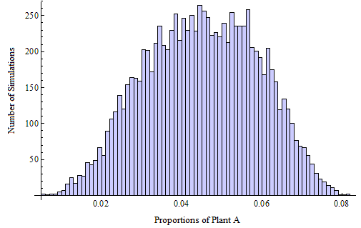
Figure 4 – Proportions of Plant A
The results depicted in the histogram are important because we can clearly see that the mean proportions for plant A are roughly around 0.05. Also, it never dominates plant B in any of the 10,000 simulations as the highest value for plant A was roughly around 0.08. There existed some variation but it was within 10⁻³ which we considered to be small. Since the variation in all 10,000 simulations was relatively small, then we can say that our model is effective at predictions.
Our methods for measuring variation were effective for the data set that we used. However, once we have three or more species, we can no longer plot in the same manner. Therefore, we used the Bray-Curtis distance, and we tried to use the mean distance (of our simulation from Samuels’ original data) as a measure of the total variability. The Bray-Curtis distance which finds the distance between two vectors {a,b,c} and {x,y,z} is defined as:

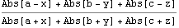
Formula I – Bray Curtis Distance (Mathematica)

where Abs [a-x] denotes the absolute value of the difference.
SECTION III
Finding Optimal Number of Individuals
Another area we wanted to explore was the variation that arises from the number of plots that we use and the variation from the number of individuals. We wanted to find the intersection of the variations. In other words, we attempt to find a value in which the noise introduced from the randomness of the number of individuals as well as the number of plots is the same. Our goal is to optimize the balance between the number of plots and the size of each plot (number of individuals). Samuels’ data sets were of plant proportions. Meaning the number of individuals was unknown, so we could use any number of individuals and match them up with her proportions. However, we are looking for the number of individuals that gives us a best approximation. We encorporated the number of individuals in to our model and ran it for individuals ranging from one to 256. Another area we wanted to explore was the variation that arises from the number of plots that we use and the variation from the number of individuals. We did some predictions using the Markov process and then we computed the Bray-Curtis distance to see how far our predicted values were from the actual values
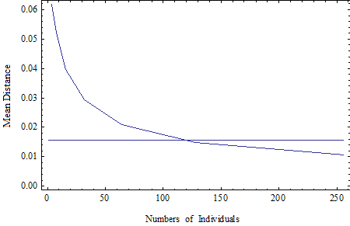
Figure 5 – Number of Individuals vs Bray Curtis Distance
The plots show that the best number of individuals to use is around 120 individuals. Any number less than that gives us a mean distance that is too high, and any more will give us one too low.
We then repeated the simulation for Samuels’ other data set of three plants. However, the number of individuals of this data set ranged from one to 64. We chose this interval for no other reason than to see a neighborhood around our point.
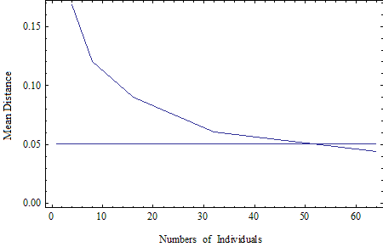
Figure 6 – Number of Individuals vs Bray Curtis Distance
For this data set, the optimal number of individuals is around 52. We also ran the simulation for Samuels’ other data set of two plant types, and we found that the best number of individuals in that case was around 40. This tells us that each data set has its own unique number that gives us an optimal balance of the stochasticities introduced by plot size and plot number. Our model was developed so we can simulate real data sets and not compare to previously known ones. However, knowing this information can help us get better approximations for any data set we come across.
Finding Optimal Number of Previous Time Steps
If we are given a large data set and we want to predict a future time step of the system, we need to see how many previous years of data we need to sample in order to create a transition matrix that will result the best predictions.
1234567
-------------------------------------------------------------------------
.3.2.4.3..5.2.4
.7.8.6.7.5.8.6
Timestep

Plant A
Plant B
Figure 7 – Timesteps and Proportions
For example, suppose we want to predict the seventh time-step. Should we take all the previous sex years of data or is there another amount of data sets that gives us a better prediction. While working on this, we discovered that this is largely affected by whether the actual data set is homogenous or non-homogenous. A data set is homogenous if each successive year is similar to the previous one. What we mean by similar in our case is that the proportions of plants from one year to the next should be close enough that the behavior at each time step is the same.
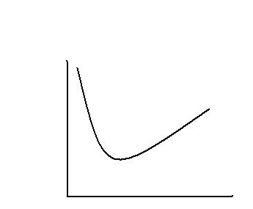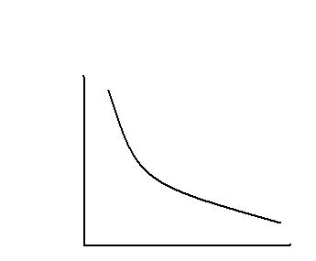
Number of Previous Timesteps
Number of Previous Timesteps
Error
Error
Figure 8 – Homogenous and Non-homogenous Data
The above figure shows us how our predictions are affected depending on whether our initial data set is homogenous or not. As we can see on the right, if we have a homogenous data set, the more time steps we take from the past the smaller our error will be. However, if we have a non-homogenous data set, then whether we take more or less data sets will not necessarily make our predictions better.
As we were checking the number of optimal time steps to take from the past, we happened to discover a way that can tell us whether a data set is homogenous or not.
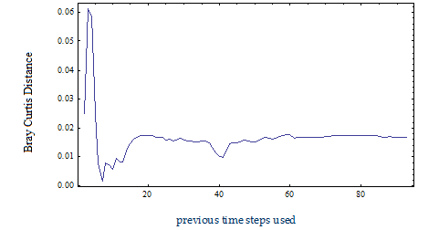
Figure 9 – Previous Time Steps Used vs Bray Curtis Distance
The figure illustrates our predictions for the 90th year, however we used a different number of time steps for each prediction. We plotted the number of previous time steps used versus the Bray Curtis distance between our predictions and the actual value. The spike at the beginning of the graph is just noise from taking too little data sets. The first big dip is coincidentally where the error is a minimum. We can see however that as we go further and take more and more time steps the distribution levels off to about 0.015. This is an example of a non-homogenous data set because in a homogenous data set the error should decrease as we take more previous time steps.
We then applied our methods to a data set that described the proportions of three cigarette types over 19 years. Below is a diagram that shows the proportions of the cigarette data over the 19 years.
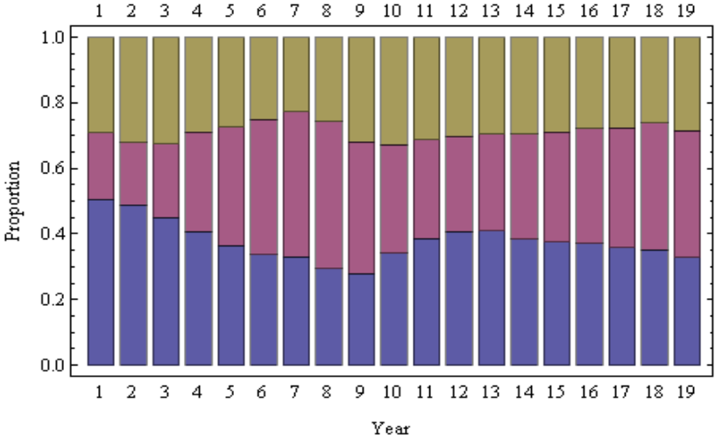
Figure 10 – Proportions of Cigarette Data Over 19 years
We started by prediction year 19 with the preceding 18 years. Then we predicted the same year using years 2-18, 3-18, and so on. We did the same process for all the years from 19 down to 11. We then took the interval that gave the best prediction which is shown below.
Results
Predicted Time Step | Best Range of Time Steps
19 | 10-18
18 | 5-17
17 | 5-16
16 | 5-15
15 | 5-14
14 | 6-13
13 | 6-12
12 | 9-11
11 | 1-10
Table 3 – Time Steps Predicted and Number of Time Steps Used
We can see that in general taking the fifth year and onward provide a good approximation in almost each case. However, in predicting year 12, we notice that only three years are necessary to predict it. This tells us that there is an inflection point around those years in the data set. This means that around those years, there is a significant difference in the proportions of the cigarettes compared to all the other years. The existence of such inflection points indicates that this is a non-homogenous data set.

CONCLUSION

Over the course of our time in UBM, Catherine and I with the help of Professor Russell, have a created a method to predict plant succession. We tested our model against Cory Samuels’ data sets. We refined the model by testing it against varying initial conditions such as number of plots and number of plant individuals. We further refined it by making it more sensitive to number of years used to predict the future, as well as the homogeneity of data. We also came up with a method to check whether data sets are homogenous or not.
FURTHER RESEARCH
Unfortunately, the only part of the experiment that we were able to complete in the time allotted was the model for prediction. We did not get a chance to test our model on real plots of land. We didn’t get a chance to see what happens in our predictions when changes are introduced to the plots such as fires or the migration of certain species of animals. So, we could further expand our research by testing with radical changes in the system, putting in changes ourselves such as new types as plants, as well as attempting to push the system to an end state that we desire.

REFERENCES
LEE, T.C., JUDGE, G.G. & ZELLNER, A. (1977). Estimating the parameters of the Markov

probability model from aggregate time series data. New York: North-Holland

Publishing Company.
Samuels, Cory. "MARKOV SET-CHAINS AS MODELS OF PLANT SUCCESSION."

(2001).

