THIS IS A REAL OLD PROPOSAL

This proposal was approved.
It is good.
But it is not perfect.

You should consider it a guideline.
But you are permitted to do better.

I have added some comments to it which are all marked with yellow highlights.

Please refer to the

MS Proposal Writing MS Report Writing MS Common Mistakes

Links to better understand why things are as they are.

Master’s Project Proposal

Children Overlap Calculator
MAKE SURE YOUR TITLE IS SPECIFIC. THIS IS THE TITLE OF YOUR WORK, NOT THE TITLE OF THE OVERALL PROJECT. IT SHOULD BE DIFFERENT FROM (MORE SPECIFIC THAN) THE TITLES OF ALL OTHER STUDENTS IN THIS PROJECT.
Project Report submitted to
The Department of Computer Science
New Jersey Institute of Technology.

In Partial fulfillment of the requirements of the Degree of Master of Science in Computer Science

Submitted by NAME
NJIT ID: ID
EMAIL

APPROVALS

Proposal Number: ________________________________

Agree to Advice: __Prof. James Geller____________
(Project Advisor)

Date Submitted: _________________________________

Approved by: ___________________________________
(MS in CS Committee)

Date Approved: __________________________________

Abstract

The UMLS (Unified Medical Language System) is being developed at the U.S. National Library of Medicine (NLM) to integrate many authoritative biomedical source terminologies into a unified knowledge representation. There are three main UMLS knowledge sources: Lexical programs, Semantic Network, and Metathesaurus. This is an ongoing project [1, 2, 11]. The main purpose of the project is to test whether it is appropriate to integrate new terminology into the UMLS. The Overlap Calculator calculates the overlapping concepts and overlapping statistic between a new terminology and the UMLS for a given concept. This tool helps auditors to measure the structural similarity between concepts in two different knowledge sources. A lower overlap ratio indicates less similarity.
The current version of the project is calculating overlap between two sources with respect to the children of a single concept. My part in this project is to add functionality to find non-overlapping concepts between two knowledge sources. I am also going to write an algorithm to calculate overlapping and non-overlapping concepts between two knowledge sources on more a granular level, by comparing two knowledge sources on one more level of descendants. To make the program more general, I am going to implement the functionality to calculate the overlap between two knowledge sources with respect to a whole terminology instead of a single concept.

Table of Contents
Topic | Page No.
- Introduction to UMLS  - Purpose of UMLS  - Conditions of UMLS  - Knowledge sources and associated tools of the UMLS  - Metathesaurus  - Scope of Metathesaurus  - Applying Metathesaurus  - Preservation of Content and Meaning from Source  Vocabularies  - Concept, Concept names and their Identifiers  - Terms and Lexical Identifiers  - Uses of Concept, String, Atom, and Term Identifiers  - Semantic Network  - SPECIALIST Lexicon and Lexical Programs  - Metamorphosys: The UMLS Installation and Customization Program | 4  5  5  6  6  8  8  9  10  12  12  14  15  16
2. An Overview of the project  - Need for the project  - GUI Description  - Tool Description | 17  18  19  21
- My Work  - Weekly Plan  - List of Deliverables | 21  22  23
References | 24

The introduction of this proposal is 13 pages long. That is quite long. Most projects don’t need that much introduction. Note, however, that most of the introduction is copied from other sources. It is perfectly okay to copy material for the introduction as long as repeated references such as [1] [2] make it clear that this is copied material. The introduction should also talk more about the problem that we are trying to solve in this project.

1. Introduction to UMLS
The UMLS (Unified Medical Language System) is being developed by the U.S. National Library of Medicine. It is an invaluable resource to the biomedical community. The latest 11th edition has incorporated 1.5 million biomedical terms from more than forty medical vocabularies, such as MESH, ICD and SNOMED [3, 4, 5]. Besides the structure inherited from the constituent vocabularies, the UMLS clusters synonym terms into concepts; it also adds inter-concept relationships based on lexical resemblance or human review of the terms and provides a categorization of the concepts in higher-level semantic types. All UMLS Knowledge Sources and associated software tools are free of charge to U.S. and international users. [1]

The conceptual model of the UMLS is given in Figure 1

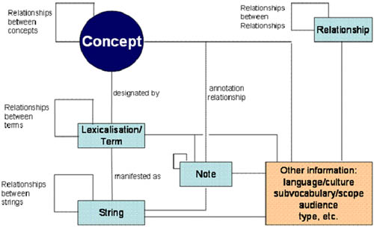

Figure 1: Conceptual Model of the UMLS [2]

There are 3 knowledge sources in the UMLS:
- Metathesaurus
- Specialist lexicon
3. Semantic network
  - Purpose of UMLS
The purpose of NLM's Unified Medical Language System (UMLS) is to facilitate the development of computer systems that behave as if they "understand" the meaning of the language of biomedicine and health. To that end, NLM produces and distributes the UMLS Knowledge Sources (databases) and associated software tools (programs) for use by system developers in building or enhancing electronic information systems that create, process, retrieve, integrate, and/or aggregate biomedical and health data and information, as well as in informatics research. By design, the UMLS Knowledge Sources are multi-purpose. They are not optimized for particular applications, but can be applied in systems that perform a range of functions involving one or more types of information, e.g., patient records, scientific literature, guidelines, and public health data. The associated UMLS software tools assist developers in customizing or using the UMLS Knowledge Sources for particular purposes. The lexical tools work more effectively in combination with the UMLS Knowledge Sources, but can also be used independently. [1]
  - Conditions of use of UMLS
All UMLS Knowledge Sources and associated software tools are free of charge to U.S. and international users [1, 7].
The Semantic Network, the SPECIALIST Lexicon, and associated lexical tools are accessible on the Internet under open terms, which include appropriate acknowledgment for their use.
To use the Metathesaurus, you must establish a license agreement. This is because the Metathesaurus includes vocabulary content produced by many different copyright holders as well as the substantial content produced by NLM.
Setting up the license agreement is done via the Web. Once the license agreement is in place, much of the content of the Metathesaurus may be used under very open conditions. Your pre-existing licenses for content with use restrictions, e.g., CPT, MedDRA, or NIC [5], will cover your use of that content as distributed within the Metathesaurus. Some vocabulary producers who require authorization to use their content will generally grant free permission.
  - Knowledge sources and associated tools of the UMLS
There are three UMLS Knowledge Sources: the Metathesaurus, the Semantic Network, and the SPECIALIST Lexicon [5]. They are distributed with several tools that facilitate their use, including the MetamorphoSys install and customization program.
1.3.1 Metathesaurus
The Metathesaurus is a very large, multi-purpose, and multi-lingual vocabulary database that contains information about biomedical and health related concepts, their various names, and the relationships among them. It is built from the electronic versions of many different thesauri, classifications, code sets, and lists of controlled terms used in patient care, health services billing, public health statistics, indexing and cataloging biomedical literature, and /or basic, clinical, and health services research. In this documentation, these are referred to as the "source vocabularies" of the Metathesaurus. In the Metathesaurus, all the source vocabularies are available in a single, fully-specified database format. [1]
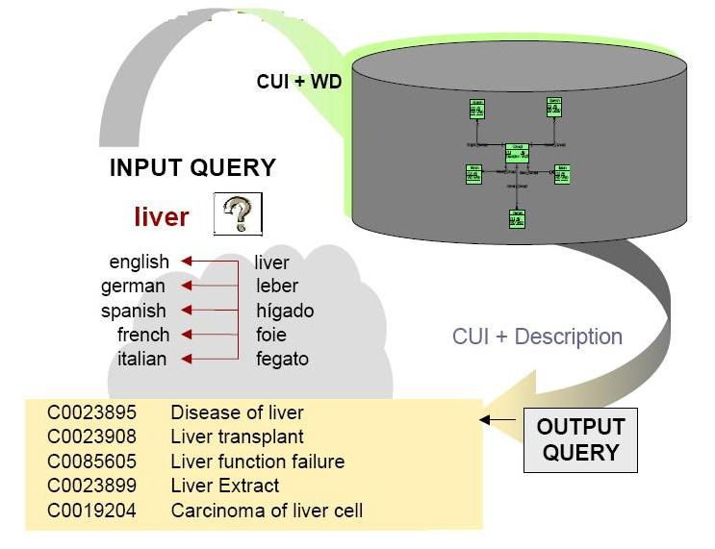
Figure 2: Overview of Metathesaurus functionality
A complete list of the source vocabularies present in this version of the Metathesaurus indicates which coding systems and vocabularies are designated as U.S. standards for administrative health transactions in accordance with HIPAA or as target U.S. government-wide clinical standards selected by the Consolidated Health Informatics eGov initiative. [5]
The Metathesaurus is organized by concept or meaning. In essence, its purpose is to link alternative names and views of the same concept together and to identify useful relationships between different concepts. All concepts in the Metathesaurus are assigned to at least one semantic type from the Semantic Network. This provides consistent categorization of all concepts in the Metathesaurus at the relatively general level represented in the Semantic Network. Many of the words and multi-word terms that appear in concept names or strings in the Metathesaurus also appear in the SPECIALIST Lexicon. The lexical tools are used to generate the word, normalized word, and normalized string indexes to the Metathesaurus. MetamorphoSys must be used to install the Metathesaurus files and is the recommended software tool for customizing the Metathesaurus for specific purposes. [1]
1.3.1.1 Scope of the Metathesaurus
The scope of the Metathesaurus is determined by the combined scope of its source vocabularies. Many relationships (primarily synonymous), concept attributes, and some concept names are added by the NLM during Metathesaurus creation and maintenance, but essentially all the concepts themselves come from one or more of the source vocabularies. Generally, if a concept does not appear in any of the source vocabularies, it will also not appear in the Metathesaurus. [1]
      - Applying Metathesaurus
The Metathesaurus supplies information that computer programs can use to create standard data, interpret user inquiries, interact with users to refine their questions, and convert the users' terms into the vocabulary used in relevant information sources [5, 11]. It is used in a wide range of applications including: linking between different clinical or biomedical vocabularies; information retrieval from databases with human assigned subject index terms and from free-text information sources; linking patient records to related information in bibliographic, full-text, or factual databases; natural language processing and automated indexing research; and structured data entry. In many cases, the utility of the Metathesaurus is enhanced when it is used in combination with the specialist lexicon, the lexical programs, and the UMLS semantic network. [1, 11]
To obtain coherent, comparable results in data creation applications, such as patient data entry, it is necessary to define which Metathesaurus concepts and terms can be included in the records being created. This may be done by selecting one or more of the many Metathesaurus source vocabularies which provide the most appropriate concepts and terms for the specific data being created. Figure 2, 3 shows us a general concept used between the UMLS-Metathesaurus. Other Metathesaurus concepts and terms will then provide synonyms and related terms which can help to lead users to the vocabularies selected for a particular data creation application. [1]
1.3.1.3 Preservation of Content and Meaning from Source Vocabularies
The Metathesaurus reflects and preserves the meanings, concept names, and relationships from its source vocabularies. When two different source vocabularies use the same name for differing concepts, the Metathesaurus represents both of the meanings and indicates which meaning is present in which source vocabulary. When the same concept appears in different hierarchical contexts in different source vocabularies, the Metathesaurus includes all the hierarchies. When conflicting relationships between two concepts appear in different source vocabularies, both views are included in the Metathesaurus. Although specific concept names or relationships from some source vocabularies may be idiosyncratic and lack face validity, they are still included in the Metathesaurus. [1, 12]
In other words, the Metathesaurus does not represent a comprehensive NLM-authored ontology of biomedicine or a single consistent view of the world (except at the high level of the semantic types assigned to all its concepts). The Metathesaurus preserves the many views of the world present in its source vocabularies because these different views may be useful for different tasks. [1, 9]
Although it preserves all the meanings and content in its source vocabularies, the Metathesaurus stores this information in a single common format. The native format of each vocabulary is carefully studied and then "inverted" into the common Metathesaurus format. For some vocabularies, this involves representing implied information in a more explicit format. For example, if a source vocabulary stores its preferred concept name as the first occurrence in a list of alternative concept names, that first name is explicitly tagged as the preferred name for that source in the Metathesaurus.[12]
      - Concept, Concept names and their Identifiers
The Metathesaurus is organized by concept. One of its primary purposes is to connect different names for the same concept from many different vocabularies. The Metathesaurus assigns several types of unique, permanent identifiers to the concepts and concept names it contains, in addition to retaining all identifiers that are present in the source vocabularies [5]. The Metathesaurus "concept structure" includes concept names, their identifiers, and key characteristics of these concept names (e.g., language, vocabulary source, name type). The entire concept structure appears in a single file in the Rich Release Format (MRCONSO.RRF). An abbreviated version of the concept structure is split between two files in the Original Format (MRCON and MRSO).

Concepts and Concept Identifiers
A concept is a meaning. A meaning can have many different names. Each concept or meaning in the Metathesaurus has a unique and permanent concept identifier (CUI).
A CUI will be removed from the Metathesaurus when it is discovered that two CUIs name the same concept. [5] Retired CUIs are never re-used.

Concept Names and String Identifiers
Each unique concept name or string in each language in the Metathesaurus has a unique and permanent string identifier (SUI). Any variation in character set, upper-lower case, or punctuation is a separate string, with a separate SUI. [5] The same string in different languages (e.g., English and Spanish) will have a different string identifier for each language. If the same string, e.g., Cold, has more than one meaning, the string identifier will be linked to more than one concept identifier (CUI).

Atoms and Atom Identifiers
The basic building blocks or "atoms" from which the Metathesaurus is constructed are the concept names or strings from each of the source vocabularies. Every occurrence of a string in each source vocabulary is assigned a unique atom identifier (AUI). [5] Unlike string identifiers, a single AUI is always linked to a single concept identifier, because each occurrence of a string in a source can only have one meaning. More than one AUI may point to one same CUI.
1.3.1.5 Terms and Lexical Identifiers
For English language entries in the Metathesaurus only, each string is linked to all of its lexical variants or minor variations by means of a common term identifier (LUI). (In the Metathesaurus, therefore, an English "term" is the group of all strings that are lexical variants of each other.) Like a string identifier, the LUI for an English string may be linked to more than one concept. This occurs when strings that are lexical variants of each other have different meanings. In contrast, each string identifier and each atom identifier can only be linked to a single LUI. [5]

1.3.1.6 Uses of Concept, String, Atom, and Term Identifiers
In the Metathesaurus, every CUI (concept) is linked to at least one AUI (atom), SUI (string), and LUI (term), but can also be linked to many of each of these [5]. Every AUI (atom) is linked to a single SUI (string), a single LUI (term), and a single CUI (concept). Each SUI (string) can be linked to many AUIs (atoms), to a single LUI (term), and to more than one CUI (concept) – although the typical case is one CUI. Each LUI (term) can be linked to many AUIs (atoms), many SUIs (strings), and more than one CUI (concept) – although the typical case is one CUI.
In the abbreviated example in Figure 4, "Atrial Fibrillation" appears as an atom in more than one source vocabulary and has a distinct AUI for each occurrence. Since each of these atoms has an identical string or concept name, they are linked to a single SUI. "Atrial Fibrillations", the plural of "Atrial Fibrillation" has a different string identifier. Since the singular and plural are lexical variants of each other, both are linked to the same LUI. There is a different LUI and different SUIs and AUIs for "Auricular Fibrillation" and its plural "Auricular Fibrillations." Since "Atrial Fibrillation" and "Auricular Fibrillation" have been judged to have the same meaning, they are linked to the same CUI [5]. All of these identifiers serve important purposes in building the Metathesaurus, in allowing efficient and accurate customization for specific purposes, and in identifying changes in its concept and concept name coverage over time.
Concept (CUI) | Terms (LUIs) | Strings (SUIs) | Atoms (AUIs)  * RRF Only
C0004238  Atrial Fibrillation  (preferred)  Atrial Fibrillations  Auricular Fibrillation  Auricular Fibrillations | L0004238  Atrial Fibrillation  (preferred)  Atrial Fibrillations | S0016668  Atrial Fibrillation  (preferred) | A0027665  Atrial Fibrillation  (from MSH)  A0027667  Atrial Fibrillation  (from PSY)
 |  | S0016669  Atrial Fibrillations | A0027668  Atrial Fibrillations  (from MSH)
 | L0004327  (synonym)  Auricular Fibrillation  Auricular Fibrillations | S0016899  Auricular Fibrillation  (preferred) | A0027930  Auricular Fibrillation  (from PSY)
 |  | S0016900  (plural variant)  Auricular Fibrillations | A0027932  Auricular Fibrillations  (from MSH)

Figure 3: Relationship between Concepts, Terms, Strings and atoms in the UMLS [11]

    - Semantic Network
The purpose of the Semantic Network is to provide a consistent categorization of all concepts represented in the UMLS Metathesaurus and to provide a set of useful relationships between these concepts. All information about specific concepts is found in the Metathesaurus; the Network provides information about the set of basic semantic types, or categories, which may be assigned to these concepts, and it defines the set of relationships that may hold between the semantic types. The current release of the Semantic Network contains 135 semantic types and 54 relationships. The Semantic Network serves as an authority for the semantic types that are assigned to concepts in the Metathesaurus. The Network defines these types, both with textual descriptions and by means of the information inherent in its hierarchies [5].
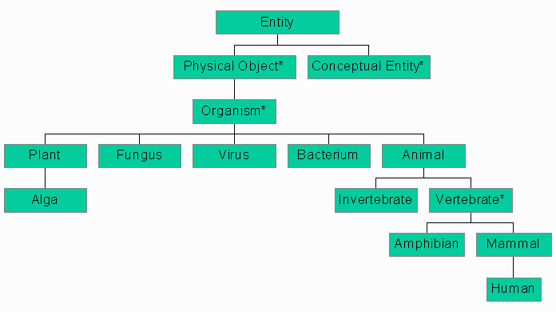
Figure 4: Subset of the UMLS Semantic Network [8]
The semantic types are the nodes in the Network, and the relationships between them are the links. There are major groupings of semantic types for organisms, anatomical structures, biologic function, chemicals, events, physical objects, and concepts or ideas [5]. The current scope of the UMLS semantic types is quite broad, allowing for the semantic categorization of a wide range of terminology in multiple domains.

1.3.3 SPECIALIST Lexicon and Lexical Programs
The SPECIALIST lexicon has been developed to provide the lexical information needed for the SPECIALIST Natural Language Processing System (NLP). It is intended to be a general English lexicon that includes many biomedical terms. Coverage includes both commonly occurring English words and biomedical vocabulary. The lexicon entry for each word or term records the syntactic, morphological, and orthographic information needed by the SPECIALIST NLP System [1].
The lexical programs or tools are designed to address the high degree of variability in natural language words and terms. Words often have several inflected forms which would properly be considered instances of the same word. The verb "treat", for example, has three inflectional variants: "treats” the third person singular present tense form, "treated" the past and past participle form, and "treating" the present participle form. Multi-word terms in the Metathesaurus and other controlled vocabularies may have word order variants in addition to their inflectional and alphabetic case variants. The lexical tools allow the user to abstract away from this sort of variation [1].
The SPECIALIST Lexicon is provided in two formats; a unit record format and a relational table format. The information associated with each lexical entry includes a unique identifier, a base form, a syntactic category code, certain agreement information, complementation information if relevant, and various other properties relevant to the particular lexical entry [2].
    - Metamorphosys: The UMLS Installation and Customization Program
MetamorphoSys is a cross-platform Java application that must be used if the UMLS Knowledge Sources (Metathesaurus, Semantic Network, and SPECIALIST Lexicon) are installed locally. MetamorphoSys also supports the creation and refinement of customized subsets of the Metathesaurus. In general, the Metathesaurus must be customized to be used effectively in specific applications.
MetamorphoSys guides you first through the installation of one or more UMLS Knowledge Sources, and then through customization of the Metathesaurus for local use. A variety of options are available, such as the inclusion or exclusion of specific source vocabularies, languages, and term types, specification of output character set (7-bit ASCII or Unicode UTF-8) and output format (Rich Release Format or Original Release Format) for the Metathesaurus files [5].

2. An Overview of the Project
This section usually describes work done by other students at NJIT that graduated already or will graduate before you, and you are continuing their work. The purpose of this section is that you should show that you really understand what exists already in software and support systems. This is different from Section 1 where you explain the overall problem and what has been done outside of NJIT on this problem.
2.1 Need for the project
The “Children Overlap Calculator” is a UMLS integrations tool. The main purpose of the project is to integrate a new terminology into the UMLS. This tool allows a user to calculate overlap ratios between children of some specific concept for two given knowledge sources. An auditor is able to enter a concept name and two knowledge sources that are needed for comparison of the children of the entered specific concept. Then, the tool calculates the set of common children of this specific concept from these two knowledge sources. This will help the auditors to measure the structural similarity between concepts in two different knowledge sources. A lower overlap ratio indicates less similarity.

UMLS-

(UMLS - MTHMST)

MTH-MST
Non-Overlapping Overlapping Concepts
Concepts between
MTH-MST and UMLS-
Fig 4: Graphical representation of the overlapping and non-overlapping concepts
2.2 GUI Description

Source 1 Focus Concept Source 2

Overlapping Concepts Overlap Statistic

Fig 5: Overlap Children Calculator Layout

The “Children Overlap Calculator” is standalone Swing based Java application. This application takes a concept and two sources as input parameters and accordingly calculates the overlap between those two knowledge sources. This application also calculates the overlap statistics using cosine, Jaccard and Dice formulas.
Cosine formula: 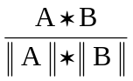

Jaccard formula: 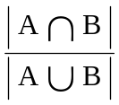

Dice formula: 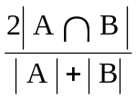

2.3 Tool Description
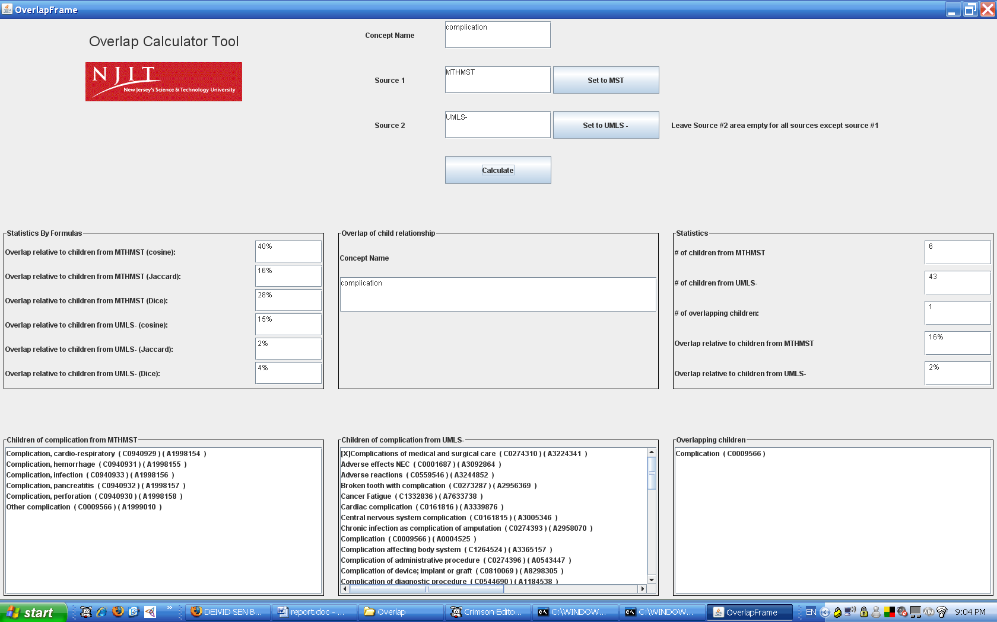
Fig 6: Overlap Children Calculator
The Children Overlap Calculator has eight panels
- Logo Panel: This panel displays the logo of the university, NJIT .
- User Query Panel: User query panel is basically design for user input, concept, SOURCE 1 and SOURCE 2.
- Overlap relationship of children Panel: This panel shows the focus concept.
- Statistics by Formulas Panel: This panel shows the overlap statistics of two sources by using cosine, Jaccard and Dice formulas.
- Statistics Panel: This panel shows the number of children from both sources, % of children overlap of two sources and number of overlapping children.
- Children from SOURCE 1 Panel: This panel displays the all the descendants of SOURCE 1 for given concept.
- Children from SOURCE 2 Panel: This panel displays the all the children (and if requested) grandchildren of SOURCE 1 for a given concept.
- Overlap Children Panel: This panel shows the concepts which are present in both SOURCE 1 and SOURCE 2.

- My Work

The My Work section here is a little short. Normally it should be about 3 pages. The reason for this is that this specific student worked on a second project also, but we decided to include only the first project in the proposal. Note: Nobody will check at the end (when you graduate) whether you did EXACTLY this work. What will be checked is whether you did ENOUGH work, whether you did it well, and whether you are describing it well. So don’t be too worried about getting this totally right.

Grandchildren overlap calculation module
I am going to develop a module for calculating overlapping concepts on a more granular level. The current version of the Children Overlap Calculator calculates the overlap between two knowledge sources with respect to children concepts. I am going to implement a module which will allow the user to compare two knowledge sources on a more granular level. This module will enable a user to calculate overlap ratios between children and grandchildren of some specific concept for two given knowledge sources.
Non-overlapping concepts calculation module
I am going to implement a module to calculate the non-overlapping concepts between two knowledge sources. The Children Overlap Calculator is used to test whether it is appropriate to integrate a new terminology to the UMLS. So it is equally important for the user to know the non-overlapping concepts between a new terminology and the UMLS. Using this module, the user can find out which concepts are present in a new terminology but not present in the UMLS and vice versa.
Generalized overlap calculation module
This module will enable a user to find overlapping and non-overlapping concepts between two knowledge sources with respect to a whole terminology. The current version of the Children Overlap Calculator allows a user to find overlapping concepts between two knowledge sources with respect to single concepts. The module which I am going to develop will allow users to find overlapping and non-overlapping concepts between two knowledge sources with respect to a whole terminology.

  - Weekly Plan

THIS SECTION IS REQUIRED BY THE DEPARTMENT.

Week | My Work
Week 1 | Getting started: installation, menus, icons, and other basics
Week 2 | Understand the UMLS data structure and find the requirement of the different modules for Name Mapping and Structure Mapping
Week 3 | Understand and learn the functionality and data flow of the “Children Overlap Calculator” tool
Week 4 | Analyze the previous program code and queries.
Week 5 | Change the layout of the tool
Week 6 | Design the Grandchildren Overlap module for calculating overlap on more granular level by adding one more level of descendants for comparison
Week 7 | Modify the previous algorithm in order to compare two sources at more granular level
Week 8 | Continued
Week 9 | Design the Non-overlapping concepts calculation module to find out non-overlapping concepts between two knowledge sources
Week 10 | Write the program code to find non-overlapping concepts model
Week 11 | Analyze the data flow to calculate overlapping and non-overlapping with respect to a whole terminology and design the Generalized Overlap Calculation module for it.
Week 12 | Change the original program code in order to calculate overlapping and non-overlapping with respect to whole terminology.
Week 12 | Do the Integration Testing of the Grandchildren Overlap module, Non-overlapping concepts calculation module, Generalized Overlap Calculation module. Start writing project report.
Week 13 | Continued
Week 14 | Do the necessary changes if required and retest it.

3.2 List of Deliverables
THIS SECTION IS REQUIRED BY THE DEPARTMENT.

1) Grandchildren overlap calculation module
Input: Concept name, SOURCE 1 and SOURCE 2
Output: Overlapping concepts between two sources by comparing two sources with
one more level of descendants
2) Non-overlapping concepts calculation module
Input: Concept name, SOURCE 1 and SOURCE 2
Output: Non-overlapping concepts between SOURCE 1 and SOURCE 2
3) Generalized overlap calculation module
Input: Terminology, SOURCE 1 and SOURCE 2
Output: Overlapping concepts between two SOURCE 1 and SOURCE 2

Make sure your references are formatted consistently and according to some standard. This is commonly a problem. Also for Web pages, check that they still exist and put the date when you checked.

4. References
1) Unified Medical Language System, http://www.nlm.nih.gov/research/umls/about_umls.html , 19 July 2004.
2) FAO corporate document repository http://www.fao.org/docrep/008/af234e/af234e03.htm
3) Fact Sheets, SPECIALIST Lexicon, http://www.nlm.nih.gov/pubs/factsheets/umlslex.html , 28 March 2006.
4) Yehoshua Perl, James Geller, Mike Halper, Barry Cohen, Partitioning to Support Auditing and Extending the UMLS, Submitted for Review, 2005.
5) Fact Sheets, UMLS Metathesaurus, http://www.nlm.nih.gov/pubs/factsheets/umlsmeta.html , 28 March 2006.
6) A Computers and Thought: A practical Introduction to Artificial Intelligence http://www.informatics.susx.ac.uk/books/computers-and- thought/chap6/node5.html Oct, 2006.
7) Wikipedia, definition of semantic network. http://en.wikipedia.org/wiki/Semantic_network Oct, 2006.
8) National Library of Medicine website http://www.nlm.nih.gov/mesh/umlsforelis.html May 2006.
  - Informatics, Semantic Networks and a little history, www.informatics.susx.ac.uk/books/computers-and-thought/chap6/node5.html, Oct, 2006.

- OWL Web Ontology Language Guide,
http://www.w3.org/TR/owl-guide/, Oct, 2006.

- Rahul Bhave, Name mapping integration methodology for Unified Medical Language System (UMLS) Integration, MS Project proposal, CS Department, New Jersey Institute of Technology, Fall 2006.

- Apurva Pareekh, Test the integration methodology by removing a current terminology from the existing UMLS, MS Project proposal, CS Department, New Jersey Institute of Technology, Spring 2007.

