

SMS
(Software Management System)
Software Requirement Specifications Document

Table of Contents
Table of Contents 2
Table of Figures 4
Table of Tables 5
Revision History 6
1. Introduction 7
1.1 Purpose 7
1.2 Scope 8
1.3 Definitions, acronyms, and abbreviations 8
1.4 References 10
1.5 Overview 10
2 Overall Description 12
2.1 Product Perspective 12
2.2 Product Functions 15
2.3 User Characteristics 16
2.4 Constraints 16
2.5 Assumptions and Dependencies 17
3 Specific Requirements 18
3.1 External Interface requirements 18
3.2 Functions 20
3.3 Performance requirements 40
3.4 Logical database requirements 41
3.5 Design constraints 41
3.6 Software system attributes or other requirements 41
Appendixes 47
Appendix A: Data Flow Diagrams 47
Appendix B: Data Dictionary 51

Table of Figures

Figure 1 SMS Use Cases 21
Figure 2 Context Level Diagram 47
Figure 3 1st Level DFD 48
Figure 4 2nd Level DFD: 8th Process 49
Figure 5 2nd Level DFD: 7th Process 50

Table of Tables
Table1. Login Page 39
Table 2. SMS Main Menu 39
Table 3. Form to add new software 40
Table 4. Data Dictionary 59

Revision History

Description | Version # | Date | Author
Draft Document | 1.0 | 3/2/2007 | Jolanta Soltis
Second Draft | 1.1 | 3/13/2007 | Jolanta Soltis
Revision | 1.2 | 3/18/2007 | Ali Avni Cirik
Revision | 1.3 | 3/19/2007 | John Krane
Revision | 1.3 | 3/19/2007 | Rich Schuler

Introduction

Purpose
The Software Management System (SMS) serves as a management effective tool for software management across university to better manage and track how software is used. The pilot program for SMS would be developed and implemented at NJIT; however the system could be adapted to any other university. The purpose of this document is to define the requirements gathering process used to elicit requirements from the product stakeholders, to list the enterprise, system functional and non-functional requirements that are essential to the success of this product, and describe the issues and improved understanding in the process.
Currently, there is no visibility of software usage across the university because there is no single repository that lists which software is in use or ready for purchase. NJIT also lacks a unified method of notifying individuals, departments, and research projects about what software is currently available. They also lack a unified method of requesting the purchasing of new software.
These issues lead to wasted resources as disparate groups attempt to acquire software on their own when it may be possible to aggregate software purchases and realize bulk savings. In addition, there is no accurate count of the current software licenses in use which may lead to having too many or too few licenses.
In order to solve these problems NJIT needs a software management tool that allows effective management of all software purchases, requests, installations, maintenances and availabilities. This system will not replace any current system since no such system is in use.
The intended audience for the SMS system includes representatives from NJIT. The systems will be usable by non-experts: students, faculty and staff, and customizable to professionals NJIT’s IT administrators.

Scope
The product we will design is called Software Management System. The system is a web-based utility used to manage all the software available to NJIT employees and students. Users will benefit from this system by being able to communicate with IT Administrators and request software, keys, and licensees. In addition users will be able to request help for specific software problems, receive notification of software updates, and request new software purchases. IT Administrators will benefit from the system by having central location for all software information. New software will be added to the database and stored there. IT Administrators will be able to run reports and display statistics about the software usage. The software will run scripts that simplify IT administrators work: adding keys to the software database, removing users from the database and requesting new keys from software vendors’ website. The goal of the system is to create central point where all software is listed, managed, and requested.

Definitions, acronyms, and abbreviations

SMS: Software Management System.

Non-Functional requirements: requirements which specify criteria that can be used to judge the operation of a system, rather than specific behaviors.

Functional requirements: define the internal workings of the software: that is, the calculations, technical details, data manipulation and processing and other specific functionality that show how the use cases are to be satisfied.

Use Cases: use case is a technique for capturing functional requirements of systems and systems-of-systems.

PHP: PHP (Hypertext Preprocessor) is a programming language designed for producing dynamic Web pages.

MySQL: An open source database server geared towards web based applications.

DD: Data Dictionary

DFD: Data Flow Diagram

NJIT: New Jersey Institute of Technology

LDAP: Lightweight Directory Access Protocol

SSL: Secure Sockets Layer

UCID: University Computing ID

References
IEEE (1998). IEEE Recommended Practice for Software Requirements Specifications (1998). Retrieved March 19, 2007, from the World Wide Web:
http://ieeexplore.ieee.org/iel4/5841/15571/00720574.pdf?tp=&isnumber=15571&arnumber
“SottRack” (2005). Enterprise Software Audit and Control Platform. Audit, Inventory, Metering, License Compliance. Retrieved March 19, 2007, from the World Wide Web: http://www.softwaremetering.com
Sommerville, I. (2004). Software Engineering. Boston, MS: Addison Wesley

Overview
This document is intended for providing an abstract overview of the Software Management System and a general overview of the entire project. The rest of the document will provide detail instruction about: the Functional and Non-Functional Requirements, Stake Holders, Team Architecture, System Functional and Non-Functional Requirements. The software requirements specification is divided into three sections: this introduction, the general description of the project, and the specific requirements of the project. The general description is an overview of the project’s requirements, including a product perspective, functional and data requirements, constraints, assumptions, dependencies, and guidelines. The specific requirements section is a more detailed look at the project’s requirements, including external interface requirements, performance requirements, quality attributes, and a detailed look at functional requirements.
SMS is divided into three sections: software information, availability and vendor information. IT Administrator can access all sections. He or she can add software, change software information, add keys to the database and request reports. He/she is notified by the system about license expiration for particular software. Faculty and staff can only request software installation or license for requested software. Students can request software key.

Overall Description
The Software Management System design for New Jersey Institute of Technology will monitor usage of variety of software, availability of licenses for particular software and it will generate reports which will allow NJIT IT Administrators to see the software download statistics and better manage software purchases. As a brand new product in the field, the system should work well in collaboration with existing web platforms to provide convenience for users at various levels within the institution or organization. The SMS system will use the existing NJIT LDAP system to authenticate the users of the application.

Product Perspective
The Software Management System is an independent product that can exist without authentication, but for the implementation at NJIT it will use LDAP for authentication. The SMS should work well in collaboration with existing web platforms to provide convenience for users at various levels within the institution or organization. The SMS is using existing LDAP system to authenticate. The application is by developed by using PHP and HTML language. The application will be accessible via the Internet. Web browsers that can be used include Internet Explorer and Netscape Navigator.

2.1.1 System interfaces
The web interface is the main system interface, used for listing software and adding new software to the database as well as new product keys. These functions are independent of each other yet share the same database. The only system interface that will alter the database will be the script that adds new software. The primary interfaces to the database will be read-only.

2.1.2 User interfaces
There are three primary interfaces which will be implemented. The first one is the login screen, which will ask for the user name and the password. The second one is the main splash menu, which will have several options to choose from (view software list, add software, generate reports, adds keys to the database, etc). The third one is an administration form used to add new software to the database and other administration functions.

2.1.3 Software interfaces
The software interfaces will be contingent upon MySQL server and PHP as well as the web server the system will be implemented on.
The interfaces will have requirements of:
2.1.3.1 Operating Systems: Any distribution of Linux (kernel v2.2 or higher; www.linux.org) or Microsoft Windows (XP, 2003; www.microsoft.com). The operating system is used to interface the SMS with the underlying hardware.

2.1.3.2 Web Server: Apache (v1.3.x or later; www.apache.org). The Web Server is used to serve SMS web pages to a user’s Web Browser.
2.1.3.3 Database: MySQL (v3.2.x or higher; www.mysql.com).
2.1.3.4 Programming Languages: PHP (v2.2.x or higher; www.php.net). XHTML (v4.x; www.w3c.org). These are the languages that SMS is built with.
2.1.3.5 Web Browser: Firefox (www.getfirefox.com) or Microsoft Internet Explorer (v6 or later; www.microsoft.com). The web browser is used to connect to the SMS over a local network or the Internet.

2.1.4 Communications interfaces
The system will use the standard TCP/IP protocol for communications between interfaces.

Product Functions

The SMS system shall have a browser-based user interface allowing authorized users to log in and manage software.

The system shall be accessible to student, faculty and staff.

The system shall expose functionality to the users as per their defined access levels.

The system shall provide unrestricted access to IT Administrators.

The system shall allow users to request software key, license information and be way of communication with IT Administrators.

The system shall allow configuration and generation of detailed reports based on an IT Administrator’s query.

The system shall provide an option to send e-mail alerts that are triggered based on specified conditions set by IT Administrators.

The system shall allow IT Administrators to define access privileges that define the level of data detail available for view by different user groups.

The system shall integrate with the existing NJIT LDAP authentication scheme so users may use their current UCID to login.

User Characteristics
All active users with a valid UCID will have access to the SMS system (unless the UCID is of a restricted type). The intended users of the system will be students, staff, faculty, and IT Administrators. The functionality allowed to a user will be limited by the accessibility entitlements defined for that user.

Constraints

The product is a web-based application, so a most recent internet browser is needed (Internet Explorer 6/7, Firefox 2.0, Safari, Opera 8+).

Hardware limitations: Server hardware is unspecified as long as it meets the software requirements (PHP and MySQL)

Safety and security considerations: only NJIT students and employees should be able to access the system.

Interfaces to other applications: TCP/IP interface to MySQL, port 3306.

Audit functions: Apache and internal log auditing.

Safety and security considerations: SSL encryption for UCID/password exchange.

Assumptions and Dependencies

The system will depend on NJIT LDAP for user authentication. Sufficient access to NJIT LDAP system is assumed.

The users will have basic knowledge of web browser use.

SMS requires MySQL.

Criticality of the application: Application is not mission critical to NJIT.

Specific Requirements

External Interface requirements

User Interface: The SMS shall be a web-enabled application compatible with all major web browsers like Internet Explorer, Netscape Navigator, Mozilla FireFox, etc.

Hardware Interface: The target audience of this product shall be using an Apple, Windows PC or a computer running Linux with X windows. There is no special hardware that is required. The web browser will be the interface between the hardware and software.

Software Interfaces: The SMS system shall interface with the NJIT LDAP for user authentication. It requires PHP and MySQL.

User Authentication: The system shall require all users to login before using the system: LDAP

Internal users, i.e. users that are already logged onto the main computer network, will not be required to login again. However, if the same user tries to access the system from an external network, SMS shall require the user to login.

The external user (user not on the main intranet) shall need to use their main computer systems login id and password to login to the SMS.

The user id and password authentication shall be done with the help of the main computer system.

The system shall support two categories (general user and IT administrator) and three different types of general users (students, faculty and staff) with a capability to add new user types. The user types are characterized by the functionality available to that group. These types are defined below along with the functionalities available to them.

General user shall have access to minimum features and generic data of the system.

The general user shall request software key or license information.

Administrative Users are member of the group responsible for the configuration and maintenance of the SMS. These users shall have access to all the features specified for all the above-mentioned user groups and additional features as described below.

Administrative Users shall add or delete other users and assign them to a specific user group.

Administrative Users shall create new user groups and allow them a new set of access privileges from a combination of the functionalities that exist for the system.

3.1.8 Reliability requirements: Shall provide “three nines” uptime (99.9%) or better.

Functions

Validity checks on the inputs: java script shall have functions that make sure all is formatted properly and all required fields are field in.

Server-side or client-side functions shall be used for data and form-field validation.

All abnormal halts shall exit cleanly with no data commit.

Use Case Diagram
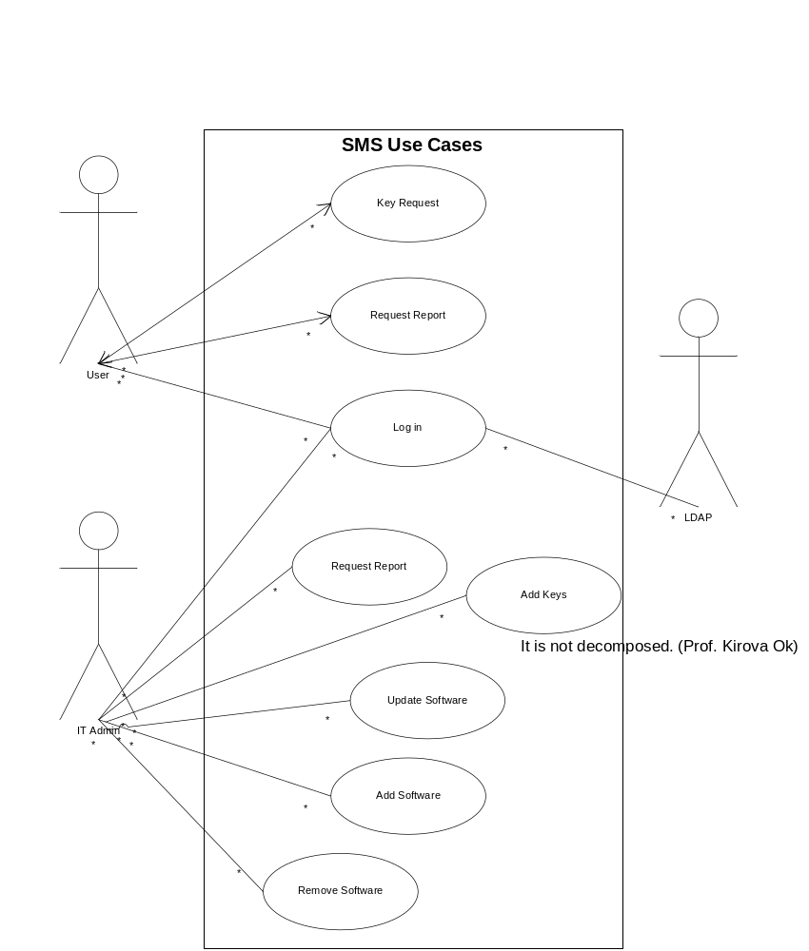
Figure 1 SMS Use Cases

Use Case 1: Update software (Admin updates system with software information)

Characteristic Information:

Goal in Context: Allow an Admin to update the system with information about a piece of software, it's availability, versions, license information, updates, and patches.

Scope: Primary task.

Primary Actor: Admin
Channel to primary actor: web browser

Supporting Actors: database
Channel to supporting actors: database

Preconditions: Admin is already logged in and authorized to make changes to the system.

Success End Condition: Changes are saved to the database.

Failed End Condition: Admin is notified that his changes were not saved and if possible given a reason why not.

Sunny Day Scenario:

- User is displayed a list of available software titles to modify.
- System checks for the existence of the software title and if found displays it and its information.
- User modifies the information about the software.
- System saves the modifications and notifies Admin that changes were saved.

Extensions:

- Database is unavailable
  - System is unable to access the database or other data retrieval failure.
    - Admin is notified that system is unavailable.
- Software the Admin is looking for is not in the database
  - Software list does not contain a software record.
    - Admin needs to add new software record.
- Data cannot be saved
  - System is unable to access the database or other data save failure.
    - Admin is notified that system is unavailable.

Variations: None

Priority: Medium
Performance Target: 3 seconds for data to be saved and Admin to be notified.
Frequency: Average 1 Admin login per day

Use Case 2: Request reports (Admin requests reports from the system) ¶
Characteristic Information

Characteristic Information:

Goal in Context: Allow Admin to view reports about data contained in the system.

Scope: Primary task.

Primary Actor: Admin
Channel to primary actor: web browser

Supporting Actors: database
Channel to supporting actors: database

Preconditions: Admin is already logged in and authorized to make changes to the system.

Success End Condition: Admin is able to view the report.

Failed End Condition: Admin is notified that the report is unavailable.

Sunny Day Scenario:

- Admin is presented with a list of report types that are available.
- Admin selects a report they wish to see.
- System fetches the required information from the database and formulates the report.
- System displays the report.

Extensions:

- Database is unavailable
- The data for the report is unavailable.
    - The Admin is notified that the report is unavailable.

Variations: None

Priority: Low
Performance Target: 3 seconds for report to be generated and displayed.
Frequency: Average 1 Admin report request per day.

Use Case 3: Key request (User requests software license/key)

Characteristic Information:

Goal in Context: User is assigned a software license/key for a certain piece of software.

Scope: Primary task.

Primary Actor: User
Channel to primary actor: web browser

Supporting Actors: database
Channel to supporting actors: database

Preconditions: User is logged in and has access to at least 1 piece of software.

Success End Condition: User is granted a software license/key for the requested software.

Failed End Condition: User is notified why their request is unable to be fulfilled.

Sunny Day Scenario:

- User selects the software package that they are interested in getting a license/key for
- System checks if the User is authorized to be granted a license/key for the software.
- System checks if there is an available license/key for the software.
- System returns the license/key information to the user.

Extensions:

- No software available to user or desired software not listed
- The software they want a license/key for is not listed
- User cannot request license/key.
- User is not allowed to request license/key for selected software
- The User is not authorized
- The user is notified that they are not authorized.
- Software license/keys are used up, no keys available.
- There are no available licenses/keys.
- User is notified that there are no available licenses/keys.
- Admin is notified that there are no more licenses/keys for that software.

Variations: None

Priority: Medium
Performance Target: 3 seconds for request to be checked for availability and authorization.
Frequency: Average 20 User key requests per day.

Use Case 4: Request reports (User requests reports from the system)

Characteristic Information:

Goal in Context: Allow a User to requests reports from the system. Example of reports would be how many licenses they currently have assigned to them.

Scope: Primary task.

Primary Actor: User
Channel to primary actor: web browser

Supporting Actors: database
Channel to supporting actors: database

Preconditions: User is already logged in and authorized to view reports.

Success End Condition: User views selected report.

Failed End Condition: User is notified selected report is unavailable.

Sunny Day Scenario:

- User is presented with a list of report types that are available.
- User selects the report type.
- System fetches the required information from the database and formulates the report.
- System displays the report.

Extensions:

- Database is unavailable.
- The data for the report is unavailable.
- The User is notified that the report is unavailable.

Variations: None

Priority: Low
Performance Target: 3 seconds for report to be generated and displayed.
Frequency: Average 1 User report generated per day.

Use Case 5: Log in (User/Admin logs in to the system)

Characteristic Information:

Goal in Context: The proper authentication and authorization of a user/admin into the system.

Scope: Primary task.

Primary Actor: User/Admin
Channel to primary actor: web browser

Supporting Actors: NJIT LDAP Server, database
Channel to supporting actors: LDAP directory, database

Preconditions: User/Admin already has valid username and password.

Success End Condition: User/Admin is logged in successfully and granted access to appropriate parts of the system via a menu.

Failed End Condition: User/Admin is notified that they have not successfully logged in, and are asked to try again.

Trigger: User/Admin goes to web site homepage of the system.

Sunny Day Scenario:

- User/Admin is presented with a login page where they enter their username and password.
- The system accesses the NJIT LDAP Server to authenticate their username and password.
- Authenticated user is checked against list of acceptible Admin usernames.
- The system associates that user with either Admin or User rights.
- The system then notifies the user that they have logged in.
- The system allows access to appropriate parts of the system via a menu.

Extensions:

- User/Admin provides incorrect username and password.
  - The username and password did not authenticate.
    - The User/Admin is notified and presented with the information they might need to reset their account.
    - The system starts at the beginning of the login.
- LDAP authentication is unavailable.
  - LDAP cannot be contacted to authenticate the user.
    - User/Admin is told system is unavailable.
- Admin is not presented with appropriate admin menu functions.
  - The system did not associate the user with Admin rights
    - The system associates the user with User rights.

Variations: None

Priority: Critical
Performance Target: Less than 3 seconds once login form is submitted.
Frequency: Average 20 logins per day.

Use Case 6: Add software (Admin adds software entries to the system)

Characteristic Information:

Goal in Context: Successful addition of a new software package record in the system.

Scope: Primary task.

Primary Actor: Admin
Channel to primary actor: web browser

Supporting Actors: database
Channel to supporting actors: database

Preconditions: Admin is logged in and authorized.

Success End Condition: Admin successfully added a new software package to the system.

Failed End Condition: Admin is notified that their addition has been unsuccessful and why.

Sunny Day Scenario:

- Admin selects the software package to be removed.
- System checks off a "make unavailable" option for software entry.
- Admin confirms removal.
- System removes the software package from the available list and records it as a removed package.
- System notifies Admin of successful removal.

Extensions:

- Admin cannot remove software package
  - Confirmation is declined.
    - Admin is notified that removal could not be completed and why.

Variations: None

Priority: Medium
Performance Target: Less than 3 seconds once request form is submitted.
Frequency: One-time entering of all current software packages. Additional packages added as needed.

Use Case 7: Remove software (Admin removes software from the system)

Characteristic Information:

Goal in Context: Successful removal of a software package record in the system.

Scope: Primary task.

Primary Actor: Admin
Channel to primary actor: web browser

Supporting Actors: database
Channel to supporting actors: database

Preconditions: Admin is logged in and authorized.

Success End Condition: Admin successfully removed a software package to the system.

Failed End Condition: Admin is notified that their removal has been unsuccessful and why.

Sunny Day Scenario:

- Admin selects the software package to be removed.
- System checks off a "make unavailable" option for software entry.
- Admin confirms removal.
- System removes the software package from the available list and records it as a removed package.
- System notifies Admin of successful removal.

Extensions:

- Admin cannot remove software package
  - Confirmation is declined.
    - Admin is notified that removal could not be completed and why.

Variations: None

Priority: Medium
Performance Target: Less than 3 seconds once removal form is submitted.
Frequency: Rare, only after software license agreement with vendor has expired and there are no more issued licenses/keys active.

Use Case 8: Remove Report problem (User reports a software problem / help request)

Characteristic Information:

Goal in Context: Successful addition of a software problem / help request into the database.

Scope: Primary task.

Primary Actor: User
Channel to primary actor: web browser

Supporting Actors: database
Channel to supporting actors: database

Preconditions: User is logged in and authorized.

Success End Condition: User successfully submits a software problem / help request.

Failed End Condition: User is notified that their submission has been unsuccessful and why.

Sunny Day Scenario:

- User selects the software package to submit a problem or help request for.
- User enters in the problem description.
- User submits to the system for a preview of their problem description
- System checks preview submission for errors.
- User reviews submission and submits.
- System notifies User of successful submission.

Extensions:

- System encounters an error with the preview submissions
  - User is presented with information on what error was encountered and how to correct it.
    - Return to step 3

Variations: None

Priority: Low
Performance Target: Less than 3 seconds once request form is submitted.
Frequency: Average 5 reports per day.

Login Page
Purpose | The purpose of the login page is to provide the user with an interface for authentication.
Inputs | The inputs to the Main Menu will come in the form text.
Processing | The user name and password will be verified by LDAP and depends on the role: students or staff/faculty user will see Main Menu with features available to them.
Outputs | User will see the SMS Main Menu.
Table1. Login Page

SMS Main Menu
Purpose | The purpose of the main page is to provide the user with an interface for Administrator to request information about existing software, add new software to the database or request report. User will be able to request product key and submit problem.
Inputs | The inputs to the Main Menu will come in the form of clicks to hyperlinks that will move the user to desired areas.
Processing | The amount of data processing is minimal because the web browser will handle the mouse clicks and webpage linking and parsing.
Outputs | The output will come in the form of the user moving from one page to another.
Table 2. SMS Main Menu

Form to add new software
Purpose | This section will initialize the interface necessary input information about new software.
Inputs | The inputs to the program will come in the form of text that will be saved to the database.
Processing | Data will be moved to the server database.
Outputs | Dialog box will show the user that the operation is completed.
Table 3. Form to add new software

Performance requirements

The number of terminals to be supported: the software shall run from the browser.

The number of simultaneous users to be supported: The hardware shall have the capacity to support 300 users.

Amount and type of information to be handled: The information shall be related to the needs of the IT Administrators. The system shall store information about software vendor, users and departments that shall request keys and software keys downloaded from software website. 95% of the transactions shall be processed in less than 5 s.

The performance required for this product shall largely depend on the hardware used.

Logical database requirements

The types of information used by various functions shall be mostly strings, dates and integer values.

Design constraints

Report shall have format of graphs and statistics

Software system attributes or other requirements

Availability
3.6.1.1 The system shall be available 24x7 to all user groups. The web servers shall be in a cluster to allow maintenance of the system without any down time.

Security
Introduction:
The system authenticates the user against an LDAP directory using a username and password. The login form should be submitted over Secure Socket Layer (SSL) connection via the web browser. This will ensure that the submission of the username and password are encrypted through the network. An authentication hash should be stored on in a browser cookie and checked on load of every subsequent page. It should not be possible to stumble onto a page past the authentication front-end and have the system perform authenticated functions. For added security, web pages in the system that accept or display license keys can also be encrypted via SSL, to prevent keys from being “sniffed” out of the network traffic. It is possible to require VPN authentication from off-campus as well.
The system shall
3.6.2.1 The system shall authenticate the user against NJIT's LDAP directory using their UCID and password
3.6.2.2 The system shall use SSL for all communication involving the UCID and password
3.6.2.3 The system shall check for validity of the user upon load of every page
3.6.2.4 The system shall require the use of secure tunnel (VPN) when connecting from off-campus
3.6.2.5 The system shall transmit web pages that display software key information over SSL (Optional)

Maintainability
3.6.3.1 All processes and detailed design shall be well documented to allow for easy maintenance and upgrading of the system to add new functionality.
3.6.3.2 All components shall be modular and loosely coupled with each other.

Portability

Percentage of components host-dependent code shall be: 0%

Percentage of code that is host dependent shall be: 0%

Portable language shall be HTML code and java script code

Particular compiler or language subset shall be XHTML, PHP

The operating system shall be Linux or Microsoft Windows.

Interoperability:

3.6.5.1 The system shall be able to interpret data from NJIT’s LDAP directory.

Reliability:

3.6.6.1 The system shall be reliable so as to confirm to the availability requirements given above.

3.6.6.2 System shall be deployed on reliable hardware and the application testing should be done before making the system
3.6.6.3 The system shall be to have PHP, web server and MySQL enabled.

Backup and Recovery:

3.6.7.1 Full data backup shall be taken every week and incremental backup taken every night.

Accessibility:

3.6.8.1 The system shall be accessible to anyone with a valid username and password, and who is also either a student or faculty/staff member. Guest accounts are not permitted.

3.6.8.2 The system website shall support the 2 major web browsers (Internet Explorer, Firefox).

3.6.8.3 The system shall run 24 hours a day, 7 days a week, and shall be available from any IP address range (unless VPN restrictions are in place).
3.6.8.4 The system shall run 24 hours a day, 7 days a week
3.6.8.5 The system shall be accessible to anyone with a valid UCID and password
3.6.8.6 The system shall disallow guest, temporary, other such designated UCIDs
3.6.8.7 The system shall be viewable through two major web browsers (Microsoft Internet Explorer and Firefox)

Performance:
Introduction
As with any modern web site, the system should respond almost instantly to simple requests (page requests), and have a <5 second response time on pages that are processing or fetching data from the database or the LDAP directory. This means that the web server, database server, and LDAP directory server must also meet similar performance metrics. A response time of <3 seconds is optimal. Anything longer than >5 seconds and the user may think the system: a) has failed to receive their last request, b) has become unresponsive, or c) is not designed with performance or the user experience in mind. With sufficient processing power and network bandwidth, this system should have near-instant response times.
The system shall
3.6.9.1 The system shall respond to non-interactive page requests in <5 seconds, preferably <2 seconds
3.6.9.2 The system shall respond to interactive and query-based requests in <5 seconds
3.6.9.3 The system shall be able to accommodate approximately 10 simultaneous users within these performance metrics

Data retention:

3.6.10.1 User data should be retained from 10 years.

Appendixes

Appendix A: Data Flow Diagrams

Context Level Diagram
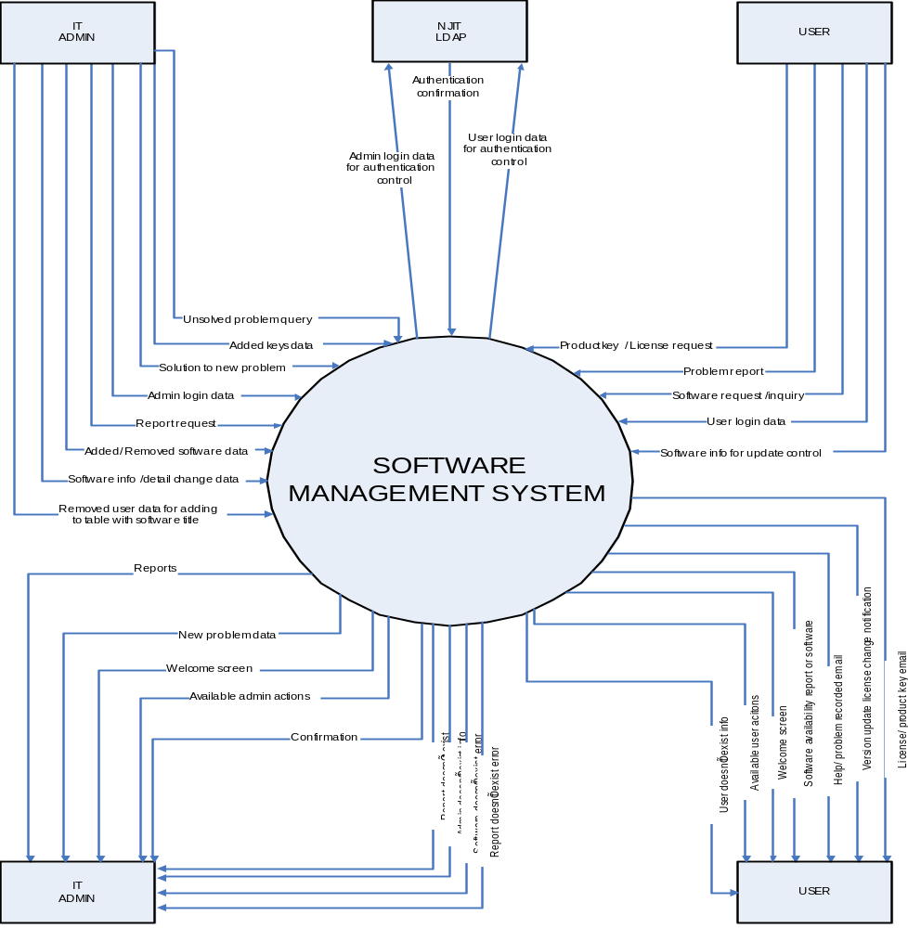
Figure 2 Context Level Diagram

1st Level DFD
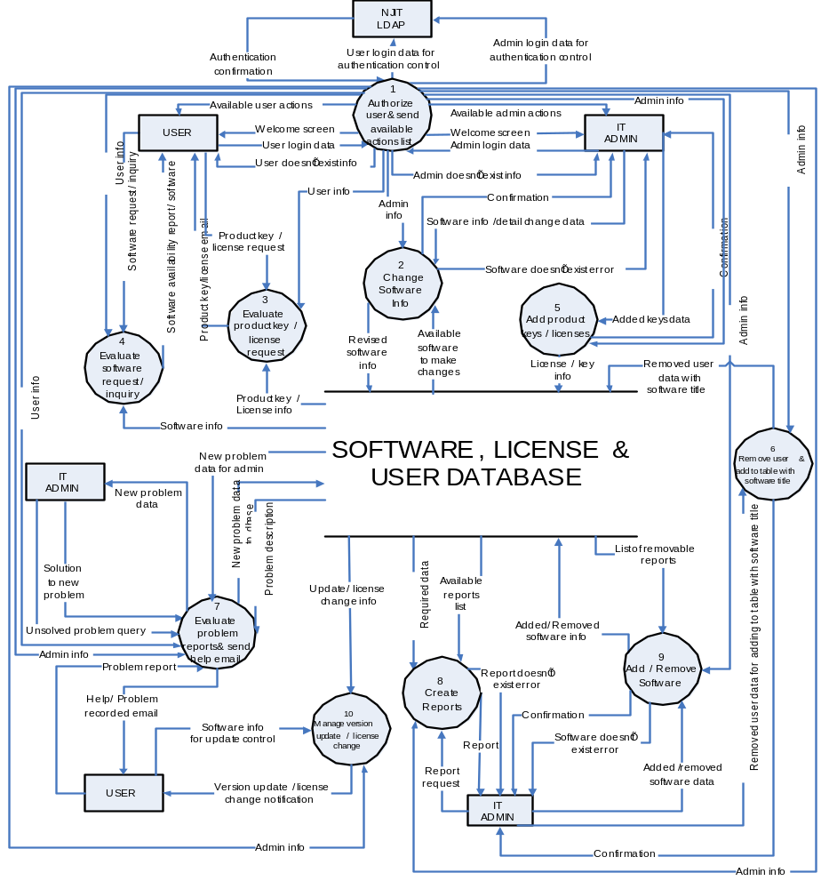
Figure 3 1st Level DFD
2nd Level DFD
8th Process
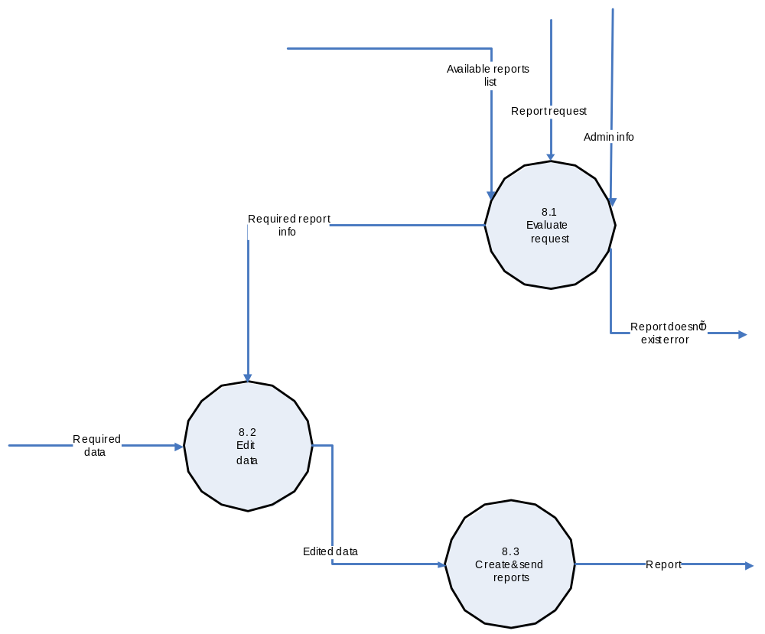
Figure 4 2nd Level DFD: 8th Process
7th Process
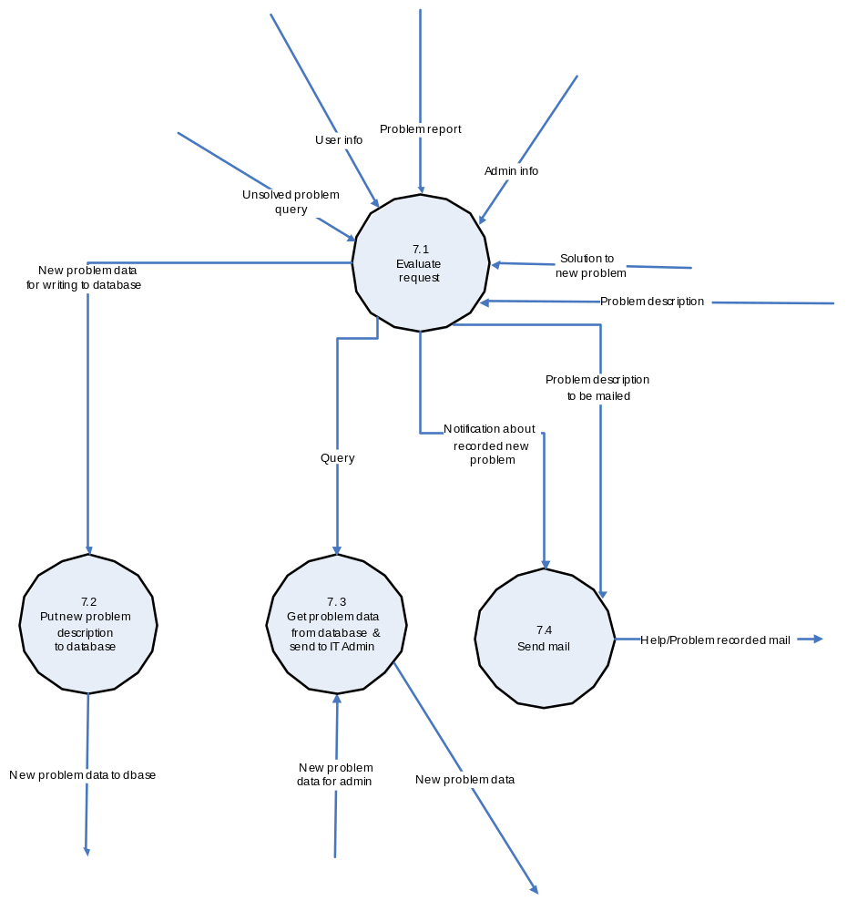
Figure 5 2nd Level DFD: 7th Process

Appendix B: Data Dictionary
Data Dictionary of Software Management System
Data Flow Structure | Description/ Purpose | Connections to processes - Source | Connections to processes - Sink
User login data for authentication control | Provide user login info/ data to be given authentication control process | 1-authorize user & send available action list | NJIT LDAP
Authentication confirmation | Authenticate login confirmation to valid user/ Admin | NJIT LDAP | 1-authorize user & send available action list
Admin login data for authentication control | Provide Admin login info/ data to be given authentication control process | 1-authorize user & send available action list | NJIT LDAP
Welcome screen | Display “welcome” on the screen while user successful login | 1-authorize user & send available action list | User
Welcome screen | Display “welcome” on the screen while Admin successful login | 1-authorize user & send available action list | IT Admin
Available user actions | Authorize user to proceed actions | 1-authorize user & send available action list | User
Available Admin actions | Authorize Admin to proceed actions | 1-authorize user & send available action list | IT Admin
User login data | User provides individual information to login | User | 1-authorize user & send available action list
Admin login data | Admin provides individual information to login | IT Admin | 1-authorize user & send available action list
User doesn’t exist info | Display wrong user individual information & send feedback to user who logged | 1-authorize user & send available action list | User
Admin doesn’t exist info | Display wrong user individual information & send feedback to Admin who logged | 1-authorize user & send available action list | IT Admin
Admin info | Provides Admin info to internal process (2) | 1-authorize user & send available action list | 2-change software info
Software doesn’t exist error | Display wrong software info and status to IT Admin | 2-change software info | IT Admin
Software info/ detail change data | Make change of software info and detail to be updated | IT Admin | 2-change software info
Confirmation | Give feedback of confirmation to IT Admin | 2-change software info | IT Admin
Revised software info | Proceed revised software and send to Database | 2-change software info | SOFTWARE, LICENSE & USER DATABASE
Available software to make changes | Database confirmed changes of software info and send feedback into to internal process (2) | SOFTWARE, LICENSE & USER DATABASE | 2-change software info
Product key/ license request | Users request license key for using | User | 3-evaluate product key/ license request
Product key/ license email | Evaluate product key or license available status and send keys or license to user | 3-evaluate product key/ license request | User
Product key/ license info | Database provides product key & license information to internal system process (3) | SOFTWARE, LICENSE & USER DATABASE | 3-evaluate product key/ license request
User info | Provides user info to internal process (3) | 1-authorize user & send available action list | 3-evaluate product key/ license request
Software request/inquiry | Users request or inquire software for using | User | 4-evaluate software request/ inquiry
Software availability report/ software | Report available software status to users who request or inquiry for individual software | 4-evaluate software request/ inquiry | User
Software info | Database provides software information to internal process (4) | SOFTWARE, LICENSE & USER DATABASE | 4-evaluate software request/ inquiry
User info | Provides user info to internal process (4) | 1-authorize user & send available action list | 4-evaluate software request/ inquiry
Admin info | Provides Admin info to internal process (5) | 1-authorize user & send available action list | 5-add product keys/ licenses
Added keys data | Make addition license keys for using | IT Admin | 5-add product keys/ licenses
Confirmation | Give feedback of confirmation to IT Admin | 5-add product keys/ licenses | IT Admin
License/ key info | Proceed added license keys to be added into Database | 5-add product keys/ licenses | SOFTWARE, LICENSE & USER DATABASE
Admin info | Provides Admin info to internal process (6) | 1-authorize user & send available action list | 6-remove user & add to table with software title
Removed user data for adding to table with software title | Remove user from database and gather statistics of title of software | IT Admin | 6-remove user & add to table with software title
Confirmation | Give feedback of confirmation to IT Admin | 6-remove user & add to table with software title | IT Admin
Removed user data with software title | Proceed removed user data with software title to be updated in Database | 6-remove user & add to table with software title | SOFTWARE, LICENSE & USER DATABASE
Admin info | Provides Admin info to internal process (7) | 1-authorize user & send available action list | 7-evaluate problem reports & send help email
User info | Provides user info to internal process (7) | 1-authorize user & send available action list | 7-evaluate problem reports & send help email
Solution to new problem | Provide and list solution to new problem comes from Database | IT Admin | 7-evaluate problem reports & send help email
New problem data | Give new problem data to IT Admin | 7-evaluate problem reports & send help email | IT Admin
Unsolved problem query | Provide unsolved problem into internal process (7) for query | IT Admin | 7-evaluate problem reports & send help email
Problem report | Users provide discovered problem and report back | User | 7-evaluate problem reports & send help email
Help/ problem recorded email | Send help/ problem recorded email to user for solving problems which user faced | 7-evaluate problem reports & send help email | User
New problem data to dbase | Provide new problem data to be recorded into Database | 7-evaluate problem reports & send help email | SOFTWARE, LICENSE & USER DATABASE
Problem description | Problem description provided by Database | SOFTWARE, LICENSE & USER DATABASE | 7-evaluate problem reports & send help email
New problem data for Admin | Provide new problem data for Admin using | SOFTWARE, LICENSE & USER DATABASE | 7-evaluate problem reports & send help email
Admin info | Provides Admin info to internal process (8) | 1-authorize user & send available action list | 8-create reports
Report request | Request for reports | IT Admin | 8-create reports
Report | Send information of reports | 8-create reports | IT Admin
Report doesn’t exist error | Display error information of exist and send to IT Admin | 8-create reports | IT Admin
Required data | Provide updated required data | SOFTWARE, LICENSE & USER DATABASE | 8-create reports
Available reports list | Provide updated available reports list | SOFTWARE, LICENSE & USER DATABASE | 8-create reports
Admin info | Provides Admin info to internal process (9) | 1-authorize user & send available action list | 9-add/ remove software
Added/ removed software data | Make added or removed software data for updated | IT Admin | 9-add/ remove software
Confirmation | Give feedback of confirmation to IT Admin | 9-add/ remove software | IT Admin
Software doesn’t exist error | Display error information of exist and send to IT Admin | 9-add/ remove software | IT Admin
Added/ removed software info | Proceed added/ removed software info to be updated in Database | 9-add/ remove software | SOFTWARE, LICENSE & USER DATABASE
List of removable reports | Make list of removable reports to internal process (9) | SOFTWARE, LICENSE & USER DATABASE | 9-add/ remove software
Admin info | Provides Admin info to internal process (10) | 1-authorize user & send available action list | 10-manage version update/ license change
Software info for update control | Request software info update | User | 10-manage version update/ license change
Version update/ license change notification | Notify user of software info update, license change, software version update | 10-manage version update/ license change | User
Update/ license change info | Provide valid software info update and license change | SOFTWARE, LICENSE & USER DATABASE | 10-manage version update/ license change
Table 4. Data Dictionary

Data Dictonary Level 1 for User
1. software request/ inquiry: users request or inquiry individual software
1.1source: user
1.2sink: 4-evaluate software request/ inquiry
1.3BNF descriptio006E
(software request/ inquiry = sfw_req)
sfw_req => Login_info + sfw_info
Login_info => Login + pwd
Login => “LoginID”+ ¹⁰{α/n}¹⁰
pwd => “psd” + ¹⁰{α/n}¹⁰
sfw_info => sfw_id + sd_action_cd + [ {sfw_data}*| action_result_message]
sfw_id => {n}¹⁶
sd_action_cd => [SFW_ADD | SFW_DELETE | SFW_UPDATE]
sfw_data => sfw_name + sfw_description

2. product key/ license request: Users request license key for registering individual software authentication
2.1. source: user
2.2. sink: 3-evaluate product key/ license request
2.3. BNF description
( Pdt= product, lic= license, req= request, pwd= password)
(product key/ license request= Pdt_key_lic_req)
Pdt_key_lic_req => login_info + lic_info
Login_info => Login + pwd
Login => “LoginID”+ ¹⁰{α/n}¹⁰
pwd => “psd” + ¹⁰{α/n}¹⁰
lic_info => lic_id + ld_action_cd + [ {lic_data}*| action_result_message]
lic_id => {n}¹⁶
ld_action_cd => [LIC_ADD | LIC_DELETE | LIC_UPDATE]

