Coxsackie Virus and its effect on the dynamics of the cellular Arf-1 protein

Anirudh Chintalapani
Dr. Bose, Dr. Nadim, Dr. Golowasch
Undergraduate Biology and Math Training Program
December 19, 2007

Abstract: One major protein responsible for trafficking between the ER and Golgi is the protein Arf-1. During viral infection of the Coxsackie virus it has been shown that Arf is an essential protein in the replication of this virus because removal of this protein prevents further increase in viral RNA. Also in a normal cell Arf cannot be detected due to its high binding and unbinding rates on the ER. However during viral infection Arf that has been tagged with a Green Fluorescent Protein accumulates and shows up under a microscope as spots that increase in number and size over time. The question becomes whether the virus interferes with the on and off rates of Arf or if it is some other mechanism by which this happens. Our hypothesis is that the off rate of Arf on the membrane is slowed down and that this results in the accumulation of Arf that is observed and we created a model to see predict whether this is the case. To experimentally test this we performed a FRAP (Fluorescent Recovery After Photobleach) in which we photobleached the GFP-Arf that appeared as spots and measured recovery of the spots over a three minute period and did this over an 8 hour period. After gathering data we calculated the on and off rates to determine whether it changes over the 8 hour period. We found that over the 8 hour period the on rate remains relatively constant while the off rate shows a significant decrease. To support this we ran a BFA experiment which allowed us to directly measure the off rate by inhibiting the on rate. We found that the rate of unbinding of Arf was much slower in the infected cells versus the uninfected cells thereby supporting our FRAP data. To try and understand how the off rate is decreasing we ran an experiment in which we tagged the protein responsible for the unbinding of Arf off the membrane (GAP) and found that the amount of GAP in the cell had significantly decreased over the 8 hour infection period.
Introduction:
Role of Arf in a normal cell:
In a eukaryotic cell there is a very important trafficking system that takes place between the Endoplasmic Reticulum and the Golgi apparatus that allows for the transport of proteins and other molecules throughout the cell. One protein that facilitates this movement is the Arf-1 protein. Arf-1 works by first binding to the Endoplasmic Reticulum at specific binding sites. Once it binds to these sites it recruits other molecules known as effector molecules. Some of these effectors include but are not limited to: Sar1, CopII, and Pi4-Kinase (Bonnet). These molecules work in conjunction with Arf to differentiate the membrane placing Golgi specific proteins on the membrane allowing it to bulge out to form a vesicle. The vesicle then pinches off and heads towards the Golgi and the Arf having completed its task unbinds to the membrane. Arf is also found to bind to the Golgi and like the ER differentiates the membrane to traffic the membrane back to the ER. At steady state the movement of membrane to the Golgi is high enough and movement of membrane from the Golgi to the ER is low enough that the Golgi does not dissolve and remains as a functional component of the cell.
Binding and unbinding cycle of Arf:
The binding and unbinding of Arf to these membranes is a complicated process that involves two crucial systems. Arf that is found free floating in the cytosol exists as Arf-GDP. A system known as GTP Exchange Factor (GEF) works by replacing the GDP on the Arf with a more active GTP (Bonnet). Now Arf-GTP binds to the membranes where it can perform its functions. The protein that removes Arf-GTP from the membrane is GTP-ase Activating Protein (GAP) and this protein functions by hydrolyzing the GTP back to the inactive GDP and consequently removes Arf from the membrane and back into the cytosol (Bonnet). (see Figure 1.)
Normally this process occurs at a very high rate and as a result Arf cannot be seen on the ER. However, despite the fact that the Arf behaves the same way on the Golgi in a control cell Arf can be viewed due to the fact that the Golgi is a more condensed structure whereas the ER is spread throughout the entire cell.
Coxsackie virus and its effect on the cell:
The Coxsackie virus is a single positive stranded RNA virus. When it infects the cell it uses the cell’s machinery to make the viral proteins that will be used in forming new capsids and also uses the cells machinery to replicate its own RNA (Figure 2). One of the cellular proteins that is very important in the RNA replication is this Arf-1 protein. A fungal toxin known as Brefeldin A was used to show that viral RNA replication is dependent on Arf-GTP. What Brefeldin-A does is that it interferes with the GEF thereby inhibiting the binding of Arf to the membrane. If the cells are treated with BFA and then the virus is added no new viral RNA is observed (Belov 36).
During infection of the Coxsackie virus a few observations have been noted. The first is that in a normal cell as mentioned earlier Arf can only been seen in the Golgi. However, after infection of the virus at around three to four hours post infection small spots begin to appear on the cell and over time these spots increase in number and size. The spots are accumulations of Arf that are found at the ER export sites and this is shown when the Arf and the ER is tagged (Belov 36). (Figure 3)
Another observation that is made is between the viral protein and Arf. During infection there appears to be a strong amount of colocalization between the viral protein and Arf. This was shown in an experiment in which the cell was fixed after four hours of infection and immnostained to show both Arf and the viral protein 2BC. This helps to show that the Arf membrane domains are rich in viral machinery and again support the notion that this Arf accumulation is taking place at these ER export sites (Figure 4).
With these things in mind the question now becomes what is the cause for this accumulation of Arf that is observed in an infected cell but not in an uninfected cell. Our hypothesis is that the off rate or the hydrolysis and subsequent unbinding of Arf-GTP to Arf-GDP is being slowed down or inhibited while the on rate remains relatively constant.
Mathematical Modeling:
To predict our hypothesis we constructed a mathematical model of the Arf dynamics. Our equation looked at Arf primarily during the FRAP experiment and consisted of several stages:

Pre Bleach:
Our first variable that we need to define is Arf-GTP:

X = Arf-GTP
X_{f} = Fluorescent Arf-GTP
X_{u} = Unlabeled Arf-GTP

Note that the relationship between these three variables is the following:

X = X_{f} + X_{u}

Next we define the second major variable which is Arf-GDP:

Y = Arf-GDP

And Y is also composed of Y_{f} and Y_{u} and the relationship is the same as with X:

Y = Y_{f} + Y_{u}

If we relate X and Y we obtain the following equation:

X_{f} + X_{u} + V (Y_{f} +Y_{u}) = C

Here C is the total amount of Arf in the cell and V is the volume of the cell. The reason we have to multiply Y by V is that X is measured in numbers since it is bound to the ER membrane and Y is measure in concentration and so we need to multiply Y by the volume to obtain a number.

Next we define the total number of sites on the cell as S and assume that it is constant which is a reasonable assumption since our FRAP experiments are taken over the four minute period at which point there is negligible change in the total number of sites:

S = X_{f} + X_{u} + E

Where E stands for the number of empty sites that do not have Arf bound to them.

During Bleach:
The following figure describes the bleaching process:
γ

Bleaching X_{f} X_{u}

γX_{f} (0⁻) = X_{u} (0⁺)
Before Bleaching (-)
After Bleaching (+)

What this means is that in terms of initial conditions the amount of unlabeled Arf-GTP increases proportionally to the fluorescent Arf-GTP and a fraction of bleaching.

Along with the intial conditions the variables also change during the bleaching process:

X_{f- after bleach} ≡ Xu + γXf
X_{u -after bleach} ≡ Xf - γXf
Y_{f -after bleach} ≡ Yu + γ(Y_{f}(Area_{membrane}/Area_{total cell}))
Y_{u- after bleach} ≡ Yf – γ(Y_{f}(Area_{membrane}/Area_{total cell}))

For all intents we will continue to label X and Y as before even though they have undergone a change in variable.

After Bleach:

The schematic for the binding and unbinding of Arf to the membrane and its subsequent unbiding can be describes as the following:
E
k_{on}
X_{f}
X_{f}
k_{off}
E
k_{on}
X_{u}
X_{u}
k_{off}

The following diagram shows that X_{f} binds to an empty site at a rate k_{on} and unbinds to the membrane at a rate k_{off} with the same being true for unlabeled Arf which we assume behaves with the same kinetics as fluorescent Arf. We make this assumption based on the assumption that the fluorescent tag has negligible effect on the dynamics of Arf and serves only as a marker for indentification. Also k_{on} can be written as:

k_{on}= К_{on}Y_{f}

where К_{on} is the rate at which Y_{f} becomes X_{f} and binds to the membrane.

With the following variables and parameters in mind we can begin to construct a model for the change in amount of Arf over time. Our model derives itself from Mass action law and is as follows:

dX_{f}/dt= -k_{off}X_{f} + k_{on} (E)

dX_{u}/dt= -k_{off}X_{u} + k_{on}(E)

this equation can be rewritten into the following:

dX_{f}/dt= -k_{off}X_{f} + k_{on}(S - X_{f} - X_{u})

dX_{u}/dt= -k_{off}X_{u} + k_{on} (S - X_{f} - X_{u})

this equation can even further be simplified and k_{on} can be rewritten as:

dX_{f,u}/dt = -k_{off} X_{f,u} + К_{on}Y_{f} (S - X_{f} - X_{u})

Y_{f} can be rewritten as:

dX_{f,u}/dt = -k_{off} X_{f,u} + К_{on} (((C - X_{f} - X_{u}) / V ) – Y_{f,u} )(S - X_{f} - X_{u})

where: Y_{f}= ((C - X_{f} - X_{u}) / V ) - Y_{u}

One assumption we made is that the initial amount of unlabeled Arf is negligible compared to the fluorescent Arf in the cell and our equation therefore becomes:

dX_{f}/dt = -k_{off} X_{f} + К_{on} (((C - X_{f}) / V ) - Y_{f} )(S - X_{f})

next we say that К_{on}/V = К’_{on} from that we can say:

dX_{f}/dt = -k_{off} X_{f} + К’_{on} ((C - X_{f}) - Y_{f} )(S - X_{f})

and since k_{on}Y_{f} = К’_{on} ((C - X_{f}) - Y_{f} ):

dX_{f}/dt = -k_{off} X_{f} + k_{on}Y_{f} (S - X_{f})

Now while S represents the total number of sites on the cell and the amount of total sites on the cell is dependent on two following factors:

S = αR

Where R is the total area of the Endoplasmic Reticulum and α is the fraction of the ER that can be considered an ER export site for Arf to bind to. This is to account for any possible change in the number of sites on the cell. If we solve for R we get:

R = β* S where β = 1/ α

We can now divide our two equations in order to nondimensionalize the fact that Arf-GTP is measure in amount and Arf-GDP is measure in concentration. First off we have a redefinition of our variables:

χ_{f} = X_{f} / (β S) and χ_{u} = X_{u} / (β S)

and our original equations now become:

dχ_{f}/dt = -K_{off} χ_{f} + K_{on} (α – χ_{f} – χ_{u} )
dχ_{u}/dt = -K_{off} χ_{u} + K_{on} (α – χ_{f} – χ_{u} )

If we look at the equation at steady state we obtain the following:

χ_{f} K_{off} = K_{on} (α – χ_{f} – χ_{u} )

χ_{u} K_{off} = K_{on} (α – χ_{f} – χ_{u} )

another assumption we are making is that while the amount of unlabeled Arf does change during bleach it doesn’t change when we are recording the recovery period and so we can rewrite the equation as:

χ_{f} K_{off} = K_{on} (α – χ_{f} )

now if we look at the ratio of χ_{f} to Y_{f} we obtain our K value. K is obtained experimentally by taking the ratio of the Arf-GTP to Arf-GDP and in our model we get the following:

K= χ_{f} / Y_{f} = (К_{on} / K_{off})(α – χ_{f} )
Where: K_{on}= К_{on}Y_{f}

Our last assumption is that X_{f} >>> α. This means that the amount of Arf-GTP is negligible compared to α which is proportional to the total number of sites. In other words we are assuming that there is no saturation of the sites and this is a reasonable assumption since we are hypothesizing that the virus is affecting the proteins involved in the exchange of Arf and not the sites themselves. Therefore our equation at steady state becomes:

K= χ_{f} / Y_{f} = (К_{on} / K_{off})(α)

Looking at this equation we can see that the change in K can be caused either by a changing on and off rate or that it is caused by an increase in the number of sites. According to our hypothesis it is a change in the off rate and this is what we will test.

Methods:
In order to test our hypothesis we will run several different experiments. The main experiment we will be running is known as a Fluorescent Recovery After Photobleach (FRAP) experiment. For the experiment we will be using Hela cells. These cells are cancer cells that have all the same organelles and functions as a normal human cell but also have the capability to divide continuously so long as they are placed in a controlled medium at a temperature of 37 degrees Celsius. These cells are then transfected with a Green Flourescent Protein (GFP) that binds to the Arf. The cells are then taken under a microscope and a region of interest is drawn. On that region a high powered laser is used to photobleach or remove the fluorescent tag on the GFP for the Arf on the membrane (Figure 5). Therefore the only way for a highlighted area to regain fluorescence is for the bleached Arf-GTP to unbind off the membrane and for unbleached Arf-GDP to bind to the membrane. We can record this binding and unbinding and use the date to calculate our K_{on} and K_{off}. Once the cells have been photobleached we measure the recovery over a period of three to four minutes. First this is done for control cells with no virus and we photobleach about 10 to 15 cells. The dish is then infected with virus and the process is repeated every hour until the eight-hour period when the cells begin to lyse.
After we receive our data we find the fluorescence of the spots using a program known as Laser Scanning Microscope (LSM). We highlight the same region that we bleached and obtain the pixel intensity of the area over the three-minute period. We then use the following equation:

Spot fluorescence = [ (spot pixel intensity – background intensity) area of spot ]/[ (cell pixel intensity – background pixel intensity ) area of cell ]

This is to normalize the fluorescence of the spot relative to the cell. We also find the percentage recover over the 3-minute period. From there we construct a plot of the % recovery vs time. We then fit an exponential to that graph and the slope of that curve is our tau value. This tau value is equal to:

1/τ = K_{off} + K_{on}

We also take a region of interest of the Arf-GDP in the cytosol and take the ratio of the Arf-GTP to the Arf-GDP to find the value K which is equivalent to:

K = Arf-GTP/Arf-GDP = K_{on}/K_{off}

Both K and τ give us two equations with two unknowns which allow us to solve for K_{off} and K_{on}.
The second experiment that is run is one in which Arf is transfected with GFP but at time points of one hour apart are treated with Brefeldin-A. This is a drug that interferes with the on rate of Arf and prevents Arf from binding to these sites. We first treat control cells with Brefeldin A and watch how quickly the fluorescence is lost. We repeat the same procedure for an infected cell and look at this for cells at every hour over the eight-hour period.
The last experiment that we will be running is a simple observation of Arf through the viral infection. However, in this experiment we also will be tagging the GAP with a Yellow Fluorescent Protein (YFP). The specific GAP that we will tag is the ArfGap1 protein. The purpose of this experiment is to obtain a possibly explanation as to how the virus is affecting the off rate of Arf if indeed the off rate is being slowed down.

Results and Conclusion:

After performing the FRAP experiment, collecting the LSM data, and computing the on and off rates these are the following values that we obtained of all the cells compiled together and averaged (Figure 6).
The analysis shows that the on rate has remained relatively constant throughout the infection period. However, the K_{off} rate has significantly decreased going from .076 s⁻¹ to about .03 s⁻¹. This agrees with our hypothesis that the off rate has significantly decreased. However, this data alone does not definitively prove our hypothesis since there is always room for error, which is where our Brefeldin A experiment comes in (Figure 7). This experiment will let us look at the off rate directly and confirm our FRAP data. When we ran the experiment the control cells showed a significant decrease in Arf over a short time span. However when we looked at the infected cells the rate at which Arf hydrolyzed back to its GDP form had significantly decreased and there was more Arf in the infected cell over the same time frame than in the uninfected cell. This serves as a support to our FRAP data that shows the decrease in K_{off} as well as our hypothesis.
In order to understand a possible reason as to why the off rate was decreasing we tagged the GAP and observed its concentration over time following infection (Figure 8). In a control cell there appeared an abundance of GAP with Arf closely colocalized with it. However, post infection the amount of GAP has significantly decreased and there is a greater amount of visible Arf-GTP in the cell. This suggests that the virus could possibly have some effect on the GAP protein causing this decrease.
While the kinetics of the Arf protein during viral infection is more understood there still are many questions regarding the relationship between the Coxsackie virus and Arf. One main question is how and why does the Coxsackie virus affect the specific relationship between Arf and GAP. One possible theory as to how is that the virus directly interferes with GAP and uses it to make its own viral protein thereby providing less available GAP to hydrolyze Arf. Another theory is that the virus is somehow affecting Arf and interfering with the binding of GAP to it. This in turn would cause GAP to possibly hydrolyze other molecules once again decreasing the amount of available GAP in the cell as is observed. The third theory is that the virus is indirectly interfering with the process by affecting the effectors. Normally both the effectors and GAP compete for the activity of Arf. If the virus were to somehow enhance the effector’s affinity to Arf it would result in an abundance of Arf on the membrane but a decreased amount of available Arf for GAP to bind to. These are possible theories and questions that can and should be explored further.

Arf1-GDP
Arf1-GTP
GEF
BFA
effectors
Endoplasmic reticulum membrane
cytoplasm
GAP

Fig 1. Shows the exchange between Arf1-GTP (membrane-bound) and Arf1-GDP (cytosolic) pools in cells.

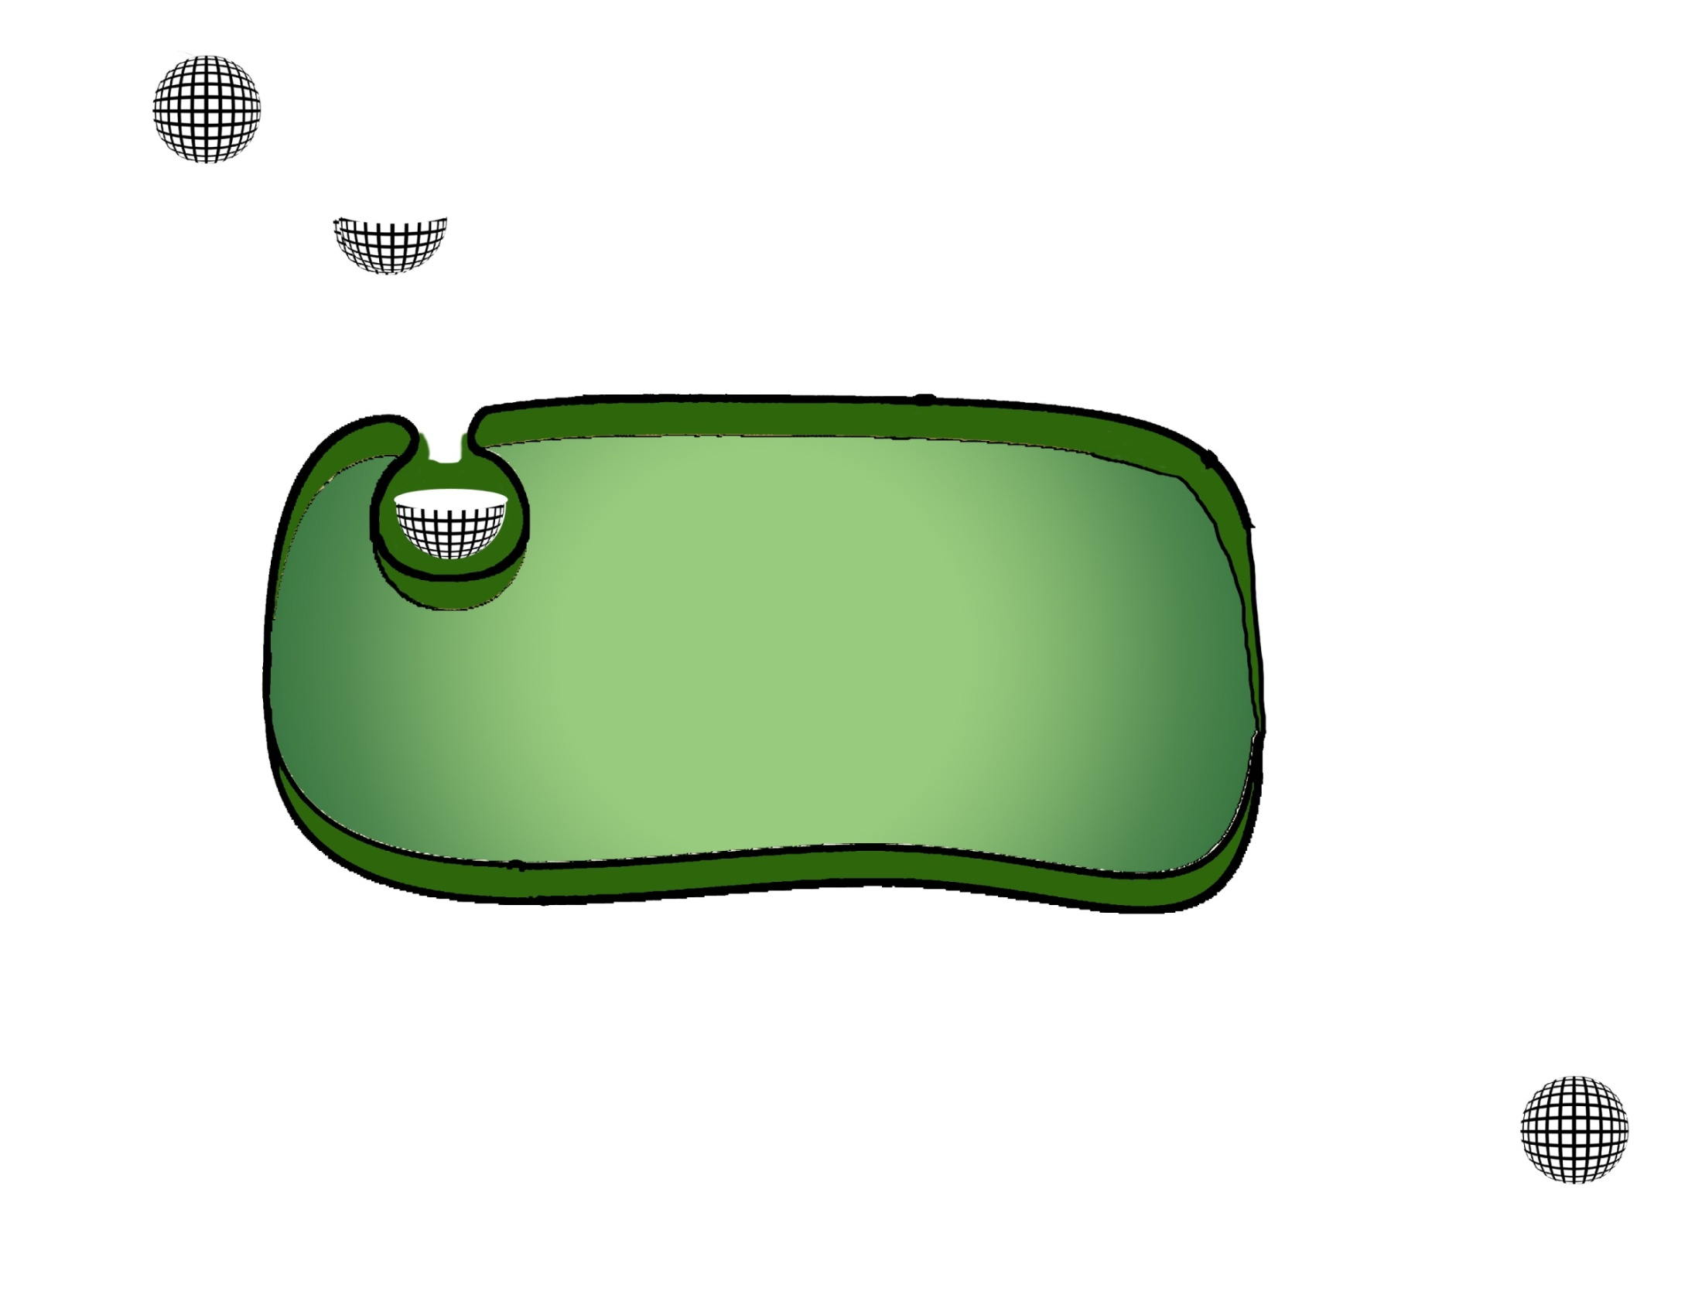

Virus
(-) strand
Viral replication and capsid proteins
Virus
Viral Capsid Coat
Viral RNA
CAR receptor
Arf1
Nucleus

Figure 2. Schematic cartoon of how the Coxsackie Virus infects a cell and replicates.
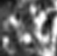
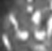
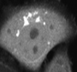
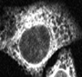
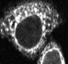
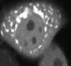
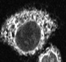
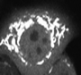
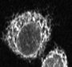
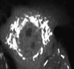
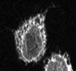

Figure 3. Arf1-GFP at different times post CVB3 infection. At time 0 hours, Arf1 is primarily in its GTP-bound state at the Golgi Apparatus, and in the GDP-bound state in the cytosol. As infection progresses, there is an accumulation of Arf1 at discrete ER sites. Cells are co-expressing Arf1-GFP and ssRFPKDEL plasmids.
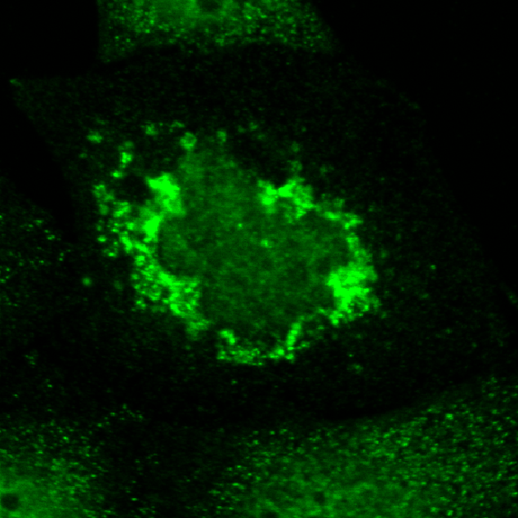
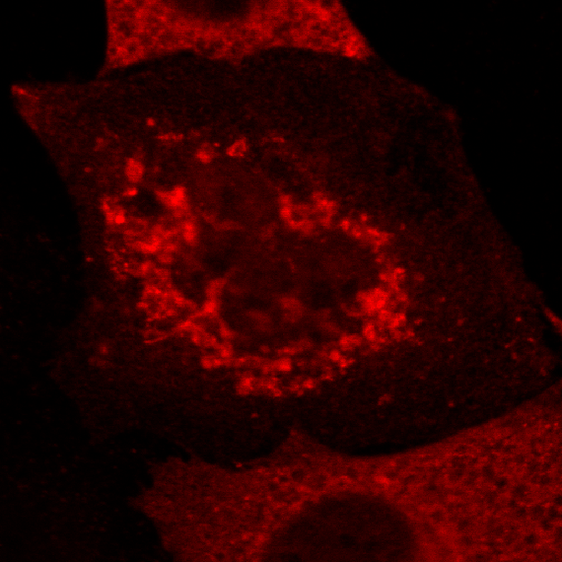
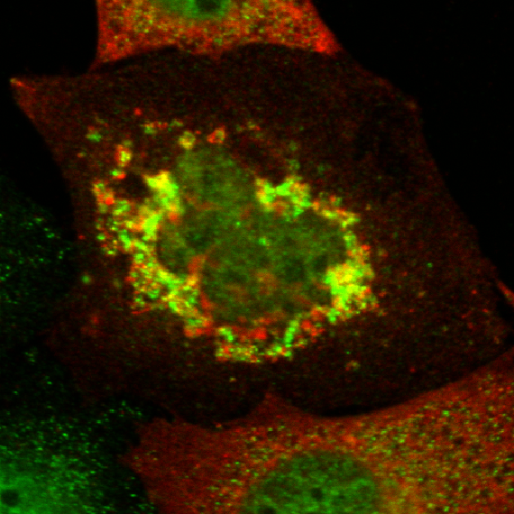
Arf1-GFP
Viral 2BC

Figure 4. Arf1 accumulated membrane domains are enriched in viral replication machinery components. At 4 hours post infection, cells expressing Arf1-GFP, were fixed and immunostained with antibodies to GFP ( to recognize Arf1) and viral protein 2BC. Scale bar 5μm.
Bleach area

Figure 5. Control cell (uninfected) FRAP of the Arf1-GFP pool at the Golgi apparatus.The first three data points are the fluorescence before photobleaching.Then the region of interest is photobleached rapidly with a high intensity laser light and images are taken immediately following the photobleach over a time course of several minutes.
Data analysis includes normalization for the starting amounts fluorescent material in the cell, for the extent of photobleaching and for the loss in photobleaching of the entire cellular fluorescence both during and after the photobleach period.

Figure 6. Association and Dissociation rates for Arf1 during the course of infection. We looked for differences in the association(k_{on} ) and dissociation(k_{off}) rates for Arf1 during infection to account for the accumulation of Arf1-GTP on ER domains. We calculated k_{on} and k_{off} rates using the τ values obtained from the FRAP curve fits and by measuring the abundances (K) of Arf1 on the membrane sites and cytosol which can be approximated by k_{on}/k_{off}. We find that over the course of infection there is a decrease in the rate of Arf1 dissociation.

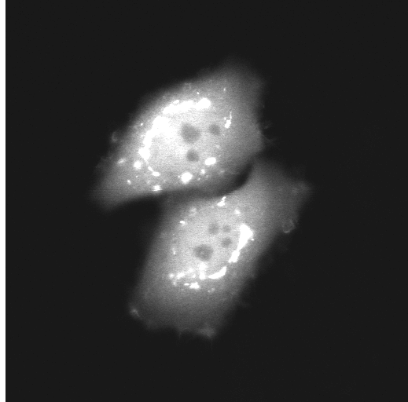
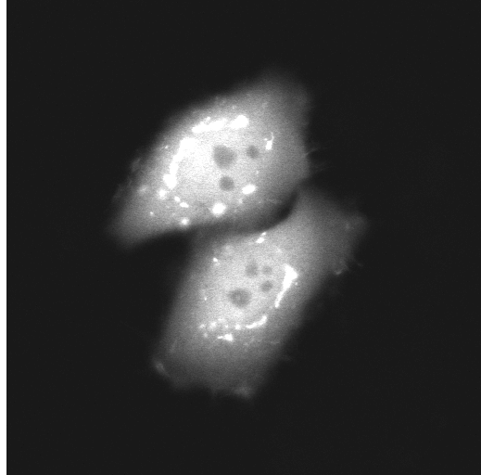
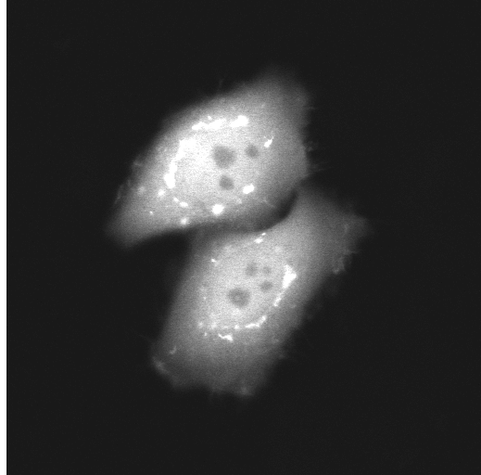
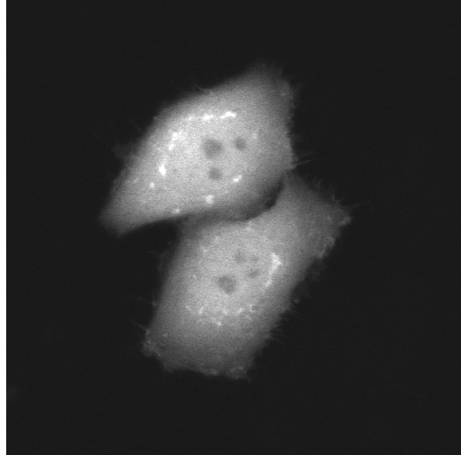
Control Cell
Cell,
3 hours p.i
0 sec 44 97 241
0 sec 19 77 211

Figure 7. Brefeldin A (BFA) is a cell permeable fungal toxin which specifically and rapidly blocks the GDP/GTP exchange on Arf1(i.e. association), leaving the GTP hydrolysis step (i.e. dissociation) unaffected. Therefore we treated cells with BFA at different time points of infection, in order to observe the rate of dissociation of Arf1 from membranes. We found that Arf1 dissociation from membranes was significantly slowed down in infected cells.
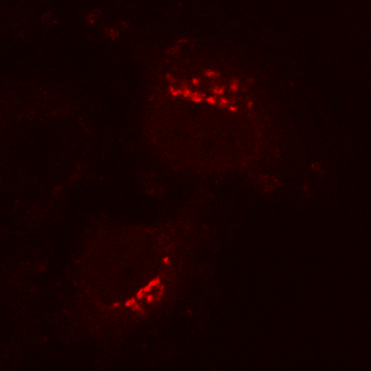
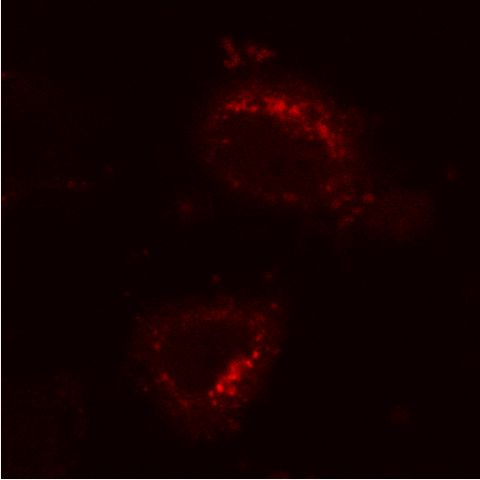
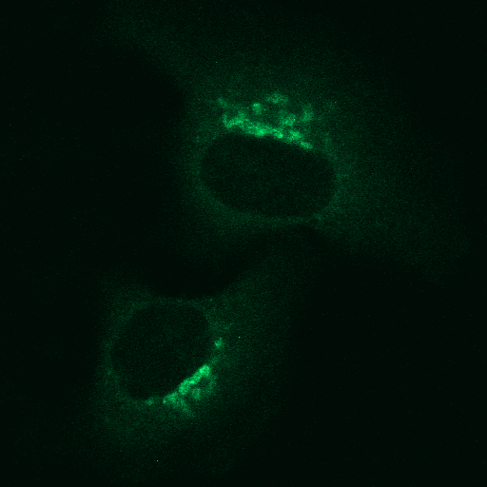
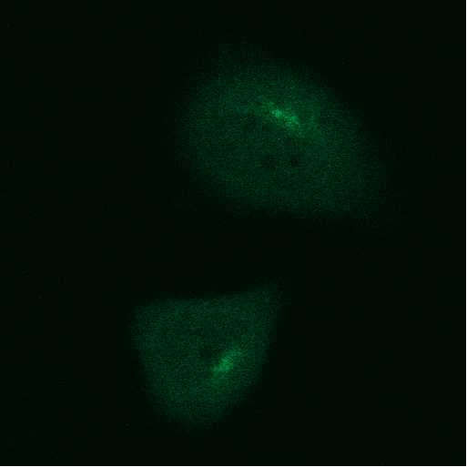
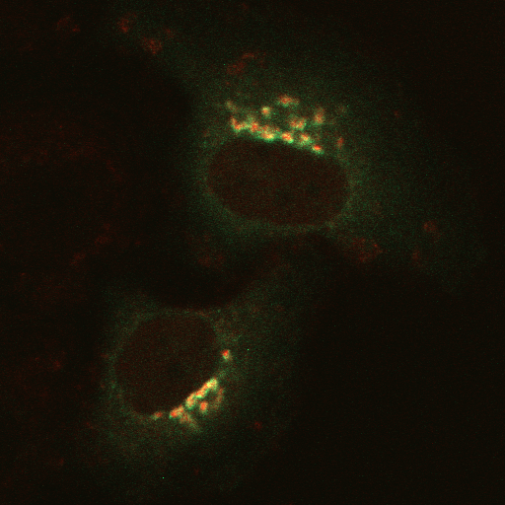
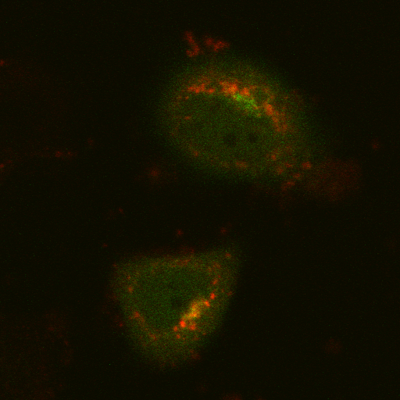
ARF1-RFP
ARFGAP1-YFP
0 hours p.I.
4 hours
p.I.
Merge
ARF1-RFP
ARFGAP1-YFP
Merge

Figure 8. ARFGAP1 dynamics during infection. To look for a potential mechanistic explanation for why Arf1 dissociation may be slowed during infection, we decided to investigate the dynamics of ARF1GAP,which is a critical regulator of Arf1 GTP hydrolysis (I.e. dissociation rates) on membranes. Cells are co-expressing Arf1-RFP and Arf1GAP-YFP and have been infected with CVB3.Time lapse images taken of 2 cells are shown above. Note that unlike at time 0 hours when Arf1 and ARf1GAP are both associated with Golgi membranes, as infection goes on less and less ARf1GAP is found at sites where Arf1 accumulates.

Work Cited
Belov GA, Ehrenfield E. Involvement of cellular membrane traffic proteins in poliovirus replication. Cell Cycle. 2007 Jan 1;6(1):36-38 Epub 2007 Jan 11. Review.

Bonnet, Nihal-Alton. Group Lecture. Role of Arf-1 in a Control and Virally Infected Cell. Rutgers University. Newark, NJ. 21 June 2007.

