Measuring the Capacitance of a Multi-compartment Cell

Arlene Pineda
UBMTP- Math 491
Prof. Bose, Prof. Golowasch, Prof. Nadim
12/18/06

Abstract:
The cell membrane exhibits electrical properties which allows for the measurement of capacitance of the cell. The capacitance is measured using three methods: current step, voltage step, and voltage ramp. Theoretically these methods should produce the same capacitance being that they are executed on the same cell. However, they produce results that vary up to an entire magnitude. This presents the problem that there is no accurate method for the measurement of capacitance of a cell. Using the Cancer Borealis crab to analyze the capacitance of a neuron in the stomatogastric ganglion and creating mathematical models for simulation purposes as well as predictions, we found that the most accurate method was the current step and that the least accurate method for measuring capacitance was the voltage step which is the most widely used method.

I. Introduction
The structure of the selectively permeable cell membrane consists of a phospholipids bilayer that contains protein channels imbedded within the bilayer. The purpose of the membrane is to regulate what enters and exits a cell. The lipid bilayer acts as a barrier between the inside of the cell and its environment and the protein channels regulate the flow of ions into the cell. The polar heads of the phospholipids molecules face the intracellular cytoplasm and the extracellular space, thereby separating the internal and external conducting solutions. The lipid bilayer and the protein channels create electrical properties similar to electrical circuits. The membrane capacitance represents the membrane dielectric property as a whole from the bilayer, and it is independent of local variations of permeation channels (Johnston & Wu). The membrane resistance represents ion permeation through cross-membrane protein or channels. Unlike membrane capacitance, membrane resistances in excitable cells are often highly dependent on cross-membrane voltage and time (Johnston & Wu).
The capacitance C is a measure of how much charge Q needs to be distributed across the membrane in order for a certain potential V_{m} to build up (Koch). In membrane biophysics, the capacitance is usually specified in terms of the specific membrane capacitance C_{m} (μm/cm²). The actual value of C is obtained by multiplying C_{m} by the total membrane area (Koch).

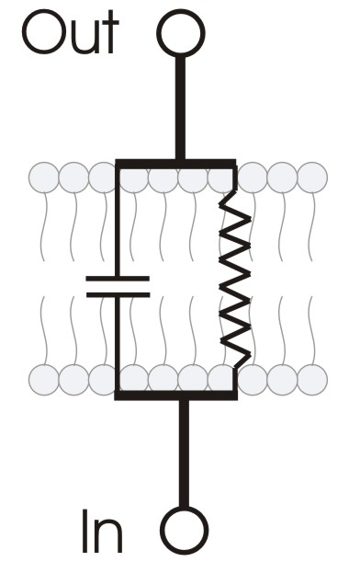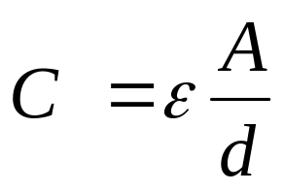

- (b)

Fig.1. (a) Schematic of the cell membrane with an RC circuit superimposed. (b) The relationship of capacitance
and area.

Schematically, the cell membrane can be depicted as a resistor and capacitor in parallel as depicted in figure1. Because the dimensions of the cell are so small, the electrical potential across the membrane is homogeneous and we can neglect any spatial dependencies making the cell isopotential. The net resistance R is determined by the specific membrane resistance R_{m} divided by the total membrane area πd², where the specific membrane resistance R_{m} is in Ωcm².
When current is injected into a cell, it goes both to the resistive and capacitive parts of the cell. From Kirchoff’s current law as well as Ohm’s Law, current across a capacitor is given by
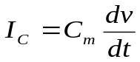 and the current through the resistor is given by 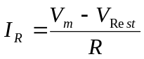. I_{m} represents the sum of the capacitive and resistive current, 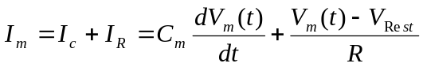. With τ=RC (ΩF=sec), Im can be written as 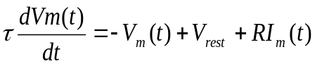, known as the membrane equation and is a first-order , ordinary differential equation (Koch).
If a sudden step change in I_{m} from zero to some constant value is applied to the membrane, the solution to the membrane equation is, 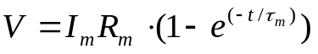 where
τ = RC = τ_{m} = R_{m}C_{m} called the membrane time constant. τ_{m} is the time at which voltage rises to (1-e-1) approximately two-thirds of its steady state value 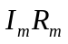.
The problem our paper addresses is the lack of an accurate method for the measurement of capacitance from a cell. We analyzed three methods of measuring capacitance: current step (in current clamp) which involves the injection of current into a cell, voltage step (in voltage clamp) entails the injection of current into a cell in order to hold the potential at specific value, and voltage ramp (in voltage clamp) where a gradual increase in the potential of the cell is observed. Theoretically the capacitance should be the same being that it is measured from the same cell, however, it was found that when these three methods were executed on the same cell, the result for capacitance differed by an entire magnitude.
These recordings may be inaccurate due to the complexity in the structure of a neuron. The lack of uniformity throughout the cell as well as dendritic branching may account for the discrepancy in the measurement of capacitance. The goal is to understand why this difference occurs by performing experiments using neurons derived from the stomatogastric ganglion (STF) of the Cancer Borealis crab in order to measure capacitance as well as gain an understanding from a biological stand point. Mathematical modeling is also used for simulation as well as predicting outcomes with varying parameters.

II. Methods
In executing the three methods for finding capacitance, non-voltage gated channels were of interest because they produce ohmic properties, that is, they produce a linear relationship between the conductance and voltage of a cell. One way of obtaining non-voltage gated channels is to apply the drug neurotoxin tetrodotoxin (TTX) which blocks action potentials by binding to the pores of the voltage-gated sodium channels in nerve cell membranes.

Methods for measuring capacitance
Current Step
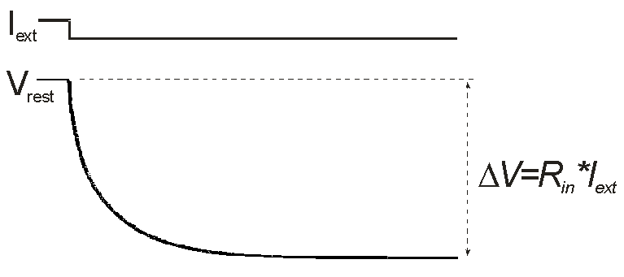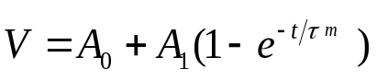

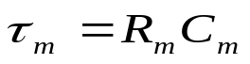

Fig. 2 Voltage curve for the injection of negative current into an isopotential spherical cell. The charging curve is able to be fit with a one exponential function due to the fact that the exponential rise is a result of the charging of the membrane.

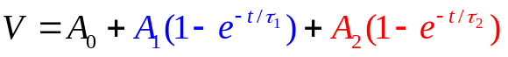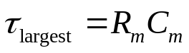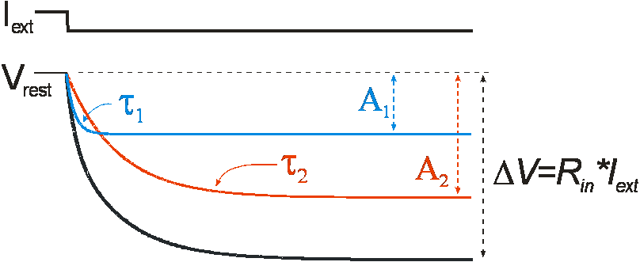
Fig. 3 Voltage curve for the injection of negative current into a multi-compartment cell. Here you see that there are two processes taking place: equalization of the cell (given by the blue term in the equation) as well as the charging of the membrane (given by the red term). The distinction between these two processes makes it possible to accurately measure capacitance in a cell.

In the current clamp method, a step of current is injected into the cell and produces a corresponding change in voltage over time graph which signifies the change in membrane potential. In the case of a positive current injection, given by (1), an exponential rise in voltage occurs. A negative current injection produces an exponential drop in voltage which is given by (2). (1) and (2) provide the equation for a two exponential fit.
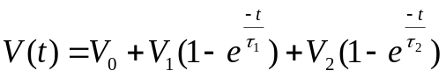 (1) 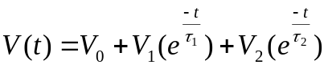 (2)

In (1) and (2), V₀ is the resting potential of the membrane and the coefficients V₁ and V₂ represent the magnitude of the change in membrane potential. The τ’s, referred to as charging constants, represent the time needed to charge the membrane. When a step of current is injected into a cell, equalization of the cell as well as the charging of the membrane occurs. The larger of the τ’s represent the charging of the membrane being that this process is slower than equalizing the cell. Using Ohm’s law, the resistance is found by dividing the coefficient corresponding to the slower τ, V1 or V2, by the amount of current injected into the cell. Because τ=RC, capacitance is determined by dividing τ by the resistance found.

Voltage Step
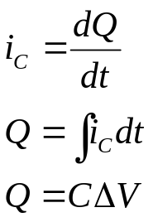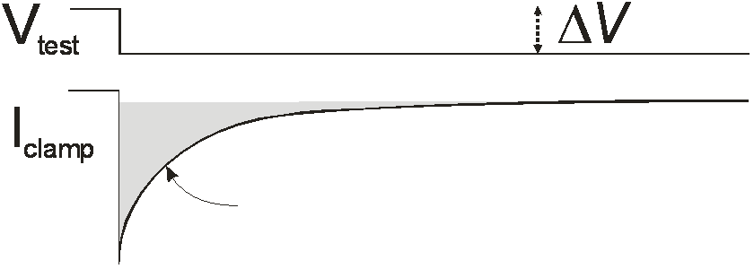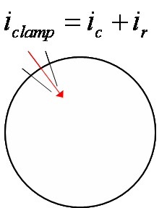
Fig. 4 Voltage step method with corresponding current graph. Integration under the capacitive artifact is given by the shaded area on the current curve.

In the voltage step method, a brief current injection into the cell holds the voltage at a fixed amount from the resting potential. A corresponding current over time graph that contains a curve produced by a capacitive artifact (signifying the charging of the capacitor) is produced. Using the equation for the charging of a capacitor, Q=C ΔV, where Q is the charge on the capacitor, the capacitance C can be determined. I_{C} represents the change in capacitive current with respect to time and is given by (3). The change in voltage over time graph contains the sum of the capacitive current and the current that flows across the membrane, the resistive current I_{R}. Therefore, the total current is given by (4).
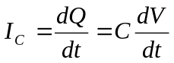 (3)
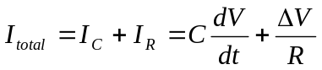 (4)
The curve of the resistive current can be scaled against the change in current over time curve due to the linear relationship of voltage and current. By subtracting the resistive current from the total current, the capacitive current curve can be obtained. Integrating under the capacitive current curve will produce the charge on the capacitor, Q. By inspection of the graph of voltage over time, ΔV is obtained where ΔV=V_{f}-V_{i}. The capacitance of the cell can then be solved for by manipulation of (3) where C= Q/ ΔV.

Voltage Ramp
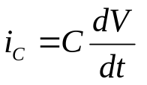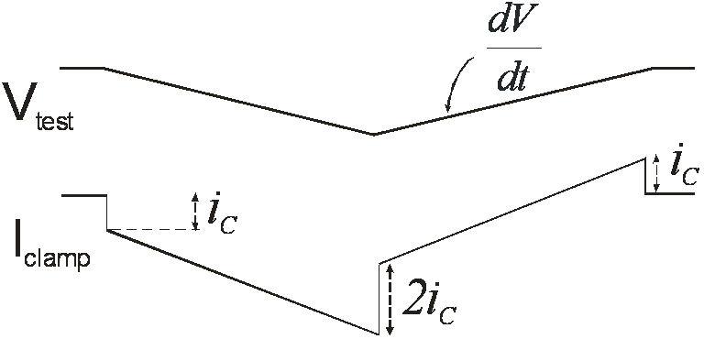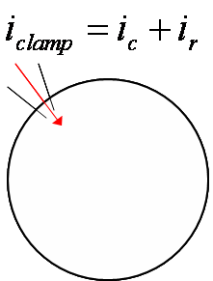
Fig.5 Voltage ramp method. Voltage plot shown with corresponding current plot. The current plot contains capacitive current shown by the jumps in the curve. I_{C} represents the change in capacitive current with respect to time.

In the voltage ramp method, current is injected into the cell at a constant rate which produces a gradual increase in voltage, 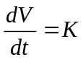. The voltage is then decreased at the same rate that it was increased,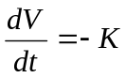. This gradual increase and decrease in voltage produces a corresponding current over time graph with small jumps in current representing the capacitors charge and discharge. If the slope of the voltage ramp is given by ,-K for the rise and fall of the ramp, the capacitance can be measured using a current over voltage graph which contains two parallel lines of the same slope by different y-intercepts, given by the equation of a straight line, y=mx+b. From (3), it is seen that the jumps observed in the current over time graph are equal to the product of the slope of the voltage over time graph and the capacitance given by (5).
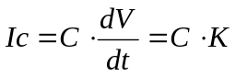 (5)
From the current over voltage graph, the difference in the y-intercepts of the two parallel lines produced is equivalent to twice (5). With the difference between the y-intercepts in the current over time graph, the slope of the voltage over time graph, the capacitance of the cell can be found by manipulation of (5), C=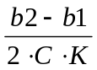.

Experimental

The Cancer Borealis crabs were dissected for experiments in order to collect and analyze data and to understand the biological aspect of measuring the capacitance in a neuron. They were obtained from a local fish market and stored in seawater aquaria at approximately 12ºC. Microelectrodes were pulled using the Flaming/Brown Micropipette puller (Sutter Instruments Co.)
The crabs were obtained and sedated by submerging it in ice for approximately 15-20 minutes. The crabs were excised using methods outlined in Golowasch & Mader, 1992. The STG was desheathed and pinned to a Sylgard lined petri dish where it was superfused with Cancer saline composed of (in mM) 440 NaCl, 11KCl, 13CaCl₂, 26 MgCl₂, 5 maleic acid, 11 trizma base, and pH 7.4-7.5. 10⁻⁷M TTX was added to the saline in order to prevent action potentials from firing.
Two microelectrodes were used to impale the neuron and were filled with 0.6M K₂SO₄ + 20mM KCl solution. The resistances of the microelectrodes varied between 20-25MΩ and 25-30MΩ. Current step, voltage step, and voltage ramp were executed and analyzed on the computer using the pClamp software from Axon instruments.
Measurements were taken using a feedback amplifier. All cells were held at -60mV. For the current clamp method, 1sec long pulses of -2nA of current were injected and voltage was sampled at 20 kHz . For the voltage clamp step method, the voltage was held at -60 mV and stepped to -80 mV for 0.3 sec. Current was sampled at a rate of 100 kHz. The voltage clamp gain was adjusted so that the voltage drop resembled a step as closely as possible. For the voltage ramp method, the cells were held at -60 mV ramped down to -80mV and back to -60mV. The ramp duration was adjusted to obtain different rates of voltage change. Current was sampled at a rate of 10 kHz . Twenty sweeps were taken for each of the three methods. The especially noisy sweeps were deleted while the remaining sweeps were averaged in order to maximize the signal to noise ratio. The signals were acquired and analyzed using the pClamp9.2 software package (Molecular Devices).
Analysis of Experimental Data
In the current step method, the voltage over time graph was fitted with a three exponential function given in (1) which directly provided the charging as well as the equalizing time constants. Three times the time constant corresponding to the equalizing process was not used in fitting. The points which remained were then fitted with a one exponential function. The time constant given by this fit corresponded to the charging of the membrane. The voltage change was determined by the amplitude given by the points which remained after removal of the three times the fastest time constant.
In voltage step, upon obtaining the voltage over time graph, the resistive current was subtracted from the total current by scaling the voltage plot against the total current plot. The result was a plot containing only the capacitive current which contained a capacitive artifact. Integrating under the capacitive artifact produces I_{C} which is then divided by ∆V to obtain capacitance.
In voltage ramp, a current over voltage graph was created which depicted two parallel lines. Both lines were fit with the equation y=mx+b. The difference in the slope of the lines was calculated and divided by twice the slope of the voltage curve to obtain capacitance.
Each method was analyzed using Clampfit 9.2.

Modeling in XPP
Algorithms for current step, voltage step, and voltage ramp were written for XPP, a program used to solve ordinary differential equations. These algorithms were based on the models we developed and were used for simulation purposes and the comparison of each method.
We created three different models and wrote algorithms for the three methods based on these models. The first model we created was the dual compartment model which consisted of a soma and dendrite represented by isopotential spheres attached to a cable which was given by a resistor. In the second model, we added a membrane to the cable and divided it into 10 compartments of equal length. In the third model, we changed the structure of the dendrite to that of a cylinder which we also divided into 10 compartments of equal lengths.
Several assumptions were made in order to simplify our models. We assumed axial resistance R_{i}, membrane resistance R_{m}, and membrane capacitance C_{m} to be constant. We also assumed the resting potential to be zero in order to reference all voltages to it.
Parameters of the models are given by Table 1.
Table 1. Parameter Values for Model Simulations
Parameter | Description | Value/Formula | Units
R_{m} | Membrane resistance | 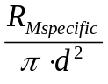 | Ω-cm
C_{m} | Membrane capacitance | 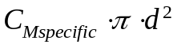 | μF/cm
R_{i} | Axial resistance | 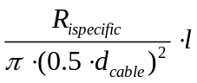 | Ω-cm
dsoma | Diameter of soma | .004 | cm
Rmspecific | Specific membrane resistivity in soma | 40,000 | Ω-cm
Cmspecific | Specific membrane capacitance | .001 | mF/cm
dcable | Diameter of cable | .001 | cm
l | Length of cable | 0.06 | cm
Rispecific | Specific intracellular resistivity | 100 | Ω-cm
d | Diameter of dendrite | .004 | cm
Rm2specific | Specific membrane resistivity in dendrite | 40,000 | Ω-cm
Cm2specific | Specific membrane resistivity in dendrite | .001 | mF/cm
Vr | Resting voltage | 0 | mV

1) Dual Compartment
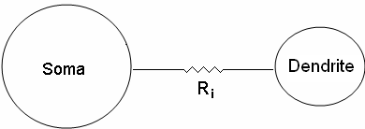
Fig. 6. Schematic of the dual compartment model in which the soma and the dendrite are isopotential spheres connected by a cable represented by a resistor, Ri.

Fig. 6. Depicts a schematic of the dual compartment model. Here you see that the soma and the dendrite represented by two isopotential spheres are connected to a cable represented by a resistor. Fig. 7 shows the current flowing through the soma and dendrite. The potential difference measured from the soma and the dendrite is given by (6) and (7):
I_{AS}
I_{RS}
I_{RD}

Fig. 7. Current flowing through the dual compartment model. Ri represents the axial resistance.

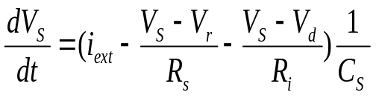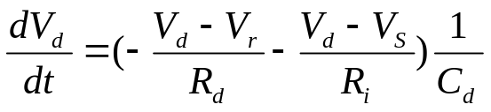
(6) (7)
I_{RS}
I_{AD}
I_{AS}
I_{RD}

In (6), the first term corresponds to the current being injected, the second term is the current flowing through the soma with respect to the resting potential, and the third term is the axial current flowing into the soma. These three terms are inversely proportional to the capacitance of the soma. Likewise for the dendrite, the first term is the current flowing through the dendrite with respect to the resting potential; the second term is the axial current flowing into the dendrite. These two terms are inversely proportional to the capacitance of the dendrite.
The significance of investigating this model is to observe the results of representing the total surface area of the dendrite as a lumped sphere attached to the soma.

2) Dual Compartment with compartmentalized cable
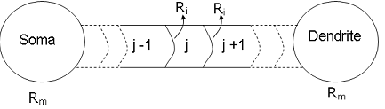
Fig. 8. Representation of spherical isopotential soma and dendrite attached by compartmentalized cable with added membrane.

In this model we have a spherical isopotential soma and dendrite; however, in order to make the model more realistic, membrane was added to the cable and it was divided into 10 compartments of equal length. The compartments were indexed using j.
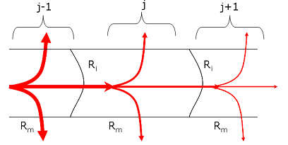
Fig. 9. A view of current flowing through the compartments of the cable. Ri is the axial resistance and Rm is the membrane resistance.

Fig. 9 shows a closer view of the current flowing through the compartments off the cable. The equation for potential difference across each compartment is given by (8).
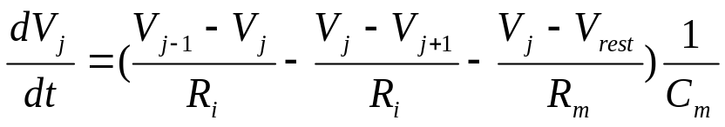 (8)
The first term is due to the current flowing into the compartment, the second term refers to the current flowing into the adjacent compartment, and the last term is the current flowing into the membrane. These three terms are inversely proportional to the membrane capacitance.

3) Compartmentalized dendrite
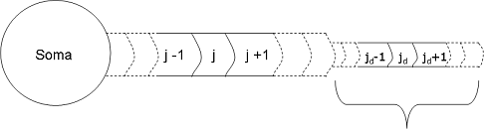
Dendrite

Fig. 10. A spherical soma attached to a cylindrical dendrite divided into 10 compartments of equal length.

Fig. 10 shows a spherical soma attached to a cylindrical dendrite that is divided into 10 compartments of equal length. The potential difference in each compartment of the dendrite is given by (8). The dendrites in real cells are not spherical but branched structures; therefore, changing the structure of the dendrite from a sphere to a cylinder strives to create a more realistic representation of dendrites in a real cell.

Analysis of data from models
Data obtained from the current step method was imported into Origin6.1 and fitted with three exponentials. Positive current was used due to the fact the model took into account the passivity of the cells. The fit is given by (1). Resistance can be found by dividing the coefficient of the largest τ by the current injected. Capacitance can be found by dividing τ by R.
For the voltage step method, data was exported into Matlab. An algorithm was written which subtracted the resistive current from the total current and the trapezoidal method was used to integrate under the capacitive artifact.
In the voltage ramp method, the slope of the voltage over time graph as well as the difference between the parallel lines in the current over voltage graph were manually calculated by looking at the data points. To find the slope, two points on the voltage over time graph were used and the difference in the parallel lines given by the current over voltage graph was found by subtracting two points of current for a given point of voltage.

IV. Results
Experimental
After running several experiments, 6 were analyzed for current step and 8 were analyzed for voltage step and ramp. As shown in table 2, the average capacitances that were measured using the three experiments for current step was 23.68nF, for voltage step it was 2.87nF and voltage ramp produced an average capacitance of 2.72nF. These results confirmed that there is a discrepancy between the three methods seeing that the current clamp gives results that are approximately ten times the results of the voltage step and ramp.
Table 2. Experimental Results
Experiment | Current Clamp (nF) | Voltage Clamp (nF) | Voltage Ramp (nF) | % diff (CC,VC) | % diff  (CC,VR) | % diff (VC,VR)
1 | 50.87 | 3.115 | 2.622 | 93.88 | 71.71 | 15.80
2 | - | 3.527 | 3.449 | - | - | 2.20
3 | 34.834 | 2.482 | 2.397 | 92.87 | 84.53 | 3.44
4 | - | 1.625 | 1.943 | - | - | -19.55
5 | 6.45 | 2.539 | 2.380 | 60.63 | 93.44 | 6.26
6 | 12.37 | 3.188 | 2.687 | 74.23 | 69.25 | 15.71
7 | 29.63 | 3.728 | 3.582 | 87.42 | 75.12 | 3.90
8 | 7.93 | 2.728 | 2.708 | 65.60 | 73.22 | 0.72
Average | 23.681 | 2.866 | 2.708 | 79.10 | 77.88 | 5.07

Modeling in XPP
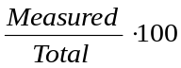Parameters were varied in the model in order to determine whether the structure of the cell influenced the measurement of capacitance. In order to test the accuracy of our models we calculated the percent actual capacitance which is the capacitance obtained from running the three methods in the model over the total capacitance: Percent Actual Capacitance =
Given below are the equations for the total capacitance for each model as well as the equations for the capacitance of the soma, dendrite, and cable.

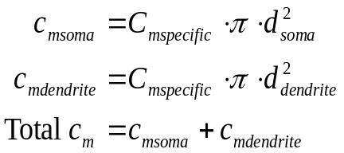Dual Compartment Model:

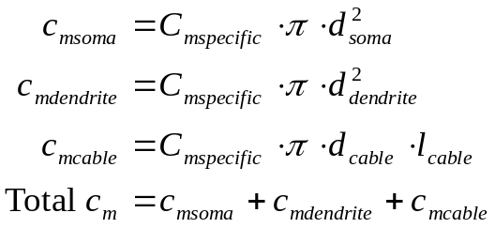Compartmentalized Cable

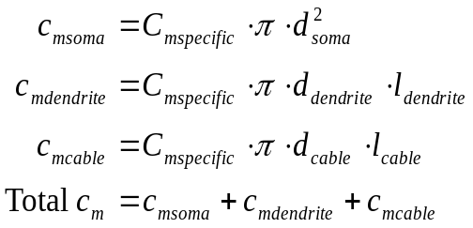Cylindrical Compartmentalized Dendrite

Dual compartment Model
Percent Actual Capacitance vs. Dendrite Diameter
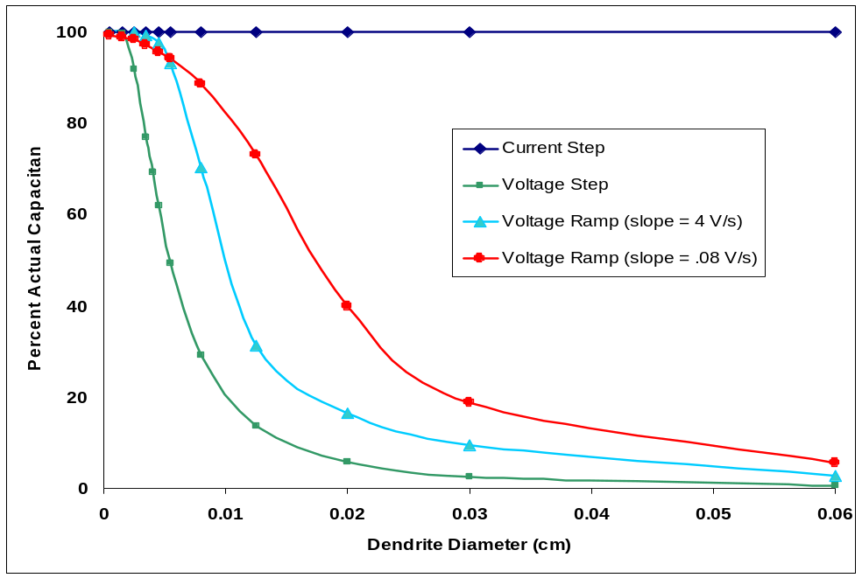

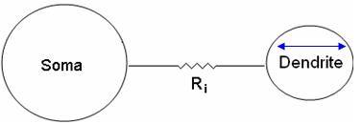
Fig. 11. Plot of Percent Actual Capacitance vs. Dendrite Diameter f or the dual compartment model

Fig. 11 shows the graph of percent actual capacitance vs. dendrite diameter. Holding the diameter of the soma at 40μm and the length of the cable at 0.06cm, the diameter of the dendrite was varied. Superimposing each method on the same graph, it is readily seen that the current step provides the most accurate measurement of capacitance being 100% straight across. The percent actual capacitance of the voltage step, represented by the green curve, and the voltage ramp represented by the red and teal were observed to decrease with increasing diameter.
In testing different slopes for the voltage ramp it was found that a slower slope produced more accurate results. As seen in Fig 6. a voltage ramp of slope 0.08 V/s given by the red curve produced more accurate results than for a slope of 4 V/s given by the teal curve. Changing the slope of the ramp would shift the curve lower or higher; therefore, the fast ramp will be omitted from the proceeding graphs.

Percent Actual Capacitance vs. Cable Length
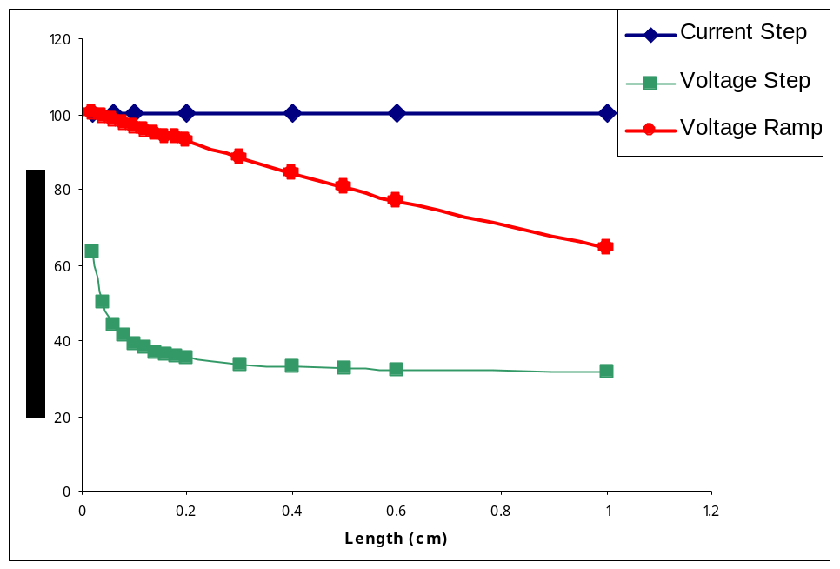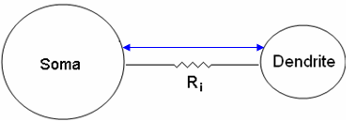
Fig 12. Plot of Percent Actual Capacitance vs. Cable Length for the dual compartment model

Next, the length of the resistive cable was varied. Shown above is the plot of percent actual capacitance vs. cable length for a cell of dendrite diameter 60μm. Again it is observed that the current step gives the best results while the voltage step and ramp decrease with increasing cable length. This can be due to the fact that as the cable length increases, access to the dendrite becomes more limited resulting in an inaccurate measurement of capacitance.

Compartmentalized Cable

Percent Actual Capacitance vs. Dendrite Area
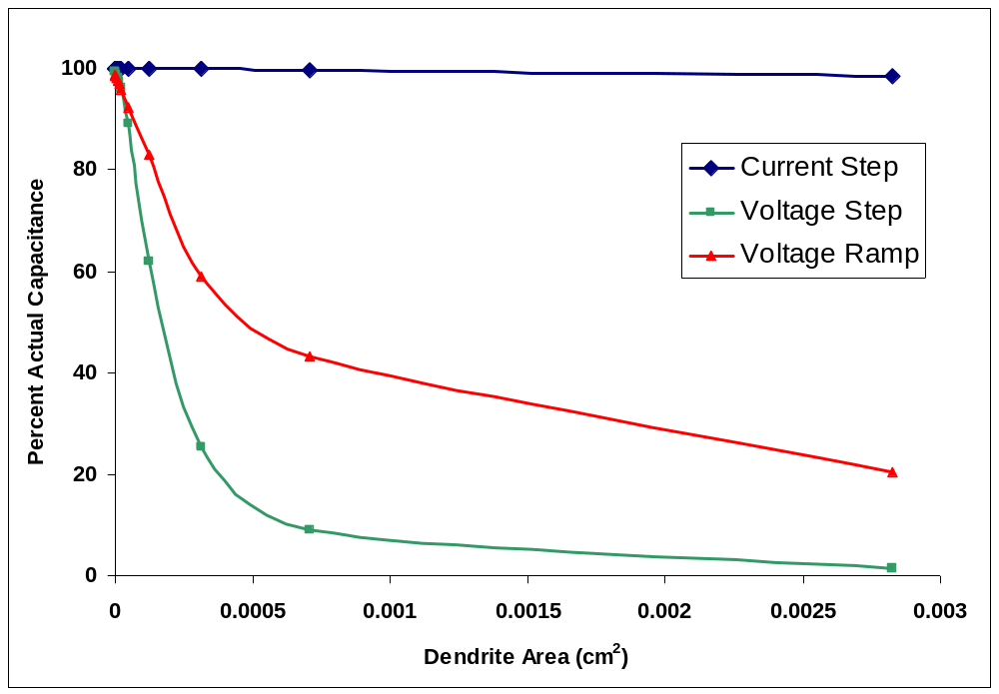

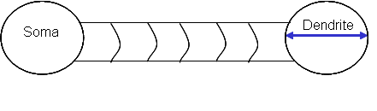
Fig. 13 Percent Actual Capacitance vs. Dendrite area for compartmentalized cable model

Fig.8 shows a plot of Percent Actual Capacitance vs. Dendrite Area. Again the soma and cable length are held constant while the dendrite diameter is allowed to vary. Similar to the previous graphs for the dual compartment model, the current step curve produces the best results while the voltage ramp produces the next best results and the voltage step produces the least accurate results.

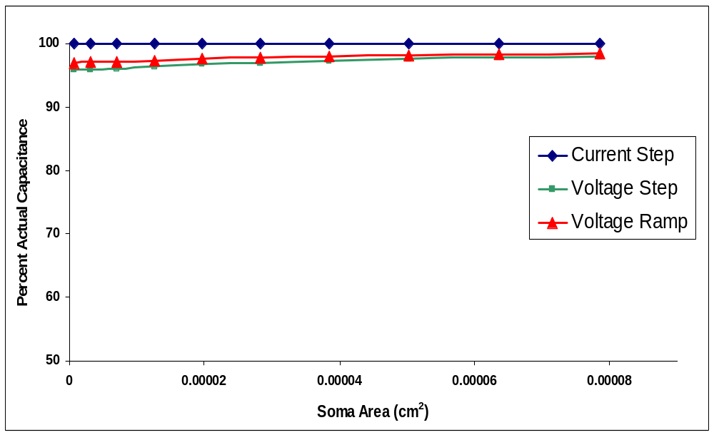
Percent Actual Capacitance vs. Soma Area

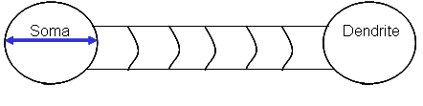
Fig. 14 Percent Actual Capacitance vs. Soma Area for the compartmentalized cable model

Fig. 14 shows a plot of Percent Actual Capacitance vs. Soma Area. Here, the diameter of the soma was varied as the cable length and dendrite diameter were held constant. In this plot, current step stays at a constant 100%. Unlike the previous plots, voltage ramp and step do not show a decrease in percent actual capacitance as the soma area increases; however, they still do not provide results as accurate as the current step. These results indicate that the three methods are approximately independent of the soma area.

Percent Actual Capacitance vs. Cable Diameter
0
20
40
60
80
100
0.00E+00
2.00E-03
4.00E-03
6.00E-03
8.00E-03
1.00E-02
Cable Diameter
Percent Acutal Capacitance
Current Step
Voltage Step
Voltage Ramp
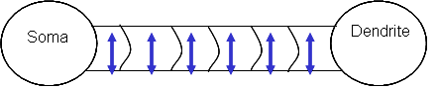
Fig. 15 Percent Actual Capacitance vs. Cable Diameter for the compartmentalized cable model

Fig. 15 shows the plot of Percent Actual Capacitance vs. Cable Diameter. The diameters of the soma and the dendrite have been kept constant while the diameter of the cable was varied. From the graph it is seen that current step again gives the best results while the voltage step and ramp gradually improve with increasing cable diameter. This could be due to the fact that the larger the cable diameter, the easier the access to the dendrite by the current becomes. Access to the dendrite would result in a more accurate measurement of capacitance.
Cylindrical Compartmentalized Dendrite

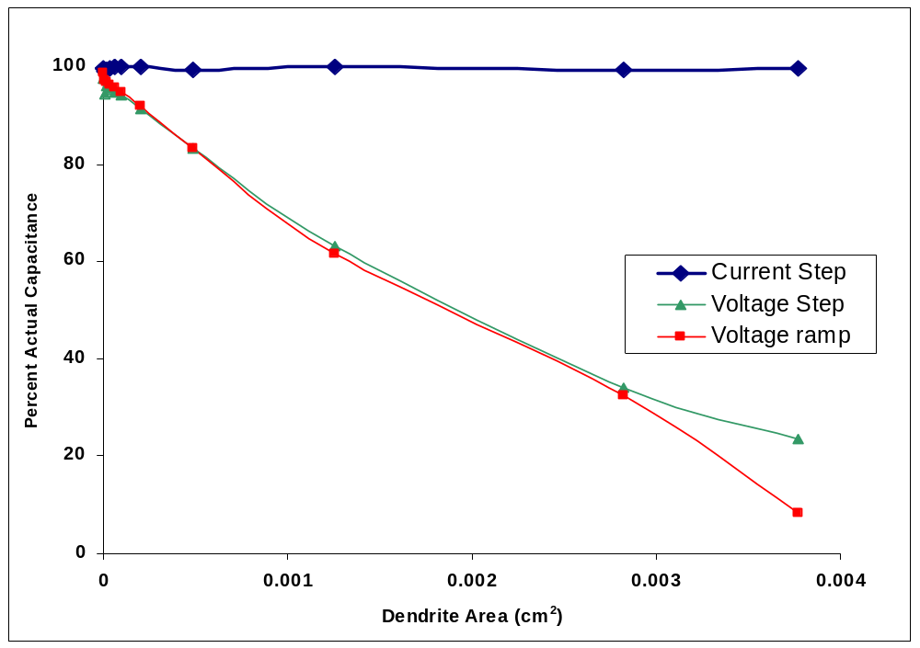
Percent Actual Capacitance vs. Dendrite Area

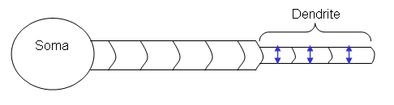
Fig. 16 Percent Actual Capacitance vs. Dendrite Diameter in the cylindrical compartmentalized dendrite model

Fig 16 shows the plot of Percent Actual Capacitance vs. Dendrite Diameter. In this model the dendrite’s structure changes from a sphere to a cylinder. The cylinder diameter is varied while the diameters of the cable and soma remain constant. From the graph it is seen that current clamp produces the most accurate results while the voltage step and ramp decrease with increasing dendrite diameter.

V. Discussion

In executing the experiments and running the models, the relationship between current clamp and the voltage clamp are of most interest. The voltage ramp method is used mainly as a check on the voltage clamp.

Experimental

As seen in table 2, the discrepancy between the measurements of capacitance between current step and voltage step and ramp were large. Voltage step and current step differed by 79.10%, current step and voltage ramp differed by 77.88%, and the voltage ramp and voltage step differed by 5.07%. These large percent differences indicate that there is a discrepancy existing between the methods.

Modeling in XPP
The models that we created were done so in order to simulate experimental recordings in order to test which method provided the most accurate measurement of capacitance
Shown by figures 11-16, it is deduced that current step provides the best method for measuring capacitance. This can be attributed to the fact that the voltage curve produced by the current step depicts two distinct processes: equalization and the charging of the membrane. When current is initially injected into a cell by the current step method, the current distributes evenly throughout the cell creating a homogenous potential difference (an isopotential cell). The current then serves to charge the membrane which is the slower process. The ability to distinguish between these two processes from the equation of the voltage curve makes it possible to accurately measure capacitance.
The graphs also indicate that this method is independent of the morphology of the cell, as the diameter of the dendrite, cable, and soma were varied in each model; the current step method provided the most accurate results. It is interesting to note that this occurs despite the fact that the current step was developed for isopotential cells; however, testing non-isopotential cells though model 2 and 3, current step still provides the better measurement of capacitance.
From the plots it is shown that the voltage ramp provides better results than the voltage step and that the voltage step method provided the least reliable results. This can be due to the fact that unlike the current step method, rapid injection of current into the cell does not allow equalization to occur causing an unequal distribution of current. Because of this, the two exponential fit is unable to be obtained and the time constant corresponding to the charging of the membrane is indistinguishable.
Being that voltage step is the most widely used method of measuring capacitance; we expected it to give the most accurate results. However, it gave the most inaccurate results in each model.

Future Work
From the obtained results, the quest to understand why the capacitances differ and what biological implications this may have is still underway. Future work could include, adding more dendrites to the model at different locations along the cable in order to accurately represent the structure of the cell.

