How To: Rutgers Animal Training
Go To: https://acfc.rutgers.edu/index.php
Click “Login without an RU NetID”
- Make up a username and password. Click sign in.
- You will see this form
- Fill out your first and last name, institution (University) and department, email address. Create and retype the same password you used previously along with a secret question.

- Under User Groups, select other/unspecified and click register
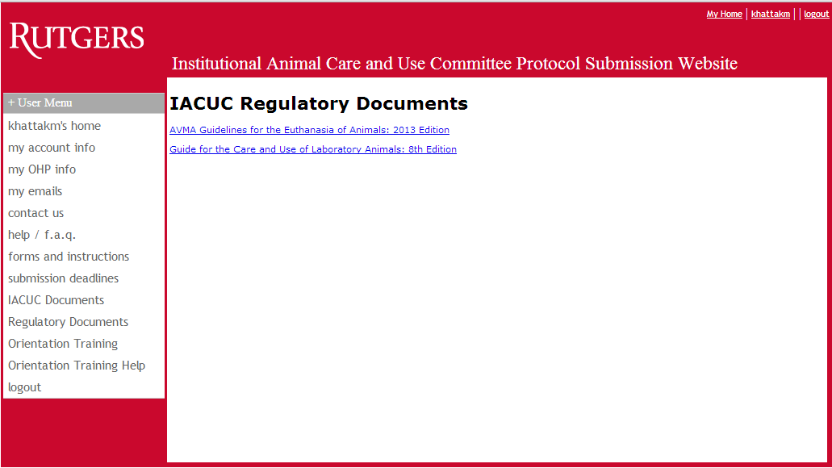
- Click on the +User Menu and click on orientation training. It will bring you to this screen:
- Fill out all areas marked with an * (Salutation, first & last name, title, organization, street address, city, state, zip code, phone number, and email address )
  - For the title fill in student and for the organization Rutgers the State University of New Jersey
- Check off the show RACE Certificates on Transcript and press submit
Animal Care and Use Courses
- Click on the course link in the bottom left of the screen
- View each of the 16 lessons
- You must view all pages before taking the exam – I recommend downloading each page so that they are available for the exam.
- Click on the final exam at the bottom of the page.
Taking the Final Exam
- Click on the button “Click here to generate the exam”
- The exam consists of 30 multiple choice questions. When completed, click submit and then press the click here button to submit the exam and receive your score
- You can retake the exam as many times as needed in order to pass.
- You must continue retaking the exam until you pass.
After you have passed, save the certificate as an image and e-mail it to eric.fortune@njit.edu.

