Master’s Project report
CS700B

Deep Web Mining
And
Enriching the Ontology-Enabled Web Search

Submitted to the
Department of Computer Science
College of Computing Sciences
New Jersey Institute of Technology

In Partial Fulfillment of
The Requirements for the Degree of
Master’s of Science

By

Ashish Rajbar
ar237@njit.edu

NJIT ID: 216-70-798

Project Advisor: Prof. James Geller
Project Number:

- Approval by Project Advisor.
Project Advisor: Dr. James Geller
Signature: ___________________
Date:_______________________

- Approval by MS in CS Committee.
Project Number: _____________________
Submission Date: ____________________
Project Evaluation: ___________________
(By Graduate Advisor / Committee)
Date: ______________________________
Signature: __________________________

- I hereby affirm that I have followed the directions as published in the program web page http://cs.njit.edu/~mscs/ and I confirm, that this report is own personal work and that all material other than my own is properly referenced.
Student’s Name: Ashish Rajbar
Student’s Signature:

Acknowledgment

Apart from my efforts, the tremendous success of this project depends largely on the encouragement and guidelines of many others. I take this opportunity to express my gratitude to the people who have been instrumental in the successful completion of this project.
Working on this project has been a great learning experience and I would like to show my greatest appreciation to Dr. James Geller for his constant support and help. Without his encouragement and guidance this project would not have materialized.
The guidance and support received from all the team members including Tian Tian and Yagnesh Bhat who contributed and are contributing to this project, was vital for the success of the project. I am grateful for their constant support and help.

Abstract

The “Ontology-Enabled Web Search” project aims at utilizing the vast information extracted from the Deep Web in assisting users in their search for Web pages by increasing the number of relevant Web sites that are returned. To that end, the project aims at mining the Deep Web for instances (useful information), building domain specific ontologies with those instances and finally providing the users with a friendly interface for analyzing the search terms entered and getting relevant Web sites, to show the contribution of the enriched ontology to Web search effectiveness. Mining the Deep Web for relevant instances based upon a particular ontology is an important process as this information is used in the development and enrichment of the ontology and thus making it more usable for indexing of the Deep Web sites.
This is an ongoing project. My area of concentration was to mine the Deep Web for useful information about famous people. Right now the focus was on information about musicians by gathering a list of singers along with their useful information such as their name, birth name, date of birth, place of birth, genres of music they are singing, etc. Previously the mining of the Deep Web for the “Airports” ontology was done by building a parser that gathers information from a Deep Web site by repeatedly filling out the front end forms depending on the structure of that particular Web page and extracting the returned results [2].
As a successor developer of this project, I developed a Deep Web Mining tool (WikiMiner) for gathering the relevant information and building a database depending on the type of ontology to be built which right now referred to “Singers.” WikiMiner consists of three modules that extract a list belonging to a particular category on Wikipedia, gather information about that list, filter out any duplicate or incorrect information and finally load an Oracle database for different categories. This information is then used for building and enriching the ontologies for the “Ontology-Enabled Web Search.”

Table of Contents

Acknowledgment 3
Abstract 4
1. Introduction 7
1.1 What is the Deep Web? 9
1.2 Ontologies 9
1.3 Deep Web Mining 11
1.4 Role of Ontologies in search for Web pages 13
2. Previous Work 15
2.1 Enriching Ontology for Deep Web Search 15
2.2 Automatic Attribute Extraction from the Deep Web Data Sources. 16
3. My Work 18
3.1 Scenario 18
3.2 Methodology Used 19
3.3 Phase 1 21
3.3.1 Introduction 21
3.3.2 Why Wikipedia? 21
3.3.3 Wikipedia Categories 21
3.3.4 Designing WikiMiner’s Modules 23
3.4 Phase 2 25
3.4.1 Introduction 25
3.4.2 Category List Extractor Module (CLX) 25
3.4.3 Input for CLX 26
3.4.4 CLX Output 28
3.5 Phase 3 29
3.5.1 Introduction 29
3.5.2 Background Information Extractor (BIX) 29
3.5.3 Input for BIX 32
3.5.4 BIX output 32

3.6 Phase 4 32
3.6.1 Introduction 32
3.6.2 Database Generator Module 33
4. Conclusions 34
5. Future Work 36
References 37
Appendix A: User Manual 39
A.1 Installing Java [16] 39
A1.1 Downloading JDK 1.6 39
A1.2 Installing JDK 1.6 on Windows 39
A1.3 Configuring JDK 1.6 on Windows 40
A.2 Executing WikiMiner 41
Appendix B: Source Code 42
B.1 Source code -Wikiminer.java 42
B.2 Source code - Miner.java 49

Introduction

What is the Deep Web?
“Deep Web” refers to Web pages dynamically generated via query interfaces implemented as Web forms or Web services in fact the Deep Web is the World Wide Web content that is not part of the surface Web, only the surface Web is indexed by standard search engines. A great deal of information may be caught in the internet, but there is a wealth of information that is deep and therefore missed. Most of the Web's information is buried far down on dynamically generated sites, and standard search engines do not find it. Traditional search engines cannot see or retrieve content in the Deep Web. These Web pages do not exist until they are created dynamically as the result of a specific search. Accordingly, the Web information can be classified according to the relevant Web pages retuned on a particular search by a user depending on its indexing by Web crawlers as illustrated in Figure 1 below.
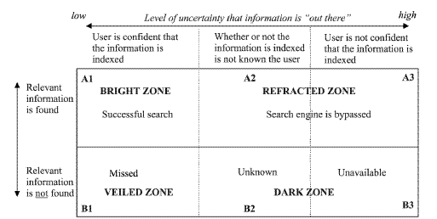
Figure 1: Distribution of the Web pages search results based on relevance [11].
Due to its dynamic nature, existing Web crawlers cannot access the Deep Web. Thus, accessing and maintaining the huge amount of Deep Web information remain challenging research issues. Information in a Deep Web site is categorized as being either in textual or structured databases. While a textual database needs input keywords for searching text documents, a structured database requires a user to fill in input fields of a query interface.
Deep Web content includes information in private databases that are accessible over the Internet but search engines are unable to crawl due to various reasons, for example, some universities, government agencies and other organizations maintain databases of information that were not created for general public access. Other sites may restrict database access to members or subscribers.
The Deep Web contained somewhere in the vicinity of 900 billion pages of information. In contrast, Google, the largest search engine, had indexed just 25 billion pages [8]. The term, "Deep Web," was coined by “Michael K. Bergman” co-founder and chairman of BrightPlanet, an Internet search technology company that specializes in searching deep Web content. In their 2001 white paper, 'The Deep Web: Surfacing Hidden Value,' Bergman noted that the Deep Web was growing much more quickly than the surface Web and that the quality of the content within it was significantly higher than the vast majority of surface Web content. Although some of the content is not open to the general public, BrightPlanet estimates that 95% of the Deep Web can be accessed through specialized search [9].

1.2 Ontologies

Ontology in computer science and information science is a formal representation of a set of concepts within a domain and the relationships between those concepts. It is used to reason about the properties of that domain and may be used to define the domain. In the words of Thomas Gruber, “An ontology is an explicit specification of a conceptualization. A conceptualization is an abstract, simplified view of the world that we want to represent. If the specification medium is a formal language, the ontology defines a representational foundation” [2].
For example, Figure 2 gives a pictorial representation of a roadway ontology which consists of various instances and their corresponding relations.

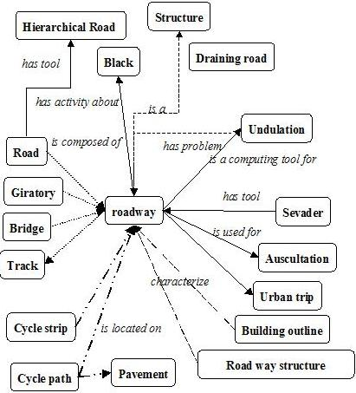
Figure 2: An example of roadway ontology [10].
According to James Geller’s more precise and detailed definition of ontology, it is a graph (the data Structure). Every Node of this graph stands for a “concept” which is a unit that one can think about and corresponds to words or short phrases. Typically, a concept corresponds to a noun or noun phrase like house, man, car, New York, etc., but that is not an obligation [1].

The nodes of the ontology are connected by different kinds of links. The most important kind of link is called IS-A link. The nodes and IS-A links together form a Rooted Directed Acyclic Graph (Rooted DAG). Rooted means that there is one single "highest node" called the Root. All other nodes are connected by one IS-A link or a chain of several IS-A links to the Root. In our definition IS-A links points upward. If an IS-A link points from a concept X to a concept Y that means that every real world thing that can be called an X also can be called a Y. In other words, every X IS-A Y. (Some people have IS-A-like links but pointing downwards.) Examples: A car IS-A vehicle. A dog IS-A animal [1].

Acyclic means that if you start at one node and move away from it following an IS-A link, you can never return to this node, even if you follow many IS-A links. Most nodes also have other information attached. This information includes attributes, relationships and rules [1].

Ontologies represent information in a form that can be used for some forms of reasoning that are at least partially similar to human reasoning. This includes inheritance reasoning, transitivity reasoning and classification. A concept may inherit information from several other concepts. This is called multiple inheritance. Transitivity reasoning corresponds to chaining of IS-A links. Classification means that if we know the attributes of a concept we can decide under which other concepts it belongs in the ontology.

1.3 Deep Web Mining
Just because a Web search engine can't find something doesn't mean it isn't there. The Deep Web is a vast information repository not always indexed by automated search engines but readily accessible to enlightened individuals. The Shallow Web, also known as the Surface Web or Static Web, is a collection of Web sites indexed by automated search engines.

A search engine robot or Web crawler follows URL links, indexes the content and then relays the results back to “search engine central” for consolidation and user query. Ideally, the process eventually scours the entire Web, subject to vendor time and storage constraints. Most of the time, information is stored on Web sites in such a way that the user initially comes in contact with what are called Menu pages. Menus are numerous and too thin i.e. they are just having basic information and users are driven through an endless series of nested menus in order to reach important information stored on backend inside content pages as shown in Figure 2 below.

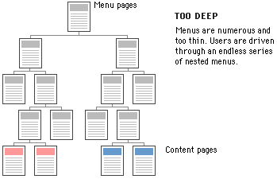
Figure 3: Information storage format on a typical Web site.

The crux of the process lies in the indexing. A Web crawler does not report what it can't index.
And we know the search result for a particular Web page in terms of its relevance depends greatly on that. This was a minor issue when the early Web consisted primarily of static generic HTML code, but contemporary Web sites now contain multimedia, scripts and other forms of dynamic content. The Deep Web consists of Web pages that search engines cannot or will not index. The popular term "Invisible Web" which refers to the Deep Web is actually a misnomer, because the information is not invisible, it's just not indexed by the Web crawler. The Deep Web is five to 500 times as vast as the Shallow Web, thus making it an immense and extraordinary online resource. The major search engines together index approximately 20% of the Web, and thus missing 80% of the content [9].

Search engines typically do not index the following types of Web sites:

- Proprietary sites
- Sites requiring a registration
- Sites with scripts
- Dynamic sites
- Ephemeral sites
- Sites blocked by local webmasters
- Sites blocked by search engine policy
- Sites with special formats
- Searchable databases

Proprietary sites require a fee. Registration sites require a login or password. A Web crawler can index script code (e.g., Flash, JavaScript), but it can't always ascertain what the script actually does and the Web crawler may get trapped within infinite loops. Dynamic Web sites are created on demand and have no existence prior to the query and limited existence afterward [14].

Webmasters can request that their sites not be indexed (Robot Exclusion Protocol), and some search engines skip sites based on their own inscrutable corporate policies. Not long ago, search engines could not index files in PDF, thus missing an enormous quantity of vendor white papers and technical reports, not to mention government documents. Special formats become less of an issue as index engines become smarter. The most valuable Deep Web resources are searchable databases. There are thousands of high-quality, authoritative online specialty databases. These resources are extremely useful for a focused search [14].

1.4 Role of Ontologies in search for Web pages

Recently, there has been a growing interest in Web searches that are intended to locate information that exists in the backend data bases of Web services. Web sites in E-commerce domains such as airfares, automobiles, books, car rentals, hotels, jobs, movies and music records usually store huge amounts of information, which is of interest to many users, in their backend databases.
Information in E-commerce backend databases is usually not “visible” to general search engines. The information in backend databases is often called Deep Web data. Finding the relevant E-commerce sites and accessing, retrieving and indexing the huge amounts of Deep Web data raises challenging research issues.
Ontologies could play an important role in assisting users in their search for Web pages. Domain ontologies can be constructed that support users in their Web search efforts and that increase the number of relevant Web pages that are returned. To achieve this goal the Deep Web information, which consists of dynamically generated Web pages, which cannot be indexed by the existing automated Web crawlers, is combined with ontologies.
The process of building ontologies consists of several steps, as shown in Figure 4. Firstly, the possible search terms, called attributes of Deep Web data sources, are automatically extracted from a static collection of Deep Web sites. Secondly, a separate domain ontology is built for each domain, using the extracted search terms. Thirdly, by probing a few Deep Web sites, domain terms from the backend databases are extracted. Next, the domain ontology is extended to include these Deep Web terms as instances. Finally, the domain ontology is extended with relationships between instances [3].
Figure 4: The Flow for an Ontology-Supported Deep Web Search [3].

2. Previous Work

The previous work on this project included addressing the problems of extracting instances from the Deep Web, enriching a domain-specific ontology with those instances, and using this ontology to improve Web search. In the initial phase of the project, information was gathered about all the airports located across North America by mining the Deep Web for building an `Airports` ontology based on that. This information was then used to provide users with additional search terms for making the search more specific and getting more relevant Web pages. The effectiveness of this methodology was shown by comparing the number of relevant Web sites by a search engine with a user’s search terms only, with the Web sites found when using additional ontology-based search terms. In the current phase of this project the domain has been extended to searching out information about famous people like singers, basketball players, researchers etc.

2.1 Enriching Ontology for Deep Web Search
Enrichment of ontology is a process that extends it by adding concepts, instances and new relations between concepts. In the related paper [3], a method for extracting instances from the DW is based on developing “robots” (agents) that send many queries to the same DW site to extract as many data values as possible. When a robot encounters an input field, it may enter random values or leave the field empty and then submit the page to elicit an informative response [3].
Figure 5 shows the workflow for extending the ontology with instances. The concept discovery of the robot is guided by a human in its initial stage. Initial pairs of a concept and its corresponding instances are defined, which we call a robot image. The robot submits input values into the query interface. If the input values are not suitable for the form, most Web sites display error messages. The analysis of the error messages often gives useful clues to the robot to guess suitable input values and launch better probing queries. Thus, the queried Web sources may provide information about concepts, instances and semantic relationships, which is recorded in the ontology [3].
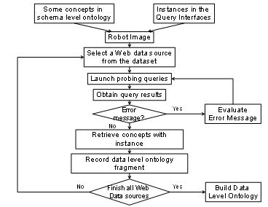
Figure 5: A Flow for generating data level ontology fragments [3].

2.2 Automatic Attribute Extraction from the Deep Web Data Sources.
Understanding the attributes and contents of Deep Web data sources is also important in order to locate the most relevant Deep Web data sources for a user, since these sources use different attributes to access contents. The related paper [4], presents a novel approach to automatically extracting attributes from query interfaces in order to address the current limitations in accessing Deep Web data sources. It introduces the Semantic Deep Web for utilizing an ontology to determine attributes to access the Deep Web [4].
In the general sense, an attribute of a Web data source is any item of information that describes this source. The more specific meaning of “attribute” is derived from the HTML/XML syntax. A tag of HTML consists of a mandatory name between angular brackets, which may be followed by optional attribute/value pairs. As an example, the Web page in Figure 6 is generated by the HTML code in Figure 7, which contains several attribute/value pairs. Thus the tag <SELECT> contains the attribute “size” with the value 2. The attribute and the value of such a pair are separated by an equal sign (=) [4].
Figure 6: An Example of a simple Form [4].
<FORM action= “...” method= “…”>
<P><LABEL for= “departure_city”>Departure<BR>
</LABEL>
<SELECT size= “2” name= “depart_city”>
<OPTION selected value= “city1”>Newark</OPTION>
<OPTION>Arlington</OPTION></SELECT><P>
Where is your departure city? <BR>
<INPUT type= “text” id= “origin”><P> Search by:<BR>
<INPUT type= “radio” name=“searchBy” value=“fare”> fare<BR>
<INPUT type=“radio” name=“searchBy” value= “schedule”>
schedule<P>
<INPUT type= “submit” value= “Go”> </P> </FORM>

Figure 7: HTML corresponding to Figure 6 [4].

3. My Work

3.1 Scenario
The goal of this project as stated earlier is to extract instances from the Deep Web, and then enrich a domain specific ontology with those instances, and finally use this ontology to improve Web search for users. For this purpose, I developed a Deep Web Mining tool (WikiMiner) for gathering the required information and building a database depending on the type of ontology to be built, which right now refers to `Singers` and can easily be extended to `Basketball players,` `Researchers,` etc.

I developed the WikiMiner application in Java which consists of three modules. The first module, i.e., the Category List Extractor (CLX) is used for the extraction of famous people lists singers, basketball players, actors, noble laureates, etc.
The second module, i.e., the Background Information Extractor gathers information about the “singers” in the list. Then it filters the information generated and removes any duplicate or incorrect information again by making use of the information stored inside the Deep Web itself.
The third module, i.e., the DBGenerator finally loads the desired information into an Oracle database. For example, I used two tables for storing the information regarding singers. The table “Music_Artists” is used to store the list of all the singers along with there background information and table “Artists_Genres” is used to store the information about a musician style of music i.e., the genres. This information is then used for building and enriching the ontologies for the “Ontology Enabled Web Search.”

3.2 Methodology Used
I developed a Java application (WikiMiner) which is a robot used for extracting instances from the Deep Web. The extraction is done by sending multiple queries to the same Web site to get as many data values as possible. The process includes first of all finding a suitable Web site that has all the information regarding singers. Then the WikiMiner submits input values into the query interface by analyzing the structure of that particular Web page and extracts as many names of the singers as possible. If the input values are not suitable for a form, most Web sites display an error message which helps WikiMiner to guess suitable input values and launch better probing queries to extract the list and information about all singers.
One of the problems faced during the extraction was that most of the Web sites list the singers, bands and musicians as artists in general. So it was very difficult for robots to guess that all the names that it had collected are indeed singers and not band names, disk jockeys, etc., who do not sing but release commercial music albums.
For example, Metallica, one of the most famous names in music industry, will be listed as an artist in almost all music Web sites, but what we were interested in were the names of all the singers in that particular band.

Another problem faced was that format in which the desired information is available varied enormously. For example, date of birth can be displayed as MM-DD-YY, MM-DD-YYYY, DD-MM-YYYY and so on. So we needed to make sure that this is the information we are looking for and then extract it in the format we needed.

s
For this purpose the information extracted from the Deep Web needs to be filtered and scanned over and over again by applying various filtering techniques that I developed depending on the type of information required to be extracted. This is in fact, part of Background Information Extractor module. It takes the information generated by WikiMiner from the database, i.e., the name list of singers and then selects a Deep Web site namely Wikipedia, that has information about musicians, like their name, sex, genres, locations, etc., in short all the useful information that separates singers from different kinds of music artists. This information not only helps WikiMiner to filter out the names of singers from unnecessary information collected from the Web sites, but will also helps in gathering important instances for the domain ontology. The process includes parsing a Web pages and then analyzing its structure, i.e., the attribute /value pairs of the HTML code as it defines the only way for accessing the form information. The work flow for this process is also depicted in Figure 8.

Deep Web

Names Extractor Module
Filtering and Information Enrichment Module

Database
DB Generator Module
DB Generator Module

Singer database

Figure 8: Flow of Data Extraction and Filtering Process.

3.3 Phase 1 - Research and Design

3.3.1 Introduction
The first phase of the project included one of the biggest challenges in Deep Web mining, which is finding a suitable website for information extraction of the music artists. For this I scanned through hundreds of music Web sites which included Web sites for downloading music, Web sites offering song lyrics or general Web sites having information about music artists and as a result the Web site I choose for extracting the required information was “Wikipedia” and thus resulting in the name “WikiMiner” [12]. Along with that I also worked on the design of the application, which consisted of the listing of all the modules needed and also the “information flow” and “functional requirements” of each specific module.

3.3.2 Why Wikipedia?
Wikipedia is one of the most detailed and enormous information encyclopedias for everything, including famous peoples. After going through the structure of information stored, Wikipedia was the best possible match for extracting information about music artists, and at the later stage of my project proved to be extremely useful for extending the scope of WikiMiner to various other categories of famous peoples like basketball players, actors and so on. Along with names it also had all the information that was needed for building the ontology like genres of songs, age, birth name, etc., about most of the music artists.

3.3.3 Wikipedia Categories
The desired information is stored in Wikipedia based on various Wikipedia categories. Categories are a software feature of Wikipedia, which enables pages to be added to automatic listings. These help structure a project such as Wikipedia by grouping together pages on similar subjects. A category page is a page in the “Category” namespace. The page “Category:Name” corresponds to the category called “Name.” For example, “Category:American_singers” corresponds to the Wikipedia category relating to all the singers in America [15].
Categories can be defined as subcategories of other categories, allowing easy navigation between connected subject areas via tree-like structures. Wikipedia’s categories form a hierarchical structure, consisting of overlapping trees. Because subcategories can have more than one immediate parent, the system as a whole is not a tree, but rather approximates a directed acyclic graph as depicted in Figure 9.

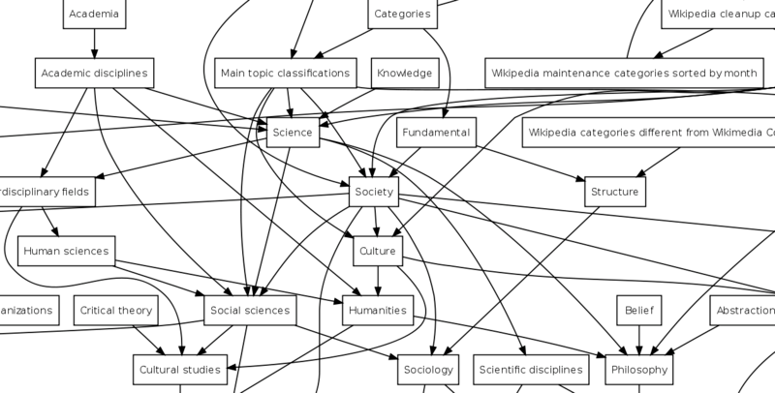
Figure 9: Partial view of Wikipedia's category system [13].

Categories are of two basic types:
- Topic categories – These contain articles on a particular topic.
For example, “Category:Music” contains articles on subjects related to music.
- List Categories – These contain articles whose subjects are members of a particular set.
For example, “Category:Musicians” contains articles on musicians.
WikiMiner looks for the appropriate category based on the type of information to be extracted from the Deep Web and then analyzes the categorical structure for parsing through the Web pages at Wikipedia by sending repeated queries and extracting the information needed. This is done by analyzing the categorical index at Wikipedia, finding a suitable match and then sending queries to the Wikipedia API’s to find the start of a current Wikipedia category list and finally extracting the useful information from that Web page while remembering the next linked URL (uniform resource locator).

3.3.4 Designing WikiMiner’s Modules
I designed the WikiMiner’s information and process flow for a successful extraction process while carefully listing the functional requirements to include the Deep Web mining techniques. The final design consisted of three functional modules as shown in the Figure 10.
- The Category List Extractor module
- The Background Information Extractor Module
- The Database Generator
Each module of WikiMiner was developed carefully to make it not only easy to debug but also make it as flexible as possible in its process flow.
The Category List Extractor module gathers lists of any Wikipedia category, like singers, basketball players, etc.
The Background Information Extractor module uses the output of the Category List Extractor as feed to extract useful information, like date of birth, place of birth, genres, etc., which are used to build up the ontologies.
The Database Generator Module is used to interact with the Oracle database and store all the extracted information in the required database tables.

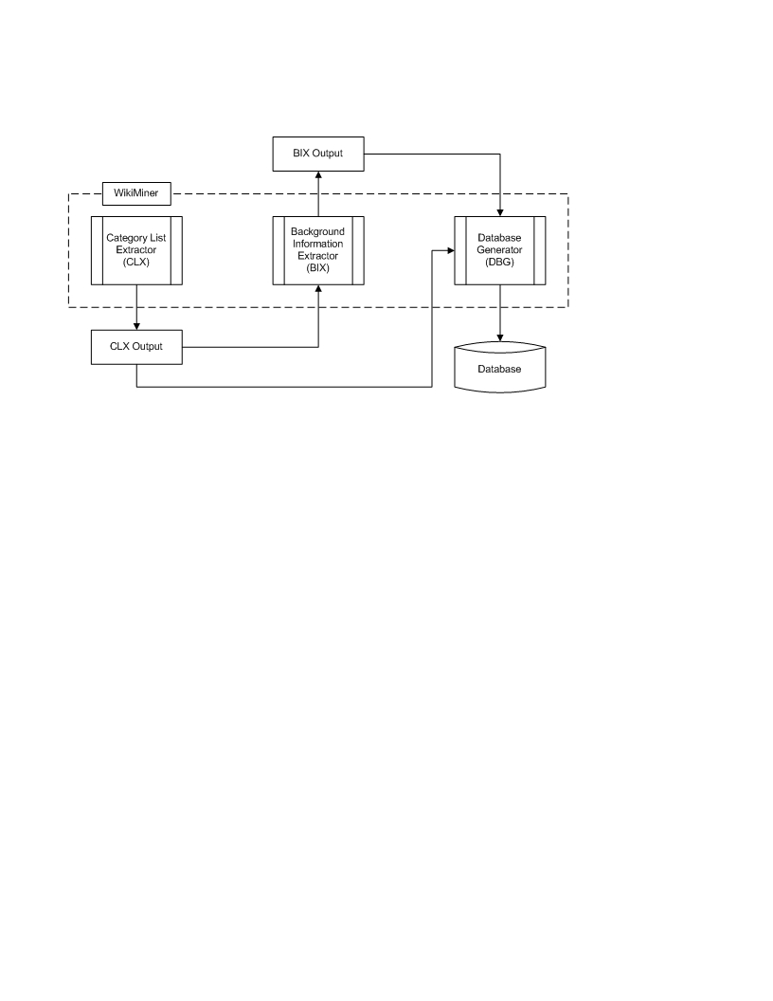
Figure 10: WikiMiner’s Information Flow Process.

3.4 Phase 2 - Category List Extractor module development

3.4.1 Introduction
The second phase of the project consisted of developing the WikiMiner code, starting with the Category List Extractor module. It was needed to develop powerful Deep Web mining techniques for parsing through various Wikipedia categories and finally getting a list of all the people listed as singers in the Wikipedia Database. WikiMiner’s user friendly interface starts with menu options for the different modules depending on the user’s choice as shown in the Figure 11.
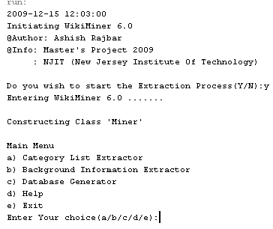
Figure 11: WikiMiner main menu.

3.4.2 Category List Extractor Module (CLX)
I developed the first module of the WikiMiner called the Category List Extractor (CLX). The CLX module is used to extract various Wikipedia categories. The user has the option to either select any of the predefined Wikipedia Categories like “Male Singers,” “Female Singers,” “Basketball Players” or choose an option to enter a new Wikipedia category as shown in Figure 12.
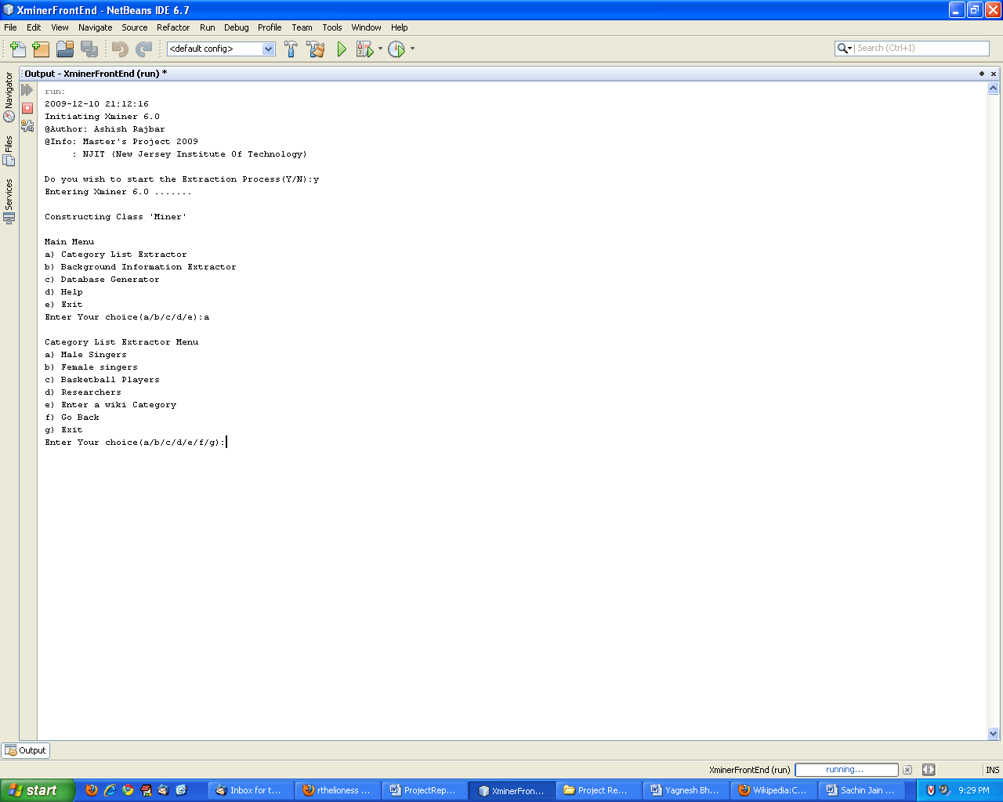
Figure 12: Category List Extractor (CLX) menu.

- Predefined Categories:
The CLX goes to the appropriate Wikipedia categories seed page, applies the Deep Web mining techniques and parses the information present on that Web page which may consist of either the people list in that particular category, the next seed page or the information that this particular Web page is the end of the Wikipedia category list. Depending on the information found on that Web pag,e the CLX either stores the information or acts on the information by going deep into another Wikipedia category page and returning when the end of that particular list is found.
- Entering a new Wikipedia Category:
The CLX goes to the Wikipedia’s category index page to retrieve that particular category and resumes normal operation if that category is found or else returns to the CLX menu notifying the user that the particular category does not exist or is not entered in the right format.

3.4.3 Input for CLX
The input for WikiMiner’s CLX module depends on the choice made by the user in either selecting a predefined category or entering a new Wikipedia category from the Wikipedia’s categorical index page. For the predefined lists, the user has to enter a name for the file he wishes to save the category list in. The file is saved as a text file with the name provided by the user in the current directory where WikiMiner is being executed as shown in Figure 13.
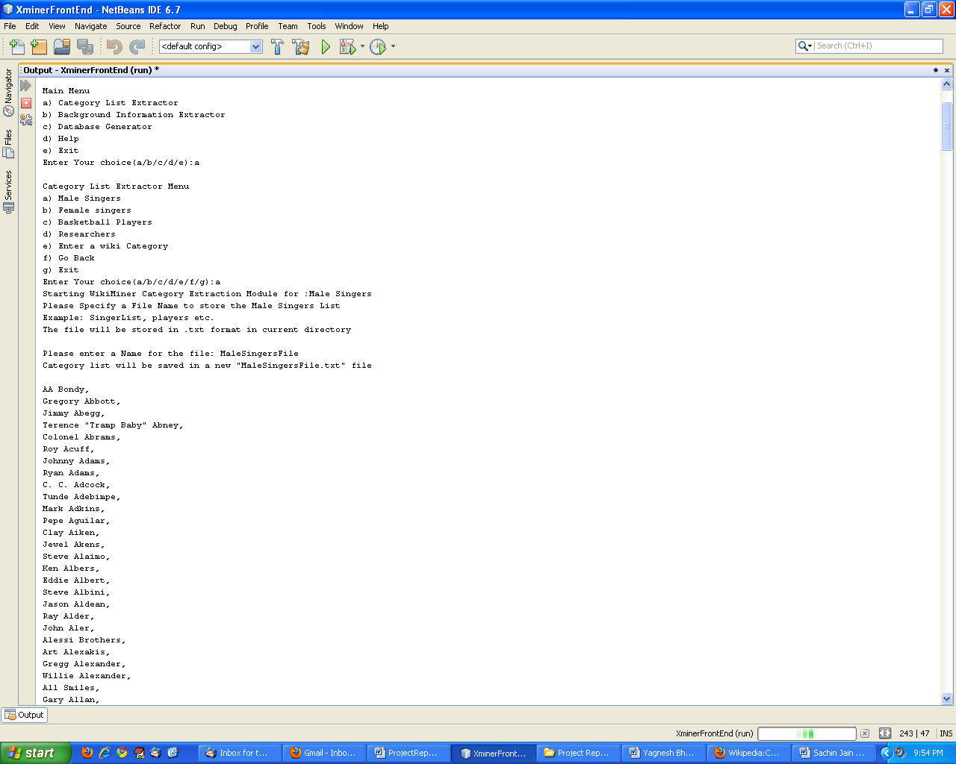
Figure 13: Input for Category List Extractor predefined Category.

If the user chooses to enter a new Wikipedia category from the Wikipedia Categorical index page, then the CLX takes as input the category name as specified in Wikipedia and also the file name to store that category list. The user is notified about the format in which the category name has to be entered and then the CLX is executed for the given category by saving the list in the file specified by the user in the current directory, as shown in Figure 14.
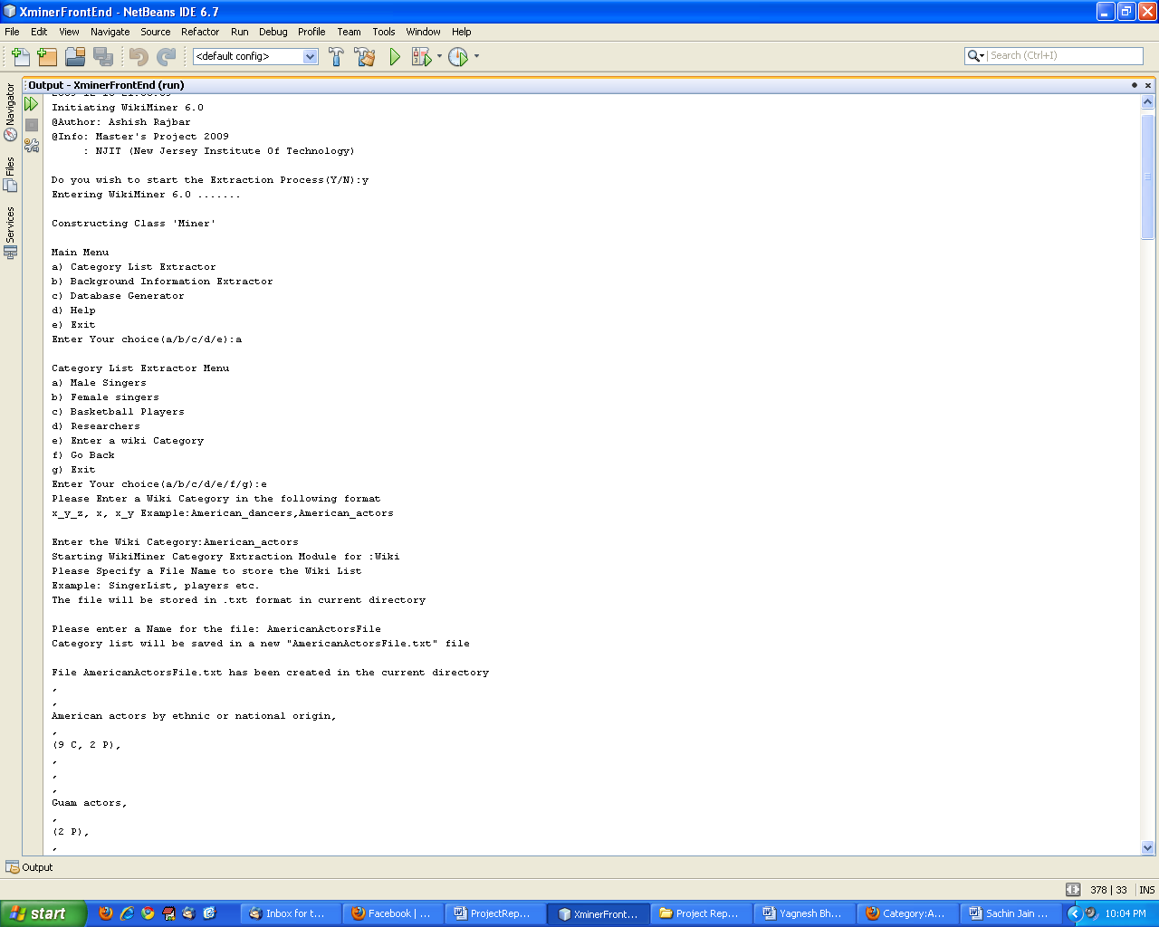
Figure 14: Input for Category List Extractor new Category.

3.4.4 CLX Output
The output generated by the CLX module is in a text file containing the list of all people in the particular category specified by the user. The CLX first parses the particular category seed page for the information required and then, depending on the type of information extracted, either stores the information in a text file or digs deep inside the Wikipedia to look for required information. As specified earlier, one of the major advantages of WikiMiner’s CLX module is that not only does it extract the list of all the singers but it can even extract the list of all basketball players, actors, dancers, and so on.
The CLX module was successful in not only extracting a list of over 5000 singers but also a list of around 3600 basketball players, 2500 actors and so on. The saved text files can either be used as a feed for the WikiMiner’s Background Information Extractor module or can be loaded into the database directly using the WikiMiner’s Database Generator module. The entire work flow of the WikiMiner’s CLX module is shown in Figure 15.

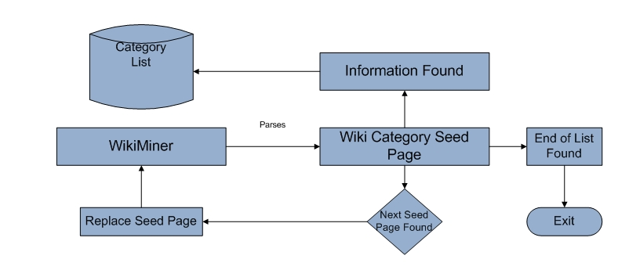
Figure 15: Process Flow Category List Extractor. Module

3.5 Phase 3 – Background Information Extractor module development

3.5.1 Introduction
The second phase of the project consisted of developing the WikiMiner’s second module, i.e., the Background Information Extractor (BIX). The BIX is the heart of WikiMiner and is used to extract all the information required for the list of singers that was collected by the CLX module.
For this, it takes as input the list of all the singers which is saved in a text file and then goes to Wikipedia for searching the required information depending on the type of category to be extracted. If it finds the information then it stores it along with the name of the music artist or else it goes to the next artist while keeping track of what information was found for whom.

3.5.2 Background Information Extractor (BIX)
The BIX menu consists of choices for the user to select the type of ontology the user is trying to collect information for, as shown in Figure 16.
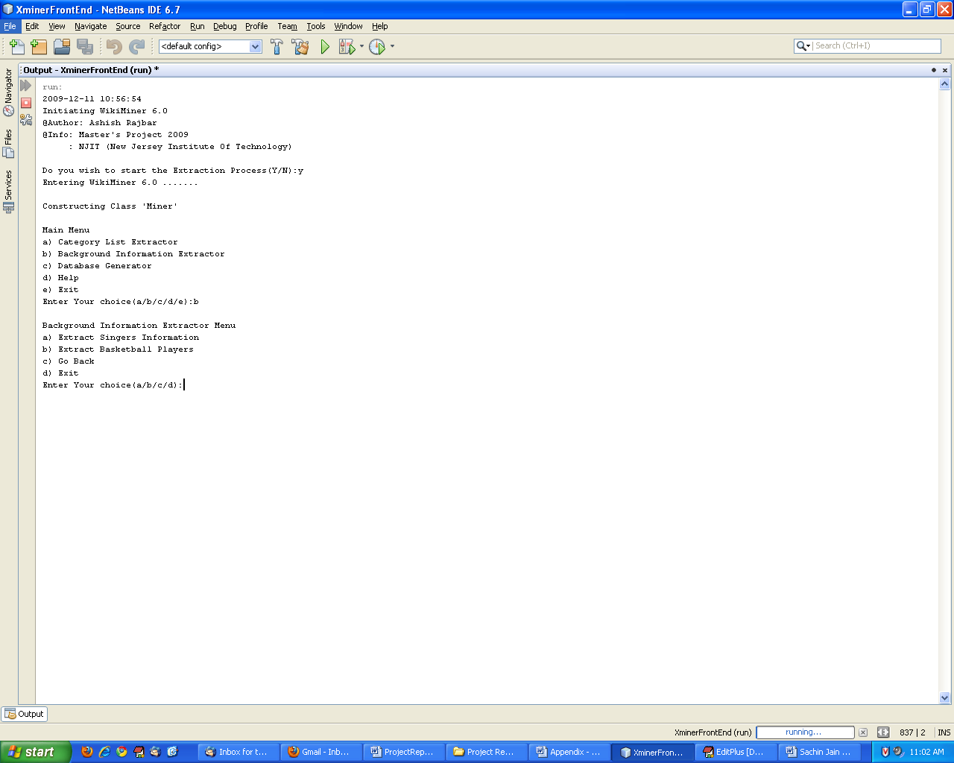
Figure 16: Background Information Extractor menu.

Once the type of information was selected, the real work of BIX starts. It goes through the whole list of singers one by one and finds the Web page relating to the particular singer at Wikipedia in the “Singers” category. If it is unable to find the particular singer then it disregards that music artist as it may be a band or a disk jockey. If the related page is found, it continues with the execution, finding information related to that that particular singer.
This is done by first mining the text for that particular singer at Wikipedia under the category “Singers,” then removing all the unwanted tags in the HTML page and scanning through the whole page. This is done to find the relevant information which relates to the style of music of that particular singer (Genres) and also the background information such as the date of birth, birth name and place of birth. The most challenging part was to identify the type of information collected as the information can be available in various different formats.
For example, the place of birth information can be available as city, state or city, state, country or just Country. The birth information can be in the format DD-MM-YYYY or YYYY or MM-DD-YYYY, etc. The information can be available or it may not be there at all. The birth information can be before the genres information or after.
To solve this problem, I applied various pattern matching techniques using regular expressions which were implied on the raw information collected from Wikipedia to retrieve the exact information required.
Regular expressions provide a concise and flexible means for matching strings of text, such as particular characters, words, or patterns of characters. It is used to search and manipulate text based on patterns. A regular expression, often called a pattern, is an expression that describes a set of strings. The following common operations are used to construct regular expressions,
- Boolean “or”
A vertical bar separates alternatives. For example, gray|grey can match “gray” or “grey”
- Grouping
Parentheses are used to define the scope and precedence of the operators.

- Quantification
A quantifier after a token (such as a character) or group specifies how often that preceding element is allowed to occur. The most common quantifiers are the question mark, the asterisk, and the plus sign.
Some of the common matching symbol patterns are given below:
- ‘.’ – Matches any sign.
- ‘[abc]’ - Set definition, can match the letter a or b or c.
- [abc[vz]] - Set definition, can match a or b or c followed by either v or z.
- [^abc] - This can match any character except a or b or c.
- [a-d1-7] - Ranges, letter between a and d and figures from 1 to 7, will not match d1.
- X|Z - Finds X or Z.
- XZ - Finds X directly followed by Z.

The work flow for BIX is as shown in Figure 17.
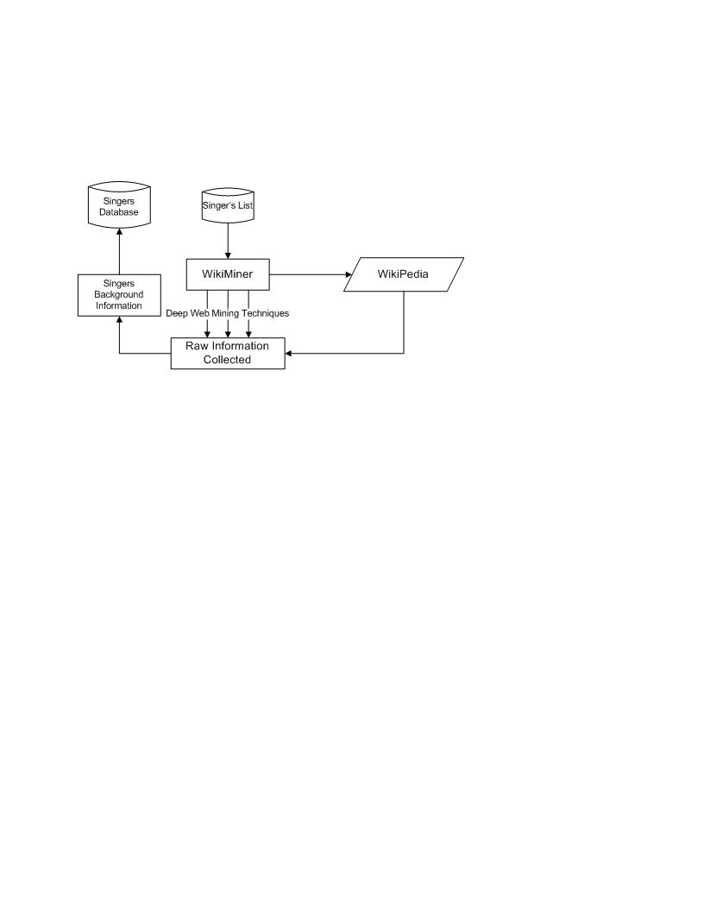
Figure 17: Background Information Extractor work flow.

3.5.3 Input for BIX
The input for BIX is the output generated by the CLX module, which is a list of all the singers stored on the text file. When the user chooses the type of information to be collected, i.e., the information about all the singers, the BIX asks for the filename of the file that was created by the CLX module containing the list of all the singers, as shown in Figure 18.
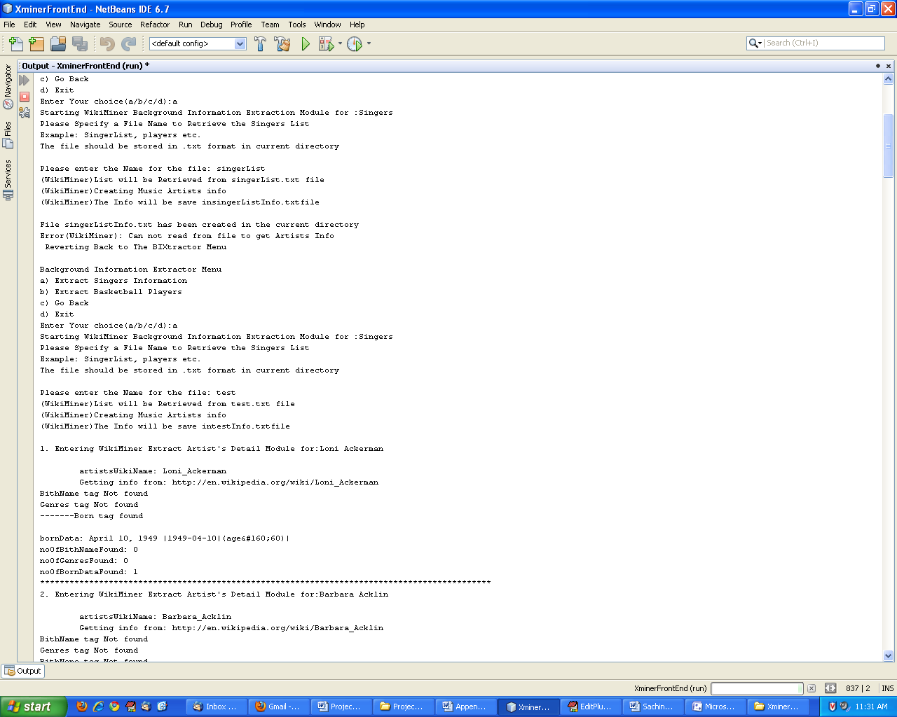
Figure 16: Background Information Extractor Input

3.5.4 BIX output
The output generated by BIX consists of all the extracted information regarding a singer, in the following order: (ArtistID, ArtistName, hasBirthNameOf, wasBornOnDate, wasBornInMonth, wasBornInYear). The information is stored in a load file which is a text file in the same directory as the input singer’s list file that was specified.

3.6 Phase 4 – Database Generator module development

3.6.1 Introduction
The third phase of the project consisted of developing the WikiMiner’s third module, i.e., the Database Generator. All the information that was collected till now about all the singers including the list and the background information is stored in an Oracle database, which is the work of WikiMiner’s third module.

3.6.2 Database Generator Module
The Database Generator (DBGenerator) module is used to add all the data from the load files generated by the different WikiMiner’s modules which are as follows:
- Singers, Basketball players, etc., category lists created by the Category List Extractor.
- Singers List with the background information created in a load file by the Background Information Extractor.
The DBGenerator does this by connecting to the Oracle database by using the Java Database Connectivity API and then loading the information into the appropriate table depending on the type of information to be loaded.
For example,
I used two Oracle tables to store the “Singers” information
- Table Music_Artist contains the list of all the singers with a unique ArtistID (unique identifier for each singer found) and the information relating to that artist columns in the following order - ArtistID, ArtistName, hasBirthNameOf, wasBornOnDate, wasBornInMonth, wasBornInYear.
- Table Artists_Genres contains the list of genres of all the singers found during the WikiMiner’s extraction process in two columns ArtistID, ArtistGenre.
The DBGenerator loads the singer’s information into both of the Oracle tables. The information for different categories such as the basketball players, actors etc, are stored in their individual databases.

Conclusions

The “Deep Web Mining and Enriching the Ontology-Enabled Web Search” project was primarily developed to enrich a domain-specific ontology for “Singers,” and due to the success of its powerful Deep Web mining techniques, was extended to gather the list of any Wikipedia category which can be singers, basketball players, cars, actors, and many others.
During the designing of WikiMiner it was of my utmost concern to make the application as flexible as possible for integrating different modules in such a way that the resulting application is not only easy to debug, but also scalable for future research. During the initial design phase of WikiMiner, I careful listed all the modules needed including the “information flow” and “functional requirements” of each specific module, which resulted in each module having a separate work flow and still being able to interact easily with each other.

The WikiMiner application consists of three modules. (1) The Category List Extractor module that gathers lists of any Wikipedia category, like singers, basketball players, etc. (2) The Background Information Extractor module that uses the output of the Category List Extractor as feed to extract useful information like date of birth, place of birth, genres, etc., which are used to build up the ontologies. (3) The Database Generator Module is used to interact with the Oracle database and store all the extracted information in the required database tables.
The Category List Extractor module accesses the appropriate Wikipedia categories seed page, applies the Deep Web mining techniques and parses the information present on that Web page, which may consist of either the people list in that particular category, the next seed page or the information that this particular Web page is the end of the Wikipedia category list. Depending on the information found on that Web page, the Category List Extractor module either stores the information or acts on the information by accessing into another Wikipedia category page and returning when the end of that particular list is found.
The Background Information Extractor module takes as input the list of all the singers generated by the Category List Extractor, which is saved in a text file, and then goes to Wikipedia for searching the required information using the powerful Deep Web mining techniques (including pattern matching, regular expressions, etc.) depending on the type of category to be extracted. If it finds the information then it stores it along with the name of the music artist or else it goes to the next artist, while keeping track of what information was found for whom.
The Database Generator (DBGenerator) module is used to add all the data from the load files generated by the other WikiMiner’s modules to the Oracle database by using the Java Database Connectivity API and then loading the information into the tables Music_Artists, Artists_Genresm Basketball_Players, etc., depending on the type of information to be loaded.

The success of WikiMiner gave us a completely new direction and helped us integrate many powerful techniques like pattern matching, regular expressions, Wikipedia API’s, JDBC connections, etc., with the traditional Web mining approach, to develop a useful tool which is both scalable and flexible, and therefore easily extendable towards our final goal, which is to utilize the vast information extracted from the Deep Web in assisting users in their search for Web pages by increasing the number of relevant Web sites that are returned.

Future Work

As stated earlier the “Ontology-Enabled Web Search” is an ongoing project and aims at utilizing the vast information extracted from the Deep Web in assisting users in their search for Web pages by increasing the number of relevant Web sites that are returned.
The “Deep Web Mining and Enriching the Ontology-Enabled Web Search” project was primarily developed to enrich a domain-specific ontology for “Singers,” and due to the success of its powerful Deep Web mining techniques, was extended to gather the list of any Wikipedia category which can be singers, basketball players, cars, actors, and many others.
The Category List Extractor (CLX) module of WikiMiner is a general purpose module which is used to extract the list of famous people in general from Wikipedia categories. The category list can be of singers, basketball players, actors, noble laureates and so on.
The Background Information Extractor (BIX) module of WikiMiner right now is used to gather information about the singer list extracted by the CLX and can be extended in the future to gather information about different category lists like researchers, actors, etc.
The DBGenerator module of WikiMiner and can be used to store any nature of data in the Oracle tables by just specifying the schema of the appropriate table and generating the proper load file for the same via CLX or BIX modules.
Another important extension of this project would be to integrate WikiMiner with different websites along with Wikipedia. This can be achieved by carefully studying the structure of some useful websites and then integrating the extraction process in either CLX or BIX.

References

- James Geller. Definition of Ontology, http://web.njit.edu/~geller/what_is_an_ontology.html, February 16, 2009.
- Thomas Gruber (2008), Ontology. Entry in the Encyclopedia of Database Systems, Ling Liu and M. Tamer Özsu (Eds.), Springer-Verlag. February 16, 2009.
- Yoo Jung An, Soon Ae Chun, Kuo-chuan Huang, James Geller: Enriching Ontology for Deep Web Search. DEXA 2008: 73-80, January 24, 2009.
- Yoo Jung An, James Geller, Yi-Ta Wu, Soon Ae Chun: Semantic Deep Web-Automatic Attribute Extraction from the Deep Web Data Sources, March 12, 2009.
- Yoo Jung An, Soon Ae Chun, Kuo-chuan Huang, James Geller: Assessment for Ontology Supported Deep Web Search, March 14, 2009. March 7, 2009.
- Yagnesh Bhat, Building Ontologies for Ontology Enabled Web Search, NJIT, CS Department, Completing in Fall 2009.
- Tian Tian, Enriching Multi-Domain Ontology for Web Search, PhD Project Proposal, NJIT, CS Department, Completing in Fall 2009.
- http://en.wikipedia.org/wiki/Google_search, February 21, 2009.
- http://brightplanet.com, February 21, 2009.
- http://www.cybergeo.eu/docannexe/image/8322/img-1.jpg, March 12, 2009.
- http://www.wowter.nl/blog/uploaded_images/ford-795385.gif, March 15, 2009.
- http://www.wikipedia.org/, April 7,2009
- http://en.wikipedia.org/wiki/Wikipedia:Categorization, Fall 2009
- http://www.computerworld.com/, April 16,2009
- http://en.wikipedia.org/wiki/Portal:Contents/Categorical_index , Fall 2009

Appendix A: User Manual

A.1 Installing Java [16]

A1.1 Downloading JDK 1.6
You can download the latest JDK 1.6 from http://java.sun.com/javase/downloads/index.jsp. The Windows version of JDK download file is named jdk-6-windowsi586.exe.
NOTE: New versions or updates may be available. If you download a new version or an update version, the file name may be slightly different from jdk-6-windowsi586.exe.

A1.2 Installing JDK 1.6 on Windows
Follow the steps below to install JDK 1.6:
1. Double click jdk-6-windows-i586.exe to run the installation program. You will see the JDK License dialog displayed.
2. Click Accept to display the JDK Custom Setup dialog.
3. You may install JDK in a custom directory. For simplicity, don’t change the directory. Click Next to install JDK. After a while, the JRE Custom Setup dialog is displayed.
4. You may install JRE in a custom directory. For simplicity, don’t change the directory. Click Next to install JRE.
5. After installation completed, the complete dialog is displayed. Click Finish to close the dialog.
6. For testing the installation just open Windows command prompt through
Start→Run→: typing `cmd` and type `javac` at the command prompt this will give you the listing of all the java classes installed.

A1.3 Configuring JDK 1.6 on Windows
To configure JDK is to make it available in the operating system so that Windows can find your JDK commands such as javac.

To configure JDK on Windows NT, 2000, ME, and XP, set the environment variables as follows:
1. Right-click the My Computer icon on your desktop to display a context menu. Choose Properties from the context menu to open the System Properties window.
2. In the System properties window, click Environment Variables in the Advanced tab to display the Environment Variables window.
3. You can set or modify user variables or systems variables. User variables affect the individual users and system variables affect all the users in the system. In the User variables section, select PATH and click Edit if PATH is already a user variable. Otherwise, click New to display the New User Variable Window.
4. Type PATH in the Variable field and c:\Program Files\Java\jdk1.6.0\bin;%path% in the Variable Value field. Click OK.
NOTE: You don’t have to reboot the computer, but you have to open a new command window to use JDK commands.
NOTE: If you download a new version or an update version, the directory name jdk1.6.0 may be slightly different.
For example, the directory name is jdk1.6.0_02 for JDK 1.6 Update 2.

A.2 Executing WikiMiner
1. Compile java file WikiMiner.java and Miner.java
Type “javac WikiMiner.java“ and “javac Miner.java“ at command prompt.
2. This will generate two java class files in the same directory.
WikiMiner.class and Miner.class
3. Run the java Appliaction WikiMiner by executing the class file WikiMiner.class
Type “java Wikiminer” at the command prompt .
4. This will start the execution of WikiMiner and the user interface of WikiMiner will appear on
the command prompt.
5. Please enter the appropriate module you wish to execute and follow the instructions on screen.

Appendix B: Source Code

B.1 Source code for WikiMiner.java
package xminerfrontend;

import java.util.Scanner;
import java.util.Calendar;
import java.text.SimpleDateFormat;
/**
*
* @author AR237
*/
public class WikiMiner {

/**
* @param args the command line arguments
*/
public static void main(String[] args) {
// TODO code application logic here

System.out.println(now()+"\n"
+"Initiating WikiMiner 6.0\n"
+"@Author: Ashish Rajbar\n"
+"@Info: Master's Project 2009\n"
+" : NJIT (New Jersey Institute Of Technology)\n");
System.out.print("Do you wish to start the Extraction Process(Y/N):");

Scanner sc = new Scanner(System.in);
String userInput;
boolean checkYesNo=false;
String selection ="WikiMiner Menu";
boolean checkSelection=false;

do{
userInput=sc.next();

if(userInput.toUpperCase().equals("N")){
checkYesNo=true;
System.out.println("\nExiting WikiMiner 6.0 ....... Good Bye !!");
}
else if(userInput.toUpperCase().equals("Y")){
checkYesNo=true;
System.out.println("Entering WikiMiner 6.0 .......");
Miner miner = new Miner();

do{
if (selection.equals("WikiMiner Menu")){
System.out.println("\nMain Menu\n"
+"a) Category List Extractor\n"
+"b) Background Information Extractor\n"
+"c) Database Generator\n"
+"d) Help\n"
+"e) Exit");
System.out.print("Enter Your choice(a/b/c/d/e):");

boolean checkInput = false;
while(!checkInput){
userInput=sc.next();
if(userInput.toUpperCase().equals("A")){
checkInput = true;
selection="CLXMenu";
}
else if (userInput.toUpperCase().equals("B")){
checkInput = true;
selection="BIXtractor";
}
else if (userInput.toUpperCase().equals("C")){
checkInput = true;
selection="DBGeneratorMenu";
}
else if (userInput.toUpperCase().equals("D")){
checkInput = true;
selection="Help";

}
else if (userInput.toUpperCase().equals("E")){
checkInput = true;
selection="Exit";
System.out.println("Thank you for using WikiMiner 6.0 ....... Good Bye !!");
}
else{
System.out.print("Please Enter a Valid Input(a/b/c/d/e)");
}
}//while WikiMiner menu choice

}//if WikiMiner Menu

if (selection.equals("CLXMenu")){
System.out.println("\nCategory List Extractor Menu\n"
+"a) Male Singers\n"
+"b) Female singers\n"
+"c) Basketball Players\n"
+"d) Researchers\n"
+"e) Enter a wiki Category\n"
+"f) Go Back\n"
+"g) Exit");
System.out.print("Enter Your choice(a/b/c/d/e/f/g):");

boolean checkInput = false;
while(!checkInput){
userInput=sc.next();
if(userInput.toUpperCase().equals("A")){
checkInput = true;
miner.extractCategoryList("Male Singers");
selection="CLXMenu";

}
else if (userInput.toUpperCase().equals("B")){
checkInput = true;
miner.extractCategoryList("Female Singers");
selection="CLXMenu";
}
else if (userInput.toUpperCase().equals("C")){
checkInput = true;
miner.extractCategoryList("Basketball Players");
selection="CLXMenu";
}
else if (userInput.toUpperCase().equals("D")){
checkInput = true;
miner.extractCategoryList("Researchers");
//System.out.println("Oops !! This Module is Under Construction");
selection="CLXMenu";

}
else if (userInput.toUpperCase().equals("E")){
checkInput = true;
miner.extractCategoryList("Wiki");
selection="CLXMenu";

}
else if (userInput.toUpperCase().equals("F")){
checkInput = true;
selection="WikiMiner Menu";

}
else if (userInput.toUpperCase().equals("G")){
checkInput = true;
selection="Exit";
System.out.println("Thank you for using WikiMiner 6.0 ....... Good Bye !!");
}
else{
System.out.print("Please Enter a Valid Input(a/b/c/d/e/f/g)");
}
}//while CLXMenu choice

}//if CLXMenu

if (selection.equals("BIXtractor")){
System.out.println("\nBackground Information Extractor Menu\n"
+"a) Extract Singers Information\n"
+"b) Extract Basketball Players\n"
+"c) Go Back\n"
+"d) Exit");
System.out.print("Enter Your choice(a/b/c/d):");

boolean checkInput = false;
while(!checkInput){
userInput=sc.next();
if(userInput.toUpperCase().equals("A")){
checkInput = true;
miner.extractBackgroundInfo("Singers");
selection="BIXtractor";

}
else if (userInput.toUpperCase().equals("B")){
checkInput = true;
miner.extractBackgroundInfo("Basketball Players");
selection="BIXtractor";
}
else if (userInput.toUpperCase().equals("C")){
checkInput = true;
selection="WikiMiner Menu";

}
else if (userInput.toUpperCase().equals("D")){
checkInput = true;
selection="Exit";
System.out.println("Thank you for using WikiMiner 6.0 ....... Good Bye !!");
}
else{
System.out.print("Please Enter a Valid Input(a/b/c/d/e/f/g)");
}
}//while BIXtractor choice

}//if BIXtractor

if (selection.equals("DBGeneratorMenu")){
System.out.println("\nDatabase Generator Menu\n"
+"a) Load Singers Database\n"
+"b) Load Basketball Players database\n"
+"c) Load Researchers database\n"
+"d) Go Back\n"
+"e) Exit");
System.out.print("Enter Your choice(a/b/c/d/e):");

boolean checkInput = false;
while(!checkInput){
userInput=sc.next();
if(userInput.toUpperCase().equals("A")){
checkInput = true;
try{
miner.loadIntoDatabase("Singers");
}catch(Exception e){
System.out.println("(WikiMiner): Unable to Load into the Singers Database:"+e);
}
selection="DBGeneratorMenu";
}
else if (userInput.toUpperCase().equals("B")){
checkInput = true;
try{
miner.loadIntoDatabase("Basketball Players");
}catch(Exception e){
System.out.println("(WikiMiner):Unable to Load into the Basketball Players Database:"+e);
}
selection="DBGeneratorMenu";
}
else if (userInput.toUpperCase().equals("C")){
checkInput = true;
try{
miner.loadIntoDatabase("Researchers");
}catch(Exception e){
System.out.println("(WikiMiner):Unable to Load into the Researchers Database:"+e);
}
selection="DBGeneratorMenu";
}
else if (userInput.toUpperCase().equals("D")){
checkInput = true;
selection="WikiMiner Menu";

}
else if (userInput.toUpperCase().equals("E")){
checkInput = true;
selection="Exit";
System.out.println("Thank you for using WikiMiner 6.0 ....... Good Bye !!");
}
else{
System.out.print("Please Enter a Valid Input(a/b/c/d/e)");
}
}//while DBGenerator choice

}//if DBGenerator Menu

if (selection.equals("Help")){
System.out.println("\nWikiMiner Help Menu\n"
+"WikiMiner is developed as a part of ongoing Research\n"
+"At NJIT(New Jersey Institute of Technology) 2009.\n"
+"It can be used to extract any category from Wikipedia\n"
+"It is still an ongoing project and has infact spread\n"
+"some light on ground breaking Ideas in Web Mining Technology.");
System.out.print("Press a key to Return to the Main Menu");
String returnHelp =sc.next();
selection="WikiMiner Menu";

}//if Help Menu

}while(!selection.equals("Exit"));

}// If User input=Y
else {
System.out.print("Please Enter a Valid Input(Y/N)");
}

}while(!checkYesNo);
}

public static String now() {
String DATE_FORMAT_NOW = "yyyy-MM-dd HH:mm:ss";
Calendar cal = Calendar.getInstance();
SimpleDateFormat sdf = new SimpleDateFormat(DATE_FORMAT_NOW);
return sdf.format(cal.getTime());

B.2 Source code for Miner.java

package xminerfrontend;

import java.net.*;
import java.sql.*;
import java.io.*;
import java.util.*;

/**
* @author Ashish Rajbar
*
*/
public class Miner {
private String htmlText;
private String urlToRead;
private String musicArtistsFile;
private String databaseInputFile;
private String musicArtistsInfoFile;;

int noOfBithNameFound;
int noOfBornDataFound;
int noOfGenresFound;
private int counter;
private int artistID;
private String artistsNameFromFile;
private String artistsName;
private String artistsWikiName;
private String artistsBirthName;
Vector<String> artistsGenres_Vector;

//Used for Clearing born info
String artistsDate;
String artistsMonth;
String artistsYear;
boolean gotDOB,gotPOB;
String[] dobInfo;
String[] cityState;
String[] cityStateCountry;
String artistsCity,artistsState,artistsCountry;

//Declaring Constructor
Miner(){
System.out.println("\nConstructing Class 'Miner'");

}

protected void extractBackgroundInfo(String category){

if (category.equals("Singers")){
}
else{// Need to change this in order to add more categories for BIXtractor
System.out.println("Oops !! Basketball Players Module is under Construction !!");
return;
}

Scanner scan = new Scanner(System.in);
System.out.println("Starting WikiMiner Background Information Extraction Module for :"+category
+"\nPlease Specify a File Name to Retrieve the "+category+" List\n"
+"Example: SingerList, players etc.\n"
+"The file should be stored in .txt format in current directory\n");
System.out.print("Please enter the Name for the file: ");
musicArtistsFile=scan.next();

musicArtistsInfoFile=musicArtistsFile+"Info";
System.out.println("(WikiMiner)List will be Retrieved from "+musicArtistsFile+".txt file\n"
+"(WikiMiner)Creating Music Artists info\n"
+"(WikiMiner)The Info will be save in"+musicArtistsInfoFile+".txtfile\n");

createFile(musicArtistsInfoFile);

try{
// Opening the file
// Needs to be changed
//FileInputStream fstream = new FileInputStream(musicArtistsFile+".txt");

FileInputStream fstream = new FileInputStream(musicArtistsFile+".txt");
// Get the object of DataInputStream
DataInputStream in = new DataInputStream(fstream);
BufferedReader br = new BufferedReader(new InputStreamReader(in));
String strLine;
//Reading File Line By Line;
//Reading Names one by one from the file
//Setting the artist id Starting from 1000001
counter = 1;
artistID = 1000001;
noOfBithNameFound=0;
noOfGenresFound=0;
noOfBornDataFound=0;
while ((strLine = br.readLine()) != null) {
// Getting One Artist Name from the file
artistsNameFromFile = strLine;
artistsBirthName ="";
artistsGenres_Vector =null;
artistsDate="";
artistsMonth="";
artistsYear="";
gotDOB =false;
gotPOB =false;
dobInfo =null;
cityState =null;
cityStateCountry =null;
artistsCity = "";
artistsState="";
artistsCountry ="";
extractArtistsDetails();
System.out.println("noOfBithNameFound: "+noOfBithNameFound);
System.out.println("noOfGenresFound: "+noOfGenresFound);
System.out.println("noOfBornDataFound: "+noOfBornDataFound);
clearArtistName();
System.out.println("\t\t\t\tartistsName :"+ artistsName);
System.out.println("***************************************" +
"*****************************************************");
writeBGTofile();
artistID++;

// System.out.println(artistsWikiName);
// Initiating Details Extraction
//initiateExtraction();
}
//Closing the input stream
in.close();
}catch (Exception e){
// Printing the error if any
System.out.println("Error(WikiMiner): Can not read from file to "
+"get Artists Info\n Reverting Back to The BIXtractor Menu");
}
}

private void extractArtistsDetails(){
System.out.println(counter+". Entering WikiMiner Extract Artist's Detail Module"
+" for:"+artistsNameFromFile+"\n");
counter++;

artistsWikiName=artistsNameFromFile.replace(' ','_');
System.out.println("\tartistsWikiName: "+artistsWikiName);
urlToRead = "http://en.wikipedia.org/wiki/"+artistsWikiName;
System.out.println("\tGetting info from: "+urlToRead);
//Getting the Html File from the wikipedia for the found Artist

getHTMLText(urlToRead);
if (htmlText.length() > 0){
//Extracting Birthnames

int startIndex = htmlText.indexOf(">Birth name<");
//System.out.println("startIndex:"+startIndex);
if (startIndex!=-1){
startIndex=startIndex+11;
System.out.println("-------BithName tag found");
int endIndex=htmlText.indexOf("</tr>",startIndex);
endIndex=endIndex+5;
String subStringHtmlText = htmlText.substring(startIndex, endIndex);
//System.out.println("\t\t\t\tsubStringHtmlText: "+subStringHtmlText);
//</th><td class="nickname">Jack Anthony Svicarevich</td>

startIndex =subStringHtmlText.indexOf("class=\"nickname\">", 0)+17;
endIndex =subStringHtmlText.indexOf("<",startIndex );
artistsBirthName=subStringHtmlText.substring(startIndex, endIndex);

/*
Method One
int secondHtmlTagEnd=0;
int index=0;
while(secondHtmlTagEnd!=2){
if(subStringHtmlText.charAt(index)=='>'){
secondHtmlTagEnd++;
}
index++;
}
artistsBirthName="";

while(subStringHtmlText.charAt(index)!='<'){
artistsBirthName+= subStringHtmlText.charAt(index);
index++;
}
*/
System.out.println("\tartistsBirthName: "+artistsBirthName);
noOfBithNameFound++;
}
else{
System.out.println("BithName tag Not found");
}
// System.out.println("\tnoOfBithNameFound:"+noOfBithNameFound);

//Extracting Genres

artistsGenres_Vector = new <String>Vector() ;
int index;
index = htmlText.indexOf(">Genres<");

if(index!=-1){

System.out.println("-------Found Artist Genres");
index=index+16; //increasing the inndex to the start of <td>
// System.out.println(htmlText.substring(index, index+10));
int indexLast = htmlText.indexOf("</tr>", index);
//System.out.println(htmlText.substring(index, indexLast));
String genresHTML = htmlText.substring(index, indexLast);
String genresString="";
artistsGenres_Vector = new <String>Vector();

for(int i=0 ; i<genresHTML.length()-1 ;i++){

if(genresHTML.charAt(i) == '<'){
while(genresHTML.charAt(i) != '>'){
i++;
}//while
// System.out.println("after leaving '<'"+htmlText.charAt(i));
}//if
if(genresHTML.charAt(i)=='>'){
//do nothing
}
else{
genresString="";
//System.out.println("Entered at i = "+i);
while(genresHTML.charAt(i) != '<'){
//System.out.print(htmlText.charAt(i++));
genresString += genresHTML.charAt(i++);
}
//System.out.print("after leaving data"+htmlText.charAt(i));
if (genresString.trim().length() > 2)
{
String [] genres = genresString.split(",");
for(int j = 0; j<genres.length;j++){
//System.out.println(genres[j].trim());
//if(genres[j].trim().equals("R&amp;B"))
//artistsGenres_Vector.add("R&B");
genres[j]=genres[j].replaceAll("&amp;", "&");
//artistsGenres_Vector.add("R&B");
genres[j]=genres[j].replaceAll("/", " ");
genres[j]=genres[j].replaceAll("-", " ");
artistsGenres_Vector.add(genres[j].trim().toUpperCase());
}
}
i--;
}

}//for
System.out.println("\tGenres: ");
for(int i=0;i<artistsGenres_Vector.size();i++){
System.out.print("\t");
System.out.println(artistsGenres_Vector.elementAt(i));
}
noOfGenresFound++;

}//ARTIST GENRES FOUND EXIT
else{
System.out.println("Genres tag Not found");
}
// System.out.println("\n\tnoOfGenresFound:"+noOfGenresFound);

//Extracting Born Tag
String bornData="";
Vector<String> birthInfoVector = new <String>Vector();
startIndex = htmlText.indexOf(">Born<");
//System.out.println("startIndex:"+startIndex);
if (startIndex!=-1){
startIndex=startIndex+5;
System.out.println("-------Born tag found\n");
int endIndex=htmlText.indexOf("</tr>",startIndex);
endIndex=endIndex+5;

String subStringHtmlText = htmlText.substring(startIndex, endIndex);
//System.out.println("\t\t\t\tBornTagInfo: "+subStringHtmlText);

String temp="";

for(int i=0 ; i<subStringHtmlText.length()-1 ;i++){

if(subStringHtmlText.charAt(i) == '<'){
if(temp.length()>2){
bornData+=temp+"|";
birthInfoVector.add(temp.trim());
}

temp="";

while(subStringHtmlText.charAt(i) != '>'){
i++;
}//while
}//if

if (subStringHtmlText.charAt(i) == '>'){
}
else{
temp+=subStringHtmlText.charAt(i);

}

}//for
noOfBornDataFound++;
}
else{
System.out.println("BithName tag Not found");
}

System.out.println("bornData: "+bornData);
//Sorting information fro born info vector
for(int i=0;i<birthInfoVector.size();i++){
//System.out.print(" -");
//System.out.println(birthInfoVector.elementAt(i));
if(birthInfoVector.elementAt(i).contains("-"))
{ gotDOB=true;
//System.out.println(">"+birthInfoVector.elementAt(i)+"<");
dobInfo = birthInfoVector.elementAt(i).split("-");
//System.out.println(">"+birthInfoVector.elementAt(i)+"<");
if (i==birthInfoVector.size()-1){
System.out.println("No further info ");
}
else{ i++;
//System.out.println(">"+birthInfoVector.elementAt(i)+"<");
if(birthInfoVector.elementAt(i).contains("#")){
//it has more info after DOB

if (i==birthInfoVector.size()-1){
//System.out.println("No further info after # age ");
}
else{// Therefore the pob info starts from this points
//System.out.println("\t\t\t\tPrinting the rest of info:");
i++;//to skip("#")
/*while(i<birthInfoVector.size())
{ System.out.println("\t\t\t\t"+birthInfoVector.elementAt(i));
i++;

}*/
if (i==birthInfoVector.size()-1){
//Therefore only only line info is available
// i.e. either city,state or city,state ,country
// System.out.println("Extracting one line info from");
// System.out.println("\t\t\t\t"+birthInfoVector.elementAt(i));
cityStateCountry = birthInfoVector.elementAt(i).split(",");
gotPOB=true;
}

if (i==birthInfoVector.size()-2){
//Therefore only only line info is available
// i.e. either city,state or city,state ,country
if (birthInfoVector.elementAt(i).contains(",")){
cityState = birthInfoVector.elementAt(i).split(",");
i++;
artistsCity = cityState[0];
artistsState = cityState[1];
artistsCountry = birthInfoVector.elementAt(i);
//String [] cityStateCountryKnown;
}
else{
artistsCity = birthInfoVector.elementAt(i);
i++;
artistsState = birthInfoVector.elementAt(i);
//artistsCountry ="U.S.A.";
}

gotPOB=true;
}

if (i==birthInfoVector.size()-3){

artistsCity = birthInfoVector.elementAt(i);
i++;
artistsState = birthInfoVector.elementAt(i);
i++;
artistsCountry =birthInfoVector.elementAt(i);
gotPOB=true;
}

while(i<birthInfoVector.size())
{ System.out.println("Printing the while loop");
System.out.println("\t\t\t\t"+birthInfoVector.elementAt(i));
i++;

}

}

}
else{
//System.out.println("\t\t\t\tPrinting the rest of info:");

if (i==birthInfoVector.size()-1){
//Therefore only only line info is available
// i.e. either city,state or city,state ,country
// System.out.println("Extracting one line info from");
// System.out.println("\t\t\t\t"+birthInfoVector.elementAt(i));
cityStateCountry = birthInfoVector.elementAt(i).split(",");
gotPOB=true;
}

if (i==birthInfoVector.size()-2){
//Therefore only only line info is available
// i.e. either city,state or city,state ,country
if (birthInfoVector.elementAt(i).contains(",")){
cityState = birthInfoVector.elementAt(i).split(",");
i++;
artistsCity = cityState[0];
artistsState = cityState[1];
artistsCountry = birthInfoVector.elementAt(i);
//String [] cityStateCountryKnown;
}
else{
artistsCity = birthInfoVector.elementAt(i);
i++;
artistsState = birthInfoVector.elementAt(i);
//artistsCountry ="U.S.A.";
}

gotPOB=true;
}

if (i==birthInfoVector.size()-3){

artistsCity = birthInfoVector.elementAt(i);
i++;
artistsState = birthInfoVector.elementAt(i);
i++;
artistsCountry =birthInfoVector.elementAt(i);
gotPOB=true;
}

while(i<birthInfoVector.size())
{ System.out.println("Printing While 2");
System.out.println("\t\t\t\t"+birthInfoVector.elementAt(i));
i++;

}
}

}
}//if'-'
}//for

if(gotDOB)
{ System.out.println("\t\t\t\t\t\t\tDOB Info YY/MM/DD");
for (int i=0;i<3;i++){
//System.out.println("\t\t\t\t\t\t\t"+dobInfo[i]);
}
artistsDate = dobInfo[2];
artistsMonth = dobInfo[1];
artistsYear = dobInfo[0];
// System.out.println("\t\t\t\t\t\t\t PLace of Birth Info:");
System.out.println("\t\t\t\t\t\t\tYear:"+artistsYear.trim());
System.out.println("\t\t\t\t\t\t\tMonth:"+artistsMonth.trim());
System.out.println("\t\t\t\t\t\t\tDate:"+artistsDate.trim());
}
//System.out.println("noOfBornDataFound: "+noOfBornDataFound);

}// ifhtmltext>0
}

void writeBGTofile(){
try{
// Create file
FileWriter fstream = new FileWriter("output.txt",true);
//BufferedWriter out = new BufferedWriter(new FileWriter("filename", true));
//out.write("aString");
// out.close();
String Memo="";
BufferedWriter out = new BufferedWriter(fstream);
out.write(artistID+","+"\""+artistsName.trim()+"\","+"\""+artistsBirthName.trim()+"\","+artistsDate+","+artistsMonth+","+artistsYear
+","+"\""+artistsCity.trim()+"\",\""+artistsState.trim()+"\",\""+artistsCountry.trim()
+"\",\""+Memo+"\""+"\n");

//Close the output stream
out.close();
}catch (Exception e){//Catch exception if any
System.err.println("Error: " + e.getMessage());
}
//Writing the genres
try{
// Create file
FileWriter fstream = new FileWriter("outputGenres.txt",true);
//BufferedWriter out = new BufferedWriter(new FileWriter("filename", true));
//out.write("aString");
// out.close();

BufferedWriter out = new BufferedWriter(fstream);

for(int i=0;i<artistsGenres_Vector.size();i++){
out.write(artistID+",\""+artistsGenres_Vector.elementAt(i)+"\"");
out.write("\n");
}
//Close the output stream
out.close();
}catch (Exception e){//Catch exception if any
//System.err.println("Error: " + e.getMessage());
}

//ArtistID++;

}

void clearArtistName(){
if (artistsWikiName.contains("\"") || artistsWikiName.contains("(")){

artistsName = artistsName.replaceAll("[\"][a-zA-Z\\s]{1,}[\"]","");
artistsName = artistsName.replaceAll("[(][a-zA-Z\\s]{1,}[)]","");
artistsName = artistsName.replaceAll("[ ]{1,}"," ");
}
else{
artistsName=artistsWikiName;
}
artistsName=artistsName.replaceAll("_"," ");

}

void musicArtistsMiner(){
System.out.println("Starting Extraction of Music Artists......."
+"Please Specify a File Name to store the Music Artists List\n"
+"Example: SingerList, Musicians etc.\n");
Scanner scan = new Scanner(System.in);
musicArtistsFile = scan.next();
System.out.println("Singers list will be saved in \""+musicArtistsFile+".txt\" file");
createFile(musicArtistsFile);
System.out.println("Gathering Music artists listed on 'http://www.wikipedia.org/' ");
urlToRead="http://en.wikipedia.org/wiki/Category:American_male_singers";
//urlToRead="http://en.wikipedia.org/wiki/Category:American_female_singers";
//urlToRead="http://en.wikipedia.org/wiki/Category:American_basketball_players";
//urlToRead="http://en.wikipedia.org/wiki/Category:American_basketball_players";
// Need to uncomment this to start the Categoiry Extraction Process
/*
try{
extractWikiCategoryList();
}catch(Exception e){
System.out.println("Error(WikiMiner): Next URL page not coded properly in Wikipedia");
}
*/
/*
* Needs to be uncommented
* in order for the list to have both male female
* Music Aritsts

urlToRead="http://en.wikipedia.org/wiki/Category:American_female_singers";

try{
extractWikiCategoryList();
}catch(Exception e){
System.out.println("Error(WikiMiner): Next URL page not coded properly in Wikipedia");
}
*/

//musicArtistsFile can be replaced with the file provided by the user
//Starting the Extraction of Information from here

/*Needs to up uncomented
*/
musicArtistsInfoFile=musicArtistsFile+"Info";
System.out.println("(WikiMiner)List Created in "+musicArtistsFile+".txt file\n"
+"(WikiMiner)Getting Music Artists info\n"
+"(WikiMiner)The Info will be save in"+musicArtistsInfoFile+".txtfile\n");

createFile(musicArtistsInfoFile);

try{
// Opening the file
// Needs to be changed
//FileInputStream fstream = new FileInputStream(musicArtistsFile+".txt");
System.out.println("Needs to cvhange the files name and activate the extractiion list ");
FileInputStream fstream = new FileInputStream("test.txt");
// Get the object of DataInputStream
DataInputStream in = new DataInputStream(fstream);
BufferedReader br = new BufferedReader(new InputStreamReader(in));
String strLine;
//Reading File Line By Line;
//Setting the artist id Starting from 1000001
counter = 1;
artistID = 1000001;
noOfBithNameFound=0;
noOfGenresFound=0;
noOfBornDataFound=0;
while ((strLine = br.readLine()) != null) {
// Getting One Artist Name from the file
artistsNameFromFile = strLine;
extractArtistsDetails();
System.out.println("********************************************************************************************");
// System.out.println(artistsWikiName);
// Initiating Details Extraction
//initiateExtraction();
}
//Closing the input stream
in.close();
}catch (Exception e){
// Printing the error if any
System.err.println("Error(WikiMiner): Can not read from file to "
+"get Artists Info" + e.getMessage());
}
//Reading music artists Name one by one from the file
}

protected void extractCategoryList(String category){
Scanner scan = new Scanner(System.in);
if(category.equals("Male Singers")){
urlToRead="http://en.wikipedia.org/wiki/Category:American_male_singers";
//urlToRead="http://en.wikipedia.org/w/index.php?title=Category:American_male_singers&until=Vickrey%2C+Dan";
}
else if(category.equals("Female Singers")){
urlToRead="http://en.wikipedia.org/wiki/Category:American_female_singers";
}
else if(category.equals("Basketball Players")){
urlToRead="http://en.wikipedia.org/wiki/Category:American_basketball_players";
}
else if(category.equals("Researchers")){
extractResearchersList();
}
else{
System.out.println("Please Enter a Wiki Category in the following format\n"
+"x_y_z, x, x_y Example:American_dancers,American_actors");
System.out.print("\nEnter the Wiki Category:");
String cat=scan.next();
urlToRead="http://en.wikipedia.org/wiki/Category:"+cat;
}
System.out.println("Starting WikiMiner Category Extraction Module for :"+category
+"\nPlease Specify a File Name to store the "+category+" List\n"
+"Example: SingerList, players etc.\n"
+"The file will be stored in .txt format in current directory\n");
System.out.print("Please enter a Name for the file: ");

musicArtistsFile = scan.next();
System.out.println("Category list will be saved in a new \""+musicArtistsFile+".txt\" file\n");
createFile(musicArtistsFile);

try{
extractWikiCategoryList();
}catch(Exception e){
System.out.println("Error(WikiMiner): Next URL page not coded properly in Wikipedia");
}
System.out.println("\nCategory List is saved in \""+musicArtistsFile+".txt\" file\n");
musicArtistsFile="";

}
// Following function is used to extract the Researchers List from
//DBLP http://www.informatik.uni-trier.de/~ley/db/
private void extractResearchersList(){

boolean endOfWikiList=false;
//while loop to continue parsing all the webpages till no page found
while(!endOfWikiList){
getHTMLText(urlToRead);
//System.out.println(htmlText);

int startIndex;//<table width="100%"><tr valign="top">
int endIndex; //</td><td></td></tr></table>
startIndex = htmlText.indexOf("<table width=\"100%\"><tr valign=\"top\">");
endIndex = htmlText.indexOf("<td></td></tr></table>");
/* Can be added if we dnt want the next url to give an exceptions
* but then we wont know if the page is coded properly or not
if (startIndex==-1){
endOfWikiList=true;
continue;
}
* */
String subsrtHtmlText = htmlText.substring(startIndex, endIndex);
//System.out.println(subsrtHtmlText);

//Removing tags from html and writing artists name to the file
String clearedText="";
String artistNameFound="";
for(int i =0;i<subsrtHtmlText.length();i++){
if(subsrtHtmlText.charAt(i)=='<')
{ //System.out.println("found"+text.charAt(i));
if(artistNameFound.length()>0){
//System.out.println(artistNameFound+",");
artistNameFound=artistNameFound.trim();

//for sending only the artists name and removing A,A cont. B,C etc
if (artistNameFound.contains("cont.")||artistNameFound.length()==1){
}
else{
artistNameFound=artistNameFound.replaceAll("&quot;", "\"");
System.out.println(artistNameFound+",");
writeToFile(musicArtistsFile,artistNameFound);
}
}
while(subsrtHtmlText.charAt(i)!='>'){
i++;
}
artistNameFound="";
}
else{
artistNameFound+=subsrtHtmlText.charAt(i);
clearedText+=subsrtHtmlText.charAt(i);
}
}
//System.out.println(clearedText);
//System.out.println(subsrtHtmlText);

// finding the next url link parsing backword

endIndex = htmlText.indexOf("next 200");

if(htmlText.charAt(endIndex-1)=='('){
//Set this in order to stop parsing
endOfWikiList=true;
}
else{//continuing Parsing
System.out.println("Redirecting to another page:");
//<a href="/w/index.php?title=Category:American_male_singers&amp;from=Cash%2C+Johnny"
//title="Category:American male singers">next 200
int checkSecondQuotes=0;

//going to third quote
while(checkSecondQuotes!=3){
if (htmlText.charAt(endIndex)=='"'){
checkSecondQuotes++;
}
endIndex--;
//System.out.println("checkSecondQuotes="+checkSecondQuotes);
}

String nextUrl="";

do{
nextUrl+= htmlText.charAt(endIndex--);
}while(htmlText.charAt(endIndex)!='"');
//System.out.println("Next URL -->"+nextUrl);
//Reversing the String as url is got backwards
String temp="";
for(int i =nextUrl.length()-1;i>=0;i--){
temp+=nextUrl.charAt(i);
}
//System.out.println(temp);
nextUrl=temp;
nextUrl="http://en.wikipedia.org"+nextUrl;
nextUrl=nextUrl.replaceAll("&amp;","&");
System.out.println("Next URL -->"+nextUrl);
urlToRead = nextUrl;
}

}
}//extract researchers
// Following function is used to extract any wiki category list by just
//changing the url to read which will be the initial page for starting extraction
// can be changed in the future to an api tht just takes the category name
private void extractWikiCategoryList(){
boolean endOfWikiList=false;
//while loop to continue parsing all the webpages till no page found
while(!endOfWikiList){
getHTMLText(urlToRead);
//System.out.println(htmlText);

int startIndex;//<table width="100%"><tr valign="top">
int endIndex; //</td><td></td></tr></table>
startIndex = htmlText.indexOf("<table width=\"100%\"><tr valign=\"top\">");
endIndex = htmlText.indexOf("<td></td></tr></table>");
/* Can be added if we dnt want the next url to give an exceptions
* but then we wont know if the page is coded properly or not
if (startIndex==-1){
endOfWikiList=true;
continue;
}
* */
String subsrtHtmlText = htmlText.substring(startIndex, endIndex);
//System.out.println(subsrtHtmlText);

//Removing tags from html and writing artists name to the file
String clearedText="";
String artistNameFound="";
for(int i =0;i<subsrtHtmlText.length();i++){
if(subsrtHtmlText.charAt(i)=='<')
{ //System.out.println("found"+text.charAt(i));
if(artistNameFound.length()>0){
//System.out.println(artistNameFound+",");
artistNameFound=artistNameFound.trim();

//for sending only the artists name and removing A,A cont. B,C etc
if (artistNameFound.contains("cont.")||artistNameFound.length()==1){
}
else{
artistNameFound=artistNameFound.replaceAll("&quot;", "\"");
System.out.println(artistNameFound+",");
writeToFile(musicArtistsFile,artistNameFound);
}
}
while(subsrtHtmlText.charAt(i)!='>'){
i++;
}
artistNameFound="";
}
else{
artistNameFound+=subsrtHtmlText.charAt(i);
clearedText+=subsrtHtmlText.charAt(i);
}
}
//System.out.println(clearedText);
//System.out.println(subsrtHtmlText);

// finding the next url link parsing backword

endIndex = htmlText.indexOf("next 200");

if(htmlText.charAt(endIndex-1)=='('){
//Set this in order to stop parsing
endOfWikiList=true;
}
else{//continuing Parsing
System.out.println("Redirecting to another page:");
//<a href="/w/index.php?title=Category:American_male_singers&amp;from=Cash%2C+Johnny"
//title="Category:American male singers">next 200
int checkSecondQuotes=0;

//going to third quote
while(checkSecondQuotes!=3){
if (htmlText.charAt(endIndex)=='"'){
checkSecondQuotes++;
}
endIndex--;
//System.out.println("checkSecondQuotes="+checkSecondQuotes);
}

String nextUrl="";

do{
nextUrl+= htmlText.charAt(endIndex--);
}while(htmlText.charAt(endIndex)!='"');
//System.out.println("Next URL -->"+nextUrl);
//Reversing the String as url is got backwards
String temp="";
for(int i =nextUrl.length()-1;i>=0;i--){
temp+=nextUrl.charAt(i);
}
//System.out.println(temp);
nextUrl=temp;
nextUrl="http://en.wikipedia.org"+nextUrl;
nextUrl=nextUrl.replaceAll("&amp;","&");
System.out.println("Next URL -->"+nextUrl);
urlToRead = nextUrl;
}

//Set this in order to stop parsing setted
// Set up in the if loop
//endOfWikiList=true;

}//While end of wiki list
}

protected void loadIntoDatabase(String category) throws Exception{

DriverManager.registerDriver(new oracle.jdbc.driver.OracleDriver());
String url = "jdbc:oracle:thin:@seer.njit.edu:1521:research";
//String url = "jdbc:oracle:thin:@seer.njit.edu:1521:project";
Connection conn = DriverManager.getConnection (url, "ar237", "6gGlBnXv");
//Connection conn = DriverManager.getConnection (url, "ar237", "6gGlBnXv");

Statement stmt = conn.createStatement ();

try {
String url1 = System.getProperty("JDBC_URL");
if (url1 != null)
url = url1;
} catch (Exception e) {
// If there is any security exception, ignore it
// and use the default
}

System.out.println("");
if (category.equals("Singers")){
Scanner scan = new Scanner(System.in);

System.out.println("Starting WikiMiner Data Base Generator Module for :"+category
+"\nPlease Specify the two Files needed to Load the Singers Database\n"
+"Example: SingerList, genresetc.\n"
+"The files should be stored in .txt format in current directory\n" +
"The Data format should be as specified \n" +
"\nInputFile 1:(Artists Genres List) Sample-ArtistGenres.txt\n" +
"List of all the Artists with the genres list\n" +
"Example Input: (ArtistID,'Genre')\n" +
" 1000001,'Rock'\n");
System.out.print("Please enter the Name for the Artist Genres file: ");
databaseInputFile=scan.next();
String dataForDatabase;
try{
FileInputStream fstream = new FileInputStream(databaseInputFile+".txt");
// Get the object of DataInputStream
DataInputStream in = new DataInputStream(fstream);
BufferedReader br = new BufferedReader(new InputStreamReader(in));
String strLine;
//Reading File Line By Line;
//Setting the artist id Starting from 1000001
while ((strLine = br.readLine()) != null) {
// Getting One Artist Name from the file
dataForDatabase = strLine;
System.out.println("Entering the following into the DB :"+dataForDatabase);
//stmt.executeUpdate ("INSERT into \"Artists_Genres\" values("+dataForDatabase+")");

}
//Closing the input stream
in.close();
}catch (Exception e){
// Printing the error if any
System.out.println("Error(WikiMiner): Can not Load Genres Data into the Database"
+"\nReverting Back to The DBGenerator Menu"+e);
return;
}

//Entering information into Music_Artists File
System.out.println(""+
"\nInputFile 2:(Artists Background Information)\n" +
"List of all the Artists with there information\n" +
"Example Input: (ArtistID,'ArtistName','BirthName',BirthDate,BirthMonth,BirthYear"
+",'Birth City','Birth State','Birth Country')\n"
+" 1000001,'Michael Jackson','Michael Joseph Jackson',21,1,1970,"
+"'Los Angeles','California','USA'\n");
System.out.print("Please enter the Name for the Artist Information file: ");
databaseInputFile=scan.next();
dataForDatabase="";
try{
FileInputStream fstream = new FileInputStream(databaseInputFile+".txt");
// Get the object of DataInputStream
DataInputStream in = new DataInputStream(fstream);
BufferedReader br = new BufferedReader(new InputStreamReader(in));
String strLine;
//Reading File Line By Line;
//Setting the artist id Starting from 1000001
while ((strLine = br.readLine()) != null) {
// Getting One Artist Name from the file
dataForDatabase = strLine;
System.out.println("Entering the following into the DB :"+dataForDatabase);
//stmt.executeUpdate ("INSERT into \"Music_Artists\"values("+dataForDatabase+")");
}
//Closing the input stream
in.close();
}catch (Exception e){
// Printing the error if any
System.out.println("Error(WikiMiner): Can not Load Information Data into the Database"
+"\nReverting Back to The DBGenerator Menu"+e);
return;
}
System.out.println("(WikiMiner)Data Successfully Loaded into Music Artists the Database");

}//category singers End
else if(category.equals("Basketball Players")){
Scanner scan = new Scanner(System.in);
System.out.println("Starting WikiMiner Data Base Generator Module for :"+category
+"\nPlease Specify the File needed to Load the BasketBall Players Database\n"
+"Example: players, basketball etc.\n"
+"The file should be stored in .txt format in current directory\n" +
"The Data format should be as specified \n" +
"\nInputFile :(Basketball Players Information) Sample-BasketballPlayers.txt\n" +
"List of all the Basketball Players with there Information\n"
+"Example Input: (PlayerID,'PlayerName',BirthDate,BirthMonth,BirthYear"
+",'Birth City','Birth State','Birth Country')\n"
+" 1000001,'Michael Jordan',21,1,1970,"
+"'Los Angeles','California','USA'\n");
System.out.print("Please enter the Name for the Basketball Player Information file: ");
databaseInputFile=scan.next();
String dataForDatabase;
try{
FileInputStream fstream = new FileInputStream(databaseInputFile+".txt");
// Get the object of DataInputStream
DataInputStream in = new DataInputStream(fstream);
BufferedReader br = new BufferedReader(new InputStreamReader(in));
String strLine;
//Reading File Line By Line;
//Setting the artist id Starting from 1000001
while ((strLine = br.readLine()) != null) {
// Getting One Artist Name from the file
dataForDatabase = strLine;
System.out.println("Entering the following into the DB :"+dataForDatabase);
//stmt.executeUpdate ("INSERT into \"Basketball_Players\" values("+dataForDatabase+")");

}
//Closing the input stream
in.close();
}catch (Exception e){
// Printing the error if any
System.out.println("Error(WikiMiner): Can not Load Data into the Basketball Players Database"
+"\nReverting Back to The DBGenerator Menu"+e);
return;
}

System.out.println("(WikiMiner)Data Successfully Loaded into the Basketball Players Database");

}
else if(category.equals("Researchers")){
Scanner scan = new Scanner(System.in);
System.out.println("Starting WikiMiner Data Base Generator Module for :"+category
+"\nPlease Specify the File needed to Load the Researchers Database\n"
+"Example: researchers, Researchers etc.\n"
+"The file should be stored in .txt format in current directory\n" +
"The Data format should be as specified \n" +
"\nInputFile :(Basketball Players Information) Sample-BasketballPlayers.txt\n" +
"List of all the Basketball Players with there Information\n"
+"Example Input: (ResearcherID,'ResearcherName',BirthDate,BirthMonth,BirthYear"
+",'Birth City','Birth State','Birth Country')\n"
+" 1000001,'Michael Jackson',21,1,1970,"
+"'Los Angeles','California','USA'\n");
System.out.print("Please enter the Name for the Researchers Information file: ");
databaseInputFile=scan.next();
String dataForDatabase;
try{
FileInputStream fstream = new FileInputStream(databaseInputFile+".txt");
// Get the object of DataInputStream
DataInputStream in = new DataInputStream(fstream);
BufferedReader br = new BufferedReader(new InputStreamReader(in));
String strLine;
//Reading File Line By Line;
//Setting the artist id Starting from 1000001
while ((strLine = br.readLine()) != null) {
// Getting One Artist Name from the file
dataForDatabase = strLine;
System.out.println("Entering the following into the DB :"+dataForDatabase);
//stmt.executeUpdate ("INSERT into \"Researchers\" values("+dataForDatabase+")");

}
//Closing the input stream
in.close();
}catch (Exception e){
// Printing the error if any
System.out.println("Error(WikiMiner): Can not Load Data into the Researchers Database"
+"\nReverting Back to The DBGenerator Menu"+e);
return;
}

System.out.println("(WikiMiner)Data Successfully Loaded into the Researchers Database");
}

}

private void getHTMLText(String urlToRead) {
URL url;
HttpURLConnection conn;
BufferedReader rd;
String line;
htmlText = "";
try {
url = new URL(urlToRead);
conn = (HttpURLConnection) url.openConnection();
conn.setRequestMethod("GET");
rd = new BufferedReader(new InputStreamReader(conn.getInputStream()));
while ((line = rd.readLine()) != null) {
htmlText += line;
}
rd.close();
} catch (Exception e) {
System.out.println("Error(WikiMiner): No such URL found\n"+e);
}

}

private void createFile(String fileName){
try{
File f = new File(fileName+".txt");
if(!f.exists()){
f.createNewFile();
System.out.println("File "+fileName+".txt has been created in the current directory");
}
}catch(Exception e){
System.out.println("Error(WikiMiner): Unable to Create File\n"+e);
}
}

private void writeToFile(String fileName,String text){
fileName=fileName+".txt";
try{
FileWriter fstream = new FileWriter(fileName,true);
BufferedWriter out = new BufferedWriter(fstream);
out.write(text+"\n");
out.close();
}catch(Exception e){
System.err.println("Error(WikiMiner): Can not write to the file " + e.getMessage());
}

}
}

Thank You

