Master of Science in Computer Science Project Proposal

Automatically Extracting Useful Information from DBpedia Into an Ontology to Improve Search Query Suggestions

Project Report Submitted to
The Department of Computer Science
New Jersey Institute of Technology

In partial fulfillment of the requirements of the Degree of Master of Science in Computer Science.

Submitted By: Christopher Ochs
NJIT ID: 215-61-729
cro3@njit.edu

APPROVALS

Proposal Number: ________________________________

Agree to Advise: _________________________________
(Project Advisor)

Date Submitted: _________________________________

Approved by: ___________________________________
(MS in CS Committee)

Date Approved: __________________________________

Abstract

In the early 2000s Google introduced the ability to see a small subset of common search queries as a user typed a query of his or her own. This feature, named Google Autocomplete, helped evolve how people use search engines. The search experience was significantly sped up; a user didn’t have to enter an entire search term to find what the query he or she was planning on entering. Additionally, if a user is unsure of what he or she is looking for, Google Autocomplete provides more specific suggestions for an entered query [1]. However there is a significant issue with Google Autocomplete; the suggestions are generated based on other users’ queries, which often results in useless suggestions [1]. In order to further improve the search experience provided by today’s search engines, there needs to be a way to provide better suggestions that result in more relevant results to a suggested query.
To improve query suggestions Dr. Geller’s group has been working on a project named Ontology Supported Web Search (OSWS) to integrate ontologies, a type of structured knowledge base, into search engines. It is hoped that the structured manner of an ontology will provide better search query suggestions. As an ongoing project significant work has already been done, but since the introduction of the OSWS new sources of data have been discovered. In the current iteration of the project the ontology was built by hand using data from Wikipedia and suggestions were displayed in a Google-like search box. The next stage of the project, as proposed in this document, is to use new sources of knowledge, largely a project named DBpedia, and implement better methods of data extraction. I will also propose a new, semi-automated way of adding new data to the project’s Ontology.
Table of Contents
1 Background 4
1.1 Search Engines 4
1.2 Automatic Query Suggestions 6
1.3 Ontologies 7
1.3.1 Concepts 7
1.3.2 Relationships 8
1.4 DBpedia 10
1.4.1 The DBpedia Ontology 11
1.4.2 Yet Another Great Ontology (YAGO) 13
2 The Ontology Supported Web Search Project 14
2.1 Previously Completed Work on OSWS 15
2.2 Research Leading to This Proposal 16
3 Proposal for Improving the OSWS System 18
3.1 Phase 1: Useful Data Extraction and Data Cleaning 18
3.1.1 Problems with DBpedia Information 19
3.1.2 Expected Results of this Phase 20
3.2 Phase 2: Building an Ontology from Famous People 21
3.3 Phase 3: Automating the Ontology Building Process 22
3.3.1 Obtaining New Names 23
3.4 Phase 4: Interface for Automatically Building Ontology 24
4 Conclusion 25
5 Project Deliverables 25
5.1 Systems 25
5.2 System Modules 26
6 Project Timetable 29

Background
As a project integrating many facets of the latest Web technology, as well as the latest research into ontologies, there are many subjects that must be understood in order to grasp the entire Ontology Supported Web Search project, as well as the improvements I will be suggesting in this proposal. Before I introduce the implementation details of my project, I will cover all of the major areas that this project touches on in order to provide a better understanding of what I will accomplish over the fifteen weeks of this project.

Search Engines
As the Web expanded in the early to mid-1990s there were many efforts to aid users search for data. Search Engines automatically visit web pages, saving and indexing the content stored on the pages and following links within each page. Search engines provide users a simple interface to enter a search term and will return pages with content related to that term. Figure 1, below, shows a Google page containing results for the term “Sematic Web.” Throughout the early days of internet companies like Yahoo, Google, Ask Jeeves, Altavista, and Microsoft all fought for their share of the search market [10]. As use of the Web exploded in the late 1990s, billions of web pages had been indexed by the search companies, and they all battled to attract the largest share of an exponentially growing user base.

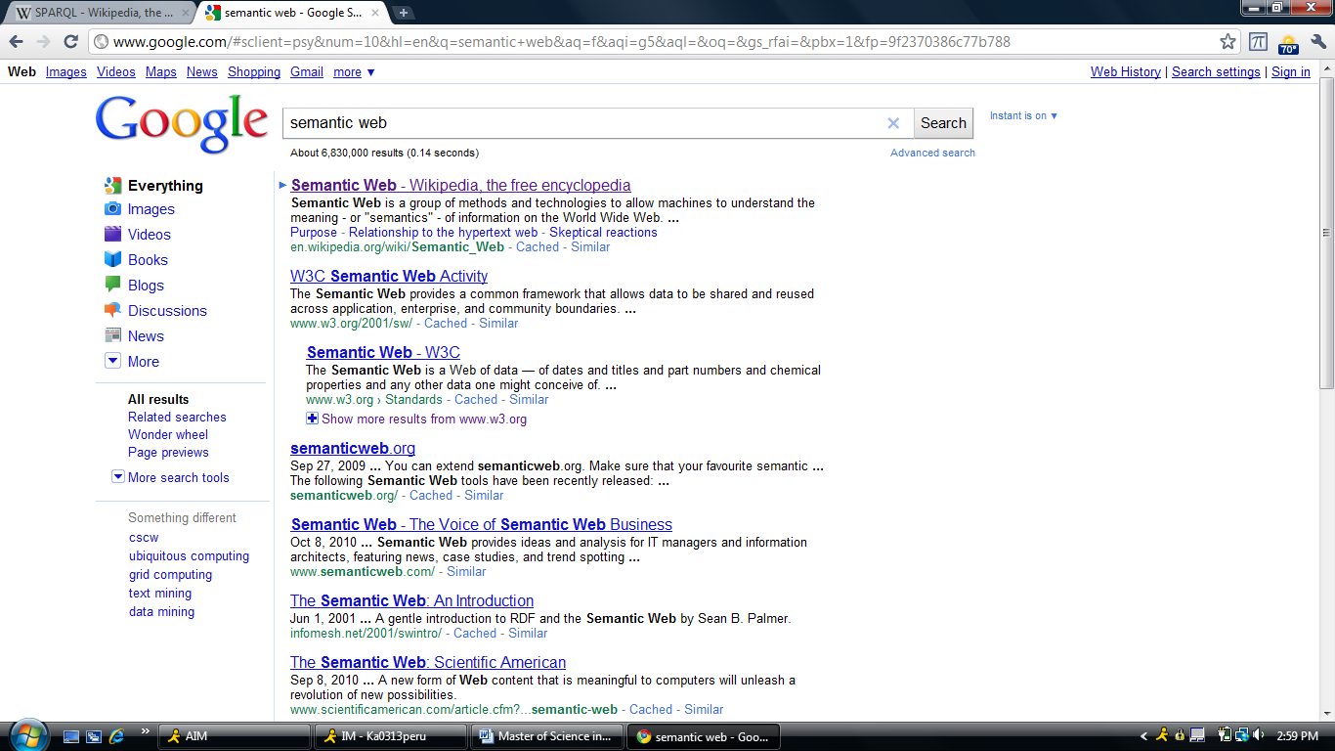
Figure 1: A standard Google search results page. This particular results page is for the term “semantic web.” [11]
By the early 2000s Google had established itself as the leading search provided in the world. Google serves nearly 67% of searches on the Web [12]. Their indexing method, named PageRank, aided search indexing by giving a weight to a webpage based on how many other pages link to it [13]. Google has succeeded at providing the best search experience. Their interface is clutter free, giving users only a search box and a button to initiate the search. Results are displayed in an easy to read list with the most relevant results returned first. This is in contrast to companies like Yahoo and AOL, which view themselves as “Web Portals,” offering more information and features outside of search.
Google has spent much of their effort attempting to create the most relevant first page of results. If users can find what they are looking for on the first page then there is little need for them to browse through dozens of search result pages. Google has also introduced new features to further improve the speed of their search engine. In 2004 they introduced Google Autocomplete, described in the next section, and most recently introduced Google Instant, which automatically updates the results page [1].

Automatic Query Suggestions
In 2004 Google introduced a feature named Google Autocomplete, which presents users with a popup containing a small subset of common search queries. The suggested queries that are returned are based on the search term a user has entered by typing [1]. Google Autocomplete updates this display in real time as a user continues to enter his or her search term. In Figure 2, below, you can see a sample Google Autocomplete popup for the term “semantic web.” Autocomplete has been significant for a number of reasons. Primarily, it sped up the search process by giving users the ability to choose from likely search queries before they had completed their own. Secondly, if a user is not sure of what he or she is searching for, Google Autocomplete provides helpful suggestions based on what the user has currently entered.

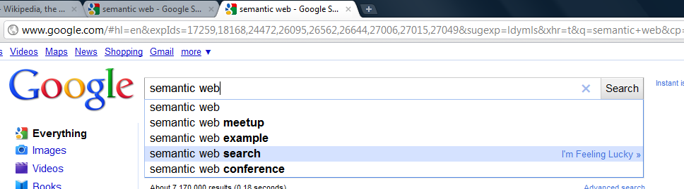
Figure 2: A Google Autocomplete window for the search term “Semantic Web.” [11]
Google Autocomplete works by providing suggestions based off of other user’s queries [1]. All suggested search queries were at some point entered by another user [1]. In this way, Google Autocomplete will stay up to date with relevant search queries. By providing users with a simple to use and incredible useful feature, Google made searching faster and more accurate. Other search engines soon followed suite, and search suggestions have become a standard feature in almost all search engines [1,3,4]. Additionally, products that include search functionality, such as YouTube, Wikipedia, and Gmail, provide a Google Autocomplete-like experience for search terms.

Ontologies
In philosophy, ontology is the metaphysical study of the nature of being and existence [9]. In computer science an ontology is much more concrete in nature; it is a rigorous and exhaustive organization of some knowledge domain that is usually hierarchical and contains all the relevant entities and their relations [9]. In layman’s terms, an ontology is a highly organized knowledge base that stores relevant data on some topic. Ontologies are used extensively in artificial intelligence, medical informatics, and semantic web research. Ontologies are made up of two primary pieces; concepts and relationships. Using these building blocks, an ontology can structurally represent many kinds of knowledge.

Concepts
Ontologies are built from concepts, which are (informally) order points of information that can be related to other pieces of information through various kinds of relationships [9]. Formally, a concept is an abstract or general idea inferred or derived from specific instances [9]. An oft-used comparison is to Object Oriented Programming; in OOP there are objects being instances of classes. In an ontology concepts are instances of some class. For example, Michael Jackson is an instance of Musician. Concepts are usually defined within the domain a given ontology covers.
Concepts have some unique identifier that distinguishes them from other concepts, which in many cases may be similar. For example, if there are two people named Michael Jackson who are singers, then there needs to be some way to uniquely differentiate one Michael Jackson from another. A concept may also store characteristics or qualities about itself; these are called attributes. Attributes are values that help to further define a concept.

Relationships
In an ontology, concepts are linked together using what are called relationships. A relationships represents a link between two concepts; it explicitly shows that two pieces of knowledge are related to each other. Relationships are often hierarchical in nature; they show that one piece of knowledge is more specific than another, much like a class inheritance tree in OOP. The set of hierarchical relationships generally forms either a tree structure or a directed acyclic graph of concepts that go from very specific to non-specific. For example, a Singer is a Musician, a Musician is an Artist, and an Artist is an Entertainer, and an Entertainer is a Person. This hierarchical structure can be used to classify concepts based on where they exist within the hierarchy. Figure 3, below, shows a small subset of the DBpedia Ontology’s class structure.

Person

Politician

Scientist

Artist

Actor

Musical Artist

President

Senator

Figure 3: A subset of the DBpedia Ontology Person Hierarchy. Classes are linked by hierarchical relationships. Concepts are instances of one of these classes [14].

A second type of relationship is the semantic relationship, or associative relationship. These non-hierarchical relationships link one concept to another concept, showing that two concepts are related in some way. This is in contrast to attributes, which are simply named data values stored within a concept. For example, a musician may play some kind of instrument, or play a specific kind of music. A visual example is provided in Figure 4 below. In an ontology of musicians, types of instruments will be stored as concepts. An instance of musician will have a “plays instrument” relationship to some instrument concept. These semantic relationships help further define a concept based on specific information on that concept.

Michael Jackson
Description:SingerBirthdate:1958-08-29 Death:2009-06-25
Musical Artist
Band
The Jackson 5
Company
Motown Records
record label
associated band
Figure 4: An example from the DBpedia Ontology. Michael Jackson is an instance of Musical Artist with attributes Description, Birthdate, and Death. Michael Jackson has semantic relationships “associated band” and “record label” to concepts “The Jackson 5” and “Motown Records,” respectively. [15]

DBpedia
DBpedia is a massive collection of data extracted from Wikipedia and other sources [6]. The DBpedia project was started in the late 2000s by Free University of Berlin and the University of Leipzig [6]. DBpedia currently stores information on more than 3.4 million things covering many domains, including people, places, and organizations [6]. Data is stored in a format named Resource Description Framework (RDF) [6,7]. RDF is a triple storing two entities and some relationship between those entities. In DBpedia the entities stored in this triple are either concepts or attributes. For example, the triple for the associated band attribute in Figure 4, above, would have the entities dbpedia:Michael_Jackson and dbpedia:The_Jackson_5, and the relationship linking them would be dbpedia-owl:associatedBand [15].
DBpedia contains over a billion of these triples in its dataset, a majority of which are non-English in nature, but roughly 257 million are from the English Wikipedia pages [7,8]. DBpedia is made up of various sources of information, including their own ontology (the DBpedia Ontology), YAGO (Yet Another Great Ontology), and Friend of a Friend (FOAF). DBpedia allows users to extract information from their dataset via a web-based SPARQL (SPARQL Protocol and RDF Query Language) interface or by downloading the entire dataset [7].

The DBpedia Ontology
In order to understand how the DBpedia Ontology was constructed, one needs to first understand how Wikipedia represents data on its pages. On many Wikipedia pages there is a box on the right side of the page, generally with pictures and with several relationship-attribute pairs, these are called Infoboxes. These Infoboxes are standardized in nature, such that a musician will have a Musician Infobox and a basketball player will have a Basketball Player Infobox. Each type of Infobox stores different kinds of information. A Musician Infobox will have information such as genres, record labels, and when they were born, while a Basketball Player Info box will have information such as what team the person plays on. In the DBpedia Ontology these information box types are treated like classes [7]. The DBpedia project organized these Infoboxes into a shallow hierarchical structure [7]. The class structure is only a few levels deep, but there are many instances of each class. Every page that contains an Infobox will be an instance of the class of the Infobox type on the page [7]. For example, Michael Jackson is a musician because he has a Musical Artist Infobox. Tom Hanks is an Actor because he has an Actor Infobox.

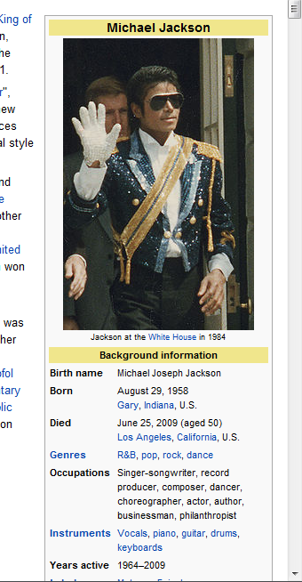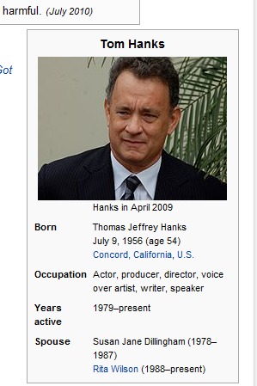
Figure 5: The InfoBoxes for Michael Jackson and Tom Hanks [16].
The DBpedia project extracts all of this Infobox data from Wikipedia pages and stores each page, plus the attributes and relationships within the page, in its dataset [7,8,9]. Pages are treated as concepts; since they have a type of infobox, they are an instance of the class associated with their Infobox’s type. Hierarchical data is derived from the class structure created by DBpedia. Semantic Relationships are obtained when an attribute in an Infobox is another Wikipedia page [7,8,9]. For example, in Figure 5 above, Tom Hanks’s has a Spouse attribute with a value Rita Wilson [16]. Rita Wilson has a Wikipedia page, so within the DBpedia Ontology is an instance of a class, in this case Actor [17]. There is a dbpedia-owl:spouse relationship between Tom Hanks and Rita Wilson [17]. Attribute values are obtained when the value of an attribute in an Infobox is not a Wikipedia page, such as birth date. Since the ontology is built off of Wikipedia, the DBpedia Ontology provides a large dataset that is reasonably well structured.

Yet Another Great Ontology (YAGO)
In addition to the DBpedia Ontology, DBpedia also includes the YAGO project’s ontology. YAGO, short for Yet Another Great Ontology, is another ontology project using Wikipedia as its starting point. YAGO is being developed by the Max Planck Institute for Computer Science. The project takes the category names of Wikipedia pages and matches them to instances in WordNet [18]. WordNet is a massive ontology of English language words managed by the Cognitive Science Laboratory at Princeton University, and has been supported by the National Science Foundation [18].
Nearly every page on Wikipedia is given a set of categories. For example, the Tom Hanks page belongs to the categories 1956 Births, Living people, American Film Actors, and American Film Directors [17]. These Wikipedia categories are semi-hierarchical in nature, but YAGO does not use this hierarchy. The YAGO project analyzes the categories of Wikipedia pages and maps them to WordNet classes, essentially making the Wikipedia category a subclass of a WordNet class [19]. Pages are then treated as instances of the classes created from their categories [19]. From the example above, Tom Hanks is an instance of AmericanFilmActors and AmericanTelevisionActors [17]. The categories American Film Actor and American Television Actor were created as subclasses of the WordNet class Actor (Id #109765278) [17].
In DBpedia, the YAGO categories are listed for any DBpedia resource (Wikipedia page) that has been mapped in YAGO. This forms a second ontology within DBpedia that contains information on pages that may not have an Infobox and therefore were not covered by the DBpedia Ontology. The YAGO Ontology is less organized than the DBpedia Ontology. YAGO has a number of issues; most importantly concepts may belong to a relatively large number of classes. This is in sharp contrast to the DBpedia Ontology, where every concept is an instance of exactly one class.

The Ontology Supported Web Search Project
The project described in this proposal will be an extension of current work done by Dr. Geller and his students [5]. The Ontology Supported Web Search (OSWS) project began in 2009. The project’s goal is to seamlessly integrate ontologies into web search for the purpose of providing improved search results [5]. The first part of the project integrated an ontology of five thousand American musicians, Basketball players, and Football players into a Google Autocomplete-like interface (see Figure 6 below) [2,5]. The interface provides users with helpful suggestions for entered search terms, similar to Autocomplete. However, instead of being based off other user’s previous queries, the suggestions were based off knowledge stored in an ontology [5].
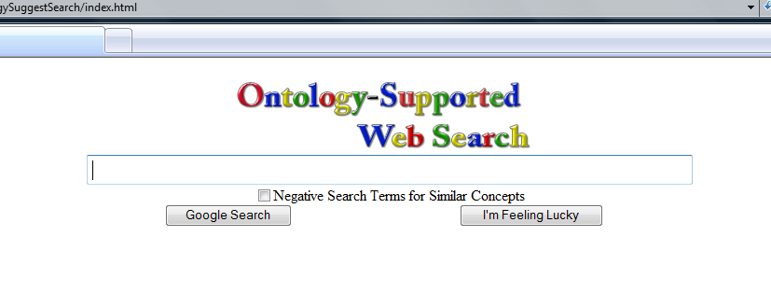
Figure 6: The Ontology Support Web Search interface [2].
There was also significant research done in support of this project during the Summer of 2010. Research was done on extracting search suggestions directly from Google and matching the suggestions to names. The discovery of DBpedia led to a shift in how the data used to build the OSWS Ontology was obtained.

Previously Completed Work on OSWS
While my proposal is focused on improving search results via an ontology, my work will be more of a continuation of work already completed in support of the OSWS system. To begin the OSWS project, a small ontology was built with the limited domains mentioned previously. The set of data, while limited, served as a proof of concept and provided the foundation for a usable system.
The first ontology was built from data extracted directly from Wikipedia [5]. As discussed previous, Wikipedia classifies each page into a variety of categories. When browsing to the page for a given category, a list of all the Wikipedia pages that belong to that category are displayed. These lists were extracted and the pages linked from them were parsed for useful information. This information was later entered into the OSWS Ontology and then used to generate search suggestions by the OSWS interface [5].
When a user entered a term into the OSWS interface (see Figure 6 above) he or she were presented with not only the suggested name, but also that person’s class and a set of attributes about that person, such as place of birth or the team they play on [2]. The ontology-supported suggestions would be more specific and remove ambiguity from search terms (see Figure 7). For example, there are three Michael Jacksons in the OSWS Ontology. One is the singer, another is a football player, and the last is a basketball player. By appending the class name (for example, singer) onto the end of the suggested name the search query will be more exact, giving better search results.
The OSWS interface we created used our suggested search queries to search Google itself; the suggested queries were forwarded to Google and an actual Google results page was displayed. Using this method it was perceived that search results are generally more relevant and closer to what a user was looking for [5].
This version of the OSWS project also introduced the idea of negative search term suggestions for concepts that were similar in nature [5]. For example, there are three people with the name Michael Jackson within the Ontology. In Google Autocomplete there is no context to what is being suggested. The Michael Jackson suggested by Google could be Michael Jackson the singer or Michael Jackson the football player. The OSWS tool inserts negative search terms into the suggestions, which further refines search results.
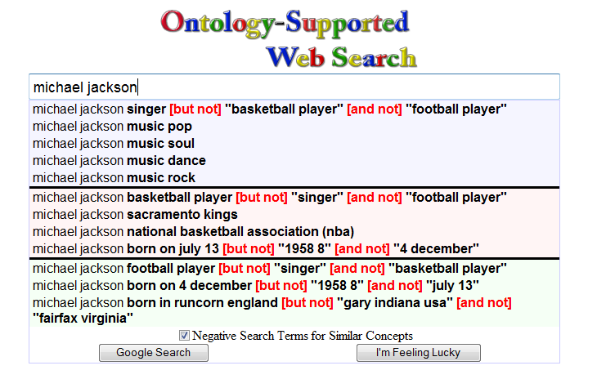
Figure 7: Negative search terms in the Ontology Supported Web Search [2].

Research Leading to This Proposal
This previous summer I became involved with the Ontology Support Web Search project. I implemented the aforementioned OSWS interface and implemented the functionality specified in the research paper. I then began research into expanding the ontology used within our system. Over the summer we extracted over half a million names from Google’s Autocompletion results. We searched for first and last names we obtained from US Census data and stored search suggestions that matched valid names.
We initially began by searching for only first names. They are suggestions that are returned once a user has entered an entire first name but no part of their last name. We classified these people as “famous,” or “The A-List,” because they are the first results for a given first name. The second phase was named “The B-List;” people who are returned as suggestions once a first name and the first letter of a last name have been entered. This list consisted of nearly 30,000 valid names. The final step was “The C-List,” which consisted of nearly half a million valid names returned from entering a first name and the first two letters of their last name.
After we obtained over half a million valid names from Google Autocomplete, we used a small subset of this data, roughly five thousand of the most “popular” names (The A-List) and determined how many of them existed within DBpedia. We assumed that since they were returned first by Google that we would be able to find information on them because they are popular. We were able to identify nearly four thousand people using this method; a majority of the valid names we obtained.
Once we identified who was a valid person, we again used DBpedia to find out what kinds of attributes we can extract about them. For example, we could find record labels for musicians, teams for sports players, and many other kinds of useful information. DBpedia was clearly a good source of information; it contained attributes and semantic relationships for thousands of people. However, initial research has shown that it is disorganized and nearly impossible to use for the purpose of search suggestions. Many of the attributes stored within DBpedia are not helpful for search suggestions, so we cannot simply extract all the attributes. For example, there are artist of semantic relationships to many of Michael Jackson’s albums, which we consider useful. But there is also data such as birthplace, Wikipedia comments, and Wikipedia abstract, which are not useful for search suggestions.
Additionally, while there is significant coverage by the DBpedia Ontology, not all people belong to the Ontology. There are many pages for people that do not have an Infobox. These people will likely be in the YAGO Ontology, but YAGO’s hierarchy does not fit into DBpedia Ontology’s. We found that we would have to map YAGO categories to DBpedia’s in order to have greater domain coverage.

Proposal for Improving the OSWS System
Based on this previous experience working on the OSWS, I have come up with a plan to not only use DBpedia as a starting point for the ontology being used in OSWS, but to also automate the process of further expanding this ontology. To accomplish this goal I have separated the project into three distinct phases.

Phase 1: Useful Data Extraction and Data Cleaning
The first phase of the project will take full advantage of the preliminary work and research I performed this summer. I will be using the subset of four thousand names we have identified within DBpedia to build an ontology about these people. Since we have already identified the people, their types, and their attributes, the first phase will involve analysis of the data extracted and identifying useful attributes and type information that we can use within our ontology. Essentially we will be extracting a subset of DBpedia and improving it significantly for use in our OSWS system.

Problems with DBpedia Information
A “cleaning” step for DBpedia data is necessary for a number of reasons. First DBpedia is massive; it contains large amounts of data and attributes. Unfortunately, many of these attributes are useless for the OSWS system. They are either too general (such as birth date), not relevant (such as WordNet type), or will not be useful for search suggestions (such Wikipedia data, like comments). The large majority of attributes fall into this category. By using statistical methods and an analytic approach I will identify which attributes are useful to specific classes of person.
Most analysis will be performed by querying a database with identified people and the relationships they have. One statistical method would be querying to see how many of what type of relationships a class has. For example, if 70% of actors have the attribute “starring,” then it will almost certainly be considered a useful attribute. In the event a useful attribute can not be identified statistically, I will analyze all attributes associated with a class. If through my analysis I identify a useful attribute, such as designer of for a musician, I will add it to the list of useful attributes. At this stage its ensured that our ontology for OSWS will only consist of attributes we believe to be useful to an end user.
A second issue with DBpedia is that while the DBpedia Ontology is large, it is not complete. If a person’s page does not have an Infobox then the information on that person will be limited. As a solution to this problem, YAGO provides its own classification system based on WordNet’s hierarchy. If a person’s YAGO category is a subclass of the WordNet Person class, then we know that the page on DBpedia represents a person, even if that page is not classified as a person in the DBpedia Ontology.
There are, understandably, large amounts of overlap between the DBpedia Ontology and YAGO. However, we identified roughly five hundred people in our subset that are in YAGO but not in the DBpedia Ontology. By using both ontologies we believe we’ll have greater domain coverage and will be able to include more people within our Ontology. To merge these two information sources together we have already begun the process of mapping YAGO categories to DBpedia Ontology Categories. This allows us to add people from YAGO into our ontology, which, as described in the next section, is based off of the DBpedia Ontology.

Expected Results of this Phase
To find useful information I will analyze the attributes we extracted from DBpedia. I will use statistical methods and analysis of our current data to identify useful attributes for different classes of people. For example, for a musician knowing the band, genre, and discography are useful pieces of information. For any kind of athlete we will need to identify the team they played on and their position. To identify this useful information I will analyze the types of relationships obtained from the previous research. If a certain percentage of musicians in our ontology have the “instrument” attribute, then it will be considered a useful attribute. Similarly, if I’m analyzing the relationships associated with the “Actor” class, if I notice a relationship that looks relevant, such as starred in, I will identify it as useful. By the end of this phase we should have a set of useful information about all of the categories stored in our ontology.
To merge the DBpedia and YAGO ontologies I will use automatic methods, such as string matching, to map between the two, but I will also have to perform manual work to match those that are more difficult to match. An issue that remains is many people in the YAGO ontology are mapped to the “Player” class. This is ambiguous, and doesn’t match to the specific kind of sport they play (i.e. Baseball Player). A possible solutions is to analyze the attributes and abstract to identify what type of player they are. We should hopefully have most categories within our subset mapped by the first phase. Once the mapping step is complete we will have greater domain coverage and will be able to classify more people within our subset.
Data collected from this step, including the data from DBpedia along with our mappings and important relationships, will be stored in a relational database. The database created in this phase will prove integral for the second and third phases of development. The automatic ontology extension mechanisms described in Phase 3 that will greatly evolve how the OSWS system works.

Phase 2: Building an Ontology from Famous People
The second phase of my project will involve building an ontology of “famous” people. The Famous Person Ontology will consist of the four thousand people we extracted from Google Autocomplete and then identified via DBpedia over the summer. I will use the attributes and mappings created in the first phase to build up our ontology. I will be using the “Person” sub hierarchy from the DBpedia Ontology as a starting point. The mappings from YAGO will allow us to expand this sub hierarchy, meaning it will contain more concepts than the equivalent subset in the DBpedia Ontology.
I will use the Ontology tool Protégé and its programming API to complete this phase. I have worked with it on my previous OSWS work and our base hierarchy is already in place, so this phase is essentially transferring data from a database and placing it within our Ontology. Once this phase has been completed and results verified, the ontology will be integrated into the OSWS interface I developed last summer.

Phase 3: Automating the Ontology Building Process
The third phase will be the most difficult and time consuming of the project; as it essentially automates parts of the processes covered in the previous two phases. If we can manually build a useful ontology out of our famous people subset, than semi-automation is the logical next step. Well built ontologies are often created by hand; concepts and their attributes are entered by humans one at a time. These ontologies are generally small and static in nature; containing only a couple hundred thousand concepts and are updated only when their creators release a new version. They are also difficult to maintain and often after an initial release an ontology will not have adequate support. Automatically generated ontologies, such as DBpedia and YAGO, contain large amounts of data that is extracted automatically. Unfortunately, it is poorly organized and often difficult to use.
At this phase I propose a system to automate the process of adding new concepts and relationships to the ontology. Using the mappings, attributes, and relationships I obtained in the first phase of my project, I will implement a method of automatic extraction of data from DBpedia. Using the previously identified class and attribute information from DBpedia will allow us to extract similar information every time a new person must be added to the ontology. Ideally, the system will take a name and then query DBpedia. If a valid page exists, then I the program will extract the information we have previously deemed useful.

Obtaining New Names
Since our ontology will start with the four thousand famous people identified via Google search suggestions, I will be using the same method to identify new people. I will integrate the Google Autocomplete API into the OSWS middleware and extract new suggested names from the suggested completions. When a user enters a name into the OSWS interface, it will query Google and get Autocomplete suggestions. If any one of those suggestions is a valid name, I will then query DBpedia and see if a page with the same name exists. If a page does exist and has a class that exists within our Ontology, I will use an automated method to extract the information we deemed useful for the class in Phase 1. Once useful information has been extracted, the information will be stored in the database created earlier. Afterwards, the data will be inserted into our Ontology as related to a new Concept. Finally the name and attributes will potentially be returned as one of the suggestions for the given query and all future queries. The state diagram for this process can be viewed in Figure 8.

User Enters
Name in OSWS
Get Google
Suggestions
While
Google
Suggestions
Left
Suggestion
In Ontology?
Yes
Suggestion
Valid Name?
Yes
Yes
No
Query DBpedia
No
No
Get Suggestions
From Ontology
Select Top 4
Suggestions
Sort Top 4
Suggestions
Return
Suggestions
Valid Page
Exists?
No
Add Person
to Ontology
Yes
Figure 8: The automation process for expanding the Person Ontology used in OSWS.

Phase 4: Interface for Automatically Building Ontology
Since the expanding ontology will be based off of the knowledge gained in the first and second phases of the project, finding mappings and useful attributes within our four thousand person subset, it is inevitable that a type we have not classified will appear at some point in the future. Additionally, new types and attribute types may be added by future versions of DBpedia. To account for these potential changes, I will store type and attribute information for all new concepts that are added to the ontology. The data will be stored in the database mentioned previous.
Assuming the first three phases are successful and there is time left, the fourth and final phase of the project will be the construction of an interface to analyze this data. The interface will identify unmapped YAGO types, new attributes types, and other potentially useful information that has not yet been integrated into our ontology building process. Any changes implemented within this interface will propagate to all new concepts that are added into the person ontology.

Conclusion
In this proposal I outlined how I intend to expand upon the OSWS system. I will use the data I obtained over the summer to find useful attributes and mappings and turn this data into an Ontology. Afterwards I will implement functionality to automate the ontology building process. This will allow OSWS to obtain information on new people dynamically, which will improve search results for future users. In the final phase I will create software to manage new, unorganized data. The interface of this software will allow users to look for new and useful attributes and easily make changes to the ontology building process.
The intended end result is a system that will improve search suggestions via a dynamically growing ontology. By integrating my new ontology into the OSWS front end, I hope to show that by removing ambiguity from search suggestions, better search results are obtained.

Project Deliverables

Systems
For this project I will deliver the following systems which support the OSWS project:

- A database consisting of valid attributes, mappings between DBpedia Ontology and YAGO, and data extracted from DBpedia.
- The ontology created in phase two of this project, consisting of the four thousand people identified via Google Autocomplete and the data extracted from DBpedia.
- Improved OSWS system that works as described in phase three. Extracts data from Google, queries DBpedia, and then adds new people to our Ontolgoy. The ontology created from this will also be delivered.
- Interface that will identify unmapped types and attributes that have not yet been deemed useful or not useful.

System Modules
The software systems developed for this project will consist of a number of modules. Each phase will take advantage of work completed in a previous phase, so these modules can be expected to be modified extensively throughout development.
Module 1: googleSuggestionRetriever()
Input: A string containing a search term
Output: A list of strings containing the Autocomplete suggestions for the given string from Google.

This module will use the Google Autocomplete API and retrieve search suggestions for the search term passed into the module. Data will be parsed from the XML returned from the API.

Module 2: validNameIdentifier()
Input: A list of strings that may be valid names
Output: The set of strings which are classified as valid names.

This module will use US Census data to determine if a string is a properly formatted name. I.E. it has a valid first name, possible middle initial, and valid last name. If a name is valid it will be returned in the set of results.

Module 3: validPersonIdentifier()
Input: A list of strings that may be people.
Output: The set of strings which are classified as people according to DBpedia and their class name.

The valid person identifier will query DBpedia’s SPARQL interface and return the set of strings which are classified as either dbpedia-owl:Person or yago:LivingPeople within DBpedia. Returns the rdf:types of the identified person.

Module 4: attributeRetriever()
Input: A string which is an identifier person’s name and their class.
Output: The set of useful relationship – attribute pairs associated with this person from DBpedia.

This module queries DBpedia based on the given person’s type. The previously identified useful relationship values will be retrieved from DBpedia and returned as a set of valid attributes for the person.

Module 5: insertIntoOntology()
Input: A name, type, and set of attributes/relationships for a valid person
Result: After this module has been run, the name will be inserted into our ontology as an instance of type.

This module will take previous collected data and insert it into our Ontology. The name will be inserted as an instance of its previously identified class. Attributes will be loaded into the instance, and if there are valid relationships (such as what instrument a musician plays), that data will be inserted into the Ontology as a concept as well.

Module 6: Automatic Ontology Building
Input: User search term from OSWS interface
Result: New suggestions will be added the Ontology based on the suggested results from Google Autocomplete.

This module will incorporate all of the above into a single system. Search terms will be entered into the OSWS interface by a user. I will then retrieve Google’s suggestions, determine if there are any valid names, identify if the name is a person, and then query relevant data from DBpedia. Once information has been retrieved on a name, useful data will be loaded into our Ontology.

Module 7: Ontology Builder UI
The final module is a web page or application developed to allow users to analyze data that has been collected on new additions to the Ontology. It will display potentially useful relationships and attributes that are missing from a type. The interface will also display unmapped YAGO categories and classes with few attributes.
Time pending, I will also implement the ability to update the Ontology building procedure from this interface. This will allow further expansion of the OSWS system based on new versions of DBpedia and identification of new types.

Project Timetable
Week | Goal
Week 1 | Begin analysis of extracted types and attributes. Begin mapping from YAGO to DBpedia-OWL, begin saving useful attributes for DBpedia-OWL types. Modules 1, 2, and 3 will be used extensively.
Week 2 | Continue analysis and finalize all mappings and useful attributes. Learn how to add concepts within the Protégé API. This will form the basis for Module 5.
Week 3 | Using the data extracted and the names identified, add all concepts into our ontology. Module 5 will be used to insert names as concepts in our Ontology.
Week 4 | Using the attributes we deemed as useful, extract values from DBpedia when possible and add them to our ontology as attributes. Module 4 will be used to retrieve attributes and Module 5 will insert them into the Ontology.
Week 5 | Quality test ontology that was built, making sure data is complete and correct.
Week 6 | Integrate all software used until this point for the automation process. Ideally the automation will be done by a single program whos parts are made up of the programs used to extract and analyze data in the previous steps. Involves Modules 1-5, and forms the basis for Module 6.
Week 7 | Implement automatic extraction of information from Google suggestions. Update to Module 1.
Week 8 | Implement automatic insertion of concepts into our ontology. Involves identify the type a person is an inserting them in proper location. Updates to Modules 2, 3, and 5.
Week 9 | Implement automatic insertion of attributes into our ontology. Extract the attributes of a person from DBpedia and dynamically insert that data into our ontology. Updates to Modules 2 and 5.
Week 10 | Quality test ontology that has had automatic suggestions generated.
Week 11 | Bug testing and fixing of automatic addition bugs. Updates to Module 6.
Week 12 | Begin developing an interface for unmapped types and unused attributes. This will make adding new types and attributes easier in the future. This is the start of Module 7.
Week 13 | Continue work from week 12. Continued work on Module 7.
Week 14 | Begin work on final report and bug testing.
Week 15 | Finish final report and complete all bug testing.

References

[1] “Autocomplete: Features.” Internet: http://www.google.com/support/websearch/
bin/answer.py?hl=en&answer=106230, [October 15, 2010].
[2] “Ontology Supported Web Search.” Internet: http://osws.njit.edu, June 2010* [October 15, 2010].
[3] “Yahoo Search Assistant.” Internet: http://tools.search.yahoo.com/newsearch/
searchassist.html. [October 15, 2010].
[4] “Bing Search Suggestions.” Internet: http://help.live.com/help.aspx?project=
wl_searchv1&querytype=keyword&query=tseggusotua&mkt=en-US. [October 15, 2010].
[5] Tian Tian, James Geller, Soon Ae Chun: “Improving Web Search Results for Homonyms by Suggesting Completions from an Ontology.” In: 2th International Workshop on
Semantic Web Information Management - SWIM 2010 (2010).
[6] Christian Bizer, Jens Lehmann, Georgi Kobilarov, et. al.: DBpedia – A Crystallization Point for the Web of Data. Journal of Web Semantics: Science, Services and Agents on the World Wide Web, Issue 7, Pages 154–165, 2009.
[7] Christian Becker: DBpedia – Extracting structured data from Wikipedia. Presentation at Wikimania 2009, Buenos Aires, Argentinia, August 2009.
[8] Christian Bizer et al.: DBpedia – Querying Wikipedia like a Database. Presentation at WWW2007.
[9] “WordNet Search – 3.0.” Internet: http://wordnetweb.princeton.edu/perl/
webwn?s=ontology. [October 15, 2010].
[10] “A Brief History of Search Engines.” Lee Underwoord. Internet: http://www.webreference.com/authoring/search_history/. August 18, 2004* [October 15, 2010].
[11] “Google.” Internet: http://www.google.com/. [October 15, 2010].
[12] “Google Search Share Up After Instance, Yahoo Down After Bing Transition.” Danny Sullivan. October 13, 2010* [October 15, 2010].
[13] “Corporate Information – Google.” Internet: http://www.google.com/corporate/
tech.html. [October 15, 2010].
[14] ”DBpedia Mappings.” Internet: http://mappings.dbpedia.org/server/ontology/classes. [October 15, 2010].
[15] ”About: Michel Jackson.” Internet: http://dbpedia.org/page/Michael_Jackson. [October 15, 2010].
[16] “Wikipedia.” Internet: http://www.wikipedia.org/. [October 15, 2010].
[17] ”About: Tom Hanks.” Internet: http://dbpedia.org/page/Tom_Hanks. [October 15, 2010].
[18] Fabian Suchanek, Gjergji Kasneci, Gerhard Weikum: “YAGO: A Core of Semantic Knowledge Unifying WordNet and Wikipedia.” In: WWW2007 / Semantic Web Track. May 12, 2007* [October 15, 2010].

