CS 700B
Master’s Project Report

COMMUNITY BASED FLOOD MANAGEMENT SYSTEM USING WEB 2.0

Submitted to the
Department of Computer Science
College of Computing Sciences
New Jersey Institute of Technology

In Partial Fulfillment of
The Requirements for the Degree of
Master of Science
By

Elangovan Anbalahan
ea39@njit.edu
NJIT ID – 21663799

Project Advisor: Dr. James Geller
Project Number:

1. Approval by Project Advisor.

Project Advisor: Dr. James Geller
Signature: _______________
Date: _________

- Approval by MS in CS Committee.

Project Number:
Submission Date:
Project Evaluation:
(By Graduate Advisor / Committee)

Date:
Signature:

3. I hereby affirm that I have followed the directions as published in the program web page http://cs.njit.edu/~mscs/ and I confirm, that this report is own personal work and that all material other than my own is properly referenced.

Student’s Name: Elangovan Anbalahan
Student’s Signature:
Date:
Acknowledgement
Working on this project has been a great learning experience for me, one that will surely help me in the future. Dr. Chun and Dr. Geller have been excellent project guides who encouraged me to work on new technologies. Without the support of these people, the project would not have materialized.

ABSTRACT

The Meadowlands are the most fertile region in North East America. The Storm Surge warning System (SSWS) project is dedicated to protect the Meadowlands from getting flooded. The Meadowlands consist of roughly 8,400 acres (34 km²) of open, undeveloped space in addition to the vast developed areas that previously were part of the natural wetlands. Once written off as wasteland, the Meadowlands are now experiencing a renaissance thanks to the conservation efforts of the New Jersey Meadowland Commission (NJMC) [1].
Members of MERI (Meadowlands Environmental Research Institute), have developed a flood warning system, which periodically reads Storm Surge Data from the NOAA Website. Whenever these readings reach to a particular threshold value, the SSWS system generates warning messages and sends it automatically to listed subscribers. These alerts enable the subscribers take necessary action in case of such emergencies. Although these alerts go to government officials, there is no communication channel aimed directly to pass this important information to common citizens.
In this thesis, we have developed a participatory model of flood management and an implementation of this community based flood management system using WEB 2.0 technologies, which aims at making the concerned citizens aware of these information updates. This system enables citizens not only to receive flood warnings via various WEB 2.0 tools like emails, twitter, mobile messages etc but also to post and share the flood situations and resources. Specifically, the system has features, such as twitter based automatic flood alerts that can be shared by any citizen, crowd sourcing features such as a resource sharing tool, via which the concerned citizens can register and share their voluntary citizen expertise, services and resources that can be used in case of flood emergencies, as well as a flood situation awareness tool where citizens witness accounts on flood incidents can be posted and shared. The system also has a forum/community page, through which users can share any information and post/participate in any discussion topics.

Table of Contents
1. INTRODUCTION 6
2. PREVIOUS WORK 10
2.1 STORM SURGE VALUE IS CALCULATED AND UPDATED 10
2.2 LOCAL WATER LEVEL PREDICTIONS 12
2.3 LOCAL WATER LEVEL MONITORING – OBSERVATIONS 12
2.4 FLOOD WARNING NOTIFICATION SYSTEM 13
2.5 AGENCY SUBSCRIPTION MODULE 15
2.6 LIMITATIONS 16
3. CROWDSOURCING FOR NEW JERSEY MEADOWLANDS FLOOD WARNING COMMUNITY 17
3.1 FLOOD WARNING COMMUNITY PORTAL: NJMFWC 18
3.2 TWITTER-BASED FLOOD WARNING DISSEMINATION 19
3.3 USHAHIDI-BASED CROWDSOURCING TO REPORT AND SHARE FLOOD INCIDENTS 23
3.4 CROWDSOURCING TO SHARE VOLUNTARY SERVICES AND RESOURCES 30
3.5 KUNEA: FLOOD NJ FORUM 41
4. LITERATURE REVIEW 44
5. CONCLUSIONS 45
REFERENCES 46
APPENDIX A: SOURCE CODE 49

INTRODUCTION

Low-lying coastal, residential and industrial areas are of great concern to emergency managers because of their susceptibility to tidal flooding and sea level surges. Floods from sea surges have caused great loss of lives over the years [2]. According to the Federal Interagency Flood Plain Management Task Force, 1996 sea surges have caused greater damage to life and commodities in USA than all other natural hazards combined. The New Jersey Meadowlands District (District) is located in a low-lying flat glacial valley of the lower Hackensack River where the average elevation is 1 foot above the high water mark (see Figure 1). Not only does it serves as a major transportation corridor between New Jersey and New York for thousands of commuters, it houses over 5100 homes and over 2100 commercial and industrial buildings (According to Federal Emergency Management Administration-FEMA).

The New Jersey Meadowlands Commission (NJMC) is a zoning, planning and regulatory body established by the State of New Jersey to protect the environment, manage solid waste disposal and provide for the orderly development of the Meadowlands District. The mission of the NJMC to protect the environment of the Hackensack Meadowlands is similar to that of other entities established throughout the U.S. to protect waterways and other natural resources. What differentiates the NJMC is:
1. Its multi-faceted legislative mandate which includes providing for orderly economic development and solid waste management as well as protecting the environment in the district.
2. Its top-down zoning and regulatory authority to direct change and manage policy in a specific geographic area across the environment-development-solid waste spectrum.

NJMC emphasizes the following main aspects:
1. Preservation of the environment,
2. Solid waste management,
3. The orderly development of the Hackensack Meadowlands.

The population in the Meadowlands area has increased rapidly and the economy has grown and diversified. Population and economic growth however also have brought environmental problems which increased exponentially when companies routinely dumped their raw sewage and refuse into and near the Hackensack River.

NJMC is focusing on various aspects by virtue of which the Meadowlands can be protected and developed. One of the main aspects involves protecting the environment and keeping the lands fertile, which is the main focus of our project [2].

Floods from sea surges have caused a greater loss of life and property and have devastated more families and communities in the United States than all other natural hazards combined [18]. The New Jersey Meadowlands District (District) is located in a low lying flat glacial valley of the lower Hackensack River where the average elevation is only one foot above the high water mark. It also serves as a major transportation corridor for thousands of commuters between the New Jersey and New York City metro areas. According to the Federal Emergency Management Administration [19], there are 5,100 homes and 2,100 commercial and industrial buildings in the 100 year flood plain. During Tropical Storm Floyd in September 1999, FEMA reported that 7,410 people were evacuated from district properties, 1,722 were displaced and 2,042 were sheltered [20]. The District consists of 14 Municipalities and each, with their limited resources, independently oversees flood prevention structures. They are assisted by a regional planning agency (NJMC) that maintains ditches and collaborates with other agencies in emergency repairs of tide gates. An extensive network of drainage ditches constructed during the 1930’s for mosquito control [21] drain water away from buildings and populated places, however, under sea surge conditions, these same ditches bring in flood waters. The NJMC’s Geographical Information System has information regarding the overall lay out of the ditch network, their elevations and their proximity to buildings and populated areas. If we add to this a reliable sea surge warning system from NOAA, then all the information needed to build a flood warning system already exists. In the absence of a national warning system strategy [8], we set out to develop a local sea surge warning system that can be easily installed and maintained and can inform emergency managers about specific properties and infrastructure at risk of flooding at least three to six hours in advance.

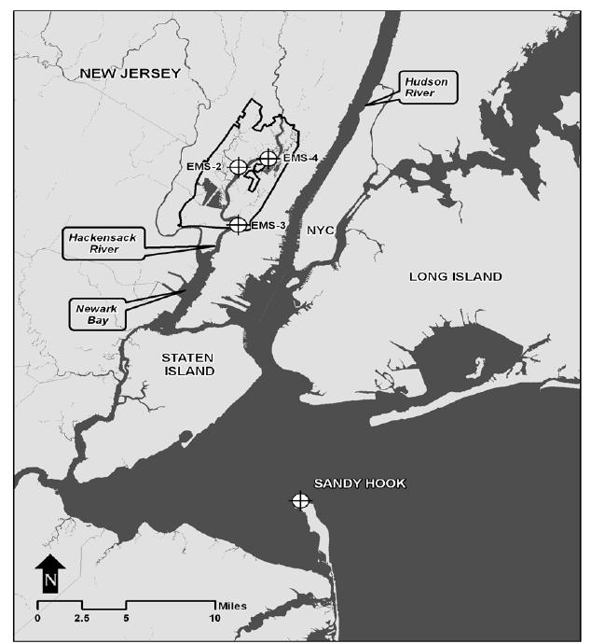
Figure 1: NJMC District boundary and the location of the water depth monitoring stations along the Hackensack River (EMS2, EMS3 and EMS4). Also shown is the Sandy Hook location where NOAA models predict ocean surge water levels [3].

PREVIOUS WORK

NJMC developed a Web-based Flood Warning system to monitor the tide data at the Hackensack River, Amtrak Rail Road, and Swing Bridge area based on NOAA’s New York control point. In addition, the storm surge level data is monitored at the Sandy Hook, NJ station, which is also provided by NOAA. The graphical data from the NOAA site is imported into the NJMC Web pages and provides visual monitoring capabilities of the tide and surge information. NJMC also set up 14 control points throughout the Meadowlands area for floods. Engineers and field workers were dispatched to measure the flood levels and incidents in these positions and kept track of the flood events through Web based interface data were stored in the “flood event database.” In case that a flood event is imminent according to tide and surge data, a warning message was entered through the NJMC Web site, and sent out to the subscribers that include emergency management personnel at each local municipality, e.g. fire chiefs, municipal Commissioners, etc. [5].

STORM SURGE VALUE IS CALCULATED AND UPDATED

Storm Surge Values are observed at Sandy Hook, New Jersey. Based on a prediction model, the NOAA Website updates observed and predicted value at Sandy Hook every six minutes.

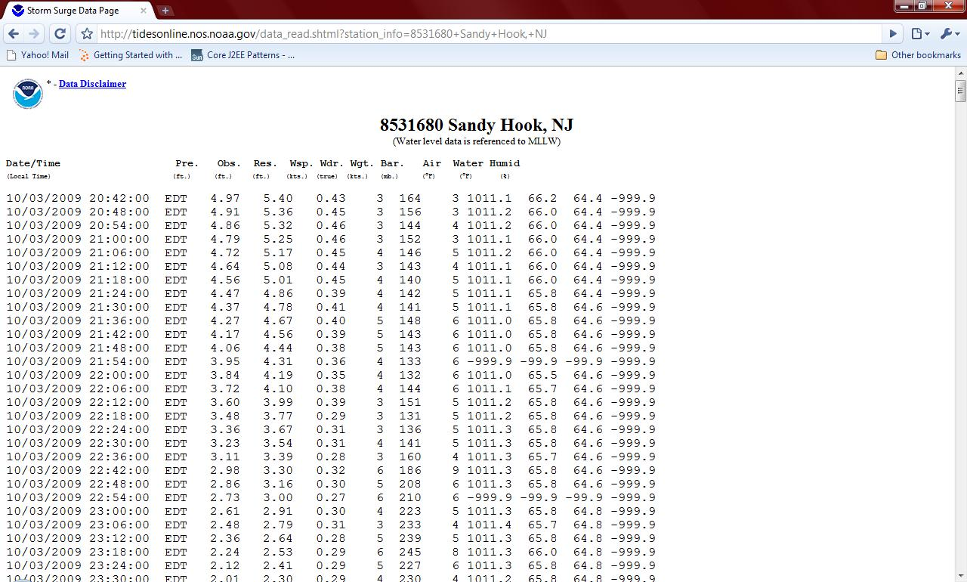

Figure 2. Tide Information Website [6]

This Website has the date and precise time of recording those data. It has a predicted value, observed value, the residual that is the difference of observed value and predicted value. These three values are the most integral part of this model that determines the work of the warning system. For a sound and accurate model its entire credibility depends on the residual value. The lower the residual value the better is the model because then it would mean that model is calculating the correct value.

LOCAL WATER LEVEL PREDICTIONS

MERI recently developed a storm surge extractor program, which periodically extracts predicted and actual storm surge levels from the NOAA Website. The NOAA Web page is updated every six minutes with the latest and predicted surge levels on various stations across New Jersey.
The Extractor system shows the observed and predicted values at Sandy Hook surge monitoring station. Based on a mathematical prediction model it then calculates predicted value of the storm surge at Kearney, Berry’s Creek, Mills Creek and Sandy Hook station. Figure 3 shows a sample page.
The prediction model for a local predicted water level is based on conversion factors; these can be changed from this page. These variables are responsible for calculating predicted storm surge levels at Kearney, Berry’s Creek, Mills Creek and Sandy Hook. Local level conversion factors are based on the distance from Sandy Hook and the elevation levels of the local areas [12].

LOCAL WATER LEVEL MONITORING – OBSERVATIONS

The actual observed water levels at the NJMC areas are captured through the three monitoring stations stationed at Kearney, Berry’s Creek, Mills Creek and Sandy Hook. These predicted and observed values of storm surge levels at Kearney, Berry’s Creek, Mills Creek and Sandy Hook are captured in a database every 60 minutes [12].

FLOOD WARNING NOTIFICATION SYSTEM

When the surge level exceeds a threshold value, the system automatically generates email alerts and sends them to the list of subscribers. The alert message contains information regarding the observed and predicted surge level at one of the four locations. This enables the emergency managers to take appropriate actions to save the situation.

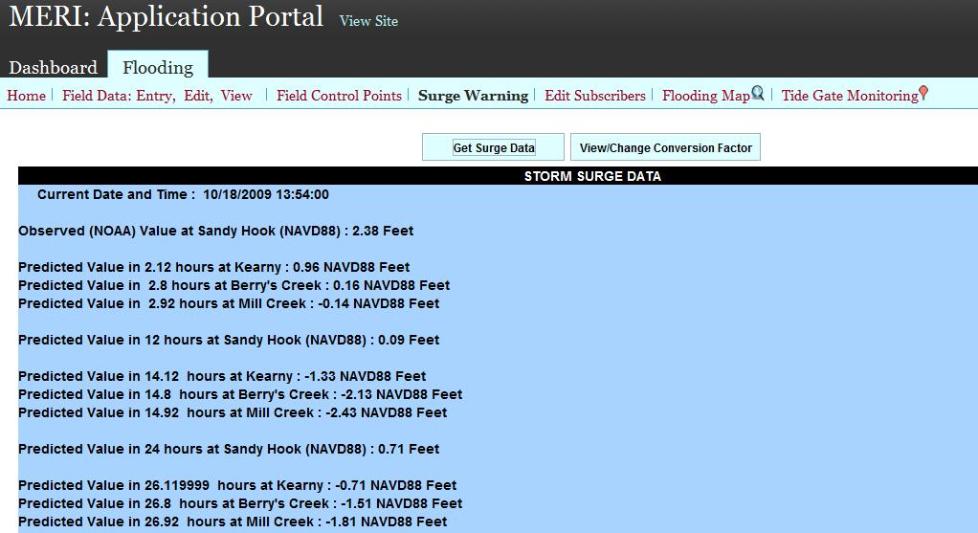

Figure 3: Storm surge data extractor webpage shows observed data extracted from NOAA Website, and predicted surge values at various locations [7].
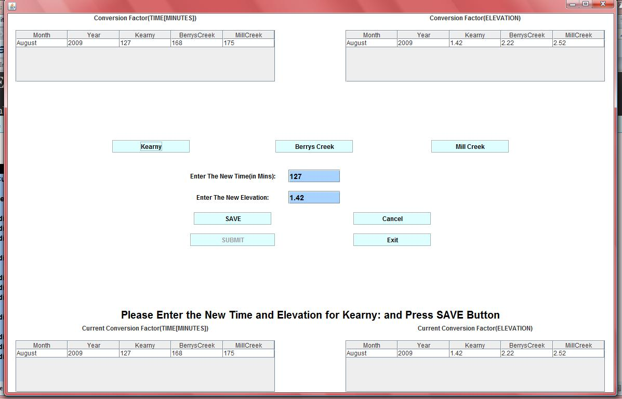
Figure 4: Time and elevation modification page [7]

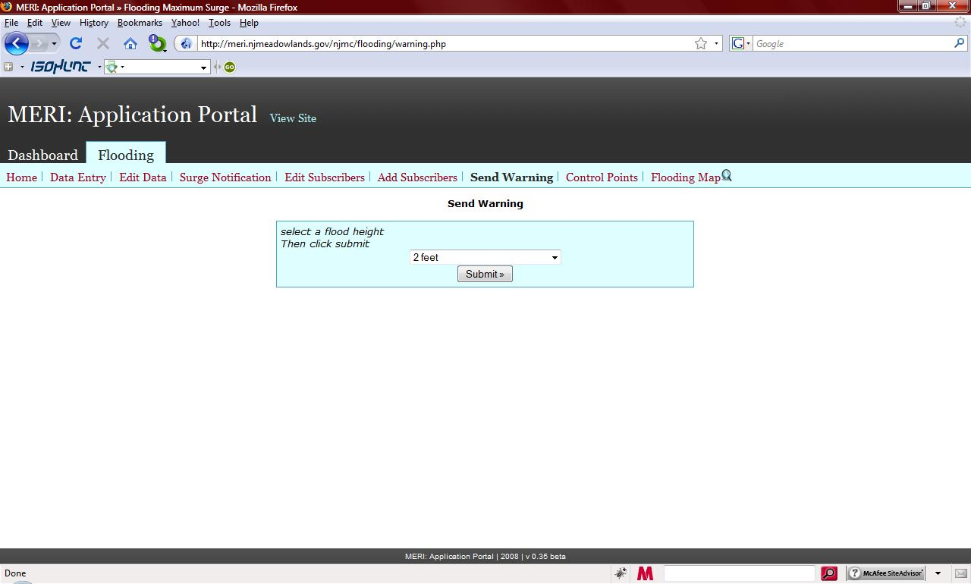
Figure 5: Send warning page [8].

AGENCY SUBSCRIPTION MODULE

The subscribers are emergency managers in the municipal governments within the NJMC area, and MERI Website Administrators. The system continuously monitors the storm surge level and the subscribers get automatically notified by storm surge warning via email alerts (Figure 5). The Administrators have the ability to add, edit and remove subscribers.

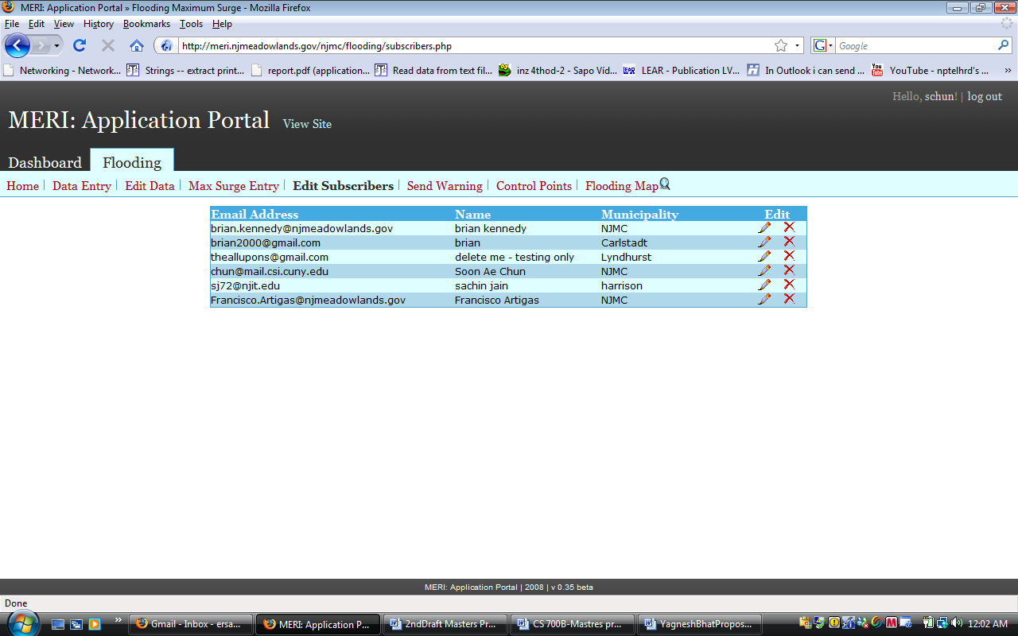

Figure 5: Information of Subscribers is edited shows list of subscribers and icons in each row is used for editing and deleting the subscriber [9].

LIMITATIONS

Although this flood warning system provides an enormous tool for flood management decision makers, the system is mostly for the government officials only. There is no citizens’ role or participation in this flood management and early warning system. The citizens are left to rely on the traditional notification through radios or TV’s, and do not directly benefit from the local flood monitoring tools. The citizen’s resources such as their assets such as boats or trucks or their expertise are not exploited in this platform. We consider that the citizens should be notified as early as possible for the impending flood and play an active role in flood management by providing their resources, instead of resorting only to the government resources. The collaborative aspects of the citizens are the focus of this study that may address some of these limitations.

CROWDSOURCING FOR NEW JERSEY MEADOWLANDS FLOOD WARNING COMMUNITY

The New Jersey Meadowlands Flood Warning Community Project (also referred to as NJMFWC) is aimed at disseminating flood warning alerts through various popular Web tools like email, twitter messages, discussion forums, etc. These are the Web tools that people use on a daily basis to get information and they have become part of everyone’s lifestyle. This project is aimed at seamlessly integrating flood warning alerts into their day-to-day activities. This is an important aspect as well as a distinctive feature, which separates the NJMFWC from other existing systems. Citizens do not have to make an effort to get or pull such information from a specific source; rather the information comes to them automatically using automatic feeds and alerts.
The project also provides a Web platform wherein registered citizens can share their voluntary services and equipment that they can offer during flood emergencies. This will be available to everyone in the forum. During emergencies, this information can be very useful. Citizens do not have to solely depend on governmental agencies for flood relief; often there may be people around who can provide help faster. This is another distinctive feature of the developed system. Government agencies and citizens of the region can equally benefit from such a framework.
The NJMFWC is aimed at making the concerned citizens aware of flood related information updates. Major features of the system include, the Flood NJ Twitter page that gets the latest warning messages generated by the NJMC, the Flood NJ Forum via which users can post and participate in discussion topics, the Resource Sharing feature that enables citizens to see voluntary services and equipment that are available near them, the Report an Incident feature wherein users can post any incidents and incident-related information (e.g. flood damage pictures) that they have witnessed or have knowledge of, which they want other citizens to know about. These resources are location-aware, so the GIS-based resource sharing enhances the situation awareness and location-based sharing.

FLOOD WARNING COMMUNITY PORTAL: NJMFWC

The NJMFWC is a Website (Figure 6) that is dedicated to forming a community of citizens in and around the New Jersey's Meadowlands region, who can contribute towards better emergency preparedness and management before and during flooding.
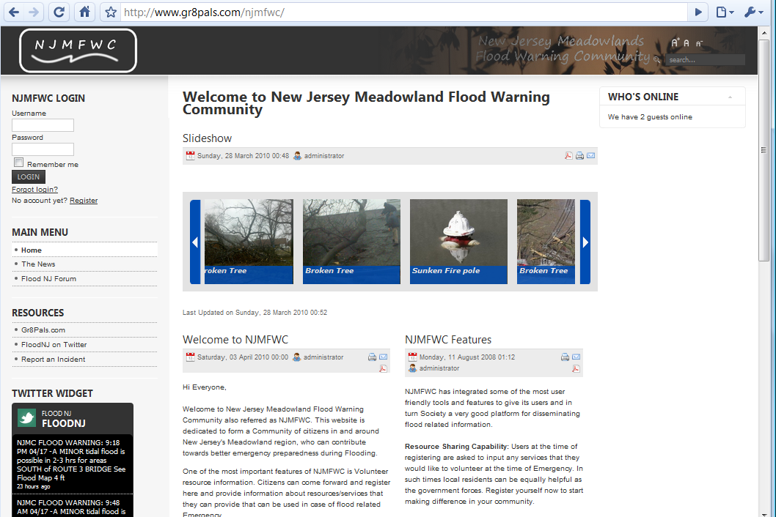
Figure 6: The NJMFWC Home Page.
The following are the features of NJMFWC:
- Joomla Content Management System to manage flood-related information sharing portal.
- Twitter to disseminate and share the flood warnings to large group of interested people.
- USHAHIDI to report and share the flood incidents to enhance the flood situation awareness.
- Volunteer Services and Resource Sharing to register, search and notify available: services and resources.
- Kunea Forum to discuss and share flood related information.
The NJMFWC is developed using Joomla [14]. Joomla is one of most popular content management system (CMS), which enables users to build Websites and powerful online applications. A content management system is software that keeps track of every piece of content on a Website. This is like a local public library that keeps track of books and stores them. Many aspects, including its ease-of-use and extensibility, have made Joomla the most popular Website building software available. Joomla is an open source solution that is freely available. Joomla can be installed manually from source code on a system running a Web server which supports PHP applications [16].

TWITTER-BASED FLOOD WARNING DISSEMINATION

Twitter is a social networking and micro blogging service that enables its users to send and read messages known as tweets. Tweets are text-based posts of up to 140 characters displayed on the author's profile page and delivered to the author's subscribers who are known as followers. Twitter has very fast become a convenient way of sharing information and updates and also has become very popular among users.
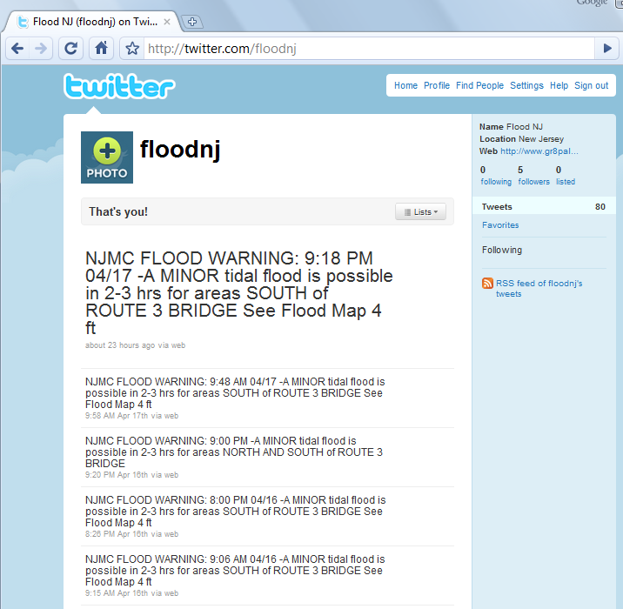
Figure 7: The FloodNJ Twitter Home Page.

We have set up the FloodNJ Twitter page http://twitter.com/floodnj (Figure 7) that gets automatically updated with new tweets, every time that NJMC generates flood warning messages by flood warning component [12]. These messages warn users of flood situations 3-6 hours in advance. Any user following the FloodNJ on Twitter will get automatically updated via tweets on their Twitter account.
Apart from seeing the tweets on the Web, users can choose to receive Twitter updates on their mobile phone, usually by paying a service fees to their respective mobile subscribers.

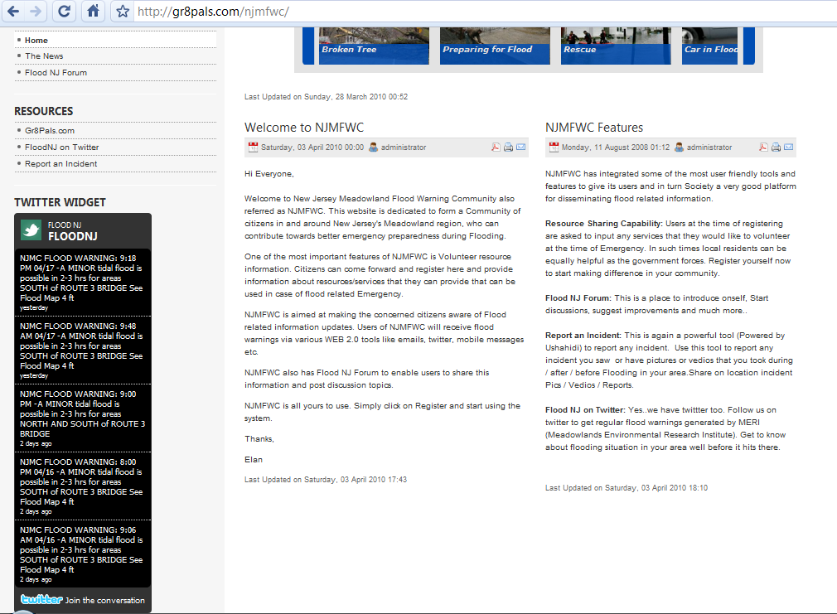
Figure 8: Twitter module on the NJMFWC home page.

The most recent Twitter messages on the FloodNJ twitter page can also be seen at the NJMFWC Website under the main menu (Figure 8). Users can click ‘Join the conversation’ at the bottom of the module to start following the FloodNJ on Twitter.
The Twitter Module on the NJMFWC home page (Figure 9) lets you see the latest five messages posted on the FloodNJ Twitter page. This module is present at every page of Website under the main menu.

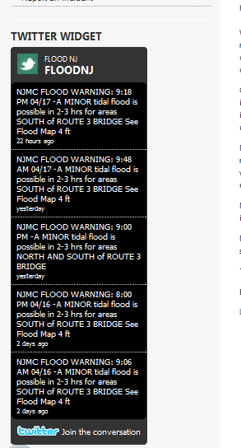
Figure 9: Closer View of the Twitter module that shows five most recent tweets.

USHAHIDI-BASED CROWDSOURCING TO REPORT AND SHARE FLOOD INCIDENTS

The Report an Incident Web page on the NJMFWC is another powerful Web tool for the users via which they can share any incident that they have witnessed or have knowledge of, which they want the community to know about (Figure 10). This Web tool is powered by USHAHIDI [13]. USHAHIDI means testimony in Kiswahili.
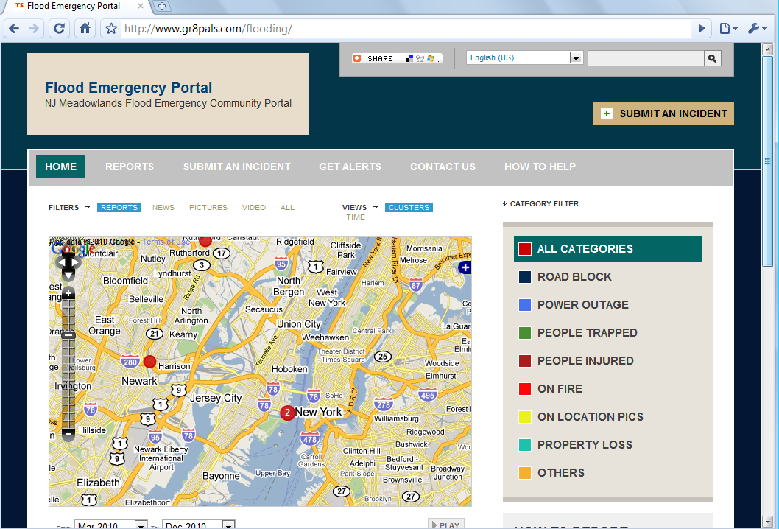
Figure 10: The Report an Incident Home Page.
The Incident Report Page (Figure 10) shows a map displaying events reported, which are depicted by the red dots on the map. Users can click on those to see the topic of the report. Each incident report should specify a location and an incident type. The location of the incident can be explicitly specified via a form-based interface or implicitly via selecting a location on the map.

USHAHIDI provides a mechanism for local observers to submit reports using their mobile phones or the Internet, while simultaneously creating a temporal and geospatial archive of events [13]. The USHAHIDI Platform allows anyone to gather distributed data via Short Messaging Service (SMS) sent from cell phones, email or Web and visualize it on a map or timeline. Our goal is to create the simplest way of aggregating information from the public for use in crisis response [13]. USHAHIDI uses the concept of crowdsourcing for social activism and public accountability, serving as an initial model for what has been coined 'activist mapping' - the combination of social activism, citizen journalism and geospatial information. USHAHIDI provides a mechanism for local observers to submit reports using their mobile phones or the Internet, while simultaneously creating a temporal and geospatial archive of events [17]. Figure 11 shows a map of Incidents reported on a location with the report headings.
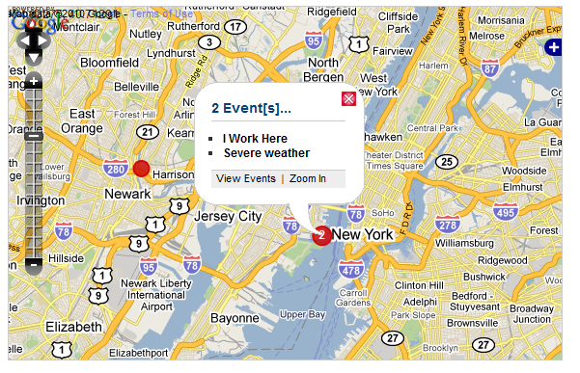
Figure 11: Report an Incident Home Page Map when user clicks on one of the event dots brings up a list of incidents reported on that area.
Clicking the event dots brings up a menu that displays the list of incidents reported in that place. Users can click the report headings to go to the main report page. Users can also zoom in to see more accurately the place of the event, or they can zoom out to see other incidents reported in that area or region.

SUBMIT AN INCIDENT

Users can use the Submit an Incident tool to report an incident they witnessed. They can upload images, associate videos and a news source of an incident. Most importantly, they can select the place where the incident occurred via a Google map. They can also search for the exact place by using the ‘Find Location’ search bar below the map (Figure 12).
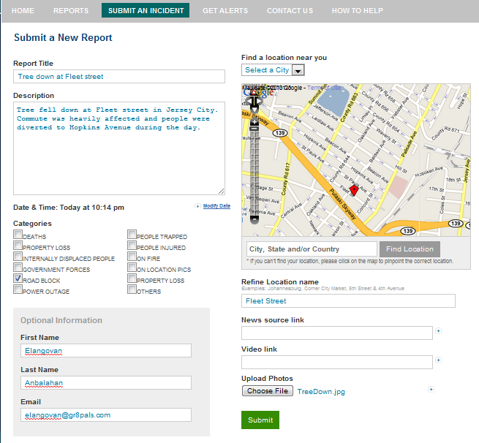
Figure 12: Users can report an incident on the ‘Submit an Incident’ Screen. The figure shows a sample report by a user.

MANAGING INCIDENT REPORTS

Once a user submits a report, it goes into the unapproved report queue for an Administrator to approve it. The application has an Administration page from which he/she can perform administrative tasks, like approving/rejecting and verifying user submitted reports, adding/deleting categories, editing reports, etc. (Figure 13).

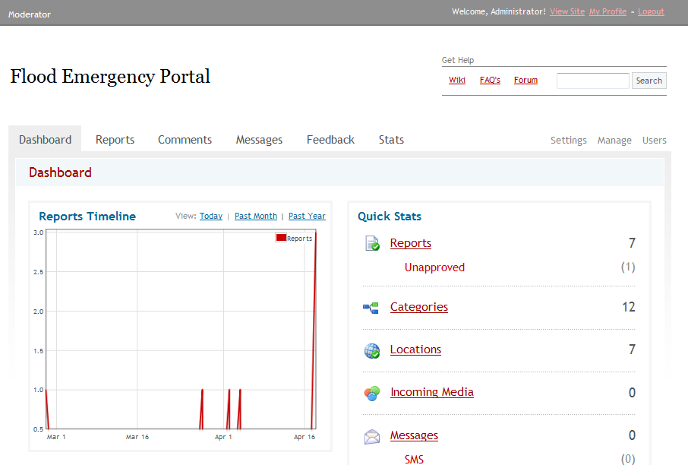
Figure 13: Administrator Home Page for Submit an Incident to manage reported incidents.

The Administrator can approve pending reports by going into the unapproved reports page. S/he can view the report and can decide on whether to approve it or not. S/he also has the option of verifying the report. Once the Administrator approves the reported incident it gets published on the main Webpage.

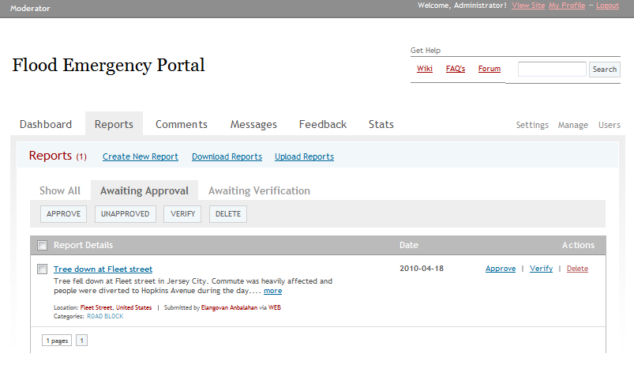
Figure 14: Administrator can approve, verify or delete the incident.

VIEW AN INCIDENT

Once a report was approved by Administrator, it shows up in the Report an Incident’s main page. Users can click on the report to see its contents.

Users can zoom in or zoom out of the map to see reported incidents so far. The page has a Category section which classifies the types of incidents reported, such as Power Outage, People Injured, etc. Users have the ability to see the reports belonging to a particular category by clicking on the category name (Figure 15).

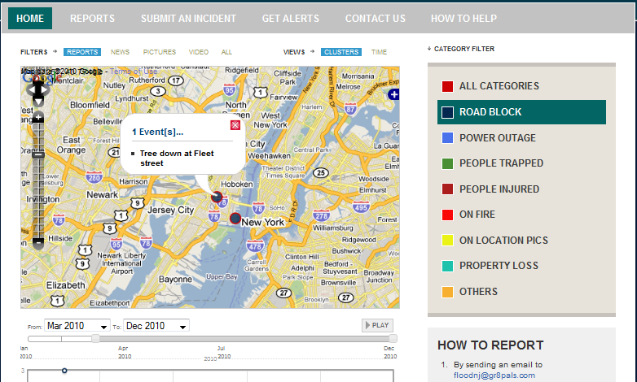
Figure 15: After Administrator approves, the incident reports are available and shared by everyone.

Reported Incident page (Figure 16) shows the details of selected incident.
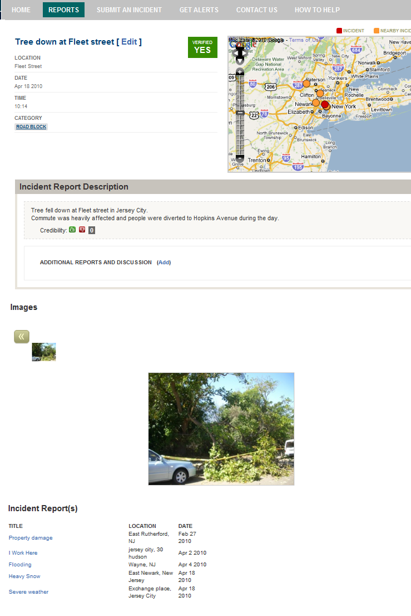
Figure 16: Reported Incident Page.

CROWDSOURCING TO SHARE VOLUNTARY SERVICES AND RESOURCES

Resource Sharing is one of the key features of the NJMFWC system. It allows users to come forward and share information about services or equipment that they wish to volunteer at the time of emergency. Local authorities and people can equally benefit from this feature for better preparing and combating any emergency situations and at raising awareness of flooding problems. This is aimed at making citizens better equipped to face unexpected situations.

SERVICES AND RESOURCES REGISTRATION

The User Registration page (figure 18) at the NJMFWC lets users register with the Website and become members of the NJMFWC. Users can opt to select any voluntary services and or equipment he/she wishes to share at a time of emergency. Once a user fills in all the mandatory fields and click ‘Register,’ s/he is sent a verification email to verify the validity of the email address. Once the user verifies his/her email account by clicking on the verification link in the email, s/he is confirmed as the NJMFWC member. The member can now start using the Website’s services like searching other members, services or equipment. S/he can also start using the FloodNJ forum.
The types of volunteer services include Fire Fighter, Doctor, Electrician, Plumber, etc and equipment resource includes Handsaw, Bulldozer, Ambulance, etc. Users can add new services and equipment by filling in ‘Did we miss any services’ field. The Administrator will check and add the fields to existing ones.
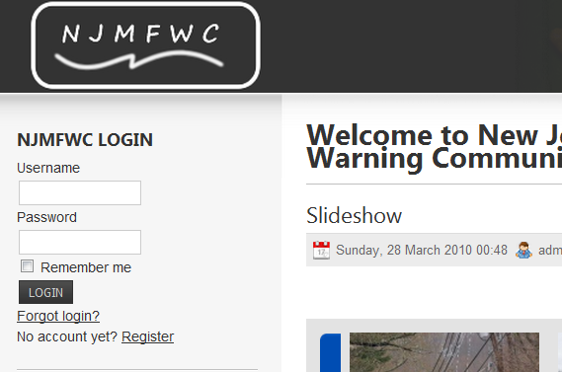
Figure 17: The Login section in the NJMFWC.
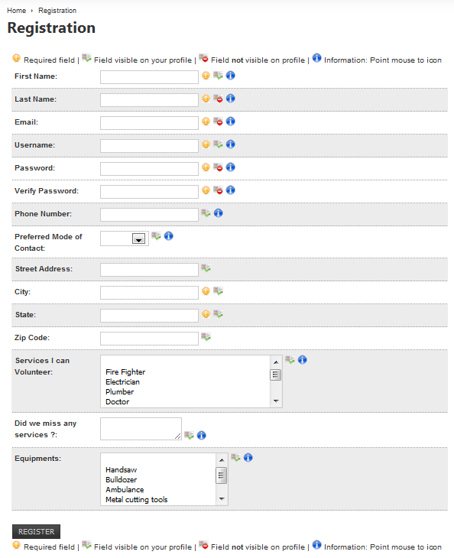
Figure 18: The User Registration Page.

SEARCH VOLUNTEERS, SERVICES AND EQUIPMENT

Logged in users have the ability to search other users, and for resources volunteered by fellow citizens (Figure 19).

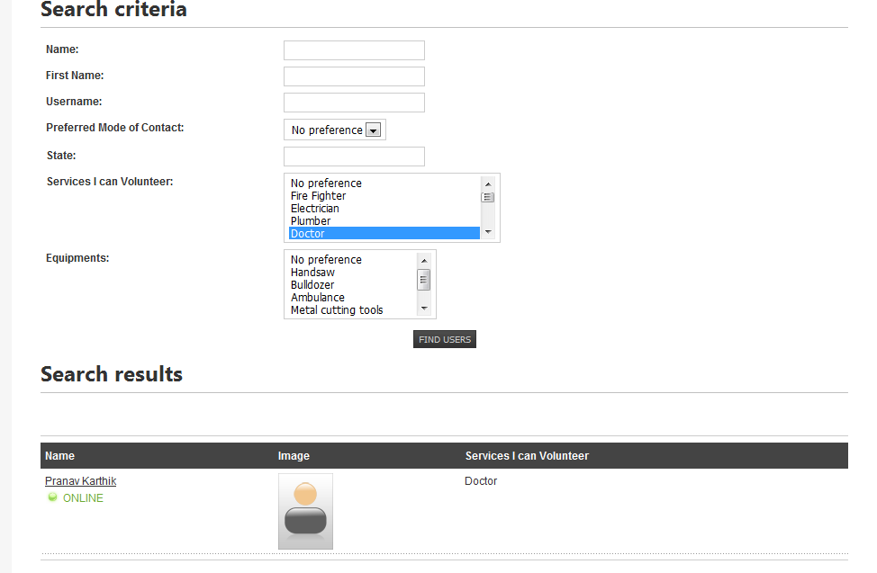
Figure 19: The User Search page, displaying the searchable fields and the search results.

BROWSING NJMFWC USER PROFILES, AND VOLUNTEER RESOURCES

One can browse all the registered members on the NJMFWC users page. This page displays the username, online status, profile image, volunteered services and volunteered equipment (Figure 20).
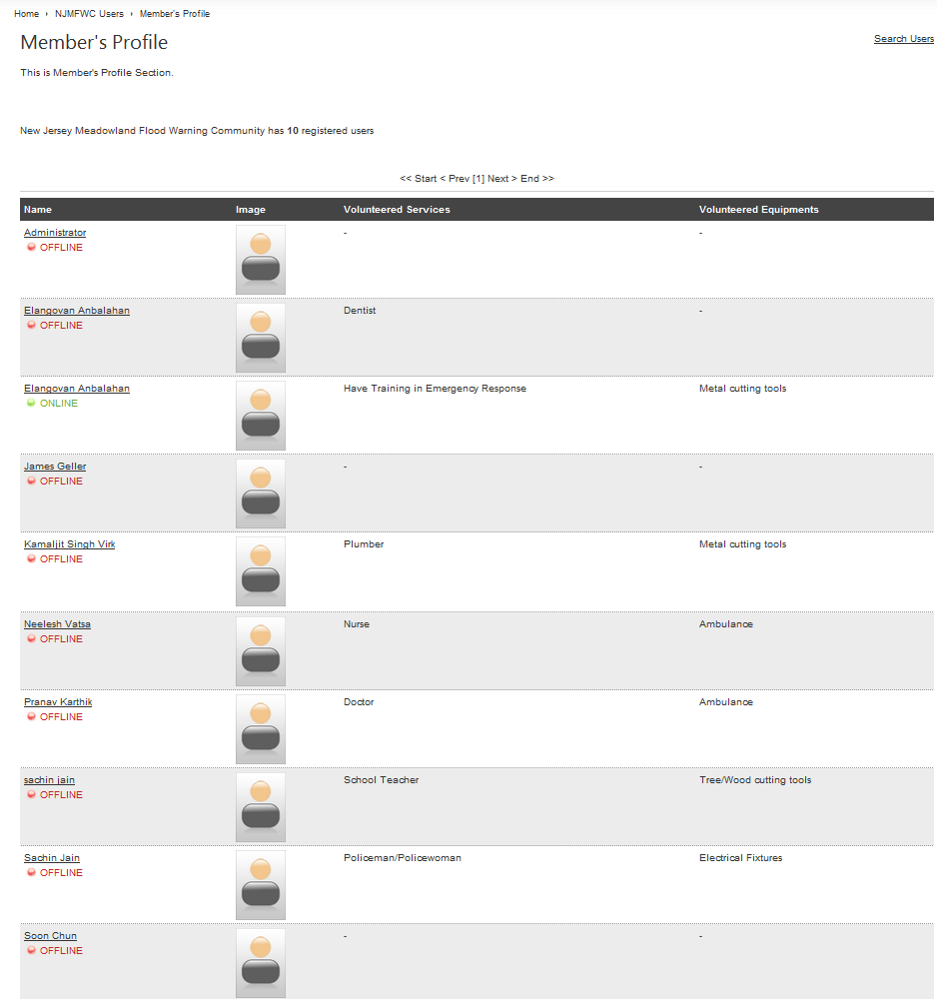
Figure 20: The NJMFWC members’ page displaying all the members.

Users can click on a member (Figure 20) to see more information about her/him (Figure 21), and the volunteer services or equipment by the user can be shown by clicking on the volunteer service tab (Figure 22).
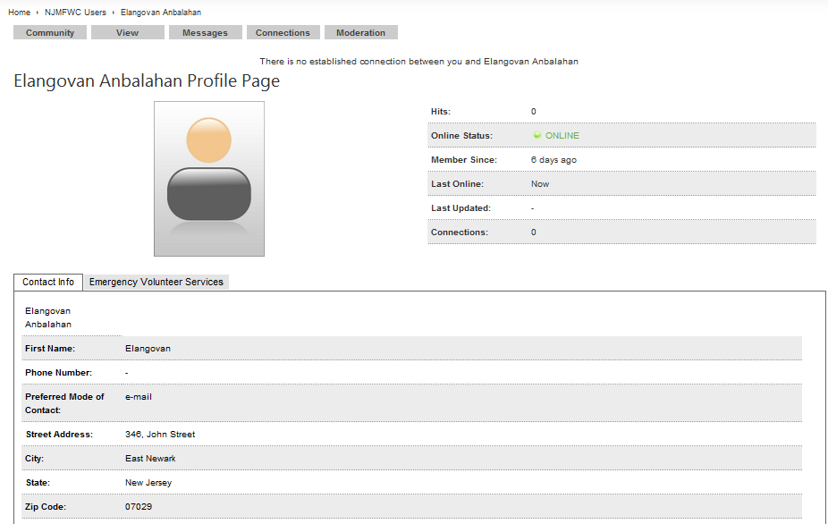
Figure 21: Members Profile page - Contact tab shows contact information of the member.

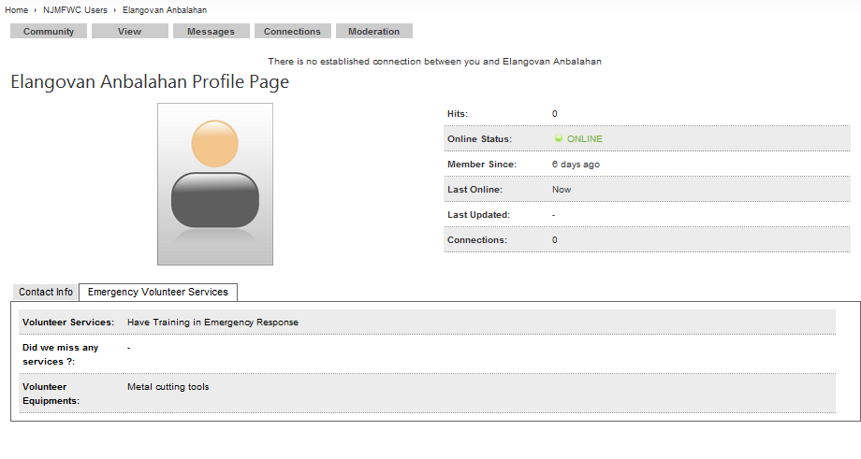
Figure 22: Members Profile page – Emergency volunteer service tab show the services and equipment volunteered by the member.

RESOURCE REQUEST

Any user can search for services and or equipment volunteered by other users and can request an alert email whenever the service or equipment becomes available. Links to the Resource Request Page (Figure 23) can be found on the NJMFWC Home Page, both in the menu and in the Features section.
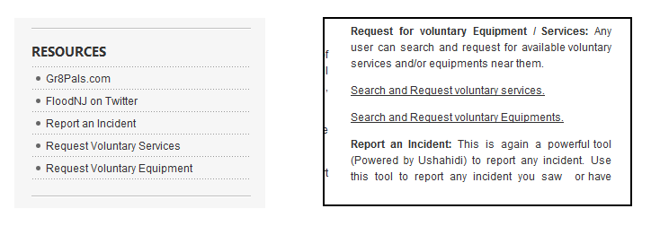
Figure 23: Links to Resource Request in the NJMFWC Home Page.

- NJMFC REQUEST FOR SERVICE
Users can use the NJMFWC Request for Service page (Figure 24) to search for available resources near their area. Users can select from the available list of services that are available in the services drop down menu, and can enter city and state information where they are looking for these services and click on “search” to display the results.

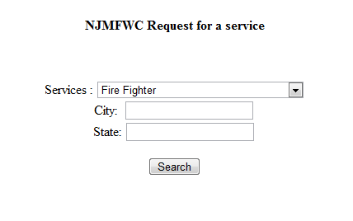
Figure 24: The NJMFWC Request for a resource page.

The search results (Figure 25) will list the services available in the user-entered area. Users can also opt for not filling in city or state information, in which case the system brings up all the places where the selected resource is available.

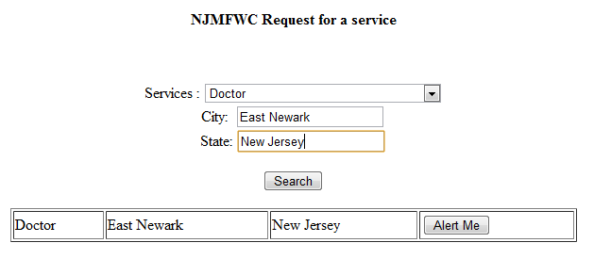
Figure 25: The NJMFWC Request for a resource page displaying the search results.
In that case the search result only displays the services name and its location. It does not disclose any information of the NJMFWC member who has volunteered to offer the service. This is done to keep the anonymity of the NJMFWC members intact.

Users can opt to receive email alerts when a particular service becomes available, by clicking on the ‘Alert Me’ button. Clicking ‘Alert Me’ brings up a form (Figure 26) wherein a user can enter his/her contact details (Name and Email).

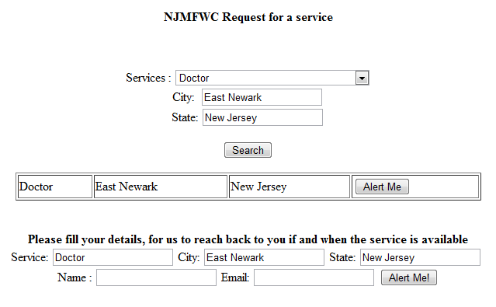

Figure 26: The Request for a Service page showing ‘Alert Me’ dialog for user to enter their contact details.

Once a user submits the form he/she is presented with a confirmation message (Figure 27) saying that the user will be alerted when the service is made available.

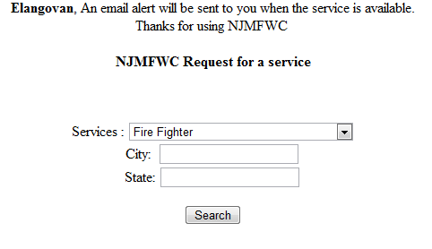
Figure 27: The Request for a resource page with confirmation message on the top.

User’s resource request information is stored in the database. The Administrator can use this information for sending an email alert to the user whenever the requested service becomes available.

- REQUEST FOR EQUIPMENT
The NJMFC Request for equipment (Figure 28) is a very similar feature which lets users search and opt to be alerted them as and when equipment is made available.

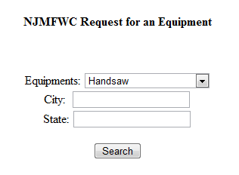
Figure 28: The Request for an Equipment page.

This page also has a similar work flow as the Request for Resource page (Section 3.4.4.1). Users will be able to use the page in the same way as the Request for a Resource page.

The user’s name and email address get stored in the database. The Administrator can use this information to send emails to users to alert them when the equipment is made available.

- NJMFC RESOURCE MAP
All the services and equipment registered with the NJMFWC can be seen at the Resource Map Page (Figure 29). It shows a map with locations where a particular service or equipment is available. This gives a general idea of how near or far a volunteered service or equipment is available to someone.

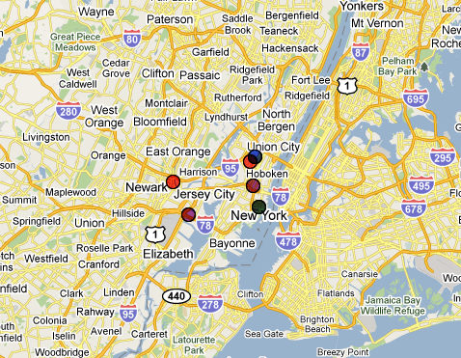
Figure 29: The NJMFWC Resource Map.

KUNEA: FLOOD NJ FORUM

The Flood NJ forum (Figure 30) is an online bulletin board also referred to as online discussion site. The Forum is an online tool powered by Kunea [15] that lets members post messages and comment on messages of others. Users have to register to become members, and only members are allowed to post topics or comments. Registration is the same for using the Forum as well as the Resource Sharing feature.

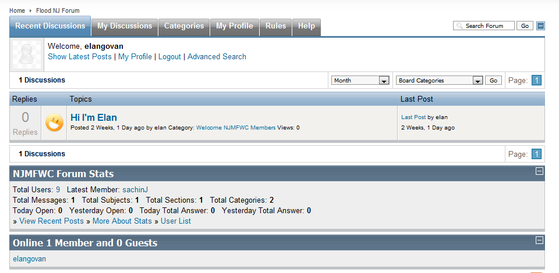
Figure 30: The Flood NJ Forum main page, showing the latest messages.

The Flood NJ Forum has the following main tabs: Recent discussions, My Discussions, Categories, My Profile, Rules and Help.
Recent Discussions: The Home screen (Figure 30) of the Forum page lets you see the recent posts at a glance. This tab shows the latest messages posted by members. Clicking on it will take you to the discussion page. One can then post new threads or reply to any existing discussion threads.
My Discussions: Shows the latest posts posted by the member, with the most recent post on the top.
Categories: This is the main page (Figure 31), which lists the categories of discussion. These categories are generated by the Administrator. Members can click on the category name to view the ongoing topics for discussion under it.

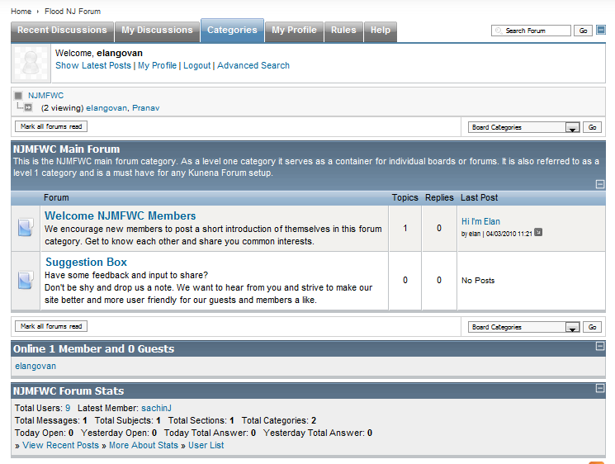
Figure 31: The Forum NJ category page.
Under a category a member can create a new thread (discussion topic) and also post comments on existing discussion topics.
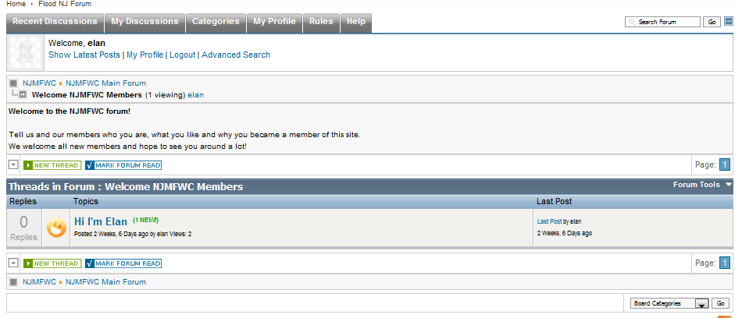
Figure 32: The Flood NJ Forum Category topic main page. It displays the entire discussion topic on that category.
Members can start a new discussion topic by clicking on the ‘New Thread’ link (Figure 32). Members can also take part in ongoing discussions by clicking on ‘Reply’ (Figure 33) of any existing thread.
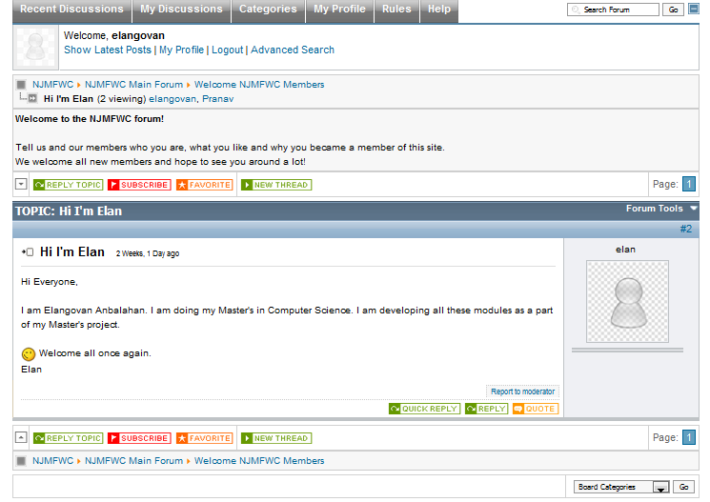
Figure 33: A Discussion topic page.

LITERATURE REVIEW

Emergency Management systems face a multitude of challenges. One of them is to bring Disaster Management Agencies to use Crowdsourcing for better emergency preparedness and response. Crowdsourcing is a neologistic compound of "crowd" and "outsourcing" for the act of outsourcing tasks, traditionally performed by an employee or contractor, to a large group of people or a community (a crowd) [22].
Web 2.0 technologies like Twitter, Blogs, Discussion forums, etc. can help in achieving better emergency response. “IT systems make it possible to handle large amounts of data to assess the situation after a disaster has struck, but we need to move in the direction of community response, developing media centers that accommodate citizen journalists,” says Kathleen Tierney [23]. “Official agencies need to interact with citizen first responders and assess information being gathered in the field, rather than depending on information that is filtered through hierarchical organizations.” [23]. Another advance that Ramesh Rao suggests is dual use of technology [24]. During peaceful times, dual-use technology, such as mobile phones, operates as everyday personal communications devices, but during an emergency phones transform into information sensors and disseminators. This overcomes aversion to using different communications equipment during a crisis and eliminates the time lag caused by government agencies collecting, processing, and distributing crisis-related data [25].
Emergency Management Systems can be made better by addressing the issue of how agency-to-citizens and citizens-to-citizens communication can be made better and quicker. The NJMFWC project is developed to address these issues and provide an efficient way of disseminating disaster information.

CONCLUSIONS

The New Jersey Meadowlands Flood Warning Community was built as an addition to the existing NJMC Flood Warning System. The NJMC Flood Warning System informs emergency managers about the risk of flooding, whereas the NJMFWC is developed for making common citizens aware of flooding emergencies.
We have developed this system to form a community of citizens, who will be aware of flooding emergencies in advance. The NJMFWC is aimed at enabling them to receive flooding emergency related information from both emergency managers and fellow citizens and it would instantly become available on various popular communication tools like email, mobile text message, Twitter messages, discussion forums, etc. During an emergency, time is of the essence. By enabling citizens to disseminate emergency information among themselves, I have tried to eliminate precious time lost when information flows through a series of agencies before reaching the citizens. The NJMFWC also serves as a place where citizens can come forward and offer volunteer services and equipment which their fellow citizens and local authorities could use during flood emergencies.
We have designed and developed the NJMFWC for residents to be better informed and well equipped so that the damage caused by flooding could be minimized. Success of the NJMFWC depends on active participation from the citizens. The bigger the participation, the more successful the system will be in fulfilling its purpose.
Future works include studying a human behavior model of crowdsourcing in emergency situations to answer questions on what types of resources and services are highly demanded for sharing in flood management. Most importantly, whether the Website like the NJMFWC is effectively used by the citizens and incident commanders for managing flood incidents.

REFERENCES

- New Jersey Meadowlands Commission: History of the Meadowlands, http://www.njmeadowlands.gov/about/timeline/history_F.html Accessed May 5, 2010.
- Francisco Artigas, Soon Ae Chun and Yogi Sookhu Real-time Ocean Surge Warning System, Meadowlands District of New Jersey. May 2009
- FEMA 2006. Digital Flood Insurance Rate Map. FEMA map service center.
- John H. Sorensen (2000). "Hazard warning systems: Review of 20 years of progress." Natural Hazards Review 1(2): 119-125
- The New Jersey Meadowlands Commission: Navigating Through the Intergovernmental Maze by Marilyn Marks Rubin, Professor, John Jay College, and City University of New York. (1978).
- NOAA Storm surge data page, http://www.tidesonline.nos.noaa.gov/data_read.shtml?station_info=8531680+sandy+hook,+NJ Accessed October 10, 2009.
- MERI: Application Portal. Storm Surge Data, http://meri.njmeadowlands.gov/njmc/flooding/surge_n.php Accessed October 10, 2009.
- MERI: Application Portal. Send Warning, http://meri.njmeadowlands.gov/njmc/flooding/warning.php Accessed February, 2009.
- MERI: Application Portal. Edit Subscribers, http://meri.njmeadowlands.gov/njmc/flooding/subscribers.php Accessed February, 2009.
- Community-based early flood warning system (CBEFWS): April 2007, http://www.sea-user.org/download_pubdoc.php?doc=3439 Accessed May 5, 2010.
- Flood Warning System. City of Issaquah, Washington – Updated February 2009, http://www.ci.issaquah.wa.us/page.asp?navid=464 Accessed March 5, 2010.
- Sachin Jain (2009)- Database access and mathematical modeling for coastal flood warning system. Master’s Project, NJIT, Spring 2009.
- USHAHIDI an open source project which allows users to crowdsource crisis information, http://www.ushahidi.com/ Accessed March 5, 2010.
- Joomla is an Open Source content Management system, http://www.joomla.org/ Accessed March 5, 2010.
- Kunena is a forum Component for Joomla, http://www.kunena.com/ Accessed March 5, 2010.
- Joomla Wikipedia Page, http://en.wikipedia.org/wiki/Joomla Accessed March 5, 2010.
- USHAHIDI – Wikipedia Page, http://en.wikipedia.org/wiki/Ushahidi Accessed March 5, 2010.
- Federal Interagency Flood Plain Management Task Force, 1996.
- FEMA 2006. Digital Flood Insurance Rate Map. FEMA Map Service Center. Jessup, Maryland.
- The Perfect Storm , NY Times, November 1999.
- L.E. Hagmann and D.M.Jobbins, 1964. The story of the mosquito and its control. Circular (New Jersey Agricultural Experiment Station), 585-A. New Brunswick, N.J.: New Jersey Agricultural Experiment Station.
- Crowdsourcing Wikipedia page, http://en.wikipedia.org/wiki/Crowdsourcing Accessed March 5, 2010.
- Kathleen J. Tierney, 2007. From the Margins to the Mainstream? Disaster Research at the Crossroads. Annual Review of Sociology, Paulo Alto, CA.
- Raheleh B. Dilmaghani, Ramesh R. Rao, 2009. A Systematic Approach to Improve Communication for Emergency Response.
- Sarah Underwood, 2009. Improving Disaster Management. Communications of the ACM, Vol. 53 No. 2, Pages 18-20.

APPENDIX A: SOURCE CODE
Source code for generating service alerts
<?
getDBConnection();

$showResults = false;
$services = "";
$equipments = "";
$city = "";
$search_result = null;
$search_count;

$services_query="SELECT * FROM jos_comprofiler_field_values where fieldid=54";
$services_result=mysql_query($services_query);
$services_count=mysql_numrows($services_result);

$equipments_query="SELECT * FROM jos_comprofiler_field_values where fieldid=66";
$equipments_result=mysql_query($equipments_query);
$equipments_count=mysql_numrows($equipments_result);

mysql_close();

if (isset($_GET['action']) && $_GET['action'] == 'validateForm')
{
validateForm();
}
if (isset($_GET['action']) && $_GET['action'] == 'alertMe')
{
alertMe();
}
function getDBConnection(){
$user="XXXXXX";
$password="XXXX";
$database="XXXXXXXX";

mysql_connect(localhost,$user,$password);
@mysql_select_db($database) or die( "Unable to select database");
}

function validateForm(){
global $showResults,$services,$equipments,$city,$search_result,$search_count ;
$services = $_POST['services'];
$city = $_POST['city'];
$state = $_POST['state'];
getDBConnection();

if( (trim($city)=="") && (trim($state)=="") ){
$search_query="SELECT cb_volunteerservices,cb_city,cb_state FROM jos_comprofiler where
cb_volunteerservices='$services'";
}else if(trim($city)==""){
$search_query="SELECT cb_volunteerservices,cb_city,cb_state FROM jos_comprofiler where
cb_volunteerservices='$services' AND cb_state='$state'";
}else if(trim($state)==""){
$search_query="SELECT cb_volunteerservices,cb_city,cb_state FROM jos_comprofiler where
cb_volunteerservices='$services' AND cb_city='$city'";
}else{
$search_query="SELECT cb_volunteerservices,cb_city,cb_state FROM jos_comprofiler where
cb_volunteerservices='$services' AND cb_city='$city' AND cb_state='$state'" ;
}

$search_result=mysql_query($search_query);
$search_count=mysql_numrows($search_result);
mysql_close();
$showResults = true;
}
function alertMe(){
$alert_name = $_POST['alert_name'];
$alert_email = $_POST['alert_email'];

$alert_service = $_POST['alert_service'];
$alert_city = $_POST['alert_city'];
$alert_state = $_POST['alert_state'];

getDBConnection();
$alert_query="INSERT INTO cb_alertUser(name,email,service,city,state) VALUES
('$alert_name','$alert_email','$alert_service','$alert_city','$alert_state')";
mysql_query($alert_query);
mysql_close();
echo "$alert_name, An email alert will be sent to you when the service is available.<br> Thanks for using NJMFWC";
}

?>
<a href="http://www.gr8pals.com/njmfwc"> NJMFWC Home </a>
<br /><b><center>NJMFWC Request for a service</center></b><br><br>
<script type="text/javascript">
function JS_showAlertMeModule(service_name,city_name,state_name){
document.getElementById('alertModule').style.display = "block";

document.getElementById('alert_service').value = service_name;
document.getElementById('alert_city').value = city_name;
document.getElementById('alert_state').value = state_name;
}
</script>

<style type="text/css">
<!--
#main{
width:500px;
}
#hidden {
width:500px;
display: none;
}
-->
</style>
<center>
<form name="serviceSearch" method="post" action="serviceAlert.php?action=validateForm">
<p>Services :
<select name="services">
<?
$i=0;
while ($i < $services_count) {
$service_name=mysql_result($services_result,$i,"fieldtitle");
echo"<option value=\"$service_name\">$service_name</option>";
$i++;
}

?>
</select><br />

City:&nbsp; <input type="text" name="city" /><br />
State: <input type="text" name="state" /></p>

<p><input type="submit" value="Search"></p>
</form>

<?
if($showResults){
?>
<table width="600" border="1">
<?
if($search_count == 0){
echo "No results to display";
}
$i=0;
while ($i < $search_count) {
$service_name=mysql_result($search_result,$i,"cb_volunteerservices");
$city_name=mysql_result($search_result,$i,"cb_city");
$state_name=mysql_result($search_result,$i,"cb_state");
echo"<tr>";
echo"<td>$service_name</td>";
echo"<td>$city_name</td>";
echo"<td>$state_name</td>";

echo "<td><input type='button' name='alertMe' value='Alert Me'
onClick='JS_showAlertMeModule(\"$service_name\",\"$city_name\",\"$state_name\");'></td>";
echo"</tr>";
$i++;
}
?>
</table>
<?
}
?>
<br /><br />
<div id="alertModule" style="display:none">
<B>Please fill your details, for us to reach back to you if and when the service is available</B>
<form name="alertMeForm" action="serviceAlert.php?action=alertMe" method="post">
Service: <input type="text" name="alert_service" id="alert_service"/>
City: <input type="text" name="alert_city" id="alert_city"/>
State: <input type="text" name="alert_state" id="alert_state"/>
<br />
Name : <input type="text" name="alert_name" />
Email: <input type="text" name="alert_email" />
<input type="submit" value="Alert Me!" />
</form>
</div>
</center>

Source code for generating equipments alert
<?
getDBConnection();

$showResults = false;
$services = "";
$equipments = "";
$city = "";
$search_result = null;
$search_count;

$services_query="SELECT * FROM jos_comprofiler_field_values where fieldid=54";
$services_result=mysql_query($services_query);
$services_count=mysql_numrows($services_result);

$equipments_query="SELECT * FROM jos_comprofiler_field_values where fieldid=66";
$equipments_result=mysql_query($equipments_query);
$equipments_count=mysql_numrows($equipments_result);

mysql_close();

if (isset($_GET['action']) && $_GET['action'] == 'validateForm')
{
validateForm();
}
if (isset($_GET['action']) && $_GET['action'] == 'alertMe')
{
alertMe();
}
function getDBConnection(){
$user="greigpal_test";
$password="test";
$database="greigpal_njmfwc";

mysql_connect(localhost,$user,$password);
@mysql_select_db($database) or die( "Unable to select database");
}

function validateForm(){
global $showResults,$services,$equipments,$city,$search_result,$search_count ;
$equipments = $_POST['equipments'];
$city = $_POST['city'];
$state = $_POST['state'];
getDBConnection();

if( (trim($city)=="") && (trim($state)=="") ){
$search_query="SELECT cb_equipments,cb_city,cb_state FROM jos_comprofiler where
cb_equipments='$equipments'";
}else if(trim($city)==""){
$search_query="SELECT cb_equipments,cb_city,cb_state FROM jos_comprofiler where
cb_equipments='$equipments' AND cb_state='$state'";
}else if(trim($state)==""){
$search_query="SELECT cb_equipments,cb_city,cb_state FROM jos_comprofiler where
cb_equipments='$equipments' AND cb_city='$city'";
}else{
$search_query="SELECT cb_equipments,cb_city,cb_state FROM jos_comprofiler where
cb_equipments='$equipments' AND cb_city='$city' AND cb_state='$state'" ;
}

$search_result=mysql_query($search_query);
$search_count=mysql_numrows($search_result);
mysql_close();
$showResults = true;
}
function alertMe(){
$alert_name = $_POST['alert_name'];
$alert_email = $_POST['alert_email'];

$alert_equipment = $_POST['alert_equipment'];
$alert_city = $_POST['alert_city'];
$alert_state = $_POST['alert_state'];

getDBConnection();
$alert_query="INSERT INTO cb_alertUser(name,email,equipment,city,state) VALUES
('$alert_name','$alert_email','$alert_equipment','$alert_city','$alert_state')";
mysql_query($alert_query);
mysql_close();
echo "$alert_name, An email alert will be sent to you when the equipment is available.<br> Thanks for using NJMFWC";
}

?>

<script type="text/javascript">
function JS_showAlertMeModule(equipment_name,city_name,state_name){
document.getElementById('alertModule').style.display = "block";

document.getElementById('alert_equipment').value = equipment_name;
document.getElementById('alert_city').value = city_name;
document.getElementById('alert_state').value = state_name;
}
</script>

<style type="text/css">
<!--
#main{
width:500px;
}
#hidden {
width:500px;
display: none;
}
-->
</style>

<a href="http://www.gr8pals.com/njmfwc"> NJMFWC Home </a>
<b><center>NJMFWC Request for an Equipment</center></b><br /><br />

<center>
<form name="serviceSearch" method="post" action="equipmentAlert.php?action=validateForm">
<p>
Equipments:
<select name="equipments">
<?
$i=0;
while ($i < $equipments_count) {
$equipment_name=mysql_result($equipments_result,$i,"fieldtitle");
echo"<option value=\"$equipment_name\">$equipment_name</option>";
$i++;
}

?>
</select><br />
City:&nbsp; <input type="text" name="city" /><br />
State: <input type="text" name="state" /></p>

<p><input type="submit" value="Search"></p>
</form>

<?
if($showResults){
?>
<table width="600" border="1">
<?
$i=0;
while ($i < $search_count) {
$equipment_name=mysql_result($search_result,$i,"cb_equipments");
$city_name=mysql_result($search_result,$i,"cb_city");
$state_name=mysql_result($search_result,$i,"cb_state");
echo"<tr>";
echo"<td>$equipment_name</td>";
echo"<td>$city_name</td>";
echo"<td>$state_name</td>";

echo "<td><input type='button' name='alertMe' value='Alert Me'
onClick='JS_showAlertMeModule(\"$equipment_name\",\"$city_name\",\"$state_name\");'></td>";
echo"</tr>";
$i++;
}
?>
</table>
<?
}
?>
<br /><br />
<div id="alertModule" style="display:none">
<B>Please fill your details, for us to reach back to you if and when the service/equipment is available</B>
<form name="alertMeForm" action="equipmentAlert.php?action=alertMe" method="post">
Equipment: <input type="text" name="alert_equipment" id="alert_equipment"/>
City: <input type="text" name="alert_city" id="alert_city"/>
State: <input type="text" name="alert_state" id="alert_state"/>
<br />
Name : <input type="text" name="alert_name" />
Email: <input type="text" name="alert_email" />
<input type="submit" value="Alert Me!" />
</form>
</div>
</center>

