CS 700B
Master’s Project Proposal

COMMUNITY BASED FLOOD MANAGEMENT SYSTEM USING WEB 2.0

Submitted to the
Department of Computer Science
College of Computing Sciences
New Jersey Institute of Technology

In Partial Fulfillment of
The Requirements for the Degree of
Master of Science
By

Elangovan Anbalahan
ea39@njit.edu
NJIT ID – 21663799

Proposal Number
Agree to Advise | _Dr. James Geller__  (Project Advisor)
Date Submitted
Approved By | ____________________  (MS in CS Committee)
Date Approved

ABSTRACT

The Meadowlands are the most fertile region in North East America. The Storm Surge warning System (SSWS) project is dedicated to protect the Meadowlands from getting flooded. The Meadowlands consist of roughly 8,400 acres (34 km²) of open, undeveloped space in addition to the vast developed areas that previously were part of the natural wetlands. Once written off as wasteland, the Meadowlands are now experiencing a renaissance thanks to the conservation efforts of the New Jersey Meadowland Commission (NJMC) [1].
Members of MERI (Meadowlands Environmental Research Institute), have developed a flood warning system, which periodically reads Storm Surge Data from the NOAA website. Whenever these readings reach to a particular threshold value, the SSWS system generates warning messages and sends it automatically to listed subscribers. These alerts enable the subscribers take necessary action in case of such emergencies. Although these alerts go to government officials, there is no communication channel aimed directly to pass this important information to common citizens.
I will develop a community based flood management system using WEB 2.0 technologies, which will aim at making the concerned citizens aware of these information updates. This system will enable citizens to receive flood warnings via various WEB 2.0 tools like emails, twitter, mobile messages etc. The system will have WEB tools, via which the concerned citizens can share information about their voluntary citizen expertise that can be used in case of flood emergencies. The system will also have a networking/community website, which will enable users to share this information and post discussion topics.
Table of Contents

Abstract 3
1 Introduction 5
2 Previous Work 7

  - Storm Surge Value is Calculated and Updated 7

  - Local water level predictions 8

  - Local water level monitoring-Observation 9

  - Flood warning notification system 10

  - Agency subscription module 11

  - Limitations 12

- Proposed Work 13

  - Flood warning content management system 13

  - WIKI pages 14

  - Send warning alerts 14

  - Sharing voluntary resources 15

  - Model test program 15

  - Weekly Plan 16

4 Related Work 17
  - CBFEWS: Philippine Examples 17
  - Flood Warning System: City of Issaquah, Washington 18
  - How is my proposed system different? 18

- References 20
- INTRODUCTION

Low-lying coastal, residential and industrial areas are of great concern to emergency managers because of their susceptibility to tidal flooding and sea level surges. Floods from sea surges have caused great loss of lives over the years [2]. According to the Federal Interagency Flood Plain Management Task Force, 1996 sea surges have caused greater damage to life and commodities in USA than all other natural hazards combined. The New Jersey Meadowlands District (District) is located in a low-lying flat glacial valley of the lower Hackensack river where the average elevation is 1 foot above the high water mark (see Figure 1). Not only does it serves as a major transportation corridor between New Jersey and New York for thousands of commuters, it houses over 5100 homes and over 2100 commercial and industrial buildings (According to Federal Emergency Management Administration-FEMA).

In the absence of a national warning system strategy (Sorensen 2000 [4] ), the NJMC set out to develop a local sea surge warning system that can be easily installed and maintained and can inform the emergency managers about risk of flooding at least three to six hours in advance. As a way to offset the shortness of funds and expertise from the local communities, the approach consisted of integrating already existing information and deploying novel inexpensive sensor systems using computer technology that requires minimal human intervention [3].

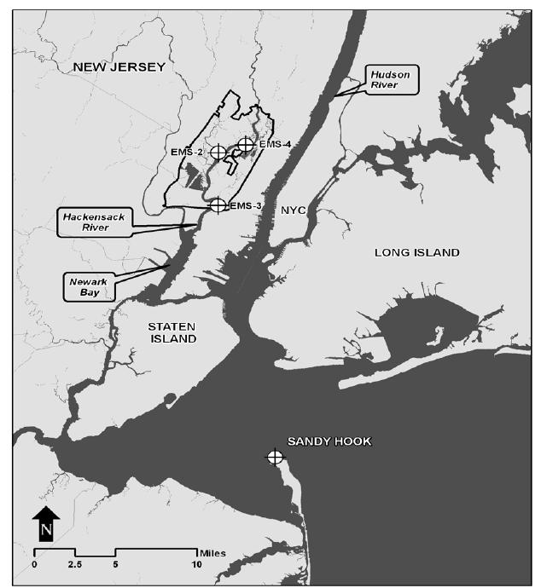
Figure 1: NJMC District boundary and the location of the water depth monitoring stations along the Hackensack River (EMS2, EMS3 and EMS4). Also shown is the Sandy Hook location where NOAA models predict ocean surge water levels [3].

- PREVIOUS WORK

The New Jersey Meadowlands Commission (NJMC) originally started this project. The National Oceanic and Atmospheric Administration (NOAA) accepted the formal plan by NJMC in 1978. A mathematical model calculates the predicted surge level based on Storm Surge Data. A warning message is then generated if that goes beyond certain threshold [5].

- STORM SURGE VALUE IS CALCULATED AND UPDATED

Storm Surge Values are observed at Sandy Hook, New Jersey. Based on a prediction model, the NOAA website updates observed and predicted value at Sandy Hook every six minutes.

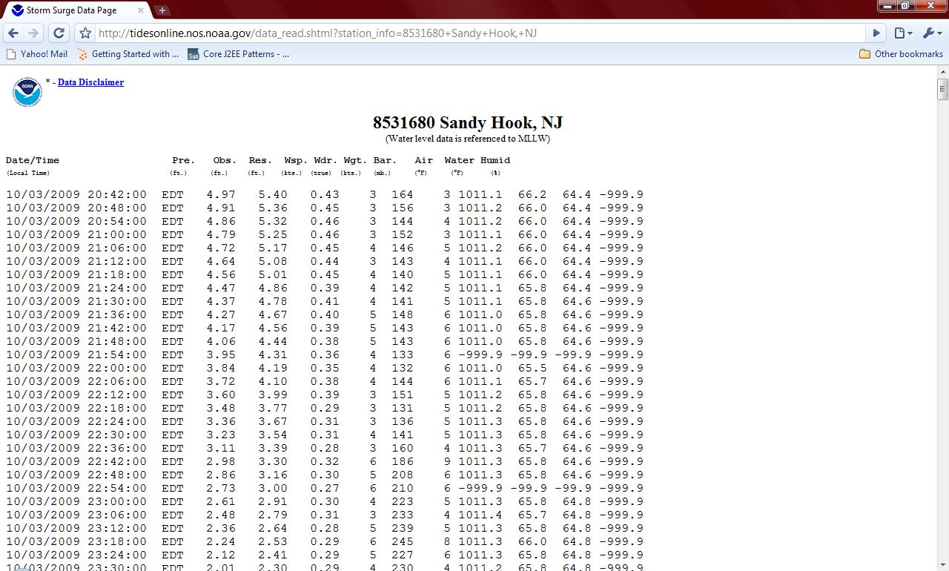

Figure 2. Tide Information Website [6]

This website has the date and precise time of recording those data. It has a predicted value, observed value, the residual that is the difference of observed value and predicted value. These three values are the most integral part of this model that determines the work of the warning system. For a sound and accurate model its entire credibility depends on the residual value. The lower the residual value the better is the model because then it would mean that model is calculating the correct value.

- LOCAL WATER LEVEL PREDICTIONS

MERI recently developed a storm surge extractor program, which periodically extracts predicted and actual storm surge levels from the NOAA website. The NOAA web page is updated every six minutes with the latest and predicted surge levels on various stations across New Jersey.
The Extractor system shows the observed and predicted values at Sandy Hook surge monitoring station. Based on a mathematical prediction model it then calculates predicted value of the storm surge at Kearney, Berry’s Creek, Mills Creek and Sandy Hook station. Figure 3 shows a sample page.
The prediction model for a local predicted water level is based on conversion factors; these can be changed from this page. These variables are responsible for calculating predicted storm surge levels at Kearney, Berry’s Creek, Mills Creek and Sandy Hook. Local level conversion factors are based on the distance from Sandy Hook and the elevation levels of the local areas [12].

- LOCAL WATER LEVEL MONITORING – OBSERVATIONS

The actual observed water levels at the NJMC areas are captured through the three monitoring stations stationed at Kearney, Berry’s Creek, Mills Creek and Sandy Hook. These predicted and observed values of storm surge levels at Kearney, Berry’s Creek, Mills Creek and Sandy Hook are captured in a database every 60 minutes[12].

- FLOOD WARNING NOTIFICATION SYSTEM

When the surge level exceeds a threshold value, the system automatically generates email alerts and sends them to the list of subscribers. The alert message contains information regarding the observed and predicted surge level at one of the four locations. This enables the emergency managers to take appropriate actions to save the situation.

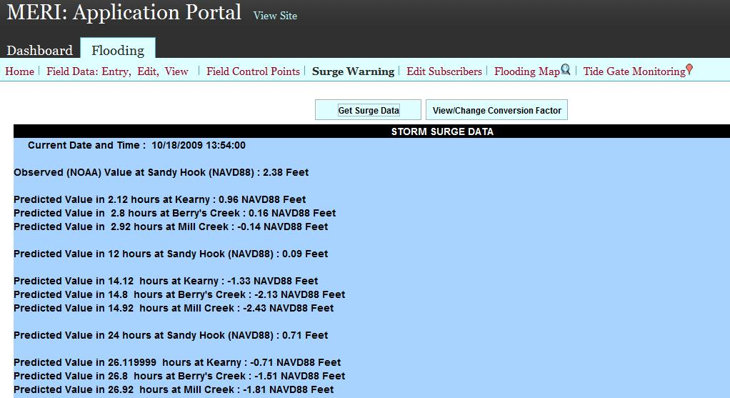

Figure 3: Storm surge data extractor webpage shows observed data extracted from NOAA website, and predicted surge values at various locations [7].
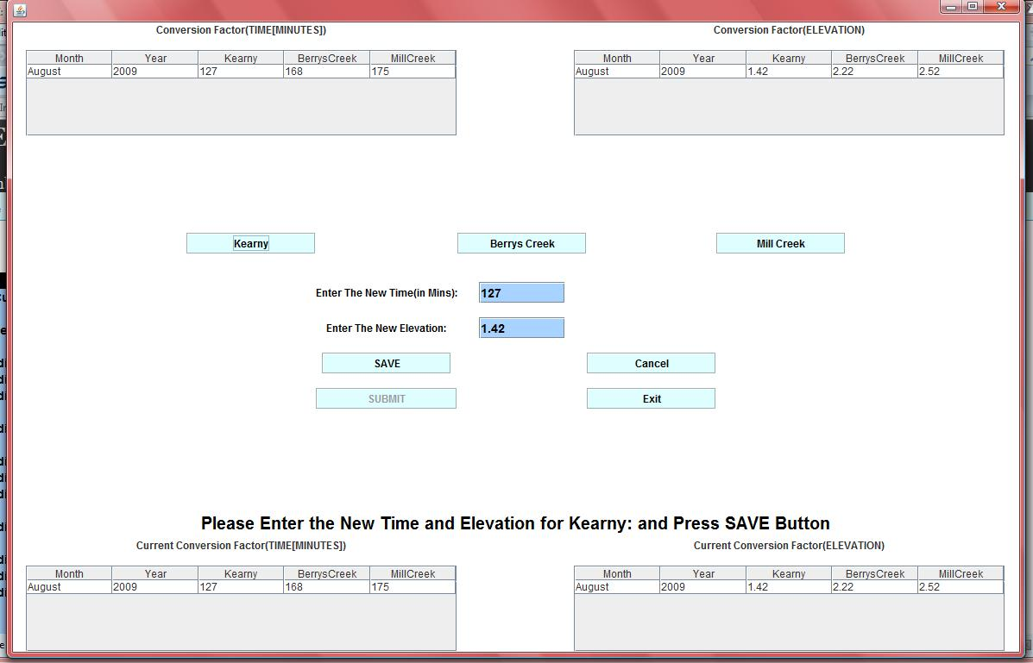

Figure 4: Time and elevation modification page [7]

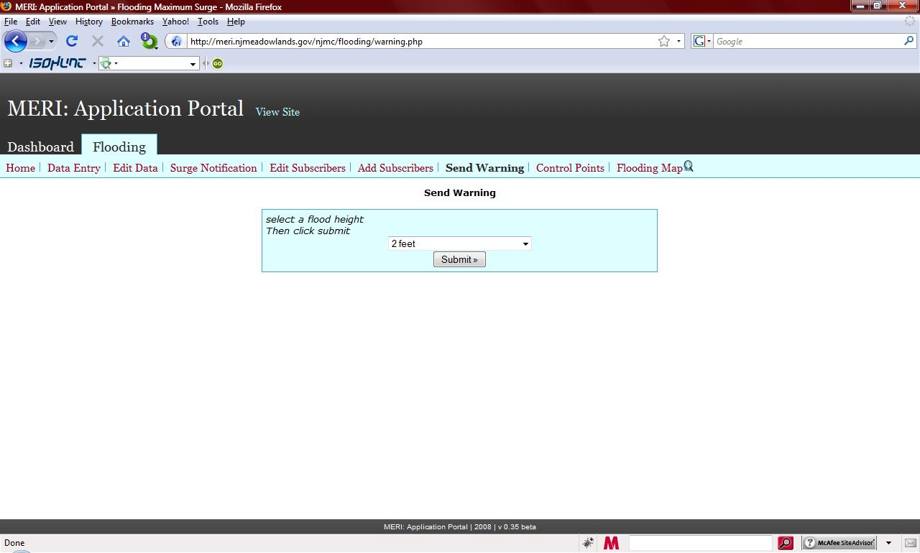

Figure 5: Send warning page [8].

- AGENCY SUBSCRIPTION MODULE

The subscribers are emergency managers in the municipal governments within the NJMC area, and MERI website administrators. The system continuously monitors the storm surge level and the subscribers get automatically notified by storm surge warning via email alerts (Figure 5). The administrators have the ability to add, edit and remove subscribers.

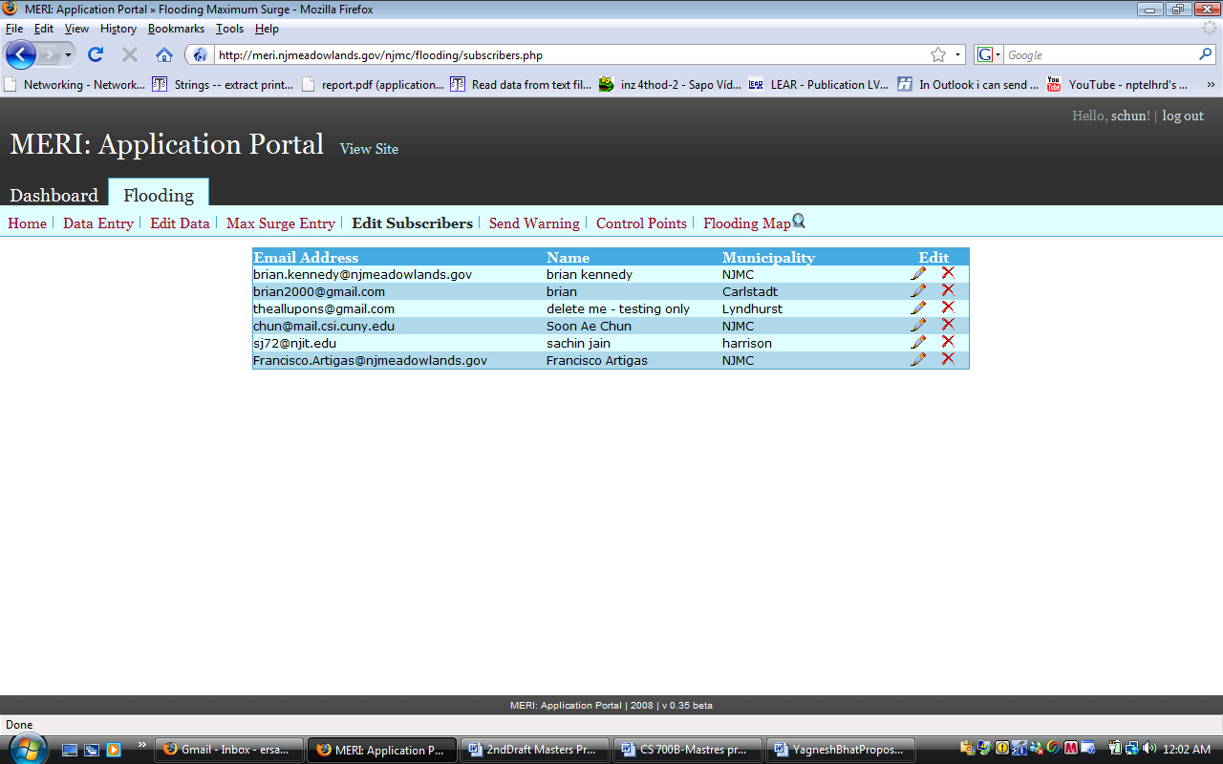

Figure 5: Information of Subscribers is edited shows list of subscribers and icons in each row is used for editing and deleting the subscriber [9].

- LIMITATIONS

Although this flood warning system provides an enormous tool for flood management decision makers, the system is mostly for the government officials only. There is no citizens’ role or participation in this flood management and early warning system. The citizens are left to rely on the traditional notification through radios or TV’s, and do not directly benefit from the local flood monitoring tools. The citizen’s resources such as their assets such as boats or trucks or their expertise are not exploited in this platform. We consider that the citizens should be notified as early as possible for the impending flood and play an active role in flood management by providing their resources, instead of resorting only to the government resources. The collaborative aspects of the citizens are the focus of this study that may address some of these limitations.

- PROPOSED WORK

My work in this project is to use and develop various WEB 2.0 based collaborative tools to make concerned common citizens aware of storm surge warnings and provide a communication channel to empower them to effectively share and dissipate warning information to the general public. In addition, these WEB tools will also enable these concerned citizens to register and share their voluntary resources that can be used in case of any emergencies.
Although the existing storm surge warning system effectively and quickly makes warning alerts available to subscribers, there is a lack of communication channel that informs citizens of that region of these warnings. If citizens are notified in time it can give them opportunity to take appropriate preventive measures. My system will also provide a common platform via which citizens will be able to register and share information about their voluntary resources. This can be very useful in case of flood emergencies.

DELIVERABLES

- FLOOD WARNING CONTENT MANAGEMENT SYSTEM

Use an open source Content Management System (CMS), to develop WEB tools that will enable citizens to share information about their voluntary resources. Resources can be anything from lending their vehicles to offering services like plumbering, carpentering. Users will be able to register and add information about resources they can provide in case of flood related emergencies. The tool will also provide users with a forum via which they can post discussion topics and contribute to them.
This WEB module will be developed using open source Content Management System ‘JOOMLA’. This will be used to develop a community-based portal.
- Set up JOOMLA Content Management System.
- Set up community portal, with the help of JOOMLA plugins and configure it using PHP.
- Develop the user registration and resource sharing module.
- Test the community WEB portal.

- WIKI PAGES:

This WEB interface will also house WIKI pages that would have information regarding various topics, from using the system to latest decisions that emergency managers are making.
- Gather Content for building WIKI pages
- Develop and host the WIKI pages
- Develop a forum where users can contribute to and update existing WIKI pages.

- WEB 2.0-BASED SITUATION AWARENESS AND WARNING ALERTS

The web site will have interface wherein users can provide information about their preferred way of getting storm surge warning alerts. The alerts shall be received via any/all of the following ways, twitter updates, emails, and forum blogs.

- Develop and integrate tweets generator (Twitter messages), with the existing storm surge warning system.
- Develop and integrate a bulletin board blog that will get automatically updated in case of warning storm surge alerts.
- Develop automatic email alert functionality, and integrate it with the existing storm surge warning system.

- SHARING CITIZEN RESOURCES

Develop a WEB based module from which users will be able to register and add information about resources they can provide that can be used in case of flood related emergencies.
- Develop a customizable interface for administrator, via which he/she can add or edit the list of resources users can volunteer to provide.
- Develop user registration page, via which users can specify resources they can volunteer and add their contact information and preferred medium of contact.
- Develop a blog wherein users can post their suggestions to improve the website.

- MODEL TEST PROGRAM

Input: Whether the system should be in TEST mode.
Output: Let the users to run the system as a test, not as real warnings.

- WEEKLY PLAN

Week 1 | Getting started: Studying the history of past work done on the project.
Week 2 | Go through the various modules of the project to be updated.
Week 3 | LEARN AND CONFIGURE JOOMLA:  Learn how to use JOOMLA plugin in existing website.  Learn and configure JOOMLA Content Management System
Week 4 | Continued.
Week 5 | DEVELOP COMMUNITY WEBSITE:  Develop community website using JOOMLA and hand written code in PHP.
Week 6 | WIKI Pages:  Gather information and document it.  Develop WIKI pages and populate them with gathered information.
Week 7 | WIKI Pages:  Develop WEB module via which registered users can view and contribute existing WIKI pages.
Week 8 | SEND WARNING ALERTS:  Tweets Generator: Develop program to generate twitter messages (Tweets).
Week 9 | SEND WARNING ALERTS:  Develop program to generate automatic email and forum blog alerts and integrate all of these with existing warning message functionality.
Week 10 | SHARING VOLUNTARY RESOURCES:  Develop user registration page, blog wherein users can post their suggestions to improve the website.
Week 11 | SHARING VOLUNTARY RESOURCES:  Develop a customizable interface for administrator, via which he/she can add or edit list of resources users can volunteer to provide
Week 12 | MODEL TEST PROGRAM:  Let the user test the program in a test mode with out sending the actual flood warning.
Week 13 | Continued.
Week 14 | Writing report for the work done.

- RELATED WORK

Flood warning system plays a crucial role wherein local, regional, or national authorities can contact members of public to warn them of an impending flood. Timely warning can help to save both public and their property. There are numerous flood-warning systems over the globe but not much importance is given for community-based awareness. Community-based systems are aimed at making information accessible to citizens. The following lists and discusses briefly two such systems. We will also show how the proposed work will be different from such systems.

- CBFEWS: Philippine Examples
The Philippine Atmospheric, Geophysical and Astronomical Services Administration (PAGASA), put forth the concept of a community-based early warning system (CBEWS). CBEWS is a ‘People-centered’ system and empowers individuals and communities threatened by hazards to act in sufficient time and in an appropriate manner so as to reduce the possibility of personal injury, loss of life, damage to property, environment and loss of livelihood. The Philippines implemented CBEWS successfully for the province of Bulcan in 2005 [10]. They used radio transmission to broadcast emergency warnings. Radio was chosen as communication medium because its transmission can be done independent of electricity or wired mediums. They made sure the message was simple and understandable to everyone. It showcased its success in its very first year [10].

- Flood Warning System: City of Issaquah, Washington
The Issaquah Flood Warning System provides residents with a way to obtain information on impending floodwaters so that they can take proper defensive actions and prepare themselves before serious flooding occurs. Depending on the location, the system provides 3-4 hours of lead-time to residents before arrival of the flood peak [11].
Current flood information is available to citizens through these sources [11]:
- City Emergency Information Line (837-3028)
- City TV Channel 21/61 (when under flood phase alert)
- City 1700 AM Radio
- City WEB site
- Real-time data for Issaquah Creek (USGS) gauge at Hobart

The system is very unique in the sense that it helps disseminating the flood warning alerts in multiple ways.

- How is the proposed system different?
The proposed project is aimed at disseminating flood warning alerts through various popular WEB tools like emails, twitter messages, discussion forums etc. These are the WEB tools people use on daily basis to get his or her information and these has in a way become part of everyone’s lifestyle. The project is aimed at seamlessly integrating the warning alerts in their day-to-day applications. This is an important aspect as well as a distinct feature, which separates it from the existing systems. Citizens do not have to make an effort to get such information from a specific source; rather the information comes to them automatically.
The project will also have WEB platform wherein registered citizens can share their voluntary services that they can offer during emergencies. This, along with their preferred contact information will be available to everyone in the forum. During emergencies, this information can be very useful. Citizens do not have to solely depend on governmental agencies for flood relief; often there may be people around who can provide help faster. This is another distinct feature of the proposed system; Government agencies and citizens of the region can equally and largely benefit by such a framework.

- REFERENCES

- New Jersey Meadowlands Commission: History of the Meadowlands - (http://www.njmeadowlands.gov/about/timeline/history_F.html )

- Francisco Artigas, Soon Ae Chun and Yogi Sookhu Real-time Ocean Surge Warning System, Meadowlands District of New Jersey. May 2009

- FEMA 2006. Digital Flood Insurance Rate Map. FEMA map service center.

- Sorensen, J. H. (2000). "Hazard warning systems: Review of 20 years of progress." Natural Hazards Review 1(2): 119-125

- The New Jersey Meadowlands Commission: Navigating Through the Intergovernmental Maze by Marilyn Marks Rubin, Professor, John Jay College, and City University of New York. (1978).

- NOAA Storm surge data page – 10/2009 (http://www.tidesonline.nos.noaa.gov/data_read.shtml?station_info=8531680+sandy+hook,+NJ)

- MERI: Application Portal. Storm Surge Data - 10/2009 (http://meri.njmeadowlands.gov/njmc/flooding/surge_n.php)

- MERI: Application Portal. Send Warning - 02/2009 (http://meri.njmeadowlands.gov/njmc/flooding/warning.php)

- MERI: Application Portal. Edit Subscribers - 02/2009 (http://meri.njmeadowlands.gov/njmc/flooding/subscribers.php)

- Community-based early flood warning system (CBEFWS): April 2007 (http://www.sea-user.org/download_pubdoc.php?doc=3439)

- Flood Warning System. City of Issaquah, Washington – Updated February 2009 (http://www.ci.issaquah.wa.us/page.asp?navid=464)

- Sachin Jain (2009)- Database access and mathematical modeling for coastal flood management.MS Proposal, NJIT, Spring 2009.

