Master’s Project Report
CS700B

Predicting Web Search Hit Counts Using Yahoo! and Bing Search APIs
and
Creating Web Interface with Suggested Completions

Submitted to the Department of Computer Science, College of Computing Sciences
New Jersey Institute of Technology
In Partial Fulfillment of the Requirements for the Degree of Master’s of Science
By
Anushri Mahajan
ahm5@njit.edu
NJIT ID: 216-47-089
Mansi Pedgaonkar
map36@njit.edu
NJIT ID: 216-59-576
Project Advisor: Prof. James Geller
Project Number:

- Approval by Project Advisor.
Project Advisor: Dr. James Geller
Signature: ___________________
Date: _______________________

- Approval by MS in CS Committee.
Project Number: _____________________
Submission Date: ____________________
Project Evaluation: ___________________
(By Graduate Advisor / Committee)
Date: ______________________________
Signature: __________________________
- We hereby affirm that we have followed the directions as published in the program web page http://cs.njit.edu/~mscs/ and we confirm, that this report is our personal work and that all material other than our own is properly referenced.
Student’s Name: Anushri Mahajan
Student’s Signature:
Student’s Name: Mansi Pedgaonkar
Student’s Signature:

Acknowledgment
Apart from our efforts, the tremendous success of this project depends largely on the encouragement and guidelines of many others. We take this opportunity to express our gratitude to the people who have been instrumental in the successful completion of this project.
Working on this project has been a great learning experience and we would like to show our greatest appreciation to Dr. James Geller for his constant support and help. Without his encouragement and guidance this project would not have materialized.
The guidance and support received from all the team members including Tian Tian and who contributed and are contributing to this project, was vital for the success of the project. We are grateful for their constant support and help.

Abstract
In previous work, ontology supported Web search was implemented. It presented the user with a choice of additional words for her search terms. The user could mark these terms as positive, i.e., they should be included in the Web search results, by clicking the associated check boxes. One problem with this approach is that users do not want to be bothered by (too many) questions. A more benign approach to eliciting additional information from a user can be seen in the use of suggested completions in a Web interface.
Keyword-based search engines often return unexpected numbers of results. The search results with zero hits are naturally undesirable, while results with too many hits are likely to be overwhelming and of low precision. We worked on the approach to find the predicted number of hits.
Using word frequencies derived from a large corpus, we constructed random samples of combinations of these words as search terms. Then we derived a correlation function between the computed probabilities of search terms and the observed hit counts for them. This correlation is used to predict the hit counts for a user’s new searches. We report the results of experiments with Yahoo! and Bing to validate this methodology. We then worked on the processing of negative search terms by, the Yahoo! and Bing search engines, and find that Yahoo! processes them most consistently.
The improved Web interface was developed using the Google Web Toolkit (GWT). It serves as a front-end for the Oracle database of Music Artists and Basketball players. This database was created using Deep Web mining [10]. The Web interface is such that whenever the user starts typing in a word, the system simultaneously returns the results from the databases that closely match. This makes the search faster since a drop down list will be presented to the user and the user can select from it.

Table of Contents

1. Introduction 7
1.1 Web Search Predictions........................................................................................................7
1.2 Ontology Supported Web Search.........................................................................................7
1.2.1 What is the Deep Web ? ………………………….....................................................8
1.2.2 Ontologies…………………………………………………………………………...9
1.2.3 Deep Web Mining………………………………………………………………….11
1.2.4 Role of Ontologies in search for Web pages………………………………………13
2. Previous Work 15
2.1 Enriching Ontology for Deep Web Search........................................................................15
2.2 Automatic Attribute Extraction from the Deep Web Data Sources...................................15
2.3 Creation of Ontology Supported Web Search System (Using Checkboxes).....................16
3. Introduction to Technologies ....................................................................................................18
4. Our Work 24
4.1 Predicting Web Search Hit Counts……………………………………………………….24
4.1.1 Hit Count Prediction using Bing Application Programming Interface (API)........24
4.1.2 Hit Count Prediction using Yahoo! API ................................................................27
4.1.3 Results of the Experiment ......................................................................................29
4.2 Ontology supported Web Interface.................................................................................... 30
5. Conclusion 39
6. Future Work 40
References 41
Appendix A: User Manual 43
A.1 Installing Java [16]……………………………………………………………………….43
A1.1 Downloading JDK 1.6 43
A1.2 Installing JDK 1.6 on Windows 43
A1.3 Configuring JDK 1.6 on Windows 43
A1.4 Configuring Cypal Studio on Eclipse....................................................................44
Appendix B: Source Code 47
B.1 Source code –BingHits.java……………………………………………………………...47
B.2 Source code – YahooHits.java…………………………………………………………..49
B.3 Source code - Matlab Code ……………………………………………………………...51
B.4 Source code - AutoCompleteGWT .................................................................................. 55

1. Introduction
1.1 Web Search Predictions
Keyword-based search engines often return too many results, which may lead to information overload. The search engines return more than thousand results. These results are often overwhelming. Most relevant results are reported on the first page itself or at the most few pages of hits. However this is not the case. To determine which documents are useful, users often have to sift through hundreds of hits to find a few that are relevant, or repeatedly refine their search terms. Another technique to increase the number of useful results in the first few pages is to include negative search terms. Thus, a negative search term of the form “- xyz” should reduce the number of irrelevant results.
In the first phase of the project, we were reporting on extensive experiments with the hit count estimate prediction module. The prediction results are strongly dependent on the number of search terms used in one search. Naturally, we are using the hit count estimates of the search engines. However, it has been observed that the quality of hit count estimates goes down considerably when transitioning from one search term to two search terms.
Thus, we distinguished between different predicted cases, based on the number of search terms, allowing up to five positive and five negative search terms. Thirty different “search cases” were chosen with the three commonly-used search engines, Google, Yahoo! and Bing as targets.
During the course of these experiments we observed that the hit count estimates for negative search terms contradicted even minimal requirements for logical combinations of search terms. We analyzed another sample of search terms to quantify this (mis) behavior. We also show the result of our study that indicates that negative search terms often lead to hit count estimates which cannot be logically correct, and that there are wide differences between search engines.
1.2 Ontology -Supported Web Search
Users’ information needs in the digital era can be fulfilled by keyword-based search engines. Such search engines have become the universal catalogs for world-wide resources. Unlike the old library catalogs that are mostly searchable by fixed fields (e.g., by authors, titles, and keywords predefined by authors), modern Web search engines provide a flexible, easy way to express search terms. However, the search results are typically long lists of hits that contain many irrelevant links [11]. Past research has concentrated either on refining the search keywords or on sifting and filtering the search results, to improve the precision of the returned hit lists [11]. We worked on giving users more accurate searches using suggested completions. The database used here is Oracle Database [10]. The data used was mined from the Deep Web.

What is the Deep Web?
“Deep Web” refers to Web pages dynamically generated via query interfaces implemented as Web forms or Web services in fact the Deep Web is the World Wide Web content that is not part of the surface Web, only the surface Web is indexed by standard search engines. A great deal of information may be caught in the internet, but there is a wealth of information that is deep and therefore missed. Most of the Web's information is buried far down on dynamically generated sites, and standard search engines do not find it. Traditional search engines cannot see or retrieve content in the Deep Web. These Web pages do not exist until they are created dynamically as the result of a specific search. Accordingly, the Web information can be classified according to the relevant Web pages retuned on a particular search by a user depending on its indexing by Web crawlers as illustrated in Figure 1 below [9].
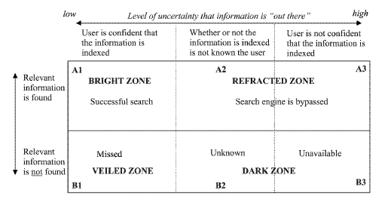
Figure 1: Distribution of the Web pages search results based on relevance [11].
Due to its dynamic nature, existing Web crawlers cannot access the Deep Web. Thus, accessing and maintaining the huge amount of Deep Web information remain challenging research issues. Information in a Deep Web site is categorized as being either in textual or structured databases. While a textual database needs input keywords for searching text documents, a structured database requires a user to fill in input fields of a query interface.
Deep Web content includes information in private databases that are accessible over the Internet but search engines are unable to crawl due to various reasons, for example, some universities, government agencies and other organizations maintain databases of information that were not created for general public access. Other sites may restrict database access to members or subscribers [9].
The Deep Web contained somewhere in the vicinity of 900 billion pages of information. In contrast, Google, the largest search engine, had indexed just 25 billion pages [8]. The term, "Deep Web," was coined by Michael K. Bergman co-founder and chairman of BrightPlanet, an Internet search technology company that specializes in searching deep Web content. In their 2001 white paper, 'The Deep Web: Surfacing Hidden Value,' Bergman noted that the Deep Web was growing much more quickly than the surface Web and that the quality of the content within it was significantly higher than the vast majority of surface Web content. Although some of the content is not open to the general public, BrightPlanet estimates that 95% of the Deep Web can be accessed through specialized search [9].

1.2.2 Ontologies
Ontology in computer science and information science is a formal representation of a set of concepts within a domain and the relationships between those concepts. It is used to reason about the properties of that domain and may be used to define the domain. In the words of Thomas Gruber, “An ontology is an explicit specification of a conceptualization. A conceptualization is an abstract, simplified view of the world that we want to represent. If the medium of specification is a formal language, then the ontology would define a representational foundation” [12].
For example, Figure 2 gives a pictorial representation of a roadway ontology which consists of various instances and their corresponding relations.

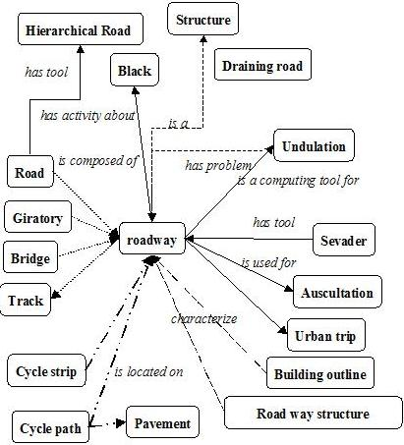
Figure 2: An example of roadway ontology [10].

According to Geller’s more precise and detailed definition of ontology, it is a graph (the data Structure). Every node of this graph stands for a “concept” which is a unit that one can think about and corresponds to words or short phrases. Typically, a concept corresponds to a noun or noun phrase like house, man, car, New York, etc., but that is not an obligation [13].
The nodes of the ontology are connected by different kinds of links. The most important kind of link is called IS-A link. The nodes and IS-A links together form a Rooted Directed Acyclic Graph (Rooted DAG). Rooted means that there is one single "highest node" called the Root. All other nodes are connected by one IS-A link or a chain of several IS-A links to the Root. In our definition IS-A links points upward. If an IS-A link points from a concept X to a concept Y that means that every real world thing that can be called an X also can be called a Y. In other words, every X IS-A Y. (Some people have IS-A-like links but pointing downwards.) Examples: A car IS-A vehicle. A dog IS-A animal [13].

Acyclic means that if you start at one node and move away from it following an IS-A link, you can never return to this node, even if you follow many IS-A links. Most nodes also have other information attached. This information includes attributes, relationships and rules [13].
Ontologies represent information in a form that can be used for some forms of reasoning that are at least partially similar to human reasoning. This includes inheritance reasoning, transitivity reasoning and classification. A concept may inherit information from several other concepts. This is called multiple inheritance. Transitivity reasoning corresponds to chaining of IS-A links. Classification means that if we know the attributes of a concept we can decide under which other concepts it belongs in the ontology.

1.2.3 Deep Web Mining
Just because a Web search engine can't find something doesn't mean it isn't there. The Deep Web is a vast information repository not always indexed by automated search engines but readily accessible to enlightened individuals. The Shallow Web, also known as the Surface Web or Static Web, is a collection of Web sites indexed by automated search engines.
A search engine robot or Web crawler follows URL links, indexes the content and then relays the results back to “search engine central” for consolidation and user query. Ideally, the process eventually scours the entire Web, subject to vendor time and storage constraints.
Most of the time, information is stored on Web sites in such a way that the user initially comes in contact with what are called Menu pages. Menus are numerous and too thin i.e. they are just having basic information and users are driven through an endless series of nested menus in order to reach important information stored on backend inside content pages as shown in Figure 2 below.
The crux of the process lies in the indexing. A Web crawler does not report what it can't index.
And we know the search result for a particular Web page in terms of its relevance depends greatly on that. This was a minor issue when the early Web consisted primarily of static generic HTML code, but contemporary Web sites now contain multimedia, scripts and other forms of dynamic content. The Deep Web consists of Web pages that search engines cannot or will not index. The popular term "Invisible Web" which refers to the Deep Web is actually a misnomer, because the information is not invisible, it's just not indexed by the Web crawler. The Deep Web is five to 500 times as vast as the Shallow Web, thus making it an immense and extraordinary online resource. The major search engines together index approximately 20% of the Web, and thus missing 80% of the content [9].

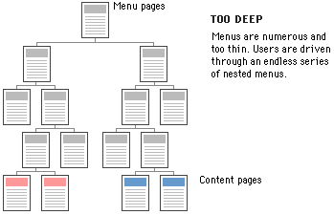
Figure 3: Information storage format on a typical Web site [10].

Search engines typically do not index the following types of Web sites:
- Proprietary sites
- Sites requiring a registration
- Sites with scripts
- Dynamic sites
- Ephemeral sites
- Sites blocked by local webmasters
- Sites blocked by search engine policy
- Sites with special formats
- Searchable databases

Proprietary sites require a fee. Registration sites require a login or password. A Web crawler can index script code (e.g., Flash, JavaScript), but it can't always ascertain what the script actually does and the Web crawler may get trapped within infinite loops. Dynamic Web sites are created on demand and have no existence prior to the query and limited existence afterward [14].
Webmasters can request that their sites not be indexed (Robot Exclusion Protocol), and some search engines skip sites based on their own inscrutable corporate policies. Not long ago, search engines could not index files in PDF, thus missing an enormous quantity of vendor white papers and technical reports, not to mention government documents. Special formats become less of an issue as index engines become smarter. The most valuable Deep Web resources are searchable databases. There are thousands of high-quality, authoritative online specialty databases. These resources are extremely useful for a focused search [14].

1.2.4 Role of Ontologies in search for Web pages

Recently, there has been a growing interest in Web searches that are intended to locate information that exists in the backend data bases of Web services. Web sites in E-commerce domains such as airfares, automobiles, books, car rentals, hotels, jobs, movies and music records usually store huge amounts of information, which is of interest to many users, in their backend databases.
Information in E-commerce backend databases is usually not “visible” to general search engines. The information in backend databases is often called Deep Web data. Finding the relevant E-commerce sites and accessing, retrieving and indexing the huge amounts of Deep Web data raises challenging research issues.
Ontologies could play an important role in assisting users in their search for Web pages. Domain ontologies can be constructed that support users in their Web search efforts and that increase the number of relevant Web pages that are returned. To achieve this goal the Deep Web information, which consists of dynamically generated Web pages, which cannot be indexed by the existing automated Web crawlers, is combined with ontologies.
The process of building ontologies consists of several steps, as shown in Figure 4. Firstly, the possible search terms, called attributes of Deep Web data sources, are automatically extracted from a static collection of Deep Web sites. Secondly, a separate domain ontology is built for each domain, using the extracted search terms. Thirdly, by probing a few Deep Web sites, domain terms from the backend databases are extracted. Next, the domain ontology is extended to include these Deep Web terms as instances. Finally, the domain ontology is extended with relationships between instances [15].
Figure 4: The Flow for an Ontology-Supported Deep Web Search [15].

2. Previous Work
The previous work on this project included addressing the problems of extracting instances from the Deep Web, enriching a domain specific ontology with those instances, and using this ontology to improve Web search. In the initial phase of the project information was gathered about all the searching information about famous people like basketball players and singers by mining the Deep Web for building an ontology based on that. This information was then used to provide users with additional search terms for making the search more specific and getting more relevant Web pages. The effectiveness of this methodology was shown by comparing the number of relevant Websites by a search engine with a user’s search terms only, with the websites found when using additional ontology-based search terms.
2.1 Enriching Ontology for Deep Web Search
Enrichment of ontology is a process that extends it by adding concepts, instances and new relations between concepts. In the related paper method for extracting instances from the DW is based on developing “robots” (agents) that sent many queries to the same DW site to extract as many data values as possible. When a robot encounters an input field it may enter random values or leave the field empty and then submit the page to elicit an informative response [13].
The concept discovery of the robot is guided by a human in its initial stage. Initial pairs of a concept and its corresponding instances are defined, which we call a robot image. The robot submits input values into the query interface. If the input values are not suitable for the form, most Websites display error messages. The analysis of the error messages often gives useful clues to the robot to guess suitable input values and launch better probing queries. Thus, the queried Web sources may provide information about concepts, instances and semantic relationships, which is recorded in the ontology [12].
2.2 Automatic Attribute Extraction from the Deep Web Data Sources
Understanding the attributes and contents of Deep Web data sources is also important in order to locate the most relevant Deep Web data sources for a user, since these sources use different attributes to access contents. The related paper presents a novel approach to automatically extract attributes from query interfaces in order to address the current limitations in accessing Deep Web data sources. It introduces the Semantic Deep Web for utilizing ontology to determine attributes to access the Deep Web [12].
In the general sense, an attribute of a Web data source is any item of information that describes this source. The more specific meaning of “attribute” is derived from the HTML/XML syntax. A tag of HTML consists of a mandatory name between angular brackets, which may be followed by optional attribute/value pairs. As an example, the Web page in Figure 5 is generated by the HTML code in Figure 6, which contains several attribute/value pairs. Thus the tag <SELECT> contains the attribute “size” with the value 2. The attribute and the value of such a pair are separated by an equal sign (=) [12].
  - Creation of Ontology Supported Web Search System (Using Checkboxes)
In our previous research on an ontology-supported Web search system, the user was presented with a number of choices of additional search terms. She could mark such terms as positive, i.e., they should be included in the Web search results, by clicking on associated check boxes (see Figure 6)[16]. One problem with this approach is that users do not want to be bothered by (too many) questions
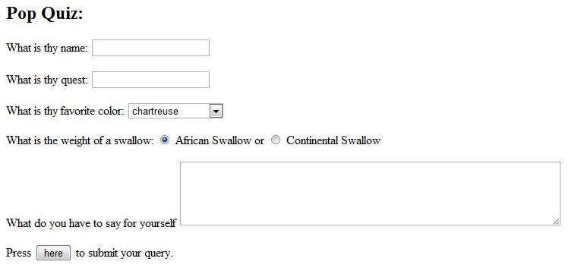
Figure 5: An Example of a simple Form [16].

Figure 6: Search screen of ontology-supported Web search system [16].

3. Introduction to Technologies

JavaScript Object Notation (JSON)
JSON (JavaScript Object Notation) is a lightweight data-interchange format. It is easy for humans to read and write. It is easy for machines to parse and generate. It is based on a subset of the JavaScript Programming Language. JSON is a text format that is completely language independent but uses conventions that are familiar to programmers of the C-family of languages, including C, C++, C#, Java, JavaScript, Perl, Python, and many others. These properties make JSON an ideal data-interchange language [5].
JSON is built on two structures:
- A collection of name/value pairs. In various languages, this is realized as an object, record, struct, dictionary, hash table, keyed list, or associative array.
- An ordered list of values. In most languages, this is realized as an array, vector, list, or sequence.
These are universal data structures. Virtually all modern programming languages support them in one form or another. It makes sense that a data format that is interchangeable with programming languages also be based on these structures.
In JSON, they take on these forms:
An object is an unordered set of name/value pairs. An object begins with “{“(left brace) and ends with”}” (right brace). Each name is followed by “:” (colon) and the name/value pairs are separated by “,” (comma) [5].
A JSONObject is an unordered collection of name/value pairs. Its external form is a string wrapped in curly braces with colons between the names and values, with commas between the values and names. The internal form is an object having get() and opt() methods for accessing the values by name, and put() methods for adding or replacing values by name. The values can be any of these types: Boolean, JSONArray, JSONObject, Number, String, NULL objects [5].
A JSONArray is an ordered sequence of values. Its external form is a string wrapped in square brackets with commas between the values. The internal form is an object having get() and opt() methods for accessing the values by index, and put() methods for adding or replacing values. The values can be any of these types: Boolean, JSONArray, JSONObject, Number, String, NULL objects [5].
A JSONException is thrown when a syntax or procedural error is detected [5].
Introduction to Google Web Toolkit (GWT)
The Google Web Toolkit (GWT) is a toolkit to develop Ajax Web application with Java. The developer can develop in Java and debug the code. Once the code is finished the GWT compiler translates the Java code into JavaScript. This compiler also makes sure that all the major browsers are correctly support [2].
To support this GWT provides two modes
- Development Mode: allows debugging the Java code of your application directly via the standard Java debugger.
- Web mode: the application is translated into HTML and JavaScript code and can be deployed on a Web server [2].
Modules, Entry Points and HTML pages
GWT applications are described as so-called modules. . A module "modulename" is described by a configuration file "modulename.gwt.xml". Each module can define one or more Entry points classes.
- An entry point in GWT is the starting point for a GWT application similar to the main method in a standard Java program.
- The module is connected with an HTML page, which is called in GWT the host page. The code for a GWT Web application executes within this HTML document. The HTML page can define "div" containers to which the GWT application can assign UI components. Alternatively the GWT UI components can be assigned to the body of the HTML page [2].
GWT provides its own remote procedure calls (RPC's) which allow the GWT client to call server-side methods. The implementation of GWT RPC is based on the servlet technology. GWT allows Java objects to be sent directly between the client and the server; which are automatically serialized by the framework. With GWT RPC the communication is almost transparent for the GWT client and always asynchronous so that the client does not block during the communication.
The server-side servlet is usually referred to as a "service" and the a remote procedure call is referred to as "invoking a service." These objects can then be used on the client (UI) side.
To create a GWT service you need to define the following:
- An interface which extends RemoteService that lists the service methods.
- An implementation - implements the interface and extends the RemoteServiceServlet.
- Define an asynchronous interface to your service which will be used in the client code [2].
The client server communication is based on an interface which defines the possible communication methods.
GWT uses asynchronous communication therefore you also need to create the asynchronous version of this interface. The name of this interface must be the interface name concatenated with "Async" [2].
To receive a callback a class needs to be implemented which can then react on a failure or success in the communication. The interface AsyncCallback defines these two methods: "OnSuccess" and "OnFailure"[2].
Debugging a GWT application in development mode is easy. In this case you can just debug the Java code. Put a breakpoint into your coding and start the debugger via selecting your project, right-mouse click → debug as → Web Application [2].
Cypal Studio and GWT
Cypal Studio for GWT is a set of Eclipse plugins for making GWT development easier. It currently helps you in:
- Creating a module
- Creating a remote service
- Maintaining the Async file
- Running your app in hosted mode
- Compiling your app to JavaScript
- Deploying to an external server
- Exporting as WAR operation
GWT is a set of tools that allows a Java programmer to write dynamic Ajax Web applications completely within the Java programming language, with no JavaScript required. A GWT application runs in all the major browsers, allows for rich interaction with the user, and can be fully tested and debugged within your Java development environment.
The GWT framework has four major components. A collection of widgets, implemented in the Java language, provides all the standard user interface (UI) functionality you would expect in a somewhat simpler application program interface (API) than, say, Swing. A remote procedure mechanism allows for communication between client and server, with GWT handling all the pipe and data translation. A fully integrated browser simulator allows GWT to run on its own during development, including niceties like being able to set breakpoints in your editor during a GWT debugging session. Finally, a compiler converts your Java code into the cross-browser JavaScript code that is actually executed in the client browser [6].
While GWT simplifies the process by which you create an Ajax application, it still has several parts you must keep synchronized for it to work. As of this writing, advanced tool support for GWT is beginning to emerge in the major Java development environments [6].
Cypal Studio for GWT is a plug-in for Eclipse that simplifies many of the common tasks performed during GWT development [6].
Eclipse Integrated Development Environment (IDE)
Download eclipse from http://www.eclipse.org/downloads/
Installing Google Plugin:
- Start Eclipse, then select Help > Install New Software... In the dialog that appears, enter the update site URL into the Work with text box: http://dl.google.com/eclipse/plugin/3.5
Click on the Add... button.
- Leave the Name text box empty (the name will be retrieved from the update site). Click OK.
- Back in the Install dialog, you should see the center box filled with Plugin and SDKs. Select the checkbox next to both of these. This will install the plugin, a Google App Engine Java SDK and a Google Web Toolkit SDK. Click Next.
- Review the features that you are about to install. Click Next.
- Read the license agreements and then select I accept the terms of the license agreements. Click Finish.
- You will then be asked be asked if you would like to restart Eclipse. Click Yes.
Apache Tomcat Web Server
The application is deployed in Tomcat container and runs on an Apache Web server.
Introduction
Apache Tomcat is an open source software implementation of the Java Servlet and JavaServer Pages technologies. The Java Servlet and JavaServer Pages specifications are developed under the Java Community Process [3].
Apache Tomcat is developed in an open and participatory environment and released under the Apache License version 2. Apache Tomcat is intended to be a collaboration of the best-of-breed developers from around the world. Apache Tomcat powers numerous large-scale, mission-critical Web applications across a diverse range of industries and organizations [3].
Installing Tomcat Preconfigured to Eclipse
- Unzip Tomcat. Unzip tomcat-6.0.18-preconfigured.zip into the top level of the C drive.
- Tell MyEclipse about Tomcat. Select Window, Preferences, MyEclipse, Servers, Tomcat, Tomcat 6. Click "Enable". Select "Tomcat Home Directory" and hit "Browse". Navigate to the Tomcat installation directory Click Apply & OK.
- Run Tomcat. Click on Servers tab at bottom. R-click on Tomcat 6, choose "Run Server". Open http://localhost/ in a browser.
- Import and Test a Sample Web App. Grab intro-app-myeclipse.zip, save it, and import it into MyEclipse. Use File, Import, Existing Projects, Select archive file. Then click Browse and navigate to intro-app-myeclipse.zip. Click on Servers tab at bottom. R-click on Tomcat 6, choose "Manage Deployments". Choose intro app. Start Tomcat if not already running. Open http://localhost/intro/ in browser [22].

Our Work

Predicting Web Search Hit Counts

We studied technologies like JSON, Bing API and Yahoo! BOSS API. In this part of the project, we are predicting hit count estimates based on the frequency of the search terms supplied to two search engines, Bing and Yahoo!. Frequencies are taken from a corpus of the English language [27]. A number of second degree correlation functions were derived, based on samples from the word list of the corpus. The derived functions are then used for the purpose of predicting the hit count estimates. Due to the varying behavior of the search engines depending on the number of search terms passed to them, we have derived separate correlation functions for 30 different cases. We also studied the effect of adding negative search terms in the queries.

4.1.1 Hits Extraction from Bing API (Application Programming Interface)

Bing API
You can send a request to the Bing Application Programming Interface (API) using one of three protocols:
- JavaScript Object Notation (JSON), a data interchange format based on a subset of the JavaScript programming language.
- Extended Markup Language (XML), a flexible data format derived from Structured Generalized Markup Language (SGML).
- SOAP (originally an acronym for Simple Object Access Protocol), an XML-based protocol for exchange of information in a decentralized, distributed environment [4].
Using JSON (Bing, Version 2)
The Bing JSON interface is an HTTP GET interface which accepts search requests in URL format and returns search results in JSON format [4].

Sending a Request in URL Format
In order to use the JSON interface, you need to know is how to submit a search request in URL format. When a search request is submitted in URL format, each URL parameter presents a field in the search request. A simple search request that returns a Web result and a Spell result could look like this:
http://api.bing.net/json.aspx?AppId=YOUR_APPID&Version=2.2&Market=en-US&Query=testign&Sources=web+spell&Web.Count=1
AppId, Version, Market, Query, and Sources are the first-level fields of SearchRequest object, which can be directly specified as URL parameters. Simple types like AppId can be specified by the syntax Field=Value. However, array types such as Sources, the list of SourceType enumerations, should be separated by +. Thus, the syntax will look like Field=Value1+Value2+…+ValueN. In addition, to specify the value of fields in a structure type, like Count in WebRequest, the . operator is used to access sub-fields with the syntax Field.SubField=Value.
Note: Arrays of arrays or structures are not supported in the request interface of Bing API 2.0. For arrays of strings, space in each string must be encoded. For example, use %20 as opposed to + [4].

Using JSONType
For the JSON interface, there is an interface-specific parameter JSONType, which can control the format of the response. If raw enumeration is specified, search results are returned in pure JSON format. If callback enumeration is specified, a JavaScript statement will be returned to call the callback function specified in the JSONCallback parameter and search results will be passed in as arguments. If the function enumeration is specified, a JavaScript function will be returned and the search results will be returned when the function is invoked. The following sections give an example request and response for each of these options [4].

Raw Enumeration Example

Request
http://api.bing.net/json.aspx?AppId=YOUR_APPID&Version=2.2&Market=en-US&Query=testign&Sources=web+spell&Web.Count=1&JsonType=raw
Note: For information about obtaining an AppId, create an account with Hotmail [4].

Response
Copy
{
"SearchResponse":{
"Version":"2.2",
"Query":{
"SearchTerms":"testing"},
"Spell":{
"Total":1,
"Results": [
{"Value":"testing”} ]
},
"Web":{
"Total":5100,
"Offset":0,
"Results": [
{ "Title":"Testing part 2 - Tiernan OTools Programming Blog",
"Description":"If this works, it means nothing really, but i have managed to build a .TEXT blog posting app. could be handy if i move my main blog to .TEXT, which i am thinking about..",
"Url":"http:\/\/weblogs.asp.net\/tiernanotoole\/archive\/2004\/09\/24\/233830.aspx",
"DisplayUrl":"http:\/\/weblogs.asp.net\/tiernanotoole\/archive\/2004\/09\/24\/233830.aspx",
"DateTime":"2008-10-21T05:08:05Z"
}
]
}}}[4]

The request consists of various positive and negative terms. The response is received in JSON format. The response object from Bing API is called ‘SearchResponse.’ From ‘SearchResponse,’ ‘Web’ object is extracted. In Web object there is a field called ‘Total.’ This field is the total number of hits returned from Bing API. This information is extracted from response of the request that was sent to the API.

count=json.getJSONObject("SearchResponse").getJSONObject("Web").getLong("Total");

The number of hits was found out using Bing API. Various analytical measures like correlation and standard deviation were computed between the predicted number of hits and the actual hits. The regression analysis graph was plotted using Matlab. The Matlab program read from the input files, i.e. the hit count file and the frequency file. The analysis was done for 30 word files which had various combinations of positive terms and negative terms [17].

4.1.2 Hits Extraction from Yahoo! API (Application Programming Interface)
Yahoo! Build your Own Search Service Application Programming Interface (BOSS API)
BOSS (Build your Own Search Service) is Yahoo!'s open search Web services platform. The goal of BOSS is simple: to foster innovation in the search industry. It also allows researchers to utilize the entire Yahoo! Search index. BOSS gives access to Yahoo!'s investments in crawling and indexing, ranking and relevancy algorithms, and powerful infrastructure. By combining our ideas with Yahoo! search technology assets, BOSS is a platform for the next generation of search innovation, serving hundreds of millions of users across the Web [23].
The first step involves registering with Yahoo! to obtain an app id which will be used while querying to obtain the result in the specified format. The argument value consists of a comma-separated list specifying the document types or type groups to include. A format group is a logical collection of several document formats for simplification. Format currently supports the following document types [23]:
- html
- text
- pdf (Adobe Portable Document Format)
- xl (Microsoft Excel: xls, xla, xl)
- msword (Microsoft Word)
- ppt (Microsoft Power Point)
Format currently supports the following type groups:
- msoffice: xl, msword, ppt
- nonhtml: text, pdf, xl, msword, ppt
You can also specify a format group then exclude an item:
- type=msoffice,-ppt
This example searches for the same query term in the nonhtml type group (text, pdf, xl, msword, ppt):
- type=nonhtml
You can combine inclusion, exclusion, document types, and type groups like this:
- type=html,msoffice,-pdf [23].
Example:
http://boss.yahooapis.com/asearch/web/v1/moon?format=xml&count=2&type=msoffice
http://boss.yahooapis.com/ysearch/web/v1/apple?appid=PhYT4G3V34E5h3hmjpIuc7Al2BFixwpO0xIPyoyLTLSbl5WJS4Vs___eGi1UpWMW6b_h&format=json
Here “apple” is the value to query, the next part of the query string is the app id that is obtained after registering with Yahoo! and the last part is the format of the result. I have requested this result to be returned in JSON format.
Response
Part of search response
{"ysearchresponse":{"responsecode":"200","nextpage":"\/ysearch\/web\/v1\/apple?format=json&count=10&appid=PhYT4G3V34E5h3hmjpIuc7Al2BFixwpO0xIPyoyLTLSbl5WJS4Vs___eGi1UpWMW6b_h&start=10","totalhits":"123950386","deephits":"813000000","count":"10","start":"0","resultset_web":}}

The request consists of various positive and negative terms. The response object is received in JSON format. The response object from Yahoo! API is called ‘ysearchresponse.’ The field called ‘totalhits’ is the total number of hits returned from Yahoo! API. This information is extracted from response of the request that was sent to API.

Matlab

Just as for the Bing API various analytical measures like correlation and standard deviation were computed between the predicted number of hits and the actual hits. A regression analysis graph was plotted using Matlab. The Matlab program read from the input files, i.e. the hit count file and the frequency file. The analysis was done for 30 word files which had various combinations of positive terms and negative terms [18].

The first set of files had one positive word and had one/two/three/four or five negative words. The second set of files had two positive words and one/two/three/four or five negative words. The third set of files had three positive words and one/two/three/four or five negative words. The fourth set of files had four positive words and one/two/three/four or five negative words. The fifth set of files had five positive words and one/two/three/four or five negative words [17] [18].

4.1.3 Results of the Experiments
In Figure 7, the X axis represents the word frequencies for one search term and Y represents the corresponding Yahoo! hit count estimates, both in log scale. We notice that most of the outliers appear when the frequencies or the hit counts are relatively low or high. Thus, a trimmed mean method will be applied. We discard the words with the lowest 1% and the highest 1% frequencies. Next, we discard the words with the lowest 1.5% and the highest 1.5% hit count estimates. In total, 4.94% edge data are trimmed.
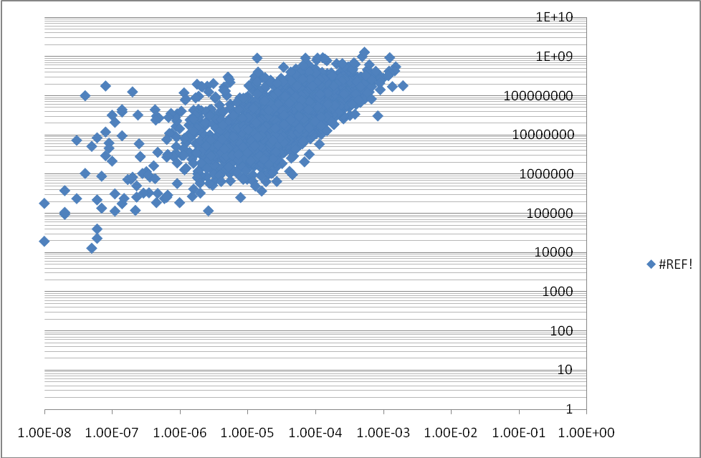
Figure 7: Scatter plot of word frequencies and Yahoo! hits in log-log scale for a positive term
The cases are named in the format of aPbN, where aP represents the number of positive terms and bN represents the number of negative ones. Thus 2P3N stands for the case with 2 positive and 3 negative search terms.

Table 1: Correlation summary for thirty Cases
 | Bing  Average Error (E) (%) | Bing  Deviation (SD) (%) | Bing RMS (%) | Yahoo! Average Error (E) (%) | Yahoo!  Deviation (SD) (%) | Yahoo! RMS (%)
1P | 113.0 | 69.6 | 124.8 | 61.4 | 24.3 | 64.7  7
2P | 103.4 | 59.9 | 116.9 | 68.2 | 29.6 | 73.1
1P1N | 103.4 | 49.7 | 110.2 | 97.6 | 40.6 | 111.8
3P | 84.6 | 18.3 | 85.0 | 81.1 | 38.7 | 89.2
2P1N | 42.8 | 13.9 | 46.0 | 140.8 | 77.3 | 161.1
1P2N | 76.0 | 32.6 | 78.1 | 78.1 | 56.0 | 97.2
4P | 134.3 | 97.6 | 153.7 | 76.3 | 50.7 | 90.2
3P1N | 119.9 | 121.0 | 147.7 | 76.5 | 42.2 | 88.6
2P2N | 205.8 | 149.1 | 187.7 | 78.3 | 51.4 | 89.8
1P3N | 75.2 | 48.8 | 85.5 | 86.9 | 54.4 | 96.8
5P | 131.1 | 64.7 | 140.1 | 95.1 | 76.0 | 116.5
4P1N | 70.3 | 23.4 | 73.8 | 102.6 | 42.1 | 104.4
3P2N | 144.5 | 162.2 | 199.0 | 75.9 | 65.7 | 98.6
2P3N | 143.6 | 178.1 | 212.1 | 72.2 | 66.1 | 95.4
1P4N | 70.5 | 61.7 | 92.7 | 92.6 | 66.8 | 107.2
5P1N | 139.2 | 62.7 | 150.5 | 61.6 | 40.9 | 77.1
4P2N | 114.3 | 57.2 | 127.7 | 260.4 | 228.0 | 161.6
3P3N | 97.2 | 81.0 | 116.0 | 91.6 | 62.4 | 105.5
2P4N | 141.2 | 100.7 | 164.1 | 139.0 | 121.8 | 156.1
1P5N | 63.3 | 54.7 | 84.0 | 103.8 | 109.9 | 147.3
5P2N | 94.9 | 60.9 | 108.5 | 100.0 | 85.5 | 119.9
4P3N | 95.0 | 48.2 | 107.0 | 127.4 | 224.2 | 89.4
3P4N | 89.0 | 50.9 | 100.8 | 94.2 | 64.5 | 98.4
2P5N | 104.6 | 60.6 | 114.9 | 266.3 | 341.7 | 199.0
5P3N | 68.2 | 45.6 | 82.4 | 106.3 | 95.7 | 139.5
4P4N | 120.0 | 86.7 | 133.4 | 125.3 | 109.4 | 165.9
3P5N | 82.4 | 41.5 | 92.5 | 114.4 | 91.3 | 124.3
5P4N | 79.2 | 60.4 | 98.1 | 51.6 | 24.5 | 58.9
4P5N | 80.7 | 59.0 | 92.5 | 84.9 | 68.5 | 106.9
5P5N | 80.3 | 48.8 | 92.1 | 99.9 | 38.8 | 107.0
Avg | 102.3 | 69.0 | 117.3 | 103.7 | 83.0 | 111.4

4.2 Ontology - Supported Web Search
While a user types in the first (few) word(s) of her search, the search engine displays several suggested search completions, which will possibly describe the search that the user has in mind. These completions are presumably based on the observed frequencies of many searches of other search engine users [3]. While the user continues to type, the suggested completions change rapidly. Most major search engines have such a mechanism. Google calls them “query suggestions” appearing in the “search box”, Yahoo! calls them “search assistant”, and Bing calls them “search suggestions”.
Creating Web Application
To create a Web Application, select File > New > Web Application Project from the Eclipse menu.
In the New Web Application Project wizard, enter a name for your project and a java package name, e.g., com.mycompany.mywebapp. If you installed the Google App Engine SDK, the wizard gives you the option to use App Engine as well. For now, uncheck this option and click Finish [24].

Data Service - Server & Client Side
For our application we need a service that provides data for our client side page. This service will be provided through a servlet which is running on the server side. Generally, we would write only a single servlet that extends from javax.servlet.http.HttpServlet, but in GWT we must define two interfaces inside client package (com.njit.mansi.autocompletegwt.client) along with the servlet [25].

Service Interface
The services provided by the server-side must be declared in a Service interface first. The methods declared in the Service interface will be available to the client side. It is an interface which must extend the com.google.gwt.user.client.rpc.RemoteService interface. We defined the service interface with only one method that returns a string [25].
package com.njit.mansi.autocompletegwt.client;

import com.google.gwt.user.client.rpc.RemoteService;
import com.google.gwt.user.client.rpc.RemoteServiceRelativePath;

@RemoteServiceRelativePath("autocomplete")

public interface AutoCompleteService extends RemoteService {

String autocompleteServer() throws IllegalArgumentException;

public String[] getSuggestions(String s);
}

Asynchronous Service Interface
Next we defined another interface called "Asynchronous interface." This interface is used to define the asynchronous feature of the service. That is, whenever a call is made to this interface, the caller can expect the service to be asynchronous and the result will be available after sometime. The caller must provide a callback object to receive the resulting data. There are some important points to note [25].
- Asynchronous interface must be in the same package as the service interface.
- This interface's name must be as <Service-Interface-Name>Async (same name with Async suffix).
- Add a new parameter of type com.google.gwt.user.client.rpc.AsyncCallback to the parameter list of every method.
- All methods must have void as return type.
package com.njit.mansi.autocompletegwt.client;

import com.google.gwt.user.client.rpc.AsyncCallback;

public interface AutoCompleteServiceAsync {
void autocompleteServer(AsyncCallback<String> callback)
throws IllegalArgumentException;
public void getSuggestions(String s, AsyncCallback<String[]> callback);
}
The above interface is named AutoCompleteServiceAsync (using AutoCompleteService + Async) and the AutoCompleteService.getSuggestions()method is provided with a new parameter while having void return type [25].

Service Servlet

Define the service servlet which does the actual work. This class must implement above declared AutoCompleteService interface and extend the com.google.gwt.user.server.rpc.RemoteServiceServlet class [25].

package com.njit.mansi.autocompletegwt.server;
import com.google.gwt.user.server.rpc.RemoteServiceServlet;
import com.njit.mansi.autocompletegwt.client.AutoCompleteService;
public class AutoCompleteServiceImpl extends RemoteServiceServlet implements AutoCompleteService {

public String[] getSuggestions(String boxcontent){
//Coding Logic
}
}
Above class implements the getSuggestions() method of AutoCompleteService interface and returns a String array with simple logic. Even though we call this a servlet, no servlet specific implementation is available. The super class, RemoteServiceServlet is a servlet [25].

Servlet Configuration (web.xml)
Now we have to specify the servlet in a web.xml file.
Create a file named web.xml inside AutoCompleteGWT/war/lib folder with the following content [25].
<?xml version="1.0" encoding="UTF-8"?>
<!DOCTYPE web-app
PUBLIC "-//Sun Microsystems, Inc.//DTD Web Application 2.3//EN"
"http://java.sun.com/dtd/web-app_2_3.dtd">

<web-app>

<!-- Servlets -->
<servlet>
<servlet-name>autocompleteServlet</servlet-name>
<servlet-class>com.njit.mansi.autocompletegwt.server.AutoCompleteServiceImpl</servlet-class>
</servlet>

<servlet-mapping>
<servlet-name>autocompleteServlet</servlet-name>
<url-pattern>/autocompletegwt/autocomplete</url-pattern>
</servlet-mapping>

<!-- Default page to serve -->
<welcome-file-list>
<welcome-file>AutoCompleteGWT.html</welcome-file>
</welcome-file-list>

</web-app>

Here we have defined a URL pattern for our above mentioned AutoCompleteServiceImpl servlet.

Widget
Client Side
Widget is the component displayed on the Web page. The application is sent across the network to a user, where it runs as JavaScript inside their Web browser. Everything that happens within the user's Web browser is referred to as client-side processing. When you write client-side code that is intended to run in the Web browser, remember that it ultimately becomes JavaScript. Thus, it is important to use only libraries and Java language constructs that can be translated into JavaScript [20].
Creating an Entry Point Class
To begin writing a GWT module, subclass the EntryPoint class.
Writing the entry point method
The entry point method is onModuleLoad(). It contains the code that executes when you launch the application. Typically, the types of things you do in the onModuleLoad() method are:
- create new user interface components
- set up event handlers
- modify the browser DOM in some way

public class AutoCompleteGWT implements EntryPoint {
private final AutoCompleteServiceAsync greetingService = GWT.create(AutoCompleteService.class);

public void onModuleLoad() {}

}

SuggestBox
A SuggestBox is a text box or text area which displays a pre-configured set of selections that match the user's input. Each SuggestBox is associated with a single SuggestOracle. The SuggestOracle is used to provide a set of selections given a specific query string [20].
Note: This has nothing to do with an Oracle database.
By default, the SuggestBox uses a MultiWordSuggestOracle as its oracle. Below we show how a MultiWordSuggestOracle can be configured:
MultiWordSuggestOracle oracle = new MultiWordSuggestOracle();
oracle.add("Cat");
oracle.add("Dog");
oracle.add("Horse");
oracle.add("Canary");

SuggestBox box = new SuggestBox(oracle);

Using the example above, if the user types "C" into the text widget, the oracle will configure the suggestions with the "Cat" and "Canary" suggestions. Specifically, whenever the user types a key into the text widget, the value is submitted to the MultiWordSuggestOracle [20].
Sever Side Coding
Creating Database Access in GWT
1. Add your DB connector JAR to your Tomcat's classpath.
2. Add TWO interfaces to your project's client package that specify all the methods you can call from within your GWT user interface: One for synchronous callback, one for asynchronous callback. In those, specify the methods that will provide DB queries for you.
3. Add a DB connection class to your project's server package that will handle all the DB queries, just like with any other Java application. This class must extend RemoteServlet and implement your synchronous interface from point 2.
4. Add a RPC provider that implements the asynchronous interface to the GWT application component that needs to query the DB. Also add a nested class to that GUI component that implements AsyncCallback. This handler will do stuff with your GUI depending on the query result.
5. Now you can call the method specified by your interfaces using the RPC provider and applying the callback handler.
6. Create some serializable objects on client side to send more than primitive types (including Strings) to and from the database [20].

Java Database Connectivity (JDBC)
The Java Database Connectivity API is a set of classes allowing a straightforward and vendor-neutral access to database management systems. We will review the basic features of JDBC and their use with the Oracle database [26].

Accessibility
JDBC provides a set of high-level classes that enable anyone acquainted with SQL and Java to write database applications. Considerations like networking and database protocols are transparent to the application programmer. These are handled by classes within JDBC drivers [26].
We have used the thin driver to connect to Oracle and execute an update statement.
private boolean establishConnection() {

try {
DriverManager.registerDriver(new oracle.jdbc.driver.OracleDriver());
String url1 = System.getProperty("JDBC_URL");
if (url1 != null)
url = url1;
conn = DriverManager.getConnection (url, user, password);
return true;
} catch (Exception e) {
// If there is any security exception, ignore it
// and use the default
return false;
}

}

Screen Shots
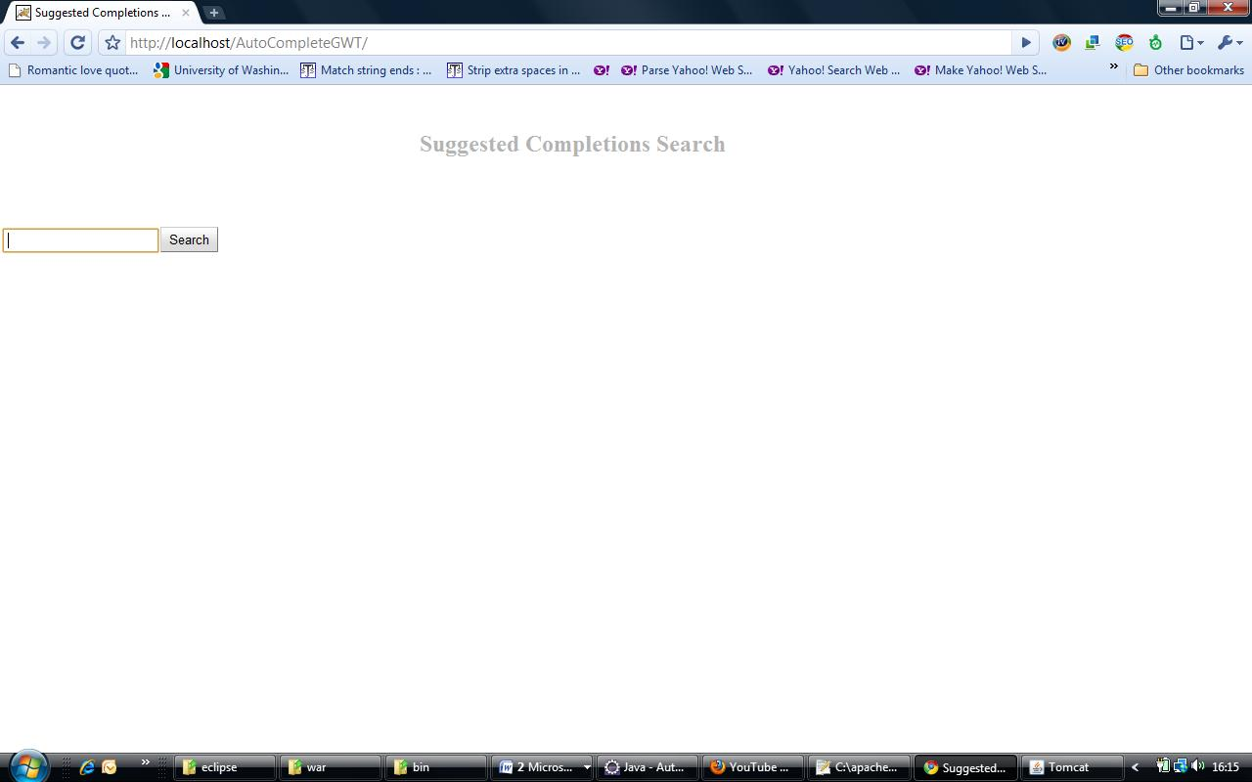
Figure 7: Suggested Completions Search interface
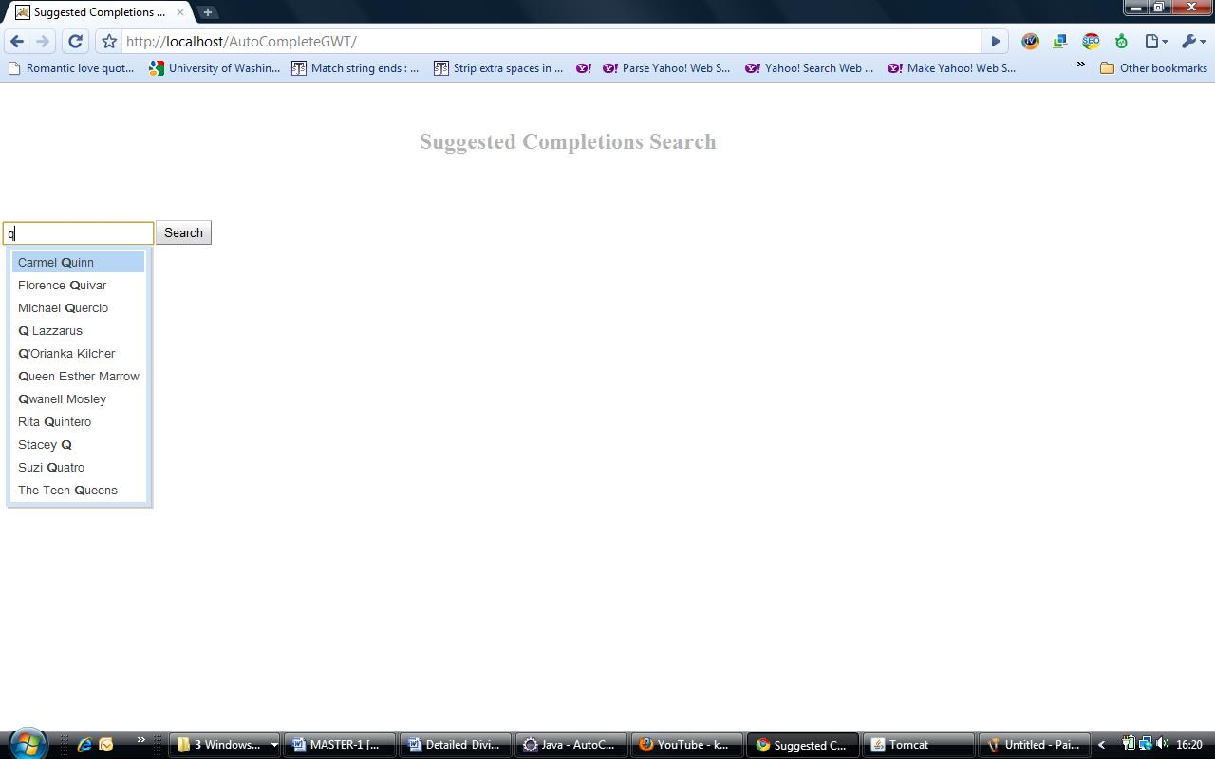
Figure 8: Suggestion for the letter “q”.
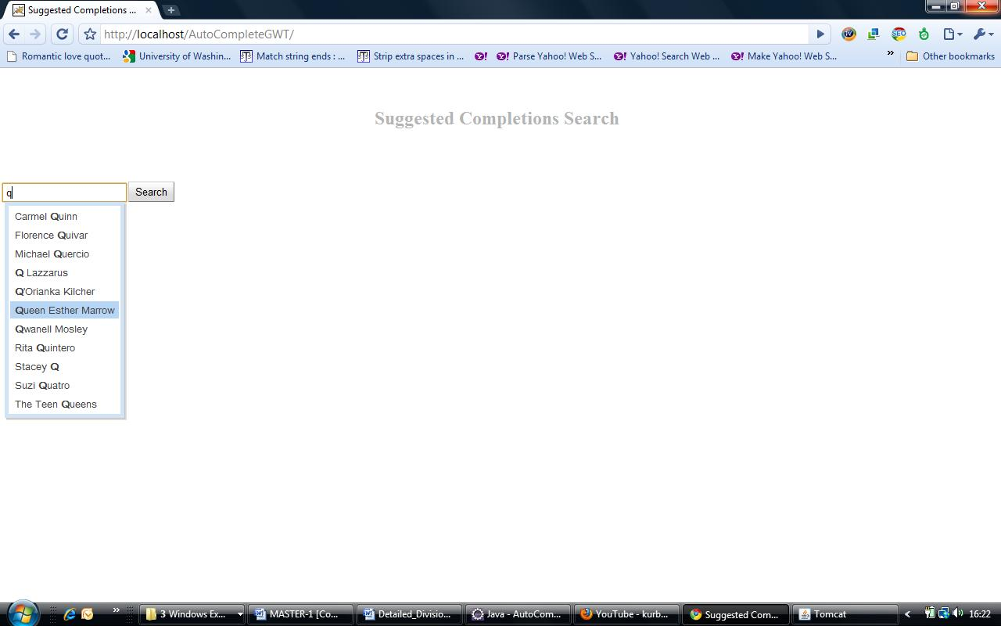
Figure 9: Selected “Queen Esther Marrow” from the list of suggestions.
Detailed Division of Project Work
Work done by Mansi Pedgoankar:
- Worked with the Yahoo! BOSS API.
- Retrieved the hit counts for 30 word files using the Yahoo! API.
- Did the regression analysis for the 30 files.
- Worked on the Matlab Program for 30 word files.
- Downloaded and configured Eclipse IDE with Apache Tomcat.
- Developed interface using Google Web Toolkit (GWT).
- Used event handlers in the Google Web Toolkit.
- Created policy.d file in Apache Tomcat to allow GWT to access local files and Oracle database. This allows GWT to connect to Oracle database without violating any security restrictions.
Work done by Anushri Mahajan
- Worked with the Bing API.
- Retrieved the hit counts for 30 word files using the Bing API.
- Did the regression analysis for the 30 files.
- Worked on the Matlab Program for 30 word files.
- Downloaded and configured Eclipse IDE with Apache Tomcat.
- Configured Oracle database system with the Google Web Toolkit.
- Connected Oracle database system with the Web Interface.
- Queried the database for corresponding values as the input text changes.
- Conclusions
In this part of project we have motivated and described a method for predicting hit count estimates based on the frequency of the search terms supplied to common search engines. Yahoo! Search and Bing were studied in this report. Frequencies were taken from a corpus of the English language [27]. A number of second degree correlation functions were derived, based on samples from the word list of the corpus. The derived functions were then used for the purpose of predicting the hit count estimates. Due to the varying behavior of the search engines depending on the number of search terms passed to them, we have derived separate correlation functions for 30 different cases. Our experiments indicated that the predictions made for our samples were very close to the hit count estimates returned by the search engines.
We also studied the effect of adding negative search terms in the queries. In the second part of the experiments it was shown that when between one and five negative search terms are added to a single positive search term, the observed hit count estimates do not behave monotonically for many cases.
We have also worked on an interface mechanism that improves the previous work on ontology-supported Web search by the method that common search engines use for suggesting completions of user search terms. While a user types in the first (few) word(s) of her search, the search engine displays suggested search completions, which will possibly describe the search that the user has in mind. While the user continues to type, the suggested completions change rapidly. Most major search engines have such a mechanism. Suggested completions are presented to the user while she is typing and is generated very quickly to avoid any appreciable delay.

6. Future Work
For the Web search prediction using Bing API and Yahoo! API we used 30 sample files. For each file we derived a trend line. The use of thirty different trend lines for different numbers of search terms appears excessive. In the future we will attempt to reduce the number of prediction functions to a smaller set, with each function covering several cases.
For the future we would like to create the Ontologies for domains like Politicians and Religious leaders. This is done so that the Ontology supported Web Search can be extended to other domains too.
Suggested completions can also have negative search words. This might make the search easier for the user. For Example, Michael Jackson Basketball –Singer
In both those suggested completions we are using a bold font to indicate the words that have been entered by the user. Thus, neighbors of a node that are used as positive search terms for one homonym should be introduced as negative search terms for the other homonym. To our knowledge, none of the major existing search engines suggests completions with negative search terms to the users.
The negative sign in front of the word would mean:
Michael Jackson Basketball [but not] Singer
Michael Jackson Singer [but not] Basketball

Conceptually, we also plan to study how many negative terms should be added in each suggested query. Adding too many might result in getting no Web search results at all. It is highly undesirable to suggest a completion to a user which will then not result in any Web page hits.

References:
1. J.Geller. Definition of Ontology, http://web.njit.edu/~geller/what_is_an_ontology.html, retrieved on February 16, 2009.
2. Google Web Toolkit: http://www.vogella.de/articles/GWT/article.html, retrieved on May 8, 2010.
3. Apache Tomcat: http://tomcat.apache.org/, retrieved on May 7, 2010.
4. Bing API http://msdn.microsoft.com/en-us/library/062fe394-e595-4589-b205-9323aa7bebad, retrieved on May 7, 2010.
5. JSON article http://www.json.org/, retrieved on May 7, 2010.
6. Eclipse IDE documentation : http://www.ibm.com/developerworks/opensource/library/os-eclipse-ajaxcypal/, retrieved on May 7, 2010.
7. Y. An, S. Chun, K. Huang and J. Geller, “Enriching
Ontology for Deep Web Search”, DEXA 2008, Lecture Notes in Computer Science, Turin, Italy, September 2008, vol. 5181, pp 73-80.
8. Deep Web accessed http://en.wikipedia.org/wiki/Google_search, retrieved on February 21, 2009.
9. Articles on Deep Web accessed http://brightplanet.com, retrieved on February 21, 2009.
10. Database creation of Artists and Basketball Players by A. Rajbar.
11. D. Radev, Fan, W., Zhang, Z.: Web In Essence: A Personalized Web-Based Multi-Document Summarization and Recommendation System. In: NAACL Workshop on Automatic Summarization. Pittsburgh, PA (2001).
12. T. Gruber (2008), Ontology. Entry in the Encyclopedia of Database Systems, L. Liu and M. T. Özsu (Eds.), Springer-Verlag. retrieved on February 16, 2009.
13. J. Geller. Definition of Ontology, http://web.njit.edu/~geller/what_is_an_ontology.html, retrieved on February 16, 2009.
14. For article on Deep Web accessed http://www.computerworld.com/, retrieved on April 16, 2009.
15. Y. An, S. Chun, K. Huang, J. Geller: Enriching Ontology for Deep Web Search. DEXA 2008: 73-80, retrieved on January 24, 2009.
16. Creation of ontology by Y. Bhat.
17. A. Mahajan worked on Bing API and Web Interface.
18. M. Pedgoankar worked on Yahoo! BOSS API and Web Interface.
19. Installing Eclipse IDE accessed http://code.google.com/webtoolkit/usingeclipse.html, retrieved on May 5, 2010.
20. GWT Suggested Box http://code.google.com/webtoolkit/doc/latest/DevGuideCodingBasicsClient.html#creating, retrieved on May 5, 2010.
21. Connecting Database with GWT Application http://www-lehre.inf.uos.de/~btenberg/tenbergen.org/misc/DB-Access-in-GWT-The-Missing-Tutorial.pdf, retrieved on May 7, 2010.
22. Installing Apache Tomcat with Eclipse IDE, http://www.coreservlets.com/Apache-Tomcat-Tutorial/eclipse.html, retrieved on May 5, 2010.
23. Yahoo! Developer Network, BOSS API Guide, http://developer.yahoo.com/search/boss/boss_guide/BOSS_Getting_Started.html, retrieved on May 10, 2010.
24. Google Web Toolkit Documentation, http://code.google.com/webtoolkit/usingeclipse.html, retrieved on May 10, 2010.
25. GWT Tutorial, http://lkamal.blogspot.com/2008/09/java-gwt-servlets-web-app-tutorial.html, retrieved on May 5, 2010.
26. Introduction to Oracle and Java, http://lkamal.blogspot.com/2008/09/java-gwt-servlets-web-app-tutorial.html, retrieved on May 5, 2010.
27. American National Corpus (ANC), http://www.americannationalcorpus.org/, retrieved on March 21, 2010.

Appendix A: User Manual

A.1 Installing Java [16]

A1.1 Downloading JDK 1.6
You can download the latest JDK 1.6 from http://java.sun.com/javase/downloads/index.jsp. The Windows version of JDK download file is named jdk-6-windowsi586.exe.
NOTE: New versions or updates may be available. If you download a new version or an update version, the file name may be slightly different from jdk-6-windowsi586.exe.

A1.2 Installing JDK 1.6 on Windows
Follow the steps below to install JDK 1.6:
1. Double click jdk-6-windows-i586.exe to run the installation program. You will see the JDK License dialog displayed.
2. Click Accept to display the JDK Custom Setup dialog.
3. You may install JDK in a custom directory. For simplicity, don’t change the directory. Click Next to install JDK. After a while, the JRE Custom Setup dialog is displayed.
4. You may install JRE in a custom directory. For simplicity, don’t change the directory. Click Next to install JRE.
5. After installation completed, the complete dialog is displayed. Click Finish to close the dialog.
6. For testing the installation just open Windows command prompt through
Start→Run→: typing `cmd` and type `javac` at the command prompt this will give you the listing of all the java classes installed.

A1.3 Configuring JDK 1.6 on Windows
To configure JDK is to make it available in the operating system so that Windows can find your JDK commands such as javac.
To configure JDK on Windows NT, 2000, ME, and XP, set the environment variables as follows:
1. Right-click the My Computer icon on your desktop to display a context menu. Choose Properties from the context menu to open the System Properties window.
2. In the System properties window, click Environment Variables in the Advanced tab to display the Environment Variables window.
3. You can set or modify user variables or systems variables. User variables affect the individual users and system variables affect all the users in the system. In the User variables section, select PATH and click Edit if PATH is already a user variable. Otherwise, click New to display the New User Variable Window.
4. Type PATH in the Variable field and c:\Program Files\Java\jdk1.6.0\bin;%path% in the Variable Value field. Click OK.
NOTE: You don’t have to reboot the computer, but you have to open a new command window to use JDK commands.
NOTE: If you download a new version or an update version, the directory name jdk1.6.0 may be slightly different.
For example, the directory name is jdk1.6.0_02 for JDK 1.6 Update 2.
A 1.4 Configuring Cypal studio on Eclipse
Before you can work with Cypal Studio for GWT, you must download it. As of this writing, the current GWT version is 1.3, and it's available for Microsoft® Windows®, Mac OS X, and Linux®. Cypal may not support the GWT V1.4 release candidate that was available as this was written. Simply download the file for your operating system, extract it, and place the resulting folder someplace handy.
Next, you need a version of Eclipse with the Web Tools Platform (WTP) plug-ins. WTP is an omnibus collection of tools supporting Web application development. It includes editor support for Web standards, such as HTML and Cascading Style Sheets (CSS), JavaServer Pages (JSP) editor support, support for creating and maintaining the database you use in your Web application, and running the application on a Web server during development.
Those features are all very nice, but they're somewhat outside the scope of this article. At the moment, we are interested in WTP because Cypal Studio for GWT requires it to run; see Resources for further information about WTP.
The easiest way to get an Eclipse system that has WTP enabled is to download the whole thing in one shot. This is especially recommended if you are downloading Eclipse for the first time. The WTP download page offers an all-in-one download for all the WTP plug-ins, as well as a handful of prerequisite plug-ins. The page is a little on the confusing side: Look for Web Tools Platform; All-in-one. As of this writing, the current WTP version is 1.5.4. There are versions for Windows, Linux, and Mac OS X; download the one appropriate to your platform.
If downloading the whole thing at once strikes you as too straightforward or — more likely — you already have Eclipse and you don't want to download the whole thing all over again, you can download WTP as a plug-in. The download page lists a few requirement plug-ins. Download those, extract them, and place them in the plugins directory of your Eclipse installation. Then download Web Tools Platform (WTP, JST, and WST combined), with a file name something like wtp-R-1.5.4.zip. Extract that file to your plugins directory, as well.
Having done all that, you're finally ready to get the latest version of Cypal Studio for GWT. As of this writing, the current version appears with the name cypal.studio.for.gwt-beta.zip. Extracting that file to your Eclipse directory places files in the features and plugins directories.
Note: If you had installed the old Googlipse plug-in, you may need to remove that plug-in for the Cypal Studio for GWT plug-in to install cleanly.
Now that everything is downloaded, there's still one configuration option you must set before you can start. Fire up Eclipse and access the Preferences window, as shown in Figure 1. If everything has gone well, Cypal Studio should have an entry on the left-hand side. Simply set the GWT Home setting to the top-level directory of the GWT installation you created earlier.
Database Access in GWT
Do the following steps and it will work (assuming your GWT is up and running and all you have to do is implement the DB connection):
1. Add your DB connector JAR to your Tomcat's classpath.
2. Add TWO interfaces to your project's client package that specify all the methods you can call from within your GWT user interface: One for synchronous callback, one for asynchronous callback. In those, specify the methods that will provide DB queries for you.
3. Add a DB connection class to your project's server package that will handle all the DB queries, just like with any other Java application. This class must extend RemoteServlet and implement your synchronous interface from point 2.
4. Add a RPC provider that implements the asynchronous interface to the GWT application component that needs to query the DB. Also add a nested class to that GUI component that implements AsyncCallback. This handler will do stuff with your GUI depending on the query result.
5. Now you can call the method specified by your interfaces using the RPC provider and applying the callback handler.
6. Create some serializable objects on your client side - in case you want to send more than primitive types (including Strings) to and from the database.
Add Oracle to Java.
You need to make sure that you have your database driver - get the Oracle Java DB Connector. This should be a JAR file, which you have to add to your classpath. You need to add it to your Eclipse classpath and your Tomcat classpath. Otherwise Eclipse won't let you access the Oracle database and/or Tomcat can't find the DB driver later on. Eclipse specifies a classpath for each project individually.
Right-click on your project, click on properties, then on Java Build Path. Click on Add External Jar, and find the Oracle DB Connector JAR file to the project from your file system. This will allow you to have access to the Oracle Java Connector API from within Eclipse - this way the auto completion and syntax checking and IDE features work. Also, in the same window, make sure Cypal Studio added the file "gwt-servlet.jar" and "gwt-user.jar" libraries to the build path of your project. Next, check that the WebContent folder in your project has the same jar added to it. Do so by expanding the WebContent folder, navigate to WEB-INF, then lib. Into there, you can just drag-and-drop the Oracle Connector JAR file from your file system - Eclipse will do the behind the scenes adding itself.

Appendix B: Source Code
B.1 Source Code – Bing API
import java.io.*;
import java.net.*;
import java.util.*;
import org.json.JSONArray; // JSON library from http://www.json.org/java/
import org.json.JSONObject;
class BingHits2 {
// Put your website here
private final String HTTP_REFERER = "http://www.example.com/";
private long count;
private long k=0;
private ArrayList hits=new ArrayList();
private File read=new File("C:\\Users\\anushri\\Desktop\\studies and career\\4P\\word_4P.txt");
private File write=new File("C:\\Users\\anushri\\Desktop\\studies and career\\4P\\hit_4P.txt");
String count1;
//private MSLiveSearchResult current;
//Preferences preferences = Preferences.getPreferences("livesearch");
public BingHits2() {
String temp;
try {
BufferedReader br = new BufferedReader(new FileReader(read));
temp=br.readLine();
while(temp!=null){
makeQuery(temp);
temp=br.readLine();
}
br.close();
} catch (IOException e) {
e.printStackTrace();
}
printResult();
}
private void makeQuery(String query) {
//System.out.println("\nQuerying for " + query);
try
{
// Convert spaces to +, etc. to make a valid URL
query = URLEncoder.encode(query, "UTF-8");
URL url = new URL("http://api.search.live.net/json.aspx?AppId=6FD7E913C2017FA7A59CC4009B565B9B73D018A6&Query="+query+"&Sources=Web&Web.Count=1&Web.Offset=0&JsonType=raw");
URLConnection connection = url.openConnection();
connection.addRequestProperty("Referer", HTTP_REFERER);
// Get the JSON response
String line;
StringBuilder builder = new StringBuilder();
BufferedReader reader = new BufferedReader(new InputStreamReader(connection.getInputStream()));
while((line = reader.readLine()) != null){
builder.append(line);
}
String response = builder.toString();
JSONObject json = new JSONObject(response);
System.out.println("Total results = " +json.getJSONObject("SearchResponse").getJSONObject("Query").getString("SearchTerms") );
//System.out.println("here: "+json.getJSONObject("SearchResponse"));
count=json.getJSONObject("SearchResponse").getJSONObject("Web").getLong("Total");
System.out.println(k+"Total results = " +count);
k++;
hits.add(count);
}
catch (Exception e) {
System.err.println("Something went wrong...");
e.printStackTrace();
}
}
public void printResult(){
String s;
Iterator temp=hits.iterator();
try {
BufferedWriter bw = new BufferedWriter(new FileWriter(write));
while(temp.hasNext()){
s=temp.next().toString();
System.out.println(s);
bw.write(s+"\r\n");
}
bw.close();
}catch (IOException e) {
e.printStackTrace();
}
}
public static void main(String args[]) {
new BingHits2();
}
}
B.2 Source Code –Yahoo! API
/*
* To change this template, choose Tools | Templates
* and open the template in the editor.
*/

package YahooHits;

import java.io.*;
import java.net.*;
import java.util.*;
import YahooHits.org.json.JSONArray; // JSON library from http://www.json.org/java/
import YahooHits.org.json.JSONObject;
/**
*
* @author pedgaonkarm
*/
public class YBossHits {
// Put your website here
private final String HTTP_REFERER = "http://www.example.com/";
private String count="";
private long k=0;
private ArrayList hits=new ArrayList();
private File read=new File("C:\\Study Material\\Master_Project\\FIRST_HALF\\Perfect\\1P2N\\word_1P2N.txt");
private File write=new File("C:\\Study Material\\Master_Project\\FIRST_HALF\\Perfect\\1P2N\\hit_1P2N.txt");

public YBossHits(){
String temp;
try {
BufferedReader br = new BufferedReader(new FileReader(read));
temp=br.readLine();
while(temp!=null){
makeQuery(temp);
//System.out.println(temp);
temp=br.readLine();
}
br.close();
} catch (IOException e) {
e.printStackTrace();
}
printResult();
}
private void makeQuery(String query) {
//System.out.println("\nQuerying for " + query);
try
{
// Convert spaces to +, etc. to make a valid URL
query = URLEncoder.encode(query, "UTF-8");

// URL url = new URL("http://boss.yahooapis.com/ysearch/web/v1/foo?appid=lTTaPkPV34FyYigaqexXn7uOW05RK5lZM0_MW7w.ff2qCZtUpcDFLNskdXGgNldmi90S&format=json&query="+ query);
URL url = new URL("http://boss.yahooapis.com/ysearch/web/v1/"+query+"?appid=PhYT4G3V34E5h3hmjpIuc7Al2BFixwpO0xIPyoyLTLSbl5WJS4Vs___eGi1UpWMW6b_h&format=json");

URLConnection connection = url.openConnection();
connection.addRequestProperty("Referer", HTTP_REFERER);

// Get the JSON response
String line;
StringBuilder builder = new StringBuilder();
BufferedReader reader = new BufferedReader(new InputStreamReader(connection.getInputStream()));
while((line = reader.readLine()) != null){
builder.append(line);
}
String response = builder.toString();
JSONObject json = new JSONObject(response);

//System.out.println("Total results = " + json.getJSONObject("responseData").getJSONObject("cursor").getString("estimatedResultCount"));

count=json.getJSONObject("ysearchresponse").getString("totalhits");
System.out.println(k+"Total results = " +count+ "Word is "+ query);
k++;
hits.add(count);
}
catch (Exception e) {
System.err.println("Something went wrong -------------> ");
e.printStackTrace();
hits.add("ERROR HERE");
}
}
public void printResult(){
String s;
Iterator temp=hits.iterator();
try {
BufferedWriter bw = new BufferedWriter(new FileWriter(write));
while(temp.hasNext()){
s=temp.next().toString();
// System.out.println(s);
bw.write(s+"\r\n");
}
bw.close();
}catch (IOException e) {
e.printStackTrace();
}
}
/**
* @param args the command line arguments
*/
public static void main(String[] args) {
// TODO code application logic here
new YBossHits();

}
}
B.3 Matlab Code
Statistics file
file_name='1P5N';
freq=textread(strcat('C:\Users\Tian\workspace\GoogleHits\BNC\', file_name, '\freq_', file_name, '.txt'), '%f');
hit=textread(strcat('C:\Users\Tian\workspace\GoogleHits\BNC\', file_name, '\hit_', file_name, '.txt'), '%f');
count=0;
i=1;
while i<=length(hit)
if hit(i)==0
hit(i)=[];
freq(i)=[];
count=count+1;
i=i-1;
end
i=i+1;
end
disp(count);
N=length(freq);
fold=10;
test_size=round(N/fold);

i=1;
freq_test=freq(1:test_size);
freq_train=freq;
freq_train(1:test_size)=[];
hit_test=hit(1:test_size);
hit_train=hit;
hit_train(1:test_size)=[];
p=polyfit(log10(freq_train), log10(hit_train), 2);
hit_predict=10.^(p(1)*(log10(freq_test)).^2+p(2)*log10(freq_test)+p(3));
c1=corrcoef(freq_test, hit_test);
c2=corrcoef(hit_test, hit_predict);
correlation_1(i)=c1(2);
correlation_2(i)=c2(2);
error=abs(hit_test-hit_predict)./hit_test*100;
average_error(i)=mean(error);
deviation(i)=std(error);
square=(hit_test-hit_predict).^2;
rms(i)=sqrt(sum(square)/length(square))/mean(hit_test)*100;

for i=2:fold-1
freq_test=freq(test_size*(i-1):test_size*i);
freq_train=freq;
freq_train(test_size*(i-1):test_size*i)=[];
hit_test=hit(test_size*(i-1):test_size*i);
hit_train=hit;
hit_train(test_size*(i-1):test_size*i)=[];
p=polyfit(log10(freq_train), log10(hit_train), 2);
hit_predict=10.^(p(1)*(log10(freq_test)).^2+p(2)*log10(freq_test)+p(3));
c1=corrcoef(freq_test, hit_test);
c2=corrcoef(hit_test, hit_predict);
correlation_1(i)=c1(2);
correlation_2(i)=c2(2);
error=abs(hit_test-hit_predict)./hit_test*100;
average_error(i)=mean(error);
deviation(i)=std(error);
square=(hit_test-hit_predict).^2;
rms(i)=sqrt(sum(square)/length(square))/mean(hit_test)*100;
end

i=fold;
freq_test=freq(test_size*(i-1):end);
freq_train=freq;
freq_train(test_size*(i-1):end)=[];
hit_test=hit(test_size*(i-1):end);
hit_train=hit;
hit_train(test_size*(i-1):end)=[];
p=polyfit(log10(freq_train), log10(hit_train), 2);
hit_predict=10.^(p(1)*(log10(freq_test)).^2+p(2)*log10(freq_test)+p(3));
c1=corrcoef(freq_test, hit_test);
c2=corrcoef(hit_test, hit_predict);
correlation_1(i)=c1(2);
correlation_2(i)=c2(2);
error=abs(hit_test-hit_predict)./hit_test*100;
average_error(i)=mean(error);
deviation(i)=std(error);
square=(hit_test-hit_predict).^2;
rms(i)=sqrt(sum(square)/length(square))/mean(hit_test)*100;

result(1)=mean(correlation_1);
result(2)=mean(correlation_2);
result(3)=mean(average_error);
result(4)=mean(deviation);
result(5)=mean(rms);

disp(result);

fid=fopen(strcat('C:\Users\Tian\workspace\GoogleHits\BNC\', file_name, '\result_', file_name, '.txt'), 'wt');
fprintf(fid, '%.3f \n', result);
fclose(fid);

Statistics remove file
file_name='5P4N';
freq=textread(strcat('C:\Users\Tian\workspace\GoogleHits\BNC\', file_name, '\freq_', file_name, '.txt'), '%f');
hit=textread(strcat('C:\Users\Tian\workspace\GoogleHits\BNC\', file_name, '\hit_', file_name, '.txt'), '%f');
count=0;
i=1;
while i<=length(hit)
if hit(i)==0
hit(i)=[];
freq(i)=[];
count=count+1;
i=i-1;
end
i=i+1;
end
disp(count);
%sort the freq vector, cut off 1% from top and bottom
[freq,index]=sort(freq);
hit_temp=hit(index);
hit=hit_temp;
cut_off=0.01;
cut=round(length(freq)*cut_off);
freq(length(freq)-cut+1:end)=[];
freq(1:cut)=[];
hit(length(hit)-cut+1:end)=[];
hit(1:cut)=[];
%sort the hit vector, cut off 1.5% from top and bottom
[hit,index]=sort(hit);
freq_temp=freq(index);
freq=freq_temp;
cut_off=0.015;
cut=round(length(freq)*cut_off);
freq(length(freq)-cut+1:end)=[];
freq(1:cut)=[];
hit(length(hit)-cut+1:end)=[];
hit(1:cut)=[];
N=length(freq);
fold=10;
test_size=round(N/fold);

i=1;
freq_test=freq(1:test_size);
freq_train=freq;
freq_train(1:test_size)=[];
hit_test=hit(1:test_size);
hit_train=hit;
hit_train(1:test_size)=[];
p=polyfit(log10(freq_train), log10(hit_train), 2);
hit_predict=10.^(p(1)*(log10(freq_test)).^2+p(2)*log10(freq_test)+p(3));
c1=corrcoef(freq_test, hit_test);
c2=corrcoef(hit_test, hit_predict);
correlation_1(i)=c1(2);
correlation_2(i)=c2(2);
error=abs(hit_test-hit_predict)./hit_test*100;
average_error(i)=mean(error);
deviation(i)=std(error);
square=(hit_test-hit_predict).^2;
rms(i)=sqrt(sum(square)/length(square))/mean(hit_test)*100;

for i=2:fold-1
freq_test=freq(test_size*(i-1):test_size*i);
freq_train=freq;
freq_train(test_size*(i-1):test_size*i)=[];
hit_test=hit(test_size*(i-1):test_size*i);
hit_train=hit;
hit_train(test_size*(i-1):test_size*i)=[];
p=polyfit(log10(freq_train), log10(hit_train), 2);
hit_predict=10.^(p(1)*(log10(freq_test)).^2+p(2)*log10(freq_test)+p(3));
c1=corrcoef(freq_test, hit_test);
c2=corrcoef(hit_test, hit_predict);
correlation_1(i)=c1(2);
correlation_2(i)=c2(2);
error=abs(hit_test-hit_predict)./hit_test*100;
average_error(i)=mean(error);
deviation(i)=std(error);
square=(hit_test-hit_predict).^2;
rms(i)=sqrt(sum(square)/length(square))/mean(hit_test)*100;
end

i=fold;
freq_test=freq(test_size*(i-1):end);
freq_train=freq;
freq_train(test_size*(i-1):end)=[];
hit_test=hit(test_size*(i-1):end);
hit_train=hit;
hit_train(test_size*(i-1):end)=[];
p=polyfit(log10(freq_train), log10(hit_train), 2);
hit_predict=10.^(p(1)*(log10(freq_test)).^2+p(2)*log10(freq_test)+p(3));
c1=corrcoef(freq_test, hit_test);
c2=corrcoef(hit_test, hit_predict);
correlation_1(i)=c1(2);
correlation_2(i)=c2(2);
error=abs(hit_test-hit_predict)./hit_test*100;
average_error(i)=mean(error);
deviation(i)=std(error);
square=(hit_test-hit_predict).^2;
rms(i)=sqrt(sum(square)/length(square))/mean(hit_test)*100;

result(1)=mean(correlation_1);
result(2)=mean(correlation_2);
result(3)=mean(average_error);
result(4)=mean(deviation);
result(5)=mean(rms);

disp(result);

fid=fopen(strcat('C:\Users\Tian\workspace\GoogleHits\BNC\', file_name, '\result_', file_name, '_remove.txt'), 'wt');
fprintf(fid, '%.3f \n', result);
fclose(fid);

B.4 AutoCompleteGWT
Client Side Code
AutoCompleteGWT.java
package com.njit.mansi.autocompletegwt.client;
import com.google.gwt.core.client.EntryPoint;
import com.google.gwt.core.client.GWT;
import com.google.gwt.event.dom.client.ClickEvent;
import com.google.gwt.event.dom.client.ClickHandler;
import com.google.gwt.user.client.Window;
import com.google.gwt.user.client.rpc.AsyncCallback;
import com.google.gwt.user.client.ui.Button;
import com.google.gwt.user.client.ui.HorizontalPanel;
import com.google.gwt.user.client.ui.Label;
import com.google.gwt.user.client.ui.MultiWordSuggestOracle;
import com.google.gwt.user.client.ui.Panel;
import com.google.gwt.user.client.ui.RootPanel;
import com.google.gwt.user.client.ui.SuggestBox;
import com.google.gwt.user.client.ui.VerticalPanel;

/**
* Entry point classes define <code>onModuleLoad()</code>.
*/
public class AutoCompleteGWT implements EntryPoint {
/**
* Defining UI elements used by the Application
*/

private VerticalPanel mainPanel = new VerticalPanel();
HorizontalPanel suggestPanel = new HorizontalPanel();
private Button searchArtistButton = new Button("Search");
private Label lastUpdatedLabel = new Label();
private Label suggestBoxLabel = new Label();
private Label errorLabel = new Label();
private Label debugLabel = new Label();

/**
* Create a remote service proxy to talk to the server-side Artists service.
*/
private final AutoCompleteServiceAsync greetingService = GWT
.create(AutoCompleteService.class);

/**
* Entry point method.
*/
public void onModuleLoad() {
// Instatiate the Oracle
final MultiWordSuggestOracle oracle = new MultiWordSuggestOracle();

// Get Stuff from Server
greetingService.autocompleteServer(new AsyncCallback<String>() {
public void onFailure(Throwable caught) {
// Show the RPC error message to the user
errorLabel
.setText("Remote Procedure Call - Failure " + caught.getMessage());
}

public void onSuccess(String result) {
errorLabel.setText("Remote Procedure Call - Success " + result);
//List<String> artistList = new ArrayList<String>(100);
String[] artists = result.split(",");
for(int i = 0; i < artists.length ; i++) {
if(artists[i] != "") {
oracle.add(artists[i].trim());
debugLabel.setText("Last Set " + artists[i].trim());

}
}
}
});
final SuggestBox suggestBox = new SuggestBox(oracle);

suggestPanel.add(suggestBoxLabel);
suggestPanel.add(suggestBox);
suggestPanel.add(searchArtistButton);

mainPanel.add(suggestPanel);
mainPanel.add(lastUpdatedLabel);
mainPanel.add(errorLabel);
mainPanel.add(debugLabel);

// Associate the Main panel with the HTML host page.
RootPanel.get("musicArtistsSearch").add(mainPanel);

// Set Focus to Suggest Box
suggestBox.setFocus(true);

// Listen for events on the Search Button

searchArtistButton.addClickHandler(new ClickHandler() {
public void onClick(ClickEvent event) {
// TODO change this code to actually search for the word

AsyncCallback<String[]> callback = new AsyncCallback<String[]>() {

public void onSuccess(String [] suggestions) {
suggestBox.setText(suggestions[1]); // CHANGE THIS TO OPEN A NEW WINDOW
Window.alert("Searching for the text " + suggestions[1]);

}
public void onFailure(Throwable error) {
Window.alert("ERRORZ");
}
};
greetingService.getSuggestions(suggestBox.getText(), callback);
// ((AutoCompleteServiceAsync) event.getSource()).getSuggestions(suggestBox.getText(), callback);
}
});
}
}

AutoCompleteService.java

package com.njit.mansi.autocompletegwt.client;

import com.google.gwt.user.client.rpc.RemoteService;
import com.google.gwt.user.client.rpc.RemoteServiceRelativePath;

/**
* The client side stub for the RPC service.
*/
@RemoteServiceRelativePath("autocomplete")
public interface AutoCompleteService extends RemoteService {
String autocompleteServer() throws IllegalArgumentException;
public String[] getSuggestions(String s);
}

AutoCompleteServiceAsync.java

package com.njit.mansi.autocompletegwt.client;

import com.google.gwt.user.client.rpc.AsyncCallback;

/**
* The async counterpart of <code>GreetingService</code>.
*/
public interface AutoCompleteServiceAsync {
void autocompleteServer(AsyncCallback<String> callback)
throws IllegalArgumentException;
public void getSuggestions(String s, AsyncCallback<String[]> callback);
}

Server Side Code

AutoCompleteServiceImpl.java

package com.njit.mansi.autocompletegwt.server;

import java.sql.Connection;
import java.sql.DriverManager;
import java.sql.PreparedStatement;
import java.sql.ResultSet;
import java.sql.SQLException;
import java.util.ArrayList;
import java.util.List;

import com.google.gwt.user.server.rpc.RemoteServiceServlet;
import com.njit.mansi.autocompletegwt.client.AutoCompleteService;

/**
* The server side implementation of the RPC service.
*/
@SuppressWarnings("serial")
public class AutoCompleteServiceImpl extends RemoteServiceServlet implements
AutoCompleteService {

private Connection conn;
//private String url = "jdbc:mysql://localhost/supermarket";
private String url = "jdbc:oracle:thin:@seer.njit.edu:1521:research";
private String user = "ar237";
private String password = "6gGlBnXv";

private boolean establishConnection() {

try {
DriverManager.registerDriver(new oracle.jdbc.driver.OracleDriver());
String url1 = System.getProperty("JDBC_URL");
if (url1 != null)
url = url1;
conn = DriverManager.getConnection (url, user, password);

return true;
} catch (Exception e) {
// If there is any security exception, ignore it
// and use the default
return false;
}

}
public String autocompleteServer() {
// return Comma Separated Artists from the Database
if ( establishConnection() == false ) {
return "FAIL";
}
// TODO get this list from the database using JDBC and return it to the client
List<String> artistList = fetchArtists();
return listToString(artistList);
}
/*
* Helper function to serialise a List<String> to Comma Separated String
*/
private String listToString(List<String> artistList) {

StringBuilder builder = new StringBuilder();
for(String artist : artistList) {
builder.append(artist + ",");
}
return builder.toString();
}

/**
* TODO Modify this function to get stuff from the database
*/
public String[] getSuggestions(String boxcontent){
ArrayList<String> artistDetails = new ArrayList<String>();
try {
PreparedStatement ps = conn.prepareStatement("select * from \"Music_Artists\" where \"Artist\"='"+boxcontent+"'");
ResultSet result = ps.executeQuery();
while(result.next()) {
String artistName = (String)result.getString(2);
artistDetails.add(artistName);
System.out.println(artistName);
}
} catch (SQLException e) {
// TODO Auto-generated catch block
e.printStackTrace();
}
String[] strarr = new String[4];
strarr[1]=artistDetails.toString();
return strarr;
}
private List<String> fetchArtists() {
String str = "Music_Artists";

List<String> artistList = new ArrayList<String>(100);

try {
PreparedStatement ps = conn.prepareStatement("select * from \"Music_Artists\"");
ResultSet result = ps.executeQuery();

while(result.next()) {

String artistName = (String)result.getString(2);
artistList.add(artistName);
}
PreparedStatement ps1 = conn.prepareStatement("select * from \"Basketball_Players\"");
ResultSet result1 = ps1.executeQuery();

while(result1.next()) {

String artistName = (String)result.getString(2);
artistList.add(artistName);
}

} catch (SQLException e) {
// TODO Auto-generated catch block
e.printStackTrace();
}
return artistList;
}
}
AutoCompleteGWT

<?xml version="1.0" encoding="UTF-8"?>
<module rename-to='autocompletegwt'>
<!-- Inherit the core Web Toolkit stuff. -->
<inherits name='com.google.gwt.user.User'/>

<!-- Inherit the default GWT style sheet. You can change -->
<!-- the theme of your GWT application by uncommenting -->
<!-- any one of the following lines. -->
<inherits name='com.google.gwt.user.theme.standard.Standard'/>
<!-- <inherits name='com.google.gwt.user.theme.chrome.Chrome'/> -->
<!-- <inherits name='com.google.gwt.user.theme.dark.Dark'/> -->

<!-- Other module inherits -->

<!-- Specify the app entry point class. -->
<entry-point class='com.njit.mansi.autocompletegwt.client.AutoCompleteGWT'/>

<!-- Specify the paths for translatable code -->
<source path='client'/>
<source path='shared'/>

</module>

Web.xml

<?xml version="1.0" encoding="UTF-8"?>
<!DOCTYPE web-app
PUBLIC "-//Sun Microsystems, Inc.//DTD Web Application 2.3//EN"
"http://java.sun.com/dtd/web-app_2_3.dtd">

<web-app>

<!-- Servlets -->
<servlet>
<servlet-name>autocompleteServlet</servlet-name>
<servlet-class>com.njit.mansi.autocompletegwt.server.AutoCompleteServiceImpl</servlet-class>
</servlet>

<servlet-mapping>
<servlet-name>autocompleteServlet</servlet-name>
<url-pattern>/autocompletegwt/autocomplete</url-pattern>
</servlet-mapping>

<!-- Default page to serve -->
<welcome-file-list>
<welcome-file>AutoCompleteGWT.html</welcome-file>
</welcome-file-list>

</web-app>

