Master’s Project Proposal
CS700B

Deep Web Mining
for
Information Retrieval
about
Famous People in
Publishing and Acting

Submitted to the
Department of Computer Science
College of Computing Sciences
New Jersey Institute of Technology

In Partial Fulfillment of
The Requirements for the Degree of
Master’s of Science

By
Mansi Pedgaonkar
map36@njit.edu
Proposal Number
Agree to Advise | Dr. James Geller (Project Advisor)
Date Submitted
Approved By | (MS in CS Committee)
Date Approved

Abstract
The project of `Ontology Enabled Web Search` aims at utilizing the vast information extracted from the Deep Web in assisting users in their search for web pages by increasing the number of relevant websites that are returned. To that end, the project aims at mining the Deep Web for instances (useful information), building domain specific ontologies with those instances and finally providing the users with a friendly interface for analyzing the search terms entered and getting relevant websites to show the contribution of the enriched ontology to web search effectiveness. Mining the Deep Web for relevant instances based upon a particular ontology is an important process as this information is used in the development and enriching of the ontologies and thus making them more usable for indexing of the Deep websites. [12]
This is an ongoing project and my area of work is Deep Web mining to extract information about famous people in the areas of publishing and movies. I will gather a list of the publishers and information such as the bestsellers, published books, awards they won, etc. Previously, the mining of the Deep Web for ‘singers’ and ‘basketball players’ was done by mining a particular website. Earlier to that the mining of Deep Web was done for ‘Airports’ by building a parser that would gather information out of the Deep Web by completing the forms on the surface web pages, that would generate the dynamic pages.
I will be developing a tool for Deep Web mining which will gather relevant information from the web and store this into a database. After this the information will be re-evaluated for any duplicate data. This data will be used for building an ontology for ‘Ontology enabled web Search’.
This project is joint work with Anushri Mahajan and Jalaj Asher.

Table of Contents

Abstract....................................................................................................................................3
- Introduction……………………………………………………………………………...5
  - What is Deep Web………………………………………………………………..…5
  - Ontologies………………………………………………………………………...…6
  - Deep Web Mining………………………………………………………………...…9
  - Role of Ontologies in search for Web pages………………………………………..11
- Previous Work…………………………………………………………………………...14
2.1 Enriching Ontology for Deep Web Search…………………………………………..14
2.2 Automatic Attribute Extraction from the Deep Web Data Sources………………….15
- My Work………………………………………………………………………………...17
  - Scenario………………………………………………………………………………17
  - Methodology…………………………………………………………………………17
  - Deliverables………………………………………………………………………….18
  - Weekly Plan………………………………………………………………………….20

- Introduction

  - What is Deep Web?
The Deep Web refers to information served up on websites that is hidden or generally inaccessible through traditional search methods as these results are not indexed by search engines. For example, information that resides or is provided through searchable databases, the results of which can only be discovered through queries or by filling out Web based forms is considered Deep Web data. It contains web pages that are dynamically generated via query interfaces implemented as web forms or web services it is not part of the surface web. A great deal of information may be caught in the web crawlers and search engines, but there is a wealth of information that is deep and therefore missed. Most of the web's information is buried far down on dynamically generated sites, and standard search engines do not find it. These web pages do not exist until they are created dynamically as the result of a specific search [12]. The figure1 below shows one method of crawling Deep Web [11].
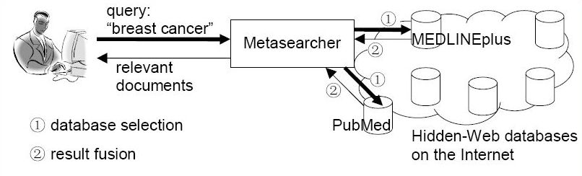
Figure 1: Web Crawling Method [11].
Due to its dynamic nature, existing web crawlers cannot access the Deep Web. Thus, accessing and maintaining the huge amount of Deep Web information remains a challenging research issue. Information in Deep websites Information is categorized as being either in textual or structured databases. While a textual database needs input keywords for searching text documents, a structured database requires a user to fill in input fields of a query interface.
Deep Web content includes information in private databases that are accessible over the Internet but search engines are unable to crawl due to various reasons. For example, some universities, government agencies and other organizations maintain databases of information that were not created for general public access. Other sites may restrict database access to members or subscribers.
The deep web is infinitely large. It contained somewhere in the vicinity of 900 billion pages of information. In contrast, Google, the largest search engine, had indexed just 25 billion pages [8].With millions of databases connected to the Web, and endless possible permutations of search terms, there is simply no way for any search engine — no matter how powerful — to sift through every possible combination of data on the fly.
To extract meaningful data from the Deep Web, search engines have to analyze users’ search terms and figure out how to pass those queries particular databases. In practice the vast variety of database structures and possible search terms poses a computational challenge.
1.2 Ontologies
In the context of computer and information sciences, ontology defines a set of representational primitives with which to model a domain of knowledge or discourse. The representational primitives are typically classes (or sets), attributes (or properties), and relationships (or relations among class members) [15]. That is, ontology is a shared understanding of the structure of a domain of interest. Ontologies make it easy both for human beings (not necessarily computer programmers) to compile and maintain a body of knowledge and for computer programs to use this knowledge to intelligently manipulate data. An ontology organizes all data using the concepts of class, object, and relationship. Classes are organized into a hierarchy, ordered by subclass. [13]
Ontology in computer science and information science is a formal representation of a set of concepts within a domain and the relationships between those concepts. It is used to reason about the properties of that domain, and may be used to define the domain. In the words of Thomas Gruber ontology is an explicit specification of a conceptualization. A conceptualization is an abstract, simplified view of the world that we want to represent. If the specification medium is a formal language, the ontology defines a representational foundation [2].
Example: Figure 2 gives a pictorial representation of roadway ontology which consists of various instances and there corresponding relations.
According to Dr. James Geller’s more precise and detailed definition of ontology it is a graph (the data Structure). Every Node of this graph stands for a “concept” which is a unit that one can think about and corresponds to words or short phrases. Typically, a concept corresponds to a noun or noun phrase like house, man, car, New York etc. but that is not an obligation [1][12].
The nodes of the ontology are connected by different kinds of links. The most important kind of link is called IS-A link. The nodes and IS-A links together form a Rooted Directed Acyclic Graph (Rooted DAG). Rooted means that there is one single "highest node" called the Root. All other nodes are connected by one IS-A link or a chain of several IS-A links to the Root. In our definition, IS-A links point upwards. If an IS-A link points from a concept X to a concept Y that means that every real world thing that can be called an X also can be called a Y. In other words, every X IS-A Y. (Some people have IS-A-like links but pointing downwards.) Examples: Every dog IS-A animal, every Car IS-A vehicle [1,12].

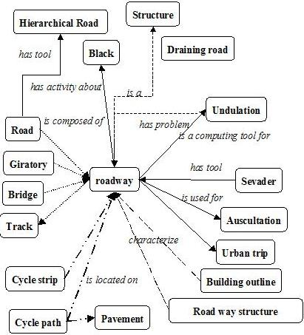
Figure 2: An example of roadway ontology [10].

Acyclic means that if you start at one node and move away from it following an IS-A link, you can never return to this node, even if you follow many IS-A links. Most nodes also have other information attached. This information includes attributes, relationships and rules [1].
Ontologies represent information in a form that can be used for some forms of reasoning that are at least partially similar to human reasoning. This includes inheritance reasoning, transitivity reasoning and classification. A concept may inherit information from several other concepts. This is called multiple inheritance. Transitivity reasoning corresponds to chaining of IS-A links. Classification means that if we know the attributes of a concept we can decide under which other concepts it belongs in the ontology.
1.3 Deep Web Mining
Just because a web search engine can't find something doesn't mean it isn't there. The Deep Web is a vast information repository not always indexed by automated search engines but readily accessible to enlightened individuals. The Shallow Web, also known as the Surface Web or Static Web, is a collection of Websites indexed by automated search engines.

A search engine robots or web crawler follows URL links, indexes the content and then relays the results back to search engine central for consolidation and user query. Ideally, the process eventually scours the entire web, subject to vendor time and storage constraints. Most of the time information is stored on websites in such a way that the user initially comes in contact with what are called Menu pages. Menus are numerous and too thin i.e. they are just having basic information and users are driven through an endless series of nested menus in order to reach important information stored on backend inside Content pages as shown in Figure 2 below.
The crux of the process lies in the indexing. A web crawler does not report what it can't index.
And we know the search result for a particular web page in terms of its relevance depends greatly on that. This was a minor issue when the early web consisted primarily of static generic HTML code, but contemporary Websites now contain multimedia, scripts and other forms of dynamic content. The Deep Web consists of web pages that search engines cannot or will not index. The popular term "Invisible Web" which refers to Deep Web is actually a misnomer, because the information is not invisible, it's just not indexed by the Web crawler. The Deep Web is five to 500 times as vast as the Shallow Web, thus making it an immense and extraordinary online resource. The major search engines together index approximately 20% of the web, and thus missing 80% of the content.

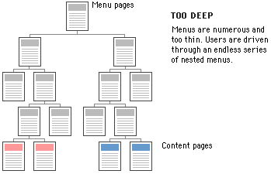
Figure 3: Information storage format on a typical Web site.

Search engines typically do not index the following types of Websites:

- Proprietary sites
- Sites requiring a registration
- Sites with scripts
- Dynamic sites
- Ephemeral sites
- Sites blocked by local webmasters
- Sites blocked by search engine policy
- Sites with special formats
- Searchable databases

Proprietary sites require a fee. Registration sites require a login or password. A Web crawler can index script code (e.g., Flash, JavaScript), but it can't always ascertain what the script actually does and the Web crawler may get trapped within infinite loops. Dynamic Websites are created on demand and have no existence prior to the query and limited existence afterward.

- Webmasters can request that their sites not be indexed (Robot Exclusion Protocol), and some search engines skip sites based on their own inscrutable corporate policies. Not long ago, search engines could not index files in PDF, thus missing an enormous quantity of vendor white papers and technical reports, not to mention government documents. Special formats become less of an issue as index engines become smarter. The most valuable Deep Web resources are searchable databases. There are thousands of high-quality, authoritative online specialty databases. These resources are extremely useful for a focused search.[14]
1.4 Role of Ontologies in search for Web pages

Recently, there has been a growing interest in Web searches that are intended to locate information that exists in the backend data bases of Web services. Websites in E-commerce domains such as airfares, automobiles, books, car rentals, hotels, jobs, movies and music records usually store huge amounts of information, which is of interest to many users, in their backend databases.
Information in E-commerce backend databases is usually not “visible” to general search engines. The information in backend databases is often called Deep Web data. Finding the relevant E-commerce sites and accessing, retrieving and indexing the huge amounts of Deep Web data raises challenging research issues.
Ontologies could play an important role in assisting users in their search for Web pages. Domain ontologies can be constructed that support users in their Web search efforts and that increase the number of relevant Web pages that are returned. To achieve this goal the Deep Web information, which consists of dynamically generated Web pages, which cannot be indexed by the existing automated Web crawlers, is combined with ontologies.
The process of building ontologies consists of several steps as shown in Figure 4. Firstly the possible search terms, called attributes of Deep Web data sources are automatically extracted from a static collection of Deep Websites. Secondly, separate domain ontology is built for each domain, using the extracted search terms. Thirdly, by probing a few Deep Websites domain terms from the backend databases are extracted. Next, the domain ontology is extended to include these Deep Web terms as instances. Finally, the domain ontology is extended with relationships between instances [3].
Figure 4: The Flow for an Ontology-Supported Deep Web Search [3].
2. Previous Work
The previous work on this project included addressing the problems of extracting instances from the Deep Web, enriching a domain specific ontology with those instances, and using this ontology to improve web search. In the initial phase of the project information was gathered about all the airports located all across North America by mining the Deep Web for building an `Airports` ontology based on that. This information was then used to provide users with additional search terms for making the search more specific and getting more relevant web pages. The effectiveness of this methodology was shown by comparing the number of relevant Websites by a search engine with a user’s search terms only, with the websites found when using additional ontology-based search terms. In the current phase of this project the domain has been extended to searching out information about famous people like singers, basketball players, researchers etc.[12]
2.1 Enriching Ontology for Deep Web Search
Enrichment of ontology is a process that extends it by adding concepts, instances and new relations between concepts. In the related paper method for extracting instances from the DW is based on developing “robots” (agents) that sent many queries to the same DW site to extract as many data values as possible. When a robot encounters an input field it may enter random values or leave the field empty and then submit the page to elicit an informative response [3].
Figure 5 shows the workflow for extending the ontology with instances. The concept discovery of the robot is guided by a human in its initial stage. Initial pairs of a concept and its corresponding instances are defined, which we call a robot image. The robot submits input values into the query interface. If the input values are not suitable for the form, most Websites display error messages. The analysis of the error messages often gives useful clues to the robot to guess suitable input values and launch better probing queries. Thus, the queried Web sources may provide information about concepts, instances and semantic relationships, which is recorded in the ontology [3][12].
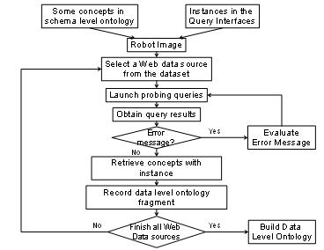
Figure 5: A Flow for generating data level ontology fragments [3].
2.2 Automatic Attribute Extraction from the Deep Web Data Sources.
Understanding the attributes and contents of Deep Web data sources is also important in order to locate the most relevant Deep Web data sources for a user, since these sources use different attributes to access contents. The related paper presents a novel approach to automatically extract attributes from query interfaces in order to address the current limitations in accessing Deep Web data sources. It introduces the Semantic Deep Web for utilizing ontology to determine attributes to access the Deep Web [4].
In the general sense, an attribute of a Web data source is any item of information that describes this source. The more specific meaning of “attribute” is derived from the HTML/XML syntax. A tag of HTML consists of a mandatory name between angular brackets, which may be followed by optional attribute/value pairs. As an example, the Web page in Figure 6 is generated by the HTML code in Figure 7, which contains several attribute/value pairs. Thus the tag <SELECT> contains the attribute “size” with the value 2. The attribute and the value of such a pair are separated by an equal sign (=) [4].
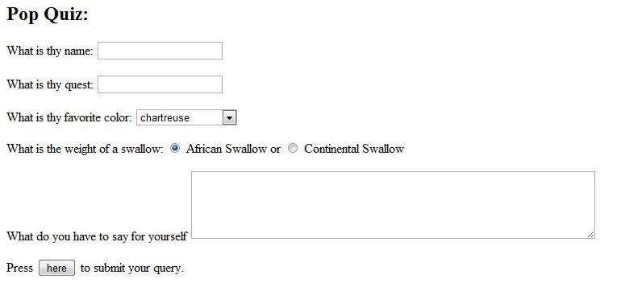
Figure 6: An Example of a simple Form [16].

<html>
<head>
<form method....">
<H2> Pop Quiz: </H2>
What is thy name: <input name="name"><P>
What is thy quest: <input name="quest"><P>

What is thy favorite color:
<select name="color"> <option selected>chartreuse <option>azure
<option>puce <option>cornflower
</select>
<P>

What is the weight of a swallow: <input type="radio" name="swallow"
value="african" checked> African Swallow or
<input type="radio" name="swallow" value="continental"> Continental Swallow
<P>
What do you have to say for yourself
<textarea name="text" rows=5 cols=60></textarea>
<P>

Press <input type="submit" value="here"> to submit your query.
</form>
</body>
</html>

Figure 7: HTML corresponding to Figure 6 [16]

- My Work

3.1 Scenario
The goal of this project is to extract instances from the Deep Web. First, we eliminate the sites which cannot be used for extracting information, such as government sites, proprietary sites etc. Later we enrich a domain specific ontology with those instances. Finally, we use this ontology to improve web search for users. My work in the project is to first eliminate sites from which it is not possible to extract information and then to develop a Deep Web Mining tool for gathering the relevant information and build a database with the extracted data. This work is part of an ongoing project dealing with famous people. My part of the project deals with famous people in publishing and can be further extended to people in movies.
3.2 Methodology
I will develop an agent for extracting instances from the Deep Web by sending many queries to the same website to extract as many data values as possible. This includes first of all finding a list of suitable websites that have information regarding authors, screenwriters, directors, producers etc. Then the robot submits input values into the query interface by analyzing the structure of that particular Web page and extracting as many names as it can. The work flow for this process is also depicted in Figure 8.
Next the information extracted from the Deep Web needs to be filtered and that will be the part of my second module. It will take the information gathered by the agent from the database i.e. names of authors and then select some Deep Web site that has information about authors like the books they wrote, the movies they appeared in, the awards they won etc.
This information will not only help us to filter out names of authors from unnecessary information collected from the Websites but will also help us gather important instances for the domain ontology. This will be done by parsing the Web pages and then analyzing their structure i.e. the attribute /value pairs of the HTML code as it defines the only way for accessing the form information. In the process non-searchable pages will be eliminated (e.g. Login Pages).

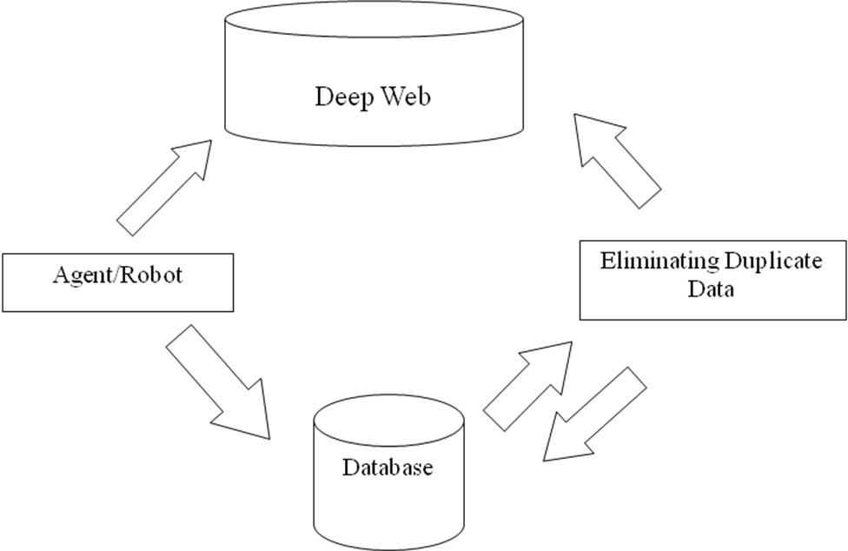
Figure8: Flow of Extraction and Filtering Process
3.3 Deliverables
1. Deep Web Instances Extractor (robot/agent for extracting names of authors, actors, publishers, etc)
Input: Deep Web site containing names of authors, actors, publishers, etc.
Process:
- Parse the website for finding all the attributes/values pairs.
- Analyze the structure of a particular Web page.
- Submit queries according to the information to be extracted.
- Try to group websites and modify query accordingly or discard those websites that cannot be mined for technical reasons.
- Extract names of authors.
- Connect to an Oracle database.
- Enter the gathered information into the database.
Output: Database containing names of authors.
2. Duplicates Elimination Module.
Input: Names of the authors in database.
Process:
- Connect to the database and retrieve the names of authors, publishers, actors, etc.
- Connect to a suitable Deep Web site for filtering out the names for any duplicate information collected by again parsing that particular Web site.
- If the name of the author is valid then gather any additional information about that author. Example: age, gender, location etc.
- Store the information extracted into the database along with the names of authors, actors, publishers, etc.
Output: Required list of authors and there additional information.

3.4 Weekly Plan

Week 1 | Getting Started: Studying the past work done, the limitations and problems faced previously.
Week 2 | Researching various Deep Websites for related information about politicians and find the errors that websites generate and try to classify those errors, understand the general structure of sites, Web technologies that can be helpful.
Week 3 | Writing the code for the Deep Web Instances Extractor for extracting information from Deep Web.
Week 4 | Continued.
Week 5 | Adding the information collected to the database and optimizing the code.
Week 6 | Writing the code for the Duplicates Elimination Module.
Week 7 | Continued.
Week 8 | Connecting the code for Deep Web Instances Extractor and Duplicates Elimination Module, with the author database and gathering additional information.
Week 9 | Continued.
Week 10 | Extending the Domain to Actors.
Week 11 | Continued.
Week 12 | Testing the Deep Web Instances Extractor and Duplicates Elimination Module.
Week 13 | Continued.
Week 14 | Writing Report for the work done.

References

- James Geller. Definition of Ontology,
http://web.njit.edu/~geller/what_is_an_ontology.html, February 16, 2009.
- Thomas Gruber (2008), Ontology. Entry in the Encyclopedia of Database Systems, Ling Liu and M. Tamer Özsu (Eds.), Springer-Verlag. February 16, 2009.
- Yoo Jung An, Soon Ae Chun, Kuo-chuan Huang, James Geller: Enriching Ontology for Deep Web Search. DEXA 2008: 73-80, January 24, 2009.
- Yoo Jung An, James Geller, Yi-Ta Wu, Soon Ae Chun: Semantic Deep Web-Automatic Attribute Extraction from the Deep Web Data Sources, March 12, 2009.
- Yoo Jung An, Soon Ae Chun, Kuo-chuan Huang, James Geller: Assessment for Ontology Supported Deep Web Search, March 14, 2009. March 7, 2009.
- Yagnesh Bhat, Building Ontologies for Ontology Enabled Web Search, NJIT, CS Department, Completing in Fall 2009.
- Tian Tian, Enriching Multi-Domain Ontology for Web Search, PhD Project Proposal, NJIT, CS Department, in preperation.
- Google Search, http://en.wikipedia.org/wiki/Google_search, February 21, 2009.
- http://brightplanet.com, February 21, 2009.
- Cybergeo, http://www.cybergeo.eu/docannexe/image/8322/img-1.jpg, March 12, 2009.
- Frontiers in Web Data Management,http://oak.cs.ucla.edu/~cho/papers/cho-icts03.pdf
- Ashish Rajbar, Deep Web Mining and Enriching the Ontology Enabled Web search, MS Proposal, CS Department, New Jersey Institute of Technology, Fall 2009.
- http://www.xsb.com/glossary.aspx, 20 October 2009
- http://www.computerworld.com/s/article/9005757/Mining_the_Deep_Web_Search_strategies_that_work?taxonomyId=16&pageNumber=1, 20 October 2009
- Ontology by Tom Gruber, http://tomgruber.org/writing/ontology-definition-2007.htm
- Simple form, http://cgi-lib.berkeley.edu/ex/simple-form.html

