CIS 700B Master’s Project Report

PERSONAL PRIVACY POLICY CONTROL SYSTEM IN ELECTRONIC HEALTH RECORDS

Submitted to
The Department of Computer Science,
New Jersey Institute of Technology.

In Partial fulfillment of the requirements of the Degree of Master of Science in Computer Science

Submitted by PRATIK HATKAR
NJIT ID: 217-65-117
pvh3@njit.edu

Project Advisor: Dr. James Geller

APPROVALS

Proposal Number: ________________________________

Agree to Advise: __Prof. James Geller_______________
(Project Advisor)

Date Submitted: __________________________________

Approved by: ____________________________________
(MS in CS Committee)

Date Approved: __________________________________

Signature: __________________________________________
(Pratik Hatkar)

ACKNOWLEDGEMENT

My project ‘PERSONAL PRIVACY POLICY CONTROL SYSTEM IN ELECTRONIC HEALTH RECORDS’ was a great learning experience. I would like to express my gratitude to Professor Dr. James Geller for providing me a great opportunity to work under his guidance. Without his encouragement and guidance this project would not have been materialized.

I would also like to express my sincere appreciation to the external project leader, Dr. Soon Ae Chun, for her support and suggestions in doing the project. Her advice to this project is invaluable.

The project wouldn’t have been complete without the support of my colleagues who with their constant support and valuable feedback helped me to continue with the good work.
Abstract
For many years, health care records have been stored in physical paper file formats, which are difficult to access, maintain and share. To improve access, health care records have to be maintained and shared electronically in an Electronic Health Records (EHR)/ Electronic Medical Records (EMR) System. As EMRs are much easier to access remotely than paper records the patient’s privacy might be at stake. When medical and personal information of an individual is available it can be used in a negative way. Suppose a person is HIV positive and he applies for a job. During his background check through his EMR there is a possibility that he may have to face discrimination on medical grounds. He may or may not get the job, but this kind of discrimination is unethical. Thus, EMR’s content sharing should be under the control of the individual instead of health care provider organizations.
During an unexpected situation, like a flood or fire, where an individual’s life is in danger, doctors cannot wait for a patient’s approval to view her or his health data. Thus, under such circumstances, health care provider organizations should have certain rights to allow access to medical professionals. Thus, for the patient’s own benefits, a personal privacy policy should be under the patient’s control as well as under the health care provider organization’s control.
In this research, we provide personal health record privacy protection through a personal policy being shared by different heath care providers or third party health data users. We propose the “Personal Privacy Policy (PPP) Specification and Control Framework,” where the users can 1) specify their own privacy policies based on the health care provider’s roles; 2) specify a situation-based access policy, to handle dynamic, unforeseen health emergencies, allowing people without prior access policy specification, such as emergency crews, to access their personal health records depending on the situation, severity and location; 3) enforce access policies based on their personal policies; 4) enforce situation-based access control by verifying the situation using public and third party credential information, using default situation-related roles and identifying the existing policy rules for similar roles.
We have developed a prototype system for the PPP framework that allows the user specification of personal and situational policies to access different records entered in an OpenEMR. The OpenEMR system implementation allows health care providers and others (e.g. patients, doctors, insurance companies, etc.) to enter and maintain patients’ EHR to share. The information published in the system will be usable by anyone, at the discretion of the publisher. The stored data can be analyzed and the results will be useful for other patients and doctors.
The second component of the prototype is a mechanism to specify the Personal Privacy Policy on the health records of the user. Users will specify explicitly from whom his data should be protected. Users can specify when and for which reasons his data should be revealed to a third party. Users can also specify situation-related policies. Users can explicitly define what kind of data should be accessed under certain situations. Health records which should be accessed during emergency situations are not the same as those which should be accessed for research purpose.
The third component implements the “Privacy Policy Enforcement Protocol.” Whenever a request by an EHR data consumer is made to the EHR, the PPP is looked up to make sure the requester is allowed to access the requested data. Situation verification is used in case that no prior role-based policy is available. We have simulated such a situation verification repository. With the help of the situation verification repository, the PPP enforcement protocol checks whether the situation really exists or not. In addition, we have simulated the credential verification repository, where third party users’ credentials are checked before allowing access.

Table of Contents
1 | Introduction | 9
2 | Background | 12
2.1 | Health Care Environment | 12
2.2 | Privacy Issues | 13
2.3 | Industry Trends | 15
3 | Privacy Laws | 19
4 | Personal Privacy Policy Architecture | 23
4.1 | Personal Privacy Policy Specification Module | 24
4.2 | Privacy Policy Enforcement Protocol | 31
4.3 | Disclosure Notification Module | 42
4.4 | Auditing & Monitoring the Disclosure & Reports on Demand Module | 42
5 | Prototype System | 43
5.1 | Personal Privacy Policy Specification Module | 43
5.1.1 | Personal Privacy Policy Specification Module with Update & Delete operation | 43
5.1.2 | Situation Privacy Policy Specification Module | 50
5.2 | Personal Privacy Policy Enforcement Module | 52
5.2.1 | Personal Privacy Policy Enforcement | 52
5.2.2 | Situation Privacy Policy Enforcement with Simulated Data Repositories for Situation Credential Verification | 58
6 | Conclusion | 64
7 | References | 66
 | Appendix A: User Manual | 67
 | Appendix B: Code | 70

- INTRODUCTION
Health care records form an essential tool for a patient’s present and future health care. As a written collection of information about a patient’s health and treatment, they are used essentially for the present and continuing care of the patient. In addition, medical records are used in the management and planning of health care facilities and services, for medical research and the production of health care statistics. Doctors, nurses and other health care professionals write up medical/health records so that previous medical information is available when the patient returns to the health care facility. The medical/health record must therefore be available. This is the job of the medical record worker. If a medical record cannot be located, the patient may suffer because information, which could be vital for their continuing care, is not available. If the medical/health record cannot be produced when needed for patient care, the medical record system is not working properly and confidence in the overall work of the medical/health record service is affected [1].
Previously health care records were stored in physical paper files, which made availability and accessibility of health care records difficult. But now-a-days with technological advancement even the medical records need to be stored electronically. This gave birth to Electronic Health Records (EHR) and Personal Health Records (PHR). EHR and PHR are electronic records initiated and maintained by doctors and individuals respectively. These records in digital format are capable of being shared across different health care settings, by being embedded in network-connected enterprise-wide information systems. Thus, by sharing this information on the World Wide Web it will be easily available and accessible for doctors as well as patients anywhere in the world. It would be of great importance especially at the time of an emergency and also for study and research purposes.
But, in this day and age not many people are comfortable with having their entire medical history recorded and digitized for other people to see – in other words, incursion into people’s privacy. The confidentiality of the doctor - patient relationship is still sacrosanct. Besides, medical data can be used against a person in some cases – be it for a job application, insurance coverage or a college scholarship. Although it is against the law to discriminate against people with illnesses and disabilities, it is a fact of life that the fitter you are, the more competitive you are in the job market. The planned incorporation of genetic data in EMRs further adds to people’s fear of incursion into their private sphere [2].
Also, very few people are confident about the data protection and security of electronic data such as those stored in EMRs. Many people are not convinced that their data are safe from those who would want to misuse it. Current EHR systems do not take into consideration people’s privacy. Whenever a request to access EHRs is made by a third party, the individual’s willingness to share his health records is not checked. Presently, many standard health care provider organizations do not follow regulations set by Health Insurance Portability and Accountability Act (HIPAA). Such kinds of issues are being faced by the health care industry which need to be addressed.
In this project, we provide a prototype secure sharing environment of Electronic Health Records by proposing a personal privacy policy control system. This system allows the end users (patients) to specify their privacy policies that can be looked up and shared before the health records are being accessed and shared. We have developed a user friendly Web-based system to create and update the access control policies for the private health records. We have developed the PPP data model and a protocol for looking up the PPP in case of EHR access requests. In addition, the health records should be available in case of emergency situations, even though a user does not have an a priori access policy. We provide situation-related policy specification, situation verification, and situation-based access control.
During an emergency situation, the PPP control tool verifies that the person accessing a patient’s EHRs is authorized or has valid authority to access the EHRs via a personal policy. If a person is not authorized by the EHR system, the PPP control tool will verify the situation by looking up trusted third party systems to verify the authenticity of the situation. Once the situation is verified, the user can be given a default role and the permissions are derived from the roles similar to the default role in the policy rules. In addition, the user may provide an additional organizational third party for the role verification. With the credential input from the third party, the PPP control tool gives access to the EHRs.

2. BACKGROUND
2.1. Health Care Environment
Presently, EHR is an evolving concept defined as a systematic collection of electronic health information about individual patients. Those are records in digital format capable of being shared across different health care settings, by being embedded in network-connected enterprise-wide information systems. Such records may include a whole range of data in comprehensive or summary form, including demographics, medical history, medication and allergies, immunization status, laboratory test results, radiology images, vital signs, personal statistics like age and weight, and billing information. Like EHRs, Web-based PHRs are also evolving with time. They have the advantage of being easily integrated with other services. Some Web-based PHRs allow for import of medical data from external sources. Solutions including HealthVault and Google Health allow for data to be shared with other applications or specific people [2].
The basic aim of having EHR or PHR systems is providing quality health care for patients. The patient’s data is stored in different EHR/PHR systems over the World Wide Web. This data is not only accessed by doctors but also by nurses, patients, insurance companies, medical technicians, researchers, pharmacy stores, etc. Different EHR and PHR system scattered over the Web share a patient’s data, so a range of users can access it for the patient’s benefit (see figure1).

OTHER EHR & PHR SYSTEMS
DOCTORS
PHARMACY
MedClipse
PATIENTS
INTERNET
INSURANCE COMPANIES
GOOGLE
HEALTH

OpenEMR
HEALTHVAULT
USERS

DOCTORS
MEDICAL PROFESSIONALS
FreeMed
USERS

Figure 1: Health Care Environment

2.2. Privacy Issues
A major risk, which concerns consumers, relates to the privacy of health-related data. Most patients desire to keep their medical problems confidential, not only to eliminate embarrassment regarding the condition but also to protect against other troubles. For instance, if a medical record were exposed and revealed that the patient has AIDS, the patient could face trouble acquiring health insurance or obtaining a new job. To address such risks, the Health Insurance Portability and Accountability Act (HIPAA) Privacy Rule was enacted to protect the confidentiality of patient’s protected health information from improper use or disclosure. A supplement to HIPAA, known as the Security Rule, was implemented to assure the confidentiality of electronic protected health information by specifying a series of administrative, technical and physical security procedures. However, laws cannot prevent the possibility of human errors or the persistence of hackers.
Another consumer privacy concern pertains to moving sensitive medical records from paper to a digital format, then placing those records on a system that can possibly be accessed from anywhere in the world. Over 218 million data records have been stolen since January of 2005 with at least 34 million of those records being medical information. The U.S. Department of Health and Human Services reports that approximately 150 people including nurses, clinicians, and billing clerks have access to at least part of a patient's medical record. When including payers, providers and other entities that convert raw data into billing data, that number jumps up to approximately 600,000 people with access; and this is without the majority of hospitals using any type of health information management system for EHRs [3].
The only way to protect patient privacy is to give control over decisions for medical record sharing to individuals. Thus, those of us concerned with protecting medical privacy should not seek big-government solutions. Instead, we support the dissemination of personal health information, to be made by voluntary agreements between patients and those to whom they entrust their care.

2.3. Industry trends
EHR: A typical EHR has information about your health conditions, allergies, treatments, tests, and medications. Many EHRs can connect with health care providers outside your doctor’s office such as specialists, labs, imaging facilities (X-rays, CT Scans, MRIs), and the local hospital. This allows your doctor to share up-to-date information with your other providers as well as getting quick and easy access to your tests and hospital information.
Since everyone involved in your health care can share accurate information, your EHR can help lower the chances of medical errors and may help improve the quality of your health care. Some EHRs have warning systems built in to let your doctor know about drug allergies or potential problems with drug interactions.
Also, some EHRs have medical alerts to remind your doctor to perform certain tests or procedures. For example, if you have diabetes, your doctor’s EHR may remind your doctor to check your feet at every visit or order a blood sugar test.
PHR Networks: Microsoft launched Health Vault that promises benefits in health care information storage and sharing online but raises concerns about privacy of this information. Health Vault is Microsoft’s “new personal health platform that lets you gather, store, and share health information online.” Service users need a Windows Live ID to use the service. Once users create both a sufficiently safe username and a strong password, they can enter data from health and wellness devices, or upload documents to their vault. Users can then share this information with other Windows Live ID users, such as other patients or doctors.
Google also has a similar Website entitled Google Health that is similar to Microsoft’s consumer oriented approach to health information. Both companies’ focus on this field is a result of current trends. In 2007, 52 percent of adults in the US searched the Web for health information compared to 29 percent in 2001. More and more, patients are confronting their health care providers with information gathered from Websites such as WebMD. Both Google and Microsoft hope to leverage their expertise in Web search functionality with personal health information storage and sharing.
Microsoft’s Health Vault privacy statement addresses some privacy concerns, but it does not specifically address HIPAA regulations. First, the privacy statement asserts that third parties, such as companies Microsoft hires to answer customer service questions, have access to personal information such as IP addresses and email addresses. However, Microsoft also states that these third party companies are required to maintain confidentiality. Second, Microsoft states that this information “may be stored and processed in the United States or any other country in which Microsoft or its affiliates, subsidiaries, or agents maintain facilities.” Third, the statement asserts that “aggregated information from the Service for marketing” may be disclosed. While, this aggregated information is not associated with any individual account, it may be used for marketing after an “opt-in consent” from the user. Finally, the privacy policy specifically addresses cookie use, Web-beacon use, and encryption using HTTPS. While these assurances are definitely in the right direction, Microsoft will certainly want to assure compliance with HIPAA’s privacy and security rules.
Considering that Google’s use of cookies has been under the spotlight before, we are looking forward to review Google’s approach to both the privacy and security of personal health information [5].
Web-based EHR services: With EHR and PHR system helping medical professionals around the world to convert physical health files to electronic ones, some of the organizations have gone one step further. One such example is Practice Fusion. Practice Fusion is a Web-based EHR.
Using Practice Fusion, medical professional around the world can enter medical health data of their patients into a Web-based system. As it is Web-based, EHR users do not need any software and only minimal hardware prior to its use. The only requirement is Internet access. The availability of data all the time and around the world is a striking feature of Web-based EHRs like Practice Fusion. Also, a doctor’s data is under his control. A doctor can anytime import his data from the system; there are no restrictions on that at all. A doctor can enter as much data as he wants. There are no restrictions on the number of records or number of patients that can be entered. Practice Fusion also has some management tools for managing billing, appointments, staff schedulers etc.
Smart Card approach for EHR data security and privacy: Now-a-days use of smart cards ranges from telecommunication applications to bank transactions (credit and debit cards). Use of smart cards is also increasing in the health care industry. Smart cards provide unique identification of patients, synchronization of data and secure access control. Although smart cards have these benefits, certain issues are not addressed yet, as far as the health care industry is concerned. As smart card is a physical object; anyone can steal another person’s smart card and can access the individual’s health data. Updating smart cards will be the patient’s responsibility rather than the medical professional’s. Individuals can fake certain health data about themselves to gain profits. At the time of an emergency situation, individuals should have a smart card on them for medical professionals to access it.
In our project we have tried to address security and privacy issues for the patient’s EHRs and personal security and privacy policies that are accessible over the World Wide Web. Thus, the main advantage is anytime availability of personally specified policies to control access to their own EHRs that may be distributed in different places. As those are not physical objects, they cannot be stolen and patients cannot be impersonated. As the entry of records into EHRs is in the hands of medical professionals, patients cannot manipulate health data. Our approach tries to address how to allow the patients to specify the privacy policy that can be enforced when anyone tries to access anyone of the patient’s records in any EHRs in the Internet.
3. PRIVACY LAWS
Privacy law is the area of law concerned with the protection and preservation of the privacy rights of individuals. Increasingly, governments and other public as well as private organizations collect vast amounts of personal information about individuals for a variety of purposes. The law of privacy regulates the type of information, which may be collected and how this information may be used and stored [4].
The Privacy Rule protects all "individually identifiable health information" held or transmitted by a covered entity or its business associate, in any form or media, whether electronic, paper, or oral. The Privacy Rule calls this information “protected health information” (PHI) that is linked with 18 identifiers:
- Names
- All geographical subdivisions smaller than a State, including street address, city, county, precinct, zip code, and their equivalent geocodes, except for the initial three digits of a zip code, if according to the current publicly available data from the Bureau of the Census: (1) The geographic unit formed by combining all zip codes with the same three initial digits contains more than 20,000 people; and (2) The initial three digits of a zip code for all such geographic units containing 20,000 or fewer people is changed to 000
- Dates (other than year) for dates directly related to an individual, including birth date, admission date, discharge date, date of death; and all ages over 89 and all elements of dates (including year) indicative of such age, except that such ages and elements may be aggregated into a single category of age 90 or older
- Phone numbers
- Fax numbers
- Electronic mail addresses
- Social Security numbers
- Medical record numbers
- Health plan beneficiary numbers
- Account numbers
- Certificate/license numbers
- Vehicle identifiers and serial numbers, including license plate numbers
- Device identifiers and serial numbers
- Web Uniform Resource Locators (URLs)
- Internet Protocol (IP) address numbers
- Biometric identifiers, including finger, retinal and voice prints
- Full face photographic images and any comparable images
- Any other unique identifying number, characteristic, or code (note that this does not mean the unique code assigned by the investigator to code the data)
“Individually identifiable health information” is information, including demographic data, that relates to:
- The individual’s past, present or future physical or mental health or condition.
- The provision of health care to the individual, or
- The past, present, or future payment for the provision of health care to the individual
and that identifies the individual or for which there is a reasonable basis to believe it can be used to identify the individual. Individually identifiable health information includes many common identifiers (e.g., name, address, birth date, Social Security Number).
The Privacy Rule, a Federal law, gives you rights over your health information and sets rules and limits on who can look at and receive your health information. The Privacy Rule applies to all forms of individuals' protected health information, whether electronic, written, or oral. The Security Rule, a Federal law that protects health information in electronic form, requires entities covered by Health Insurance Portability and Accountability Act (HIPAA) to ensure that electronic protected health information is secure.
The Privacy Rule excludes from protected health information employment records that a covered entity maintains in its capacity as an employer and education and certain other records subject to, or defined in, the Family Educational Rights and Privacy Act, 20 U.S.C. §1232g [6].
The law calls the entities that must follow the HIPAA regulations covered entities.
Covered entities include:
- Health Plans, including health insurance companies, HMOs, company health plans, and certain government programs that pay for health care, such as Medicare and Medicaid.
- Most Health Care Providers—those that conduct certain businesses electronically, such as electronically billing your health insurance—including most doctors, clinics, hospitals, psychologists, chiropractors, nursing homes, pharmacies, and dentists.
- Health Care Clearinghouses—entities that process nonstandard health information they receive from another entity into a standard (i.e., standard electronic format or data content), or vice versa.
4. PERSONAL PRIVACY POLICY ARCHITECTURE
Changing physical health records into Electronic Health Record (EHR) to improve sharing, availability and rapid transmission of medical information and making health care systems more efficient is the need of this time. These EHRs are distributed over the Web and are accessed by different users. To avoid any malpractice suit with the sensitive data, deploying role-based accessed control is a must. Distributed health records need to be accessed across organizational boundaries for quality care. Health data is captured by different providers in different EHR and PHR systems. Thus it is very difficult to enforce personal privacy policy rules consistently across different organizations. Whenever there are no specific role-based policies, situation-based access control may be given based on the existing roles specified in the personal policy and the situation specific default roles. To address this, we propose the PPP architecture as shown in figure 2.
This approach, using a PPP where one can specify the personal privacy policy, will give the patients more control over their own health data and its access by others. Access control policies are in the hands of the individual. An individual user specifies who will access his health records and when. Implementing on such a tool in a Web hosting environment helps other users, doctors, clinicians, insurance companies and third parties to look up health records of patients from anywhere in the world. Thus, the main aim of health record availability is satisfied, while the privacy wishes of the individuals are honored at the same time. The overall architecture of the PPP control system is shown in Figure 3.

PATIENTS
PHARMACY
OTHER EHR & PHR SYSTEMS
Personal Privacy Policy Control System

MedClipse
PATIENTS
INTERNET
INSURANCE COMPANIES
GOOGLE
HEALTH

OpenEMR
HEALTHVAULT
USERS

DOCTORS
MEDICAL PROFESSIONALS
FreeMed
USERS

Figure 2: Health Care Environment with PPP Architecture

4.1. Personal Privacy Policy Specification Module
We have developed a Personal Privacy Policy system which allows users to share their EHRs using their own personal policies. The system consists of a Privacy Policy Specification (PPS) module, policy repository, privacy policy enforcement module and policy update module. Figure 2 shows the architecture. With the help of privacy policy specification tool user explicitly mention which data of his should be protected, who can access his data except him, when can his data be accessed-under what circumstances and condition. Also, user specifies what should be done with his data in case of emergency, even a user asks for a notification whenever his data is been access by someone.

PPP (policies)
Patient
PPP Specifications Module
Web, Mobile devices
PPP Specification Module
SPP Specification Module

PPP Query Processing
PPP Update/Delete
Electronic Medical Records Systems
Disclosure Notification

Monitoring & Auditing
3rd Party

PPP Lookup/Enforcement Module

Software
PPP enforcement module
Aggregator
SPP Enforcement Module
Doctors

Figure 3: Architecture of Personal Privacy Policy Control System
We considered two types of privacy policies, role-based PPP and situation-based policies, as shown in Figure 4.
Personal Health Data
Roles

USER
Doctor - General Physician
Doctor - Specialist
Locations
Police
Nurse
Hospitals

Situations
Emergency
Clinics
Research
Mobile van/ Ambulance
Insurance
Always

Figure 4: Personal Privacy Policy Specification Module

1) Role – Based Personal Privacy Policy Specification:
The Privacy Policy Specification module is a Web-based application to specify personal privacy policies. A personal privacy policy is represented as PPP. The role of PPP is to restrict third party users to access EHRs. In other words, access to EHRs is granted strictly according to the mentioned PPP. Only registered patients have the permission to specify a PPP and only for themselves. Neither doctors nor other individuals can create a PPP for a certain patient. All the PPPs are stored in the PPP repository. PPPs will be looked up whenever a request is made by any user to access a patient’s EHRs. The advantage of PPP specification is that, now the patient’s health data will be at his discretion and not totally in the hands of health care providers. A disadvantage with PPP specifications is that at the time of emergency, medical professionals may need access to a patient’s health data although he has not allowed it.
A patient can register and creates his own account in the PPS tool if and only if he has been entered into the EHR system by an authorized user. A patient can log into the PPS tool with a unique ID and password. After logging in, the PPS tool patient can specify which of his data (like demographics information, prescription, history, etc.) can be access by whom (e.g. doctor, surgeon, nurse, police, insurance company, etc.) and where (e.g. hospitals, clinics, ambulance, etc.). The set of privacy policy rules can be different for normal health care conditions, research purposes or insurance claims.
Example 1: PPP
Health Data: Demographics details, History details, Prescription details
Allowed to whom: General Physician
Allowed where: Private Clinic
Permissions: Read, Write, Update

Example 2: PPP
Health Data: Demographics details, History details, Prescription details, Immunization details, Issues details
Allowed to whom: Surgeon
Allowed where: Hospital
Permissions: Read, Write, Update

Example 3: PPP
Health Data: Demographics details, Prescription details.
Allowed to whom: Nurse
Allowed where: Hospital
Permissions: Read

2) Situational Privacy Policy Specification:
Additionally, a patient can also specify privacy rules according to situation. The situation-related privacy policy is represented as Situational Privacy Policy (SPP). The difference between PPP and SPP is that when a patient uses PPP he does not have to mention the situation, while with SPP he may mention the situation under which the health data can be accessed. The set of SPPs will differ for situations like research, insurance claims, emergencies or normal health care conditions. SPPs will restrict third party users to access EHRs according to situation.
Presently, the different types of situations we are handling are ‘Emergency,’ ‘Research,’ ‘Insurance Claim,’ and ‘Always,’ and users cannot invent their own situations. Thus, if a patient wants to share his health records for insurance claims and not for research purpose he can explicitly enforce this restriction.
Only registered patients have the permission to specify SPPs and only for themselves. Neither doctors nor other individuals can change SPPs for a patient. All the SPPs are stored in the PPP repository. SPPs will be looked up whenever a request is made by any user to access a patient’s EHRs. SPPs have default values which overcomes the disadvantage of static PPP specifications. As far as emergency situations are concerned, the set of SPPs are set to certain default values. Refer to examples 4, 5, 6 for example default values. So, medical professionals have access to a patient’s health data, although patient has not allowed it. This is possible only under emergency situation conditions. After setting up the initial privacy policy rules the patient can view them any time by just logging into the PPS Web application.

Example 4: SPP
Situation: Emergency-Fire
Default roles: Nurse, Doctor, Burn Specialist, Fire crew
Permission: Read, Write
Health Data: Demographics details, History details, Prescription details
Location: Hospital, Mobile van/Ambulance

Example 5: SPP
Situation: Emergency-Flood
Default roles: Nurse, Doctor, Emergency crew
Permission: Read, Write
Health Data: Demographics details, History details, Prescription details
Location: Hospital, Mobile van/Ambulance

Example 6: SPP
Situation: Emergency-Accident
Default roles: Nurse, Doctor, Emergency crew
Permission: Read, Write
Health Data: Demographics details, History details, Prescription details, Issues details
Location: Hospital, Mobile van/Ambulance

Example 7: SPP
Situation: Research
Role: Doctor
Permission: Read
Health Data: Demographics details, History details, Prescription details
Location: Hospital

Example 8: SPP
Situation: Insurance Claim
Role: Third Party
Permission: Read
Health Data: Demographics details, History details, Prescription details, Immunization details, Document
Location: Hospital

3) Personal Privacy Policy Repository:
We have designed and developed the PPP repository. The PPP repository is responsible for holding all the necessary data regarding the PPS tool and PPE protocol. The PPP repository was developed using a relational database, i.e. MySql.

4) Personal Privacy Policy UPDATE/DELETE:
Another tool that the module includes is the privacy policy update/delete tool. With the help of this tool a patient modifies, updates or changes his previous personal policy settings. A patient can not only modify but can also delete the previous privacy policy rules. This client tool communicates with the server specification processing to interface with the policy database.

  - Privacy Policy Enforcement Protocol
We modeled a Privacy Policy Enforcement (PPE) module in different types of access control. When a request by an EHR data consumer (covered entities, applications, 3rd party data processing programs, etc.) is made to an EHR, the EHR (at private clinics or hospitals) authenticates the user, if the user has registered already, and retrieves the roles assigned by the EHR organization. Additionally the EHR component connects to the PPP site, checks whether the patient has registered with the EHR, and looks up the relevant personal policies according to the roles assigned to the user. As per the PPP and the roles, the requester is allowed to access the requested data.
4.2.1. Role-based Privacy Policy Enforcement
A doctor, insurance company or any third party want to access the patient’s EHRs the PPE protocol takes care that only valid authority can access the particular data.
Use case 1:
A Dr. Kay wants to access a certain patient’s (say Ross) demographics, history and immunization data resides in EHR system of the hospital he is working in.
Dr. Kay logs in to EHR system, if he is already registered. If not registered user, he registers himself in EHR system. System checks if he is a valid user or not. He specifies his role as a doctor. Dr. Kay requests access to Ross’s demographics, history and immunization data. The EHR system requests the PPE, that Ross specified his Privacy policies, via Internet to verify the permissions for the role. The PPE checks PPP repository if doctor role has access to demographics, history and immunization data. According to Ross’s role based PPP, the doctor can access only demographics, history and issues data. So, finally PPP control system will allow doctor to access Ross’s demographics and history data but not immunization details.

Flowchart:
START

ENTER USERNAME & PASSWORD

IF VALID
USER
REGISTER IN EHR SYSTEM

SELECT USER’S ROLE

REQUEST TO ACCESS EHRs

CHECK PPP REPOSITORY FOR PPP ACCORDING TO SPECIFIED ROLE

GRANT ACCESS TO EHRs

END

Figure 5: Role based Privacy Policy Enforcement Flowchart.
4.2.2. Situation Privacy Policy Enforcement
Use case 2:
During fire emergency situation, an ambulance crew attending the situation wants to access patient’s (e.g. Ross’s) demographics, history and immunization details stored in his doctor’s EHR system. As ambulance crew is not registered in the EHR system.
In the above case, the emergency crew should first verify the situation whether the event is genuine or not. In order to verify the situation’s authentication, situation-related credentials are needed. The situational credentials include emergency location details such as street name, zip code and time. The situation credentials are sent to situation repository that may be maintained by third party such as police department keeps track of the emergency events or news organizations. Using the data from these third party event repositories, the situation can be verified as authentic. Once the situation is authenticated, the PPP is checked to see if there are any policies related to the situation. The default roles in the situation (e.g. fireman, police, burn specialist, etc.) can be identified with the default permissions. Now the user (e.g. fireman or a passerby claiming that he is a doctor) wants to access the patient records. The system has to verify whether he has credentials to be a fireman role or doctor role. In order to verify these roles, he needs to provide the credentials through his organization. He provides his organization name where he is working and his ID or login credentials. If the organization verifies his credentials and returns some of the roles. If these roles match with one of the default roles of the situation, e.g. doctor, then he is given permission to access the patient records (demographics, history and immunization details). If the roles from his organization are not exactly matching with the default roles of the situation, e.g. he is a doctor, but not the burn specialist, then the enforcement uses the reasoning that burn specialist is a kind of doctor, so he is given doctor-related permissions specified in SPP.
If the user is a fireman, the user needs to authenticate if he can assume one of the fire situation’s default role, i.e. fireman, using his ID and his organization. Once the authentication that he is actually a fireman, then according to default SPP for fire emergency, only demographics, history and prescription details can be accessed. So, the PPP control system will allow emergency crew to access demographics and history details but not immunization details. Access to the patient’s EHRs is allowed only after looking up SPP.
Use case 3:
For example, if doctor wants to access patient’s EHRs for research purpose. The PPE protocol will check PPP repository. PPE protocol checks whether certain patient has allowed access of his records for research purpose. If the answer is yes, then it identifies the default roles and permissions for the research purpose from SPP. The user then provides his credentials for one of the default roles. If the role matches or approximately matches, the permissions are given to access patient’s EHRs for research purpose.
As shown above, during emergency situation, a doctor or fire crew who does not have a prior permission to access patient’s EHRs has to have access to patient’s EHRs so according to patient’s past history of prescription and health records so the patient can be treated efficiently. For example at the time of fire or flood the doctor attending the situation may or may not have the access to patient’s EHRs. Consider an emergency situation where doctor is trying to access patient’s EHRs, but EHR system has not predefined policy for either doctor or emergency situation. This can also cost patient his life. Since SPP has default values for emergency situation, a doctor will have access to patient’s certain health data, even though he is a volunteer doctor who happen to be near the emergency situation. Before access is granted to doctor, PPE verifies the situation’s authenticity through querying emergency location repository whether the situation exists or not. Access is granted if and only if situation exists. PPE not only check for situation but also check if the doctor or user has proper credentials to assume the default roles. To this role verification, PPE verifies from simulated third party credential verification repository (e.g. the organization he is working currently) whether the user has proper credential for default roles in a situation. Once he is authenticated to assume a situation-related role, then he is authorized to access health data according to the situational role. Thus, a doctor or emergency crew attending a patient at a time of emergency situation has access to certain basic health information so patient can have quality care and within time constraints.

Flowchart:
START
GET EMERGENCY LOCATION CREDENTIALS FROM USER

CHECK EMERGENY LOCATION REPOSITORY

IS SPECIFIED LOCATION VALID?

CHECK PPP REPOSITORY FOR DEFAULT POLICIES

GET DEFAULT ROLES FROM THE POLICIES

GET ROLE CREDENTIALS FROM USER

CHECK ROLE CREDENTIAL VERIFICATION REPOSITORY

IS SPECIFIED ROLE VALID?

MATCH DEFAULT ROLE WITH SPECIFIED ROLE

C

C

IF MATCHED

ENFORCE LOGIC TO FIND SIMILAR ROLES

IF FOUND

GRANT ACCESS TO EHRs

END

Figure 6: Situation Privacy Policy Enforcement Flowchart.
Repository of Situational Credentials and Situational Authentication
Anyone can fake the emergency situation to software and can have access to patient’s sensitive data. We have taken care of such situation, we assumed that in future we would have access to certain repository or system which will let us know if the emergency situation really exists or not.
We have developed a simulated repository to store situation data. For example, police department may have a database that stores a series of events and situations (e.g. car accidents, fires, etc.) with information such as the location and start and end times. The situational credential verification module looks into the repository which has information about the emergency location. So whenever a person try to access EHRs under emergency situation then the tool checks whether the mention situation exists at particular street with particular zip code. Access is granted to view EHRs if and only if the situation exists. Tool not only take care part of the location but also of time constraints. If someone tries to access EHRs under Emergency situation after the situation has taken place the tool does not allow it. The tool checks for start date and end date for emergency situation, if EHRs access is within that time range then the access is granted otherwise not. See figure 7.
Third party Credential Verification and Role Identification
After we took care of emergency situation location still there are chances that someone can take advantage of emergency situation and can access the patient’s sensitive data. To stop such kind of misuse we implement third party verification. For example, an emergency crew may belong to a hospital where he has a defined role to access some patients’ records. In order to transfer his role to the emergency case, we need to verify his credentials and identify the roles in his organization. His organization that is different from the patients can provide the kind of roles he has in his organization. Once the roles are identified, the default roles in the emergency situation may be overridden or combined to give him the necessary access.
We have simulated the third party organization’s policy repository. Our situational verification module sends the user’s credentials to the third party and the third party can verify verifies if the person accessing patient’s EHRs under emergency condition is valid authority and returns a list of roles assigned in the third party policy repository. Before anyone can access the patient’s EHRs under emergency conditions, he has to enter his identification number and organization name. Then the third party verification tool verifies from the repository if such kind of person exists with particular identification number and organization name. If yes, then the PPE matches the roles in the organization with the default roles of the situation in SPP. If there are match, the SPP role related permissions are granted. See figure 7 that shows the external organization’s credential repositories and the situation credential repositories interact with the SPP and PPP system.

Emergency Situation Location Repository
Third Party Verification Repository

PPP (policies)
Patient
PPP Specifications Module
Web, Mobile devices
PPP Specification Module
SPP Specification Module

PPP Query Processing
PPP Update/Delete
Electronic Medical Records Systems
Disclosure Notification

Monitoring & Auditing
3rd Party

PPP Lookup/Enforcement Module

Software
PPP enforcement module
Aggregator
SPP Enforcement Module
Doctors

Figure 7: Architecture of Personal Privacy Policy Control System Extended with Situation & Credential Verification
  - Disclosure Notification Module
Whenever a patient data is disclosed to a third party for analysis or mashups, a user, whose information is being revealed, should be notified according to the HIPPA laws. In personal privacy policy tool a user should specify that when, how often he should be notified if his data is being disclosed for certain purposes. Patients should specify the notification parameters, for example if patient’s physician access his data he won’t opt for notification but in other cases of data extraction by third party mashups the patient may opt for notification. Also, a user may opt for regular notification alerts it can be weekly or monthly. In this way a user can be assured of his personal data usage. See figure 8.
Doctor

ACCESS MONITORING AND NOTIFICATION
EHRs
Notify Disclosure to Specific User & Deliver Reports via email or to mobile devices

Monitors all the access to EHRs
Third Party
Any other User

Figure 8: Disclosure Notification Module and Auditing, Monitoring & Reports on demand Module

  - Auditing and Monitoring the Disclosure and Reports on demand Module
Each access of Electronic Health Record of any user will be closely monitored. Information to be disclosed will be according to the Personal Privacy Policy parameters set by the user. The reports generation module will generate reports when needed by the user. The reports delivery can be weekly, monthly or yearly. Also, user can find all the reports online whenever he/she needs it.
- Prototype System
We have developed a prototype system for PPP specification and enforcement modules that can control access to patient’s EHR system. We implemented openEMR that stores the patient’s records. The PPP repository is implemented in MySql and used Java JSP to implement the specification and enforcement modules.

5.1. PPP Specification Module
5.1.1. PPP Specification Module with Update and Delete operations.
In order to specify his/her PPP/SPP policies, each patient needs to log in with first name, last name and password. See Figure 9.

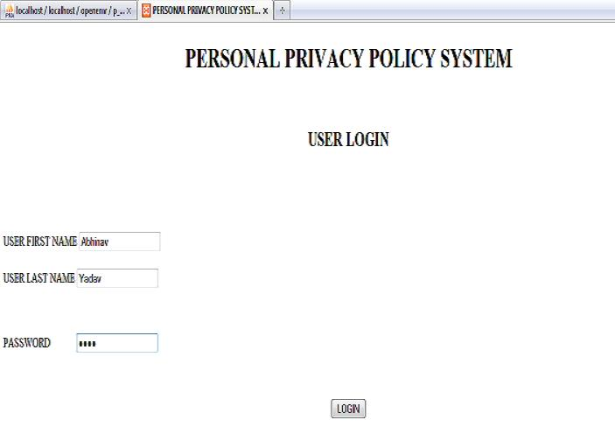

Figure 9: Personal Privacy Policy System – User Login
After logging the patient specifies the PPP in PPP specification module. See figure 10. So, whenever a general physician tries to access EHRs in his private clinic, he will be able to access general/contact data, history data, issues data, immunization details but not prescription and document details.

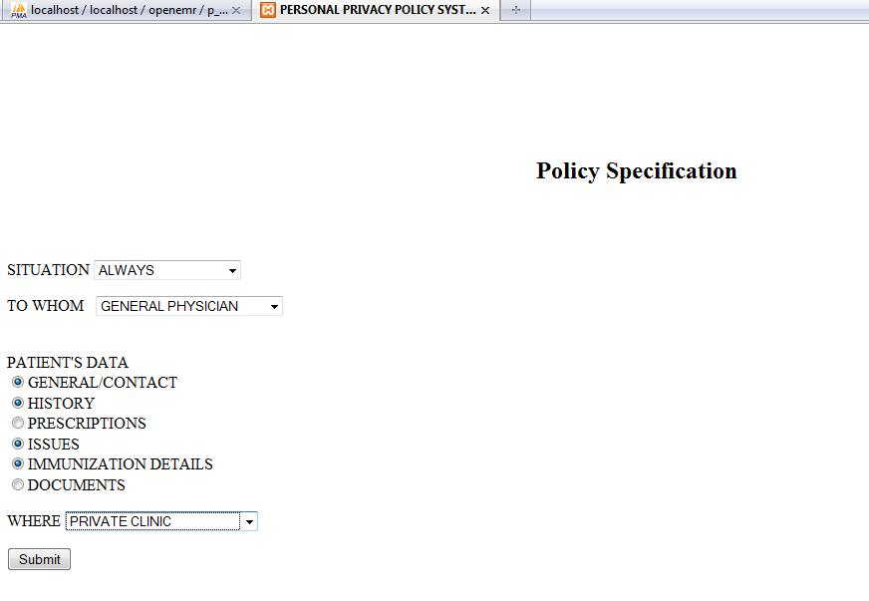

Figure 10: PPP Specification
See figure 11 for PPP repository after specifying PPP policy. It represented the policy ID, and patient information, the role, permissions for different types of patient records, and where these permissions are allowed (e.g. in hospital). In other words, the same role may have different types of permissions depending on a location (e.g. ER vs. Private Clinic). For instance, the policy ID 22 shows for patient Abhinav Yadav, a general physician(role) can access general i.e. demographics, history, issues and immunization details in his private clinic(location). The PPP policy can be different by the patient Abhinav Yadav for general physician (role) at hospital (location).
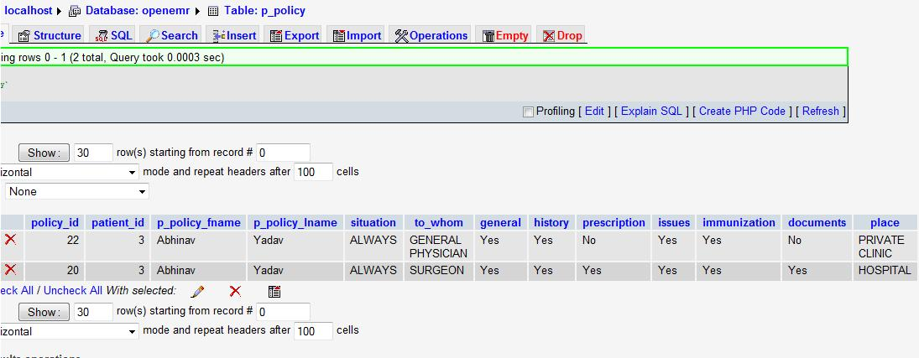

Figure 11: PPP repository after specifying PPP
After specifying PPP patient not only can update the policy but also can delete it. As you can see in figure 10 PPP with policy_id 22 has prescription set to ‘NO’. Using update option we can update the necessary PPP. Here we will update PPP with policy_id 22.

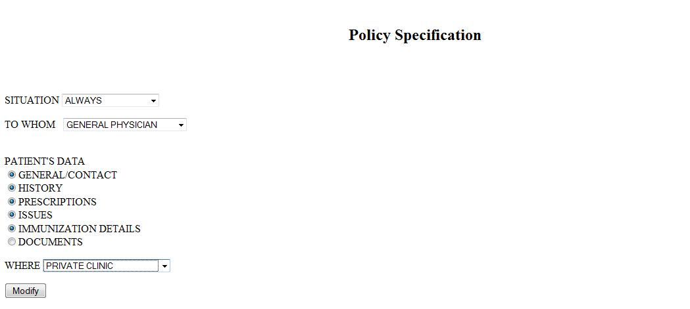

Figure 12: Update/Modify PPP

See figure 13 PPP repository after updating PPP policy. As you can observe in figure 13, the policy id 22 remains the same but the prescription column changes from ‘NO’ to ‘YES’. So, now general physician can access prescription details.

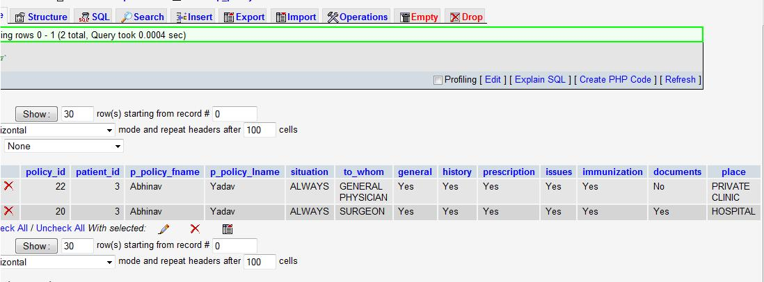
Figure 13: PPP repository after updating PPP

Patient can explicitly mention which policy he wants to delete. See figure 14 and figure 15. In figure 15 we have selected to delete PPP with policy id 22.
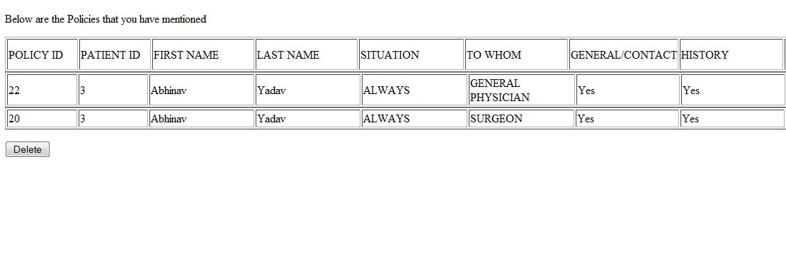
Figure 14: Delete PPP
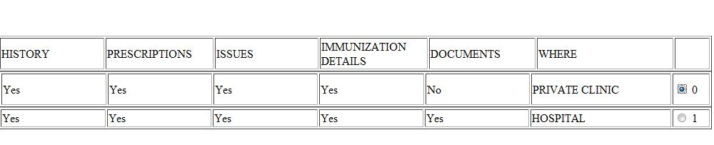
Figure 15: Delete PPP
See figure 16. We can observe that after deletion of PPP with policy id 22, the PPP is deleted from PPP repository.

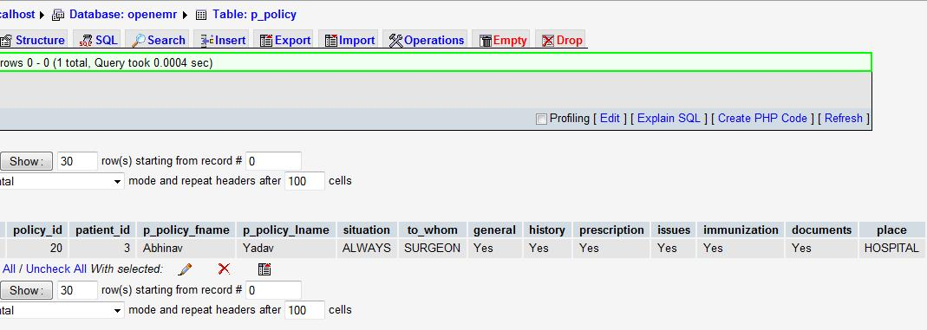
Figure 16: PPP repository after Delete operation

5.1.2. Situation PP Specification Module
We observe from figure 17, that the default PPP is set whenever the situation emergency is selected. We can also observe the different types of emergency situation. When an emergency situation is selected, automatically system asks for type of situation and then default PPP is inserted in PPP repository. We can also observe that except the ‘SITUATION’ filed and ‘EMERGENCY’ field no other field is selected.
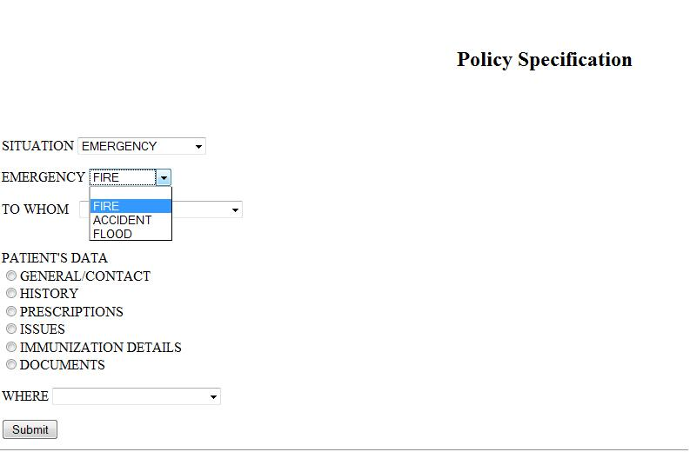
Figure 17: PPP in emergency situation

After we select the emergency situation, as specified, some default values should be entered in the PPP repository. See figure 18. We observe that the PPP with policy id 23 has default values for the emergency situation ‘FIRE’.

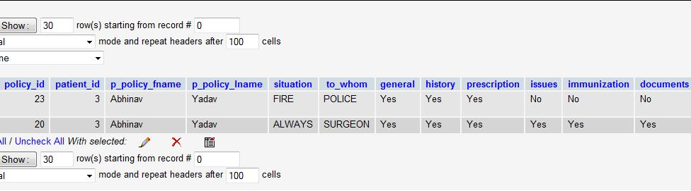
Figure 18: PPP repository after SPP entry

  - PPP Enforcement Module
5.2.1 PPP Enforcement
Observe figure 19 the patient has different PPP for ‘NURSE’ AND ‘SURGEON’ with policy id 24 and 25 respectively. So, if a nurse tries to access immunization details, she will not be able to access them, but a doctor can access immunization details. On the other hand, the demographics details can be accessed by both nurse and surgeon because the patient has allowed both roles for the access.

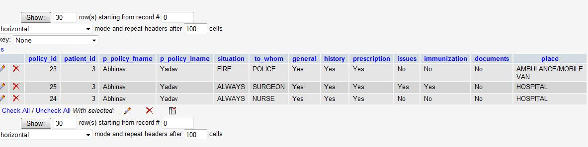
Figure 19: Snapshot of PPP repository

Figure 20 shows nurse logs in to an OpenEMR system with user name (John Smith) and password under normal conditions. Figure 18 show the nurse can have access to demographics data but not the immunization data as PPP has specified (e.g. policy id 24 in Fig 19). The name of the nurse can be seen at top left corner of the figure 18.

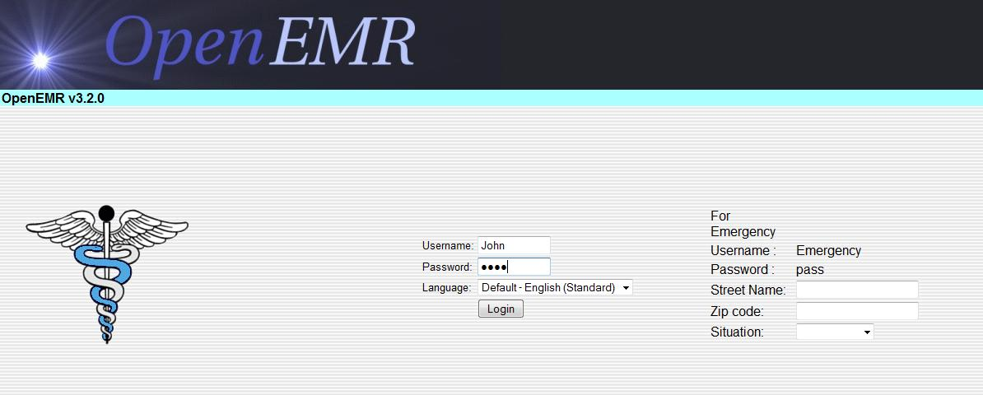
Figure 20: Nurse login under normal condition

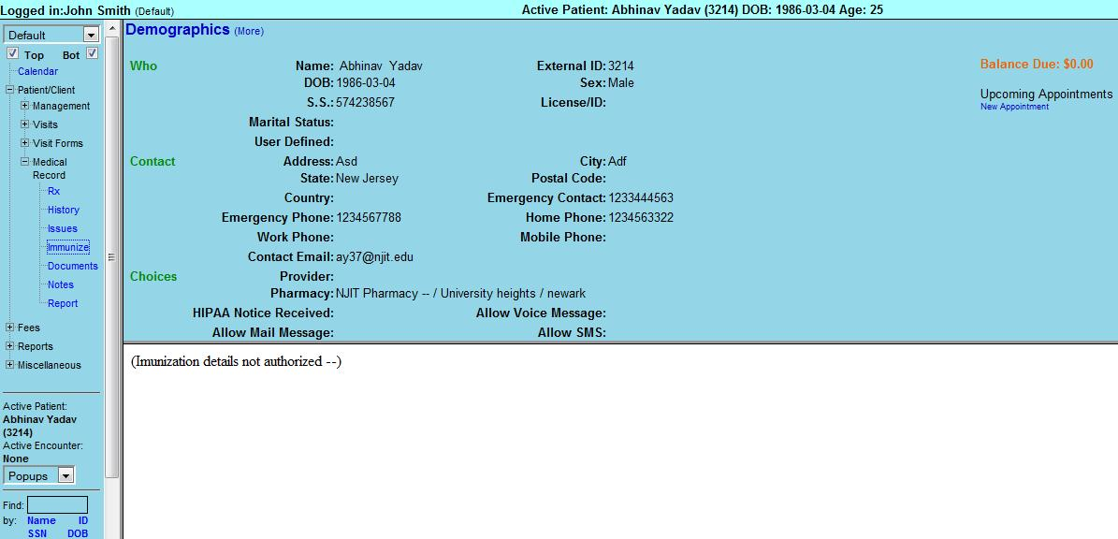

Figure 21: Nurse allowed and disallowed access according to patient’s PPP
Similarly figure 22 show a surgeon logging in with username and password under normal conditions. Figure 23 show the surgeon can have access to demographics data and the immunization data according to PPP (see policy id 25 in fig 19). The name of the surgeon can been seen at top left corner of the figure 20
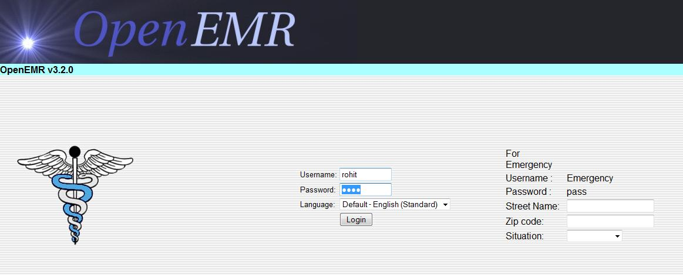
Figure 22: Surgeon login under normal condition

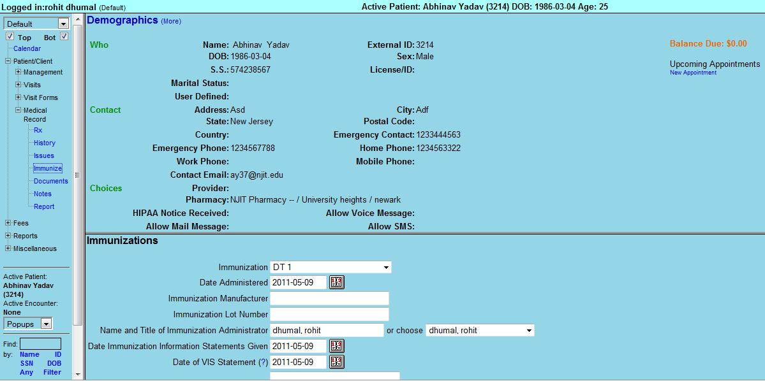
Figure 23: Surgeon allowed access according to patient’s PPP

5.2.2. SPP Enforcement with Simulated situation data repositories for situation credential verifications
Figure 24 show login under emergency condition. As far as emergency condition is concerned the user has to enter information about the emergency location with street name and zip code for authenticating the situation. User also has to enter his own credential like his organization identification number with organization name to authenticate if he can assume some of the default roles for a given situation.
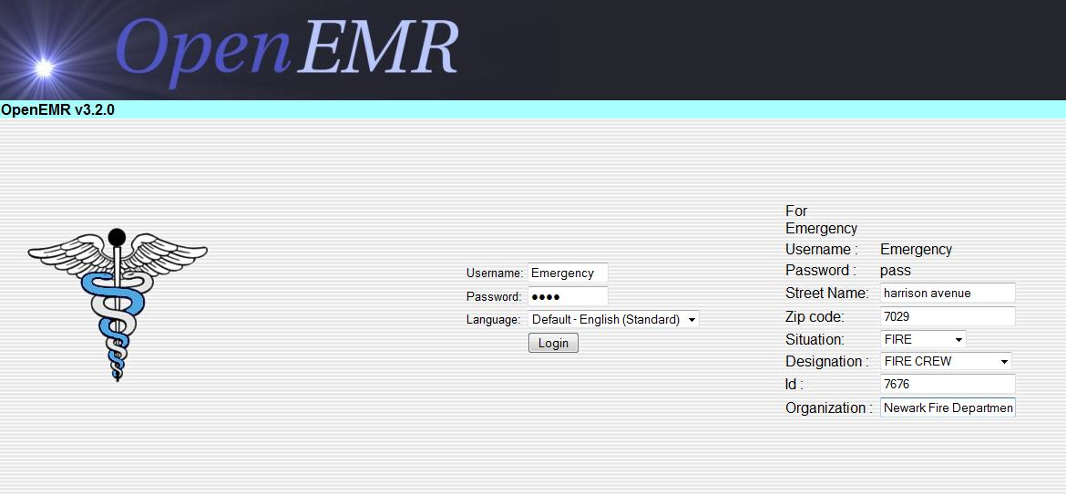
Figure 24: Login under emergency condition (Fire Crew)
The SPP enforcement protocol which check if emergency situation ‘FIRE’ in this case exists or not. It will check the simulated situation repository. SPP enforcement protocol checks for the time interval. As you will observe in figure 25 the start time for situation ‘FIRE’ (id is 1) is less than the time when the repository is accessed. The end date is 0000-00-00 00:00:00 which indicates that the situation is still on. SPP will also check the simulated organization’s user credential repository. See figure 26. If the user exists in the organization he has given, then access for the roles his organization has assigned to him is granted for certain default health records, according to the SPP.
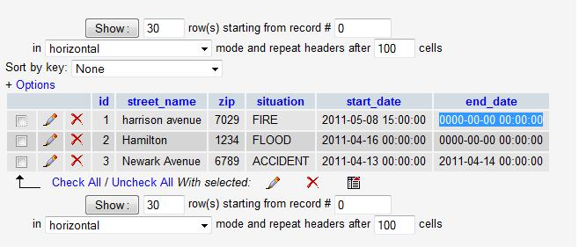
Figure 25: Simulated situation location verification
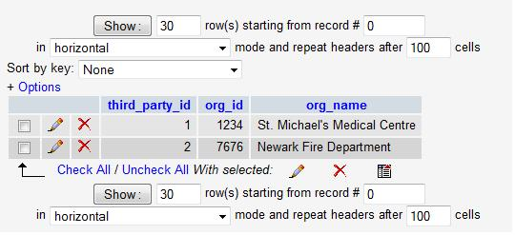
Figure 26: Simulated situation credential verification
Figure 27 show that after SPP enforcement protocol has allowed access to fire crew person he is able to see data which is only specified by default SPP for emergency fire situation. Figure 28 show login information of a burn specialist under emergency fire situation. As a burn specialist is a kind of a doctor, the SPP enforcement protocol not only allows access to default health records specified by the SPP, but also to additional health records. Before allowing access, the SPP protocol checks for an Emergency situation.
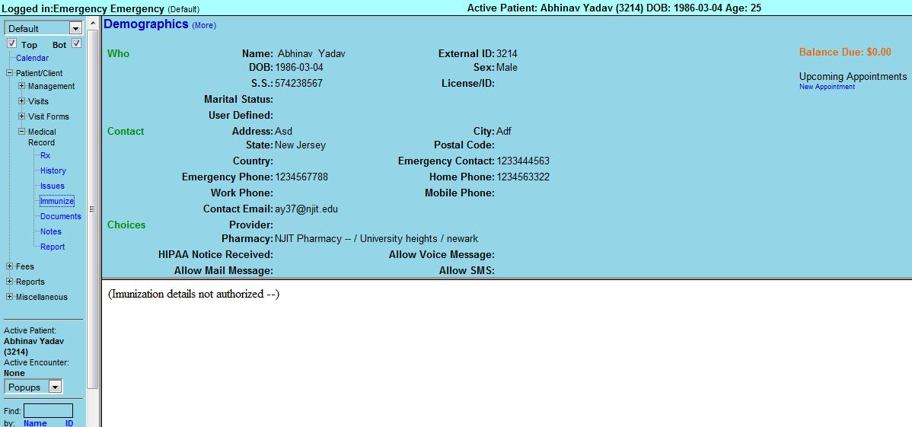
Figure 27: Fire crew allowed access under emergency fire situation.
See figure 25, figure 26 and figure 29 for simulated emergency situation verification and simulated credential verification.

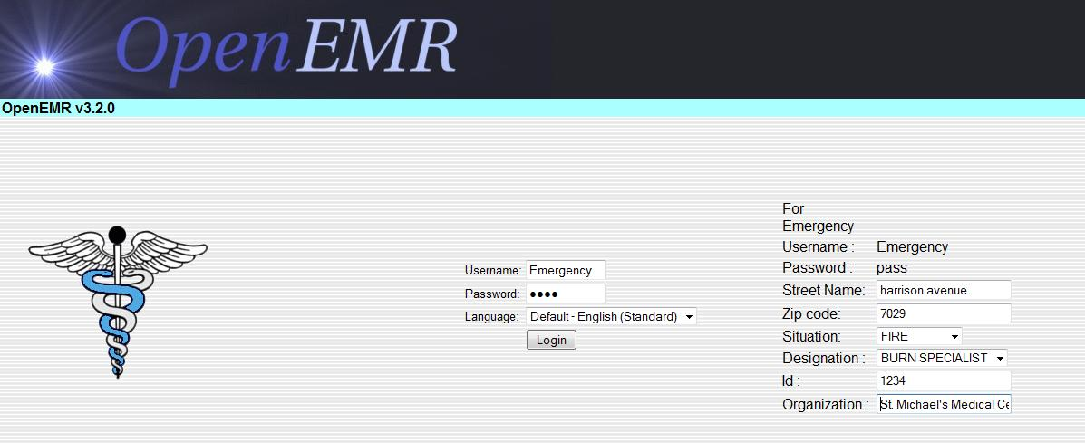
Figure 28: Login under emergency condition (Burn Specialist)

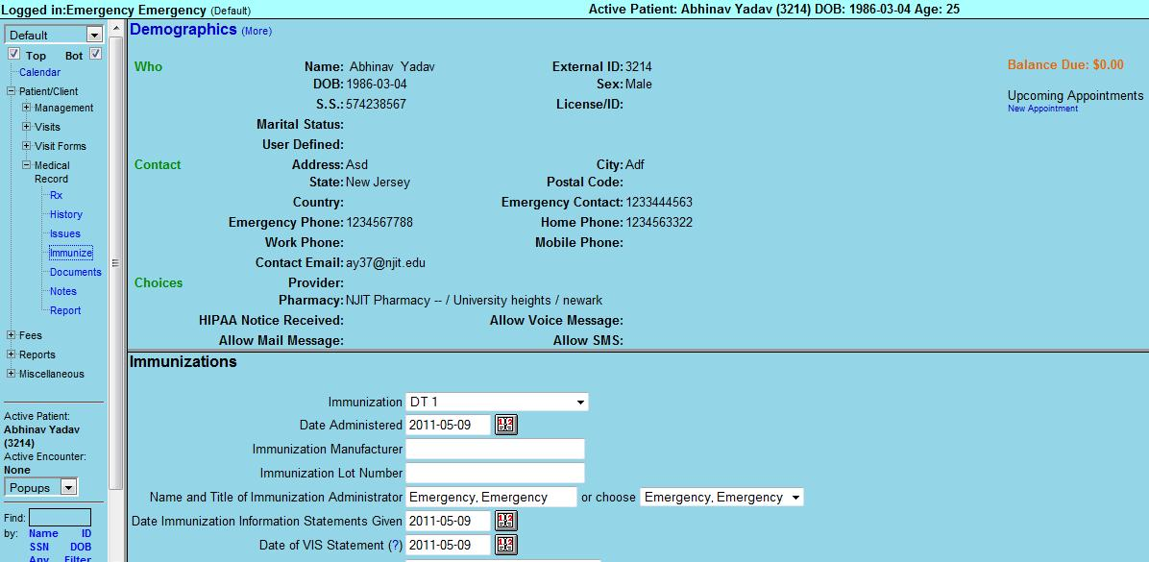
Figure 29: Burn Specialist allowed access under emergency fire situation.

- CONCLUSION
In the ‘Personal Privacy Policy Control in Electronic Health Records’ project we addressed how to protect the privacy of patients’ data in electronic health records (EHR). We designed and developed a Web-based system which helps patients to specify their own privacy policies and control over who, when, and under what situations their electronic health records can be accessed. We have taken a major step in developing a model for the health care industry by stopping misuse of electronic health records.
We successfully designed and developed the Personal Policy Specification module. This module helps a patient to specify his Personal Privacy Policy. Patients can explicitly specify which data can be seen by whom, when, where and for what purposes. This helps patients to have total control of their health data in their own hands.
We successfully designed and developed the Situation Privacy Policy Specification Module. This module helps patients to specify their PPP according to situations. We also implemented in detail the emergency situation conditions. The SPP specification module specifies some default policies for emergency situations. So, we have taken care of the case that if a person’s life is in danger in some emergency situation, then medical professionals should have access to his EHRs without releasing all the records.
We implemented our logic of the PPP enforcement module to access patient records in OpenEMR, which is an open source EHRs system. The PPP enforcement module checks whether a user accessing a patient’s EHRs has valid credentials (e.g. username and passwords). It also checks if the patient has allowed certain roles for the authenticated user to access his particular health data. Thus, this module ensures that the rights to access the patient’s EHRs are with the patient himself/herself.
We also combined our SPP enforcement module with OpenEMR. This module checks whether the patient has given rights to certain users under certain situations. Under emergency situations, the SPP enforcement module checks with the simulated emergency location verification repository. It checks whether an emergency situation really exists or not. The SPP enforcement module not only checks for emergency locations but also checks for the user’s credentials who is accessing the health data. The SPP enforcement module makes use of simulated emergency situation credential verification and third party user authentication.
In the near future, we will develop and implementthe ‘Disclosure Notification Module’ and the ‘Auditing and Monitoring the Disclosure and Reports on demand Module’ as designed.
Thus, with this project, we have made significant contributions by developing a model for enhancing privacy and security of electronic health records.
- REFERENCES
- World Health Organization, Medical Records Manual: A Guide for developing countries.
- Problems with EHR
http://healthworldnet.com/HeadsOrTails/electronic-medical-records-the-pros-and-cons/?C=6238 , accessed October 12, 2010.
- Privacy issues
http://www.thefreelibrary.com/Consumer+privacy+issues+associated+with+the+use+of+electronic+health...-a0219002331, accessed October 13, 2010.
- Wikipedia
http://en.wikipedia.org, accessed May 7, 2010.
- Microsoft Health vault information
http://blog.tsibouris.com/2007/12/microsoft-health-vault.html, accessed October 15, 2010.
- HIPAA
http://www.hhs.gov/ocr/privacy/hipaa, accessed October 14, 2010.
- Janice Warner and Soon Ae Chun, Privacy Protection for Government Mashups, Information Polity: Volume 14, Editions 1 & 2, 2009: pp 75-90.
- Hema Andal Jayprakash Narayan and Mehmat Hadi Guines, Ensuring Access Control in Cloud Provisioned Health care System, Department of Computer Science & Engineering, University of Nevada, Reno.
http://www.cse.unr.edu/~mgunes/papers/eHealth11.pdf, accessed October 14, 2010.

APPENDIX A: USER MANUAL
- Install OpenEMR on the system.
- Copy contents of files user_login.html, register.html, register.php, checklogin.php, emergency_location.php, logout.php, p_delete_policy.php, p_delete_policy2.php, p_policy.php, p_update_policy.php, p_update_policy2.php, p_update_policy3.php, p_update_policy4.php, p_view_policy.php, policy_enter.php under Appendix B, Personal Privacy Policy tool to xampp\htdocs\openemr\ Personal_Privacy_Policy.
- Copy contents of login.php under Appendix B, OpenEMR modified source code to xampp\htdocs\openemr\interface\login.
- Copy contents of main_screen.php under Appendix B, OpenEMR modified source code to xampp\htdocs\openemr\interface\main.
- Copy contents of controller.php under Appendix B, OpenEMR modified source code to xampp\htdocs\openemr.
- Copy contents of logout.php under Appendix B, OpenEMR modified source code to xampp\htdocs\openemr\interface.
- Copy contents of history.php under Appendix B, OpenEMR modified source code to xampp\htdocs\openemr\interface\patient_file\history.
- Copy contents of immunization.php, rx_frameset.php, rx_left.php, status_full.php under Appendix B, OpenEMR modified source code to xampp\htdocs\openemr\interface\patient_file\summary.
- Create following tables with particular columns and datatypes :-

p_authentication
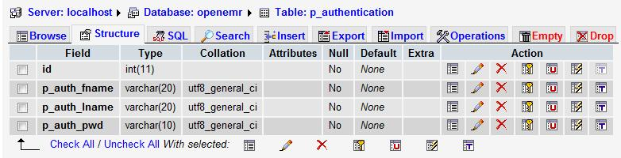

p_policy
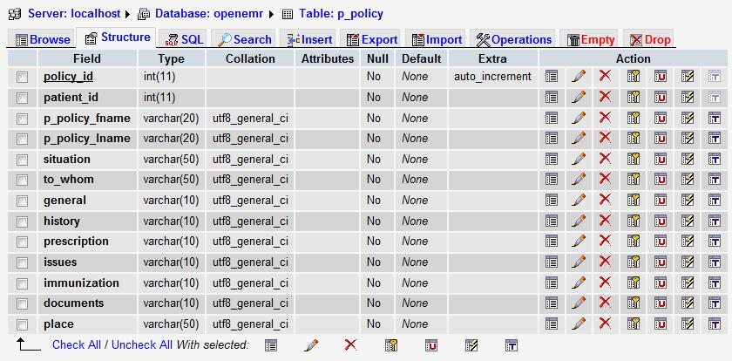
p_designation
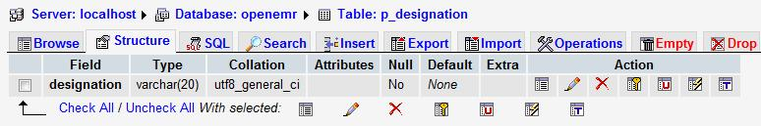

p_emergency_location
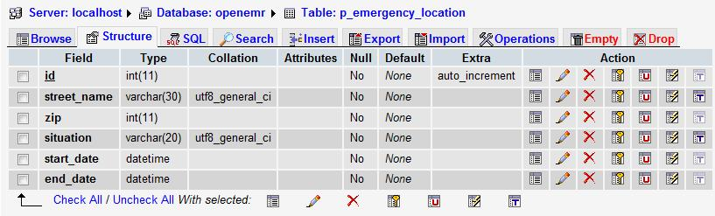

p_third_party
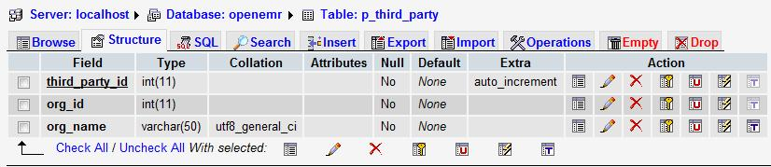
APPENDIX B: CODE
Personal Privacy Policy Tool :
user_login.html:
<!DOCTYPE html PUBLIC "-//W3C//DTD XHTML 1.0 Transitional//EN" "http://www.w3.org/TR/xhtml1/DTD/xhtml1-transitional.dtd">
<html xmlns="http://www.w3.org/1999/xhtml">
<head>
<meta http-equiv="Content-Type" content="text/html; charset=iso-8859-1" />
<title>PERSONAL PRIVACY POLICY SYSTEM</title>
</head>

<body>
<h1 align="center"> PERSONAL PRIVACY POLICY SYSTEM</h1>
<p align="center">&nbsp;</p>
<h2 align="center"> USER LOGIN</h2>
<p align="center">&nbsp;</p>
<p align="center">&nbsp;</p>
<form id="form1" name="form1" method="post" action="checklogin.php">
<label>USER FIRST NAME
<input type="text" name="textfield" />
</label>
<label><br />
<br />
USER LAST NAME
<input type="text" name="textfield1" />
</label>
<p>&nbsp;</p>
<label>PASSWORD
&nbsp;&nbsp;&nbsp;&nbsp;&nbsp;&nbsp;&nbsp;&nbsp;&nbsp;&nbsp;
<input type="password" name="textfield2" />
</label>
<p>&nbsp;</p>
<label>
<div align="center">
<input type="submit" name="Submit" value="LOGIN" />
</div>
</label>
<p>&nbsp;</p>
<label>
<div align="center">
<a href="register.html">REGISTER</a>
</div>
</label>
</form>
<p align="center">&nbsp;</p>
</body>
</html>

Register.html:
<!DOCTYPE html PUBLIC "-//W3C//DTD XHTML 1.0 Strict//EN" "http://www.w3.org/TR/xhtml1/DTD/xhtml1-strict.dtd">
<html xmlns="http://www.w3.org/1999/xhtml">
<head>
<title>PERSONAL PRIVACY POLICY SYSTEM</title>
<meta http-equiv="content-type" content="text/html; charset=utf-8" />
</head>
<body>
<div id="wrapper">
<div id="header">
<h1 id="lineone" align="center"> PERSONAL PRIVACY POLICY SYSTEM</h1>
<h2 id="linetwo"></h2>
</div>
<div id="navbar">
<ul>
<li><a href="user_login.html">LOGIN</a></li>
</ul>
</div>
<div id="leftcolumn">
<p>&nbsp;</p>
<p>&nbsp;</p>
<p>&nbsp;</p>
<h2 align="center">REGISTRATION</h2>
<form id="form1" name="form1" method="post" action="register.php">
<label><br />
<br />
</label>
<p>
<label>FIRST NAME
<input type="text" name="textfield" />
</label>
</p>
<p>
<label>LAST NAME
<input type="text" name="textfield1" />
</label>
</p>
<p>PASSWORD
<label>
<input type="password" name="textfield2" />
</label>
</p>
<p>
<label>
<input type="submit" name="Submit" value="Submit" />
</label>
</p>
<p>
<label></label>
</p>
</form>
<p align="center">&nbsp;</p>
</div>
</body>
</html>

register.php :
<?php
echo'<!DOCTYPE html PUBLIC "-//W3C//DTD XHTML 1.0 Transitional//EN" "http://www.w3.org/TR/xhtml1/DTD/xhtml1-transitional.dtd">';
echo'<html xmlns="http://www.w3.org/1999/xhtml">';
echo'<head>';
echo'<meta http-equiv="Content-Type" content="text/html; charset=iso-8859-1" />';
echo'<title>PERSONAL PRIVACY POLICY SYSTEM</title>';
echo'</head>';
echo'<body>';

$c=mysql_connect("localhost","root","");
if ( ! $c ) {
echo "Unable to connect: " .mysql_error();
die();
}
mysql_select_db("openemr", $c);

$fname=$_REQUEST["textfield"];
$lname=$_REQUEST["textfield1"];
$pwd=$_REQUEST["textfield2"];

if ($fname != NULL && $lname != NULL && $pwd != NULL)
{
$s=mysql_query("select * from patient_data");

while($row = mysql_fetch_array($s))
{
$x = $row['fname'];
$y = $row['lname'];
$id = $row['id'];

if($fname==$x && $lname==$y )
{
$r=mysql_query("insert into p_authentication values('$id','$fname','$lname','$pwd')");
echo'<meta http-equiv="REFRESH" content="0;url=user_login.html">';
}
else
echo'You are not entered in EMR system by Authorized person';
echo'<p><a href="register.html">REGISTER</a></p>';
}
}

mysql_close($c);

echo'</body>';
echo'</html>';
?>

checklogin.php :
<?php
session_start();
$session=$_REQUEST["textfield"];
$session1=$_REQUEST["textfield1"];
$_SESSION['usd']=$session;
$_SESSION['usd1']=$session1;
$usd=$_SESSION['usd'];
$usd1=$_SESSION['usd1'];
isset($_SESSION['usd']);
isset($_SESSION['usd1']);

echo'<!DOCTYPE html PUBLIC "-//W3C//DTD XHTML 1.0 Transitional//EN" "http://www.w3.org/TR/xhtml1/DTD/xhtml1-transitional.dtd">';
echo'<html xmlns="http://www.w3.org/1999/xhtml">';
echo'<head>';
echo'<meta http-equiv="Content-Type" content="text/html; charset=iso-8859-1" />';
echo'<title>PERSONAL PRIVACY POLICY SYSTEM</title>';
echo'</head>';

echo'<body>';

//Make an mysql Connection
$c=mysql_connect("localhost","root","");
if ( ! $c ) {
echo "Unable to connect: " .mysql_error();
die();
}
mysql_select_db("openemr", $c);
//$userid=$_REQUEST["textfield"];
$password=$_REQUEST["textfield2"];
//$i = 0;

if ($session != NULL && $session1 != NULL && $password != NULL)
{
$s=mysql_query("select * from p_authentication");

while($row = mysql_fetch_array($s))
{
$id = $row['id'];
$x = $row['p_auth_fname'];
$y = $row['p_auth_lname'];
$z = $row['p_auth_pwd'];

if($session==$x && $session1==$y && $password==$z)
{
//$i++;
$_SESSION['patient_id']=$id;
$id_session=$_SESSION['patient_id'];
isset($_SESSION['patient_id']);
echo'Please click the option you want to select:<br/>';

echo'<p><a href="p_policy.php">Add Policy</a><br/></p>';
// echo'<p><a href="p_update.php">Modify Policy</a><br/></p>';
echo'<p><a href="p_delete_policy.php">Delete Policy</a><br/></p>';
echo'<p><a href="p_view_policy.php">View Policy</a><br/></p>';
echo'<p><a href="logout.php">Log Out</a><br/></p>';

}
}
}

/*if($i> 0)
//echo'<meta http-equiv="REFRESH" content="0;url=index2.php">';
echo'hi';
else
//echo'<meta http-equiv="REFRESH" content="0;url=login.html">';
echo'hello';*/
mysql_close($c);

echo'</body>';
echo'</html>';

?>

emergency_location :
<?php
?>
<!DOCTYPE html PUBLIC "-//W3C//DTD XHTML 1.0 Transitional//EN" "http://www.w3.org/TR/xhtml1/DTD/xhtml1-transitional.dtd">
<html xmlns="http://www.w3.org/1999/xhtml">
<head>
<meta http-equiv="Content-Type" content="text/html; charset=iso-8859-1" />
<title>Untitled Document</title>
</head>

<body>

<form id="form1" name="form1" method="post" action="">
<table width="248" border="2">
<tr>
<td width="122">Username :</td>
<td width="108"><input name="Input" type="text" value="Default" /></td>
</tr>
<tr>
<td>Password :</td>
<td><input name="Input2" type="text" value="pass"/></td>
</tr>
<tr>
<td>Street Name: </td>
<td><input name="Input3" type="text" /></td>
</tr>
<tr>
<td>Zip code:</td>
<td><input name="Input4" type="text" /></td>
</tr>
<tr>
<td>Situation: </td>
<td><select name="select5" id="select">
<option value="" selected="selected"></option>
<option value="FIRE">FIRE</option>
<option value="ACCIDENT">ACCIDENT</option>
<option value="FLOOD">FLOOD</option>
</select></td>
</tr>
</table>

</form>
</body>
</html>

logout.php :
<?php
session_start();
session_destroy();
?>

<!DOCTYPE html PUBLIC "-//W3C//DTD XHTML 1.0 Transitional//EN" "http://www.w3.org/TR/xhtml1/DTD/xhtml1-transitional.dtd">
<html xmlns="http://www.w3.org/1999/xhtml">
<head>
<meta http-equiv="Content-Type" content="text/html; charset=iso-8859-1" />
<title>Untitled Document</title>
</head>

<body>
<center><big><b><font face="Times New Roman, Times, serif" size="+4">THANK YOU !!</font></big></b></center>

<br />
<br />
<br />
<br />
<br />

<center><b><a href="user_login.html">Click here if you want to LOGIN again</a></b></center>
</body>
</html>

p_delete_policy:
<?php
session_start();
isset($_SESSION['usd']);
isset($_SESSION['usd1']);
$usd=$_SESSION['usd'];
$usd1=$_SESSION['usd1'];
isset($_SESSION['id']);
$id_session = $_SESSION['id'];

//Make an mysql Connection
$c=mysql_connect("localhost","root","");
if ( ! $c ) {
echo "Unable to connect: " .mysql_error();
die();
}
mysql_select_db("openemr", $c);

echo'<!DOCTYPE html PUBLIC "-//W3C//DTD XHTML 1.0 Transitional//EN" "http://www.w3.org/TR/xhtml1/DTD/xhtml1-transitional.dtd">';
echo'<html xmlns="http://www.w3.org/1999/xhtml">';
echo'<head>';
echo'<meta http-equiv="Content-Type" content="text/html; charset=iso-8859-1" />';
echo'<title>PERSONAL PRIVACY POLICY SYSTEM</title>';
echo'</head>';
echo'<body>';
echo'<p> Below are the Policies that you have mentioned </p>';
echo'<form id="form1" name="form1" method="post" action="p_delete_policy2.php">';
echo'<table border="1" width="1950">
<tr>
<td width="100"> POLICY ID </td>
<td width="100"> PATIENT ID </td>
<td width="150"> FIRST NAME</td>
<td width="150"> LAST NAME </td>
<td width="150"> SITUATION </td>
<td width="150"> TO WHOM </td>
<td width="150"> GENERAL/CONTACT </td>
<td width="150"> HISTORY </td>
<td width="150"> PRESCRIPTIONS </td>
<td width="150"> ISSUES </td>
<td width="150"> IMMUNIZATION DETAILS </td>
<td width="150"> DOCUMENTS </td>
<td width="200"> WHERE </td>
<td width="50"> </td>

</tr>
</table>';
$s=mysql_query("select * from p_policy where p_policy_fname = '$usd' and p_policy_lname = '$usd1'");
$i = 0;
while($row = mysql_fetch_array($s))
{
$x0 = $row['policy_id'];
$x1 = $row['patient_id'];
$x2 = $row['p_policy_fname'];
$x3 = $row['p_policy_lname'];
$x4 = $row['situation'];
$x5 = $row['to_whom'];
$x6 = $row['general'];
$x7 = $row['history'];
$x8 = $row['prescription'];
$x9 = $row['issues'];
$x10 = $row['immunization'];
$x11 = $row['documents'];
$x12 = $row['place'];
echo'<table border="1" width="1950">';
echo' <tr>';
echo' <td width="100">'.$x0.' </td>';
echo' <td width="100">'.$x1.' </td>';
echo' <td width="150">'.$x2.'</td>';
echo' <td width="150">'.$x3.'</td>';
echo' <td width="150">'.$x4.'</td>';
echo' <td width="150">'.$x5.'</td>';
echo' <td width="150">'.$x6.'</td>';
echo' <td width="150">'.$x7.' </td>';
echo' <td width="150">'.$x8.' </td>';
echo' <td width="150">'.$x9.' </td>';
echo' <td width="150">'.$x10.' </td>';
echo' <td width="150">'.$x11.' </td>';
echo' <td width="200">'.$x12.' </td>';
echo' <td width="50"><input name="radio" type="radio" value='.$i.'> '.$i.' </td>';
echo' </tr>';
echo'</table>';
$i++;
}
echo'<p><input type="submit" name="Delete" value="Delete" /></p>';
echo'</form>';
mysql_close($c);

echo'</body>';
echo'</html>';
?>

p_delete_policy2.php:
<?php
session_start();
isset($_SESSION['usd']);
isset($_SESSION['usd1']);
$usd=$_SESSION['usd'];
$usd1=$_SESSION['usd1'];
isset($_SESSION['id']);
$id_session = $_SESSION['id'];
$del_count=$_REQUEST["radio"];

// del_count will get the value of radio button from delete and will run the for loop as per it

//Make an mysql Connection
$c=mysql_connect("localhost","root","");
if ( ! $c ) {
echo "Unable to connect: " .mysql_error();
die();
}
mysql_select_db("openemr", $c);

echo'<!DOCTYPE html PUBLIC "-//W3C//DTD XHTML 1.0 Transitional//EN" "http://www.w3.org/TR/xhtml1/DTD/xhtml1-transitional.dtd">';
echo'<html xmlns="http://www.w3.org/1999/xhtml">';
echo'<head>';
echo'<meta http-equiv="Content-Type" content="text/html; charset=iso-8859-1" />';
echo'<title>PERSONAL PRIVACY POLICY SYSTEM</title>';
echo'</head>';
echo'<body>';
$s=mysql_query("select * from p_policy where p_policy_fname = '$usd' and p_policy_lname = '$usd1'");
for($j=0;$j<=$del_count;$j++)
{
$row = mysql_fetch_array($s);
$x0 = $row['policy_id'];
$x1 = $row['patient_id'];
$x2 = $row['p_policy_fname'];
$x3 = $row['p_policy_lname'];
$x4 = $row['situation'];
$x5 = $row['to_whom'];
$x6 = $row['general'];
$x7 = $row['history'];
$x8 = $row['prescription'];
$x9 = $row['issues'];
$x10 = $row['immunization'];
$x11 = $row['documents'];
$x12 = $row['place'];
}

$del=mysql_query("delete from p_policy where policy_id = '$x0'");
mysql_close($c);
echo'<p><a href="p_policy.php">Add Policy</a><br/></p>';
echo'<p><a href="p_update_policy.php">Modify Policy</a><br/></p>';
echo'<p><a href="p_delete_policy.php">Delete Policy</a><br/></p>';
echo'<p><a href="p_view_policy.php">View Policy</a><br/></p>';
echo'<p><a href="logout.php">Log Out</a><br/></p>';
echo'</body>';
echo'</html>';
?>

p_policy.php:
<?php
session_start();
isset($_SESSION['usd']);
isset($_SESSION['usd1']);
$usd=$_SESSION['usd'];
$usd1=$_SESSION['usd1'];
isset($_SESSION['id']);
$id_session = $_SESSION['id'];

/* usd is first name
usd1 is last name */
?>

<!DOCTYPE html PUBLIC "-//W3C//DTD XHTML 1.0 Strict//EN" "http://www.w3.org/TR/xhtml1/DTD/xhtml1-strict.dtd">
<html xmlns="http://www.w3.org/1999/xhtml">
<head>
<title>PERSONAL PRIVACY POLICY SYSTEM</title>
<meta http-equiv="content-type" content="text/html; charset=utf-8" />
<script type="text/javascript">
function displaymessage()
{
var htmltxt = <label>EMERGENCY<select name="select5" id="select">
<option value="" selected="selected"></option>
<option value="FIRE">FIRE</option>
<option value="ACCIDENT">ACCIDENT</option>
<option value="FLOOD">FLOOD</option>
</select></label>;
document.getElementById('d2').innerHTML=htmltxt;

}
</script>
</head>

<body>
<div id="wrapper">

<div id="header">
<h1 id="lineone"></h1>
<h2 id="linetwo"></h2>
</div>

<div id="leftcolumn">
<p>&nbsp;</p>
<p>&nbsp;</p>
<p>&nbsp;</p>

<h2 align="center">Policy Specification </h2>
<form id="form1" name="form1" method="post" action="policy_enter.php">
<label><br />
<br />
<p>
<label>SITUATION
<select name="select5" id="select">
<option value="" selected="selected"></option>
<option value="ALWAYS">ALWAYS</option>
<option value="INSURANCE CLAIM">INSURANCE CLAIM</option>
<option value="EMERGENCY" onclick="displaymessage()">EMERGENCY</option>
<option value="RESEARCH">RESEARCH</option>
</select>
</label><div id="d2" name="d2" ></div>
</p>

</label>
<p>
<label>TO WHOM &nbsp;
<select name="select" id="select">
<option value="" selected="selected"></option>
<option value="GENERAL PHYSICIAN">GENERAL PHYSICIAN</option>
<option value="SURGEON">SURGEON</option>
<option value="RESIDENT DOCTOR">RESIDENT DOCTOR</option>
<option value="DOCTOR ON VISIT">DOCTOR ON VISIT</option>
<option value="CHIEF MATRON">CHIEF MATRON</option>
<option value="NURSE">NURSE</option>
<option value="ADMINISTRATION STAFF">ADMINISTRATION STAFF</option>
<option value="THIRD PARTY">THIRD PARTY</option>
<option value="POLICE">POLICE</option>
</select>
<br />
<br/>

</label>
</p>
<p>
<label>PATIENT'S DATA
<br />

<INPUT TYPE="RADIO" NAME="q0" value="Yes">GENERAL/CONTACT</INPUT> <br />
<INPUT TYPE="RADIO" NAME="q1" value="Yes">HISTORY</INPUT><br />
<INPUT TYPE="RADIO" NAME="q2" value="Yes">PRESCRIPTIONS</INPUT><br />
<INPUT TYPE="RADIO" NAME="q3" value="Yes">ISSUES</INPUT><br />
<INPUT TYPE="RADIO" NAME="q4" value="Yes">IMMUNIZATION DETAILS</INPUT><br />
<INPUT TYPE="RADIO" NAME="q5" value="Yes">DOCUMENTS</INPUT><br />
</label>
</p>
<p>
<label>WHERE
<select name="select4" id="select">
<option value="" selected="selected"></option>
<option value="HOSPITAL">HOSPITAL</option>
<option value="PRIVATE CLINIC">PRIVATE CLINIC</option>
<option value="PHARMACY STORE">PHARMACY STORE</option>
<option value="AMBULANCE/MOBILE VAN">AMBULANCE/MOBILE VAN</option>
</select>
</label>
</p>

<p>
<label>
<input type="submit" name="Submit" value="Submit" />
</label>
</p>
<p>
<label></label>
</p>
</form>

</body>
</html>

p_update_policy:

<?php
session_start();
isset($_SESSION['usd']);
isset($_SESSION['usd1']);
$usd=$_SESSION['usd'];
$usd1=$_SESSION['usd1'];
isset($_SESSION['id']);
$id_session = $_SESSION['id'];

//Make an mysql Connection
$c=mysql_connect("localhost","root","");
if ( ! $c ) {
echo "Unable to connect: " .mysql_error();
die();
}
mysql_select_db("openemr", $c);

echo'<!DOCTYPE html PUBLIC "-//W3C//DTD XHTML 1.0 Transitional//EN" "http://www.w3.org/TR/xhtml1/DTD/xhtml1-transitional.dtd">';
echo'<html xmlns="http://www.w3.org/1999/xhtml">';
echo'<head>';
echo'<meta http-equiv="Content-Type" content="text/html; charset=iso-8859-1" />';
echo'<title>PERSONAL PRIVACY POLICY SYSTEM</title>';
echo'</head>';
echo'<body>';
echo'<p> Below are the Policies that you have mentioned </p>';
echo'<form id="form1" name="form1" method="post" action="p_update_policy2.php">';
echo'<table border="1" width="1950">
<tr>
<td width="100"> POLICY ID </td>
<td width="100"> PATIENT ID </td>
<td width="150"> FIRST NAME</td>
<td width="150"> LAST NAME </td>
<td width="150"> SITUATION </td>
<td width="150"> TO WHOM </td>
<td width="150"> GENERAL/CONTACT </td>
<td width="150"> HISTORY </td>
<td width="150"> PRESCRIPTIONS </td>
<td width="150"> ISSUES </td>
<td width="150"> IMMUNIZATION DETAILS </td>
<td width="150"> DOCUMENTS </td>
<td width="200"> WHERE </td>
<td width="50"> </td>

</tr>
</table>';
$s=mysql_query("select * from p_policy where p_policy_fname = '$usd' and p_policy_lname = '$usd1'");
$i = 0;
while($row = mysql_fetch_array($s))
{
$x0 = $row['policy_id'];
$x1 = $row['patient_id'];
$x2 = $row['p_policy_fname'];
$x3 = $row['p_policy_lname'];
$x4 = $row['situation'];
$x5 = $row['to_whom'];
$x6 = $row['general'];
$x7 = $row['history'];
$x8 = $row['prescription'];
$x9 = $row['issues'];
$x10 = $row['immunization'];
$x11 = $row['documents'];
$x12 = $row['place'];
echo'<table border="1" width="1950">';
echo' <tr>';
echo' <td width="100">'.$x0.' </td>';
echo' <td width="100">'.$x1.' </td>';
echo' <td width="150">'.$x2.'</td>';
echo' <td width="150">'.$x3.'</td>';
echo' <td width="150">'.$x4.'</td>';
echo' <td width="150">'.$x5.'</td>';
echo' <td width="150">'.$x6.'</td>';
echo' <td width="150">'.$x7.' </td>';
echo' <td width="150">'.$x8.' </td>';
echo' <td width="150">'.$x9.' </td>';
echo' <td width="150">'.$x10.' </td>';
echo' <td width="150">'.$x11.' </td>';
echo' <td width="200">'.$x12.' </td>';
echo' <td width="50"><input name="radio" type="radio" value='.$i.'> '.$i.' </td>';
echo' </tr>';
echo'</table>';
$i++;
}
echo'<p><input type="submit" name="Update" value="Update" /></p>';
echo'</form>';
mysql_close($c);

echo'</body>';
echo'</html>';
?>

p_update_policy2:

<?php
session_start();
isset($_SESSION['usd']);
isset($_SESSION['usd1']);
$usd=$_SESSION['usd'];
$usd1=$_SESSION['usd1'];
isset($_SESSION['id']);
$id_session = $_SESSION['id'];
$del_count=$_REQUEST["radio"];

// del_count will get the value of radio button from delete and will run the for loop as per it

//Make an mysql Connection
$c=mysql_connect("localhost","root","");
if ( ! $c ) {
echo "Unable to connect: " .mysql_error();
die();
}
mysql_select_db("openemr", $c);

$s=mysql_query("select * from p_policy where p_policy_fname = '$usd' and p_policy_lname = '$usd1'");
for($j=0;$j<=$del_count;$j++)
{
$row = mysql_fetch_array($s);
$x0 = $row['policy_id'];
$x1 = $row['patient_id'];
$x2 = $row['p_policy_fname'];
$x3 = $row['p_policy_lname'];
$x4 = $row['situation'];
$x5 = $row['to_whom'];
$x6 = $row['general'];
$x7 = $row['history'];
$x8 = $row['prescription'];
$x9 = $row['issues'];
$x10 = $row['immunization'];
$x11 = $row['documents'];
$x12 = $row['place'];
}

$_SESSION['update_policy_id']=$x0;
isset($_SESSION['update_policy_id']);

echo'<!DOCTYPE html PUBLIC "-//W3C//DTD XHTML 1.0 Transitional//EN" "http://www.w3.org/TR/xhtml1/DTD/xhtml1-transitional.dtd">';
echo'<html xmlns="http://www.w3.org/1999/xhtml">';
echo'<head>';
echo'<meta http-equiv="Content-Type" content="text/html; charset=iso-8859-1" />';
echo'<title>EMR SYSTEM</title>';
echo'</head>';
echo'<body>';
echo'<meta http-equiv="REFRESH" content="0;url=p_update_policy3.php">';
echo'</body>';
echo'</html>';
mysql_close($c);
?>

p_update_policy3.php :

<?php
session_start();
isset($_SESSION['usd']);
isset($_SESSION['usd1']);
$usd=$_SESSION['usd'];
$usd1=$_SESSION['usd1'];

/* usd is first name
usd1 is last name */
?>

<!DOCTYPE html PUBLIC "-//W3C//DTD XHTML 1.0 Strict//EN" "http://www.w3.org/TR/xhtml1/DTD/xhtml1-strict.dtd">
<html xmlns="http://www.w3.org/1999/xhtml">
<head>
<title>PERSONAL PRIVACY POLICY SYSTEM</title>
<meta http-equiv="content-type" content="text/html; charset=utf-8" />
<script type="text/javascript">
function displaymessage()
{
var htmltxt = <label>EMERGENCY<select name="select5" id="select">
<option value="" selected="selected"></option>
<option value="FIRE">FIRE</option>
<option value="ACCIDENT">ACCIDENT</option>
<option value="FLOOD">FLOOD</option>
</select></label>;
document.getElementById('d2').innerHTML=htmltxt;

}
</script>
</head>

<body>
<div id="wrapper">

<div id="header">
<h1 id="lineone">EMR System</h1>
<h2 id="linetwo"></h2>
</div>

<div id="leftcolumn">
<p>&nbsp;</p>
<p>&nbsp;</p>
<p>&nbsp;</p>

<h2 align="center">Policy Specification </h2>
<form id="form1" name="form1" method="post" action="p_update_policy4.php">
<label><br />
<br />
<p>
<label>SITUATION
<select name="select5" id="select">
<option value="" selected="selected"></option>
<option value="ALWAYS">ALWAYS</option>
<option value="INSURANCE CLAIM">INSURANCE CLAIM</option>
<option value="EMERGENCY" onclick="displaymessage()">EMERGENCY</option>
<option value="RESEARCH">RESEARCH</option>
</select>
</label><div id="d2" name="d2" ></div>
</p>

</label>
<p>
<label>TO WHOM &nbsp;
<select name="select" id="select">
<option value="" selected="selected"></option>
<option value="GENERAL PHYSICIAN">GENERAL PHYSICIAN</option>
<option value="SURGEON">SURGEON</option>
<option value="RESIDENT DOCTOR">RESIDENT DOCTOR</option>
<option value="DOCTOR ON VISIT">DOCTOR ON VISIT</option>
<option value="CHIEF MATRON">CHIEF MATRON</option>
<option value="NURSE">NURSE</option>
<option value="ADMINISTRATION STAFF">ADMINISTRATION STAFF</option>
<option value="THIRD PARTY">THIRD PARTY</option>
<option value="POLICE">POLICE</option>
</select>
<br />
<br/>

</label>
</p>
<p>
<label>PATIENT'S DATA
<br />

<INPUT TYPE="RADIO" NAME="q0" value="Yes">GENERAL/CONTACT</INPUT> <br />
<INPUT TYPE="RADIO" NAME="q1" value="Yes">HISTORY</INPUT><br />
<INPUT TYPE="RADIO" NAME="q2" value="Yes">PRESCRIPTIONS</INPUT><br />
<INPUT TYPE="RADIO" NAME="q3" value="Yes">ISSUES</INPUT><br />
<INPUT TYPE="RADIO" NAME="q4" value="Yes">IMMUNIZATION DETAILS</INPUT><br />
<INPUT TYPE="RADIO" NAME="q5" value="Yes">DOCUMENTS</INPUT><br />
</label>
</p>
<p>
<label>WHERE
<select name="select4" id="select">
<option value="" selected="selected"></option>
<option value="HOSPITAL">HOSPITAL</option>
<option value="PRIVATE CLINIC">PRIVATE CLINIC</option>
<option value="PHARMACY STORE">PHARMACY STORE</option>
<option value="AMBULANCE/MOBILE VAN">AMBULANCE/MOBILE VAN</option>
</select>
</label>
</p>

<p>
<label>
<input type="submit" name="Modify" value="Modify" />
</label>
</p>
<p>
<label></label>
</p>
</form>

</body>
</html>

p_update_policy4.php :

<?php
session_start();
isset($_SESSION['usd']);
isset($_SESSION['usd1']);
$usd=$_SESSION['usd'];
$usd1=$_SESSION['usd1'];
$update_policy_id = $_SESSION['update_policy_id'];
//Make an mysql Connection
$c=mysql_connect("localhost","root","");
if ( ! $c ) {
echo "Unable to connect: " .mysql_error();
die();
}
mysql_select_db("openemr", $c);

/*
// initializa all values to No
$doc = '';
$sit = '';
$where = '';
$p_data_general = 'No';
$p_data_history = 'No';
$p_data_prescription = 'No';
$p_data_immunization = 'No';
$p_data_issues = 'No';
$p_data_documents = 'No';
// initializaion ends
*/

$doc=$_REQUEST["select"];
//$nur=$_REQUEST["select1"];
//$oth=$_REQUEST["select2"];
$p_data_general=$_REQUEST["q0"];
$p_data_history=$_REQUEST["q1"];
$p_data_prescription=$_REQUEST["q2"];
$p_data_issues=$_REQUEST["q3"];
$p_data_immunization=$_REQUEST["q4"];
$p_data_documents=$_REQUEST["q5"];
$where=$_REQUEST["select4"];
$sit=$_REQUEST["select5"];

$fname=$usd;
$lname=$usd1;
$patient_id = $_SESSION['patient_id'];

// boolean values to be entered logic
$cmp = strcmp($p_data_general, "Yes");
if(!$cmp == 0){
$p_data_general = 'No';
}
$cmp = strcmp($p_data_history, "Yes");
if(!$cmp == 0){
$p_data_history = 'No';
}
$cmp = strcmp($p_data_prescription, "Yes");
if(!$cmp == 0){
$p_data_prescription = 'No';
}
$cmp = strcmp($p_data_immunization, "Yes");
if(!$cmp == 0){
$p_data_immunization = 'No';
}
$cmp = strcmp($p_data_issues, "Yes");
if(!$cmp == 0){
$p_data_issues = 'No';
}

$cmp = strcmp($p_data_documents, "Yes");
if(!$cmp == 0){
$p_data_documents = 'No';
}

$r=mysql_query("update p_policy set patient_id = '$patient_id',p_policy_fname = '$fname',p_policy_lname = '$lname',situation = '$sit',to_whom = '$doc',general = '$p_data_general',history = '$p_data_history',prescription = '$p_data_prescription',issues = '$p_data_issues',immunization = '$p_data_immunization',documents = '$p_data_documents',place = '$where' where policy_id = '$update_policy_id'");

echo'<!DOCTYPE html PUBLIC "-//W3C//DTD XHTML 1.0 Transitional//EN" "http://www.w3.org/TR/xhtml1/DTD/xhtml1-transitional.dtd">';
echo'<html xmlns="http://www.w3.org/1999/xhtml">';
echo'<head>';
echo'<meta http-equiv="Content-Type" content="text/html; charset=iso-8859-1" />';
echo'<title>PERSONAL PRIVACY POLICY SYSTEM</title>';
echo'</head>';
echo'<body>';
echo'<meta http-equiv="REFRESH" content="0;url=p_view_policy.php">';
mysql_close($c);
echo'</body>';
echo'</html>';
?>

p_view_policy :

<?php
session_start();
isset($_SESSION['usd']);
isset($_SESSION['usd1']);
$usd=$_SESSION['usd'];
$usd1=$_SESSION['usd1'];
isset($_SESSION['id']);
$id_session = $_SESSION['id'];

//Make an mysql Connection
$c=mysql_connect("localhost","root","");
if ( ! $c ) {
echo "Unable to connect: " .mysql_error();
die();
}
mysql_select_db("openemr", $c);
echo'<!DOCTYPE html PUBLIC "-//W3C//DTD XHTML 1.0 Transitional//EN" "http://www.w3.org/TR/xhtml1/DTD/xhtml1-transitional.dtd">';
echo'<html xmlns="http://www.w3.org/1999/xhtml">';
echo'<head>';
echo'<meta http-equiv="Content-Type" content="text/html; charset=iso-8859-1" />';
echo'<title>PERSONAL PRIVACY POLICY SYSTEM</title>';
echo'</head>';
echo'<body>';
echo'<p> Below are the Policies that you have mentioned </p>';
echo'<table border="1" width="1900">
<tr>
<td width="100"> POLICY ID </td>
<td width="100"> PATIENT ID </td>
<td width="150"> FIRST NAME</td>
<td width="150"> LAST NAME </td>
<td width="150"> SITUATION </td>
<td width="150"> TO WHOM </td>
<td width="150"> GENERAL/CONTACT </td>
<td width="150"> HISTORY </td>
<td width="150"> PRESCRIPTIONS </td>
<td width="150"> ISSUES </td>
<td width="150"> IMMUNIZATION DETAILS </td>
<td width="150"> DOCUMENTS </td>
<td width="200"> WHERE </td>
</tr>
</table>';
$s=mysql_query("select * from p_policy where p_policy_fname = '$usd' and p_policy_lname = '$usd1'");
while($row = mysql_fetch_array($s))
{
$x0 = $row['policy_id'];
$x1 = $row['patient_id'];
$x2 = $row['p_policy_fname'];
$x3 = $row['p_policy_lname'];
$x4 = $row['situation'];
$x5 = $row['to_whom'];
$x6 = $row['general'];
$x7 = $row['history'];
$x8 = $row['prescription'];
$x9 = $row['issues'];
$x10 = $row['immunization'];
$x11 = $row['documents'];
$x12 = $row['place'];
echo'<table border="1" width="1900">';
echo' <tr>';
echo' <td width="100">'.$x0.' </td>';
echo' <td width="100">'.$x1.' </td>';
echo' <td width="150">'.$x2.'</td>';
echo' <td width="150">'.$x3.'</td>';
echo' <td width="150">'.$x4.'</td>';
echo' <td width="150">'.$x5.'</td>';
echo' <td width="150">'.$x6.'</td>';
echo' <td width="150">'.$x7.'</td>';
echo' <td width="150">'.$x8.'</td>';
echo' <td width="150">'.$x9.'</td>';
echo' <td width="150">'.$x10.'</td>';
echo' <td width="150">'.$x11.'</td>';
echo' <td width="200">'.$x12.'</td>';
echo' </tr>';
echo'</table>';
}
mysql_close($c);
echo'<p><a href="p_policy.php">Add Policy</a><br/></p>';
echo'<p><a href="p_update_policy.php">Modify Policy</a><br/></p>';
echo'<p><a href="p_delete_policy.php">Delete Policy</a><br/></p>';
echo'<p><a href="p_view_policy.php">View Policy</a><br/></p>';
echo'<p><a href="logout.php">Log Out</a><br/></p>';
echo'</body>';
echo'</html>';
?>

policy_enter.php :

<?php
session_start();
isset($_SESSION['usd']);
isset($_SESSION['usd1']);
$usd=$_SESSION['usd'];
$usd1=$_SESSION['usd1'];

//Make an mysql Connection
$c=mysql_connect("localhost","root","");
if ( ! $c ) {
echo "Unable to connect: " .mysql_error();
die();
}
mysql_select_db("openemr", $c);

/*
// initializa all values to No
$doc = '';
$sit = '';
$where = '';
$p_data_general = 'No';
$p_data_history = 'No';
$p_data_prescription = 'No';
$p_data_immunization = 'No';
$p_data_issues = 'No';
$p_data_documents = 'No';
// initializaion ends
*/

$doc=$_REQUEST["select"];
//$nur=$_REQUEST["select1"];
//$oth=$_REQUEST["select2"];
$p_data_general=$_REQUEST["q0"];
$p_data_history=$_REQUEST["q1"];
$p_data_prescription=$_REQUEST["q2"];
$p_data_issues=$_REQUEST["q3"];
$p_data_immunization=$_REQUEST["q4"];
$p_data_documents=$_REQUEST["q5"];
$where=$_REQUEST["select4"];
$sit=$_REQUEST["select5"];

$fname=$usd;
$lname=$usd1;
$patient_id = $_SESSION['patient_id'];

// boolean values to be entered logic
$cmp = strcmp($p_data_general, "Yes");
if(!$cmp == 0){
$p_data_general = 'No';
}
$cmp = strcmp($p_data_history, "Yes");
if(!$cmp == 0){
$p_data_history = 'No';
}
$cmp = strcmp($p_data_prescription, "Yes");
if(!$cmp == 0){
$p_data_prescription = 'No';
}
$cmp = strcmp($p_data_immunization, "Yes");
if(!$cmp == 0){
$p_data_immunization = 'No';
}
$cmp = strcmp($p_data_issues, "Yes");
if(!$cmp == 0){
$p_data_issues = 'No';
}

$cmp = strcmp($p_data_documents, "Yes");
if(!$cmp == 0){
$p_data_documents = 'No';
}

$emergency_situation = strcmp($sit,"FIRE");
$emergency_situation1 = strcmp($sit,"ACCIDENT");
$emergency_situation2 = strcmp($sit,"FLOOD");
if($emergency_situation == 0){
$doc = 'POLICE';
$p_data_general = 'Yes';
$p_data_history = 'Yes';
$p_data_prescription = 'Yes';
$p_data_immunization = 'No';
$p_data_issues = 'No';
$p_data_documents = 'No';
$where = 'AMBULANCE/MOBILE VAN';
}
if($emergency_situation1 == 0){
$doc = 'POLICE';
$p_data_general = 'Yes';
$p_data_history = 'Yes';
$p_data_prescription = 'Yes';
$p_data_immunization = 'No';
$p_data_issues = 'Yes';
$p_data_documents = 'No';
$where = 'AMBULANCE/MOBILE VAN';
}
if($emergency_situation2 == 0){
$doc = 'POLICE';
$p_data_general = 'Yes';
$p_data_history = 'Yes';
$p_data_prescription = 'Yes';
$p_data_immunization = 'No';
$p_data_issues = 'No';
$p_data_documents = 'No';
$where = 'AMBULANCE/MOBILE VAN';
}

$r=mysql_query("insert into p_policy (patient_id,p_policy_fname,p_policy_lname,situation,to_whom,general,history,prescription,issues,immunization,documents,place)values('$patient_id','$fname','$lname','$sit','$doc','$p_data_general','$p_data_history','$p_data_prescription','$p_data_issues','$p_data_immunization','$p_data_documents','$where')");

echo'<!DOCTYPE html PUBLIC "-//W3C//DTD XHTML 1.0 Transitional//EN" "http://www.w3.org/TR/xhtml1/DTD/xhtml1-transitional.dtd">';
echo'<html xmlns="http://www.w3.org/1999/xhtml">';
echo'<head>';
echo'<meta http-equiv="Content-Type" content="text/html; charset=iso-8859-1" />';
echo'<title>PERSONAL PRIVACY POLICY SYSTEM</title>';
echo'</head>';
echo'<body>';
echo'<meta http-equiv="REFRESH" content="0;url=p_view_policy.php">';
mysql_close($c);
echo'</body>';
echo'</html>';
?>

OpenEMR modified source code:
controller.php :
<?php
require_once("interface/globals.php");
require_once("library/classes/Controller.class.php");

$user = $_SESSION['authUser'];
$c=mysql_connect("localhost","root","");
if ( ! $c ) {
echo "Unable to connect: " .mysql_error();
die();
}
mysql_select_db("openemr", $c);

$t=mysql_query("select * from p_designation");
while($row1 = mysql_fetch_array($t))
{
$p_designation = $row1['designation'];
}

$s=mysql_query("select * from users where username = '$user'");
while($row = mysql_fetch_array($s))
{
$specialty = $row['specialty'];
}
$r=mysql_query("select documents from p_policy where patient_id = '$pid' and to_whom = '$specialty'");
while($row2 = mysql_fetch_array($r))
{
$continue = $row2['documents'];

}
$bool_go = strcmp($continue, 'No');
$bool_go1 = strcmp($continue, '');
$bool_emergency = strcmp($user, 'Emergency');
$bool_emergency1 = strcmp($p_designation, 'DOCTOR');
if(!($bool_emergency==0 && $bool_emergency1==0)){
if($bool_go == 0 || $bool_go1 == 0){
echo "<p>(Documents not authorized)</p>\n";
echo "</body>\n</html>\n";
exit();
}
}

echo Controller::act($_GET);

?>

demographics.php
<?php
require_once("../../globals.php");
require_once("$srcdir/patient.inc");
require_once("$srcdir/acl.inc");
require_once("$srcdir/classes/Address.class.php");
require_once("$srcdir/classes/InsuranceCompany.class.php");
require_once("./patient_picture.php");
require_once("$srcdir/options.inc.php");
if ($GLOBALS['concurrent_layout'] && $_GET['set_pid']) {
include_once("$srcdir/pid.inc");
setpid($_GET['set_pid']);
}

function print_as_money($money) {
preg_match("/(\d*)\.?(\d*)/",$money,$moneymatches);
$tmp = wordwrap(strrev($moneymatches[1]),3,",",1);
$ccheck = strrev($tmp);
if ($ccheck[0] == ",") {
$tmp = substr($ccheck,1,strlen($ccheck)-1);
}
if ($moneymatches[2] != "") {
return "$ " . strrev($tmp) . "." . $moneymatches[2];
} else {
return "$ " . strrev($tmp);
}
}
?>
<html>

<head>
<?php html_header_show();?>
<link rel="stylesheet" href="<?php echo $css_header;?>" type="text/css">
<style type="text/css">@import url(../../../library/dynarch_calendar.css);</style>
<script type="text/javascript" src="../../../library/textformat.js"></script>
<script type="text/javascript" src="../../../library/dynarch_calendar.js"></script>
<script type="text/javascript" src="../../../library/dynarch_calendar_en.js"></script>
<script type="text/javascript" src="../../../library/dynarch_calendar_setup.js"></script>
<script type="text/javascript" src="../../../library/dialog.js"></script>
<script language="JavaScript">

var mypcc = '<?php echo $GLOBALS['phone_country_code'] ?>';

function oldEvt(eventid) {
dlgopen('../../main/calendar/add_edit_event.php?eid=' + eventid, '_blank', 550, 270);
}

function refreshme() {
top.restoreSession();
location.reload();
}

// Process click on Delete link.
function deleteme() {
dlgopen('../deleter.php?patient=<?php echo $pid ?>', '_blank', 500, 450);
return false;
}

// Called by the deleteme.php window on a successful delete.
function imdeleted() {
<?php if ($GLOBALS['concurrent_layout']) { ?>
parent.left_nav.clearPatient();
<?php } else { ?>
top.restoreSession();
top.location.href = '../main/main_screen.php';
<?php } ?>
}

function validate() {
var f = document.forms[0];
<?php
if ($GLOBALS['athletic_team']) {
echo " if (f.form_userdate1.value != f.form_original_userdate1.value) {\n";
$irow = sqlQuery("SELECT id, title FROM lists WHERE " .
"pid = '$pid' AND enddate IS NULL ORDER BY begdate DESC LIMIT 1");
if (!empty($irow)) {
?>
if (confirm('Do you wish to also set this new return date in the issue titled "<?php echo addslashes($irow['title']) ?>"?')) {
f.form_issue_id.value = '<?php echo $irow['id'] ?>';
} else {
alert('OK, you will need to manually update the return date in any affected issue(s).');
}
<?php } else { ?>
alert('You have changed the return date but there are no open issues. You probably need to create or modify one.');
<?php
} // end empty $irow
echo " }\n";
} // end athletic team
?>
return true;
}

function newEvt() {
dlgopen('../../main/calendar/add_edit_event.php?patientid=<?php echo $pid ?>', '_blank', 550, 270);
return false;
}

function sendimage(pid, what) {
// alert('Not yet implemented.'); return false;
dlgopen('../upload_dialog.php?patientid=' + pid + '&file=' + what,
'_blank', 500, 400);
return false;
}

</script>
</head>

<body class="body_top">
<?php
$result = getPatientData($pid, "*, DATE_FORMAT(DOB,'%Y-%m-%d') as DOB_YMD");
$result2 = getEmployerData($pid);

$thisauth = acl_check('patients', 'demo');
if ($thisauth) {
if ($result['squad'] && ! acl_check('squads', $result['squad']))
$thisauth = 0;
}

$user = $_SESSION['authUser'];
$c=mysql_connect("localhost","root","");
if ( ! $c ) {
echo "Unable to connect: " .mysql_error();
die();
}
mysql_select_db("openemr", $c);

$t=mysql_query("select * from p_designation");
while($row1 = mysql_fetch_array($t))
{
$p_designation = $row1['designation'];
}
$s=mysql_query("select * from users where username = '$user'");
while($row = mysql_fetch_array($s))
{
$specialty = $row['specialty'];
}
$r=mysql_query("select general from p_policy where patient_id = '$pid' and to_whom = '$specialty'");
while($row2 = mysql_fetch_array($r))
{
$continue = $row2['general'];
}
$bool_go = strcmp($continue, 'No');
$bool_go1 = strcmp($continue, '');
$bool_emergency = strcmp($user, 'Emergency');
$bool_emergency1 = strcmp($p_designation, 'DOCTOR');
if(!($bool_emergency==0 && $bool_emergency1==0)){
if($bool_go == 0 || $bool_go1 == 0){
echo "<p>(Demographics not authorized)</p>\n";
echo "</body>\n</html>\n";
exit();
}
}

if (!$thisauth) {
echo "<p>(" . xl('Demographics not authorized') . ")</p>\n";
echo "</body>\n</html>\n";
exit();
}

if ($thisauth == 'write') {
foreach (pic_array() as $var) {print $var;}
echo "<p><a href='demographics_full.php'";
if (! $GLOBALS['concurrent_layout']) echo " target='Main'";
echo " onclick='top.restoreSession()'><span class='title'>" .
xl('Demographics') . "</span>" .
" <span class='more'>$tmore</span></a>";
if (acl_check('admin', 'super')) {
echo "&nbsp;&nbsp;<a href='' onclick='return deleteme()'>" .
"<span class='more' style='color:red'>(".xl('Delete').")</span></a>";
}
echo "</p>\n";
}

// Get the document ID of the patient ID card if access to it is wanted here.
$document_id = 0;
if ($GLOBALS['patient_id_category_name']) {
$tmp = sqlQuery("SELECT d.id, d.date, d.url FROM " .
"documents AS d, categories_to_documents AS cd, categories AS c " .
"WHERE d.foreign_id = $pid " .
"AND cd.document_id = d.id " .
"AND c.id = cd.category_id " .
"AND c.name LIKE '" . $GLOBALS['patient_id_category_name'] . "' " .
"ORDER BY d.date DESC LIMIT 1");
if ($tmp) $document_id = $tmp['id'];
}
?>

<table border="0" width="100%">
<tr>
<!-- Left column of main table; contains another table -->
<td align="left" valign="top">
<div id="DEM">
<table border='0' cellpadding='0'>
<?php display_layout_rows('DEM', $result, $result2); ?>
</table>
</div>

<table border='0' cellpadding='0' width='100%'>
<?php
///////////////////////////////// INSURANCE SECTION

foreach (array('primary','secondary','tertiary') as $instype) {
$enddate = 'Present';

$query = "SELECT * FROM insurance_data WHERE " .
"pid = '$pid' AND type = '$instype' " .
"ORDER BY date DESC";
$res = sqlStatement($query);
while ($row = sqlFetchArray($res)) {
if ($row['provider']) {
$icobj = new InsuranceCompany($row['provider']);
$adobj = $icobj->get_address();
$insco_name = trim($icobj->get_name());
?>
<tr>
<td valign='top' colspan='3'>
<br><span class='bold'>
<?php if (strcmp($enddate, 'Present') != 0) echo "Old "; ?>
<?php xl(ucfirst($instype) . ' Insurance','e'); ?>
<?php if (strcmp($row['date'], '0000-00-00') != 0) { ?>
<?php xl(' from','e'); echo ' ' . $row['date']; ?>
<?php } ?>
<?php xl(' until ','e'); echo $enddate; ?>
:</span>
</td>
</tr>
<tr>
<td valign='top'>
<span class='text'>
<?php
if ($insco_name) {
echo $insco_name . '<br>';
if (trim($adobj->get_line1())) {
echo $adobj->get_line1() . '<br>';
echo $adobj->get_city() . ', ' . $adobj->get_state() . ' ' . $adobj->get_zip();
}
} else {
echo "<font color='red'><b>Unassigned</b></font>";
}
?>
<br>
<?php xl('Policy Number','e'); ?>: <?php echo $row['policy_number'] ?><br>
Plan Name: <?php echo $row['plan_name']; ?><br>
Group Number: <?php echo $row['group_number']; ?></span>
</td>
<td valign='top'>
<span class='bold'><?php xl('Subscriber','e'); ?>: </span><br>
<span class='text'><?php echo $row['subscriber_fname'] . ' ' . $row['subscriber_mname'] . ' ' . $row['subscriber_lname'] ?>
<?php
if ($row['subscriber_relationship'] != "") {
echo "(" . $row['subscriber_relationship'] . ")";
}
?>
<br>
S.S.: <?php echo $row['subscriber_ss']; ?><br>
<?php xl('D.O.B.','e'); ?>:
<?php if ($row['subscriber_DOB'] != "0000-00-00 00:00:00") echo $row['subscriber_DOB']; ?><br>
Phone: <?php echo $row['subscriber_phone'] ?>
</span>
</td>
<td valign='top'>
<span class='bold'><?php xl('Subscriber Address','e'); ?>: </span><br>
<span class='text'><?php echo $row['subscriber_street']; ?><br>
<?php echo $row['subscriber_city']; ?>
<?php if($row['subscriber_state'] != "") echo ", "; echo $row['subscriber_state']; ?>
<?php if($row['subscriber_country'] != "") echo ", "; echo $row['subscriber_country']; ?>
<?php echo " " . $row['subscriber_postal_code']; ?></span>

<?php if (trim($row['subscriber_employer'])) { ?>
<br><span class='bold'><?php xl('Subscriber Employer','e'); ?>: </span><br>
<span class='text'><?php echo $row['subscriber_employer']; ?><br>
<?php echo $row['subscriber_employer_street']; ?><br>
<?php echo $row['subscriber_employer_city']; ?>
<?php if($row['subscriber_employer_city'] != "") echo ", "; echo $row['subscriber_employer_state']; ?>
<?php if($row['subscriber_employer_country'] != "") echo ", "; echo $row['subscriber_employer_country']; ?>
<?php echo " " . $row['subscriber_employer_postal_code']; ?>
</span>
<?php } ?>

</td>
</tr>
<tr>
<td>
<?php if ($row['copay'] != "") { ?>
<span class='bold'><?php xl('CoPay','e'); ?>: </span>
<span class='text'><?php echo $row['copay']; ?></span>
<?php } ?>
<br>
<span class='bold'><?php xl('Accept Assignment','e'); ?>:</span>
<span class='text'><?php if($row['accept_assignment'] == "TRUE") echo "YES"; ?>
<?php if($row['accept_assignment'] == "FALSE") echo "NO"; ?></span>
</td>
<td valign='top'></td>
<td valign='top'></td>
</tr>
<?php
} // end if ($row['provider'])
$enddate = $row['date'];
} // end while
} // end foreach

///////////////////////////////// END INSURANCE SECTION

?>
</table>
</td>

<!-- Right column of main table -->

<td valign="top" class="text">
<?php

// This is a feature for a specific client. -- Rod
if ($GLOBALS['cene_specific']) {
echo " <br />\n";

$imagedir = "$Webserver_root/documents/$pid/demographics";
$imagepath = "$Web_root/documents/$pid/demographics";

echo " <a href='' onclick=\"return sendimage($pid, 'photo');\" " .
"title='Click to attach patient image'>\n";
if (is_file("$imagedir/photo.jpg")) {
echo " <img src='$imagepath/photo.jpg' /></a>\n";
} else {
echo " Attach Patient Image</a><br />\n";
}
echo " <br />&nbsp;<br />\n";

echo " <a href='' onclick=\"return sendimage($pid, 'fingerprint');\" " .
"title='Click to attach fingerprint'>\n";
if (is_file("$imagedir/fingerprint.jpg")) {
echo " <img src='$imagepath/fingerprint.jpg' /></a>\n";
} else {
echo " Attach Biometric Fingerprint</a><br />\n";
}
echo " <br />&nbsp;<br />\n";
}

// This stuff only applies to athletic team use of OpenEMR. The client
// insisted on being able to quickly change fitness and return date here:
//
if ($GLOBALS['athletic_team']) {
// blue green yellow red orange
$fitcolors = array('#6677ff','#00cc00','#ffff00','#ff3333','#ff8800','#ffeecc','#ffccaa');
if (!empty($GLOBALS['fitness_colors'])) $fitcolors = $GLOBALS['fitness_colors'];
$fitcolor = $fitcolors[0];
$form_fitness = $_POST['form_fitness'];
$form_userdate1 = fixDate($_POST['form_userdate1'], '');
$form_issue_id = $_POST['form_issue_id'];
if ($form_submit) {
$returndate = $form_userdate1 ? "'$form_userdate1'" : "NULL";
sqlStatement("UPDATE patient_data SET fitness = '$form_fitness', " .
"userdate1 = $returndate WHERE pid = '$pid'");
// Update return date in the designated issue, if requested.
if ($form_issue_id) {
sqlStatement("UPDATE lists SET returndate = $returndate WHERE " .
"id = '$form_issue_id'");
}
} else {
$form_fitness = $result['fitness'];
if (! $form_fitness) $form_fitness = 1;
$form_userdate1 = $result['userdate1'];
}
$fitcolor = $fitcolors[$form_fitness - 1];
echo " <form method='post' action='demographics.php' onsubmit='return validate()'>\n";
echo " <span class='bold'>Fitness to Play:</span><br />\n";
echo " <select name='form_fitness' style='background-color:$fitcolor'>\n";
$res = sqlStatement("SELECT * FROM list_options WHERE " .
"list_id = 'fitness' ORDER BY seq");
while ($row = sqlFetchArray($res)) {
$key = $row['option_id'];
echo " <option value='$key'";
if ($key == $form_fitness) echo " selected";
echo ">" . $row['title'] . "</option>\n";
}
echo " </select>\n";
echo " <br /><span class='bold'>Return to Play:</span><br>\n";
echo " <input type='text' size='10' name='form_userdate1' id='form_userdate1' " .
"value='$form_userdate1' " .
"title='" . xl('yyyy-mm-dd Date of return to play') . "' " .
"onkeyup='datekeyup(this,mypcc)' onblur='dateblur(this,mypcc)' />\n" .
" <img src='../../pic/show_calendar.gif' align='absbottom' width='24' height='22' " .
"id='img_userdate1' border='0' alt='[?]' style='cursor:pointer' " .
"title='" . xl('Click here to choose a date') . "'>\n";
echo " <input type='hidden' name='form_original_userdate1' value='$form_userdate1' />\n";
echo " <input type='hidden' name='form_issue_id' value='' />\n";
echo "<p><input type='submit' name='form_submit' value='Change' /></p>\n";
echo " </form>\n";
}

if ($GLOBALS['oer_config']['ws_accounting']['enabled']) {
// Show current balance and billing note, if any.
echo "<span class='bold'><font color='#ee6600'>" . xl('Balance Due') . ": " . xl('$') .
get_patient_balance($pid) . "</font><br />";
if ($result['genericname2'] == 'Billing') {
xl('Billing Note') . ":";
echo "<span class='bold'><font color='red'>" .
$result['genericval2'] . "</font></span>";
}
echo "</span><br />";
}

// If there is a patient ID card, then show a link to it.
if ($document_id) {
echo "<a href='" . $Web_root . "/controller.php?document&retrieve" .
"&patient_id=$pid&document_id=$document_id' style='color:#00cc00' " .
"onclick='top.restoreSession()'>Click for ID card</a><br />";
}

// Show current and upcoming appointments.
if (isset($pid) && !$GLOBALS['disable_calendar']) {
$query = "SELECT e.pc_eid, e.pc_aid, e.pc_title, e.pc_eventDate, " .
"e.pc_startTime, e.pc_hometext, u.fname, u.lname, u.mname, " .
"c.pc_catname " .
"FROM openemr_postcalendar_events AS e, users AS u, " .
"openemr_postcalendar_categories AS c WHERE " .
"e.pc_pid = '$pid' AND e.pc_eventDate >= CURRENT_DATE AND " .
"u.id = e.pc_aid AND e.pc_catid = c.pc_catid " .
"ORDER BY e.pc_eventDate, e.pc_startTime";
$res = sqlStatement($query);

if (isset($res) && $res != null) {
echo "<div id='appts'><span id='apptstitle'>" . xl('Upcoming Appointments') . "</span><br>";
// link to create a new appointment
echo "<span class='link' style='margin: 2px 0px 5px 0px; width:100%; text-align: center;'>";
echo "<a href='#' onclick='return newEvt()'>".xl('New Appointment')."</a>";
echo "</span><br>";
}
while($row = sqlFetchArray($res)) {
$dayname = date("l", strtotime($row['pc_eventDate']));
$dispampm = "am";
$disphour = substr($row['pc_startTime'], 0, 2) + 0;
$dispmin = substr($row['pc_startTime'], 3, 2);
if ($disphour >= 12) {
$dispampm = "pm";
if ($disphour > 12) $disphour -= 12;
}
$etitle = xl('(Click to edit)');
if ($row['pc_hometext'] != "") {
$etitle = xl('Comments').": ".addslashes($row['pc_hometext'])."\r\n".$etitle;
}
echo "<a href='javascript:oldEvt(" . $row['pc_eid'] . ")' title='$etitle'>";
echo "<b>" . xl($dayname) . ", " . $row['pc_eventDate'] . "</b><br>";
echo "$disphour:$dispmin " . xl($dispampm) . " " . xl_appt_category($row['pc_catname']) . "<br>\n";
echo $row['fname'] . " " . $row['lname'] . "</a><br>&nbsp;<br>\n";
}
if (isset($res) && $res != null) { echo "</div>"; }
}
?>
</td>

</tr>
</table>

<?php if ($GLOBALS['concurrent_layout'] && $_GET['set_pid']) { ?>
<script language='JavaScript'>
parent.left_nav.setPatient(<?php echo "'" . addslashes($result['fname']) . " " . addslashes($result['lname']) . "',$pid,'" . addslashes($result['pubpid']) . "','', ' ".xl('DOB').": ".$result['DOB_YMD']." ".xl('Age').": ".getPatientAge($result['DOB_YMD'])."'"; ?>);
parent.left_nav.setRadio(window.name, 'dem');
<?php if (!$_GET['is_new']) { // if new pt, do not load other frame ?>
var othername = (window.name == 'RTop') ? 'RBot' : 'RTop';
parent.left_nav.forceDual();
parent.left_nav.setRadio(othername, 'sum');
parent.left_nav.loadFrame('sum1', othername, 'patient_file/summary/summary_bottom.php');
<?php } ?>
</script>
<?php } ?>

<?php if ($GLOBALS['athletic_team']) { ?>
<script language='JavaScript'>
Calendar.setup({inputField:"form_userdate1", ifFormat:"%Y-%m-%d", button:"img_userdate1"});
</script>
<?php } ?>

</body>
</html>

history.php
<?php
require_once("../../globals.php");
require_once("$srcdir/patient.inc");
require_once("history.inc.php");
require_once("$srcdir/options.inc.php");
require_once("$srcdir/acl.inc");
?>
<html>
<head>
<?php html_header_show();?>
<link rel="stylesheet" href="<?php echo $css_header;?>" type="text/css">
</head>
<body class="body_top">

<?php

$user = $_SESSION['authUser'];
$c=mysql_connect("localhost","root","");
if ( ! $c ) {
echo "Unable to connect: " .mysql_error();
die();
}
mysql_select_db("openemr", $c);

$t=mysql_query("select * from p_designation");
while($row1 = mysql_fetch_array($t))
{
$p_designation = $row1['designation'];
}

$s=mysql_query("select * from users where username = '$user'");
while($row = mysql_fetch_array($s))
{
$specialty = $row['specialty'];
}
$r=mysql_query("select history from p_policy where patient_id = '$pid' and to_whom = '$specialty'");
while($row2 = mysql_fetch_array($r))
{
$continue = $row2['history'];

}
$bool_go = strcmp($continue, 'No');
$bool_go1 = strcmp($continue, '');
$bool_emergency = strcmp($user, 'Emergency');
$bool_emergency1 = strcmp($p_designation, 'DOCTOR');
if(!($bool_emergency == 0 && $bool_emergency1 == 0)){
if($bool_go == 0 || $bool_go1 == 0){
echo "<p>(Immunize not authorized)</p>\n";
echo "</body>\n</html>\n";
exit();
}
}

$thisauth = acl_check('patients', 'med');
if ($thisauth) {
$tmp = getPatientData($pid, "squad");
if ($tmp['squad'] && ! acl_check('squads', $tmp['squad']))
$thisauth = 0;
}
if (!$thisauth) {
echo "<p>(History not authorized)</p>\n";
echo "</body>\n</html>\n";
exit();
}

$result = getHistoryData($pid);
if (!is_array($result)) {
newHistoryData($pid);
$result = getHistoryData($pid);
}
?>

<?php if ($thisauth == 'write' || $thisauth == 'addonly') { ?>
<a href="history_full.php" <?php if (!$GLOBALS['concurrent_layout']) echo "target='Main'"; ?>
onclick="top.restoreSession()">
<span class="title"><?php xl('Patient History / Lifestyle','e'); ?></span>
<span class="more"><?php echo $tmore;?></span></a><br>
<?php } ?>

<!-- New stuff begins here. -->
<div id="HIS">
<table border='0' cellpadding='0' width='100%'>
<?php
display_layout_rows('HIS', $result);
?>
</table>
</div>
<?php //echo "Hello ".$pid." ".$_SESSION['authUser']." ".$specialty." ".$continue; ?>
</body>
</html>

immunization.php
<?php
include_once("../../globals.php");
include_once("$srcdir/sql.inc");
include_once("$srcdir/options.inc.php");

$user = $_SESSION['authUser'];
$c=mysql_connect("localhost","root","");
if ( ! $c ) {
echo "Unable to connect: " .mysql_error();
die();
}
mysql_select_db("openemr", $c);

$t=mysql_query("select * from p_designation");
while($row1 = mysql_fetch_array($t))
{
$p_designation = $row1['designation'];
}

$s=mysql_query("select * from users where username = '$user'");
while($row = mysql_fetch_array($s))
{
$specialty = $row['specialty'];
}
$r=mysql_query("select immunization from p_policy where patient_id = '$pid' and to_whom = '$specialty'");
while($row2 = mysql_fetch_array($r))
{
$continue = $row2['immunization'];

}
$bool_go = strcmp($continue, 'No');
$bool_go1 = strcmp($continue, '');
$bool_emergency = strcmp($user, 'Emergency');
$bool_emergency1 = strcmp($p_designation, 'DOCTOR');
if(!($bool_emergency==0 && $bool_emergency1==0)){
if($bool_go == 0 || $bool_go1 == 0){
echo "<p>(Imunization details not authorized --)</p>\n";
echo "</body>\n</html>\n";
exit();
}
}
if (isset($mode)) {
if ($mode == "add" ) {
$sql = "REPLACE INTO immunizations set
id = '" . mysql_real_escape_string($id) . "',
administered_date = if('" . mysql_real_escape_string($administered_date) . "','" . mysql_real_escape_string($administered_date) . "',NULL),
immunization_id = '" . mysql_real_escape_string($form_immunization_id) . "',
manufacturer = '" . mysql_real_escape_string($manufacturer) . "',
lot_number = '" . mysql_real_escape_string($lot_number) . "',
administered_by_id = if(" . mysql_real_escape_string($administered_by_id) . "," . mysql_real_escape_string($administered_by_id) . ",NULL),
administered_by = if('" . mysql_real_escape_string($administered_by) . "','" . mysql_real_escape_string($administered_by) . "',NULL),
education_date = if('" . mysql_real_escape_string($education_date) . "','" . mysql_real_escape_string($education_date) . "',NULL),
vis_date = if('" . mysql_real_escape_string($vis_date) . "','" . mysql_real_escape_string($vis_date) . "',NULL),
note = '" . mysql_real_escape_string($note) . "',
patient_id = '" . mysql_real_escape_string($pid) . "',
created_by = '" . mysql_real_escape_string($_SESSION['authId']) . "',
updated_by = '" . mysql_real_escape_string($_SESSION['authId']) . "',
create_date = now() ";
sqlStatement($sql);
$administered_date=$education_date=date('Y-m-d');
$immunization_id=$manufacturer=$lot_number=$administered_by_id=$note=$id="";
$administered_by=$vis_date="";
}
elseif ($mode == "delete" ) {
// log the event
newEvent("delete", $_SESSION['authUser'], $_SESSION['authProvider'], "Immunization id ".$_POST['id']." deleted from pid ".$_POST['pid']);
// delete the immunization
$sql="DELETE FROM immunizations WHERE id =". mysql_real_escape_string($id)." LIMIT 1";
sqlStatement($sql);
}
elseif ($mode == "edit" ) {
$sql = "select * from immunizations where id = " . mysql_real_escape_string($id);
$results = sqlQ($sql);
while ($row = mysql_fetch_assoc($results)) {
$administered_date = $row['administered_date'];
$immunization_id = $row['immunization_id'];
$manufacturer = $row['manufacturer'];
$lot_number = $row['lot_number'];
$administered_by_id = ($row['administered_by_id'] ? $row['administered_by_id'] : 0);
$administered_by = $row['administered_by'];
$education_date = $row['education_date'];
$vis_date = $row['vis_date'];
$note = stripslashes($row['note']);
}
}
}

// set the default sort method for the list of past immunizations
if (!$sortby) { $sortby = 'vacc'; }

// set the default value of 'administered_by'
if (!$administered_by && !$administered_by_id) {
$stmt = "select concat(lname,', ',fname) as full_name ".
" from users where ".
" id='".$_SESSION['authId']."'";
$row = sqlQuery($stmt);
$administered_by = $row['full_name'];
}
?>
<html>
<head>
<?php html_header_show();?>

<!-- supporting javascript code -->
<script type="text/javascript" src="<?php echo $GLOBALS['Webroot'] ?>/library/js/jquery.js"></script>
<script type="text/javascript" src="<?php echo $GLOBALS['Webroot'] ?>/library/textformat.js"></script>

<!-- page styles -->
<link rel="stylesheet" href="<?php echo $css_header;?>" type="text/css">

<!-- pop up calendar -->
<style type="text/css">@import url(<?php echo $GLOBALS['Webroot'] ?>/library/dynarch_calendar.css);</style>
<script type="text/javascript" src="<?php echo $GLOBALS['Webroot'] ?>/library/dynarch_calendar.js"></script>
<script type="text/javascript" src="<?php echo $GLOBALS['Webroot'] ?>/library/dynarch_calendar_en.js"></script>
<script type="text/javascript" src="<?php echo $GLOBALS['Webroot'] ?>/library/dynarch_calendar_setup.js"></script>

<script language="JavaScript">
// required to validate date text boxes
var mypcc = '<?php echo $GLOBALS['phone_country_code'] ?>';
</script>

</head>

<body class="body_top">

<?php if ($GLOBALS['concurrent_layout']) { ?>
<span class="title"><?php xl('Immunizations','e'); ?></span>
<?php } else { ?>
<a href="patient_summary.php" target="Main" onclick="top.restoreSession()">
<span class="title"><?php xl('Immunizations','e'); ?></span>
<span class=back><?php echo $tback;?></span></a>
<?php } ?>

<form action="immunizations.php" name="add_immunization" id="add_immunization">
<input type="hidden" name="mode" id="mode" value="add">
<input type="hidden" name="id" id="id" value="<?php echo $id?>">
<input type="hidden" name="pid" id="pid" value="<?php echo $pid?>">
<br>
<table border=0 cellpadding=1 cellspacing=1>

<tr>
<td align="right">
<span class=text>
<?php xl('Immunization','e'); ?>
</span>
</td>
<td>
<?php
// Modified 7/2009 by BM to incorporate the immunization items into the list_options listings
generate_form_field(array('data_type'=>1,'field_id'=>'immunization_id','list_id'=>'immunizations','empty_title'=>'SKIP'), $immunization_id);
?>
</td>
</tr>
<tr>
<td align="right">
<span class=text>
<?php xl('Date Administered','e'); ?>
</span>
</td>
<td>

<input type='text' size='10' name="administered_date" id="administered_date"
value='<?php echo $administered_date ? $administered_date : date('Y-m-d'); ?>'
title='<?php xl('yyyy-mm-dd','e'); ?>'
onkeyup='datekeyup(this,mypcc)' onblur='dateblur(this,mypcc);'
/>
<img src='<?php echo $rootdir; ?>/pic/show_calendar.gif' align='absbottom' width='24' height='22'
id='img_administered_date' border='0' alt='[?]' style='cursor:pointer;cursor:hand'
title='<?php xl('Click here to choose a date','e'); ?>'>

</td>
</tr>
<tr>
<td align="right">
<span class=text>
<?php xl('Immunization Manufacturer','e'); ?>
</span>
</td>
<td>
<input class='text' type='text' name="manufacturer" size="25" value="<?php echo mysql_real_escape_string($manufacturer) ?>">
</td>
</tr>
<tr>
<td align="right">
<span class=text>
<?php xl('Immunization Lot Number','e'); ?>
</span>
</td>
<td>
<input class='text' type='text' name="lot_number" size="25" value="<?php echo mysql_real_escape_string($lot_number) ?>">
</td>
</tr>
<tr>
<td align="right">
<span class='text'>
<?php xl('Name and Title of Immunization Administrator','e'); ?>
</span>
</td>
<td class='text'>
<input type="text" name="administered_by" id="administered_by" size="25" value="<?php echo $administered_by; ?>">
<?php xl('or choose','e'); ?>
<!-- NEEDS WORK -->
<select name="administered_by_id" id='administered_by_id'>
<option value=""></option>
<?php
$sql = "select id, concat(lname,', ',fname) as full_name " .
"from users where username != '' " .
"order by concat(lname,', ',fname)";

$result = sqlStatement($sql);
while($row = sqlFetchArray($result)){
echo '<OPTION VALUE=' . $row{'id'};
echo (isset($administered_by_id) && $administered_by_id != "" ? $administered_by_id : $_SESSION['authId']) == $row{'id'} ? ' selected>' : '>';
echo $row{'full_name'} . '</OPTION>';
}
?>
</select>
</td>
</tr>
<tr>
<td align="right" class="text">
<?php xl('Date Immunization Information Statements Given','e'); ?>
</td>
<td>
<input type='text' size='10' name="education_date" id="education_date"
value='<?php echo $education_date? $education_date : date('Y-m-d'); ?>'
title='<?php xl('yyyy-mm-dd','e'); ?>'
onkeyup='datekeyup(this,mypcc)' onblur='dateblur(this,mypcc);'
/>
<img src='<?php echo $rootdir; ?>/pic/show_calendar.gif' align='absbottom' width='24' height='22'
id='img_education_date' border='0' alt='[?]' style='cursor:pointer;'
title='<?php xl('Click here to choose a date','e'); ?>'
/>
</td>
</tr>
<tr>
<td align="right" class="text">
<?php xl('Date of VIS Statement','e'); ?>
(<a href="http://www.cdc.gov/vaccines/pubs/vis/default.htm" title="<?php xl('Help','e'); ?>" target="_blank">?</a>)
</td>
<td>
<input type='text' size='10' name="vis_date" id="vis_date"
value='<?php echo $vis_date ? $vis_date : date('Y-m-d'); ?>'
title='<?php xl('yyyy-mm-dd','e'); ?>'
onkeyup='datekeyup(this,mypcc)' onblur='dateblur(this,mypcc);'
/>
<img src='<?php echo $rootdir; ?>/pic/show_calendar.gif' align='absbottom' width='24' height='22'
id='img_vis_date' border='0' alt='[?]' style='cursor:pointer;'
title='<?php xl('Click here to choose a date','e'); ?>'
/>
</td>
</tr>
<tr>
<td align="right" class='text'>
<?php xl('Notes','e'); ?>
</td>
<td>
<textarea class='text' name="note" id="note" rows=5 cols=25><?php echo $note ?></textarea>
</td>
</tr>
<tr>
<td colspan="3" align="center">

<input type="button" name="save" id="save" value="<?php xl('Save Immunization','e'); ?>">

<input type="button" name="print" id="print" value="<?php echo xl('Print Record') . xl('PDF','',' (',')'); ?>">

<input type="button" name="printHtml" id="printHtml" value="<?php echo xl('Print Record') . xl('HTML','',' (',')'); ?>">

<input type="reset" name="clear" id="clear" value="<?php xl('Clear','e'); ?>">
</td>
</tr>
</table>
</form>

<div id="immunization_list">

<table border=0 cellpadding=3 cellspacing=0>

<!-- some columns are sortable -->
<tr class='text bold'>
<th>
<a href="javascript:top.restoreSession();location.href='immunizations.php?sortby=vacc';" title=<?php xl('Sort by vaccine','e','\'','\''); ?>><?php xl('Vaccine','e'); ?></a>
<span class='small' style='font-family:arial'><?php if ($sortby == 'vacc') { echo 'v'; } ?></span>
</th>
<th>
<a href="javascript:top.restoreSession();location.href='immunizations.php?sortby=date';" title=<?php xl('Sort by date','e','\'','\''); ?>><?php xl('Date','e'); ?></a>
<span class='small' style='font-family:arial'><?php if ($sortby == 'date') { echo 'v'; } ?></span>
</th>
<th><?php xl('Manufacturer','e'); ?></th>
<th><?php xl('Lot Number','e'); ?></th>
<th><?php xl('Administered By','e'); ?></th>
<th><?php xl('Education Date','e'); ?></th>
<th><?php xl('Note','e'); ?></th>
<th>&nbsp;</th>
</tr>

<?php
$sql = "select i1.id ,i1.immunization_id ,i1.administered_date ".
",i1.manufacturer ,i1.lot_number ".
",ifnull(concat(u.lname,', ',u.fname),'Other') as administered_by ".
",i1.education_date ,i1.note ".
" from immunizations i1 ".
" left join users u on i1.administered_by_id = u.id ".
" where patient_id = $pid ".
" order by ";
if ($sortby == "vacc") { $sql .= " i1.immunization_id, i1.administered_date DESC"; }
else { $sql .= " administered_date desc"; }

$result = sqlStatement($sql);
while($row = sqlFetchArray($result)) {
if ($row["id"] == $id) {
echo "<tr class='immrow text selected' id='".$row["id"]."'>";
}
else {
echo "<tr class='immrow text' id='".$row["id"]."'>";
}
// Modified 7/2009 by BM to utilize immunization items from the pertinent list in list_options
echo "<td>" . generate_display_field(array('data_type'=>'1','list_id'=>'immunizations'), $row['immunization_id']) . "</td>";
echo "<td>" . $row["administered_date"] . "</td>";
echo "<td>" . $row["manufacturer"] . "</td>";
echo "<td>" . $row["lot_number"] . "</td>";
echo "<td>" . $row["administered_by"] . "</td>";
echo "<td>" . $row["education_date"] . "</td>";
echo "<td>" . $row["note"] . "</td>";
echo "<td><input type='button' class='delete' id='".$row["id"]."' value='" . xl('Delete') . "'></td>";
echo "</tr>";
}

?>

</table>
</div> <!-- end immunizations -->

</body>

<script language="javascript">
/* required for popup calendar */
Calendar.setup({inputField:"administered_date", ifFormat:"%Y-%m-%d", button:"img_administered_date"});
Calendar.setup({inputField:"education_date", ifFormat:"%Y-%m-%d", button:"img_education_date"});
Calendar.setup({inputField:"vis_date", ifFormat:"%Y-%m-%d", button:"img_vis_date"});

// jQuery stuff to make the page a little easier to use

$(document).ready(function(){
$("#save").click(function() { SaveForm(); });
$("#print").click(function() { PrintForm("pdf"); });
$("#printHtml").click(function() { PrintForm("html"); });
$(".immrow").click(function() { EditImm(this); });
$(".delete").click(function(event) { DeleteImm(this); event.stopPropagation(); });

$(".immrow").mouseover(function() { $(this).toggleClass("highlight"); });
$(".immrow").mouseout(function() { $(this).toggleClass("highlight"); });

$("#administered_by_id").change(function() { $("#administered_by").val($("#administered_by_id :selected").text()); });
});

var PrintForm = function(typ) {
top.restoreSession();
newURL='shot_record.php?output='+typ+'&sortby=<?php echo $sortby; ?>';
if (typ=="pdf") {
location.href=newURL;
}
else { // typ=html
window.open(newURL, '_blank', "menubar=1,toolbar=1,scrollbars=1,resizable=1,width=600,height=450");
}
}

var SaveForm = function() {
top.restoreSession();
$("#add_immunization").submit();
}

var EditImm = function(imm) {
top.restoreSession();
location.href='immunizations.php?mode=edit&id='+imm.id;
}

var DeleteImm = function(imm) {
if (confirm("<?php xl('This action cannot be undone.','e'); ?>" + "\n" +"<?php xl('Do you wish to PERMANENTLY delete this immunization record?','e'); ?>")) {
top.restoreSession();
location.href='immunizations.php?mode=delete&id='+imm.id;
}
}

</script>

</html>

login.php :
<?php
$ignoreAuth=true;
include_once("../globals.php");
include_once("$srcdir/md5.js");
include_once("$srcdir/sql.inc");
?>
<html>
<head>
<?php html_header_show(); ?>
<link rel=stylesheet href="<?php echo $css_header;?>" type="text/css">

<script language='JavaScript'>

function imsubmitted() {
<?php if (!empty($GLOBALS['restore_sessions'])) { ?>
// Delete the session cookie by setting its expiration date in the past.
// This forces the server to create a new session ID.
var olddate = new Date();
olddate.setFullYear(olddate.getFullYear() - 1);
document.cookie = '<?php echo session_name() . '=' . session_id() ?>; path=/; expires=' + olddate.toGMTString();
<?php } ?>
return true;
}

function firemessage()
{
var htmltxt = '<select name="select6" id="select"><option value="" selected="selected"></option><option value="DOCTOR">DOCTOR</option><option value="DOCTOR">BURN SPECIALIST</option><option value="POLICE">FIRE CREW</option></select>';
var htmltxt2 = '<input name="org_id" type="text" />';
var htmltxt3 = '<input name="org_name" type="text" />';
var htmltxt4 = '<label>Designation :</label>';
var htmltxt5 = '<label>Id :</label>';
var htmltxt6 = '<label>Organization :</label>';

document.getElementById('d2').innerHTML=htmltxt;
document.getElementById('d3').innerHTML=htmltxt2;
document.getElementById('d4').innerHTML=htmltxt3;
document.getElementById('d5').innerHTML=htmltxt4;
document.getElementById('d6').innerHTML=htmltxt5;
document.getElementById('d7').innerHTML=htmltxt6;
}
function accidentmessage()
{
var htmltxt = <select name="select6" id="select">
<option value="" selected="selected"></option>
<option value="DOCTOR">DOCTOR</option>
<option value="DOCTOR">SURGEON</option>
<option value="POLICE">EMERGENCY CREW</option>
</select>;
var htmltxt2 = '<input name="org_id" type="text" />';
var htmltxt3 = '<input name="org_name" type="text" />';
var htmltxt4 = '<label>Designation :</label>';
var htmltxt5 = '<label>Id :</label>';
var htmltxt6 = '<label>Organization :</label>';

document.getElementById('d2').innerHTML=htmltxt;
document.getElementById('d3').innerHTML=htmltxt2;
document.getElementById('d4').innerHTML=htmltxt3;
document.getElementById('d5').innerHTML=htmltxt4;
document.getElementById('d6').innerHTML=htmltxt5;
document.getElementById('d7').innerHTML=htmltxt6;
}
function floodmessage()
{
var htmltxt = <label><select name="select6" id="select">
<option value="" selected="selected"></option>
<option value="DOCTOR">SOME DOC</option>
<option value="POLICE">EMERGENCY CREW</option>
</select></label>;
var htmltxt2 = '<input name="org_id" type="text" />';
var htmltxt3 = '<input name="org_name" type="text" />';
var htmltxt4 = '<label>Designation :</label>';
var htmltxt5 = '<label>Id :</label>';
var htmltxt6 = '<label>Organization :</label>';

document.getElementById('d2').innerHTML=htmltxt;
document.getElementById('d3').innerHTML=htmltxt2;
document.getElementById('d4').innerHTML=htmltxt3;
document.getElementById('d5').innerHTML=htmltxt4;
document.getElementById('d6').innerHTML=htmltxt5;
document.getElementById('d7').innerHTML=htmltxt6;
}
</script>

</head>
<body <?php echo $login_body_line;?> onLoad="javascript:document.login_form.authUser.focus();" >

<span class="text"></span>

<center>

<form method="POST" action="../main/main_screen.php?auth=login" target="_top"
name="login_form" onSubmit="return imsubmitted();">

<?php
// collect groups
$res = sqlStatement("select distinct name from groups");
for ($iter = 0;$row = sqlFetchArray($res);$iter++)
$result[$iter] = $row;
if (count($result) == 1) {
$resvalue = $result[0]{"name"};
echo "<input type='hidden' name='authProvider' value='$resvalue' />\n";
}
// collect default language id
$res2 = sqlStatement("select * from lang_languages where lang_description = '".$GLOBALS['language_default']."'");
for ($iter = 0;$row = sqlFetchArray($res2);$iter++)
$result2[$iter] = $row;
if (count($result2) == 1) {
$defaultLangID = $result2[0]{"lang_id"};
$defaultLangName = $result2[0]{"lang_description"};
}
else {
//default to english if any problems
$defaultLangID = 1;
$defaultLangName = "English";
}
// set session variable to default so login information appears in default language
$_SESSION['language_choice'] = $defaultLangID;
// collect languages if showing language menu
if ($GLOBALS['language_menu_login']) {
$res3 = sqlStatement("select * from lang_languages order by lang_description");
for ($iter = 0;$row = sqlFetchArray($res3);$iter++)
$result3[$iter] = $row;
if (count($result3) == 1) {
//default to english if only return one language
echo "<input type='hidden' name='languageChoice' value='1' />\n";
}
}
else {
echo "<input type='hidden' name='languageChoice' value='".$defaultLanguage."' />\n";
}
?>

<table width=100% height="90%">
<tr>
<td valign=middle width=33%>
<?php echo $logocode;?>
</td>
<td align='center' valign='middle' width=34%>
<table>
<?php if (count($result) != 1) { ?>
<tr>
<td><span class="text"><?php xl('Group:','e'); ?></span></td>
<td>
<select name=authProvider>
<?php
foreach ($result as $iter) {
echo "<option value='".$iter{"name"}."'>".$iter{"name"}."</option>\n";
}
?>
</select>
</td></tr>
<?php } ?>

<?php if ($_SESSION['loginfailure'] == 1): ?>
<tr><td colspan='2' class='text' style='color:red'>
Invalid username or password
</td></tr>
<?php endif; ?>

<tr>
<td><span class="text"><?php xl('Username:','e'); ?></span></td>
<td>
<input type="text" size="10" name="authUser">
</td></tr><tr>
<td><span class="text"><?php xl('Password:','e'); ?></span></td>
<td>
<input type="password" size="10" name="clearPass">
</td></tr>

<?php
if ($GLOBALS['language_menu_login']) {
if (count($result3) != 1) { ?>
<tr>
<td><span class="text"><?php xl('Language:','e'); ?></span></td>
<td>
<select name=languageChoice size="1">
<?php
echo "<option selected='selected' value='".$defaultLangID."'>" . xl('Default','','',' -') . xl($defaultLangName,'',' ') . "</option>\n";
foreach ($result3 as $iter) {
if ($GLOBALS['language_menu_showall']) {
echo "<option value='".$iter[lang_id]."'>".xl($iter[lang_description])."</option>\n";
}
else {
if (in_array($iter[lang_description], $GLOBALS['language_menu_show'])) {
echo "<option value='".$iter[lang_id]."'>" . xl($iter[lang_description]) . "</option>\n";
}
}
}
?>
</select>
</td></tr>
<?php }} ?>

<tr><td>&nbsp;</td><td>
<input type="hidden" name="authPass">
<?php if ($GLOBALS['use_adldap_auth'] == true): ?>
<input type="submit" onClick="javascript:this.form.authPass.value=MD5(this.form.clearPass.value);" value=<?php xl('Login','e');?>>
<?php else: ?>
<input type="submit" onClick="javascript:this.form.authPass.value=MD5(this.form.clearPass.value);this.form.clearPass.value='';" value=<?php xl('Login','e');?>>
<?php endif; ?>
</td></tr>
<tr><td colspan='2' class='text' style='color:red'>
<?php
$ip=$_SERVER['REMOTE_ADDR'];

// The following commented out because it is too slow when the log
// table is large. -- Rod 2009-11-11
/*********************************************************************
$query = "select user, date, comments from log where event like 'login' and comments like '%".$ip."' order by date desc limit 1";
$statement = sqlStatement($query);
if ($result = sqlFetchArray($statement)) {
if (strpos($result['comments'],"ailure")) {
echo $result['user']." attempted unauthorized login on this machine: ".$result['date'];
}
}
*********************************************************************/

?>
</td></tr>
</table>
</td>
<td width=33%>

<table>
<tr>
<td>For Emergency</td>
</tr>
<tr>
<td width="100">Username :</td>
<td width="144">Emergency</td>
</tr>
<tr>
<td>Password :</td>
<td>pass</td>
</tr>
<tr>
<td>Street Name: </td>
<td><input name="Input3" type="text" /></td>
</tr>
<tr>
<td>Zip code:</td>
<td><input name="Input4" type="text" /></td>
</tr>
<tr>
<td>Situation: </td>
<td><select name="select5" id="select">
<option value="" selected="selected"></option>
<option value="FIRE" onclick="firemessage()">FIRE</option>
<option value="ACCIDENT" onclick="accidentmessage()">ACCIDENT</option>
<option value="FLOOD" onclick="floodmessage()">FLOOD</option>
</select></td>
</tr>
<tr>
<td><div id="d5" name="d5" ></td>
<td><div id="d2" name="d2" ></div></td>
</tr>
<tr>
<td><div id="d6" name="d6" ></td>
<td><div id="d3" name="d3" ></div></td>
</tr>
<tr>
<td><div id="d7" name="d7" ></td>
<td><div id="d4" name="d4" ></div></td></tr>
</tr>

</table>

</td>
</table>

</form>

<address>
<a href="copyright_notice.html" target="main"><?php xl('Copyright Notice','e'); ?></a><br />
</address>

</center>
</body>
</html>

logout.php
<?php

$c=mysql_connect("localhost","root","");
if ( ! $c ) {
echo "Unable to connect: " .mysql_error();
die();
}
mysql_select_db("openemr", $c);
mysql_query("truncate p_designation");
mysql_close($c);
require_once("globals.php");
?>

<html>
<head>
<?php html_header_show(); ?>

<link rel=stylesheet href="<?php echo $css_header; ?>" type="text/css">

</head>
<body bgcolor=#ffffff topmargin=0 rightmargin=0 leftmargin=2 bottommargin=0 marginwidth=2 marginheight=0>

<span class=text><?php xl('Logged out.','e'); ?></span>

<br><br>

<?php xl('This page will inline include the login page, so that we do not have to click relogin every time.','e'); ?>

<br><br>

<a class=link href="login_screen.php"><?php xl('Relogin','e'); ?></a>

<br><br>

</body>
</html>

main_screen.php :

<?php
$p_authUser=$_REQUEST["authUser"];
$street = $_REQUEST["Input3"];
$zip = $_REQUEST["Input4"];
$sit = $_REQUEST["select5"];
$designation = $_REQUEST["select6"];
$org_id = $_REQUEST["org_id"];
$org_name = $_REQUEST["org_name"];
$cmp = strcmp($p_authUser, "Emergency");

if($cmp == 0){
$c=mysql_connect("localhost","root","");
if ( ! $c ) {
echo "Unable to connect: " .mysql_error();
die();
}
mysql_select_db("openemr", $c);

$r=mysql_query("insert into p_designation (designation) values('$designation')");

$s=mysql_query("select count(id) from p_emergency_location where street_name = '$street' and zip = '$zip' and situation = '$sit'");
$row = mysql_fetch_array($s);
$count = $row['count(id)'];

$s_date = $row['start_date'];
$e_date = $row['end_date'];

$s1=mysql_query("select count(third_party_id) from p_third_party where org_id = '$org_id' and org_name = '$org_name'");
$row1 = mysql_fetch_array($s1);
$count1 = $row1['count(third_party_id)'];

mysql_close($c);
$php_s_date = strtotime($s_date);
$php_e_date = strtotime($e_date);
$curr_date = time();
$date_diff = $curr_date - $php_s_date;
if($count <= 0 || $count1 <= 0){

echo"<html>\n<body>";
echo "<p>(There is no such situation or you are not authorized person.)</p>\n";
echo "</body>\n</html>\n";
exit();
}
if($count > 0 && ($php_e_date > 0 || $date_diff < 0 )){
echo"<html>\n<body>";
echo "<p>(There is no such situation, so you are not authorized.)</p>\n";
echo "</body>\n</html>\n";
exit();
}
}

include_once("../globals.php");
$_SESSION["encounter"] = "";

if ($GLOBALS['athletic_team']) {
$frame1url = "../reports/players_report.php?embed=1";
} else {
if (isset($_GET['mode']) && $_GET['mode'] == "loadcalendar") {
$frame1url = "calendar/index.php?pid=" . $_GET['pid'];
if (isset($_GET['date'])) $frame1url .= "&date=" . $_GET['date'];
} else {
if ($GLOBALS['concurrent_layout']) {
// new layout
if ($GLOBALS['default_top_pane']) {
$frame1url=$GLOBALS['default_top_pane'];
} else {
$frame1url = "main_info.php";
}
}
else
// old layout
$frame1url = "main.php?mode=" . $_GET['mode'];
}
}
?>
<html>
<head>
<title>
<?php echo $openemr_name ?>
</title>
<script type="text/javascript" src="../../library/topdialog.js"></script>

<script language='JavaScript'>
<?php require($GLOBALS['srcdir'] . "/restoreSession.php"); ?>
</script>

<?php if ($GLOBALS['concurrent_layout']) { // start new layout ?>

</head>
<!-- border (mozilla) and framespacing (ie) are the same thing. -->
<!-- frameborder specifies a 3d look, not whether there are borders. -->
<frameset rows='<?php echo $GLOBALS['titleBarHeight'] ?>,*' frameborder='1' border='1' framespacing='1' onunload='imclosing()'>
<frame src='main_title.php' name='Title' scrolling='no' frameborder='1' noresize />
<frameset cols='<?php echo $GLOBALS['athletic_team'] ? '230' : '130'; ?>,*' id='fsbody' frameborder='1' border='4' framespacing='4'>
<frameset rows='*,0' frameborder='0' border='0' framespacing='0'>
<frame src='left_nav.php' name='left_nav' />
<frame src='daemon_frame.php' name='Daemon' scrolling='no' frameborder='0'
border='0' framespacing='0' />
</frameset>
<?php if (empty($GLOBALS['athletic_team'])) { ?>
<frameset rows='60%,*' id='fsright' bordercolor='#999999' frameborder='1'>
<?php } else { ?>
<frameset rows='100%,*' id='fsright' bordercolor='#999999' frameborder='1'>
<?php } ?>
<frame src='<?php echo $frame1url ?>' name='RTop' scrolling='auto' />
<frame src='authorizations/authorizations.php' name='RBot' scrolling='auto' />
</frameset>
<frame src="UntitledFrame-2"></frameset>
</frameset>

<?php } else { // start old layout ?>

</head>

<frameset rows="<?php echo "$GLOBALS[navBarHeight],$GLOBALS[titleBarHeight]" ?>,*"
cols="*" frameborder="no" border="0" framespacing="0"
onunload="imclosing()">
<frame src="main_navigation.php" name="Navigation" scrolling="no" noresize frameborder="no">
<frame src="main_title.php" name="Title" scrolling="no" noresize frameborder="no">
<frame src='<?php echo $frame1url ?>' name='Main' scrolling='auto' noresize frameborder='no'>
</frameset>
<noframes><body bgcolor="#FFFFFF">

Frame support required
</body></noframes>

<?php } // end old layout ?>

</html>

rx_frameset.com :

<?php
include_once("../../globals.php");

$user = $_SESSION['authUser'];
$c=mysql_connect("localhost","root","");
if ( ! $c ) {
echo "Unable to connect: " .mysql_error();
die();
}
mysql_select_db("openemr", $c);

$t=mysql_query("select * from p_designation");
while($row1 = mysql_fetch_array($t))
{
$p_designation = $row1['designation'];
}

$s=mysql_query("select * from users where username = '$user'");
while($row = mysql_fetch_array($s))
{
$specialty = $row['specialty'];
}
$r=mysql_query("select prescription from p_policy where patient_id = '$pid' and to_whom = '$specialty'");
while($row2 = mysql_fetch_array($r))
{
$continue = $row2['prescription'];

}
$bool_go = strcmp($continue, 'No');
$bool_go1 = strcmp($continue, '');
$bool_emergency = strcmp($user, 'Emergency');
$bool_emergency1 = strcmp($p_designation, 'DOCTOR');
if(!($bool_emergency==0 && $bool_emergency1==0)){
if($bool_go == 0 || $bool_go1 == 0){
echo "<p>(Prescription not authorized)</p>\n";
echo "</body>\n</html>\n";
exit();
}
}

?>
<html>
<head>
<? html_header_show();?>
<title><? xl('Prescriptions','e'); ?></title>
</head>

<frameset cols="25%,*">
<frame src="rx_left.php" name="RxLeft" scrolling="auto">
<frame src="<?php echo $GLOBALS['Webroot'] ?>/controller.php?prescription&list&id=<?php echo $pid ?>"
name="RxRight" scrolling="auto">
</frameset>

</html>

rx_left.php :

<?php
include_once("../../globals.php");

$user = $_SESSION['authUser'];
$c=mysql_connect("localhost","root","");
if ( ! $c ) {
echo "Unable to connect: " .mysql_error();
die();
}
mysql_select_db("openemr", $c);

$t=mysql_query("select * from p_designation");
while($row1 = mysql_fetch_array($t))
{
$p_designation = $row1['designation'];
}

$s=mysql_query("select * from users where username = '$user'");
while($row = mysql_fetch_array($s))
{
$specialty = $row['specialty'];
}
$r=mysql_query("select prescription from p_policy where patient_id = '$pid' and to_whom = '$specialty'");
while($row2 = mysql_fetch_array($r))
{
$continue = $row2['prescription'];

}
$bool_go = strcmp($continue, 'No');
$bool_go1 = strcmp($continue, '');
$bool_emergency = strcmp($user, 'Emergency');
$bool_emergency1 = strcmp($p_designation, 'DOCTOR');
if(!($bool_emergency==0 && $bool_emergency1==0)){
if($bool_go == 0 || $bool_go1 == 0){
echo "<p>(Prescription not authorized)</p>\n";
echo "</body>\n</html>\n";
exit();
}
}

?>
<html>
<head>
<?php html_header_show();?>
<link rel="stylesheet" href="<?php echo $css_header;?>" type="text/css">
</head>
<body class="body_bottom">

<dl>
<dt><span class="title"><?php xl('Prescriptions','e'); ?></span></dt>
<dd><a class="text" href="<?php echo $GLOBALS['Webroot']?>/controller.php?prescription&list&id=<?php echo $pid?>"
target="RxRight" onclick="top.restoreSession()">
<?php xl('List Prescriptions','e'); ?></a></dd>
<dd><a class="text" href="<?php echo $GLOBALS['Webroot']?>/controller.php?prescription&edit&id=&pid=<?php echo $pid?>"
target="RxRight" onclick="top.restoreSession()">
<?php xl('Add Prescription','e'); ?></a></dd>
</dl>

</body>
</html>

status_full.php :

<?php
// Copyright (C) 2005-2009 Rod Roark <rod@sunsetsystems.com>
//
// This program is free software; you can redistribute it and/or
// modify it under the terms of the GNU General Public License
// as published by the Free Software Foundation; either version 2
// of the License, or (at your option) any later version.

require_once("../../globals.php");
require_once("$srcdir/lists.inc");
require_once("$srcdir/acl.inc");
require_once("../../../custom/code_types.inc.php");
require_once("$srcdir/options.inc.php");

$user = $_SESSION['authUser'];
$c=mysql_connect("localhost","root","");
if ( ! $c ) {
echo "Unable to connect: " .mysql_error();
die();
}
mysql_select_db("openemr", $c);
$s=mysql_query("select * from users where username = '$user'");
while($row = mysql_fetch_array($s))
{
$specialty = $row['specialty'];
}
$r=mysql_query("select issues from p_policy where patient_id = '$pid' and to_whom = '$specialty'");
while($row2 = mysql_fetch_array($r))
{
$continue = $row2['issues'];

}
$bool_go = strcmp($continue, 'No');
$bool_go1 = strcmp($continue, '');
if($bool_go == 0 || $bool_go1 == 0){
echo "<p>(Issues not authorized)</p>\n";
echo "</body>\n</html>\n";
exit();
}
// Check authorization.
$thisauth = acl_check('patients', 'med');
if ($thisauth) {
$tmp = getPatientData($pid, "squad");
if ($tmp['squad'] && ! acl_check('squads', $tmp['squad']))
$thisauth = 0;
}
if (!$thisauth) die(xl('Not authorized'));

// get issues
$pres = sqlStatement("SELECT * FROM lists WHERE pid = $pid " .
"ORDER BY type, begdate");
?>
<html>

<head>
<?php html_header_show();?>

<link rel="stylesheet" href='<?php echo $css_header ?>' type='text/css'>

<title><?php xl('Patient Issues','e'); ?></title>

<script type="text/javascript" src="../../../library/dialog.js"></script>
<script type="text/javascript" src="<?php echo $GLOBALS['Webroot'] ?>/library/js/jquery.js"></script>

<script language="JavaScript">

// callback from add_edit_issue.php:
function refreshIssue(issue, title) {
top.restoreSession();
location.reload();
}

function dopclick(id) {
<?php if ($thisauth == 'write'): ?>
dlgopen('add_edit_issue.php?issue=' + id, '_blank', 550, 400);
<?php else: ?>
alert("<?php xl('You are not authorized to add/edit issues','e'); ?>");
<?php endif; ?>
}

// Process click on number of encounters.
function doeclick(id) {
dlgopen('../problem_encounter.php?issue=' + id, '_blank', 550, 400);
}

// Add Encounter button is clicked.
function newEncounter() {
var f = document.forms[0];
top.restoreSession();
<?php if ($GLOBALS['concurrent_layout']) { ?>
parent.left_nav.setRadio(window.name, 'nen');
location.href='../../forms/newpatient/new.php?autoloaded=1&calenc=';
<?php } else { ?>
top.Title.location.href='../encounter/encounter_title.php';
top.Main.location.href='../encounter/patient_encounter.php?mode=new';
<?php } ?>
}

</script>

</head>

<body class="body_top">
<div id='patient_stats'>

<form method='post' action='stats_full.php' onsubmit='return top.restoreSession()'>

<table>
<tr class='head'>
<th><?php xl('Type','e'); ?></th>
<th><?php xl('Title','e'); ?></th>
<th><?php xl('Begin','e'); ?></th>
<th><?php xl('End','e'); ?></th>
<th><?php xl('Diag','e'); ?></th>
<th><?php xl('Occurrence','e'); ?></th>
<?php if ($GLOBALS['athletic_team']) { ?>
<th><?php xl('Missed','e'); ?></th>
<?php } else { ?>
<th><?php xl('Referred By','e'); ?></th>
<?php } ?>
<th><?php xl('Comments','e'); ?></th>
<th><?php xl('Enc','e'); ?></th>
</tr>

<?php
$encount = 0;
$lasttype = "";
while ($row = sqlFetchArray($pres)) {
if ($lasttype != $row['type']) {
$encount = 0;
$lasttype = $row['type'];

/****
$disptype = $lasttype;
switch ($lasttype) {
case "allergy" : $disptype = "Allergies" ; break;
case "problem" :
case "medical_problem": $disptype = "Medical Problems"; break;
case "medication" : $disptype = "Medications" ; break;
case "surgery" : $disptype = "Surgeries" ; break;
}
****/
$disptype = $ISSUE_TYPES[$lasttype][0];

echo " <tr class='detail'>\n";
echo " <td class='typehead' colspan='9'><b>$disptype</b></td>\n";
echo " </tr>\n";
}

$rowid = $row['id'];

$disptitle = trim($row['title']) ? $row['title'] : "[Missing Title]";

$ierow = sqlQuery("SELECT count(*) AS count FROM issue_encounter WHERE " .
"list_id = $rowid");

// encount is used to toggle the color of the table-row output below
++$encount;
$bgclass = (($encount & 1) ? "bg1" : "bg2");

// look up the diag codes
$codetext = "";
if ($row['diagnosis'] != "") {
$diags = explode(";", $row['diagnosis']);
foreach ($diags as $diag) {
$codedesc = lookup_code_descriptions($diag);
$codetext .= $diag." (".$codedesc.")<br>";
}
}

// output the TD row of info
echo " <tr class='$bgclass detail statrow' id='$rowid'>\n";
echo " <td>&nbsp;</td>\n";
echo " <td>$disptitle</td>\n";
echo " <td>" . $row['begdate'] . "&nbsp;</td>\n";
echo " <td>" . $row['enddate'] . "&nbsp;</td>\n";
echo " <td>" . $codetext . "</td>\n";
echo " <td class='nowrap'>";
echo generate_display_field(array('data_type'=>'1','list_id'=>'occurrence'), $row['occurrence']);
echo "</td>\n";
if ($GLOBALS['athletic_team']) {
echo " <td class='center'>" . $row['extrainfo'] . "</td>\n"; // games missed
}
else {
echo " <td>" . $row['referredby'] . "</td>\n";
}
echo " <td>" . $row['comments'] . "</td>\n";
echo " <td id='e_$rowid' class='noclick center' title='" . xl('View related encounters') . "'>";
echo " <input type='button' value='" . $ierow['count'] . "' class='editenc' id='".$rowid."' />";
echo " </td>";
echo " </tr>\n";
}
?>
</table>

<div style="text-align:center" class="buttons">
<p>
<input type='button' value='<?php xl('Add Issue','e'); ?>' id='addissue' class='btn' /> &nbsp;
<input type='button' value='<?php xl('Add Encounter','e'); ?>' id='newencounter' class='btn' /> &nbsp;
<input type='button' value='<?php xl('To History','e'); ?>' id='history' class='btn' /> &nbsp;
<input type='button' value='<?php xl('Back','e'); ?>' id='back' class='btn' />
</p>
</div>

</form>
</div> <!-- end patient_stats -->

</body>

<script language="javascript">
// jQuery stuff to make the page a little easier to use

$(document).ready(function(){
$(".statrow").mouseover(function() { $(this).toggleClass("highlight"); });
$(".statrow").mouseout(function() { $(this).toggleClass("highlight"); });

$(".statrow").click(function() { dopclick(this.id); });
$(".editenc").click(function(event) { doeclick(this.id); event.stopPropagation(); });
$("#addissue").click(function() { dopclick(0); });
$("#newencounter").click(function() { newEncounter(); });
$("#history").click(function() { GotoHistory(); });
$("#back").click(function() { GoBack(); });
});

var GotoHistory = function() {
top.restoreSession();
<?php if ($GLOBALS['concurrent_layout']): ?>
parent.left_nav.setRadio(window.name,'his');
location.href='../history/history_full.php';
<?php else: ?>
location.href='../history/history_full.php';
<?php endif; ?>
}

var GoBack = function () {
top.restoreSession();
<?php if ($GLOBALS['concurrent_layout']): ?>
<?php if( $GLOBALS['dutchpc'] ): ?>
parent.left_nav.setRadio(window.name,'dem');
location.href='demographics_dutch.php';
<?php else: ?>
parent.left_nav.setRadio(window.name,'dem');
location.href='demographics.php';
<?php endif; ?>
<?php else: ?>
location.href="patient_summary.php";
<?php endif; ?>
}

</script>

</html>

Wikipedia http://en.wikipedia.org/wiki/Protected_Health_Information
In this project, we did not address the policy conflicts between those of the EHR organization and in the PPP.

