CS 700B
Master’s Project Report

Building an Ontology of Musical Artists for an Ontology-Enabled Web Search Plugin

Submitted to the
Department of Computer Science
College of Computing Sciences
New Jersey Institute of Technology

In Partial Fulfillment of
The Requirements for the Degree of
Master of Science
By

Yagnesh Bhat
ydb2@njit.edu
NJIT ID – 216-67-683

Project Advisor: Dr. James Geller
Project Number:

1. Approval by Project Advisor.

Project Advisor: Dr. James Geller
Signature: _______________
Date: _________

- Approval by MS in CS Committee.

Project Number:
Submission Date:
Project Evaluation:
(By Graduate Advisor / Committee)

Date:
Signature:

3. I hereby affirm that I have followed the directions as published in the program web page http://cs.njit.edu/~mscs/ and I confirm, that this report is own personal work and that all material other than my own is properly referenced.

Student’s Name: Yagnesh Bhat
Student’s Signature:
Date:

Acknowledgement
My project ‘Building an Ontology of Musical Artists for an Ontology-Enabled Web Search Plugin’ was a great learning experience. I would like to express my gratitude to Dr. James Geller for providing me an opportunity to work under his guidance. Without his encouragement and guidance, this project would not have been materialized.
I would also like to thank Tian Tian for all her patience, support and encouragement, throughout the course of this project. Her help was invaluable to the project.
The project wouldn’t have been complete without the support of my partner Ashish. My special thanks to him for all his help.
Last, but not the least, a big thanks for all my friends and well-wishers.

Abstract
In the context of computer and information sciences, an ontology defines a set of representational primitives with which to model a domain of knowledge or discourse. The representational primitives are typically classes (or sets), attributes (or properties), and relationships (or relations among class members). The definitions of the representational primitives include information about their meaning and constraints on their logically consistent application. In the context of database systems, an ontology can be viewed as a level of abstraction of data models, analogous to hierarchical and relational models, but intended for modeling knowledge about individuals, their attributes, and their relationships to other individuals.

The purpose of this project is to build an ontology to enable the building of an ontology-enabled web search interface. The domain under consideration is that of searching out information about musicians. I have built an ontology from the data of 5002 musicians mined from the web. For this purpose, I have made use of the OWL Java API of the Protégé knowledge representation environment. Protégé is used as a debugging tool to verify the correctness of the ontology developed. I have written Java functions for programmatically defining ontology classes and their properties and for creating instances of these classes. This ontology was validated and tested rigorously so as to enable the development of a browser plugin that makes an ontology-enabled web search possible. This will ultimately result in better search results.

Table of Contents
Abstract…………………………………….…………………...………..………………….……2
1 Introduction …………………....………………...……………………...…………………...5
  - Introduction to Ontologies…….….…………………………………………………..5
  - Components of Ontologies……………………………………………………………6
1.2.1 Instances………………...………………………..……………………………..6
1.2.2 Slots……………………………………………………………………..............7
1.2.3 Classes…………………………………………………………………………..7
1.3 Why develop an Ontology?.......………………………………………………………8
1.4 An Introduction to Protégé ………………………………………………………….10
2 Previous Work………...….……………...………............................………………………..12
2.1 Enriching a Domain Ontology for the Semantic Deep Web…………………………… 12
2.2 Web Search with Domain Ontology-Based Query Extension………………………......12
3 My Work……………………………………….……………………….……………...........14
3.1 The Music Artists Ontology as seen in the Protégé Frames Editor…………………….16
4 Conclusions.…………………………………….……………………….……………...........29
5 Future Work……………………………….……………………….……………...................31
References………………………………………………………………………………………..32
Appendix A : User Manual………………………………………………………………………34
A.1 Installing Java……………………………………………..……………………………...34
A1.1 Downloading JDK 1.6………………………………………………………………34
A1.2 Installing JDK 1.6 on Windows………………………………………………..........34
A1.3 Configuring JDK 1.6 on Windows………………………………………………….34
A1.3.1 Configuring JDK on Windows NT, 2000, XP, and ME……………………..35
A1.3.2 Configuring JDK on Windows Vista…………………………………............36
A1.4 Verifying Configurations…………………………………………………………..36
A.2 Installing Protégé………………………………………………………………………...36
A.3 Installing Eclipse…………………………………………………………………….......36
A.4 Setting up the OWL – API in Eclipse……………………………………………………37
Appendix B Source Code………………………………………………………………………...40
B.1 Source code for the small form of the Music_Artists Ontology – Done to test the
Working of the OWL API……………………………………………………………….40
B.2 Source code for the finalised form of the Music_Artists Ontology – fully
functional with the necessary properties and relationships…………………………........43

- Introduction
The goal of this project is to build an ontology for an ontology-enabled web search interface. The domain under consideration is that of searching out information about famous people. In particular, “famous people” here refers to “musicians.” Later, the same concept can be extended to sports persons, researchers, etc. I have built an ontology based on the data related to musicians mined from the web [14]. This ontology was validated rigorously for its completeness so as to enable the building of a browser plugin that does an ontology-enabled search [13]. This is an ongoing project based on the paper written by An et al. [2].

1.1 Introduction to Ontologies
According to Thomas Gruber [1], an ontology is an explicit specification of a conceptualization. A conceptualization is an abstract, simplified view of the world that we want to represent. If the specification medium is a formal language, the ontology defines a representational foundation.

In simple words, an ontology is a graph (the data structure). Every node of this graph stands for a "concept." A concept is a unit that one can think about and can correspond to words or short phrases. Typically, concepts correspond to nouns or noun phrases, but they don't have to.
Examples of concepts can be New York, World Trade Center, etc. [3]

The nodes of the ontology are connected by different kinds of links. The most important kind of
link is called IS-A link. The nodes and IS-A links together form a Rooted Directed Acyclic Graph (Rooted DAG). Rooted means that there is one single "highest node" called the Root. All other nodes are connected by one IS-A link or a chain of several IS-A links to the Root. In our definition, IS-A links point upwards. If an IS-A link points from a concept X to a concept Y that means that every real world thing that can be called an X also can be called a Y. In other words, every X IS-A Y. (Some people have IS-A-like links but pointing downwards.) Examples: A car IS-A vehicle. A dog IS-A animal. [3]

Acyclic means that if you start at one node and move away from it following an IS-A link, you can never return to this node, even if you follow many IS-A links. Most nodes also have other information attached. This information includes attributes, relationships and rules (or axioms). Ontologies represent information in a form that can be used for some forms of reasoning that are at least partially similar to human reasoning. This includes inheritance reasoning, transitivity reasoning and classification. [3]

In practical terms, developing an ontology includes:
- defining classes in the ontology,
- arranging the classes in a taxonomic (subclass–superclass) hierarchy,
- defining slots and describing allowed values for these slots,
- filling in the values for slots for instances. [4]

1.2 Components of Ontologies
Basically, an ontology consists of three components – Instances, Slots and Classes. Each of these components are explained in the subsections to follow. [5]

1.2.1 Instances
Instances represent objects in the domain that we are interested in. In particular, ‘instances’ refer to ‘instances of classes’ (Classes are explained in the subsection 1.1.2). Instances are indicated in an ontology diagram with ovals. Examples of instances can be England, Matthew, Gemma, Cat, etc. [5]

1.2.2 Slots
Slots are binary relations on the instances – i.e. slots link two instances together. For example, the slot hasSibling might link the instance Matthew to the instance Gemma. Slots can have
inverses. For example, the inverse of hasOwner is isOwnedBy. Slots can be limited to having a single value- i.e. to being functional. They can also be either transitive or symmetric. [5]

1.2.3 Classes
Classes are interpreted as sets that contain instances. They are described using formal (math-
ematical) descriptions that state precisely the requirements for membership of the class. For example, the class Cat would contain all the individuals that are cats in our domain of interest. Classes may be organised into a superclass-subclass hierarchy, which is also known as a taxonomy. Subclasses specialize (‘are subsumed by’) their superclasses. For example, consider the classes Animal and Cat – Cat might be a subclass of Animal (so Animal is the superclass of Cat). This says that, ‘All cats are animals,’ ‘All members of the class Cat are members of the class Animal,’ ‘Being a Cat implies that you’re an Animal,’ and ‘Cat is subsumed by Animal.’ [5]

The word concept is sometimes used in place of class. Classes are a concrete representation of concepts. Classes are built up of descriptions that specify the conditions that must be satisfied by an instance for it to be a member of the class. [5]

1.3 Why develop an ontology?
An ontology defines a common vocabulary for researchers who need to share information in a domain. It includes machine-interpretable definitions of basic concepts in the domain and relations among them. [4]
Why would someone want to develop an ontology? Some of the reasons are: [4]
• To share common understanding of the structure of information among people or software agents
• To enable reuse of domain knowledge
• To make domain assumptions explicit
• To separate domain knowledge from the operational knowledge
• To analyze domain knowledge
Sharing common understanding of the structure of information among people or software agents is one of the more common goals in developing ontologies [6,7]. For example, suppose several different Web sites contain medical information or provide medical e-commerce services. If these Web sites share and publish the same underlying ontology of the terms they all use, then computer agents can extract and aggregate information from these different sites. The agents can use this aggregated information to answer user queries or as input data to other applications. [4]
Enabling reuse of domain knowledge was one of the driving forces behind the surge in ontology research. For example, models for many different domains need to represent the notion of time. This representation includes the notions of time intervals, points in time, relative measures of time, and so on. If one group of researchers develops such an ontology in detail, others can simply reuse it for their domains. Additionally, if we need to build a large ontology, we can integrate several existing ontologies describing portions of the large domain. We can also reuse a general ontology, such as the UNSPSC (United Nations Standard Products and Services Code) ontology, and extend it to describe our domain of interest. [4]
Making explicit domain assumptions underlying an implementation makes it possible to change these assumptions easily if our knowledge about the domain changes. Hard-coding assumptions about the world in programming-language code makes these assumptions not only hard to find and understand but also hard to change, in particular for someone without programming expertise. In addition, explicit specifications of domain knowledge are useful for new users who must learn what terms in the domain mean. [4]
Separating the domain knowledge from the operational knowledge is another common use of ontologies. We can describe a task of configuring a product from its components according to a required specification and implement a program that does this configuration independent of the products and components themselves [7]. We can then develop an ontology of PC-components and characteristics and apply the algorithm to configure made-to-order PCs. We can also use the same algorithm to configure elevators if we “feed” an elevator component ontology to it [8].
Analyzing domain knowledge is possible once a declarative specification of the terms is available. Formal analysis of terms is extremely valuable when both attempting to reuse existing ontologies and extending them [10].
Often an ontology of the domain is not a goal in itself. Developing an ontology is akin to defining a set of data and their structure for other programs to use. Problem-solving methods, domain-independent applications, and software agents use ontologies and knowledge bases built from ontologies as data. For example, we can develop an ontology of wine and food and appropriate combinations of wine with meals. This ontology can then be used as a basis for some applications in a suite of restaurant-managing tools: One application could create wine suggestions for the menu of the day or answer queries of waiters and customers. Another application could analyze an inventory list of a wine cellar and suggest which wine categories to expand and which particular wines to purchase for upcoming menus or cookbooks. [4]
  - An Introduction to Protégé
Protégé is a free, open-source platform that provides a growing user community with a suite of tools to construct domain models and knowledge-based applications with ontologies. At its core, Protégé implements a rich set of knowledge-modeling structures and actions that support the creation, visualization, and manipulation of ontologies in various representation formats. Protégé can be customized to provide domain-friendly support for creating knowledge models and entering data. Further, Protégé can be extended by way of a plug-in architecture and a Java-based Application Programming Interface (API) for building knowledge-based tools and applications. [11]
The Protégé platform supports two main ways of modeling ontologies:
- The Protégé-Frames editor enables users to build and populate ontologies that are frame-based, in accordance with the Open Knowledge Base Connectivity protocol (OKBC). In this model, an ontology consists of a set of classes organized in a subsumption hierarchy to represent a domain's salient concepts, a set of slots associated with the classes to describe their properties and relationships, and a set of instances of those classes - individual exemplars of the concepts that hold specific values for their properties. [11]
- The Protégé-OWL editor enables users to build ontologies for the Semantic Web, in particular in the W3C's Web Ontology Language (OWL). "An OWL ontology may include descriptions of classes, properties and their instances. [11]
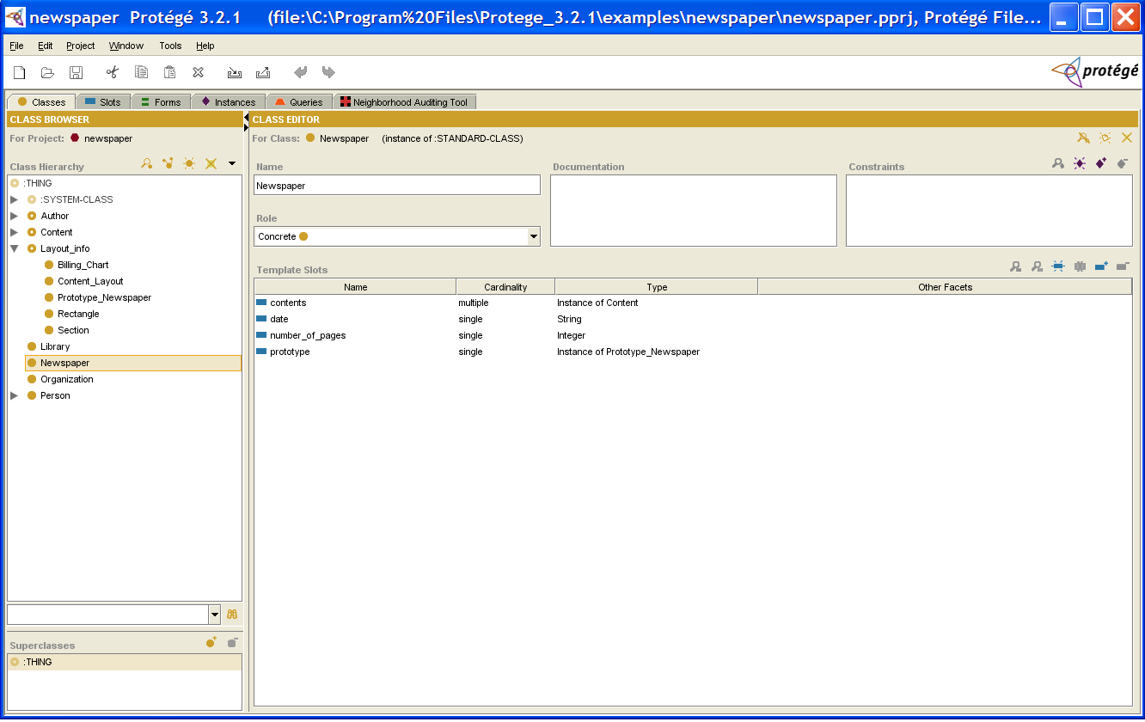
Figure 1: The Classes Tab [12]
Given such an ontology, the OWL formal semantics specifies how to derive its logical consequences, i.e. facts not literally present in the ontology, but entailed by the semantics. These entailments may be based on a single document or multiple distributed documents that have been combined using defined OWL mechanisms.” [11]
For the purpose of my project, I have used the Protégé frames editor as a debugging tool to test the correctness of the ontology built using the OWL API.

- Previous Work
The goal of this project is to build an ontology for an ontology-enabled web search interface. The domain under consideration will be that of searching out information about famous people. In particular, “famous people” here will refer to “musicians” in the beginning. Later, the same concept can be extended to sports stars, researchers etc. I have built an ontology on the data related to musicians mined from the Deep Web [14]. This ontology was be queried rigorously for their completeness so as to enable the building of a browser plugin that does an ontology enabled search [13]. This is an ongoing project based on the paper written by An et al. [2]. The paragraphs below give a glimpse of the previous work done in this field on which this project is based.

2.1 Enriching a Domain Ontology for the Semantic Deep Web
Enriching an ontology is a process that extends it by adding concepts, instances and new relations between concepts. Previous works dealt with the schema level whereas the paper on which this project is based deals with the data level, as we utilize the concepts extracted from the Deep Web (DW) result pages. While the schema level extraction finds concepts such as ‘city name,’ etc., the data level extraction results in instances such as ‘Newark’. Our method for extracting instances from the DW is based on developing “robots” (agents) that send many queries to the same DW site to extract as many data values as possible. [2]

2.2 Web Search with Domain Ontology-based Query Extension
Consider a DW site such as a Flight Reservation System. In a Domain Ontology-based Web Search module, if a user clicks on assertions related to airport codes or airports, the search module will create an extended list of key words (i.e., “New York”, ”NYC”, ”Seoul”, SEL) [2].

Based on the ontologies built, the search module will help the user in refining his search by
providing him a variety of choices based on the relationships as illustrated in the Figure 2 below.

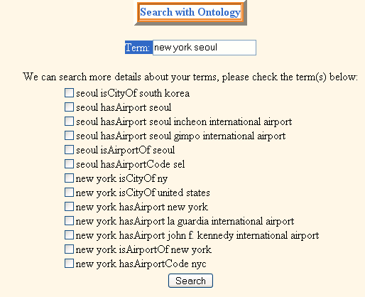

Figure 2: A Sample User Feedback Interface [2]
As a part of my project, I have built an ontology that will help in getting the enhanced search results for a particular singer. This ontology will to made to support the working of a plugin which will be developed on similar lines as shown in the Figure 2 above. [13]

- My Work
The Protégé-OWL API is an open-source Java library for the Web Ontology Language (OWL) and RDF(S) [15]. The API provides classes and methods to load and save OWL files, to query and manipulate OWL data models, and to perform reasoning based on Description Logic engines. Furthermore, the API is optimized for the implementation of graphical user interfaces.
[15]
The API is designed to be used in two contexts:
- For the development of components that are executed inside of the Protégé-OWL editor's user interface
- For the development of stand-alone applications (e.g., Swing applications, Servlets, or Eclipse plug-ins)
Protégé is a flexible, configurable platform for the development of arbitrary model-driven applications and components. Protégé has an open architecture that allows programmers to integrate plug-ins, which can appear as separate tabs, specific user interface components (widgets), or perform any other task on the current model. The Protégé-OWL editor provides many editing and browsing facilities for OWL models, and therefore can serve as an attractive starting point for rapid application development. Developers can initially wrap their components into a Protégé tab widget and later extract them to distribute them as part of a stand-alone application. [15]
As mentioned before, I have used Protégé as a debugging tool to test the correctness of the ontology that I have built using the OWL API. In the next sections, I will explain in detail as to how I built the ontology using the OWL API and how I tested its correctness using the Protégé Frames Editor.

The Protégé-OWL API is centered around a collection of Java interfaces from the model package. These interfaces provide access to the OWL model and its elements like classes, properties, and individuals. Application developers should not access the implementation of these interfaces (such as DefaultRDFIndividual) directly, but only operate on the interfaces. Using these interfaces you don't have to worry about the internal details of how Protégé stores ontologies. Everything is abstracted into interfaces and your code should not make any assumptions about the specific implementation. [15]
The most important model interface is OWLModel, which provides access to the top-level container of the resources in the ontology. You can use OWLModel to create, query, and delete resources of various types and then use the objects returned by the OWLModel to do specific operations [15]. For my project, I created an OWLModel to hold two named classes – the class of music artists and the class of their genres.
Jena is one of the most widely used Java APIs for RDF and OWL, providing services for model representation, parsing, database persistence, querying and some visualization tools. Protégé-OWL has always had a close relationship with Jena. The Jena ARP parser is still used in the Protégé-OWL parser, and various other services such as species validation and datatype handling have been reused from Jena. It is furthermore possible to convert a Protégé OWLModel into a Jena OWLModel, to get a static snapshot of the model at run time. [17]
As of August 2005, Protégé-OWL is now much more closely integrated with Jena. This integration allows programmers to user certain Jena functions at run-time, without having to go through the slow rebuild process each time [17]. We created a Jena OWL model by calling the static method createJenaOWLModel(), as shown in the code below. Then we use the OWL model created to call the createOWLNamedClass() method, which in turn creates the required OWL named classes.
OWLModel owlModel = ProtegeOWL.createJenaOWLModel();
OWLNamed musicArtistClass =owlModel.createOWLNamedClass("Music_Artists");
OWLNamedClass genreClass = owlModel.createOWLNamedClass("Genre");
To these named classes, I have assigned different properties relevant to them. For example, the Music_Artists class has properties like artist name, place of birth, birth date, etc. Here again, I would like to mention that these properties are by themselves named classes who are all related to the music artist class. So we can say that the properties relate two or more classes.
3.1 The Music Artists Ontology as seen in the Protégé Frames Editor
The Protégé frames editor is an efficient editing and debugging tool to check if the ontology created by using the OWL API was properly built or not. Figure 3 shows how my ontology looks overall, as seen in Protégé. There are five classes – Birth_City, Birth_Country, Birth_State, Genre and Music_Artists. The Genre class has been further sub-classed into approximately 550 genres that have been instantiated. Each of these classes has individuals (except the Genre class, whose subclasses have individuals).
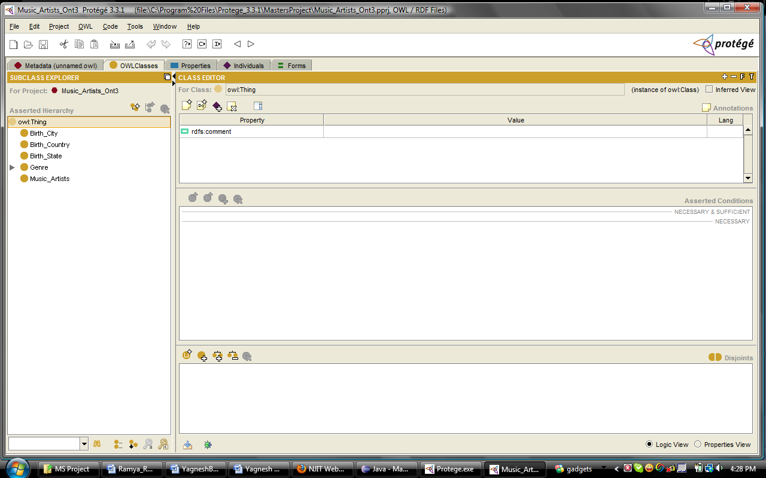
Figure 3: An Overview of all the classes developed
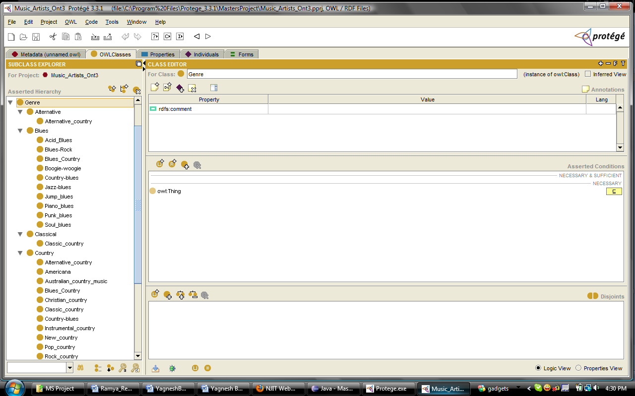
Figure 4: Subclasses of the Genre Class
The Genre class is the one that holds the genres of the music artists under consideration. I have divided the Genre class into genre types and these in turn have been subdivided into different genres that belong to a particular type. I have created approximately 550 Genre class instances and arranged them in a hierarchy based on the subclasses and superclasses of genres. For creating the subclasses, I have used the createOWLNamedSubClass method of the OWL API.

For example:
OWLNamedClass speedmetalGenre = owlModel.createOWLNamedSubclass("Speed metal",primaryheavymetalGenre);
This creates a subclass of the genre Primary_Heavy_Metal, called Speed_Metal. In a similar way, all the other subclasses were created.
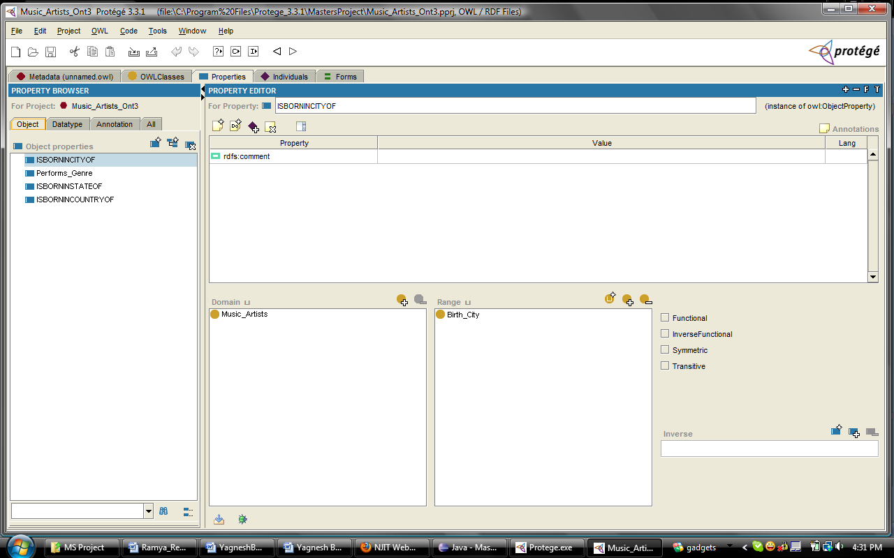
Figure 5: OWL Object Properties Developed
The OWL Object Properties Tab relates two or more objects of two or more different classes. For example, as seen in Figure 5, the OWL Object Property ‘ISBORNINCITYOF’ relates the two classes Music_Artist and Birth_City.
The following piece of code is used to achieve this kind of relationship.
temppro = owlModel.createOWLObjectProperty(rsmd.getColumnLabel(i));
if(i==7) {
temppro.setDomain(musicArtistClass);
temppro.setRange(cityClass);
relationships.add(temppro);……. . .
In the above code, the column label is taken as the property name and its domain and range are set. It is derived from the table Music_Artists which is the source of this ontology [14]. Access is done with the standard JDBC method getColumnLabel. In this way, owl:ObjectProperty is used to represent properties, i.e., to establish relations between individuals.
To create an owl:DatatypeProperty, you can useOWLModel.createOWLDatatypeProperty(String name). DatatypeProperty can take any datatype such as string and integer as argument. OWL defines several XML Schema datatypes that can be used to restrict the range of properties. The most popular XML Schema datatypes are xsd:string, xsd:int, xsd:float, and xsd:boolean. Figure 6 shows the datatype property ISBORNINMONTH.

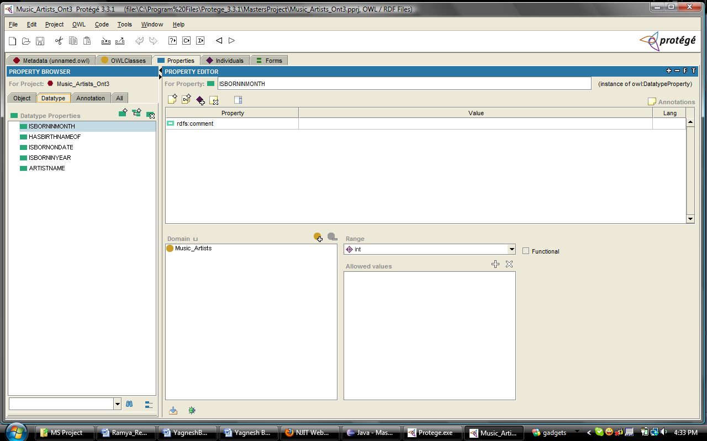
Figure 6: OWL Datatype Properties Developed

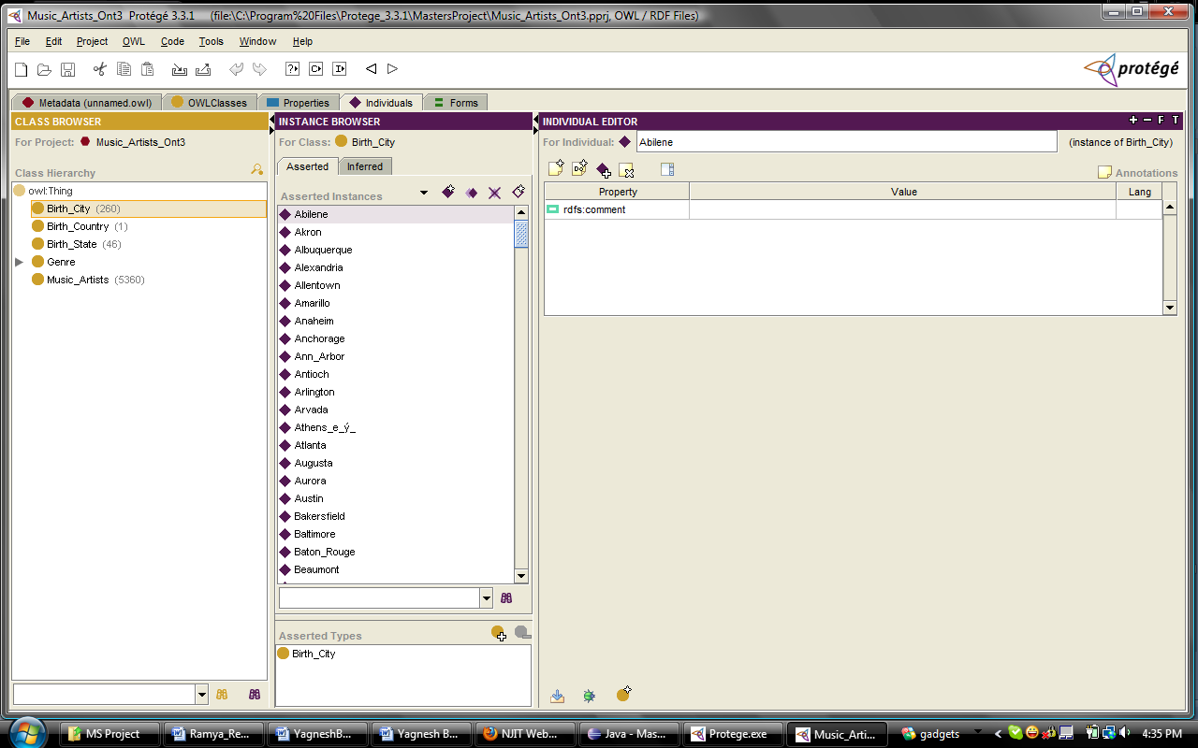
Figure 7: OWL Individuals of type Birth_City

In Figures 7 to 10, example OWL Individuals of the classes Birth_City, Birth_State, Birth_Country, and Music_Artists are shown. We can create the OWL individuals using the createRDFIndividual method of the OWL API.
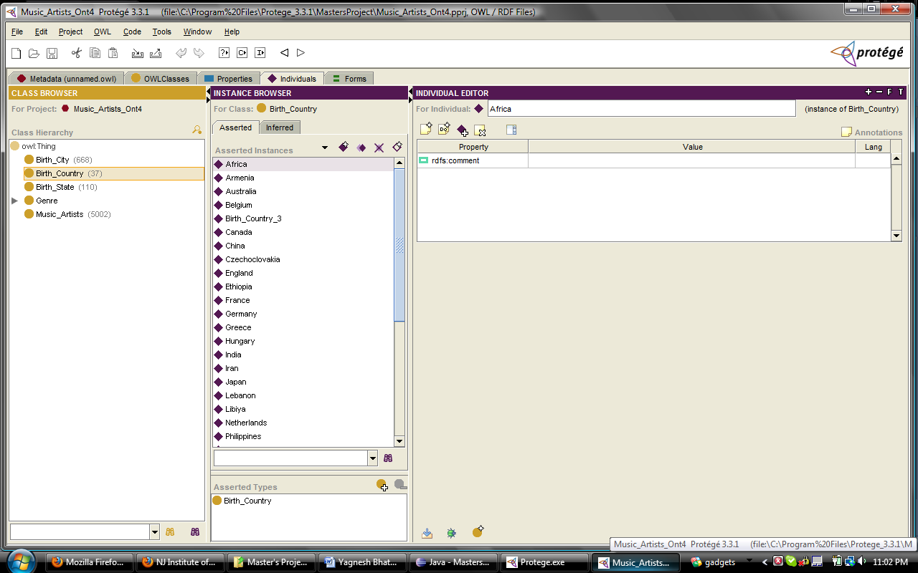
Figure 8: OWL Individuals of the type Birth_Country

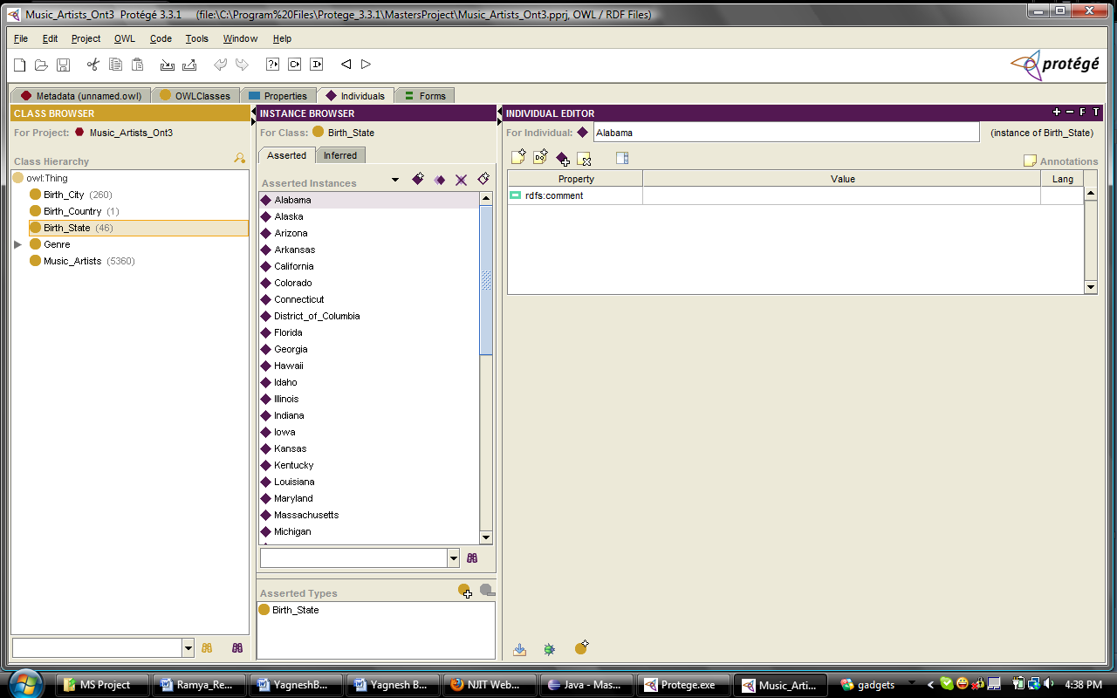
Figure 9: OWL Individuals of the type Birth_State

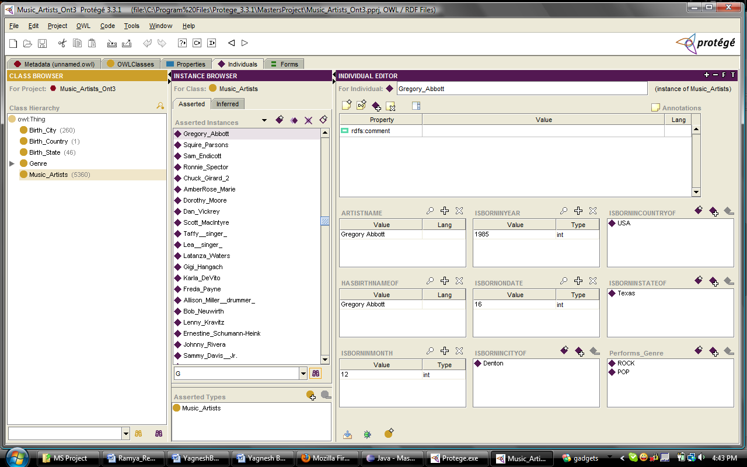
Figure 10: OWL Individuals of the type Music_Artists

The overall working of the program can be explained as follows: The program first instantiates the required OWL classes and properties and also creates vectors to store them. The list of class variables used for the entire ontology creation is given below:
OWLModel owlModel; //Instance of the OWLModel wherein OWLNamedClasses can be built
OWLNamedClass musicArtistClass; // an OWLNamedClass to be built in the OWLModel
OWLNamedClass genreClass; //another OWLNamedClass to be built in the OWLModel
OWLNamedClass cityClass; //another OWLNamedClass to be built in the OWLModel
OWLNamedClass stateClass; //another OWLNamedClass to be built in the OWLModel
OWLNamedClass countryClass; //another OWLNamedClass to be built in the OWLModel
Vector<RDFIndividual> artists; // a vector to hold the Artist instances
Vector<RDFIndividual> genres; // a Vector to hold the Genre instances
Vector<RDFIndividual> cities; //a vector to hold the City instances
Vector<RDFIndividual> states; //a vector to hold the State instances
Vector<RDFIndividual> countries; //a vector to hold the Country instances
Vector<String> cityNames; //a vector to hold cityNames from the table
Vector<String> countryNames; //a vector to hold country Names from the table
Vector<String> stateNames; // a vector to hold state Names from the table
Vector<String> genreNames; //a vector to hold genre Names from the genres created

//Finally, a vector to hold relationships between instances of two different classes in the //ontology

Vector<OWLObjectProperty> relationships;
OWLObjectProperty performsGenreproperty; //to link Artists with their respective Genres
Vector<String> artistIDs; // to store the primary keys of the Music_Artists table. We need
// this to link the artists with the Genres.
To create the individuals, I used the rows of the tables containing Music Artist data and Genre data. For this purpose, I used the Java Database Connectivity APIs. The code fragment below shows how this connectivity is achieved and how the OWL Individuals are created after retrieving data row-by-row:
DriverManager.registerDriver(new oracle.jdbc.driver.OracleDriver());

String url="jdbc:oracle:thin:@seer.njit.edu:1521:research";
try {
String url1 = System.getProperty("JDBC_URL");
if(url1!=null) {
url=url1;
}
} catch(Exception e){

}

Connection conn = DriverManager.getConnection(url, "ar237", "6gGlBnXv");//connect with database

//Create a statement
Statement stmt = conn.createStatement();
ResultSet rset = stmt.executeQuery("select * from \"Music_Artists\" order by \"Artist\"");

artistIDs = new Vector<String>(); //Storing the primary keys in a Vector
Vector<String> artistAttributes = new Vector<String>();//Storing artist name in another!

//Storing the Artist individuals in another vector
artists = new Vector<RDFIndividual>();

ResultSetMetaData rsmd = rset.getMetaData();
int numCols = rsmd.getColumnCount();
int columnType;
OWLObjectProperty temppro;

/*Setting up the names of both OWLDatatypeproperties and OWLObjectProperties from Column names. Counter i is used to keep track of number of columns obtained in the result set, and counter f is used to keep track of the elements in the vector holding the music artist properties that are essentially data type properties.*/

for (int f=0,i=2;i<=numCols;i++,f++) {
if(i<=6) {
musicArtistProperties.add(owlModel.createOWLDatatypeProperty(rsmd.getColumnLabel(i)));
columnType = rsmd.getColumnType(i);

if (columnType == 2) {
//if 2 is returned then its a numeric type else mostly its a string
musicArtistProperties.elementAt(f).setDomain(musicArtistClass);
musicArtistProperties.elementAt(f).setRange(owlModel.getXSDint());
} else {
musicArtistProperties.elementAt(f).setDomain(musicArtistClass);
musicArtistProperties.elementAt(f).setRange(owlModel.getXSDstring());
}
} else {//OWL Object Properties are stored in the separate vector relationships
temppro = owlModel.createOWLObjectProperty(rsmd.getColumnLabel(i));
if(i==7) {
temppro.setDomain(musicArtistClass);
temppro.setRange(cityClass);
relationships.add(temppro);
} else if(i==8) {
temppro.setDomain(musicArtistClass);
temppro.setRange(stateClass);
relationships.add(temppro);
} else if(i==9) {
temppro.setDomain(musicArtistClass);
temppro.setRange(countryClass);
relationships.add(temppro);
}
}
Performs_Genre is a special OWL Object Property because it can link an Artist to more than one Genre. The 550 Genres (approximately) that I have mined have been linked to approximately 2500 of the 5002 Artists. To link Music_Artists with their corresponding Genres, care has to be taken to ensure that only the musicians in the Music_Artists table are linked to their Genres. The following piece of code ensures this:
Connection conn = DriverManager.getConnection(url, "ar237", "6gGlBnXv");
//Create a statement
Statement stmt = conn.createStatement();
ResultSet rset = stmt.executeQuery("select * from \"Artists_Genres\"");
//Result header
ResultSetMetaData rsmd = rset.getMetaData();
int numCols2 = rsmd.getColumnCount(); //to store the number of columns
int k;

while(rset.next()){
for(int j=1;j<=numCols2;j++){//j to keep track of number of columns
if(j==1){
if(artistIDs.contains(rset.getString(j))){//checking if artist IDs are relevant
k = j + 1;
if(genreNames.contains(rset.getString(k))){//may need to check case sensitivity here!!!
int index = genreNames.indexOf(rset.getString(k));
artists.get(artistIDs.indexOf(rset.getString(j))).addPropertyValue(performsGenreproperty ,genres.elementAt(index)); //creating the relationship between music artist and genre
}else {
genreNames.add(rset.getString(k));
int index = genreNames.indexOf(rset.getString(k));
RDFIndividual temp = speedmetalGenre.createRDFIndividual(rset.getString(k));
genres.add(temp);
//creating the relationship between music artist and genre
artists.get(artistIDs.indexOf(rset.getString(j))).addPropertyValue(performsGenreproperty,genres.elementAt(index));
}
}
}
}
}

The code above checks whether the artists that are to be linked with the genres actually exist in the Music_Artists table. This is done by checking if the Artist ID under consideration actually exists in the vector. Also, the genres will only be assigned to the artists if they exist as individuals of the Genre class. This is done to maintain the consistency of relationships between the music artists and their respective genres.

- Conclusions
The Protégé-OWL API is an open-source Java library for the Web Ontology Language (OWL) and RDF(S). The API provides classes and methods to load and save OWL files, to query and manipulate OWL data models, and to perform reasoning based on Description Logic engines. Furthermore, the API is optimized for the implementation of graphical user interfaces. [15]

I have built an ontology of the data related to 5002 musicians initially mined . For this purpose, I have made use of the OWL (Web Ontology Language) API written in Java. These musicians are assigned four OWL object properties , namely birth city, birth state, birth country and genre. Additionally they have also being assigned five OWL datatype properties of artist name, birth name, artist birth bay, artist birth month and artist birth year.

I have linked these musicians to their genres as an object property. This relationship is different from the other OWL object properties, because one musician can have more than one genre. All these musicians along with their genres and other properties together are wrapped into a single OWL model. There are approximately 550 genres altogether.

One very notable problem that arises when we create such an ontology is that no two classes are allowed to have the same individual names. For example, eventhough it is a fact in reality, Washington cannot be a state as well as a city at the same time! Technically, this means that Washington cannot be an instance of Birth_City and Birth_State at the same time. To overcome this problem, I appended “qualifiers” to resolve these clashes. For example, in case of Washington the city, I added the letters ‘DC’ to Washington and I made ‘Washington’ an instance of Birth_State only. Thus, by adding qualifiers in parentheses, we can see to it that no two classes have same names for their individuals. But, again there should be consistency in naming the individuals.

Protégé was used as a debugging tool to verify the correctness of the ontologies developed. This ontology was validated and tested rigorously so as to enable the development of a browser plugin that makes an ontology-enabled web search possible. This will ultimately result in better search results.

- Future Work
This project is ongoing and I have just added to it by building a large ontology. The very program that I have used to create the ontology of music artists can be used to create an ontology related to some other domains like sportspersons, researchers, etc., with few modifications. It all depends on what domain the ontology is in, what column values you assign to the tables in the database and also on how many and what kinds of properties you want.

Any user who wishes to use my programs would just have to make sure that the right column values are input and also how many relationships he would like to create among the classes and accordingly needs to modify my code to get the desired results according to the domain he/she selects.

References
- Gruber, T.R. (2008), Ontology. Entry in the Encyclopedia of Database Systems, Liu, L. and Özsu, M.T. (Eds.), Springer-Verlag.
- An, Y.J., Chun, S.A., Huang, K., Geller, J. Enriching Ontology for Deep Web Search. DEXA 2008: 73-80.
- Geller, J. Definition of Ontology,
http://web.njit.edu/~geller/what_is_an_ontology.html , February 2009.
4. Noy, N.F., McGuinness, D.L. Ontology Development 101: A Guide to Creating Your First Ontology. Stanford Knowledge Systems Laboratory Technical Report KSL-01-05 and Stanford Medical Informatics Technical Report SMI-2001-0880, March 2001.
5. Horridge, M., Knublauch, H., Rector, A., Stevens, R., Wroe, C. A Practical Guide To Building OWL Ontologies Using The Prot´eg´e-OWL Plugin and CO-ODE Tools Edition 1.0, August 27, 2004.
6. Musen, M.A. (1992). Dimensions of knowledge sharing and reuse. Computers and Biomedical Research 25: 435-467.
7. Gruber, T.R. (1993). A Translation Approach to Portable Ontology Specification. Knowledge Acquisition 5: 199-220.
8. McGuinness, D.L. and Wright, J. (1998). Conceptual Modeling for Configuration: A Description Logic-based Approach. Artificial Intelligence for Engineering Design, Analysis, and Manufacturing - special issue on Configuration.
9. Rothenfluh, T.R., Gennari, J.H., Eriksson, H., Puerta, A.R., Tu, S.W. and Musen, M.A. (1996). Reusable ontologies, knowledge-acquisition tools, and performance systems:
PROTÉGÉ-II solutions to Sisyphus-2. International Journal of Human-Computer Studies 44: 303-332.
10. McGuinness, D.L., Fikes, R., Rice, J. and Wilder, S. (2000). An Environment for Merging and Testing Large Ontologies. Principles of Knowledge Representation and Reasoning: Proceedings of the Seventh International Conference (KR2000). A. G. Cohn, F. Giunchiglia and B. Selman, editors. San Francisco, CA, Morgan Kaufmann Publishers.
11. Stanford University, What is Protégé,
http://protege.stanford.edu/overview , February 2009.
12. Yakup, K., Data Caching and Display Features For Neighborhood Auditing Tool, MS Project Proposal, NJIT, CS Department, Summer/Fall 2007.
13. Tian, T., Enriching Multi-Domain Ontology for Web Search, PhD Project Proposal, NJIT, CS Department, Fall 2009.
14. Rajbar, A., Deep Web Mining And Enriching the Ontology Enabled Web Search, MS Project Proposal, NJIT, CS Department, Fall 2009.
15. Protégé-owl api programmer's guide,
http://protege.stanford.edu/plugins/owl/api/guide.html, July 2009.
16. Supplement I.B: Installing and Configuring JDK 1.6,
http://cs.armstrong.edu/liang/intro6e/supplement/Supplement1bInstallingJDK5_0.pdf
17. Integration of Jena in Protégé-OWL,
http://protege.stanford.edu/plugins/owl/jena-integration.html
Appendix A: User Manual
A.1 Installing Java [16]

A1.1 Downloading JDK 1.6
You can download the latest JDK 1.6 from http://java.sun.com/javase/downloads/index.jsp. The Windows version of JDK download file is named jdk-6-windowsi586.exe.

NOTE: New versions or updates may be available. If you download a new version or an update version, the file name may be slightly different from jdk-6-windowsi586.exe.

A1.2 Installing JDK 1.6 on Windows
Follow the steps below to install JDK 1.6:
1. Double click jdk-6-windows-i586.exe to run the installation program. You will see the JDK License dialog displayed.
2. Click Accept to display the JDK Custom Setup dialog.
3. You may install JDK in a custom directory. For simplicity, don’t change the directory. Click Next to install JDK. After a while, the JRE Custom Setup dialog is displayed.
4. You may install JRE in a custom directory. For simplicity, don’t change the directory. Click Next to install JRE.
5. After installation completed, the Complete dialog is displayed. Click Finish to close the
dialog.

A1.3 Configuring JDK 1.6 on Windows
To configure JDK is to make it available in the operating system so that Windows can find your JDK commands such as javac.

A1.3.1 Configuring JDK on Windows NT, 2000, XP, and ME
To configure JDK on Windows NT, 2000, ME, and XP, set the environment variables as follows:

1. Right-click the My Computer icon on your desktop to display a context menu. Choose Properties from the context menu to open the System Properties window.

2. In the System properties window, click Environment Variables in the Advanced tab to display the Environment Variables window.

3. You can set or modify user variables or systems variables. User variables affect the individual users and system variables affect all the users in the system. In the User variables section, select PATH and click Edit if PATH is already a user variable. Otherwise, click New to display the New User Variable Window.

4. Type PATH in the Variable field and c:\Program Files\Java\jdk1.6.0\bin;%path% in the Variable Value field. Click OK.
NOTE: You don’t have to reboot the computer, but you have to open a new command window to use JDK commands.
NOTE: If you download a new version or an update version, the directory name jdk1.6.0 may be slightly different.
For example, the directory name is jdk1.6.0_02 for JDK 1.6 Update 2.

A1.3.2 Configuring JDK on Windows Vista
Follow the steps below to configure JDK on Windows Vista:

1. Left-click on the Start button and choose Control Panel ›System and Maintenance › System › Advanced system settings. At User Account Control, type an administrator password and then click OK to display the System Properties window.

2. Same as Steps 2-4 in Section A1.3.1.

A1.4 Verifying Configurations
To verify whether JDK 1.6 is configured correctly, type
javac –version from the command prompt.

A.2 Installing Protégé
The Protégé software can be downloaded from http://protege.stanford.edu/download/release/full/ But you need to have the JDK installed beforehand to install Protégé.

A.3 Installing Eclipse
The eclipse IDE can be downloaded from www.eclipse.org/downloads/
To install Eclipse, all you do is unpack the zip file download in the desired directory. No further work is required (other than making sure you have a Java Runtime Engine installed). When you unzip the file, it creates a subdirectory called "eclipse", with multiple subdirectories under that. So, for example, in Windows you could unpack the zip file in the root directory (e.g., C:\) and Eclipse would be installed in C:\eclipse. Note that installing Eclipse does not change the Windows registry.
A.4 Setting up the OWL – APIs in Eclipse
The Protégé-OWL editor is bundled with the "full" installation of Protégé. In addition to installing Protégé, you should download the source code from the Protégé Subversion repository. The source code is the most reliable reference for the system's functionality and browsing the source code with a Java IDE is a great way to learn the API. Detailed instructions on how to download source code from our repository are available on the developer documentation page. The URL to download the Protégé-OWL source code using a Subversion client is: http://smi-protege.stanford.edu/repos/protege/owl/trunk/.[15]
You will also find Javadoc for the API useful. In particular, you will need to understand the interfaces from the edu.stanford.smi.protegex.owl.model package. [15]
Following a successful installation, your directory structure should look approximately as seen in Figure 11.
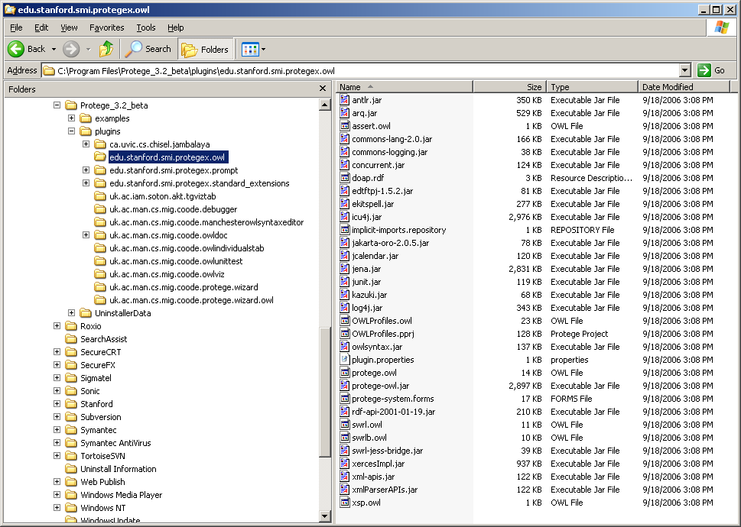
Figure 11: OWL API Files and Folders [15]
Now let us configure our Java project and write a small "Hello World" application. If you are using a Java IDE such as Eclipse or IntelliJ, select the Protégé installation folder as your project home. Next, add all the JAR files from the installation to your project classpath.
Set your compiler output path to plugins/classes.
Then create a Java class such as the following:
package com.demo.application;
import edu.stanford.smi.protegex.owl.model.OWLModel;
import edu.stanford.smi.protegex.owl.model.OWLNamedClass;
importedu.stanford.smi.protegex.owl.ProtegeOWL;
public class OWLAPIDemoApplication {
public static void main(String[] args) {
OWLModel owlModel = ProtegeOWL.createJenaOWLModel();
owlModel.getNamespaceManager().setDefaultNamespace("http://hello.com#");
OWLNamedClass worldClass = owlModel.createOWLNamedClass("World");
System.out.println("Class URI: " + worldClass.getURI());
}
}
Execute this program stand-alone. The output should be "Class URI: http://hello.com#World" [15]. Once this is done, you can proceed to create the java classes given in Appendix B next.

Appendix B: Source Code
B.1 Source code for the small form of the Music_Artists Ontology – Done to test the working of OWL APIs
package com.demo.application;

import edu.stanford.smi.protegex.owl.ProtegeOWL;
import edu.stanford.smi.protegex.owl.jena.JenaOWLModel;
import edu.stanford.smi.protegex.owl.model.*;

import com.hp.hpl.jena.util.FileUtils;
import java.util.*;
import java.io.*;
import java.sql.*;
import java.util.Vector;

public class SingerOnt {

public static void main(String[] args) throws SQLException {

OWLModel owlModel = ProtegeOWL.createJenaOWLModel();
OWLNamedClass artistClass = owlModel.createOWLNamedClass("Artist");
OWLNamedClass genreClass = owlModel.createOWLNamedClass("Genre");

//Properties for both the artist and genre classes
OWLDatatypeProperty fnameProperty = owlModel.createOWLDatatypeProperty("fname");
OWLDatatypeProperty lnameProperty = owlModel.createOWLDatatypeProperty("lname");
OWLDatatypeProperty nicknameProperty = owlModel.createOWLDatatypeProperty("nickname");
OWLDatatypeProperty addcityProperty = owlModel.createOWLDatatypeProperty("add_city");
OWLDatatypeProperty addstateProperty = owlModel.createOWLDatatypeProperty("add_state");
OWLDatatypeProperty addcountryProperty = owlModel.createOWLDatatypeProperty("add_country");
OWLDatatypeProperty dobdateProperty = owlModel.createOWLDatatypeProperty("dob_date");
OWLDatatypeProperty dobmonthProperty = owlModel.createOWLDatatypeProperty("dob_month");
OWLDatatypeProperty dobyearProperty = owlModel.createOWLDatatypeProperty("dob_year");
OWLDatatypeProperty genreProperty = owlModel.createOWLDatatypeProperty("genre");

//Setting domains and ranges for the properties
fnameProperty.setRange(owlModel.getXSDstring());
fnameProperty.setDomain(artistClass);

lnameProperty.setRange(owlModel.getXSDstring());
lnameProperty.setDomain(artistClass);

nicknameProperty.setRange(owlModel.getXSDstring());
nicknameProperty.setDomain(artistClass);

addcityProperty.setRange(owlModel.getXSDstring());
addcityProperty.setDomain(artistClass);

addstateProperty.setRange(owlModel.getXSDstring());
addstateProperty.setDomain(artistClass);

addcountryProperty.setRange(owlModel.getXSDstring());
addcountryProperty.setDomain(artistClass);

dobdateProperty.setRange(owlModel.getXSDint());
dobdateProperty.setDomain(artistClass);

dobmonthProperty.setRange(owlModel.getXSDint());
dobmonthProperty.setDomain(artistClass);

dobyearProperty.setRange(owlModel.getXSDint());
dobyearProperty.setDomain(artistClass);

genreProperty.setRange(owlModel.getXSDstring());
genreProperty.setDomain(genreClass);

OWLObjectProperty performsGenreproperty = owlModel.createOWLObjectProperty("Performs_Genre");
performsGenreproperty.setDomain(artistClass);
performsGenreproperty.setRange(genreClass);

/* Now we'll establish connection to the database and
start retrieving the data from the database. Then we shall
generate the individuals as we retrieve the data from the
database */

//Load the Oracle JDBC Driver
DriverManager.registerDriver(new oracle.jdbc.driver.OracleDriver());

String url="jdbc:oracle:thin:@prophet.njit.edu:1521:course";
try {
String url1 = System.getProperty("JDBC_URL");
if(url1!=null){
url=url1;
}
}catch(Exception e){

}

Connection conn = DriverManager.getConnection(url, "ydb2", "CLHk95bm");
//Create a statement
Statement stmt = conn.createStatement();

//Creating the Artist Class Individuals

//System.out.println("Creating the Artist Class...");

ResultSet rset = stmt.executeQuery("select * from ar237.artists");

Vector<String> artistIDs = new Vector<String>(); //Storing the primary keys in a Vector
Vector<RDFIndividual> artists = new Vector<RDFIndividual>();

ResultSetMetaData rsmd = rset.getMetaData();
int numCols = rsmd.getColumnCount();
String[] attributes = new String[100];
while(rset.next()){
for(int j=1;j<=numCols;j++){
if (j==1) {
artistIDs.add(rset.getString(j));
attributes[j] = rset.getString(j);
} else {
//String temp = rset.getString(j);
attributes[j] = rset.getString(j);
}
}
//System.out.println("\n");
RDFIndividual temp = artistClass.createRDFIndividual(attributes[4]);
temp.setPropertyValue(fnameProperty, attributes[2]);
temp.setPropertyValue(lnameProperty, attributes[3]);
temp.setPropertyValue(nicknameProperty, attributes[4]);
temp.setPropertyValue(addcityProperty,attributes[5]);
temp.setPropertyValue(addstateProperty,attributes[6]);
temp.setPropertyValue(addcountryProperty,attributes[7]);
temp.setPropertyValue(dobdateProperty,new Integer(attributes[8]));
temp.setPropertyValue(dobmonthProperty,new Integer(attributes[9]));
temp.setPropertyValue(dobyearProperty,new Integer(attributes[10]));
artists.add(temp);

}

//Creating the Genre Class individuals
rset = stmt.executeQuery("select * from ar237.artists_generes");
Vector<RDFIndividual> genres = new Vector<RDFIndividual>();

//Print the result header
rsmd = rset.getMetaData();
int numCols2 = rsmd.getColumnCount();
Vector<String> genre = new Vector<String>();
//String[] attributes2 = new String[numCols2];

//Print the result
int k;
while(rset.next()){
for(int j=1;j<=numCols2;j++){
//String temp = rset.getString(j);
//System.out.print(temp+" ");
if(j==1){
if(artistIDs.contains(rset.getString(j))){
k = j + 1;
//attributes2[j]=rset.getString(j);
artists.get(artistIDs.indexOf(rset.getString(j))).addPropertyValue(performsGenreproperty,rset.getString(k));
if(!genre.contains(rset.getString(k))){
genre.add(rset.getString(k));
RDFIndividual temp2 = genreClass.createRDFIndividual(rset.getString(k));
temp2.setPropertyValue(genreProperty,rset.getString(k));
genres.add(temp2);
}

}
}
}
}
String fileName = "C:/Program Files/Protege_3.3.1/MastersProject/SingerOnt.owl";
Collection errors = new ArrayList();
((JenaOWLModel)owlModel).save(new File(fileName).toURI(),FileUtils.langXMLAbbrev,errors);
}

}
B.2 Source code for the finalised form of the Music_Artists Ontology – fully functional with the necessary properties and relationships.
package com.demo.application;

import java.io.File;
import java.sql.Connection;
import java.sql.DriverManager;
import java.sql.ResultSet;
import java.sql.ResultSetMetaData;
import java.sql.SQLException;
import java.sql.Statement;
import java.util.ArrayList;
import java.util.Collection;
//import java.util.Iterator;
import java.util.Vector;

import com.hp.hpl.jena.util.FileUtils;

import edu.stanford.smi.protegex.owl.ProtegeOWL;
import edu.stanford.smi.protegex.owl.jena.JenaOWLModel;
import edu.stanford.smi.protegex.owl.model.OWLDatatypeProperty;
import edu.stanford.smi.protegex.owl.model.OWLModel;
import edu.stanford.smi.protegex.owl.model.OWLNamedClass;
import edu.stanford.smi.protegex.owl.model.OWLObjectProperty;
import edu.stanford.smi.protegex.owl.model.RDFIndividual;
//import edu.stanford.smi.protegex.owl.model.RDFSClass;

public class Music_Artists_Ont4 {
OWLModel owlModel; //Instance of the OWLModel wherein OWLNamedClasses can be built
OWLNamedClass musicArtistClass; // an OWLNamedClass to be built in the OWLModel
OWLNamedClass genreClass; //another OWLNamedClass to be built in the OWLModel
//OWLNamedClass birthNameClass; //another OWLNamedClass to be built in the OWLModel
OWLNamedClass cityClass; //another OWLNamedClass to be built in the OWLModel
OWLNamedClass stateClass; //another OWLNamedClass to be built in the OWLModel
OWLNamedClass countryClass; //another OWLNamedClass to be built in the OWLModel
Vector<RDFIndividual> artists; // a vector to hold the Artist instances
Vector<RDFIndividual> genres; // a Vector to hold the Genre instances
//Vector<RDFIndividual> birthNames; //a Vector to hold the birth name instances
Vector<RDFIndividual> cities; //a vector to hold the City instances
Vector<RDFIndividual> states; //a vector to hold the State instances
Vector<RDFIndividual> countries; //a vector to hold the Country instances
Vector<String> cityNames; //a vector to hold cityNames from the table
Vector<String> countryNames; //a vector to hold country Names from the table
Vector<String> stateNames; // a vector to hold state Names from the table
Vector<String> genreNames; //a vector to hold genre Names from the genres created
//Vector<String> birthNamesList; // a vector to hold birthNames from the table
//Finally, a vector to hold relationships between instances of two different classes in the ontology
Vector<OWLObjectProperty> relationships;
OWLObjectProperty performsGenreproperty; //to link Artists with their respective Genres
Vector<String> artistIDs; // to store the primary keys of the Music_Artists table. We need this
// to link the artists with the Genres.

public Music_Artists_Ont4() {
owlModel = ProtegeOWL.createJenaOWLModel();
}

public static void main(String[] args) throws SQLException {
Music_Artists_Ont4 m = new Music_Artists_Ont4();
m.createmusicArtistClass();
m.creategenreClass();
//The ontology will be stored in the file specified in the path below
String fileName = "C:/Program Files/Protege_3.3.1/MastersProject/Music_Artists_Ont4.owl";

Collection errors = new ArrayList();
((JenaOWLModel) m.owlModel).save(new File(fileName).toURI(),FileUtils.langXMLAbbrev,errors);

}

/*
* The createmusicArtistClass() creates the musicArtist Class for the owlModel object
* The individuals are created from the MusicArtists table in the database
* Properties of these individuals (or rather the musicArtistClass itself) refer to the column names
* of the MusicArtists table.
*/
public void createmusicArtistClass() throws SQLException {
int individualCount = 0;
musicArtistClass = owlModel.createOWLNamedClass("Music_Artists");
//birthNameClass = owlModel.createOWLNamedClass("Birth Name");
cityClass = owlModel.createOWLNamedClass("Birth City");
stateClass = owlModel.createOWLNamedClass("Birth State");
countryClass = owlModel.createOWLNamedClass("Birth Country");
//birthNames = new Vector<RDFIndividual>();
cities = new Vector<RDFIndividual>();
states = new Vector<RDFIndividual>();
countries = new Vector<RDFIndividual>();
cityNames = new Vector<String>();
stateNames = new Vector<String>();
countryNames = new Vector<String>();
//birthNamesList = new Vector<String>();
Vector<OWLDatatypeProperty> musicArtistProperties = new Vector<OWLDatatypeProperty>();
relationships = new Vector<OWLObjectProperty>();

/* Now we'll establish connection to the database and
start retrieving the data from the database. Then we shall
generate the individuals as we retrieve the data from the
database */

//Load the Oracle JDBC Driver
DriverManager.registerDriver(new oracle.jdbc.driver.OracleDriver());

String url="jdbc:oracle:thin:@seer.njit.edu:1521:research";
try {
String url1 = System.getProperty("JDBC_URL");
if(url1!=null){
url=url1;
}
}catch(Exception e){

}

Connection conn = DriverManager.getConnection(url, "ar237", "6gGlBnXv");

//Create a statement
Statement stmt = conn.createStatement();
ResultSet rset = stmt.executeQuery("select * from \"Music_Artists\" order by \"Artist\"");

artistIDs = new Vector<String>(); //Storing the primary keys in a Vector
Vector<String> artistAttributes = new Vector<String>();//Storing artist name in another!

//Storing the Artist individuals in another vector
artists = new Vector<RDFIndividual>();

ResultSetMetaData rsmd = rset.getMetaData();
int numCols = rsmd.getColumnCount();
int columnType;
OWLObjectProperty temppro;

//Setting up the names of both OWLDatatypeproperties and OWLObjectProperties from Column names
for (int f=0,i=2;i<=numCols;i++,f++){
if(i<=6) {
musicArtistProperties.add(owlModel.createOWLDatatypeProperty(rsmd.getColumnLabel(i)));
//System.out.println("i ="+i);
//System.out.println("musicArtistProperties.elementAt("+f+") = "+ musicArtistProperties.elementAt(f));
columnType = rsmd.getColumnType(i);
//System.out.println(columnType);
if (columnType == 2) {
//if 2 is returned then its a numeric type else mostly its a string
musicArtistProperties.elementAt(f).setDomain(musicArtistClass);
musicArtistProperties.elementAt(f).setRange(owlModel.getXSDint());

} else {
musicArtistProperties.elementAt(f).setDomain(musicArtistClass);
musicArtistProperties.elementAt(f).setRange(owlModel.getXSDstring());

}
} else {
temppro = owlModel.createOWLObjectProperty(rsmd.getColumnLabel(i));
/*if(i==6) {
temppro.setDomain(musicArtistClass);
temppro.setRange(birthNameClass);
relationships.add(temppro);
} else*/ if(i==7) {
temppro.setDomain(musicArtistClass);
temppro.setRange(cityClass);
relationships.add(temppro);
} else if(i==8) {
temppro.setDomain(musicArtistClass);
temppro.setRange(stateClass);
relationships.add(temppro);
} else if(i==9) {
temppro.setDomain(musicArtistClass);
temppro.setRange(countryClass);
relationships.add(temppro);
}
}
}

/*An array of strings to hold each of the column values in a row of Music_artists table, thats being
traversed.*/
String[] attributes = new String[1000];

artistAttributes.add(0,"#?*@$$$!@&*$%");//A dummy string - just for comparison :)

//So many counters to follow!!!
//Counter i to indicate that insertion in vector will begin from index 1 instead of 0
//Counter k to indicate index prior to i - this is useful for verifying whether the entry prior to i
//was same as i or not
//And finally the counter l to actually count the number of duplicate artist name combinations
int i=1,k,l=1;
RDFIndividual temp,city,state,country;//temporary variables...used below :)

while(rset.next()){

for(int j=1;j<=numCols;j++){
if (j==1) {
artistIDs.add(rset.getString(j));
attributes[j] = rset.getString(j);
} else {
attributes[j] = rset.getString(j);
}
}
k = i - 1;
artistAttributes.add(i,attributes[2]);
if(artistAttributes.elementAt(k).equals(artistAttributes.elementAt(i))){
l = l + 1;
temp = musicArtistClass.createRDFIndividual(attributes[2]+' '+l);
individualCount++;
//System.out.println("Length of attributes array: "+attributes.length);
/*
* The variable a in the for loop below refers to the index of the vector
* musicArtistProperties. The variable b in the for loop below refers to the
* index of the string array attributes.
*/
for(int a=0,b=2;b<=numCols;a++,b++) {//can also try attributes[b]!=null if there are no null values
//in the table
//System.out.println("b="+b);
if(b<=6) {
try {
if(b==4 || b==5 || b==6 )
temp.setPropertyValue(musicArtistProperties.elementAt(a),Integer.parseInt(attributes[b]));
else
temp.setPropertyValue(musicArtistProperties.elementAt(a),attributes[b]);
} catch (NumberFormatException e) {
// TODO Auto-generated catch block
//e.printStackTrace();
temp.setPropertyValue(musicArtistProperties.elementAt(a),Integer.parseInt("00"));
}

} else if(b==7) {
//city = cityClass.createRDFIndividual(attributes[b]);
if(!cityNames.contains(attributes[b])) {
cityNames.add(attributes[b]);
city = cityClass.createRDFIndividual(attributes[b]);
cities.add(city);
int i7 = cities.indexOf(city);
temp.setPropertyValue((OWLObjectProperty)relationships.elementAt(0), cities.elementAt(i7));
} else {
int i7 = cityNames.indexOf(attributes[b]);
temp.setPropertyValue((OWLObjectProperty)relationships.elementAt(0),cities.elementAt(i7));
}
} else if(b==8) {
//state = stateClass.createRDFIndividual(attributes[b]);
if(!stateNames.contains(attributes[b])) {
stateNames.add(attributes[b]);
state = stateClass.createRDFIndividual(attributes[b]);
states.add(state);
int i8 = states.indexOf(state);
temp.setPropertyValue((OWLObjectProperty)relationships.elementAt(1), states.elementAt(i8)); //state);
} else {
int i8 = stateNames.indexOf(attributes[b]);
temp.setPropertyValue((OWLObjectProperty)relationships.elementAt(1),states.elementAt(i8));
}
} else if(b==9) {
if (!countryNames.contains(attributes[b])) {
countryNames.add(attributes[b]);
country = countryClass.createRDFIndividual(attributes[b]);
countries.add(country);
int i9 = countries.indexOf(country);
temp.setPropertyValue((OWLObjectProperty)relationships.elementAt(2),countries.elementAt(i9));
} else {
//int i9 = countries.indexOf(countryClass.createRDFIndividual(attributes[b]));
int i9 = countryNames.indexOf(attributes[b]);
temp.setPropertyValue((OWLObjectProperty)relationships.elementAt(2), countries.elementAt(i9));

}

}
}
artists.add(temp);
} else {
//l = 1;
temp = musicArtistClass.createRDFIndividual(attributes[2]);
individualCount++;
//System.out.println("Length of attributes array in else : "+attributes.length);

for(int a=0,b=2;b<=numCols;a++,b++) {//can also try attributes[b]!=null
//System.out.println("b="+b);
if(b<=6) {
if(b == 4 || b == 5 || b ==6 ) {
try {
//System.out.println("a = "+a+ " and b= "+b);
// System.out.println("musicArtistsProperties.elementAt ("+a+") = "+musicArtistProperties.elementAt(a));
//System.out.println("Integer.parseInt(" + attributes[b] + ") = "+ Integer.parseInt(attributes[b]));
temp.setPropertyValue(musicArtistProperties.elementAt(a),Integer.parseInt(attributes[b]));
} catch (NumberFormatException e) {
// TODO Auto-generated catch block
temp.setPropertyValue(musicArtistProperties.elementAt(a),Integer.parseInt("00"));
}

}
else
temp.setPropertyValue(musicArtistProperties.elementAt(a),attributes[b]);
}
else if(b==7) {
//city = cityClass.createRDFIndividual(attributes[b]);
if(!cityNames.contains(attributes[b])) {
cityNames.add(attributes[b]);
city = cityClass.createRDFIndividual(attributes[b]);
cities.add(city);
int i7 = cities.indexOf(city);
temp.setPropertyValue((OWLObjectProperty)relationships.elementAt(0), cities.elementAt(i7));
} else {
int i7 = cityNames.indexOf(attributes[b]);
temp.setPropertyValue((OWLObjectProperty)relationships.elementAt(0),cities.elementAt(i7));
}
} else if(b==8) {
//state = stateClass.createRDFIndividual(attributes[b]);
if(!stateNames.contains(attributes[b])) {
stateNames.add(attributes[b]);
state = stateClass.createRDFIndividual(attributes[b]);
states.add(state);
int i8 = states.indexOf(state);
temp.setPropertyValue((OWLObjectProperty)relationships.elementAt(1), states.elementAt(i8)); //state);
} else {
int i8 = stateNames.indexOf(attributes[b]);
temp.setPropertyValue((OWLObjectProperty)relationships.elementAt(1),states.elementAt(i8));
}
} else if(b==9) {
if (!countryNames.contains(attributes[b])) {
countryNames.add(attributes[b]);
country = countryClass.createRDFIndividual(attributes[b]);
countries.add(country);
int i9 = countries.indexOf(country);
temp.setPropertyValue((OWLObjectProperty)relationships.elementAt(2),countries.elementAt(i9));
} else {
//int i9 = countries.indexOf(countryClass.createRDFIndividual(attributes[b]));
int i9 = countryNames.indexOf(attributes[b]);
temp.setPropertyValue((OWLObjectProperty)relationships.elementAt(2), countries.elementAt(i9));

}

}
}
artists.add(temp);
l=1;
}

i++;

}

//to verify whether all the Music Artist Individuals from the Database are created!
System.out.println(individualCount + " Music Artist individuals created");
//InstanceNeighborhoodAPIs.instanceNeighborhood(artists.elementAt(1));
/*for(int x=0;x<cityNames.size();x++) {
System.out.println(cityNames.elementAt(x));
}*/
}

//Genre class creation
private void creategenreClass() throws SQLException{

genreClass = owlModel.createOWLNamedClass("Genre");

//to store the Genre individuals
genres = new Vector<RDFIndividual>();
genreNames = new Vector<String>();

// Direct subclasses of genre - level 1 of the hierarchy
OWLNamedClass bluesGenre = owlModel.createOWLNamedSubclass("Blues",genreClass);
RDFIndividual blues = bluesGenre.createRDFIndividual("BLUES");
genres.add(blues);
genreNames.add("BLUES");//MODIFIED

OWLNamedClass countryGenre = owlModel.createOWLNamedSubclass("Country",genreClass);
RDFIndividual country = countryGenre.createRDFIndividual("COUNTRY");
genres.add(country);
genreNames.add("COUNTRY");//MODIFIED

OWLNamedClass electronicGenre = owlModel.createOWLNamedSubclass("Electronic",genreClass);
RDFIndividual electronic = electronicGenre.createRDFIndividual("ELECTRONIC");
genres.add(electronic);
genreNames.add("ELECTRONIC");//MODIFIED

OWLNamedClass hardcoreGenre = owlModel.createOWLNamedSubclass("Hardcore",genreClass);
RDFIndividual hardcore = hardcoreGenre.createRDFIndividual("HARDCORE");
genres.add(hardcore);
genreNames.add("HARDCORE");//MODIFIED

OWLNamedClass heavymetalGenre = owlModel.createOWLNamedSubclass("Heavy Metal",genreClass);
RDFIndividual heavymetal = heavymetalGenre.createRDFIndividual("HEAVY METAL");
genres.add(heavymetal);
genreNames.add("HEAVY METAL");//MODIFIED

OWLNamedClass hiphopGenre = owlModel.createOWLNamedSubclass("Hip Hop",genreClass);
RDFIndividual hiphop = hiphopGenre.createRDFIndividual("HIP HOP");
genres.add(hiphop);
genreNames.add("HIP HOP");//MODIFIED

OWLNamedClass jazzGenre = owlModel.createOWLNamedSubclass("Jazz",genreClass);
RDFIndividual jazz = jazzGenre.createRDFIndividual("JAZZ");
genres.add(jazz);
genreNames.add("JAZZ");//MODIFIED

OWLNamedClass reggaeGenre = owlModel.createOWLNamedSubclass("Reggae",genreClass);
RDFIndividual reggae = reggaeGenre.createRDFIndividual("REGGAE");
genres.add(reggae);
genreNames.add("REGGAE");//MODIFIED

OWLNamedClass rockGenre = owlModel.createOWLNamedSubclass("Rock",genreClass);
RDFIndividual rock = rockGenre.createRDFIndividual("ROCK");
genres.add(rock);
genreNames.add("ROCK");//MODIFIED

OWLNamedClass popGenre = owlModel.createOWLNamedSubclass("Pop",genreClass);
RDFIndividual pop = popGenre.createRDFIndividual("POP");
genres.add(pop);
genreNames.add("POP");//MODIFIED

OWLNamedClass alternativeGenre = owlModel.createOWLNamedSubclass("Alternative",genreClass);
RDFIndividual alternative = alternativeGenre.createRDFIndividual("ALTERNATIVE");
genres.add(alternative);
genreNames.add("ALTERNATIVE");//MODIFIED

OWLNamedClass classicalGenre = owlModel.createOWLNamedSubclass("Classical",genreClass);
RDFIndividual classical = classicalGenre.createRDFIndividual("CLASSICAL");
genres.add(classical);
genreNames.add("CLASSICAL");//MODIFIED

OWLNamedClass instrumentalGenre = owlModel.createOWLNamedSubclass("Instrumental",genreClass);
RDFIndividual instrumental = instrumentalGenre.createRDFIndividual("INSTRUMENTAL");
genres.add(instrumental);
genreNames.add("INSTRUMENTAL");//MODIFIED

OWLNamedClass spiritualGenre = owlModel.createOWLNamedSubclass("Spiritual",genreClass);
RDFIndividual spiritual = spiritualGenre.createRDFIndividual("SPIRITUAL");
genres.add(spiritual);
genreNames.add("SPIRITUAL");//NEWLY ADDED!!!

OWLNamedClass gospelGenre = owlModel.createOWLNamedSubclass("Gospel",genreClass);
RDFIndividual gospel = gospelGenre.createRDFIndividual("GOSPEL");
genres.add(gospel);
genreNames.add("GOSPEL");//NEWLY ADDED!!!

OWLNamedClass christianGenre = owlModel.createOWLNamedSubclass("Christian",genreClass);
RDFIndividual christian = christianGenre.createRDFIndividual("CHRISTIAN");
genres.add(christian);
genreNames.add("CHRISTIAN");//NEWLY ADDED!!!

OWLNamedClass danceGenre = owlModel.createOWLNamedSubclass("Dance",genreClass);
RDFIndividual dance = danceGenre.createRDFIndividual("DANCE");
genres.add(dance);
genreNames.add("DANCE");//NEWLY ADDED!!!

OWLNamedClass filmsoundtrackGenre = owlModel.createOWLNamedSubclass("Film Soundtrack",genreClass);
RDFIndividual filmsoundtrack = filmsoundtrackGenre.createRDFIndividual("FILM SOUNDTRACK");
genres.add(filmsoundtrack);
genreNames.add("FILM SOUNDTRACK");//NEWLY ADDED!!!

OWLNamedClass hinrgGenre = owlModel.createOWLNamedSubclass("Hi-Nrg",genreClass);
RDFIndividual hinrg = hinrgGenre.createRDFIndividual("HI-NRG");
genres.add(hinrg);
genreNames.add("HI-NRG");//NEWLY ADDED!!!

OWLNamedClass metalGenre = owlModel.createOWLNamedSubclass("Metal",genreClass);
RDFIndividual metal = metalGenre.createRDFIndividual("METAL");
genres.add(metal);
genreNames.add("METAL");//NEWLY ADDED!!!

OWLNamedClass parodyGenre = owlModel.createOWLNamedSubclass("Parody",genreClass);
RDFIndividual parody = parodyGenre.createRDFIndividual("PARODY");
genres.add(parody);
genreNames.add("PARODY");//NEWLY ADDED!!!

OWLNamedClass polkaGenre = owlModel.createOWLNamedSubclass("Polka",genreClass);
RDFIndividual polka = polkaGenre.createRDFIndividual("POLKA");
genres.add(polka);
genreNames.add("POLKA");//NEWLY ADDED!!!

OWLNamedClass eurodanceGenre = owlModel.createOWLNamedSubclass("Eurodance",genreClass);
RDFIndividual eurodance = eurodanceGenre.createRDFIndividual("EURODANCE");
genres.add(eurodance);
genreNames.add("EURODANCE");//NEWLY ADDED!!!

OWLNamedClass easylisteningGenre = owlModel.createOWLNamedSubclass("Easy Listening",genreClass);
RDFIndividual easylistening = easylisteningGenre.createRDFIndividual("EASY LISTENING");
genres.add(easylistening);
genreNames.add("EASY LISTENING");//NEWLY ADDED!!!

OWLNamedClass variousGenre = owlModel.createOWLNamedSubclass("Various",genreClass);
RDFIndividual various = variousGenre.createRDFIndividual("VARIOUS");
genres.add(various);
genreNames.add("VARIOUS");//NEWLY ADDED!!!

OWLNamedClass bongalooGenre = owlModel.createOWLNamedSubclass("Bongaloo",genreClass);
RDFIndividual bongaloo = bongalooGenre.createRDFIndividual("BONGALOO");
genres.add(bongaloo);
genreNames.add("BONGALOO");//NEWLY ADDED!!!

OWLNamedClass musicalsGenre = owlModel.createOWLNamedSubclass("Musicals",genreClass);
RDFIndividual musicals = musicalsGenre.createRDFIndividual("MUSICALS");
genres.add(musicals);
genreNames.add("MUSICALS");//NEWLY ADDED!!!

OWLNamedClass westernGenre = owlModel.createOWLNamedSubclass("Western",genreClass);
RDFIndividual western = westernGenre.createRDFIndividual("WESTERN");
genres.add(western);
genreNames.add("WESTERN");//NEWLY ADDED!!!

OWLNamedClass filmscoresGenre = owlModel.createOWLNamedSubclass("Film Scores",genreClass);
RDFIndividual filmscores = filmscoresGenre.createRDFIndividual("FILM SCORES");
genres.add(filmscores);
genreNames.add("FILM SCORES");//NEWLY ADDED!!!

OWLNamedClass glossolaliaGenre = owlModel.createOWLNamedSubclass("Glossolalia",genreClass);
RDFIndividual glossolalia = glossolaliaGenre.createRDFIndividual("GLOSSOLALIA");
genres.add(glossolalia);
genreNames.add("GLOSSOLALIA");//NEWLY ADDED!!!

OWLNamedClass vocalmusicGenre = owlModel.createOWLNamedSubclass("Vocal Music",genreClass);
RDFIndividual vocalmusic = vocalmusicGenre.createRDFIndividual("VOCAL MUSIC");
genres.add(vocalmusic);
genreNames.add("VOCAL MUSIC");//NEWLY ADDED!!!

OWLNamedClass surfGenre = owlModel.createOWLNamedSubclass("Surf",genreClass);
RDFIndividual surf = surfGenre.createRDFIndividual("SURF");
genres.add(surf);
genreNames.add("SURF");//NEWLY ADDED!!!

OWLNamedClass tweeGenre = owlModel.createOWLNamedSubclass("Twee",genreClass);
RDFIndividual twee = tweeGenre.createRDFIndividual("TWEE");
genres.add(twee);
genreNames.add("TWEE");//NEWLY ADDED!!!

OWLNamedClass lofimusicGenre = owlModel.createOWLNamedSubclass("Lo-Fi Music",genreClass);
RDFIndividual lofimusic = lofimusicGenre.createRDFIndividual("LO-FI MUSIC");
genres.add(lofimusic);
genreNames.add("LO-FI MUSIC");//NEWLY ADDED!!!

OWLNamedClass remixmashupGenre = owlModel.createOWLNamedSubclass("Remix/Mash-Up",genreClass);
RDFIndividual remixmashup = remixmashupGenre.createRDFIndividual("REMIX/MASH-UP");
genres.add(remixmashup);
genreNames.add("REMIX/MASH-UP");//NEWLY ADDED!!!

OWLNamedClass drumandbassGenre = owlModel.createOWLNamedSubclass("Drum and Bass",genreClass);
RDFIndividual drumandbass = drumandbassGenre.createRDFIndividual("DRUM AND BASS");
genres.add(drumandbass);
genreNames.add("DRUM AND BASS");//NEWLY ADDED!!!

OWLNamedClass vietnameseGenre = owlModel.createOWLNamedSubclass("Vietnamese",genreClass);
RDFIndividual vietnamese = vietnameseGenre.createRDFIndividual("VIETNAMESE");
genres.add(vietnamese);
genreNames.add("VIETNAMESE");//NEWLY ADDED!!!

OWLNamedClass barrelhouseGenre = owlModel.createOWLNamedSubclass("Barrelhouse",genreClass);
RDFIndividual barrelhouse = barrelhouseGenre.createRDFIndividual("BARRELHOUSE");
genres.add(barrelhouse);
genreNames.add("BARRELHOUSE");//NEWLY ADDED!!!

OWLNamedClass jambandGenre = owlModel.createOWLNamedSubclass("Jam Band",genreClass);
RDFIndividual jamband = jambandGenre.createRDFIndividual("JAM BAND");
genres.add(jamband);
genreNames.add("JAM BAND");//NEWLY ADDED!!!

OWLNamedClass fusionGenre = owlModel.createOWLNamedSubclass("Fusion",genreClass);
RDFIndividual fusion = fusionGenre.createRDFIndividual("FUSION");
genres.add(fusion);
genreNames.add("FUSION");//NEWLY ADDED!!!

OWLNamedClass mardigrasindianGenre = owlModel.createOWLNamedSubclass("Mardi Gras Indian",genreClass);
RDFIndividual mardigrasindian = mardigrasindianGenre.createRDFIndividual("MARDI GRAS INDIAN");
genres.add(mardigrasindian);
genreNames.add("MARDI GRAS INDIAN");//NEWLY ADDED!!!

OWLNamedClass gothGenre = owlModel.createOWLNamedSubclass("Goth",genreClass);
RDFIndividual goth = gothGenre.createRDFIndividual("GOTH");
genres.add(goth);
genreNames.add("GOTH");//NEWLY ADDED!!!

OWLNamedClass contemporaryGenre = owlModel.createOWLNamedSubclass("Contemporary",genreClass);
RDFIndividual contemporary = contemporaryGenre.createRDFIndividual("CONTEMPORARY");
genres.add(contemporary);
genreNames.add("CONTEMPORARY");//NEWLY ADDED!!!

OWLNamedClass ragtimeGenre = owlModel.createOWLNamedSubclass("Ragtime",genreClass);
RDFIndividual ragtime = ragtimeGenre.createRDFIndividual("RAGTIME");
genres.add(ragtime);
genreNames.add("RAGTIME");//NEWLY ADDED!!!

OWLNamedClass broadwayGenre = owlModel.createOWLNamedSubclass("Broadway",genreClass);
RDFIndividual broadway = broadwayGenre.createRDFIndividual("BROADWAY");
genres.add(broadway);
genreNames.add("BROADWAY");//NEWLY ADDED!!!

OWLNamedClass africanamericanGenre = owlModel.createOWLNamedSubclass("African American",genreClass);
RDFIndividual africanamerican = africanamericanGenre.createRDFIndividual("AFRICAN AMERICAN");
genres.add(africanamerican);
genreNames.add("AFRICAN AMERICAN");//NEWLY ADDED!!!

OWLNamedClass shoegazeGenre = owlModel.createOWLNamedSubclass("Shoegaze",genreClass);
RDFIndividual shoegaze = shoegazeGenre.createRDFIndividual("SHOEGAZE");
genres.add(shoegaze);
genreNames.add("SHOEGAZE");//NEWLY ADDED!!!

OWLNamedClass neomedievalGenre = owlModel.createOWLNamedSubclass("Neo-Medieval",genreClass);
RDFIndividual neomedieval = neomedievalGenre.createRDFIndividual("NEO-MEDIEVAL");
genres.add(neomedieval);
genreNames.add("NEO-MEDIEVAL");//NEWLY ADDED!!!

OWLNamedClass indianGenre = owlModel.createOWLNamedSubclass("Indian",genreClass);
RDFIndividual indian = indianGenre.createRDFIndividual("INDIAN");
genres.add(indian);
genreNames.add("INDIAN");//NEWLY ADDED!!!

OWLNamedClass avantgardeGenre = owlModel.createOWLNamedSubclass("Avant Garde",genreClass);
RDFIndividual avantgarde = avantgardeGenre.createRDFIndividual("AVANT GARDE");
genres.add(avantgarde);
genreNames.add("AVANT GARDE");//NEWLY ADDED!!!

OWLNamedClass sexualityGenre = owlModel.createOWLNamedSubclass("Sexuality",genreClass);
RDFIndividual sexuality = sexualityGenre.createRDFIndividual("SEXUALITY");
genres.add(sexuality);
genreNames.add("SEXUALITY");//NEWLY ADDED!!!

OWLNamedClass soulGenre = owlModel.createOWLNamedSubclass("Soul",genreClass);
RDFIndividual soul = soulGenre.createRDFIndividual("SOUL");
genres.add(soul);
genreNames.add("SOUL");//NEWLY ADDED!!!

OWLNamedClass postgrungeGenre = owlModel.createOWLNamedSubclass("Post-Grunge",genreClass);
RDFIndividual postgrunge = postgrungeGenre.createRDFIndividual("POST-GRUNGE");
genres.add(postgrunge);
genreNames.add("POST-GRUNGE");//NEWLY ADDED!!!

OWLNamedClass discoGenre = owlModel.createOWLNamedSubclass("Disco",genreClass);
RDFIndividual disco = discoGenre.createRDFIndividual("DISCO");
genres.add(disco);
genreNames.add("DISCO");//NEWLY ADDED!!!

OWLNamedClass adultcontemporaryGenre = owlModel.createOWLNamedSubclass("AdultContemporary",genreClass);
RDFIndividual adultcontemporary = adultcontemporaryGenre.createRDFIndividual("ADULT CONTEMPORARY");
genres.add(adultcontemporary);
genreNames.add("ADULT CONTEMPORARY");//NEWLY ADDED!!!

OWLNamedClass honkytonkGenre = owlModel.createOWLNamedSubclass("Honky Tonk",genreClass);
RDFIndividual honkytonk = honkytonkGenre.createRDFIndividual("HONKY TONK");
genres.add(honkytonk);
genreNames.add("HONKY TONK");//NEWLY ADDED!!!

OWLNamedClass boleroGenre = owlModel.createOWLNamedSubclass("Bolero",genreClass);
RDFIndividual bolero = boleroGenre.createRDFIndividual("BOLERO");
genres.add(bolero);
genreNames.add("BOLERO");//NEWLY ADDED!!!

OWLNamedClass salsaGenre = owlModel.createOWLNamedSubclass("Salsa",genreClass);
RDFIndividual salsa = salsaGenre.createRDFIndividual("SALSA");
genres.add(salsa);
genreNames.add("SALSA");//NEWLY ADDED!!!

OWLNamedClass dancemusicGenre = owlModel.createOWLNamedSubclass("Dance Music",genreClass);
RDFIndividual dancemusic = dancemusicGenre.createRDFIndividual("DANCE MUSIC");
genres.add(dancemusic);
genreNames.add("DANCE MUSIC");//NEWLY ADDED!!!

OWLNamedClass naturalismoGenre = owlModel.createOWLNamedSubclass("Naturalismo",genreClass);
RDFIndividual naturalismo = naturalismoGenre.createRDFIndividual("NATURALISMO");
genres.add(naturalismo);
genreNames.add("NATURALISMO");//NEWLY ADDED!!!

OWLNamedClass progressiveGenre = owlModel.createOWLNamedSubclass("Progressive",genreClass);
RDFIndividual progressive = progressiveGenre.createRDFIndividual("PROGRESSIVE");
genres.add(progressive);
genreNames.add("PROGRESSIVE");//NEWLY ADDED!!!

OWLNamedClass grindcoreGenre = owlModel.createOWLNamedSubclass("Grindcore",genreClass);
RDFIndividual grindcore = grindcoreGenre.createRDFIndividual("GRINDCORE");
genres.add(grindcore);
genreNames.add("GRINDCORE");//NEWLY ADDED!!!

OWLNamedClass bigbandGenre = owlModel.createOWLNamedSubclass("Big Band",genreClass);
RDFIndividual bigband = bigbandGenre.createRDFIndividual("BIG BAND");
genres.add(bigband);
genreNames.add("BIG BAND");//NEWLY ADDED!!!

OWLNamedClass bakersfieldsoundGenre = owlModel.createOWLNamedSubclass("Bakersfield Sound",genreClass);
RDFIndividual bakersfieldsound = bakersfieldsoundGenre.createRDFIndividual("BAKERSFIELD SOUND");
genres.add(bakersfieldsound);
genreNames.add("BAKERSFIELD SOUND");//NEWLY ADDED!!!

OWLNamedClass tejanoGenre = owlModel.createOWLNamedSubclass("Tejano",genreClass);
RDFIndividual tejano = tejanoGenre.createRDFIndividual("TEJANO");
genres.add(tejano);
genreNames.add("TEJANO");//NEWLY ADDED!!!

OWLNamedClass countrypolitanGenre = owlModel.createOWLNamedSubclass("Countrypolitan",genreClass);
RDFIndividual countrypolitan = countrypolitanGenre.createRDFIndividual("COUNTRYPOLITAN");
genres.add(countrypolitan);
genreNames.add("COUNTRYPOLITAN");//NEWLY ADDED!!!

OWLNamedClass powerviolenceGenre = owlModel.createOWLNamedSubclass("Powerviolence",genreClass);
RDFIndividual powerviolence = powerviolenceGenre.createRDFIndividual("POWERVIOLENCE");
genres.add(powerviolence);
genreNames.add("POWERVIOLENCE");//NEWLY ADDED!!!

OWLNamedClass westernmusicGenre = owlModel.createOWLNamedSubclass("Western Music",genreClass);
RDFIndividual westernmusic = westernmusicGenre.createRDFIndividual("WESTERN MUSIC");
genres.add(westernmusic);
genreNames.add("WESTERN MUSIC");//NEWLY ADDED!!!

OWLNamedClass crossoverthrashGenre = owlModel.createOWLNamedSubclass("Crossover Thrash",genreClass);
RDFIndividual crossoverthrash = crossoverthrashGenre.createRDFIndividual("CROSSOVER THRASH");
genres.add(crossoverthrash);
genreNames.add("CROSSOVER THRASH");//NEWLY ADDED!!!

OWLNamedClass bentoniaschoolGenre = owlModel.createOWLNamedSubclass("Bentonia School",genreClass);
RDFIndividual bentoniaschool = bentoniaschoolGenre.createRDFIndividual("BENTONIA SCHOOL");
genres.add(bentoniaschool);
genreNames.add("BENTONIA SCHOOL");//NEWLY ADDED!!!

OWLNamedClass beatpoetryGenre = owlModel.createOWLNamedSubclass("Beat Poetry",genreClass);
RDFIndividual beatpoetry = beatpoetryGenre.createRDFIndividual("BEAT POETRY");
genres.add(beatpoetry);
genreNames.add("BEAT POETRY");//NEWLY ADDED!!!

//subclasses of classes in created in level 1 above
OWLNamedClass acidbluesGenre = owlModel.createOWLNamedSubclass("Acid Blues",bluesGenre);
RDFIndividual acidblues = acidbluesGenre.createRDFIndividual("ACID BLUES");
genres.add(acidblues);
genreNames.add("Acid Blues");

OWLNamedClass bluesrockGenre = owlModel.createOWLNamedSubclass("Blues-Rock",bluesGenre);
RDFIndividual bluesrock = bluesrockGenre.createRDFIndividual("BLUES ROCK");
genres.add(bluesrock);
genreNames.add("BLUES ROCK");//MODIFIED
bluesrockGenre.addSuperclass(rockGenre);//one more superclass added - multiple inheritance

OWLNamedClass boogiewoogieGenre = owlModel.createOWLNamedSubclass("Boogie-woogie",bluesGenre);
RDFIndividual boogiewoogie = boogiewoogieGenre.createRDFIndividual("BOOGIE-WOOGIE");
genres.add(boogiewoogie);
genreNames.add("BOOGIE WOOGIE");//MODIFIED

OWLNamedClass countrybluesGenre = owlModel.createOWLNamedSubclass("Country-blues",bluesGenre);
RDFIndividual countryblues = countrybluesGenre.createRDFIndividual("COUNTRY-BLUES");
genres.add(countryblues);
genreNames.add("COUNTRY BLUES");//MODIFIED
countrybluesGenre.addSuperclass(countryGenre);//one more superclass added - multiple inheritance

OWLNamedClass jazzbluesGenre = owlModel.createOWLNamedSubclass("Jazz-blues",bluesGenre);
RDFIndividual jazzblues = jazzbluesGenre.createRDFIndividual("JAZZ-BLUES");
genres.add(jazzblues);
genreNames.add("JAZZ BLUES");//MODIFIED

OWLNamedClass jumpbluesGenre = owlModel.createOWLNamedSubclass("Jump blues",bluesGenre);
RDFIndividual jumpblues = jumpbluesGenre.createRDFIndividual("JUMP BLUES");
genres.add(jumpblues);
genreNames.add("JUMP BLUES");//MODIFIED

OWLNamedClass pianobluesGenre = owlModel.createOWLNamedSubclass("Piano blues",bluesGenre);
RDFIndividual pianoblues = pianobluesGenre.createRDFIndividual("PIANO BLUES");
genres.add(pianoblues);
genreNames.add("Piano blues");

OWLNamedClass punkbluesGenre = owlModel.createOWLNamedSubclass("Punk blues",bluesGenre);
RDFIndividual punkblues = punkbluesGenre.createRDFIndividual("PUNK BLUES");
genres.add(punkblues);
genreNames.add("PUNK BLUES");//MODIFIED

OWLNamedClass soulbluesGenre = owlModel.createOWLNamedSubclass("Soul blues",bluesGenre);
RDFIndividual soulblues = soulbluesGenre.createRDFIndividual("SOUL BLUES");
genres.add(soulblues);
genreNames.add("SOUL BLUES");//MODIFIED

OWLNamedClass bluescountryGenre = owlModel.createOWLNamedSubclass("Blues Country",bluesGenre);
RDFIndividual bluescountry = bluescountryGenre.createRDFIndividual("BLUES COUNTRY");
genres.add(bluescountry);
genreNames.add("Blues Country");
bluescountryGenre.addSuperclass(countryGenre);//one more superclass added - multiple inheritance

OWLNamedClass alternativecountryGenre = owlModel.createOWLNamedSubclass("Alternative country",countryGenre);
RDFIndividual alternativecountry = alternativecountryGenre.createRDFIndividual("ALTERNATIVE COUNTRY");
genres.add(alternativecountry);
genreNames.add("ALTERNATIVE COUNTRY");//MODIFIED
alternativecountryGenre.addSuperclass(alternativeGenre);

OWLNamedClass americanaGenre = owlModel.createOWLNamedSubclass("Americana",countryGenre);
RDFIndividual americana = americanaGenre.createRDFIndividual("AMERICANA");
genres.add(americana);
genreNames.add("AMERICANA");//MODIFIED

OWLNamedClass australiancountryGenre = owlModel.createOWLNamedSubclass("Australian country music",countryGenre);
RDFIndividual australiancountry = australiancountryGenre.createRDFIndividual("AUSTRALIAN COUNTRY MUSIC");
genres.add(australiancountry);
genreNames.add("Australian country music");

OWLNamedClass christiancountryGenre = owlModel.createOWLNamedSubclass("Christian country",countryGenre);
RDFIndividual christiancountry = christiancountryGenre.createRDFIndividual("CHRISTIAN COUNTRY");
genres.add(christiancountry);
genreNames.add("Christian country");

OWLNamedClass classiccountryGenre = owlModel.createOWLNamedSubclass("Classic country",countryGenre);
RDFIndividual classiccountry = classiccountryGenre.createRDFIndividual("CLASSIC COUNTRY");
genres.add(classiccountry);
genreNames.add("Classic country");
classiccountryGenre.addSuperclass(classicalGenre);

OWLNamedClass instrumentalcountryGenre = owlModel.createOWLNamedSubclass("Instrumental country",countryGenre);
RDFIndividual instrumentalcountry = instrumentalcountryGenre.createRDFIndividual("INSTRUMENTAL COUNTRY");
genres.add(instrumentalcountry);
genreNames.add("Instrumental country");
instrumentalcountryGenre.addSuperclass(instrumentalGenre);

OWLNamedClass newcountryGenre = owlModel.createOWLNamedSubclass("New country",countryGenre);
RDFIndividual newcountry = newcountryGenre.createRDFIndividual("NEW COUNTRY");
genres.add(newcountry);
genreNames.add("New country");

OWLNamedClass popcountryGenre = owlModel.createOWLNamedSubclass("Pop country",countryGenre);
RDFIndividual popcountry = popcountryGenre.createRDFIndividual("POP COUNTRY");
genres.add(popcountry);
genreNames.add("POP COUNTRY");//MODIFIED
popcountryGenre.addSuperclass(popGenre);

OWLNamedClass rockcountryGenre = owlModel.createOWLNamedSubclass("Rock country",countryGenre);
RDFIndividual rockcountry = rockcountryGenre.createRDFIndividual("ROCK COUNTRY");
genres.add(rockcountry);
genreNames.add("Rock country");
rockcountryGenre.addSuperclass(rockGenre);

OWLNamedClass traditionalcountryGenre = owlModel.createOWLNamedSubclass("Traditional country",countryGenre);
RDFIndividual traditionalcountry = traditionalcountryGenre.createRDFIndividual("TRADITIONAL COUNTRY");
genres.add(traditionalcountry);
genreNames.add("Traditional country");

OWLNamedClass truckdrivingcountryGenre = owlModel.createOWLNamedSubclass("Truck driving country",countryGenre);
RDFIndividual truckdrivingcountry = truckdrivingcountryGenre.createRDFIndividual("TRUCK DRIVING COUNTRY");
genres.add(truckdrivingcountry);
genreNames.add("Truck driving country");

OWLNamedClass ambientGenre = owlModel.createOWLNamedSubclass("Ambient",electronicGenre);
RDFIndividual ambient = ambientGenre.createRDFIndividual("AMBIENT");
genres.add(ambient);
genreNames.add("AMBIENT"); //MODIFIED

OWLNamedClass breakbeatGenre = owlModel.createOWLNamedSubclass("Breakbeat",electronicGenre);
RDFIndividual breakbeat = breakbeatGenre.createRDFIndividual("BREAKBEAT");
genres.add(breakbeat);
genreNames.add("Breakbeat");

OWLNamedClass downtempoGenre = owlModel.createOWLNamedSubclass("Downtempo",electronicGenre);
RDFIndividual downtempo = downtempoGenre.createRDFIndividual("DOWNTEMPO");
genres.add(downtempo);
genreNames.add("Downtempo");

OWLNamedClass electroGenre = owlModel.createOWLNamedSubclass("Electro",electronicGenre);
RDFIndividual electro = electroGenre.createRDFIndividual("ELECTRO");
genres.add(electro);
genreNames.add("ELECTRO");

OWLNamedClass electronicaGenre = owlModel.createOWLNamedSubclass("Electronica",electronicGenre);
RDFIndividual electronica = electronicaGenre.createRDFIndividual("ELECTRONICA");
genres.add(electronica);
genreNames.add("ELECTRONICA");

hiphopGenre.addSuperclass(hardcoreGenre);

OWLNamedClass punkrockmetalGenre = owlModel.createOWLNamedSubclass("Punk-Rock-Metal",hardcoreGenre);
RDFIndividual punkrockmetal = punkrockmetalGenre.createRDFIndividual("PUNK-ROCK-METAL");
genres.add(punkrockmetal);
genreNames.add("Punk-Rock-Metal");

OWLNamedClass crossgenreheavymetalGenre = owlModel.createOWLNamedSubclass("Cross-genre heavy metal",heavymetalGenre);
RDFIndividual crossgenreheavymetal = crossgenreheavymetalGenre.createRDFIndividual("CROSS-GENRE HEAVY METAL");
genres.add(crossgenreheavymetal);
genreNames.add("Cross-genre heavy metal");

OWLNamedClass primaryheavymetalGenre = owlModel.createOWLNamedSubclass("Primary heavy metal",heavymetalGenre);
RDFIndividual primaryheavymetal = primaryheavymetalGenre.createRDFIndividual("PRIMARY HEAVY METAL");
genres.add(primaryheavymetal);
genreNames.add("Primary heavy metal");

OWLNamedClass acidrapGenre = owlModel.createOWLNamedSubclass("Acid Rap",hiphopGenre);
RDFIndividual acidrap = acidrapGenre.createRDFIndividual("ACID RAP");
genres.add(acidrap);
genreNames.add("Acid Rap");

OWLNamedClass alternativehiphopGenre = owlModel.createOWLNamedSubclass("Alternative hip hop",hiphopGenre);
RDFIndividual alternativehiphop = alternativehiphopGenre.createRDFIndividual("ALTERNATIVE HIP HOP");
genres.add(alternativehiphop);
genreNames.add("ALTERNATIVE HIP HOP"); //MODIFIED

OWLNamedClass christianhiphopGenre = owlModel.createOWLNamedSubclass("Christian hip hop",hiphopGenre);
RDFIndividual christianhiphop = christianhiphopGenre.createRDFIndividual("CHRISTIAN HIP HOP");
genres.add(christianhiphop);
genreNames.add("CHRISTIAN HIP HOP");//MODIFIED

OWLNamedClass comedyhiphopGenre = owlModel.createOWLNamedSubclass("Comedy hip hop",hiphopGenre);
RDFIndividual comedyhiphop = comedyhiphopGenre.createRDFIndividual("COMEDY HIP HOP");
genres.add(comedyhiphop);
genreNames.add("Comedy hip hop");

OWLNamedClass hardcorehiphopGenre = owlModel.createOWLNamedSubclass("Hardcore hip hop",hiphopGenre);
RDFIndividual hardcorehiphop = hardcorehiphopGenre.createRDFIndividual("HARD CORE HIP HOP");
genres.add(hardcorehiphop);
genreNames.add("Hardcore hip hop");

OWLNamedClass horrorcoreGenre = owlModel.createOWLNamedSubclass("Horrorcore",hiphopGenre);
RDFIndividual horrorcore = horrorcoreGenre.createRDFIndividual("HORRORCORE");
genres.add(horrorcore);
genreNames.add("Horrorcore");

OWLNamedClass rapcoreGenre = owlModel.createOWLNamedSubclass("Rap core",hiphopGenre);
RDFIndividual rapcore = rapcoreGenre.createRDFIndividual("RAP CORE");
genres.add(rapcore);
genreNames.add("Rap core");

instrumentalcountryGenre.addSuperclass(instrumentalGenre);

OWLNamedClass acidjazzGenre = owlModel.createOWLNamedSubclass("Acid-jazz",jazzGenre);
RDFIndividual acidjazz = acidjazzGenre.createRDFIndividual("ACID-JAZZ");
genres.add(acidjazz);
genreNames.add("ACID JAZZ");//MODIFIED

OWLNamedClass avantjazzGenre = owlModel.createOWLNamedSubclass("Avant-jazz",jazzGenre);
RDFIndividual avantjazz = avantjazzGenre.createRDFIndividual("AVANT-JAZZ");
genres.add(avantjazz);
genreNames.add("Avant-jazz");

OWLNamedClass bebopGenre = owlModel.createOWLNamedSubclass("Bebop",jazzGenre);
RDFIndividual bebop = bebopGenre.createRDFIndividual("BEBOP");
genres.add(bebop);
genreNames.add("BEBOP");//MODIFIED

OWLNamedClass cooljazzGenre = owlModel.createOWLNamedSubclass("Cool jazz",jazzGenre);
RDFIndividual cooljazz = cooljazzGenre.createRDFIndividual("COOL JAZZ");
genres.add(cooljazz);
genreNames.add("COOL JAZZ");//MODIFIED

jazzbluesGenre.addSuperclass(bluesGenre);
jazzbluesGenre.addSuperclass(jazzGenre);

OWLNamedClass jazzrapGenre = owlModel.createOWLNamedSubclass("Jazz rap",jazzGenre);
RDFIndividual jazzrap = jazzrapGenre.createRDFIndividual("JAZZ RAP");
genres.add(jazzrap);
genreNames.add("Jazz Rap");

OWLNamedClass jazzrockGenre = owlModel.createOWLNamedSubclass("Jazz rock",jazzGenre);
RDFIndividual jazzrock = jazzrockGenre.createRDFIndividual("JAZZ ROCK");
genres.add(jazzrock);
genreNames.add("JAZZ ROCK"); //MODIFIED
jazzrockGenre.addSuperclass(rockGenre);

popcountryGenre.addSuperclass(popGenre);

OWLNamedClass dancehallGenre = owlModel.createOWLNamedSubclass("Dancehall",reggaeGenre);
RDFIndividual dancehall = dancehallGenre.createRDFIndividual("DANCEHALL");
genres.add(dancehall);
genreNames.add("DANCEHALL");//MODIFIED

OWLNamedClass deejayingGenre = owlModel.createOWLNamedSubclass("Deejaying",reggaeGenre);
RDFIndividual deejaying = deejayingGenre.createRDFIndividual("DEEJAYING");
genres.add(deejaying);
genreNames.add("Deejaying");

OWLNamedClass dubGenre = owlModel.createOWLNamedSubclass("Dub",reggaeGenre);
RDFIndividual dub = dubGenre.createRDFIndividual("DUB");
genres.add(dub);
genreNames.add("DUB");//MODIFIED

OWLNamedClass loversrockGenre = owlModel.createOWLNamedSubclass("Lovers rock",reggaeGenre);
RDFIndividual loversrock = loversrockGenre.createRDFIndividual("LOVERS ROCK");
genres.add(loversrock);
genreNames.add("Lovers rock");

OWLNamedClass rocksteadyGenre = owlModel.createOWLNamedSubclass("Rocksteady",reggaeGenre);
RDFIndividual rocksteady = rocksteadyGenre.createRDFIndividual("ROCK STEADY");
genres.add(rocksteady);
genreNames.add("Rocksteady");

OWLNamedClass rootsregaeGenre = owlModel.createOWLNamedSubclass("Roots regae",reggaeGenre);
RDFIndividual rootsregae = rootsregaeGenre.createRDFIndividual("ROOTS REGAE");
genres.add(rootsregae);
genreNames.add("Roots regae");

OWLNamedClass skaGenre = owlModel.createOWLNamedSubclass("Ska",reggaeGenre);
RDFIndividual ska = skaGenre.createRDFIndividual("SKA");
genres.add(ska);
genreNames.add("SKA");//MODIFIED

OWLNamedClass acidrockGenre = owlModel.createOWLNamedSubclass("Acid Rock",rockGenre);
RDFIndividual acidrock = acidrockGenre.createRDFIndividual("ACID ROCK");
genres.add(acidrock);
genreNames.add("ACID ROCK");//MODIFIED

OWLNamedClass alternativemetalGenre = owlModel.createOWLNamedSubclass("Alternative metal",rockGenre);
RDFIndividual alternativemetal = alternativemetalGenre.createRDFIndividual("ALTERNATIVE METAL");
genres.add(alternativemetal);
genreNames.add("ALTERNATIVE METAL");//MODIFIED

OWLNamedClass beatGenre = owlModel.createOWLNamedSubclass("Beat",rockGenre);
RDFIndividual beat = beatGenre.createRDFIndividual("BEAT");
genres.add(beat);
genreNames.add("Beat");

bluesrockGenre.addSuperclass(rockGenre);

OWLNamedClass progressiverockGenre = owlModel.createOWLNamedSubclass("Progressive Rock",rockGenre);
RDFIndividual progressiverock = progressiverockGenre.createRDFIndividual("PROGRESSIVE ROCK");
genres.add(progressiverock);
genreNames.add("PROGRESSIVE ROCK"); //MODIFIED

OWLNamedClass rockandrollGenre = owlModel.createOWLNamedSubclass("Rock and roll",rockGenre);
RDFIndividual rockandroll = rockandrollGenre.createRDFIndividual("ROCK AND ROLL");
genres.add(rockandroll);
genreNames.add("ROCK AND ROLL"); //MODIFIED

rockcountryGenre.addSuperclass(rockGenre);

OWLNamedClass rockabillyGenre = owlModel.createOWLNamedSubclass("Rockabilly",rockGenre);
RDFIndividual rockabilly = rockabillyGenre.createRDFIndividual("ROCKABILLY");
genres.add(rockabilly);
genreNames.add("ROCKABILLY");//MODIFIED

OWLNamedClass russianrockGenre = owlModel.createOWLNamedSubclass("Russian Rock",rockGenre);
RDFIndividual russianrock = russianrockGenre.createRDFIndividual("RUSSIAN ROCK");
genres.add(russianrock);
genreNames.add("Russian Rock");

OWLNamedClass softrockGenre = owlModel.createOWLNamedSubclass("Soft Rock",rockGenre);
RDFIndividual softrock = softrockGenre.createRDFIndividual("SOFT ROCK");
genres.add(softrock);
genreNames.add("SOFT ROCK");//MODIFIED

jazzrockGenre.addSuperclass(rockGenre);

//subclasses of classes in created in level 2 above
OWLNamedClass ambienthouseGenre = owlModel.createOWLNamedSubclass("Ambient house",ambientGenre);
RDFIndividual ambienthouse = ambienthouseGenre.createRDFIndividual("AMBIENT HOUSE");
genres.add(ambienthouse);
genreNames.add("Ambient house");

OWLNamedClass ambienttechnoGenre = owlModel.createOWLNamedSubclass("Ambient techno",ambientGenre);
RDFIndividual ambienttechno = ambienttechnoGenre.createRDFIndividual("AMBIENT TECHNO");
genres.add(ambienttechno);
genreNames.add("Ambient techno");

OWLNamedClass darkambientGenre = owlModel.createOWLNamedSubclass("Dark ambient",ambientGenre);
RDFIndividual darkambient = darkambientGenre.createRDFIndividual("DARK AMBIENT");
genres.add(darkambient);
genreNames.add("Dark ambient");

OWLNamedClass spacemusicGenre = owlModel.createOWLNamedSubclass("Space Music",ambientGenre);
RDFIndividual spacemusic = spacemusicGenre.createRDFIndividual("SPACE MUSIC");
genres.add(spacemusic);
genreNames.add("Space Music");

OWLNamedClass bigbeatGenre = owlModel.createOWLNamedSubclass("Big beat",breakbeatGenre);
RDFIndividual bigbeat = bigbeatGenre.createRDFIndividual("BIG BEAT");
genres.add(bigbeat);
genreNames.add("Big beat");

OWLNamedClass brokenbeatGenre = owlModel.createOWLNamedSubclass("Broken beat",breakbeatGenre);
RDFIndividual brokenbeat = brokenbeatGenre.createRDFIndividual("BROKEN BEAT");
genres.add(brokenbeat);
genreNames.add("Broken beat");

acidjazzGenre.addSuperclass(downtempoGenre);

OWLNamedClass newagemusicGenre = owlModel.createOWLNamedSubclass("New Age music",downtempoGenre);
RDFIndividual newagemusic = newagemusicGenre.createRDFIndividual("NEW AGE MUSIC");
genres.add(newagemusic);
genreNames.add("New Age music");

OWLNamedClass triphopGenre = owlModel.createOWLNamedSubclass("Trip hop",downtempoGenre);
RDFIndividual triphop = triphopGenre.createRDFIndividual("TRIP HOP");
genres.add(triphop);
genreNames.add("TRIP HOP");

OWLNamedClass freestylemusicGenre = owlModel.createOWLNamedSubclass("Freestyle music",electroGenre);
RDFIndividual freestylemusic = freestylemusicGenre.createRDFIndividual("FREE STYLE MUSIC");
genres.add(freestylemusic);
genreNames.add("Freestyle music");

OWLNamedClass technobassGenre = owlModel.createOWLNamedSubclass("Techno bass",electroGenre);
RDFIndividual technobass = technobassGenre.createRDFIndividual("TECHNO BASS");
genres.add(technobass);
genreNames.add("Techno bass");

OWLNamedClass electropopGenre = owlModel.createOWLNamedSubclass("Electropop",electronicaGenre);
RDFIndividual electropop = electropopGenre.createRDFIndividual("ELECTROPOP");
genres.add(electropop);
genreNames.add("ELECTROPOP");

OWLNamedClass idmGenre = owlModel.createOWLNamedSubclass("Idm",electronicaGenre);
RDFIndividual idm = idmGenre.createRDFIndividual("IDM");
genres.add(idm);
genreNames.add("Idm");

OWLNamedClass christianhardcoreGenre = owlModel.createOWLNamedSubclass("Christian hardcore",punkrockmetalGenre);
RDFIndividual christianhardcore = christianhardcoreGenre.createRDFIndividual("CHRISTIAN HARDCORE");
genres.add(christianhardcore);
genreNames.add("Christian hardcore");

OWLNamedClass deathcoreGenre = owlModel.createOWLNamedSubclass("Deathcore",punkrockmetalGenre);
RDFIndividual deathcore = deathcoreGenre.createRDFIndividual("DEATHCORE");
genres.add(deathcore);
genreNames.add("DEATHCORE");//MODIFIED

OWLNamedClass hardcorepunkGenre = owlModel.createOWLNamedSubclass("Hardcore punk",punkrockmetalGenre);
RDFIndividual hardcorepunk = hardcorepunkGenre.createRDFIndividual("HARDCORE PUNK");
genres.add(hardcorepunk);
genreNames.add("HARDCORE PUNK");//MODIFIED

alternativemetalGenre.addSuperclass(crossgenreheavymetalGenre);

OWLNamedClass rapmetalGenre = owlModel.createOWLNamedSubclass("Rap metal",crossgenreheavymetalGenre);
RDFIndividual rapmetal = rapmetalGenre.createRDFIndividual("RAP METAL");
genres.add(rapmetal);
genreNames.add("RAP METAL");//MODIFIED

OWLNamedClass symphonicmetalGenre = owlModel.createOWLNamedSubclass("Symphonic metal",crossgenreheavymetalGenre);
RDFIndividual symphonicmetal = symphonicmetalGenre.createRDFIndividual("SYMPHONIC METAL");
genres.add(symphonicmetal);
genreNames.add("SYMPHONIC METAL");//MODIFIED

OWLNamedClass blackmetalGenre = owlModel.createOWLNamedSubclass("Black metal",primaryheavymetalGenre);
RDFIndividual blackmetal = blackmetalGenre.createRDFIndividual("BLACK METAL");
genres.add(blackmetal);
genreNames.add("BLACK METAL");//MODIFIED

OWLNamedClass deathmetalGenre = owlModel.createOWLNamedSubclass("Death metal",primaryheavymetalGenre);
RDFIndividual deathmetal = deathmetalGenre.createRDFIndividual("DEATH METAL");
genres.add(deathmetal);
genreNames.add("DEATH METAL");//MODIFIED

OWLNamedClass doommetalGenre = owlModel.createOWLNamedSubclass("Doom metal",primaryheavymetalGenre);
RDFIndividual doommetal = doommetalGenre.createRDFIndividual("DOOM METAL");
genres.add(doommetal);
genreNames.add("DOOM METAL");//MODIFIED

OWLNamedClass dronemetalGenre = owlModel.createOWLNamedSubclass("Drone metal",primaryheavymetalGenre);
RDFIndividual dronemetal = dronemetalGenre.createRDFIndividual("DRONE METAL");
genres.add(dronemetal);
genreNames.add("Drone metal");

OWLNamedClass speedmetalGenre = owlModel.createOWLNamedSubclass("Speed metal",primaryheavymetalGenre);
RDFIndividual speedmetal = speedmetalGenre.createRDFIndividual("SPEED METAL");
genres.add(speedmetal);
genreNames.add("SPEED METAL");//MODIFIED

/*
* Now we link the artists to their respective genres. To do this, we first create an OWLObjectProperty
* called Performs_Genre. Then need to establish the database connection to retrieve the
* contents from the GENRES table.
* Then we check if the genres extracted
* from the table are actually present the Genre hierarchy created above.
* If that is true, only then we link the Artists with their respective Genres.
*/

performsGenreproperty = owlModel.createOWLObjectProperty("Performs_Genre");
performsGenreproperty.setDomain(musicArtistClass);
performsGenreproperty.setRange(genreClass);

//Load the Oracle JDBC Driver
DriverManager.registerDriver(new oracle.jdbc.driver.OracleDriver());

String url="jdbc:oracle:thin:@seer.njit.edu:1521:research";
try {
String url1 = System.getProperty("JDBC_URL");
if(url1!=null){
url=url1;
}
}catch(Exception e){

}

Connection conn = DriverManager.getConnection(url, "ar237", "6gGlBnXv");

//Create a statement
Statement stmt = conn.createStatement();
ResultSet rset = stmt.executeQuery("select * from \"Artists_Genres\"");
//Result header
ResultSetMetaData rsmd = rset.getMetaData();
int numCols2 = rsmd.getColumnCount();
int k;

while(rset.next()){
for(int j=1;j<=numCols2;j++){
if(j==1){
if(artistIDs.contains(rset.getString(j))){
k = j + 1;
if(genreNames.contains(rset.getString(k))){//may need to check case sensitivity here!!!
int index = genreNames.indexOf(rset.getString(k));
//genreNames.add(rset.getString(k));
artists.get(artistIDs.indexOf(rset.getString(j))).addPropertyValue(performsGenreproperty,genres.elementAt(index));
//RDFIndividual temp2 = genreClass.createRDFIndividual(rset.getString(k));
//temp2.setPropertyValue(genreProperties.elementAt(0),rset.getString(k));
//genres.add(temp2);
}
else {
genreNames.add(rset.getString(k));
int index = genreNames.indexOf(rset.getString(k));
RDFIndividual temp = speedmetalGenre.createRDFIndividual(rset.getString(k));
genres.add(temp);
artists.get(artistIDs.indexOf(rset.getString(j))).addPropertyValue(performsGenreproperty,genres.elementAt(index));
}

}
}
}
}

}

}

