Master’s Project Proposal

Enhancements for Ontology-Supported Web Search

Project Report submitted to
The Department of Computer Science
New Jersey Institute of Technology

In Partial fulfillment of the requirements of the Degree of Master of Science in Computer Science

Submitted by Yuwen Sun
NJIT ID: 218-46-485
ys89@njit.edu

APPROVALS

Proposal Number: _______________________________

Agree to Advice: __Prof. James Geller____________
(Project Advisor)

Date Submitted: _________________________________

Approved by: ___________________________________
(MS in CS Committee)

Date Approved: _________________________________

Abstract

The ‘Ontology-Supported Web Search’ project aims at utilizing the vast information extracted from the Deep Web in assisting users in their search for Web pages. This is done by increasing the number of relevant Web sites returned. To that end, the project aims at mining the Deep Web for useful information, building domain specific ontologies with that information and finally providing the users with a friendly interface for analyzing the search terms entered and getting relevant Web sites to show the contribution of the enriched ontology to Web search effectiveness. Mining the Deep Web for relevant instances based upon a particular ontology is an important process as this information is used in the development and enriching of the ontologies and thus making them more usable for indexing of the Deep Web sites.
My concentration is on improving the user interface of “Ontology-Supported Web Search”. I will implement “Instant Search” and “Multiple Searches” features which would give a better user experience. “Instant Search” is a new search enhancement that shows results as you type and “Multiple Searches” means the search engine can display multiple search results within one single Web page. I am also going to work on mining more knowledge from Deep Web to database. Previously, the mining of the Deep Web for ‘Airports’, ‘singers’ and ‘basketball players’ was done by mining a particular Web site and then gathering relevant information from it [12].

Table of Contents
Table of Contents 1
1. Introduction 2
1.1 What is ontology? 2
1.2 What is the Deep Web? 4
1.3 Deep Web Mining 6
1.4 Role of Ontology in search for Web pages 8
2. Previous Work 9
2.1 Enriching Ontology for a Deep Web Search 10
2.2 Trie Data Structure 12
2.3 Ontology-Supported Web Search 13
3. My Work 14
3.1 Mining more knowledge for ontology database 14
3.2 Instant Search for Ontology-Supported Web Search 14
3.3 Multiple Searches for Ontology-Supported Web Search 15
3.4 List of Deliverables 17
3.4.1 ONTOLOGY_MINING 17
3.4.2 INSTANT_SEARCH_COMPONENT 17
3.4.3 MULT_SEARCH_ COMPONENT 17
3.5 Weekly Plan 17
4. References 19

Introduction

What is ontology?
In computer science and information science, ontology is a formal representation of knowledge as a set of concepts within a domain, and the relationships between those concepts. It is used to reason about the entities within that domain, and may be used to describe the domain [17]. In the words of Thomas Gruber ontology is an explicit specification of a conceptualization. A conceptualization is an abstract, simplified view of the world that we want to represent. If the specification medium is a formal language, the ontology defines a representational foundation [2].
Example: Figure 1 gives a pictorial representation of a roaDeep Webay ontology which consists of various classes and their corresponding relationships.
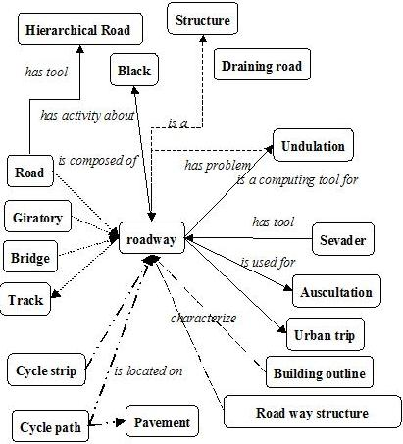
Figure 1: An example of a roaDeep Webay ontology [10]
Every Node of this graph stands for a “concept” which is a unit that one can think about and corresponds to words or short phrases. Typically, a concept corresponds to a noun or noun phrase like house, man, car New York etc. but that is not an obligation [1].
The nodes of the ontology are connected by different kinds of links. The most important kind of link is called IS-A link. The nodes and IS-A links together form a Rooted Directed Acyclic Graph (Rooted DAG). Rooted means that there is one single “highest node” called the Root. All other nodes are connected by one IS-A link or a chain of several IS-A links to the Root. In our definition, IS-A links point upward. If an IS-A link points from a concept X to a concept Y that means that every real world thing that can be called an X also can be called a Y. In other words, every X IS-A Y. (Some people have IS-A-like links but pointing downwards). Examples: A car IS-A vehicle. A dog IS-A animal [1].
Acyclic means that if you start at one node and move away from it following an IS-A link, you can never return to this node, even if you follow many IS-A links. Most nodes also have other information attached. This information includes attributes, relationships and rules [1].
An ontology represents information in a form that can be used for some forms of reasoning that are at least partially similar to human reasoning. This includes inheritance reasoning, transitivity reasoning and classification. A concept may inherit information from several other concepts. This is called multiple inheritances. Transitivity reasoning corresponds to chaining of IS-A links. Classification means that if we know the attributes of a concept we can decide under which other concepts it belongs in the ontology.

What is the Deep Web?
The Deep Web also called the Invisible Web, Dark Web or the Hidden Web refers to World Wide Web content that is not part of the Surface Web, which is indexed by standard search engines.
Mike Bergman credited with coining the phrase has said that searching on the Internet today can be compared to dragging a net across the surface of the ocean; a great deal may be caught in the net, but there is a wealth of information that is deep and therefore missed. Most of the Web's information is buried far down on dynamically generated sites, and standard search engines do not find it. Traditional search engines cannot "see" or retrieve content in the Deep Web – those pages do not exist until they are created dynamically as the result of a specific search. The Deep Web is several orders of magnitude larger than the Surface Web [18].
The Deep Web refers to information served up on Websites that is hidden or generally inaccessible through traditional search methods as these results are not indexed by search engines. For example, information that resides in or is provided through searchable databases, the results of which can only be discovered through queries or by filling out Web based forms is considered Deep Web data. It contains Web pages that are dynamically generated via query interfaces implemented as Web forms or Web services. A great deal of information may be caught in the Web crawlers and search engines, but there is a wealth of information that is deep and therefore missed [12]. According to researcher Marcus P. Zillman of DeepWebResearch.info, as of January 2006, The Deep Web contained somewhere in the vicinity of 900 billion pages of information. In contrast, Google, the largest search engine, had indexed just 25 billion pages [8]. Bright Planet, an Internet search technology company that specializes in searching Deep Web content. In their 2001 white paper, ‘The Deep Web: Surfacing Hidden Value’, Bright Planet noted that the Deep Web was growing much more quickly that the Surface Web and that the quality of the content within it was significantly higher than the vast majority of Surface Web content. Although some of the content is not open to the general public, Bright Planet estimates that 95% of the Deep Web can be accessed through specialized search [9].
Due to its dynamic nature, existing Web crawlers cannot access the Deep Web. Thus, accessing and maintaining the huge amount of Deep Web information remain challenging research issues. The Figure 2 below shows one method of crawling the Deep Web [11]. Information in Deep Web sites is categorized as being either in textual or structured databases. While a textual database needs input keywords for searching text documents, a structured database requires a user to fill in input fields of a query interface [12].
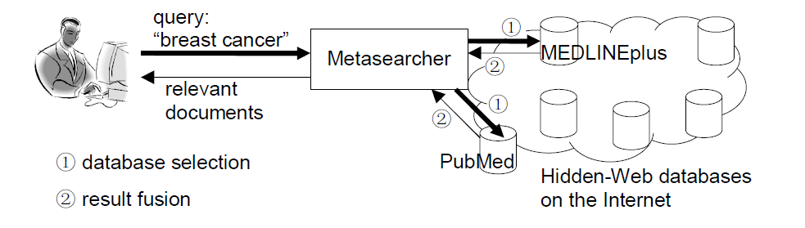
Figure 2: Web Crawling Method [11].

Deep Web content includes information in private databases that are accessible over the Internet but search engines are unable to crawl due to various reasons. For example, some universities, government agencies and other organization maintain databases of information that were not created for general public access. Other sites may restrict database access to members or subscribers [12].

Deep Web Mining
Just because a Web search engine can not find something does not mean it is not there. The Deep Web is a vast information repository not always indexed by automated search engines but readily accessible to enlightened individuals. The Shallow Web, also known as the Surface Web or Static Web, is a collection of Web sites indexed by automated search engines [12].
A search engine robot or Web crawler follows URL links, indexes the content and then relays the results back to search engine central for consolidation and user query. Ideally, the process eventually scours the entire Web, subject to vendor time and storage constraints. Most of the time information is stored on Web sites in such a way that the user initially comes in contact with what are called menu pages. Menus are numerous and too thin i.e. they are having basic information and users are driven through an endless series of nested menus in order to reach important information stored on backend content pages [12] as shown in Figure 3 below.
Figure 3: Information storage format on a typical website [12].

The crux of the process lies in the indexing. A Web crawler does not report what it can't index, and we know the search result for a particular Web page in terms of its relevance depends greatly on that. This was a minor issue when the early Web consisted primarily of static generic HTML code, but contemporary Web sites now contain multimedia, scripts and other forms of dynamic content. The Deep Web consists of Web pages that search engines cannot or will not index. The major search engines together index approximately 20% of the Web, and thus missing 80% of the content [12]. Search engines typically do not index the following types of Web sites:
• Proprietary sites
• Sites requiring a registration
• Sites with scripts
• Dynamic sites
• Ephemeral sites
• Sites blocked by local Webmasters
• Sites blocked by search engine policy
• Sites with special formats
• Searchable databases

Proprietary sites require a fee. Registration sites require a login or password. A Web crawler can index script code (e.g., Flash, JavaScript), but it can't always ascertain what the script actually does and the Web crawler may get trapped within infinite loops. Dynamic Web sites are created on demand and have no existence prior to the query and limited existence afterward [12].
Webmasters can request that their sites not be indexed (Robot Exclusion Protocol), and some search engines skip sites based on their own inscrutable corporate policies. Not long ago, search engines could not index files in PDF, thus missing an enormous quantity of vendor white papers and technical reports, not to mention government documents. Special formats become less of an issue as index engines become smarter. The most valuable Deep Web resources are searchable databases. There are thousands of high-quality, authoritative online specialty databases. These resources are extremely useful for a focused search [12].

Role of Ontology in search for Web pages
Recently, there has been a growing interest in Web searches that are intended to locate information that exists in the backend data bases of Web services. Web sites in E-commerce domains such as airfares, automobiles, books, car rentals, hotels, jobs, movies and music records usually store huge amounts of information, which is of interest to many users, in their backend databases [12].
Ontologies could play an important role in assisting users in their search for Web pages. Domain ontologies can be constructed that support users in their Web search efforts and that increase the number of relevant Web pages that are returned. To achieve this goal the Deep Web information is combined with an ontology [12].
The process of building an ontology consists of several steps as shown in Figure 4. Firstly the possible search terms, called attributes of Deep Web data sources are automatically extracted from a static collection of Deep Web sites. Secondly, a separate domain ontology is built for each domain, using the extracted search terms. Thirdly, by probing a few Deep Web sites, domain terms from the backend databases are extracted. Next, the domain ontology is extended to include these Deep Web terms as instances. Finally, the domain ontology is extended with relationships between instances [3].
Figure 4: The flow for the Ontology-Supported Deep Web Search [3].

Previous Work
The previous work on this project included addressing the problems of extracting instances from the Deep Web, enriching a domain specific ontology with those instances, using this ontology to improve Web search and a Graphical User Interface for Ontology-Supported Web Search.
In the initial phase of the project information was gathered about all the airports located all across North America by mining the Deep Web for building an ‘Airports’ ontology based on that. This information was then used to provide users with additional search terms for making the search more specific and getting more relevant Web pages. The effectiveness of this methodology was shown by comparing the number of relevant Websites by a search engine with a user's search terms only, with the Websites found when using additional ontology-based search terms. In the next phase of the project the domain was extended to searching out information about famous people like singers, publishers, actors, actresses, basketball players, researchers, religious leaders etc [14][15]. The current phase includes building of widely used Data structure called Trie, to enable faster search of ontologies.

Enriching Ontology for a Deep Web Search
Enrichment of ontology is a process that extends it by adding concepts, instances and new relations between concepts. Extracting instances from the Deep Web was based on developing "robots" (agents) that sent many queries to the same Deep Web site to extract as many data values as possible. When a robot encounters an input field it may enter random values or leave the field empty and then submit the page to elicit an informative response [3].
Figure 5: A Flow for generating data level ontology fragments [3].

Figure 5 shows the workflow for extending the ontology with instances. The concept discovery of the robot is guided by a human in its initial stage. Initial pairs of a concept and its corresponding instances are defined, which we call a robot image. The robot submits input values into the query interface. If the input values are not suitable for the form, most Web sites display error messages. The analysis of the error messages often gives useful clues to the robot to guess suitable input values and launch better probing queries. Thus, the queried Web sources may provide information about concepts, instances and semantic relationships, which is recorded in the ontology [3].

Trie Data Structure
A Trie, or prefix tree, is an ordered tree data structure that is used to store an associative array where the keys are usually strings. Unlike a binary search tree, no node in the tree stores the key associated with that node; instead, its position in the tree shows what key it is associated with. All the descendants of a node have a common prefix of the string associated with that node, and the root is associated with the empty string. Values are normally not associated with every node, only with leaves and some inner nodes that correspond to keys of interest. Trie comes from word 'retrieval' [16].
Figure 6: Example of Trie [19]
Consider Figure 6. Suppose we want to search for 'tea.' Then we start from the root node, and follow the path in the trie, character by character. From the root, we go to ’t’ then ‘e’ and then following the path for 'a' we find the keyword 'tea.' Now, suppose we want to search for 'tax.' Then, we start from the root node towards ’t’, but there is no branch for 'a' from 't', hence we know that there is no keyword 'tax' in the given trie.

Ontology-Supported Web Search
The Ontology-Supported Web Search (OSWS) System for “famous people” provides search suggestions based on the user input, every time she types a new character. As seen in Figure 7, after the user completes the search term “Martina,” the system finds all the famous people in the knowledge base with “Martina” in their names. Additional background information about these famous people is extracted from the knowledge base for generating suggested completions. In this example, the tennis players Martina Hingis and Martina Navratilova and the singer Martina McBride are found. From the information related to these three famous people the suggested completions in the dropdown box are generated and displayed to the user [16].

Figure 7: Interface of the OSWS System for search term "Martina" [16]

My Work

Mining more knowledge for ontology database
I am going to mine and parse more ontology knowledge into the database of the Ontology-Supported Web Search System. Our goal is to setup an ontology database of all famous people. Currently, the mining of the Deep Web for ‘singers’ and ‘basketball players’ was done by mining on a particular Web site and then gathering relevant information from it [12]. I will continue to work on ‘Politicians’, ‘Religious Leaders’ and ‘Researchers’ which are being mined[15].

Instant Search for Ontology-Supported Web Search
I am going to enhance the graphical user interface for current Ontology-Supported Web Search. The current version of the Ontology Web Search application connects to the ontology database, and parses user queries and displays relevant results in a categorized manner. I am going to enhance the user interface for a better user experience. The new interface will let users to see the search result for the first matched ontology term at real time. By predicting search and showing results before users finish typing, “Instant Search” can save 2-5 seconds per search [20]. This feature is similar to Google’s instant search shown in Figure 8. However, when moving the mouse down among the suggestions, the instant searches are not updated. I will implement the suggest continuations in a way that whenever the mouse is hovering above a suggested continuation, the instant search will be updated.
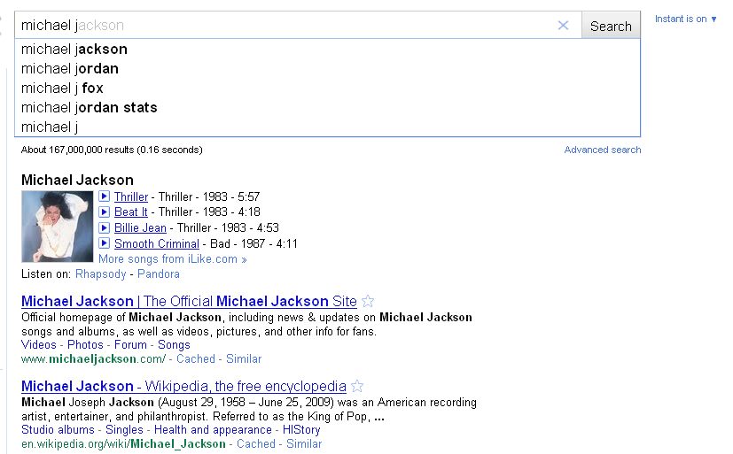
Figure 8: Google Instant Search

Multiple Searches for Ontology-Supported Web Search
I am going to enhance the search result layout. Currently, the Ontology-Supported Web Search engine can only show the results for one ontology term. Since we are getting categorized results from the ontology, it is better for user to show different categorized search result in different frames. The Figure 9 below shows the layout of multiple searches. While searching “Martina”, the display will show 3 result columns for “Martina Hingis tennis player”, “Martina Navratilova tennis player” and “Martina McBride singer”. The layout has the advantage that if a user moves the mouse up and down, the display does not have to be refreshed. Also, this layout can let users quickly locate the results they want.
Figure 9: Multiple Searches Layout

List of Deliverables

ONTOLOGY_MINING
Input: website URL
Output: Ontology knowledge contained in the URL.

INSTANT_SEARCH_COMPONENT
Input: Search query
Output: Display the search result for first ontology suggestion.

MULT_SEARCH_ COMPONENT
Input: Search query
Output: Display the first search result of each ontology suggestion category in different frames

Weekly Plan
Week | My Work
Week 1 | Getting started
Week 2 | Understand data structure and database indexing techniques
Week 3 | Design ONTOLOGY_MINING and importing into database
Week 4 | Continued.
Week 5 | design INSTANT_SEARCH_COMPONENT logic
Week 6 | Implement User Interface for the INSTANT_SEARCH_COMPONENT
Week 7 | Test INSTANT_SEARCH_COMPONENT
Week 8 | Continued
Week 9 | Write code for the MULT_SEARCH_ COMPONENT logic
Week 10 | Implement the MULT_SEARCH_ COMPONENT User Interface
Week 11 | Test MULT_SEARCH_ COMPONENT
Week 12 | Continued
Week 12 | Integration Test for the Ontology-Supported Web Search
Week 13 | Continued
Week 14 | Do the necessary changes if required and retest it.

References

- James Geller. Definition of Ontology, http://Web.njit.edu/~geller/what_is_an_ontology.html, Oct, 2010.
- Thomas Gruber (2008), Ontology. Entry in the Encyclopedia of Database Systems, Ling Liu and M. Tamer Ozsu (Eds.), Springer-Verlag. Oct, 2010.
- Yoo Jung An, Soon Ae Chun, Kuo-chuan Huang, James Geller: Enriching Ontology for Deep Web Search. DEXA 2008: 73-80, Oct, 2010.
- Yoo Jung An, James Geller, Yi-Ta Wu, Soon Ae Chun: Semantic Deep Web-Automatic Attribute Extraction from the Deep Web Data Sources, Oct, 2010.
- Yoo Jung An, Soon Ae Chun, Kuo-chuan Huang, James Geller: Assessment for Ontology Supported Deep Web Search, Oct, 2010.
- Yagnesh Bhat, Building Ontologies for Ontology Enabled Web Search, NJIT, CS Department, MS Proposal Spring 2009.
- Tian Tian, Enriching Multi-Domain Ontology for Web Search, PhD Project Proposal, NJIT, CS Department, in preparation of Ph.D.
- http://en.wikipedia.org/wiki/Google_search, Oct, 2010.
- http://brightplanet.com, Oct, 2010.
- http://vvww.cybergeo.eu/docannexe/image/8322/img-1.jpg, Oct, 2010.
- Frontiers in Web Data Management, http://oak.cs.ucla.edu/~cho/papers/cho-icts03.pdf, Accessed March 12, 2010.
- Jalaj Asher, Creating a Database from Deep Web Sources, NJIT, CS Department, MS Proposal, Fall 2010.
- http://www.di.unipi.it/didadoc/asw/grossidir/Sahni/tries.htm, Oct, 2010.
- Mansi Penedgaonkar, Deep Web Mining for Information Retrieval about Famous People in Publishing and Acting, NJIT, CS Department, MS Proposal Fall 10
- Anushri Mahajan, Building Ontologies of Politicians, Religious Leaders, Researchers for in more Accurate Web Searches, NJIT, CS Department, MS Proposal Fall 10.
- Tian Tian, James Geller, Soon Ae Chun: Improving Web Search Results for Homonyms by Suggesting Completions from an Ontology. Oct, 2010
- http://en.wikipedia.org/wiki/Ontology_%28information_science%29, Oct, 2010
- http://en.wikipedia.org/wiki/Deep_Web, Oct, 2010
- http://en.wikipedia.org/wiki/Trie, Oct, 2010
- http://www.google.com/instant/, Oct, 2010

