SYSTEM TEST PLAN

Contents
1. SCOPE 2
2. REASON FOR RE-ISSUE 2
3. INTRODUCTION 2
3.1 Description 2
3.2 Strategy 3
4. APPLICABLE DOCUMENTS 3
5. DEFINITIONS 5
6. SETUP 5
7. EQUIPMENT RECORD 5
8. TEST CASES 6
[Test Case 010] Physical Measurements 6
[Test Case 020] Airflow 10
[Test Case 030] Heating System 12
[Test Case 040] Spinning of the Spinneret 14
[Test Case 050] Heating of the Solution 16
[Test Case 060] Solution Flow Through Entire System 18
[Test Case 070] Circuitry 22
[Test Case 080] Linear Actuator 24
[Test Case 090] Whole System Test: Spinning EtO using the Centrifugal Force Spinner 26
9. APPENDIX 28
10. ATTACHMENTS 29

SCOPE
This document describes the test plan for verifying the design of the Centrifugal Force Spinner (CFS) as described in CFSFR.01. It provides the necessary procedures for the validation test of the device.

This document was written with the presumption that the pre-existing components of this CFS device, as outlined in the document issued by the Spring 2014 Capstone II Group 3 High Level Requirements, have passed the following test cases, as determined by Document # CSST.01:

REF001: Test Case 010 - Plywood Enclosure & Plexiglas Lid
REF002: Test Case 020 - Spinneret and Mount Shaft Measurements
REF003: Test Case 030 - Adapter to Spinneret Assembly Demo
REF004: Test Case 040 - Hypodermic Needle Demo

REASON FOR RE-ISSUE

ISSUE |  | REASON FOR RE-ISSUE
1 |  | This is the first time the plan has been issued
.

INTRODUCTION

3.1 Description
The following tests will be performed:

Test Case | Direct Requirement | Test
010 | REQ2.210  REQ3.210  REQ3.160  REQ3.220  REQ3.310  REQ3.330  REQ3.410  REQ3.420  REQ1010  REQ11.510  REQ11.520  REQ11.521 | Physical Measurements
020 | REQ3.110  REQ3.130  REQ3.230  REQ3.371  REQ3.430 | Air Flow
030 | REQ2.240  REQ3.140 | Heating System
040 | Section 5.5.1 Motor  Section 5.5.3 Motor Shaft  REF002: Spinneret | Spinning of Spinneret
050 | Section 5.7 Solution Storage and Heating | Heating of the Solution
060 | REQ030  Section 5.3: Peristaltic Pump  Section 5.9: Tubing | Solution Flow Through Entire System
070 | Section 5.11: Linear Actuator | Circuitry
080 | Section 5.11: Linear Actuator | Linear Actuator
090 | REQ020  REQ030 | Whole System

3.2 Strategy
1. The CFS is a new product. All tests will be conducted.

APPLICABLE DOCUMENTS
This plan is based on requirements from CFSFR.01 Centrifugal Force Spinner Functional Requirements. It is a continuation of CSST.01.
CFSFR.01 Centrifugal Force Spinner Functional Requirements
CSST.01 SYSTEM TEST PLAN CENTRIFUGAL SPINNER
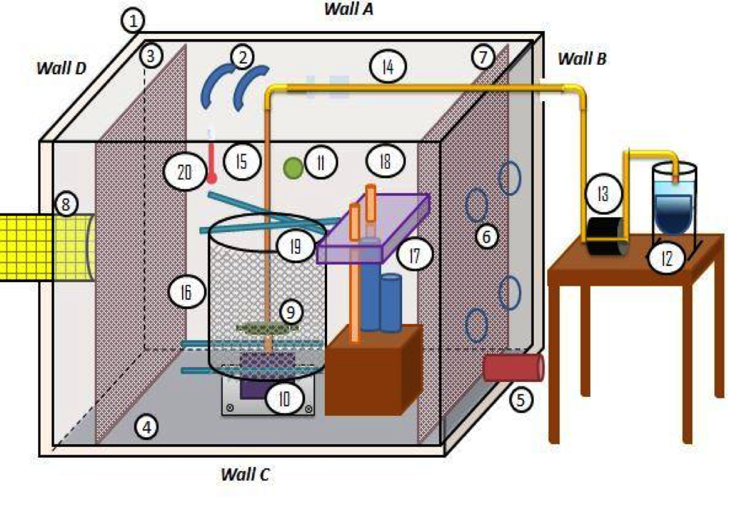
Figure 1. Centrifugal Force Spinner Device

Component Legend for Figure 1
1. Wooden Encasement
2. Plexiglas Lid
3. Floor Insulation
4. Wall Insulation
5. Air Compressor Tube Attachment
6. Ventilation Holes
7. Two-Sided Buffer System
8. Fume Hood and Fume Hood Exhaust Attachment
9. Spinneret
10. Motor and Housing
11. Speed Controller
12. Solution Storage and Heating
13. Peristaltic Pump
14. Upper Tubing
15. Lower Tubing
16. Collection Screen
17. Linear Actuator
18. Stabilization Posts of Linear Actuator
19. Collection Screen Attachment
20. Thermometer

DEFINITIONS
REFXXX: Refer to requirement in Capstone Spring 2014 Team 3 High Level Requirements Document.
REQXXX: Refer to requirement in Capstone Spring 2015 Team 8 High Level Requirements Document (CFSFR.01).

SETUP
This testing requires the following units as a minimum: A Centrifugal Force Spinner, Masterflex Peristaltic Pump, Bronco 50064 Air Compressor, and Fume Hood Exhaust.

EQUIPMENT RECORD
The following test equipment, or equivalent, is needed to execute the tests in this plan.

Item | Model Number(s) | Calibration Required?
Tape Measure | N/A | No
Digital Caliper | N/A | Yes (Zeroed)
Airflow Velocity Meter | N/A | Yes
Thermometer (Celsius) | N/A | No
Tachometer | N/A | No
Peristaltic Pump | Cole Parmer #7518-00 | No
Hot Plate | LABRepCo H3760 Series Digital Hotplate | No
Fume Hood Exhaust | N/A | No
Air Compressor | Bronco 50064 | No
Heater | Staco Energy Products Co. | No
Linear Actuator | gearWORKS AC Motor: Johnson Metal Industries CO. | No

TEST CASES

[Test Case 010] Physical Measurements

Purpose: To verify correct dimensions are used in the Centrifugal Force Spinner as specified by CFSFR.01.

Specification:
REQ2.210
REQ3.210
REQ3.160
REQ3.220
REQ3.310
REQ3.330
REQ3.410
REQ3.420
REQ1010
REQ11.510
REQ11.520
REQ11.521

Test Architecture:

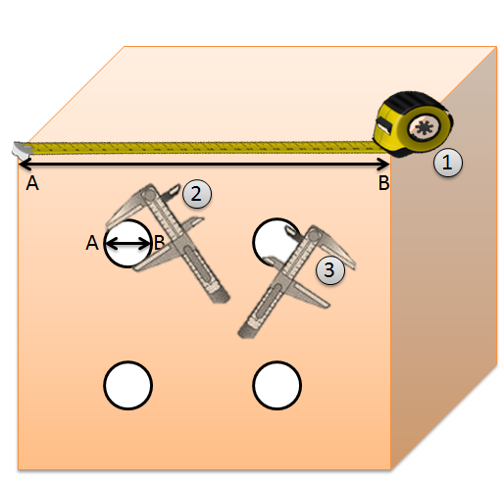
Figure 2. Directions on how to measuring using tape measure (1) and the
outside (2) and the inside (3) tongs of the caliper.

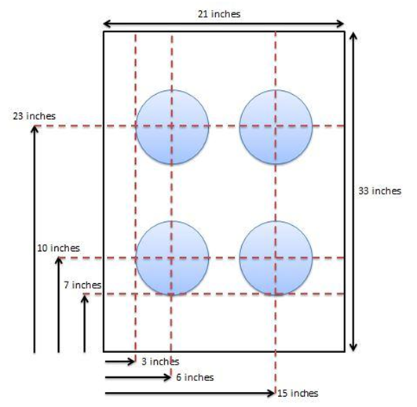
Figure 3: Size and placement of Ventilation Holes.
Equipment:
- Tape Measure (Imperial Units)
- Digital Caliper (Imperial Units)

Test Procedure:

- For dimensions greater than 10 inches, use a Tape Measure; for less than or equal to 10 inches use a digital caliper as there is greater accuracy in a caliper, but they are limited in their ability to measure large distances.
- Measure the specified distance based on the requirement.
  - Using a tape measure: (shown in Figure 2, #1)
    - Put one end of the tape measure on the end of the portion being measured.
    - Pull the tape to the other end of the portion being measured.
    - Mark the part where the edge of the item being measures lines up with the increments on the tape measure.
  - Using a Digital Caliper
    - Turn unit on.
    - Using the outside caliper, put the portion being measured between the caliper legs (seen in Figure 2, #2).
      - Compress the legs firmly until they are enclosed around the portion being measured.
    - Using the inside caliper, put the legs into the portion being measured.
    - Extend the legs until they touch the portion being measured (seen in Figure 2, #3).

Expected Results

Test passes if all of the following occurs:
- Measurements are within specified tolerances as described in Test Results Table of Test Case 010 Physical Measurements.

Test Results:

Item | Expected Result | Test Result: | Pass/Fail
Polystyrene Insulation | Side dimensions with tolerances of ± 0.5 inch  A: 19 x 31 inch  B: 19 x 34 inch  C: 19 x 31 inch  D: 19 x 34 inch  Thickness  1 ± 0.05 inch | Side dimensions  A:  B:  C:  D:  Thickness  A:  B:  C:  D:
Ventilation Holes | Refer to figure 3 | Diameter  Hole 1:  2:  3:  4:  Placement  Hole 1:  2:  3:  4:
Buffer System | Buffer size (length x width) with tolerances of ± 0.5 inch  1: 34 x 21 inch  2: 34 x 21 inch  Buffer placement from wall  1: 3 ± 0.5 inch from wall B  2: 3 ± 0.5 inch from wall C | Buffer size  1:  2:  Buffer placement from wall  1:  2:
Collection screen | Diameter:  Minimum: 15 ± 0.5 inch  Maximum: 40 ± 0.5 inch  Height: 8 ± 0.2 inch | Diameter:  Minimum:  Maximum:  Height:
Fume Hood Attachment Hole | Diameter: 8 ± 0.1 inch  Placement: 15.5 ± 0.2 inch | Diameter:  Placement:
Air Compressor Hole | Diameter: 0.5 ± 0.1 inch  Placement: 4.5 ± 0.2 inch | Diameter:  Placement:
Linear Actuator Platform | Length: 15 ± 0.1 inches  Width: ¾ ± 0.1 inch  Depth: 2 ± 0.1 inch  Vertical Holes:  Diameter: ½ ± 0.01 inch  Placement: Figure 3  Horizontal holes  Diameter ⅛ ± .01 inch  Placement: Figure 3 | Length:  Width  Depth  Vertical Holes:  Diameter:  Placement:  Horizontal holes  Diameter  Placement:

[Test Case 020] Airflow

Purpose: To verify the airflow produced by the air compressor, vents, and fume hood exhaust is correct as specified by CFSFR.01.

Specification:
REQ3.110
REQ3.130
REQ3.230
REQ3.371
REQ3.430

Test Architecture:

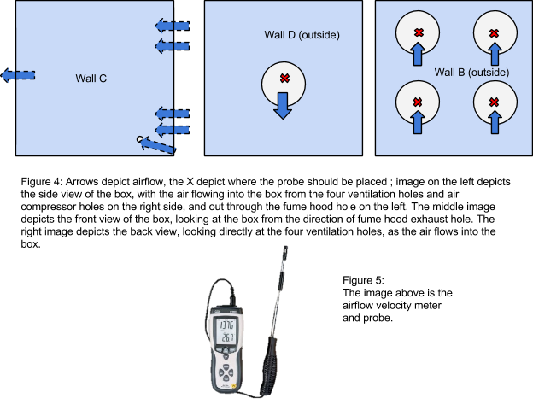

Equipment:

- Air Flow Velocity Meter

Test Procedure:

- Place airflow velocity meter probe into airflow stream of interest.
- For :
  - Vent holes, place probe in front of each hole approximately 2-4 inches from the center of the hole.
  - Air Compressor, place the probe in front of the approximately 2-4 inches from the center of the hole.
  - Buffer system, place the probe in the center of the CFS approximately 2 -4 inches from the tip of the spinneret.
  - Fume hood exhaust, place the probe inside the center of the hole approximately 2-4 inches deep.
- Turn on meter using the “ON” switch and set to airflow velocity.
- Turn on CFS using the “ON” switch found on Wall B.
- Turn the Fume Hood on using the “ON” switch found on the right side of the apparatus.
- Airflow is measured via the probe and the reading is shown on the meter.

Expected Results

Test passes if all of the following occurs:
- The airflow velocity is within the tolerance TBD by the requirement, as shown in the test Results table for Test Case 020 Airflow.

Test Results:

Item | Expected Result | Test Result: | Pass/Fail
Air compressor | Air flow rate: TBD | Air flow rate:
Ventilation holes | 80 ± 0.5 feet per minute | Hole 1:  2:  3:  4:
Buffer System | 20 ± 0.1 feet per minute | Air flow rate:
Fume Hood Exhaust | 80 ± 0.1 feet per minute | Air flow rate:

[Test Case 030] Heating System

Purpose: To verify that the heating mechanism functions to heat the encasement as specified by CFSFR.01.

Specification:
REQ2.240
REQ3.140

Test Architecture:

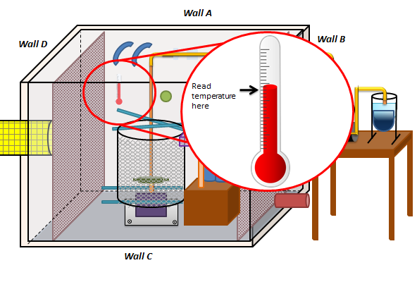
Figure 6: Diagram demonstrating the use of a thermometer in the device.

Equipment:

- Thermometer (Celsius)
- Air compressor

Test Procedure:

- Place the thermometer on inside of Wall C of the wooden encasement (Figure 5).
- Turn on the air compressor by pressing the ON button located at the top right of the air compressor
- Turn on the heater to the TBD percentage of heating value.
- Read the temperature in Celsius off the thermometer after 15 minutes, which is how long it takes the temperature in the device to stabilize. Take the reading from the point where the mercury appears closest to a temperature increment.

Expected Results

Test passes if all of the following occurs:

- The temperature is within tolerance as outlined in the Test Results table in Test Case 030 Heating System.

Test Results:

Item | Expected Result | Test Result: | Pass/Fail
Time to reach 10 degrees C above current room temperature with vents closed and fume hood exhaust off | TBD | Time:
Temperature (T initial = 30) after 10 minutes with heated air on and vents and fume hood exhaust on  (testing the ability to keep the desired temperature | 30 ± 5 °C | Temperature:

[Test Case 040] Spinning of the Spinneret

Purpose: To verify that the Spinneret and Mount Shaft are controlled by the motor that is spinning between 10,000RPM – 20,000RPM, as specified in CFSFR.01.

Specification:
Section 5.5.1 Motor
Section 5.5.3 Motor Shaft
REF002: Spinneret

Test Architecture:
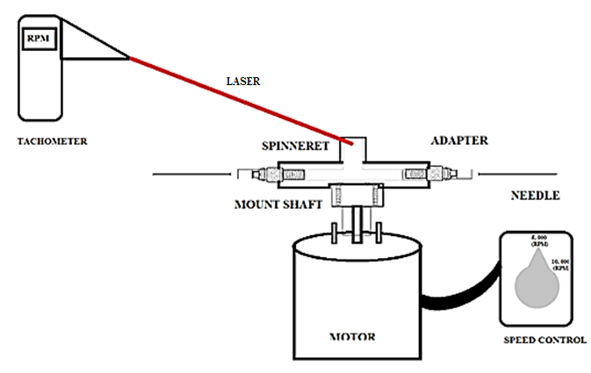
Figure 7: Diagram demonstrating the use of a thermometer in the device.

Equipment:

- Tachometer
- Spinneret and Mount Shaft connection secured
- Spinneret and Mount Shaft connection to motor

Test Procedure:

  - Securely attach the spinneret to the mount shaft structure by tightening the set screws in the lower part of the spinneret head.
      - Use a number 3 Standard Phillips Screwdriver.
  - Place the Plexiglas lid back again.
  - Turn on the device by using the “ON” switch on Wall B.
  - Initiate the Tachometer by plugging into a 110V wall socket.
  - Hold the tachometer outside Plexiglas lid and perpendicularly point the tachometer at the spinneret head as shown in test architecture.
  - Read the readings on the LCD of the tachometer as the spinneret moves..

Expected Results

Test passes if all of the following occurs:

1. The tachometer reading is within the tolerance as outlined in the Test Results table in Test Case 030 Heating System.

Test Results:

Trial | Expected Result | Test Result: | Pass/Fail
Spinneret (RPM) | 10,000RPM
 | 15,000RPM
 | 20,000RPM

[Test Case 050] Heating of the Solution

Purpose: To verify the heating of the solution is correct as specified by CFSFR.01.

Specification:
Section 5.7 Solution Storage and Heating

Test Architecture:
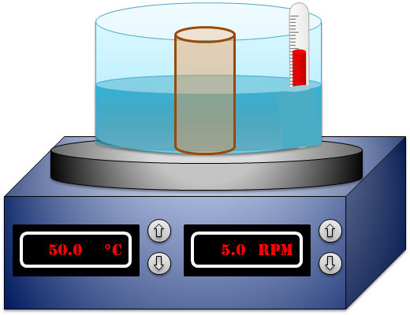
Figure 8: Diagram demonstrating the use of a thermometer in the device.

Equipment:

- 1L of prepared EtO solution (preparation is outlined in Appendix 1 of the Test Plan for Centrifugal Force Spinner)
- 1.5L Water
- LABRepCo H3760 Series Digital Hotplate with Ceramic Plate
- 1.5 L beaker
- 2500 mL crystallization dish
- 1x Magnetic Stirring 0.5” Rod
- Lab tape
- Thermometer

Test Procedure:

1. Pour the 1L of EtO solution in the 1.5 L container.
2. Take a crystalline dish and fill it with ¾ of water (a little more than a liter).
3. Place the crystalline dish filled with water on the hot plate.
4. Place the beaker with the solution in the water.
5. Turn the temperature and the stirring to 50°C.
6. Set stirring to 5 RPM.
7. Wait 30 minutes to allow the solution to mix completely.
8. Insert thermometer. Record data.

Expected Results

Test passes if all of the following occurs:
- The reading of the thermometer is consistent with the temperature setting on the hot plate.

Test Results:

Item | Expected Result | Test Result: | Pass/Fail
°C of reading on hotplate | Equivalent to hotplate reading | Temperature:

[Test Case 060] Solution Flow Through Entire System

Purpose: To verify that the Peristaltic Pump can successfully pump 1L of EtO solution through the upper and lower tubing, as outlined in CFSFR.01.

Specification:
REQ030
Section 5.3: Peristaltic Pump
Section 5.9: Tubing

Test Architecture:

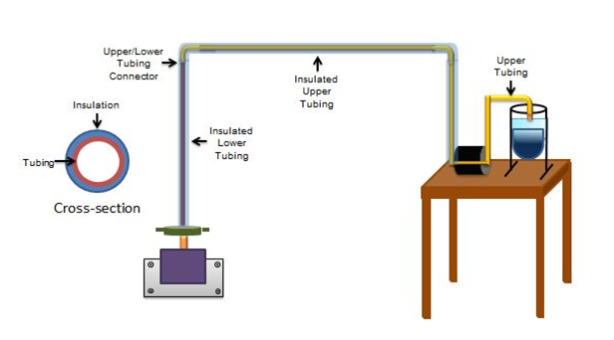
Figure 9: This figure shows the overall setup of the peristaltic pump to the tubing system. For the purposes of this test, the lower tubing will be placed in an empty beaker, as seen in Figure 11.
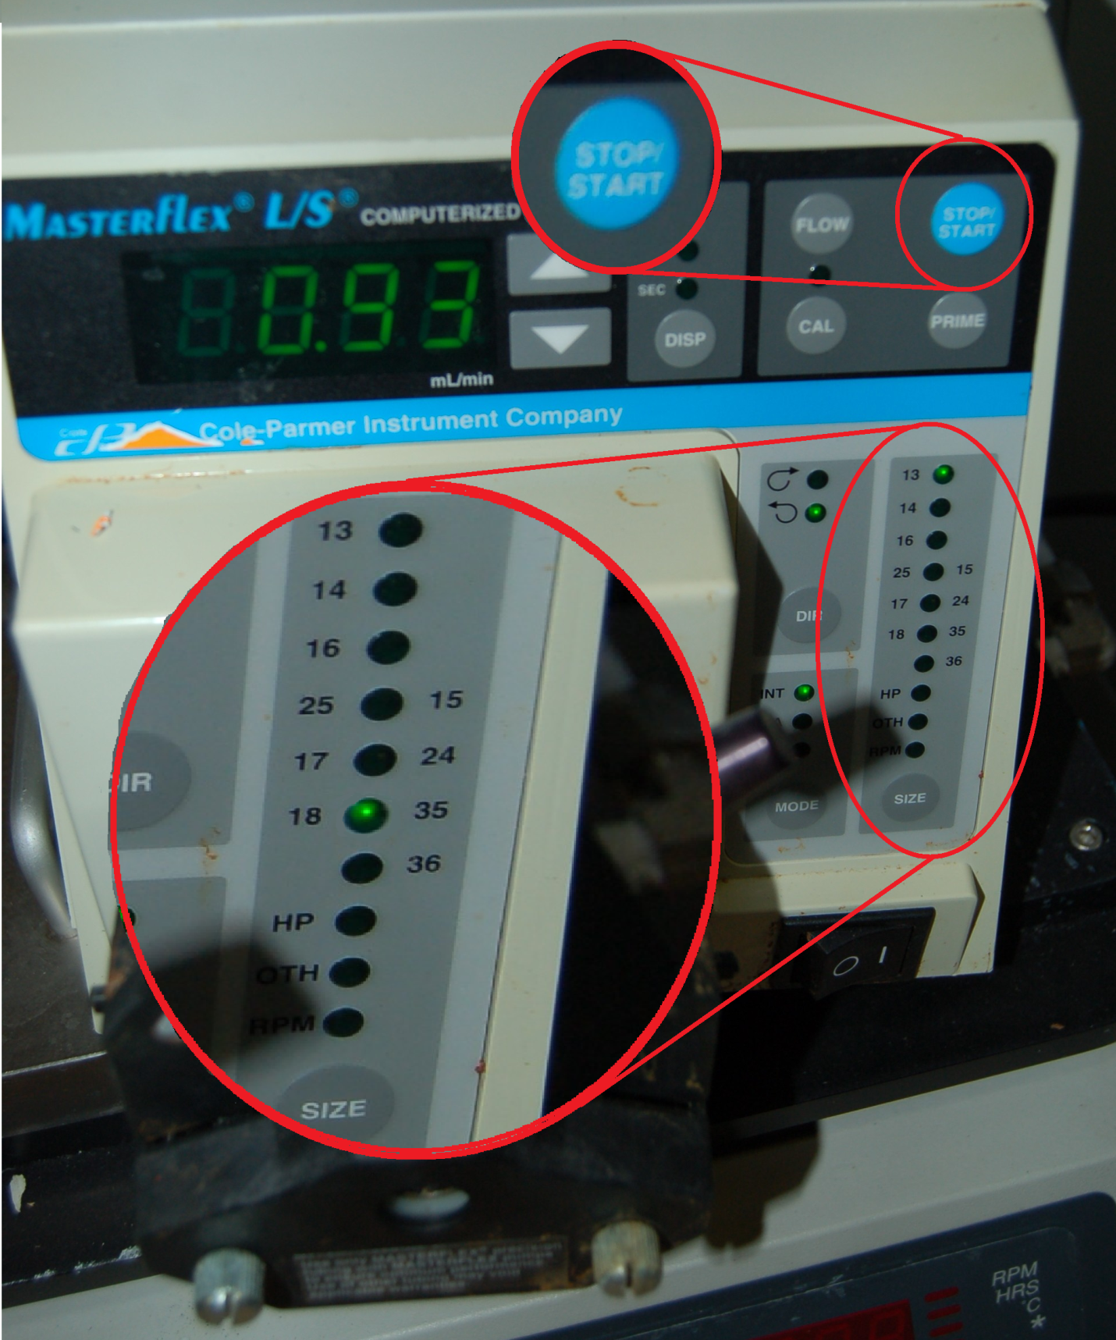
Figure 10: This image depicts the buttons that should be used to set the peristaltic pump to the settings required for this Test Case.

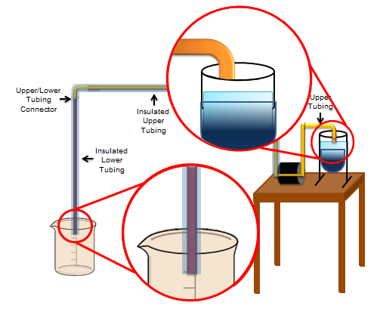
Figure 11: This diagram shows how the upper and lower tubing connect to the beaker full of solution to the empty beaker, respectively.

Equipment:
- Cole Parmer Masterflex Peristaltic Pump
- Cole Parmer Masterflex Platinum-cured Silicone Tubing, L/S 18, 1 ft.
- 1/2 in. x 1 ft. Clear PVC Tubing
- 1 L of prepared EtO solution
- 3/8 in. x 1/2 in. Plastic, 90-Degree Barb x MPT Elbow
- LABRepCo H3760 Series Digital Hotplate with Ceramic Plate
- 2 x 1.5 L beaker
- 2500 mL crystallization dish
- 1x Magnetic Stirring 3” Rod
- Lab tape
- 1.5L water
- Timer

Test Procedure:
1. Plug peristaltic pump into 110 V wall socket.
2. Turn peristaltic pump on by pressing the power button.
3. Set tube size on machine to L/S-18 by pressing “ size” button until “18” lights up. See Figure 11.
4. Lift pumphead lever to open pumphead.
5. Insert Masterflex silicone tube laterally.
6. Close pumphead lever to secure tube.
7. Insert one end of the tube into solution; secure into place by lab tape.
8. Insert the other end of the silicone tube into the 90-degree elbow connector.
9. Into the second end of the elbow connector, insert the1/2in clear PVC tubing.
10. Insert the other end of the PVC tubing into the second, empty 1.5 L beaker.
11. Secure tube to beaker using lab tape.
12. As “Start” button is pressed, begin timing simultaneously.
13. Wait until the beaker on the hot plate is emptied into the second, initially empty beaker.
14. Stop timer when that occurs; simultaneously press blue “Stop” button on peristaltic pump.

Expected Results

Test passes if all of the following occurs:

- If the output rate at the end of the lower tubing to the spinneret head is < 10mL/minute.
- If there is less than 5mL of leakage.

Test Results:

Item | Expected Results | Test Result: | Pass/Fail
Flowrate (mL/min) | < 10mL/ minute | Flowrate:
Leakage from connector | >5mL | mL:

[Test Case 070] Circuitry

Purpose: To verify that the linear actuator circuitry works to perform its intended task: move the platform up and down, as specified in CFSFR.01.

Specification:
5.11 Linear Actuator

Test Architecture:

TEST TBD UNTIL CIRCUIT IS FINALIZED

Equipment:
- Multimeter
- Linear Actuator

Test Procedure:

- Plug into wall socket.
- Identify wires across Relay 1.
- Turn on multimeter to 10 amps current. Place test leads of multimeter across Relay 1.
- Remove test leads and flip switch to “ON” position.
- Check current across Relay 1 again.
- Switch multimeter to voltage. Place probes on potentiometer from the motor.
- Visually inspect motor for vertical actuation.

Expected Results

Test passes if all of the following occurs:
- The current across Relay 1 is 0 milliamps when the switch is “OFF”.
- The current across Relay 1 is TBD when the switch is “ON”.
- The voltage across the potentiometer increases from .66 volts to 4.9 volts as the actuator moves downward.
- The voltage across the potentiometer decreases from 4.9 volts to .66 volts as the actuator moves upward.

Test Results:

Item | Expected Results | Test Result: | Pass/Fail
Current across Relay 1 (“OFF”) | 0 milliamps
Current across Relay 1  (“ON”) | TBD milliamps
Voltage rage when actuator moves up | decreases from 4.9 volts to .66 volts
Voltage rage when actuator moves down | increases from .66 volts to 4.9 volts

[Test Case 080] Linear Actuator

Purpose: To verify that the platform and collection screen attached to the linear actuator move vertically, as specified in CFSFR.01.

Specification:
Section 5.11: Linear Actuator

Test Architecture:

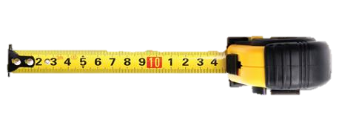
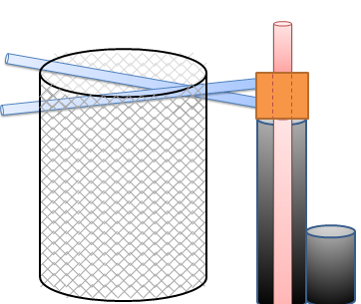
4cm

Figure 12: Diagram showing the side view of the linear actuator platform as it connects to the collection screen. The screen moves vertically when the platform moves up and down and can be visually inspected.

Equipment:
      - Centrifugal Force Spinner
      - Timer
      - Tape Measure

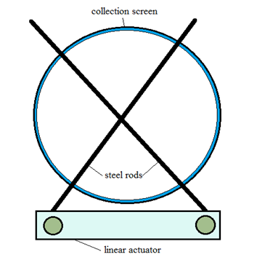
Figure 13: Top view of linear actuator and collection screen subsystem.

Test Procedure:
1. Mark the position of the platform as it appears on the tape measure.
2. Turn the linear actuator on by pressing the “ON” button, located on Wall B. See Figure 1: Overall CFS Device.
3. Simultaneously press “Start” on the timer.
4. As the linear actuator platform moves up, time its movement. Turn the device “OFF” when it reaches the top; simultaneously hit “Stop” on the timer.
5. Record the results.

Expected Results

Test passes if all of the following occurs:
1. The linear actuator platform moves a total of 4 ± 0.5 inches vertically.
2. If the linear actuator speed moves with a velocity of TBD inches/min or less.

Test Results:

Item | Test Result: | Pass/Fail
Velocity (inches/min) | 1in/min
Total Distance (inches) | 4 ± 0.5 inches

[Test Case 090] Whole System Test: Spinning EtO using the Centrifugal Force Spinner

Purpose: To verify that the CFS device performs all functions together, as specified in CFSFR.01, and outputs nanofibers when spun at a rate between 10-20,000RPM. This is assuming all subsystem tests were successful.

Specification:
REQ020
REQ030

Test Architecture:

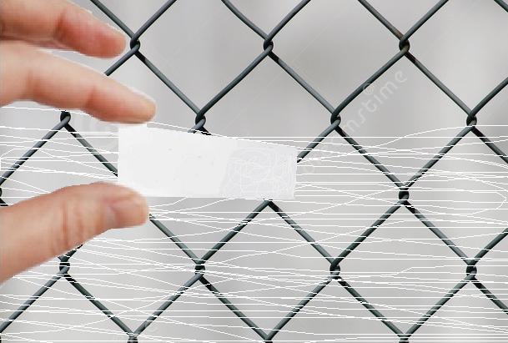
Figure 14: Diagram shows how a glass slide can be used to scrape the white nanofibers of the collection screen.

Equipment:
1. Centrifugal Force Spinner
2. 1 L of EtO solution
3. Lab glass slide

Test Procedure:

1. TBD

Expected Results

Test passes if all of the following occurs:

- The linear actuator moves the collection screen continuously up and down.
- The spinneret head spins 1L of EtO solution into nanofibers that spew onto the moving collection screen.
- Nanofibers can be scraped off screen using a glass slide. See Figure 14 above.

Test Results:

Item | Test Result: | Pass/Fail
Ability to scrape nanofibers onto glass slide
[Visual check]
Movement of the linear actuator
[Visual check]

APPENDIX

- Etheleyne Oxide (EtO) Solution Preparation
Equipment:

1. Electronic Lab Magnetic Mixer with Speed and Temperature Control
2. (1= slowest rotating speed/lowest temperature setting, 5 = fastest rotating
3. speed/highest temperature setting)
4. Electronic Lab Scale
5. EtO Powder with molecular weight of 1,000,000
6. De-ionized Water in squirt bottle
7. 10 ml graduated cylinder
8. 500 ml beaker
9. 0.5 inch magnetic stirrer
10. 20 ml disposable storage bottles
11. Straw scooper
12. Safety goggles and latex gloves
13. Labeling tape
14. Paper towels
Test Procedure:
      - Take a small piece of labeling tape and use it to cover the 20 ml bottles.
      - Make sure to label your 20ml bottles according to the following format below:
      - Obtain the water needed for spinning:
      - For weight/volume solution, measure 10mL of DI water using the squirt bottle, measure 10 ml in the graduated cylinder and pour it into the 20 ml bottle.
      - For a weight/weight solution place the 20 mL bottle onto the Electronic Scale, tare the weight to remove the bottle weight factor, and measure 10g of water by using the squirt bottle
      - To make 10% EtO measure 1.33 g of EtO using the straw scooper to pick up and transfer the powder into the 20ml bottle.
      - Place the magnetic stirrer in the 20 ml bottle.
      - Place bottle within the water bath
      - Place the 500ml beaker onto the magnetic stirrer with temperature control
      - Turn on the stirring control to 7 and temperatures 50 degree Celsius, an acceptable temperature range to heat the solution to dissolve.
      - Leave the 20 ml bottles on stirrer until a homogeneous solution forms in approximately over night.

10. ATTACHMENTS
Cover Sheet for QUALITY RECORDS
Test Plan Name
Test Engineer
Test Date
Version | (HW) (SW)
System Name
Tests covered
MRs written? | Yes or No [see next page]
Data Attached? | Yes or No
Old Results appended? | Yes or No
Record Type | System Test Results
Date Filed
Storage Location (Room #)
Approval Signature(s)

TEST STATUS

Test Case | TEST PASSED? | IT TEST FAILED  MR# | IF TEST FAILED, MR NOT ENTERED  REASON | COMMENT
END OF DOCUMENT

