Nematic Liquid Crystals: An Experimental Attempt

Priyanka Shah
Juan Pineda
Sean Naughton
Paul Dupiano

Introduction
Liquid Crystals can be described as a combinational phase of solid and liquid phases of matter, and as such have properties overlapping both phases (Senyuk). Most notably, liquid crystals have some form of orientational order; meaning that the liquid crystal particles in a sample tend to arrange themselves with the same orientation, as if they were all pointing in the same direction (Palffy-Muhoray,55). Imagine a group of middle school children arranged in a line. They would represent liquid crystals, and although they have some order, there will be a few students scattered about. Liquids can be represented by a line of kindergarten students, with very little if any order at all. Solids on the other hand, would be at the opposite extreme and could be represented by military students lining up for their daily drills. We can see a schematic of these orientational order differences in Figure 1 below. It is this orientational order and the subsequent properties associated with them that has led to the commercialization of Liquid Crystals in displays we use every day, and subsequently increased its value in academic and commercial research.
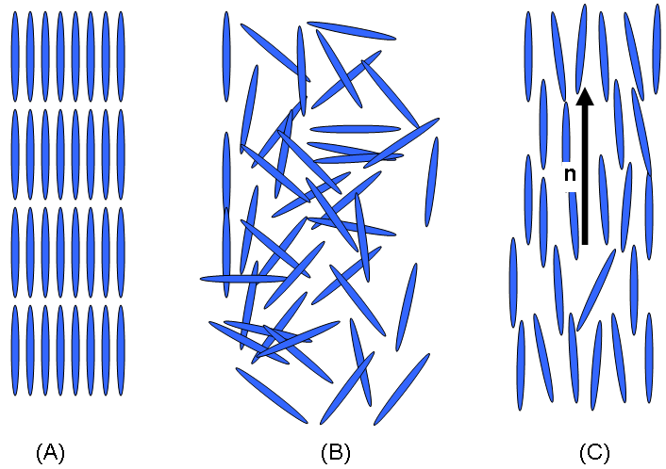
Fig. 1 This shows the orientational order observed in (a) Solids, (b) Liquids, and (c) Liquid Crystals.
The orientational order of liquid crystals along with their shape and chemical composition result in anisotropic properties. This means that liquid crystals can appear to have different properties depending on the direction you interact with them (Collings 68). Take for example sanding a block of wood. If you sand with the grain you obtain a nice smooth finish, but if you sand against the grain, you are left with a rough surface riddled with splinters. In the same way, liquid crystals interact with light by affecting how light travels through a sample. Depending on the polarization of light, liquid crystals will affect how much light passes through and how much of a phase shift occurs in the passing light. By traveling either “with or against the crystal grains,” light will appear to pass through different media. Phase shifts in light through a medium are caused by changes in indices of refraction. Because of their anisotropic properties, it appears as though liquid crystals have two indices of refractions; a property is known as birefringence (Collings, 67).

Because of their special orientational order, liquid crystals can be associated with a vector that points in the direction of the liquid crystal orientation, as depicted above in Figure 1 as vector n. By in large, a sample of liquid crystals will point in the same direction because of the overall balance of the forces acting on the liquid crystals, but additional interactions with one another or external forces can lead to localized disruptions in the liquid crystals call defects or disclinations (Collings, 69). These defects will be discussed later but it is important to note that liquid crystals exhibit a long term orientational order that can be described by a vector.

Birefringence was a key property in studying the liquid crystal samples, in particular for detecting disclinations or defects in the liquid crystals. Defects are simply points in the liquid crystal sample, where the short term orientational order is somehow disrupted. This disruption could be caused by some physical or chemical defect in the sample. We are able to detect defects by the use of polarizers and the birefringence of the liquid crystals. Polarizers are special filters that only allow certain light with electric fields in a particular direction to pass through. In this case, think of polarizers as a grating or a row of bars and you have a series of rods falling towards the grating. Only the bars oriented in a particular way corresponding with the grating will pass through, and the others will be stopped behind the grating. We can see this in Figure 2 below. In this case only bars that are oriented horizontally or in the X-direction will pass through the grating.
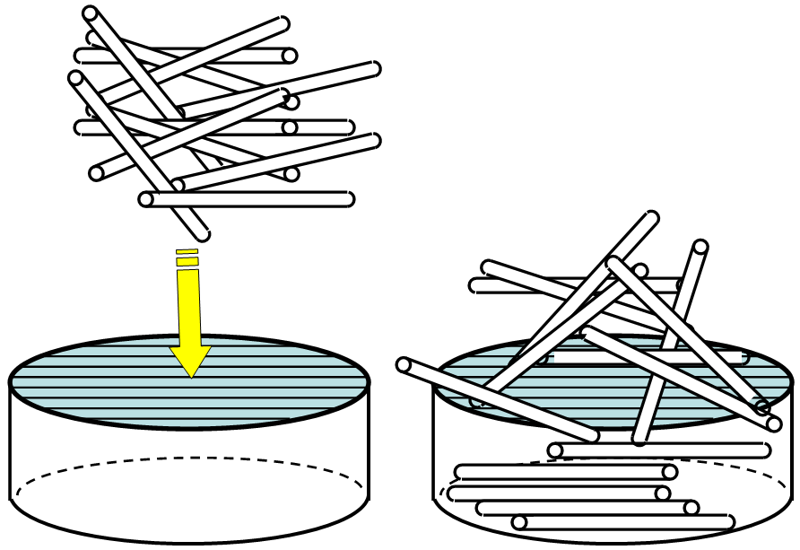
Y
X
X

Fig.2 This depicts the effects of polarizers through the use of metal rods and a grate.
Recall that liquid crystals have this multiple index of refraction property called birefringence. When we shine unpolarized light, light waves whose electromagnetic fields are not correlated, onto liquid crystals, we will observe two different emerging waves caused by the two different indices of refraction of the liquid crystal. The crucial observation in scenario is that the two waves have a specific phase difference. Now if we were to shine a polarized beam of light onto the liquid crystal, meaning that all of the light waves have their electromagnetic fields pointed in the same direction, then as a group those light waves passing through the liquid crystal will now have a differently oriented electromagnetic field. This field would be different from the original light beam shone onto the liquid crystal by a detectable phase shift. This phenomenon is depicted below in Figure 3. We see that in this scenario, the electric fields of the incoming light are all point to the positive Z axis. Notice that once they pass through the liquid crystal their electric fields have now been shifted by a certain angle due to the liquid crystal’s birefringent properties..
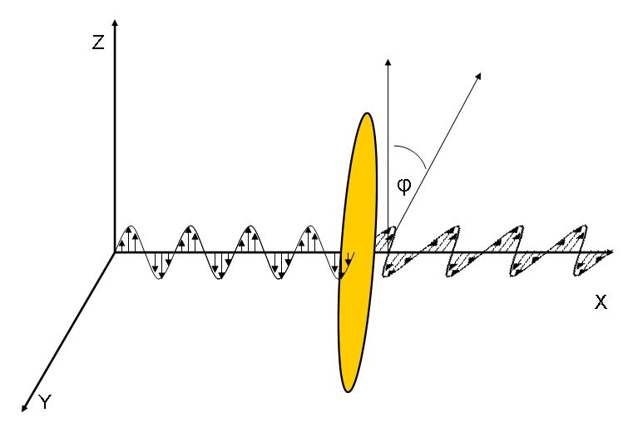
Fig. 3 This is a schematic depiction of polarized light passing through a sample of liquid crystals.
To obtain the polarized light, we used a polarizer. This ensures that only light waves with electric fields in a particular direction will pass through the polarizer, as in the grating example mentioned earlier. Now, if we use a second polarizer that is oriented perpendicular to the first polarizer we should observe that no light passes through the second polarizer; this is depicted in Figure 4 (a). Going back into the grating example in Figure 2, only the rods oriented horizontally with respect to the X axis pass through the grating. Now if a new grating oriented horizontally with respect to the Y axis was introduced, none of these rods would pass through it. But from the birefringent properties of liquid crystals, we know that we can cause a phase shift in the electromagnetic field of the passing light waves. So if we sandwich liquid crystal between two perpendicularly oriented polarizers, we can still observe light pass through the second polarizer. This is shown below in Figure 4 (b).

After passing through the first polarizer, the light waves all have electric fields in the positive Z-axis as in case (a). But after passing through the liquid crystal, they now have electric fields that are shifted from the positive Z-axis. This allows some portion of the light to then pass through the second polarizer. The scenario described is utilized in all Liquid Crystal Displays (LCD) in our word today. Manufacturers make use of the liquid crystal’s ability to “control” the electric field direction of light to allow certain frequencies or colors of light to pass through, creating the millions of color combinations we see on our laptops and televisions (Palffy-Muhoray, 56).
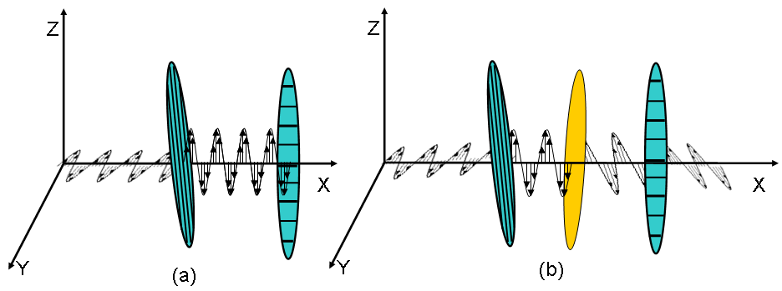

Fig. 4 This demonstrates how light can pass through cross polarizers using liquid crystals. In case (a) the polarized wave is perpendicularly polarized with respect to the polarizer, no light passes through. In case (b), the liquid crystal shifted wave is parallel to the polarizer and light passes through.

In this study, we used this same phenomenon to study liquid crystals, in particular to locate defects in the liquid crystal. As we discussed, liquid crystals cause a phase shift in polarized light that will allow the light to pass through the cross polarizers. What does it then mean to observer dark areas or spots in liquid crystals sandwiched between cross polarizers when we expect to observe light areas? We realized that these dark areas must correspond to regions wherein the liquid crystals are unable to shift the electric field of light so that it is not perpendicular to the second polarizer. Knowing that the phase shift in light is caused by the orientation of liquid crystals, we can conclude that these dark areas represent regions in the liquid crystal wherein the orientational order is some how disrupted. Recall earlier that liquid crystals have long term orientational order that can be described by a particular vector, n. These disruptions represent areas wherein the liquid crystal particles “point” or are oriented in directions that differ from the overall long term orientational order. A sample image is shown below in Figure 5 wherein a bright area is disrupted by dark lines and pinwheel like structures known as Schlieren textures (Senyuk).
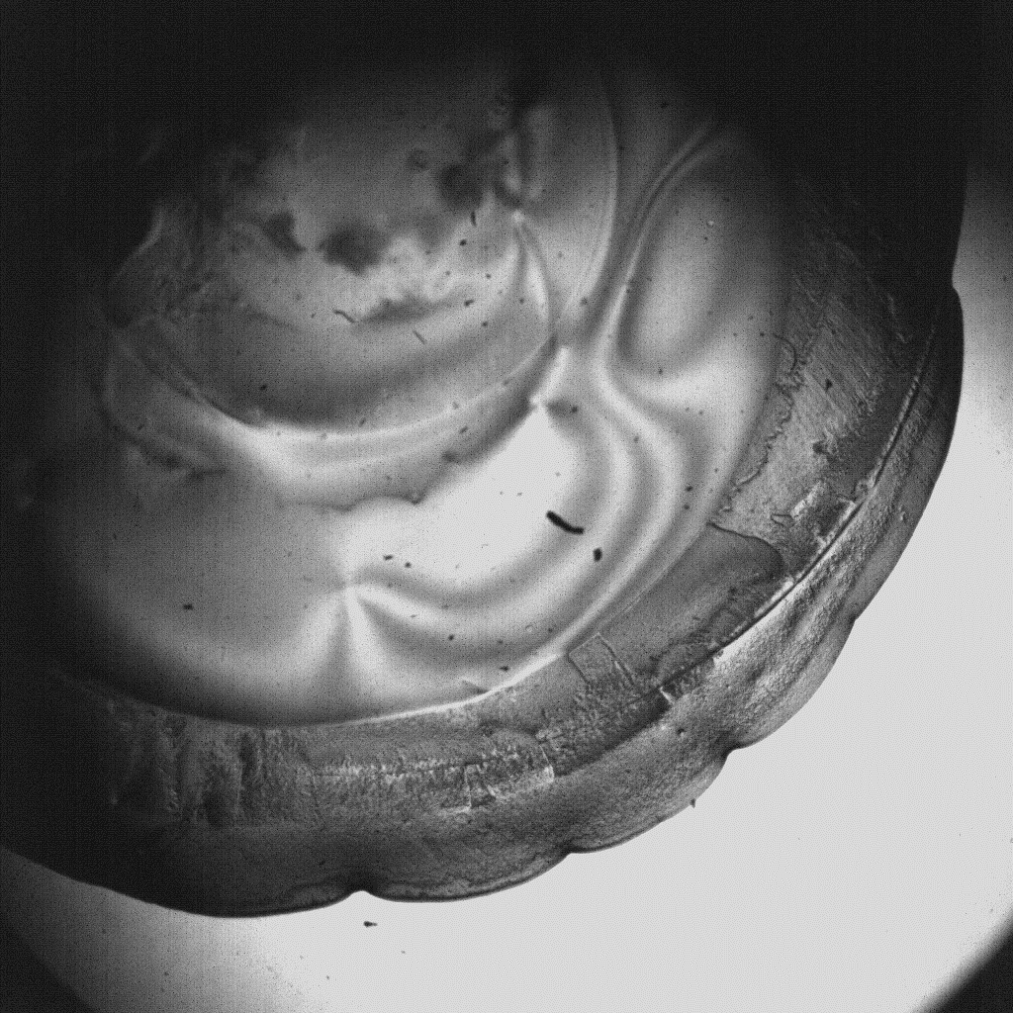
Fig. 5 A sample image of a liquid crystal through cross polarizers with defects, field of vision is 4.2mm.

In general defects are caused by external factors such as electromagnetic fields, chemicals, and other environmental factors such as temperature and humidity. Although the study of the effect of electromagnetic fields is interesting and highly sought by commercial researchers, it is beyond the scope of this study. We are limiting ourselves to the study of the effects of gravity, temperature and humidity, as well as a few chemical based experiments. What we attempted to do experimentally was detect the presence of defects and relate their formation to current work dealing with anchoring, as in Cummings et. al., and to study the effects of instabilities formed from spreading liquid crystals in different environments. The data obtained from the spreading liquid crystals were then compared to theoretical thin film models as well as numerical simulations with similar parameters as the experiments.

This study focuses on finding and detecting defects because of a possible link between defects and a particular model used in current work with liquid crystals, the notion of strong and weak anchoring. Just as it sounds, strong and weak anchoring deals with how something is attached to a particular body. In this case, it refers to what degree a liquid crystal particle will maintain its orientation along a certain direction given some perturbation or change in environment. This can best be described by the example developed earlier, how long can a middle school child stay in place when an ice cream truck passes by or when the school bell sounds the end of classes. In a similar way, a proper anchoring model would attempt to explain what occurs at the boundaries of liquid crystals when liquid crystal particles are influenced by the presence of air, water, or other chemicals in the environment. Since defects show changes in the short term orientational order of a sample of liquid crystals, detecting defects and noting their locations in a liquid crystal sample can help elucidate and lend support to anchoring models.
This study also dealt with the formation of instabilities as liquid crystals spread on different substrates. It has been shown in the past that when non-Newtonian fluids spread, they spread out in periodic patterns like paint falling from a wall and can be analyzed using Lubrication Theory (Kondic, 95-115). Another common example of instability formation is the formation of “tears of wine” in wine glasses due to the Marangoni effect, wherein the motion of a fluid is governed by gradations of surface tensions (Meggs). Liquid crystals appear to demonstrate similar behavior to these non-Newtonian fluids. Therefore, it may be possible to model the behavior of liquid crystals by viewing them as a continuous body rather than discrete particles as in the Maier-Saupe theory, wherein particle interactions are the basis for the model of liquid crystals (Collings, 182). Unlike the Maier-Saupe theory and other mean field theories where models take into account a discrete particle and enforce the same properties on all particles in a body (Collings, 183), new models set forth, as in Cummings and Ben-Amar and Cummings et. al., appear to have similar predictive properties by viewing liquid crystals as a continuous non-Newtonian fluid, rather than discrete particles. This study is an extension of that work by attempting to observe phenomenon predicted by these fluid based models of liquid crystals. Observing predicted behaviors would lead to increased validity and the utilization of these fluid based models over the previous mean field theories.
Experimental Details
The study was divided into two primary categories, detecting defects and observing the formation of instabilities. Each category was then subject to different testing conditions, which are described in greater detail below in the individual sections. The experimental variables considered in this study were temperature, humidity, substrate interaction, and gravitational forces. Special attention was paid to relative humidity readings in accordance to the theoretical models from Cummings et. al. These special ranges are outlined below in Table 1.

Relative Humidity | Predicted Behavior
<40% | Stable non-spreading droplet
>40% and <60% | Spreading droplet
>60% and <80% | Spreading unstable droplet
>80% | Spreading unstable droplet, large wave numbers
Table 1. Summary of expected experimental behavior
I. Defects
Experiments dealing with defects were performed using liquid crystals deposited on glass slides and placed between two cross polarizers as shown in Fig. 6. The liquid crystals were deposited on glass slides via micro-syringe. An initial amount of liquid crystal sample is siphoned into the syringe and approximately 50uL is pushed out of the syringe and allowed to form a bulb like shape. The sample is then deposited on the glass slide by touching the end of the bulb to the glass slide and allowing it to flow onto the slide. The slide is then observed under the microscope with cross polarizers in place.
Figure 6. This is a picture of experimental apparatus and outlining the location of two cross polarizers.

To study the sample under the microscope, we first arranging the polarizers perpendicular to one another ensuring that only light passing through the liquid crystal would appear to be bright under the microscope. This condition was tested by observing areas without liquid crystals appearing to be completely dark. Defects were then located by searching for dark spots or lines within the bright liquid crystal sample as shown in Fig. 5. One of the polarizers was then rotated to observe the behavior of the dark regions. The defects were then categorized depending on the behavior of the regions as the polarizer was rotated. Dark areas that shifted or rotated in accordance with the rotating polarizer were marked as regions of defects and other dark areas without rotational characteristics were assumed to be air bubbles disrupting the flow of the liquid crystal.

II. Instability Formation:
The experiments dealing with the spreading and formation of instabilities were subdivided into experiments with liquid crystal droplets and experiments with a flowing line of liquid crystal. Experiments concerning the instability in drops were performed on two substrates, a glass slide and a silicon wafer, whereas the instabilities formed on an incline were limited to a silicon wafer. After depositing the samples on different substrates, the liquid crystals were allowed to spread at different conditions. Relative humidity levels were varied for the case of the liquid crystal droplets and the gravitational effects were varied using different inclined planes for the liquid crystals flowing as a line. Greater detail of each category is outlined below.

II.A. Instabilities in a Drop on a horizontal Surface
The liquid crystal drops were deposited onto the substrates in a similar fashion as the defect experiments. A syringe was used to extract a constant volume of 50uL and the liquid crystals deposited onto a glass slide or silicon wafer. In these experiments, polarizers were not required and were removed from the microscope, but due to the expected sizes of the instabilities of droplet, all observations were conducted under a Nikon lab100 microscope with 3 different magnification settings which can best be described by the field of vision per setting: 4.2mm, 2.1mm, 1.05mm. Subsequent figures are described by their field of visions indicating that the maximum width of the images is the field of vision These experiments were conducted at different relative humidities in conjunction with the relative humidity levels located in Table 1. Due to difficulties in obtaining relative humidities above 40% because of environmental conditions and restraints in the lab used to conduct the experiments, collected and reported data were restricted to this regime.
II.B. Instabilities in Lines on an inclined Plane
The experiments dealing with a line of liquid crystals required a different method of depositing the samples onto the substrates. These samples were deposited in a way to ensure the most even coating possible and a perfectly straight wave propagation front, as depicted below in Figure 7. To deposit the crystals, first a large sample of liquid crystal is placed on a glass slide, the sample is approximately 300uL. Using a syringe, the sample is then coated onto the glass slide to create a uniform layer. Three glass slides are then attached together to create an edge that is roughly 0.3” and is dipped onto the liquid crystal coated glass slide, see Figure 8. Once deposited, the substrates were subjected to 30º, 45 º, and 90 º inclines and their flow down the wafer was recorded over time.
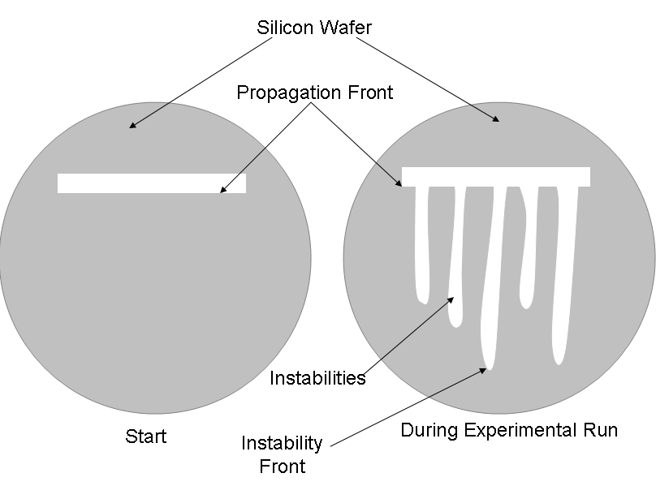
Fig. 7. This is a schematic representation of the liquid crystal propagation front down an inclined plane

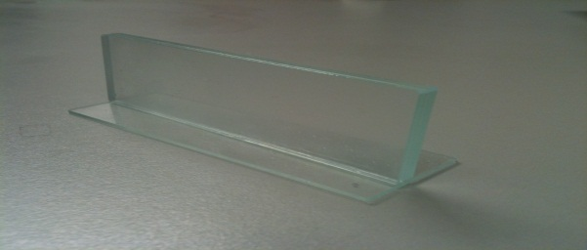
Fig. 8. This depicts a portion of the method used to deposit lines of liquid crystals on the silicon substrate
Experimental Observations

I. Defects
Defect formation was observed through a majority of samples as shown below in figure 9.a to 9.c. Defects were most commonly found in small droplets and near the center of the deposited droplets. The type of defects detected in this study were limited to point defects, which were easy to characterize by their “pinwheel” like formation and rotation along with polarizers as depicted in Figures 10.a to 10.c.

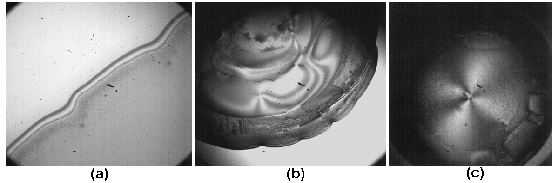
Fig. 9. These are optical microscope images of defects in different liquid crystal samples. Field of vision for sample (a) is 1.05mm, (b) and (c) are both 4.2mm

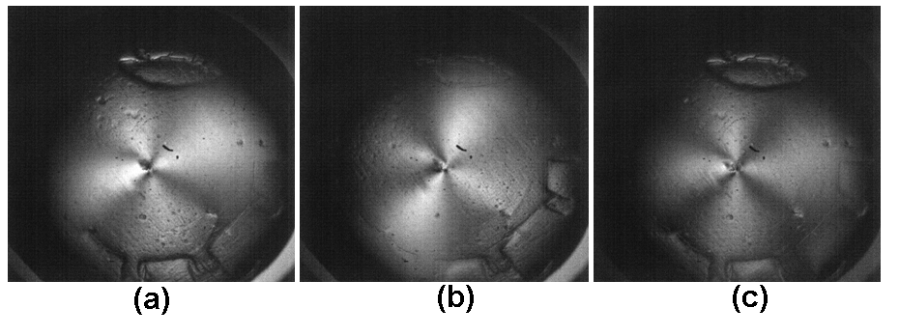
Fig. 10. This is a series of images taken of the same defect while rotating one of the polarizers. Note that the field of vision each is 4.2mm.

II. Instabilities in a Drop on a horizontal Surface
Droplet instabilities were detected but in a very small degree shown below in Fig. 11. This was due to the relatively low humidity levels obtained in the experimental set up. In most cases, we were unable to detect any instability formation due to the relatively low humidity levels as predicted in Cummings et. al.

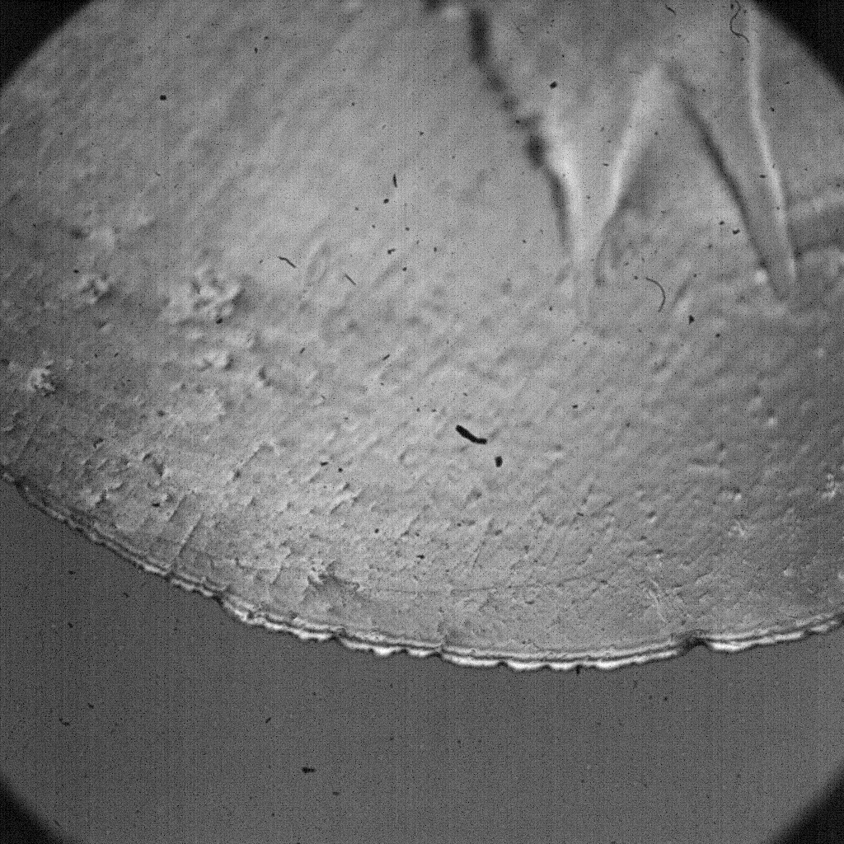
Fig. 11. This is that characteristic instability detected in liquid crystals at a relative humidity below 40%. This was taken with a field of vision of 1.05mm

III. Instabilities in Lines on an inclined Plane
Liquid crystal line instabilities were detected and shown in figures 12 and 13 below. We observed that the instability propagation was 0.9524mm/s and that the average distance between instabilities was 115mm.
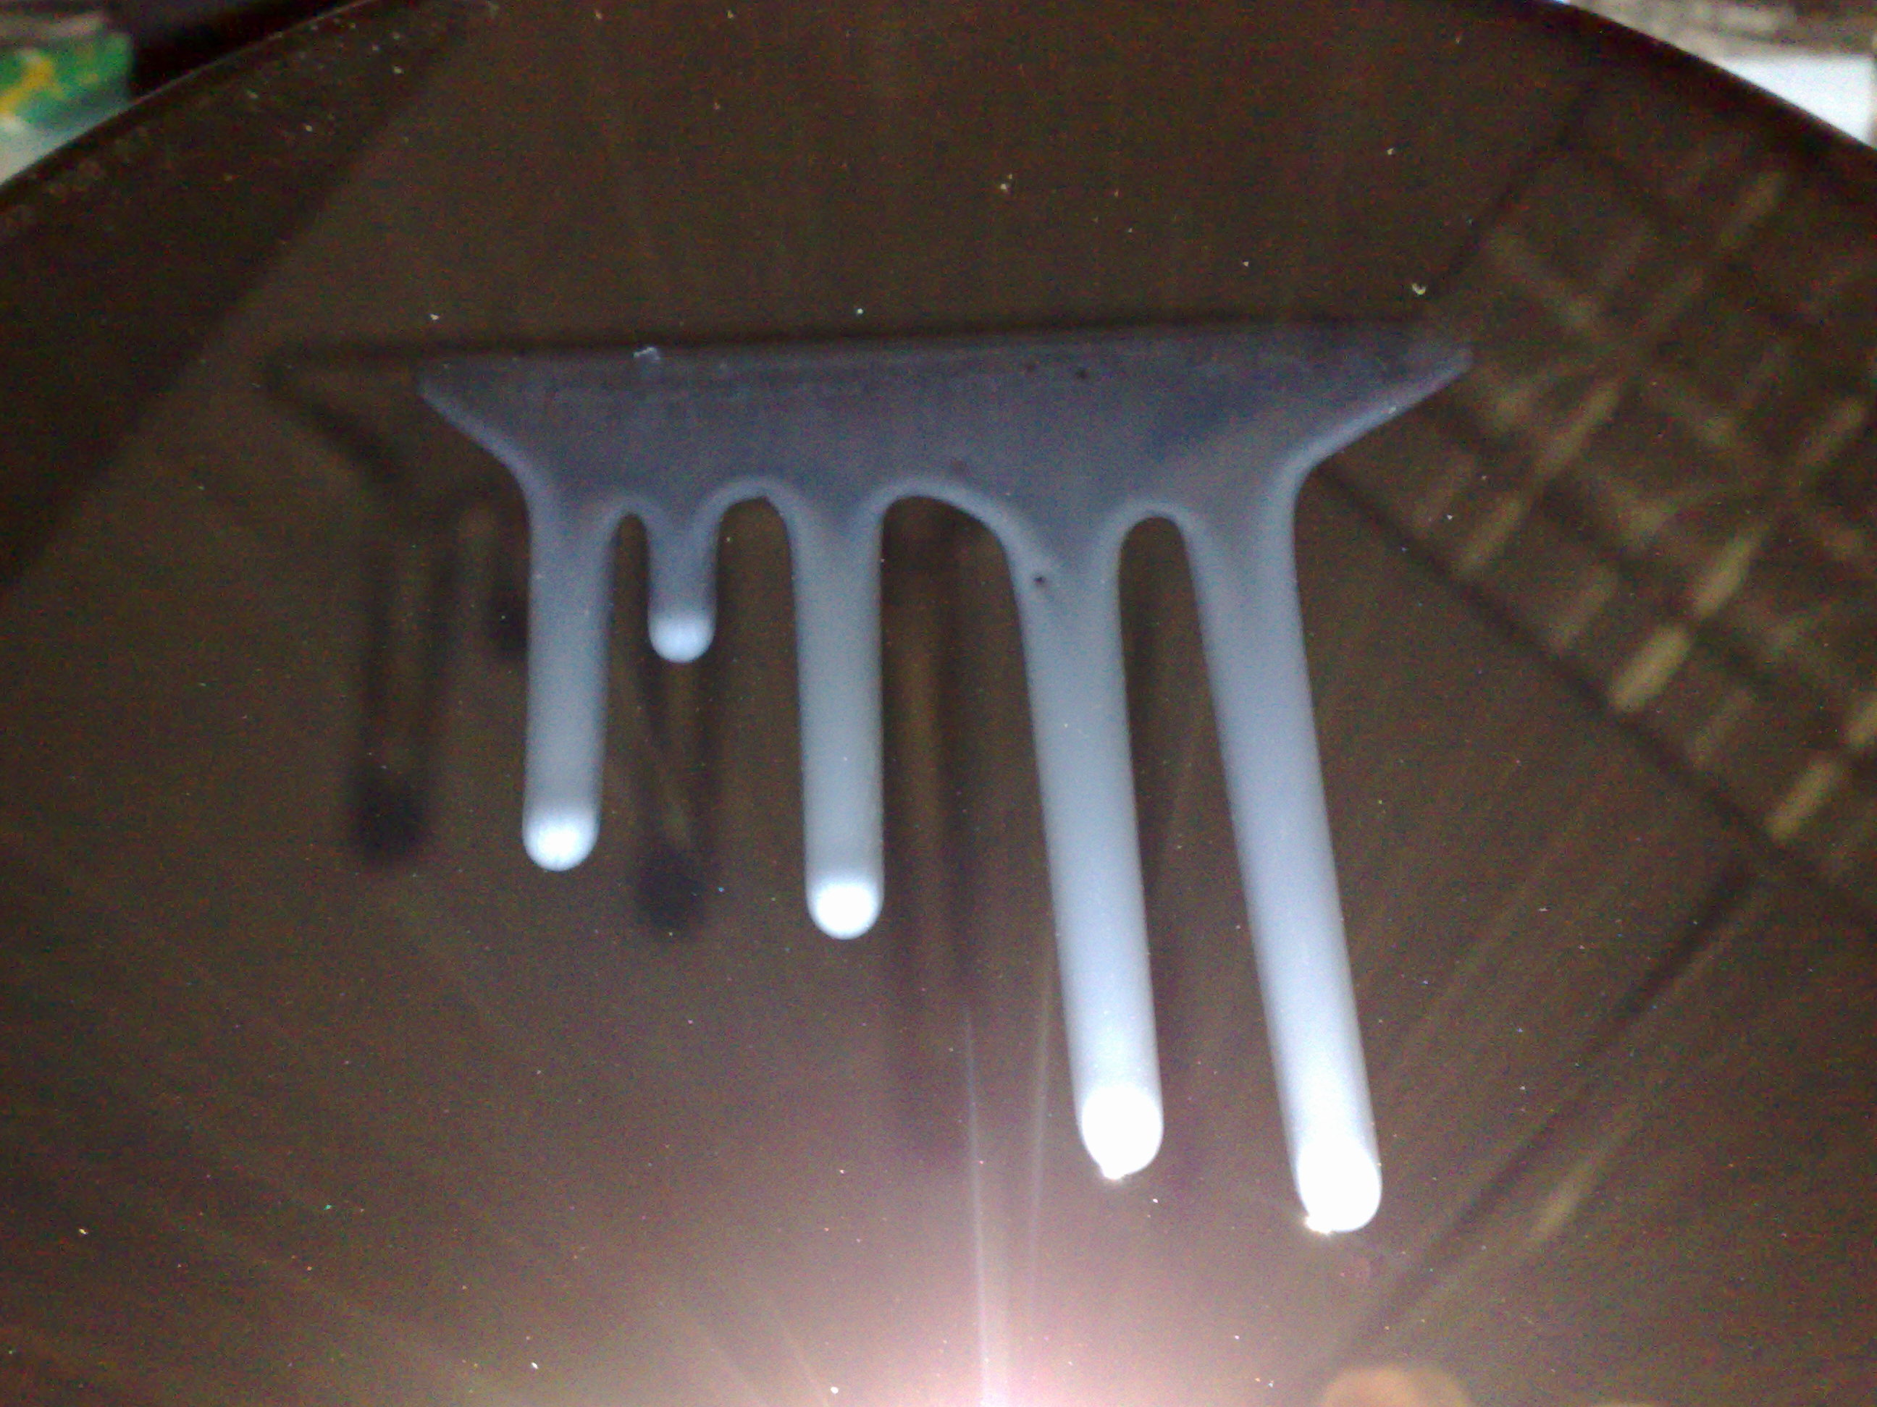
Fig. 12. Picture of observed instability of liquid crystals flowing down an incline angle of 45º

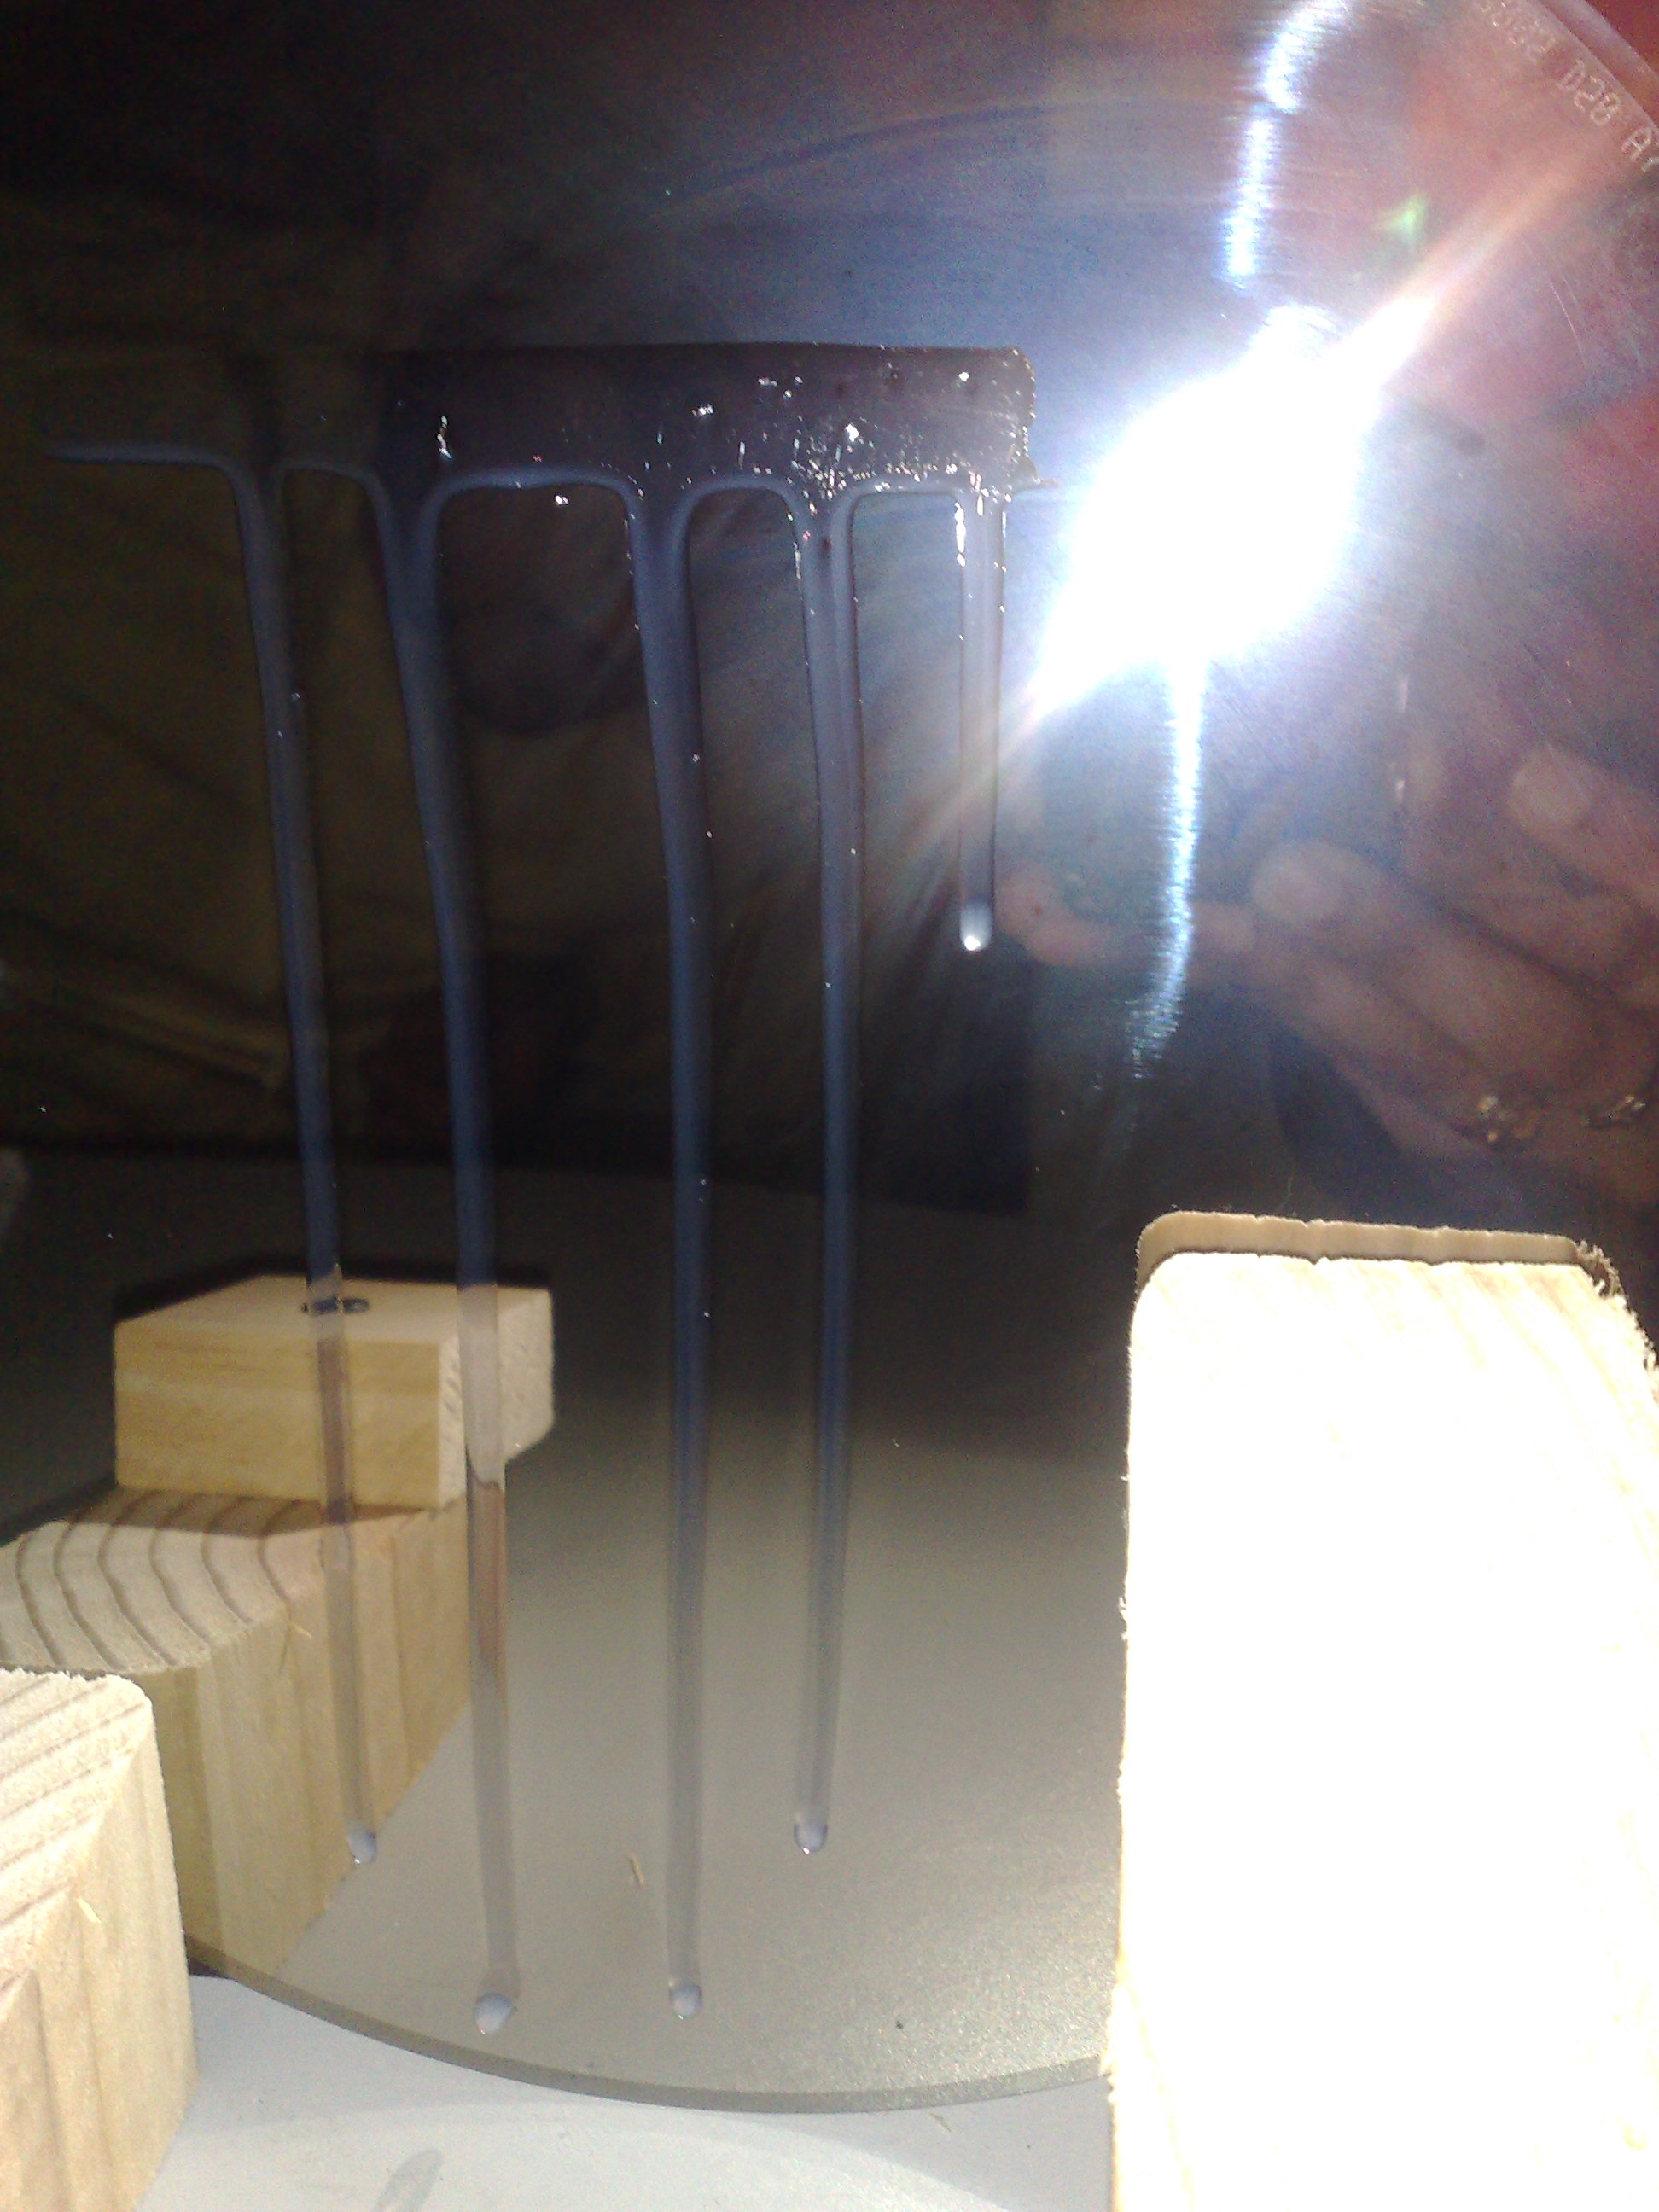
Fig. 13 Picture of observed instability of liquid crystals flowing down an incline angle of 90 º
Discussion of Results
I. Defects
As seen schematically in the Fig.14 below, a defect is a sudden change in the orientation of the liquid crystal grains. But notice that these sudden changes, highlighted in red, also result in more subtle changes to the liquid crystal grains surrounding the grains surrounded in red. This is a result of induced dipoles in the liquid crystals. Because of the dipole like structure wherein each end is oppositely “charged,” when one grain is displaced, it results in a displacement in nearby grains. Moving away from the displaced grains located in the center and circled in red in Fig. 14.a, we notice grains that have smaller and smaller perturbations from the overall orientational order of the liquid crystals. If we view the blue lines below as well defined orientation, then grains near these lines show little deviation from the orientational order. This arrangement then translates to a detectable difference between the arms of the defect, shown as a pinwheel shape in Fig. 14.b, and the main core of the defect, highlighted in red in Fig. 14.b. In the context of the liquid crystal’s orientational order, we notice the n vector depicting the overall orientation of the liquid crystals. But as we move closer towards the core, we detect increasing changes in the orientation of the liquid crystals until we get into the core wherein we have a drastic change in the orientation of the liquid crystal.
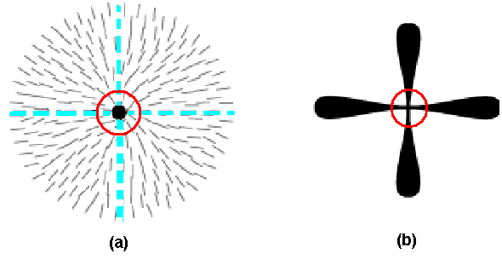
Fig. 14 This is a depiction of the liquid crystal grains at a defect highlighting the main source of the defect in red.

Because of the varying degrees of orientational disorder away from the core defect, if we rotate a polarizer we should now notice that light passes through previously dark areas (as shown in Fig. 10.a to Fig. 10.b). But because of the local differences in orientation caused by the core defect, we will also notice that some areas that were once bright turn into dark spots (also shown if Fig. 10.b to Fig. 10.c). In the case of the samples we observed, when we rotated the polarizer, the arms of the defect rotated in unison with the polarizer indicating we located defects in the samples. More importantly, we noticed that the core defects resulted in dark spots regardless of how we rotated the polarizer. These areas coincide with the core defect mentioned earlier and the notion that the core defect is such and abrupt change from the orientational order of the sample that any change in the angle of the polarizer will not result in removing the dark area caused by the core of the defect. Because of this characteristic invariance to the polarizer’s angle, the defect will always appear as a point in the liquid crystal sample and is categorized as a point defect.

II.A. Instabilities in a Drop on a horizontal Surface:
The main goal of the experiments on the horizontal surface was to observe the defects and the instabilities in Nematic Liquid Crystals at varying temperature and relative humidity. Most of the horizontal experiments were done on the glass slides except few times silicon wafers were used to observe the liquid crystals under the microscope. We deposited a small drop of the liquid crystal on each of the surfaces to observe it under the microscope. According to Cummings et. al., there are different behaviors observed in liquid crystals when they are exposed to various relative humidity (RH) and temperatures as outlined in Table 1. The temperature for all these stages would be between 18 and 28 degree Celsius to keep the liquid crystals in the nematic phase. However, our observation for the instabilities had quite a large difference in the relative humidity.

For the experiments we did on the Silicon Wafer, we expected that the crystals would spread faster on the silicon wafers as they are smoother than glass slides, but to our surprise, it did not show any exciting behavior as compared to glass slides. We observed instabilities but no defects nor spreading on it. The instabilities were formed at 40% RH and 25 degree Celsius. For the glass slides, we tried couple of ways to observe instabilities and defects. We had some issues with achieving the room temperature and humidity needed to observe the odd behavior of these crystals. We used a humidity chamber first to get high humidity and temperature but it was not able to hold required stage at the limit set. Due to some technical difficulty, we were not able use it for our purpose and thus got a room humidifier and heater to heat up the whole room. The humidifier would humidify the room at certain extent (~45% RH) but not more than that. We observed stable spreading at 40% RH and 25 degree Celsius, as noted in Cummings et. al.

There was no other way to increase the humidity beyond 40-45% and thus we tried to put some cotton dipped in alcohol, thinking alcohol will produce some humidity, around the glass slide that had the drop of liquid crystal. We saw instable fingerings in the droplet that was covered by the alcohol cotton at 45% RH and 26 degree Celsius (as measured by the humidity sensor), which is quite surprising as it should occur at 60%-80% RH. We cannot justify this instability at 45% RH as there was no right way to measure the humidity near the droplet. The humidity we measured was for the whole room but the drop was covered with the alcohol, which might have higher humidity that we are not aware of.

In order to view the instable spreading and fingerings of longer wavelength at even higher humidity, we did another experiment. A circular glass lid was kept at the top of the humidifier, thus absorbing the humid air, and as soon as it got humid/hot enough we covered the drop on the slide with that glass lid. While covering it we tried to measure the humidity inside the lid by keeping it near the sensor and it showed about 90% RH and 28 degree Celsius. We saw some instable spreading that would separate the whole drop into multiple drops, forming a “net” like structure due to water as shown below in Fig. 15. Again we did not have any instruments to reach at such a high humidity and temperature and thus we tried this to experiment to get results at higher humidity. Thus, we cannot get exact measures of humidity, and water obviously affected the spreading but we certainly found the instable spreading that occurred at very high humidity. The last try was to cover the whole microscope, except two holes of binocular, with a plastic and let the humid air flow in from the bottom of the microscope. However, it did not help much because the humidity inside the plastic got so high soon that it made the lens watery and was hard to observe the movement of the droplet. Thus, the results obtained are legitimate but few of them are incomparable to the previous papers as we were not able to make a good estimate of the humidity and temperature.
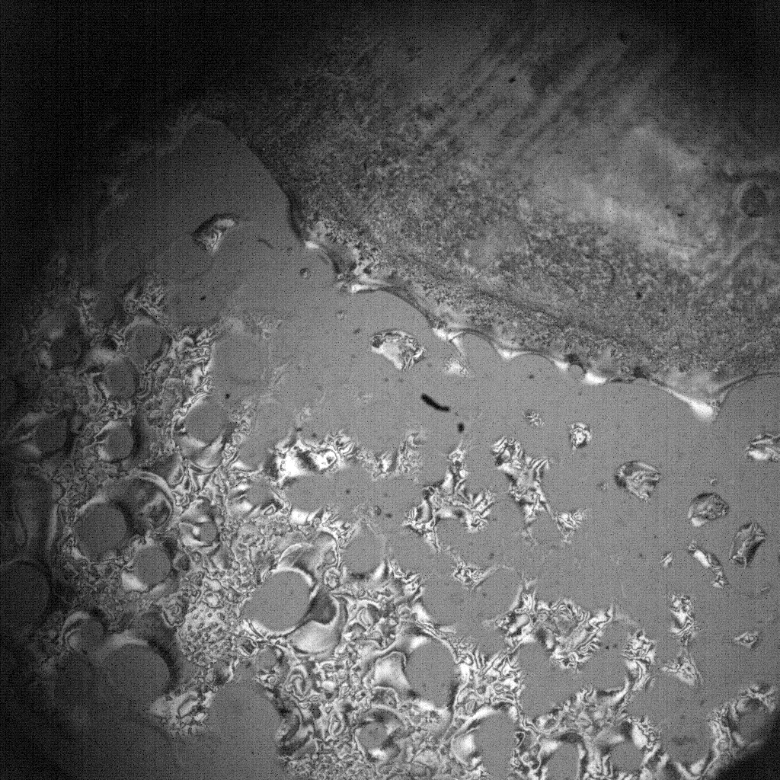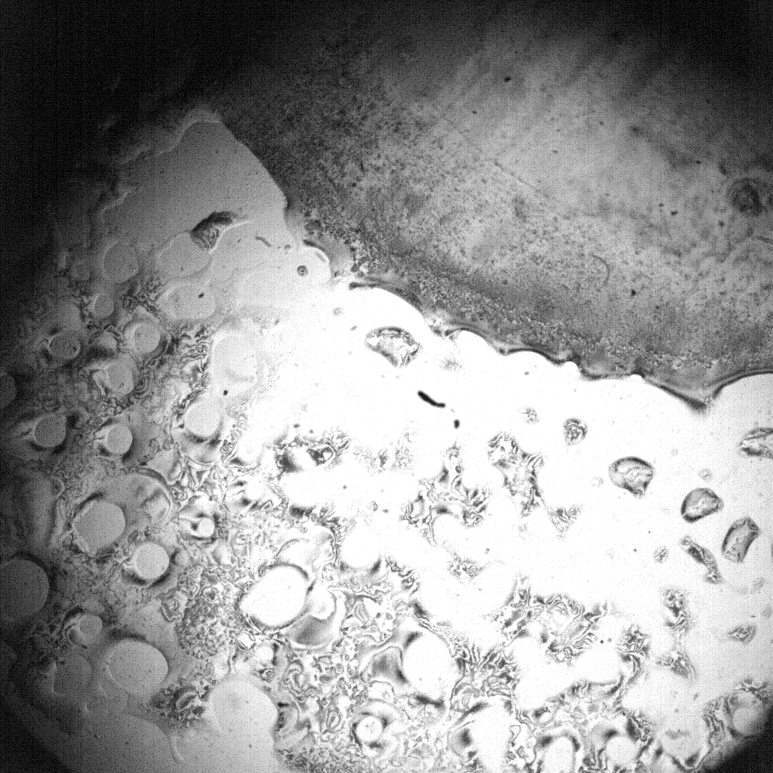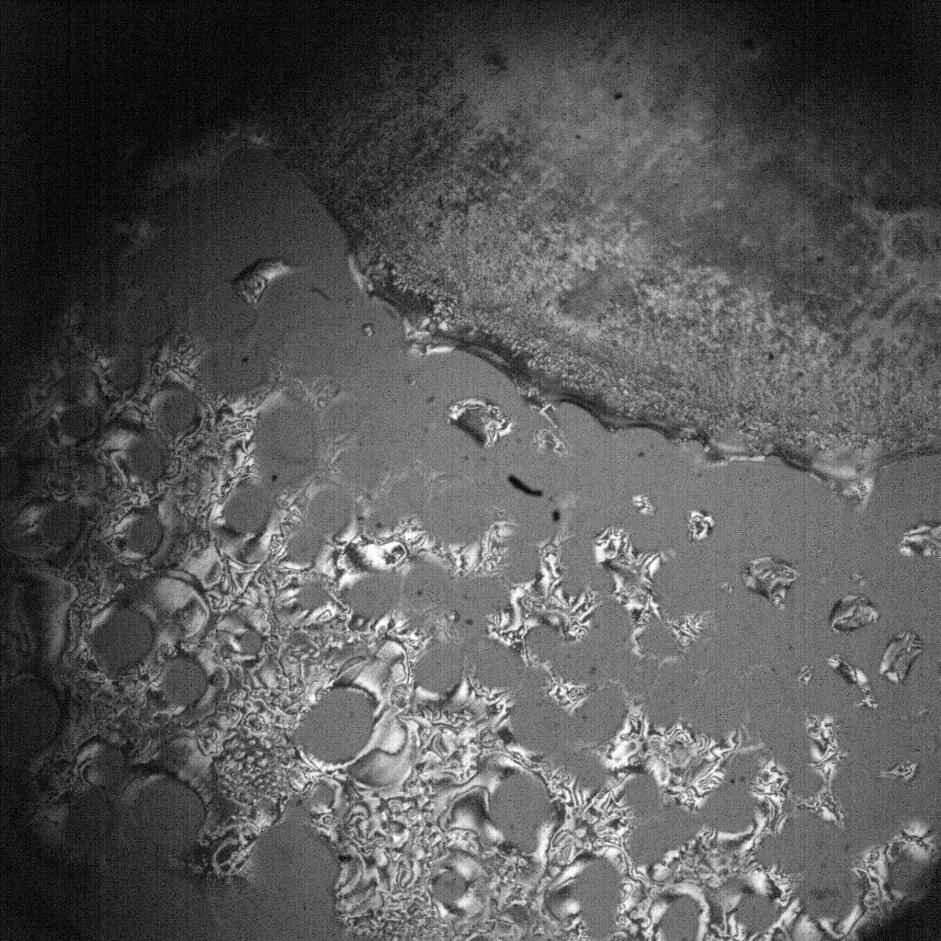

Fig.15. Interactions observed between water droplets and liquid crystals at high RH, images taken with a field of vision of 4.2mm.
II.B. Instabilities in Lines on an inclined Plane:
This part of our project consisted on depositing a solid line of liquid crystals on a flat surface. There were two types of surfaces used in these experiments: glass slides and silicon wafer. Once we had deposited the liquid crystals on the surfaces, the next procedure was to place the surfaces with the liquid crystals on an inclined plane. By varying the angle of the inclined plane, we were allowed to observe how the instabilities were formed. Similarly, the formation of fingering was noticed as soon as the surface tension of the liquid crystals was affected by gravity. As a result, the liquid crystals began to flow down the inclined plane. According to Siam’s paper, The BC at the free surface is that there is a jump of pressure across the interface. The size of this jump is proportional to the surface tension. This is a material parameter that is responsible for keeping liquid drops together (Kondic, 98).

This is why the main objective of this procedure is to show how instabilities are formed when a fluid is flowing down on an inclined plane. The usage of the silicon wafer was in much of a need, since the glass slide was very small and it did not permit the liquid to develop instabilities as well as to spread further down an inclined plane. In the most control manner ensured, a solid strip of liquid crystals was placed on a silicon wafer.

First of all, in order to ensure a clean surface, tissue papers were used to remove any type of dust from the silicon wafer. Second of all, in order to place a solid line of liquid crystals on a flat surface, we required to use a micro-syringe and glass slides. The method employed in this experiment consisted on using a micro-syringe that could hold up to 500 µL of fluid. However, we started by depositing 300µL of liquid crystals across a flat glass slide that had a length of 7.5cm and a width of 2.5cm. Subsequently, three glass slides were attached to each other in the same direction. The approximate thickness of each glass slide was 0.1cm. The largest edges of three glass slides were placed on top and perpendicularly to the one containing the liquid crystals. Using the thickness from the length of the three glass slides, we were allowed to hold an even amount of liquid crystals along their entire edge.

Briefly, the three glass slides were placed on top of the silicon wafer. By doing this procedure it allowed to leave a perfect straight line of liquid crystals on the silicon wafer. As a result, the level of error that could have manually inflicted instabilities on the liquid crystals was minimized.
Fig 16. 300µL of liquid crystals was deposited on top of a single glass slide. Using the length of the three glass slides as our thickness, we were allowed to place a solid line of liquid crystals on top of the silicon wafer.

Subsequently, the silicon wafer was positioned on a level wooden block that had an angle of inclination of 45 degrees. This inclined surface allowed the fluid to develop instabilities along the bottom edge. This process created areas in which the volume of the liquid increased. As a result, the formation of instability appeared along the strip of liquid crystals. The fluid concentrated most of the volume in some particular areas. The surface tension held the liquid crystals until the force of gravity overcame the surface tension and allowed the forming droplets to flow down the inclined plane. We recall that the theoretical analysis assumes constant thickness of the fluid, while in the experiments the fluid thins far behind the front (Kondic, 104). Moreover, the execution of this technique allowed us to reproduce the experiment in different angles. However, the boundary conditions were slightly different from the previous experiments.
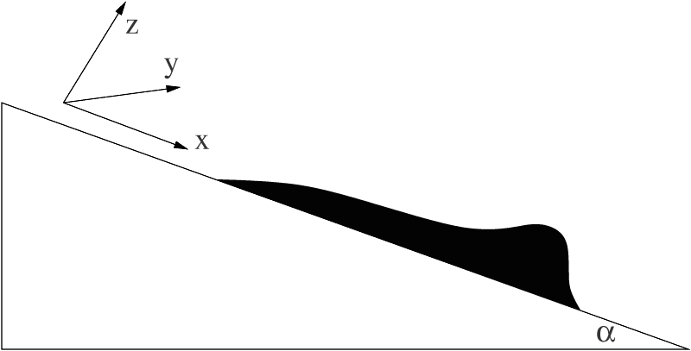
Fig 17. Experimental sketch from Kondic[1] Sketch of the fluid in two-dimensional geometry. The capillary ridge, which forms just behind the fluid front, can easily be seen in experiments as a drop that forms as the fluid flows down an incline. In most of this work we will neglect thinning of the fluid far behind the front (Kondic, 97).

During the process in which the liquid crystals were forming instabilities, we were allowed to take some pictures of the fluid, while it was flowing down the inclined plane.
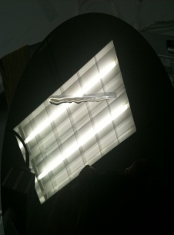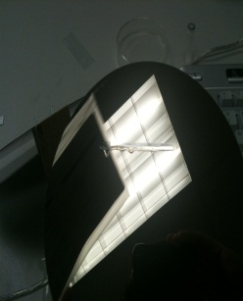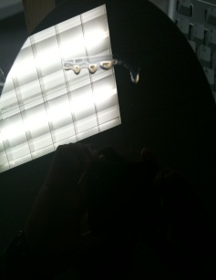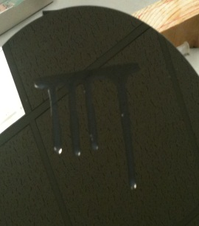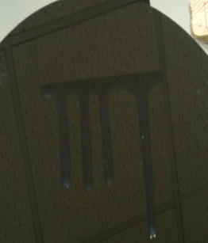
Fig 18. Photos of the fluid flowing down an inclined plane at different times, the time required for the formation of instability was t = 1, 2, 3, 8, 9 sec, staring from left to right. The angle of inclination was 45 º.
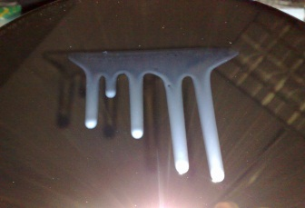
Fig 19. Photos of the fluid flowing down an inclined plane at 30 ºangle.

The fluid was cleaned off from the silicon wafer after every experiment was performed. Using cotton balls that were previously soaked in alcohol, we removed the fluid from the silicon wafer. Applying tissue papers allowed us to remove any type dust left from the alcohol balls. The main goal of the procedure was to ensure a clean surface in which we were able to reproduce the experiment without any perturbation due to some impurities on the silicon surface.
Multiple tests were carried out by changing the angle of inclination on the wedge by 90, 45, 30, 22.5, 15, 10 and 5 degrees. By doing this, the formation of instabilities and the flow of the droplets down an inclined plane occurred at higher angles such as 90º, 45 º, 30 º, 22.5 º and 15 º. In most cases, the distance between the forming droplets was around 1cm apart. In addition, the travel distance down the inclined plane of the droplets was about 11cm.The majority of these strips formed more than four fingers all across the entire strip of liquid crystals. On the contrary, when using lower angles such as 10 º and 5 º of inclination, we were not able to reproduce the formation of instabilities. Thus, the solid line of liquid crystals was maintained.
In the course of one of these experiments we were able to record the spreading of liquid crystals down an inclined plane. This observation occurred when we placed the silicon wafer that contained the liquid crystals on a wedge that had an angle of inclination of 15º.

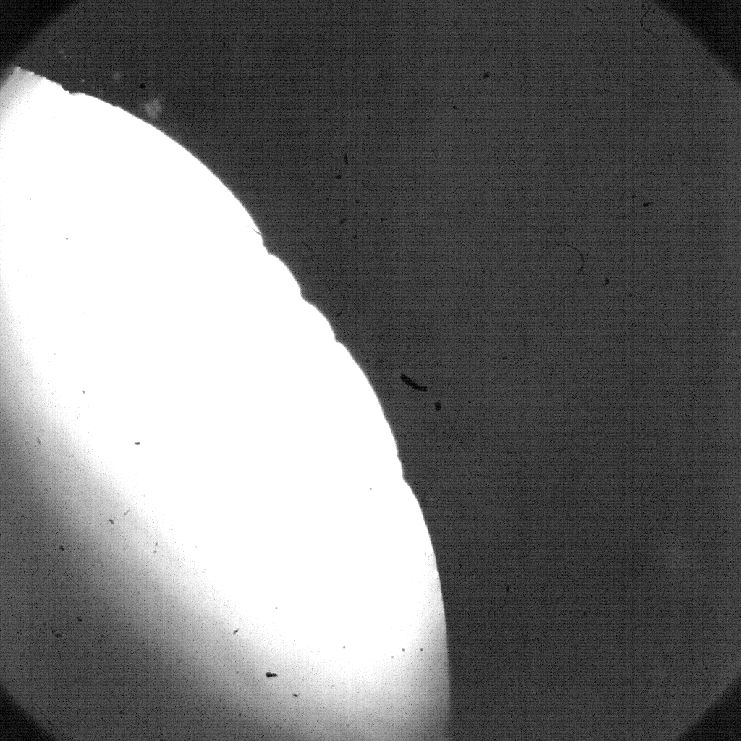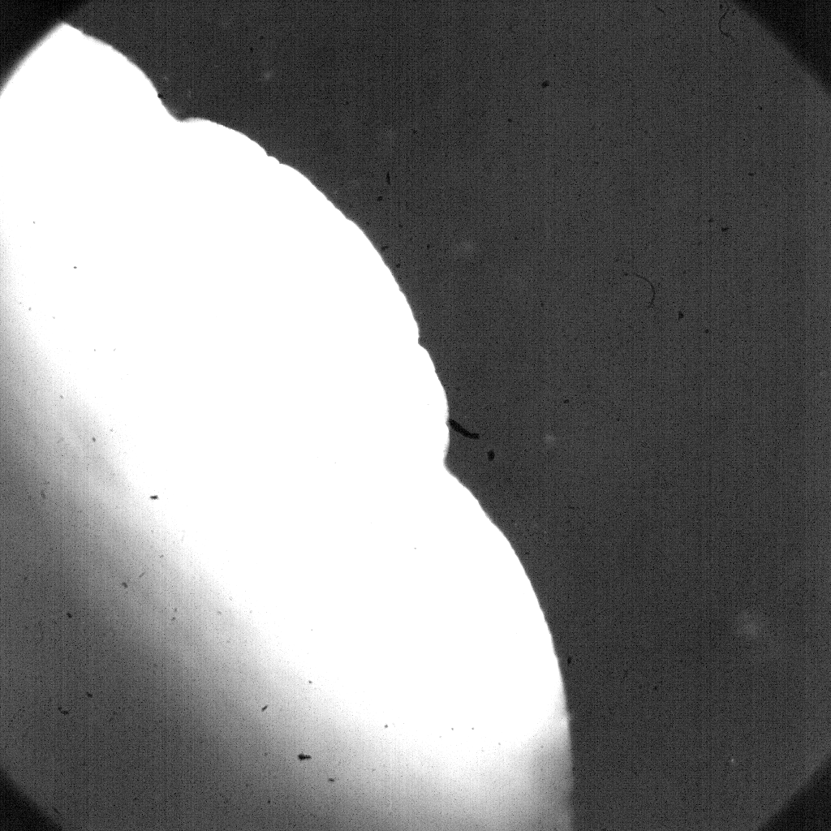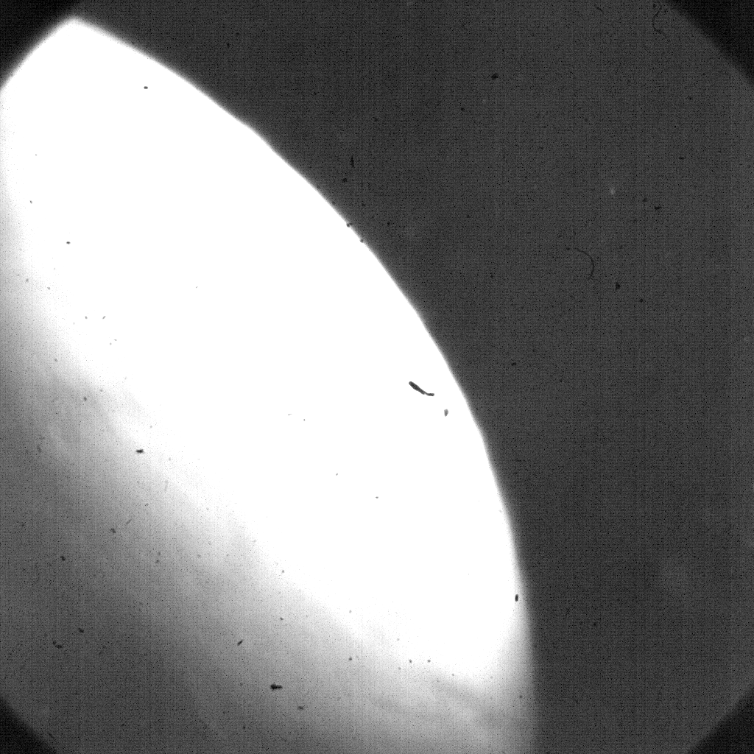

Fig 20. These pictures were taken at 15º angle of inclination the times for the pictures after the release of the fluid was 13, 15 and 17 sec, staring from left to right. In these images, the field of vision is 1.05mm

Throughout, this technique and unusual and rare situation was encountered. As the fluid was placed on the silicon wafer, instabilities began to form. As a result the fluid began to flow down the inclined plane and four fingers were formed. Unexpectedly, while the liquid was flowing down there was a section along three fingers that began to spread to the sides and created some kind of instabilities. Because of the rare formation occurred in the liquid crystals, we concluded that there must have been some kind of small perturbation on the system, or a slight change on the temperature or humidity.
1 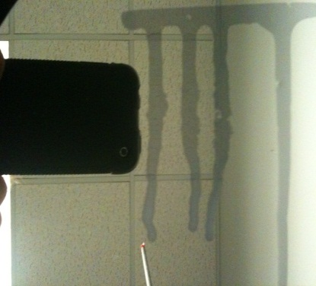2 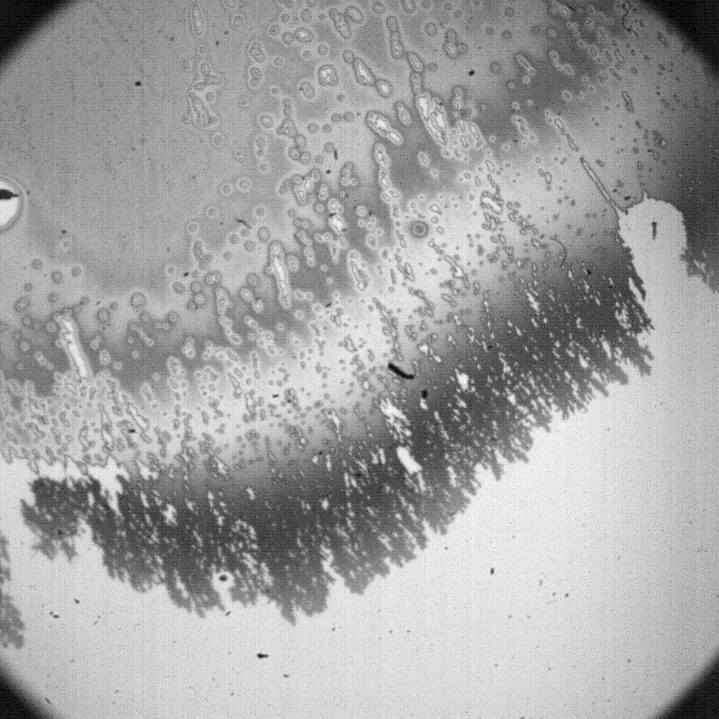3 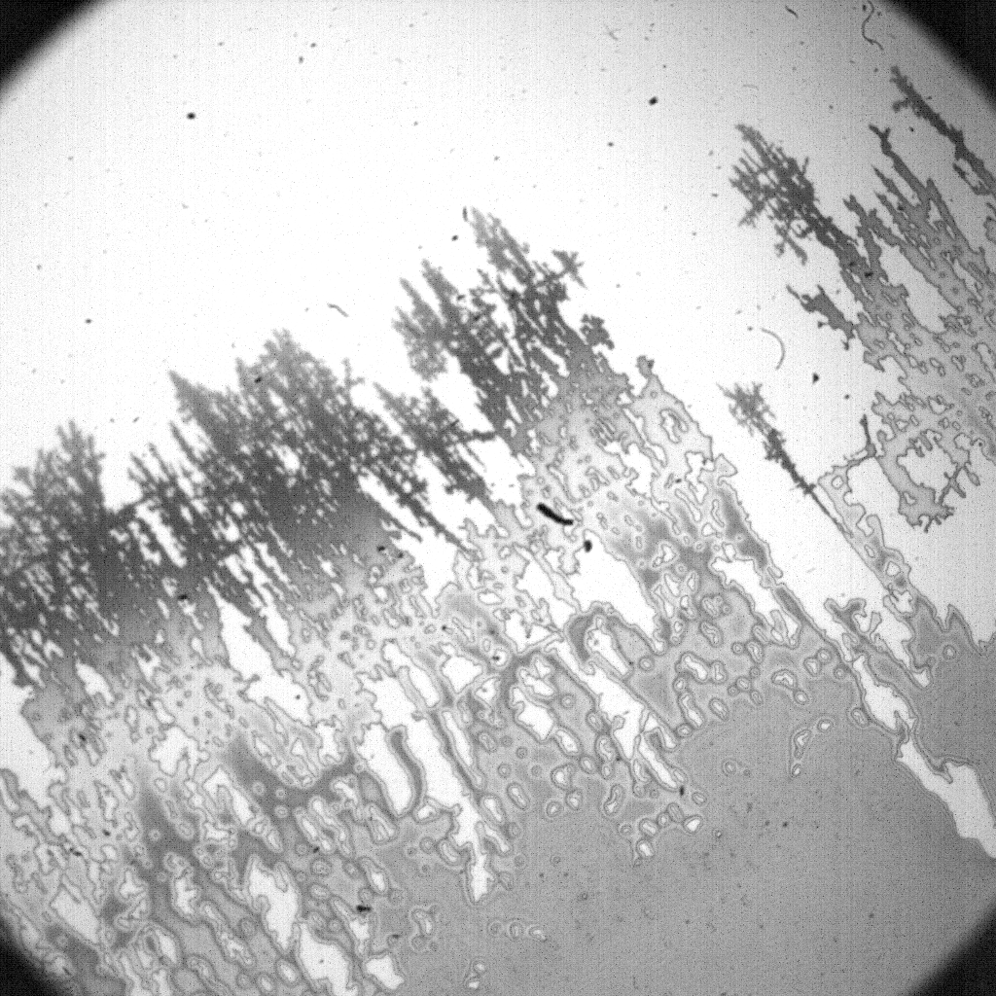

Fig 21. Some kind of perturbation in the system occurred around the middle section of the three fingers (from left to right) while the liquid was flowing down an inclined plane. The angle of inclination during this experiment was 45º. The first picture showed the droplets down an inclined plane. The second picture shown in this paper belongs to the right edge of one of these fingers. The third picture belongs to the left side of the finger. The field of vision for 2 and 3 are 1.05mm

Additionally, many other methods were tried in order to place a strip of liquid crystals on a flat surface. But the main problem of these procedures was the manual influence of instabilities when the liquid crystals were deposited on the surface.

The idea of placing three glass slides together came out from previous experiments in which we used the edge of one single glass slide. The main problem of this process was that the amount of fluid on the surface was not enough to produce instabilities on an inclined plane. Furthermore, as a way to increase the thickness of the fluid, two glass slides were put together. Unfortunately, the volume of the liquid was concentrated in one particular area. Therefore, only when this area had enough liquid, gravity would overcome the surface tension and the liquid would flow down the inclined surface. As a result, only one finger was created.

Using a different approach and in order to create a perfect straight line, 300µL of liquid crystals were dropped across the glass slide with the help of a micro-syringe. Then, the edge of the glass slide needed to be enclosed with cotton which was previously soaked in alcohol. We then placed a clean glass slide on top of the surrounding liquid crystals, but making sure not to disturb the fluid. Thus, the main goal of this procedure was to ensure a perfect straight line of liquid crystals. The idea was to create an environment in which the alcohol would help the liquid crystal to maintain a firm structure. But it turned out to be inefficient. As the cover was removed from the liquid crystals, the change in the atmospheric pressure allowed the liquid crystals to spread faster. Because of this, instabilities appeared where the thickness of liquid crystals was larger and we were not able to obtain a solid line of liquid crystals.
Alternatively, a micro-syringe was used as a method of placing a solid line of liquid crystals on a surface. 500µL of liquid crystals were obtained from the syringe. In order to create a straight line, a glass slide was quickly passed against the moving liquid that was flowing out from the syringe.

The principal problem of this technique was the irregularity of the pressure as the liquid crystals were pushed out from the syringe. There were regions along the glass slide in which the amount of liquid crystals was greater than other regions. Therefore, the manual infliction of instabilities was observed. Similarly, the edge of a glass slide was used and placed perpendicularly to the surface of the silicon wafer. Then, the syringe was used to deposit the liquid crystals between the edges of the two surfaces. Consequently, the disproportion of the amount of liquid crystals deposited by a syringe along the glass slide and silicon wafer could not guarantee a proper formation of natural instabilities.

II.C. Liquid Crystal Instabilities:

When dealing with the nematic liquid crystals (NLC), we use the following partial differential equation to govern their behavior.

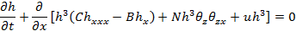

This formula has parameters N, B, u, and C. Each of these parameters deals with a different property of the NLCs. ‘C’ is known as an inverse capillary number, and it deals primarily with the surface tension of the crystals. The surface tension governs the systems desire to remain straight as it moves. For example, if a line of crystals was place on an incline plane, the surface tension is the force that keeps the line straight. It acts against any force that is causing the line to break into fingers. ‘B’ is called the bond number, having its effect on how fast the system wants to move. In the case of an incline plane, B is set equal to u₀cosα, wherein α is the angle of the inclined plane, in order to take the effect of the angle into consideration. The larger the value of B, the slower the system wants to move, and vice versa. For example, taking an angle of zero, in other words no incline, B would be equal to u₀ which is its largest possible value and we know that the system does not want to move as much without an incline. In the other direction, taking an angle of 90°, B is equal to zero, so the effect of B is ignored and the system will move as fast as it can. ‘u’ is the parameter added in for the flow down an incline plane and deals with the effects of gravity. It has an opposite effect to B and so its value is taken to be u₀sinα. To this end, a flat plane results in a value of zero and the gravitational effects are minimized, and a 90° angle results in a value of u₀, so the effects of gravity are maximized. Finally, ‘N’ is the parameter that has to do with when the flow crosses from stable to unstable regime. ‘N’ is also the parameter that separates this equation for liquid crystals from equations for straight liquids. The reason for this is in its formulation as seen in Cummings et.al.

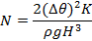
A variable K is considered which has to do with the elasticity of the crystals, something that would not be considered in any other liquid. The elasticity involves how the crystalline structure inside of the NLCs aligns itself. In the simulations that have been done, N was the parameter that was varied greatly in attempts to find out when the crystals’ flows become unstable.

Because we know what the values of the material properties – viscosity, surface tension, and density – are, we can get values for B, C, and u. First, we need to get a value for the length scale. From the Cummings et. al., we have:
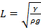, 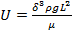, 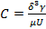, 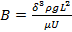
where is the surface tension, is the density, is the viscosity, is a scaling factor gotten by taking the ratio of the height to the length of the NLC, and is gravity. Substituting in these values we get L = 0.0016m or 1.6mm.

We then use the value for L to get . Finally, we can use the calculated values of L and U along with the material parameters to find values for B and C. Plugging in, we get that C ≈ 1 and B ≈ 1, both of which do not have any units.

From our experiments, we know that using 1.6mm as a typical length scale is a perfectly valid number, as we our measurements were usually around that size. In addition, we gathered that on average, the estimation of is also valid because the height was much smaller than the length by a factor of what we estimated to be 1/8 to 1/10, so we chose 1/10 for ease of calculation.

We then ran experiments and kept track of how long the fingers were taking to travel a certain amount of distance. The total distance traveled was 11cm. Times were documented when the fingers reached halfway, ¾ of the way, and the full distance. On average, the fingers covered:
Distance | 57.5mm | 86.25mm | 115mm
Time | 40s | 110s | 180s
Speed | 1.4375mm/s | 0.78409mm/s | 0.6389mm/s
Table 2. Summary of liquid crystal velocities flowing at a 90° incline.
Averaging these all together yields an average speed of 0.9524mm/s, which is an about .075 difference from what was calculated, and it has an error of about 9%. The error comes from many places, mostly human error in the depositing of the NLCs in a line on the surface, measurement of time and length, and changes in the quantity of volume of the NLCs deposited.

One issue to take note of is the decline in the speed of the flow as the distance increases. The reason for this is that there is not a steady amount of the NLCs being introduced into line as the papers assume. Instead, as the fingers grow the volume of what is left to flow down decreases. As a result, the NLCs want to flow quicker in the beginning when there is a lot of volume to spread out and slower as the volume diminishes.

In the simulations, the value C = 1 was used as above. We also set u₀ = 1 which makes sense since B = u₀cosα and we knows that B ≈ 1. This allows for the effects of gravity and bonding due to the incline of the surface.

Summary and concluding remarks
Due to the nature of the experimental limitations and lack of rigorous and repeatable experimental observations, any and all presented data can only qualitatively describe the nematic liquid crystal phase. While it was possible to observe the different expected phenomenon from the theoretical model outlined in Cummings et. al, such as instabilities and defects, the material outlined in this report cannot extend or add to the current body of information governing the nematic liquid crystal phase. The liberal approach utilized in this study, while leading to the observation of the predicted phenomenon from previous work, did not fall along the lines of rigorous methodologies that would lead to repeatable results. This study demonstrated that the current work on nematic liquid crystals are lacking well defined methods for appropriately handling the gathering data pertaining to liquid crystal experiments. As outlined in Poulard and Cazabat, experiments regarding liquid crystals are merely restricted to varying temperature regimes and rough approximations of relative humidity. Prior to any work on liquid crystals moving beyond qualitative results, it is necessary to devise experiments that will allow for constant initial conditions, measurable and repeatable data, and readily replicable results by careful description of methods utilized in the study rather than simple outlines of the environmental conditions wherein the study was performed.

Works Cited

Meggs, Lori. "The Marangoni Effect: A Fluid Phenom." NASA. NASA, n.d. Web. 5 May 2011. <http://www.nasa.gov/mission_pages/station/research/news/marangoni.html>.

Kondic, Lou. "Instabilities in Gravity Driven Flow of Thin Fluid Films." SIAM Review. 45.1 (2003): 95-115. Print.

Cummings, L.J., T.-S Lin, and L. Kondic. "Modeling and simulations of the spreading and destabilization of nematic droplets." (In Review)

Cummings, L.J., and M. Ben-Amar. "Fingering instabilities in driven thin nematic films." Physics of Fluids. 13.5 (2001): 1160-1166. Print.

Palffy-Muhoray, Peter. "The diverse world of liquid crystals." Physics Today. (September 2007): 54-60. Print.

Poulard, C., and A.M. Cazabat. "Spontaneous Spreading of Nematic Liquid Crystals." Langmuir, American Chemical Society. 21. (2005): 6270-6276.

Senyuk, B. "Liquid Crystals: a Simple View on a Complex Matter." Kent State University. Kent State University, n.d. Web. 5 May 2011. <http://dept.kent.edu/spie/liquidcrystals/>

Collings, Peter J. Liquid Crystals: Nature's Delicate Phase of Matter. 1st. Princeton, NJ: Princeton University Press, 1990. Print.

