Industrial Cost Analysis: MNET 414

Solution for Home work # 5

Chapter 7 & 8

Chapter 7
Problem 7-4
For the diagram below, compute the rate of return on the $3180 investment:
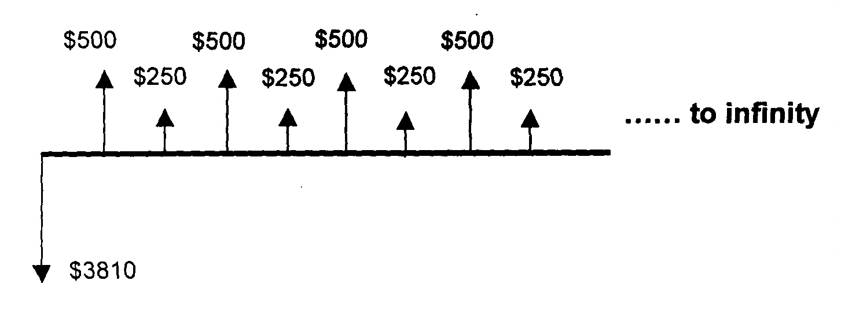
Solution
This an infinite period problem and we know only one formula, it A= P.i So the first objective would be to convert the upper series to an Uniform (A) series or in other words we are solving the following problem:
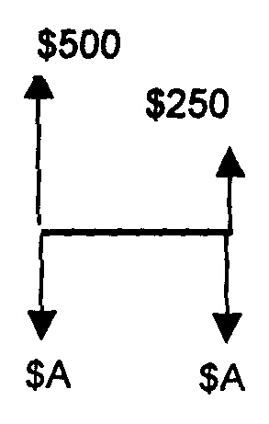
To know the value of A, we want to move $500,one period ahead and add up with $250.That gives us the future equivalent of the upper cash flow.
Then we will distribute the future equivalent to the 2 uniform cash flow.
So, A = [250+500(F/P,i,1)](A/F,i,2)
It can also be computed as the series consists of an uniform 500 minus one 250 future distributed into 2 uniform. Thus:
A = 500 - 250*(F/A, i, 2)
Also it can be computed by A = 500 -250*(G/A,i,2)
Now going back to the original problem, we know that, as the upper cash flow is repeating then the uniform equivalent should be same as the A we calculated above. In other words the equivalent cash flow is now as follows:
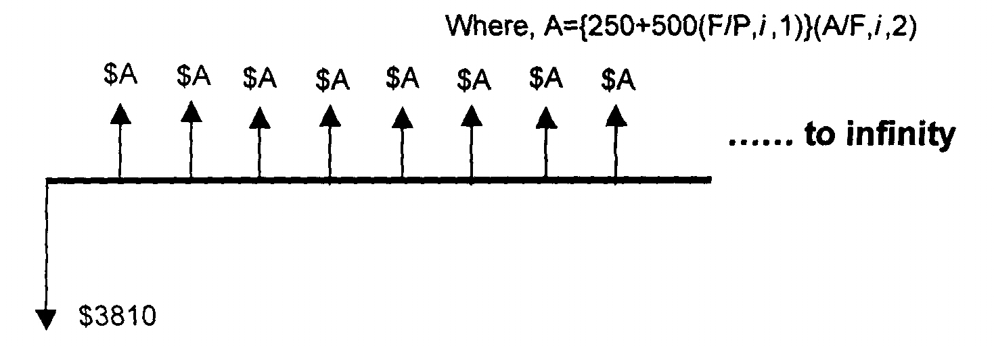
We can now apply the A=Pi formula for infinite period. (Any one alternative expression for the A from the above three can be used to solve for "i")
So, 3810 (i) = {250+500(F/P,i,1)}(A/F,i,2)
or, 3810 (i) - {250+500(F/P,i,1)}(A/F,i,2) = 0
Trying i = 8% the left hand side -75.008
Trying i = 10% the left hand side 0.048
Trying i = 12% the left hand side 75.125
So, the rate of return is very close to 10% (answer)
Problem 7-58
Two investment opportunities are as follows:
 | A | B
First cost | $150 | $100
Uniform annual benefit | 25 | 22.25
End of useful life salvage value | 20 | 0
Useful life, in years | 15 | 10
At the end of ten years, Alt. B is not replaced. Thus, the comparison is 15 years of A vs. 10 years of B. If the MARR is 10%, which alternative should be selected?
Solution
The question is "which alternative should be selected?". That means we must select one of the alternatives. To do that we develop the incremental cash flow for the whole analysis period, which is 15 years in this case. Remember always subtract the lower initial cost from the higher initial cost. The cash flows are as follows:
Year | A | B | A-B
0 | -150 | -100 | -50
1 | 25 | 22.25 | 2.75
2 | 25 | 22.25 | 2.75
3 | 25 | 22.25 | 2.75
4 | 25 | 22.25 | 2.75
5 | 25 | 22.25 | 2.75
6 | 25 | 22.25 | 2.75
7 | 25 | 22.25 | 2.75
8 | 25 | 22.25 | 2.75
9 | 25 | 22.25 | 2.75
10 | 25 | 22.25 | 2.75
11 | 25 | 0 | 25
12 | 25 | 0 | 25
13 | 25 | 0 | 25
14 | 25 | 0 | 25
15 | 45 | 0 | 45
Now, the incremental cash flow (i.e., A-B) tells us that if A (the expensive one with initial cost $150 was bought instead of B, by paying $50 extra now, it would give a savings $2.75 for the each first 10 years, plus $25 for the each oh last 4 years, and $45 at the 15th year. So, now we have to find out how much interest this additional expense $50 is giving us.
To do that we equate the NPB and NPC of the (A-B) cash flow.
50 = 2.75(P/A,i,10)+25(P/A,i,4)(P/F,i,10)+45(P/F,i,15)
Try different i values and find the value of i at which the right hand side becomes 50.
If you can prove the i is more than the MARR that will also do.
I used here Excel's IRR function 11.61%<- I plugged in =IRR(cell range)
Now their MARR = 10%, and the additional cost is generating 11.46% interest. So the conclusion is go for the higher initial cost alternative or select Alt. A
Problem 7-31
Fifteen families live in Willow Canyon. Although several water wells have been drilled none has produced water. The residents take turns driving a water truck to a fire hydrant in a nearby town. They fill the truck with water and then haul it to a storage tank in Willow Canyon. Last year it cost $3180 in truck fuel and maintenance costs. This year the residents are seriously considering spending $100,000 to install a pipeline from the nearby town to their storage tank. What rate of return would the Willow Canyon residents receive on their new water supply pipeline if the pipeline is considered to last:
a. forever?
b. 100 years?
c. 50 years?
d. Would you recommend the pipeline be installed? Explain.
Solution
The main idea of the problem is if they spend $100,000 now, then they would save the recurring uniform yearly cost of water transportation of $3180 for the life of the pipeline.
a. If the life of the pipeline is forever or infinity, then we can use the formula A = P(i)
or, 3180 = 100,000 (i) or, i = 3180/100, 3.18%(answer)
b. If they spend $100,000, they will save $3180 every year for the coming 100 years.
Doing NPC=NPB: 100,000 = 3180(P/A, i,100),
or (P/A, i,100) = 100,00/3180 = 31.446
Now for i=3%, (P/A, 3%,100) = 31.559
Now for i=2.5%, (P/A, 2.5%,100) = 27.655
So the IRR is in between 2.5-3%
c. This part is same as the part b. only n = 50 years, that is
Doing NPC=NPB: 100,000 = 3180(P/A, i,50),
or (P/A, i,50) = 31.559
Now for i=1.75%, (P/A, 1.75%,50) = 33.141
Now for i=2%, (P/A, 2%,50) = 31.424
So the IRR is in between 1.75-2%
d. In all cases the internal rate of return is less than 4%, which is the minimum interest that one can earn in this market. So that way the project is not that much lucrative. This is because they can keep the money in an interest bearing account which will pay more than $3180 yearly.
However, it is not a loosing project and it will save lot of their personal labor and inconvenience, which was not included in the cost estimates of the project. So I believe, they should go ahead and construct the pipeline anyway.
Chapter 8
8.1. Because there is a do nothing alternative included (Chicago) we should first find out the IRR of the individual alternatives. By doing so, the alternatives which has IRR less than MARR can reject for further analysis.
For each of the alternatives, there is a first cost P and there is a uniform benefit over 8 years. To find the IRR for the individual alternatives by equating the NPC= NPB, we get the equation as P = A (P/A,i,8), or
(P/A,i,8) = P/A, where i is the internal rate of return.
Now for a interest rate of 10%: (P/A,10%,8) = 5.335
For an interest rate of 12%: (P/A,12%,8) = 4.968,
thus for 10% or more the P/A value is less than 5.335
This shows that for any alternative if the P/A value is less than 5.335, the alternative will have a IRR more than 10% and vice versa.
The following table shows the P/A values for each alternative and whether they earn more or less than 10% IRR.
 | Denver | Dallas | San Antonio | Los Angeles | Cleveland | Atlanta
P | 300 | 550 | 450 | 750 | 150 | 200
A | 52 | 137 | 117 | 167 | 18 | 49
P/A | 5.769 | 4.015 | 3.846 | 4.491 | 8.333 | 4.082
IRR more or less than 10% | less | more | more | more | less | more

Thus Denver and Cleveland is earning less than MARR so can be rejected for further analysis.
For the remaining alternatives, we need to do incremental analysis. Here we will consider the incremental cost and incremental benefit. And again use the P/A values for the incremental cash flows. And here we will compare the lowest initial cost to the next higher initial cost alternative.
We start with Atlanta which has the least initial cost and compare its cost-benefits with the next higher least initial cost alternative, which is San Antonio.
Atlanta: P = 200,000, A =49,000
San Antonio: P = 450,000 A = 117,000
Incremental cost: San Antonio - Atlanta = 450,000-200,000 = 250,000
Incremental Benefit: San Antonio - Atlanta = 117,000-49,000 = 68,000
So incremental P/A = 250,000/68,000 = 3.676, and as it is less than 5.335, thus the incremental rate of return is more than MARR, thus reject Atlanta and select San Antonio.
The following table shows the incremental P/A calculations for the successive lowest initial cost alternatives.
 | San Antonio - Atlanta | Dallas -San Antonio | Los Angeles - Dallas
Incremental P | 250 | 100 | 200
Incremental A | 68 | 20 | 30
Incremental P/A | 3.676 | 5.000 | 6.667
Incremental rate of return = | Less than 5.335 | Less than 5.336 | More than 5.336
Decision is | Reject Atlanta | Reject San Antonio | Reject Los Angeles
So the most economical site is Dallas. (Try to understand the elimination process clearly, you can definitely expect a similar question in your test.)
8.10. The cash flow table for the alternatives A, B, and C are given below for the next 7 years.
Year | A | B | C
0 | -1000 | -2000 | -3000
1 | 150 | 150 | 0
2 | 150 | 150 | 0
3 | 150 | 150 | 0
4 | 150 | 150 | 0
5 | 1150 | 150 | 0
6 | 0 | 2850 | 0
7 | 0 | 0 | 5600
As one of the alternative has to be selected we proceed directly to compare the alternatives with incremental cash flow. Comparing the two lowest cost alternatives A and B the incremental cash flow for (B-A) is:
Year | A | B | B-A
0 | -1000 | -2000 | -1000
1 | 150 | 150 | 0
2 | 150 | 150 | 0
3 | 150 | 150 | 0
4 | 150 | 150 | 0
5 | 1150 | 150 | -1000
6 | 0 | 2850 | 2850
7 | 0 | 0 | 0
The incremental cash flow of B-A: Setting NPW = NPB-NPC = 0 or, 2850(P/F,i,6) -1000-1000(P/F,i,5) = 0
Trying i = 8%: NPW = 115.40, thus the incremental ROR is more than MARR. Select Higher price alternative B.
Then compare C-B
Year | B | C | C-B
0 | -2000 | -3000 | -1000
1 | 150 | 0 | -150
2 | 150 | 0 | -150
3 | 150 | 0 | -150
4 | 150 | 0 | -150
5 | 150 | 0 | -150
6 | 2850 | 0 | -2850
7 | 0 | 5600 | 5600
The incremental cash flow of C-B: Setting NPW = 0 or, NPB-NPC = 0 or, 5600(P/F,i,7)-1000-150 (P/A,i,5)-2850(P/F,i,6)= 0
Trying i = 8%: NPW = -127.34, thus the incremental ROR is less than MARR. Select lower price alternative B.
8.13. With an analysis period of 8 years, the alternative B is to be replaced after 4 years with same initial cost and benefits. Followings are the cash flow tables for alternative A, B and A-B.
Year | A | B | A-B
0 | -10700 | -5500 | -5200
1 | 2100 | 1800 | 300
2 | 2100 | 1800 | 300
3 | 2100 | 1800 | 300
4 | 2100 | -3700 | 5800
5 | 2100 | 1800 | 300
6 | 2100 | 1800 | 300
7 | 2100 | 1800 | 300
8 | 2100 | 1800 | 300
For incremental cash flow (A-B) equating NPC=NPB
5200=300(P/A,i,8)+5500(P/F,i,4)
Try i = 10%: RHS(right hand side) = 300(5.335)+5500(0.683)=5357 more than 5200 (LHS)
Try i = 12%: RHS(right hand side) = 300(4.968)+5500(0.6355)=4985.65 less than 5200 (LHS)
Thus the incremental rate of return is between 10 and 12%, hence more than 10%, and thus select the expensive one, that is 'A'.

