Eclipse Installation and Usage Example

This document shows you how to install Eclipse on Windows. After installing Eclipse there is a short tutorial on how to use Eclipse to create a Java console application.

You must have a Java Run-time Environment (JRE) installed on your PC. If you do not, Eclipse will not work. The JRE can be obtained from SUN from the site: http://java.sun.com/javase/downloads/index.jsp. You can download either the SDK or the JRE. At the SUN site you can also download a copy of the Java API. You will need to agree to the license agreement before you can download the files.

Name | Size | File
Java JDK v6 | 72.90 MB | jdk-6u11-windows-i586-p.exe
Java JRE v6 | 15.42 MB | jre-6u11-windows-i586-p.exe
Java API Documentation | 56.16 MB | jdk-6u10-docs.zip

After downloading the Java Standard Edition and installing it (either the JRE or JDK) you can download and install Eclipse. You need to remember the directory in which you installed Java in case Eclipse cannot find the program javaw.exe.

Eclipse can be obtained from the site www.eclipse.org and clicking on the download link to arrive at http://www.eclipse.org/downloads/index.php where Eclipse is available (version 3.4.1) .

Name | Size | File
Eclipse Classic 3.4.1 | 151 MB | eclipse-SDK-3.4.1-win32.zip

Unzip the Eclipse SDK into a directory (default c:\eclipse) and execute the eclipse.exe program. If Eclipse does not start the most probable reason is that the javaw.exe program cannot be found. You should be sure that the PATH environment variable has the path to the JRE/SDK binary directory than contains javaw.exe.

Welcome page

Clicking this icon brings you to Eclipse’s workbench.

Click here!

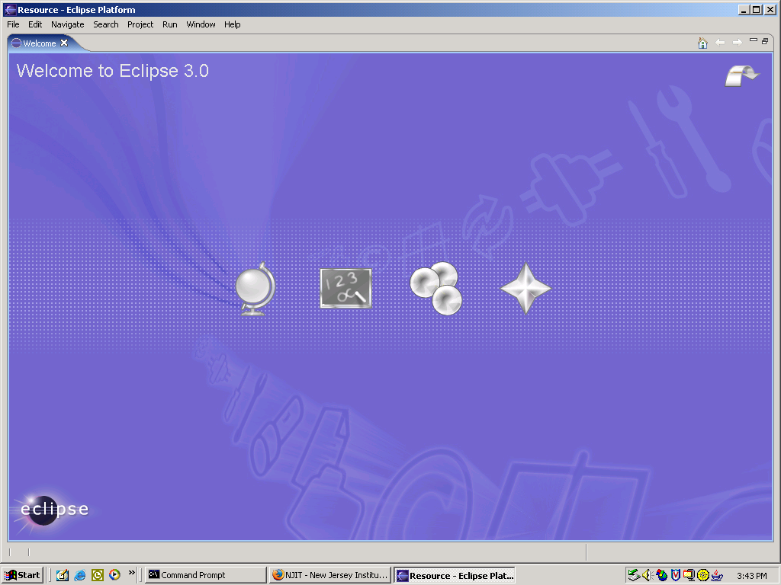
This icon is for a global overview of Eclipse
This icon points to online tutorials for Eclipse
This icon points to samples.
This icon is what’s new in Eclipse

When you start Eclipse for the first time this is the screen that appears.
Click on the icon in the upper right corner.
This will bring up a screen asking you to confirm a workspace.
The default is: c:\eclipse\workspace (you can choose your own).
Check the box on the screen and continue.

Drop down menus for various functions. You can also use the icons once a project is created.
Icons. Most are grayed out since no projects exist.

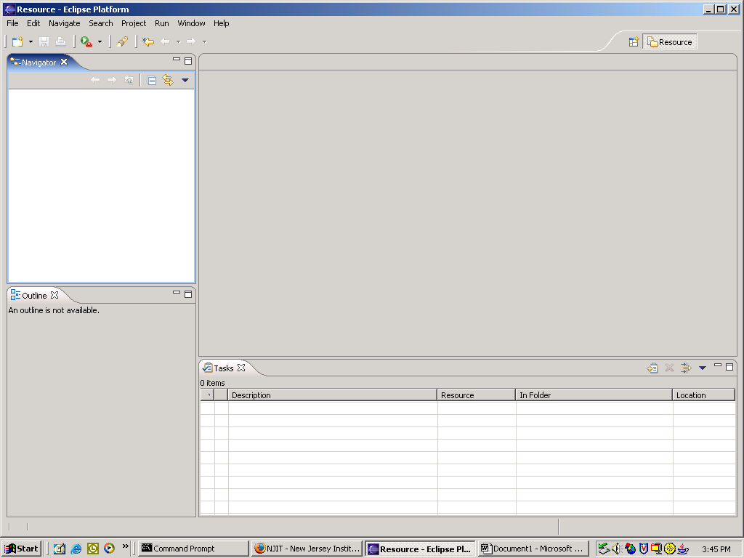
This will be the editor window.
navigator window.

This is the startup screen with no projects or files active.
When you install Eclipse in the default directory (c:\eclipse), a workspace will be created when you answer yes when changing from the introductory screen to this one.
Either the menu items listed across the top of the screen or the icons can be used to:

Create projects Create classes Execute them.

Since no projects currently exist most of the icons on the toolbar are grayed out.

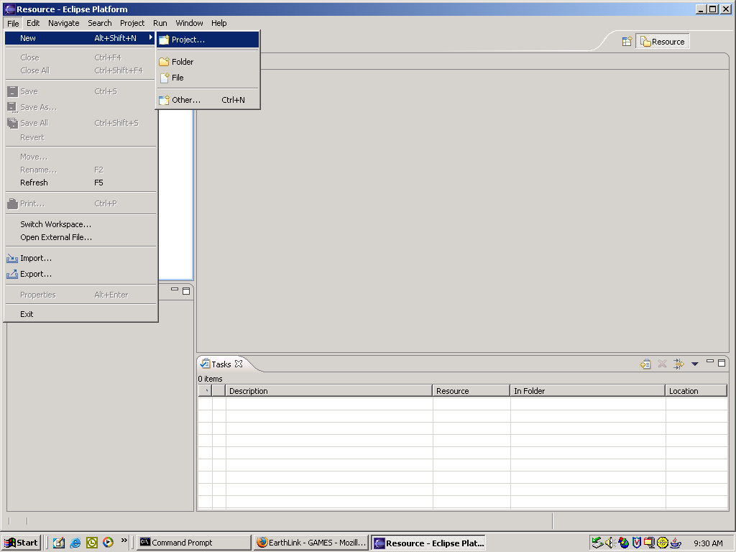

Eclipse is a project oriented integrated development environment (IDE).
You must create a project by using:

File
New
Project …

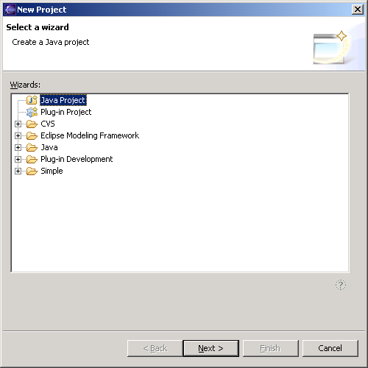
Choose this for a Java application.
Click here to continue.

This screen appears to create a new project.
Choose Java Project from the list.
Click Next.

You should type a unique name here for the project you are creating.

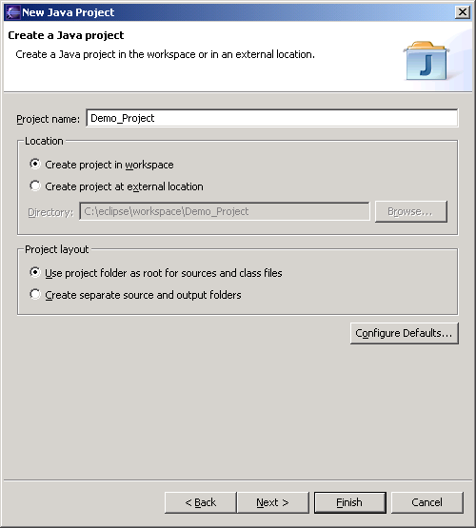
Eclipse will create a directory in your workspace for your project.
Click Finish to continue.

This screen appears.
You need to supply a unique name for the project.
Another screen will appear asking if you want the ‘Java Perspective’ associated with this project.
Answer Yes .

Either this icon or the File / New menu can be used to create a new class.

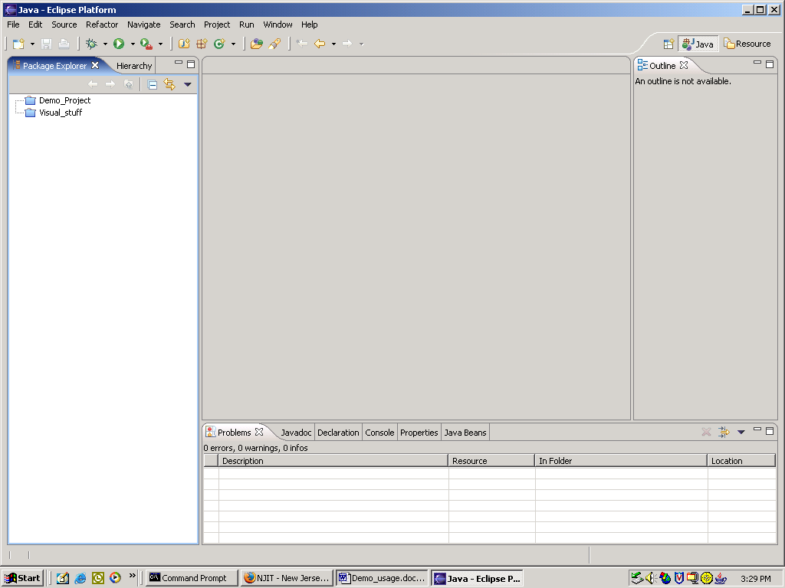
The created project is in the new panel ‘Package Explorer’.
This panel will display any syntactical error messages.

After creating the project this will be the screen.
More of the icons are now available and other panels have been created for the Java perspective.
You now need to:

Create a class

That will be your application.

This message will go away when you supply a package name.

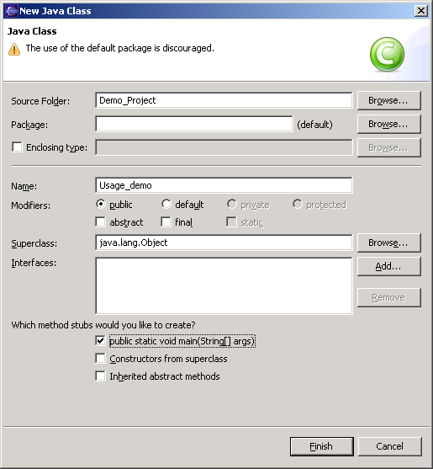
Project you created.
Leave empty until you discuss packages.
This is the file name and the class name (same).
Should be public.
This is for a Java application. You should have a main routine for the standard entry point.
Click here when ready.

Java perspective view. The Java package is the default package.

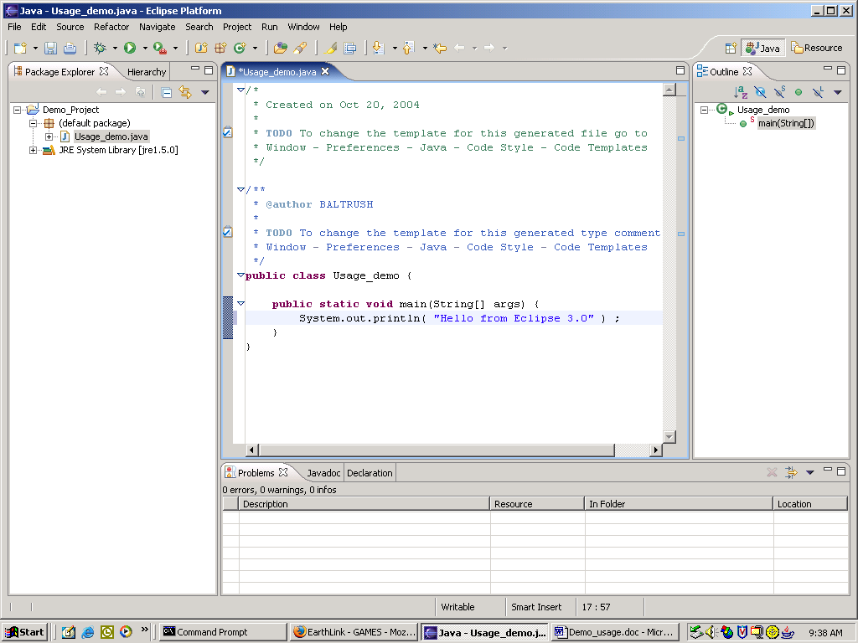
Edit pane.
Line of code added to supplied source code.

Having created the Java class the window will change to the above.
The edit pane will have a pre-defined class and main entry point.
One line was added by the programmer to the file.

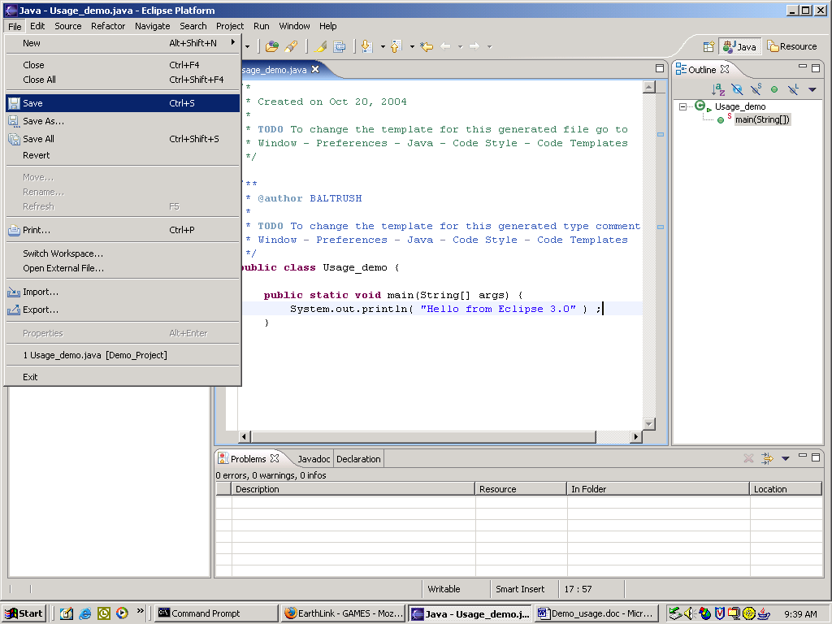

Problems pane. The compiler will list syntax errors here. You can click on the error message and the edit window will move the cursor to that point.

You must save the file using either the menu as above or the icon (floppy disk).
Eclipse will compile the source code when you save the file.
Any syntax errors will be noted in the Problems pane.

Highlight the program’s class with main in it.

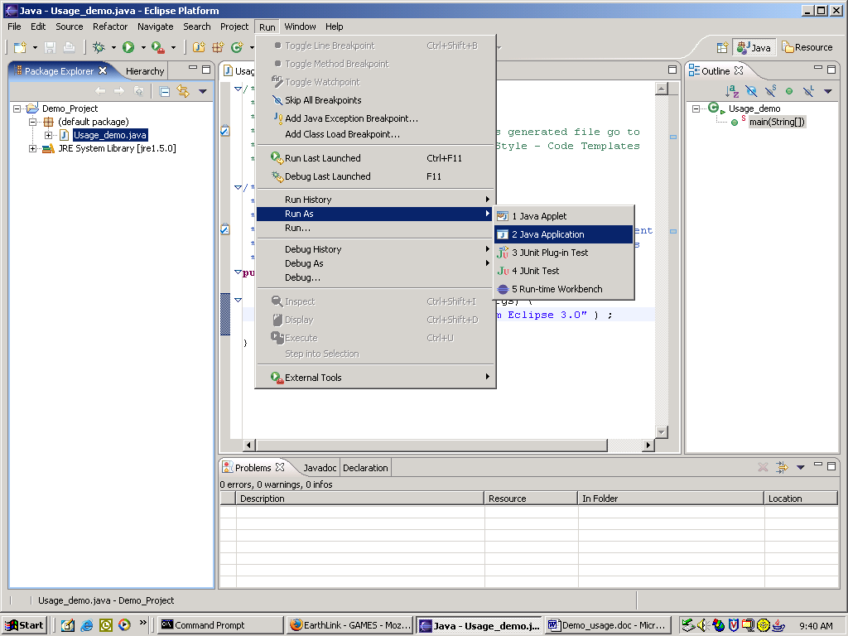
Run as a Java application.

You can execute (run) the program from the menu as above.
The example is an application.
You could also use the Run icon.
You should highlight the file that has the main method in it.

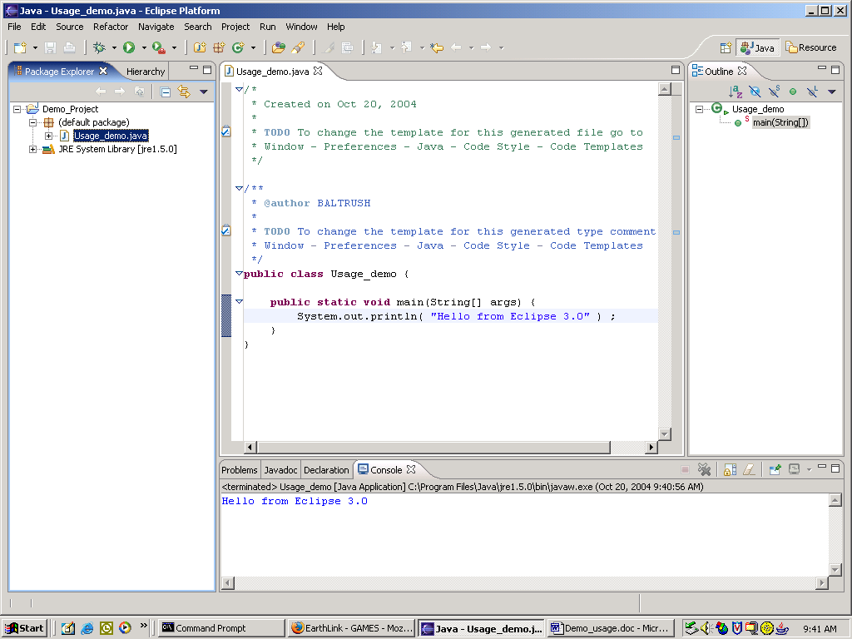
Console pane appears for display of output.

This is the result of executing the application.
The bottom pane is the console output.

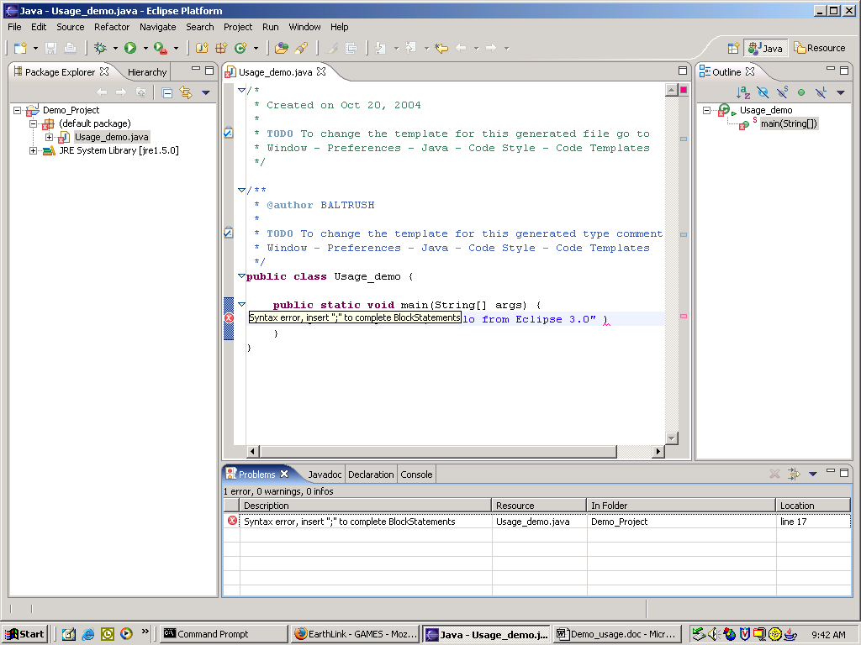

Hovering the mouse over the red ‘x’ repeats the error message in the Problems pane.
Clicking here will show the line in error in the Edit pane.

This screen shows a syntactical error in the source code.
The semicolon was left off the added line.
1- Correct the error
2- Save the file
The error indication will go away.

