MtSE 702 Mid-term Spring 2002

Name: ID:

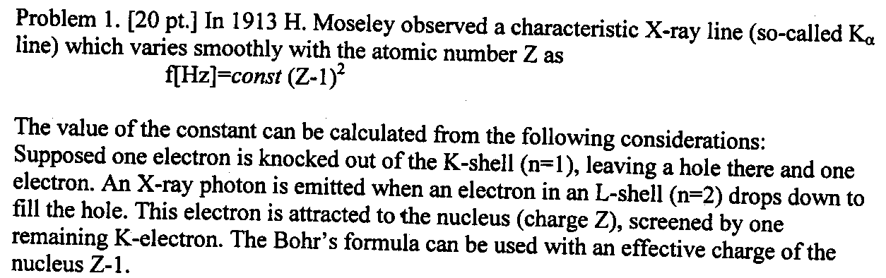
a) Calculate the value of the const in Moseleys law and restore the labeling of the y-axis in Fig. 1. b) Estimate the error in comparison with Fig. 2.

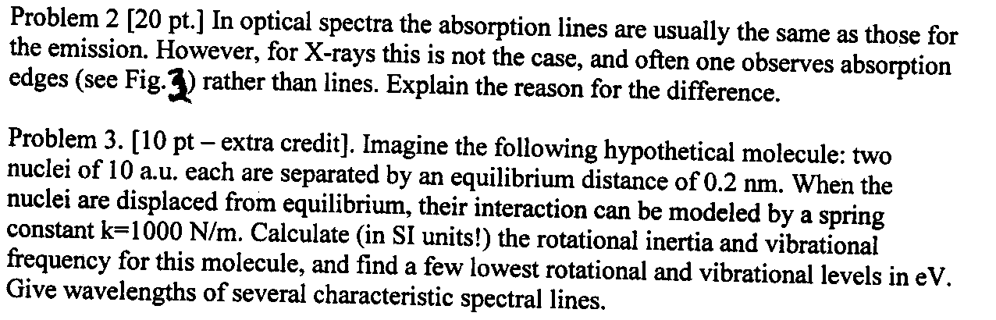

Problem 4. [10 pt.]
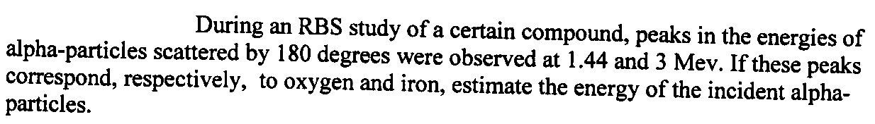

Problem 5. [10 pt.]
Fill out the Table below and give proper formulas:
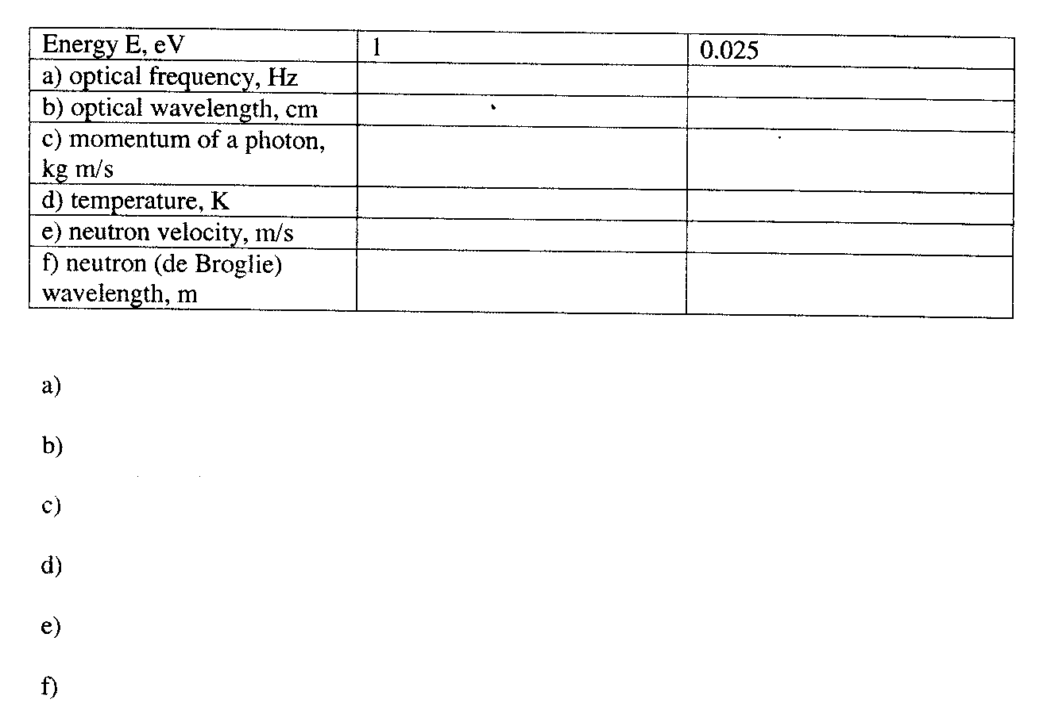

Problem 6. [10 pt.]
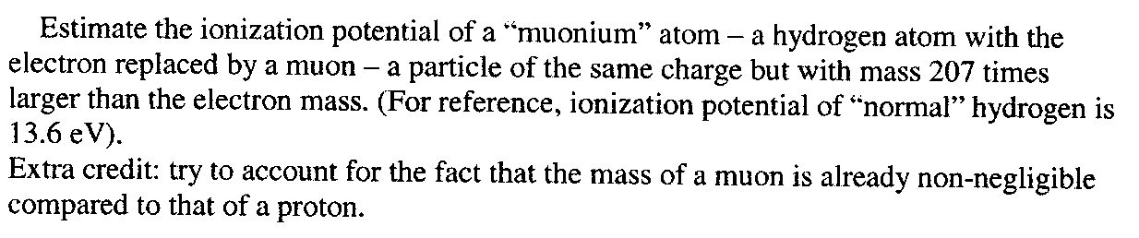

Problem 7. [20 pt.]

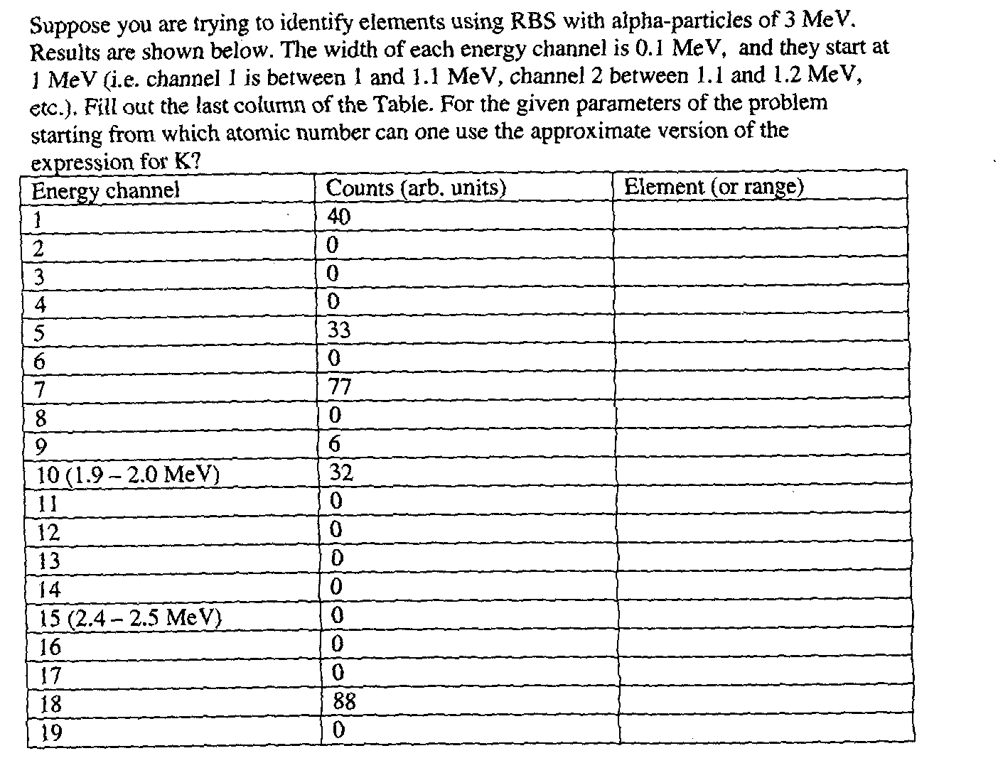
Calculate the ratio of concentrations of the elements with the three largest
numbers of counts.

Problem 8. [10 pt.] Describe qualitatively the structure of electronic spectrum a) for free motion b) for restricted motion c) for motion in periodic potential

Problem 9. [Extra credit - 10 pt.] In the Bohr’s model of the hydrogen atom, the electron revolving around the nucleus can be treated as “current”. This current will create a magnetic field at the center, where the nucleus is located. Estimate the energy levels due to the interaction of the magnetic moment of the nucleus with this magnetic field.
[Note: field due to a current I at the center of the loop of radius R is given by (in SI)
2 π10^-7 I/R]

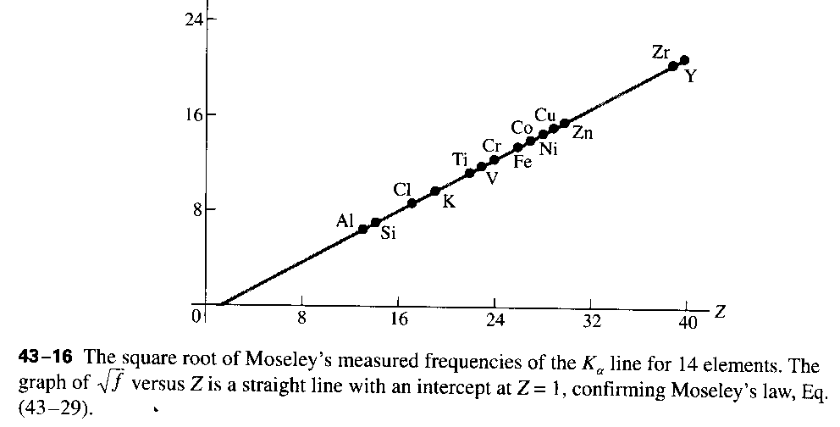
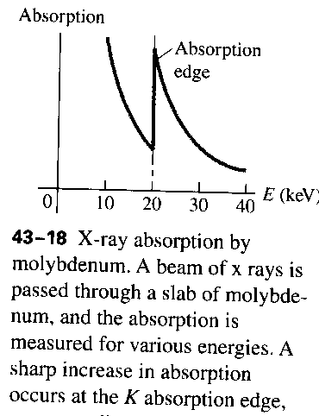
Fig. 1
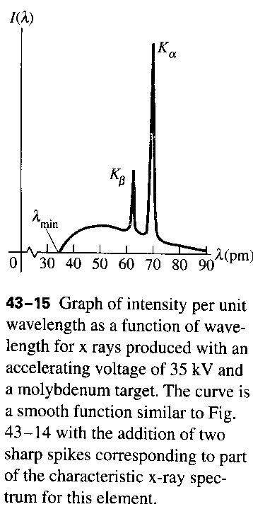
Fig. 2 Fig. 3

