COLUMN CHART FOR FINDING Cp

Sample Problem
A Douglas Fir Larch, select structural, 4x6 , is unsupported for its entire height. It is 12’-0” high and supports a beam with an end load of 3,200#s. Assume permanent load and moisture less than 19%. Is this member selection satisfactory?

Solution:
Nominal size = 4x6
Actual size = 3.5” X 5.5” where 3.5 is its “weak” dimension
le = Ke X l (NDS 1997 Appendix G P.162 or P 7.21 in 4th Ed Text)
use the recommended Ke=1.0 for practical field end conditions
therefore,
(le/d)y =12x12/3.25=41
(le/d)x =12x12/5.5= 26 therefore the max slenderness ratio controls

Note: le/d<50 so O.K as per NDS 1997 3.7.1.4

Now solve for Fc’//
Fc//=1700psi, C_{F}=1.1,C_{D}=.90,C_{M}=1.0
F*c=1700x1.1x0.9x1.0=1683psi
Go into chart for Cp where x =KceE’/F*c(le/d) ² =.3(1.9x10⁶)/1683(41) ²=.20
therefore,
Cp= .2 (for studs/solid columns) or calculate using (NDS 19973.7.1 P.22 or Text Pg.7.15 4th ed Text)
Finally,
F’c//=F*(Cp)=1683*.2= 336.6 psi 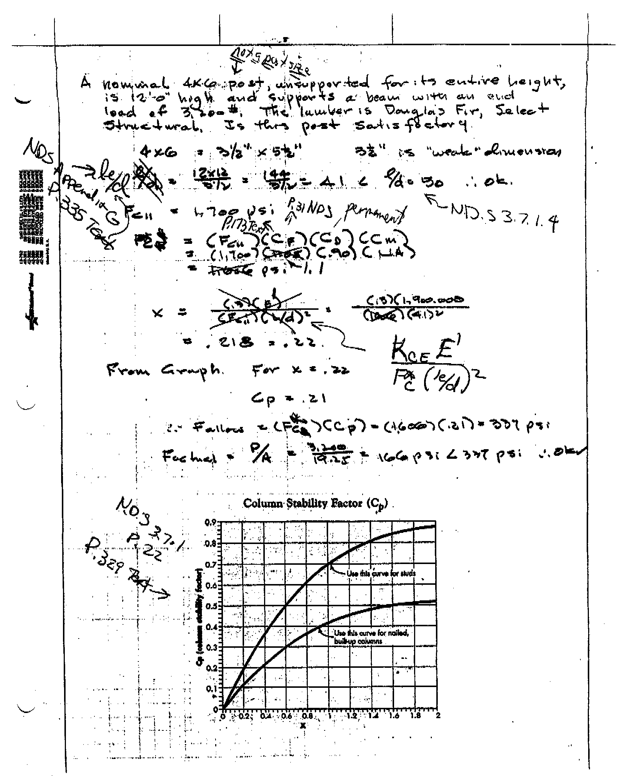 fc//=P/A=3200/19.25=166psi<337psi so O.K use this section

